A Seminar Report

On

**“Sixth Sense Technology**”

Submitted By

Mr./Ms. Yash R. Dewang

Guided By

Mr./Ms. Jyoti Rana

Submitted To



NaranLala College of Professional and Applied Sciences,

Veer Narmad South Gujarat University, Surat.

Year: 2019-2020



**NARANLALA**

**COLLEGE OF PROFESSIONAL & APPLIED SCIENCES**

**BHAGVATI SANKUL, NEAR ERU CHAR RASTA,**

**NAVSARI – 396 450**

**CERTIFICATE**

This is to certify that **Mr./Miss. Yash R. Dewang,** Exam No.280 student of **B.C.A. 6th** **semester** of our college have successfully prepared and submitted Seminar Report on “ **Sixth Sense Technology** ” as a partial fulfilment for the course of **Bachelor of Computer Application** during the academic year **2019-2020**.

____________ __________________

**DATE Guide: Mr./ Ms.**

_________________ __________________

**Dr. S. M. NAIK Dr. A. B. PATEL**

**(I/C PRINCIPAL, NLCPAS) (DEPT. HEAD, BCA)**

________________

**(EXTERNAL EXAMINER)**

Index

1. Introduction………………………………………………………………….4

2. History………………………………………………………….……………4

3. What is Sixth Sense Technology? ............................................................6

4. Why Choose Sixth Sense Technology? ......................................................7

5. Components………………………………………………………..…………7

6. Working……………………………………………………………..……….9

7. Evolution of Sixth Sense Technology …………………………………..………10

8. Application……………………………………………………………..…….11

9. Related Technologies to Sixth Sense Devices………………………………..….13

10. Education Use….…………………………………………………………...16

11. Advantage…………………………………………………………………..17

12. Disadvantage…………………………………………………………….….17

13. Current Status ……………………………………………………………...18

14. Future Scope………………………………………………………………..18

15. Conclusion………………………………………………………………....18

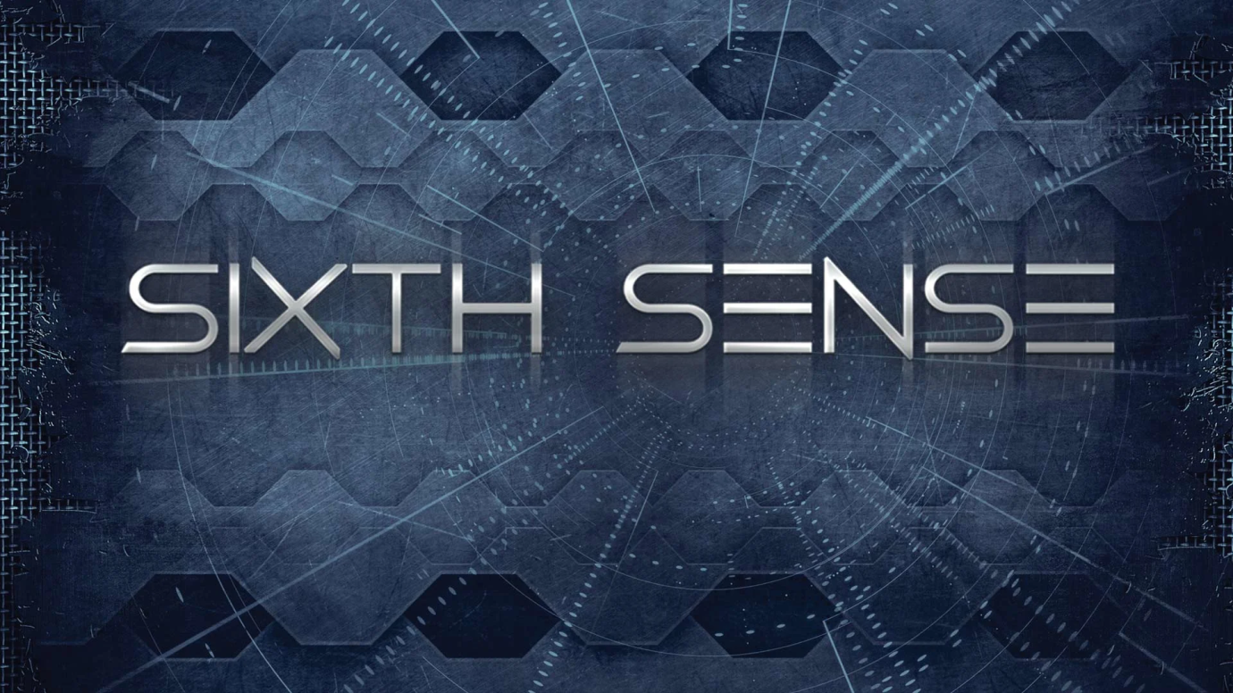

# Introduction

It’s the beginning of a new era of technology where engineering will reach new milestones. Just like in the science fiction movies where display of computer screen appears on walls, commands are given by gestures, the smart digital environment which talks to us to do our work and so on, these all will be possible very soon. You imagine it and sixth sense technology will make it possible. Isn’t it futuristic? Now it’s time for sci-fi movie directors to think ahead because the technology shown in there fiction movies soon will become household stuff. Before few years back it was considered to be supernatural or tantalizing imagination. But now it has been made possible. Thanks to Pranav Mistry, a genius who introduced mankind to this futuristic technology.

# History

Steve Mann is father of sixth sense technology who made a wearable computer in1990. The sixth sense technology was introduced as neck wearable projector with a camera. After it was used and implemented by an Indian named Pranav Mistry eho got famous recently for it.

[](https://en.wikipedia.org/wiki/File:SixthSense_SteveMann_1998_image1210.jpg)

Steve Mann wearing a camera+projector dome in 1998, which he used as one node of the collaborative Telepointer system

[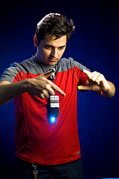](https://en.wikipedia.org/wiki/File:Pranavmistry.jpg)

Pranav Mistry wearing a similar device in 2012, which he and Maes and Chang named "WUW", for Wear yoUr World.

Sixth Sense is a [gesture-based](https://en.wikipedia.org/wiki/Gesture_recognition) [wearable computer](https://en.wikipedia.org/wiki/Wearable_computer) system developed at [MIT Media Lab](https://en.wikipedia.org/wiki/MIT_Media_Lab) by Steve Mann in 1994 and 1997 (head worn gestural interface), and 1998 (neck worn version), and further developed by [Pranav Mistry](https://en.wikipedia.org/wiki/Pranav_Mistry" \o "Pranav Mistry) (also at [MIT Media Lab](https://en.wikipedia.org/wiki/MIT_Media_Lab)), in 2009, both of whom developed both hardware and software for both head worn and neck worn versions of it. It comprises a head worn or neck-worn pendant that contains both a data projector and camera. Head worn versions were built at [MIT Media Lab](https://en.wikipedia.org/wiki/MIT_Media_Lab) in 1997 (by [Steve Mann](https://en.wikipedia.org/wiki/Steve_Mann_(inventor))) that combined cameras and illumination systems for interactive photographic art, and also included gesture recognition (e.g. finger-tracking using colour tape on the fingers).

Sixth Sense is a name for extra information supplied by a wearable computer, such as the device called Eye Tap (Mann), Telepointer (Mann), and "WuW" (Wear yoUr World) by [Pranav Mistry](https://en.wikipedia.org/wiki/Pranav_Mistry" \o "Pranav Mistry).

# What is sixth sense?

# *Sixth Sense is a wearable gestural interface that enhances the physical world around us with digital information and lets us use natural hand gestures to interact with that information*. It is based on the concepts of augmented reality and has well implemented the perceptions of it. Sixth sense technology has integrated the real world objects with digital world. The fabulous 6th sense technology is a blend of many exquisite technologies. The thing which makes it magnificent is the marvelous integration of all those technologies and presents it into a single portable and economical product. It associates technologies like hand [gesture recognition](https://www.engineersgarage.com/articles/gesture-recognition-technology), image capturing, processing, and manipulation, etc. It superimposes the digital world on the real world.

Sixth sense technology is a perception of augmented reality concept. Like senses enable us to perceive information about the environment in different ways it also aims at perceiving information. Sixth sense is in fact, about comprehending information more than our available senses. And today there is not just this physical world from where we get information but also the digital world which has become a part of our life. This digital world is now as important to us as this physical world. And with the internet the digital world can be expanded many times the physical world. God hasn’t given us sense to interact with the digital world so we have created them like smart phones, tablets, computers, laptops, net books, PDAs, music players, and others gadgets. These gadgets enable us to communicate with the digital world around us.

But we’re humans and our physical body isn’t meant for digital world so we can’t interact directly to the digital world. For instance we press keys to dial a number; we type text to search it and so on. This means for an individual to communicate with the digital world he/she must learn it. We don’t communicate directly and efficiently to the digital world as we do with the real world. The sixth sense technology is all about interacting to the digital world in most efficient and direct way. Hence, it wouldn’t be wrong to conclude sixth sense technology as gateway between digital and real world.  Before Wear Ur World (WuW) came there were other methods like [speech recognition](https://www.engineersgarage.com/articles/speech-recognition) software, touch recognition etc., which empowered us with direct interfacing.

This WuW or sixth sense device invented by Pranav Mistry is a prototype of next level of digital to real world interfacing. It comprises of a camera, a projector, a mobile cum computing device and colored sensors which are put on the fingers of a human being. The device efficiently senses the motion of the colored markers. Using them it provides us the freedom of directly interacting with the digital world. This technology enables people to interact in the digital world as if they are interacting in the real world.

# Why choose sixth sense technology?

Humans take decisions after acquiring inputs from the senses. But the information we collect aren’t enough to result in the right decisions. But the information which could help making a good decision is largely available on internet. Although the information can be gathered by connecting devices like computers and mobiles but they are restricted to the screen and there is no direct interaction between the tangible physical world and intangible digital world. This sixth sense technology provides us with the freedom of interacting with the digital world with hand gestures. This technology has a wide application in the field of [artificial intelligence](https://www.engineersgarage.com/articles/artificial-intelligence). This methodology can aid in synthesis of bots that will be able to interact with humans.

# Components

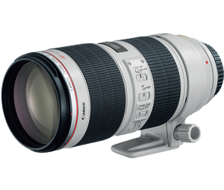

**Camera:** Camera scans surrounding area and creates digital data of it and sends it to smart phone

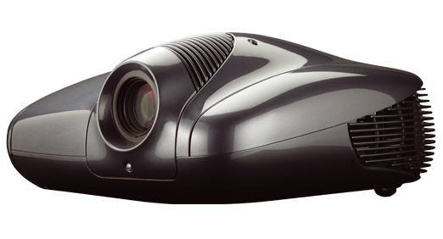

**Projector:** The projector projects the visual information on any surface, including the object itself or your hand. The project itself contains a battery inside, with 3 hours of battery life.

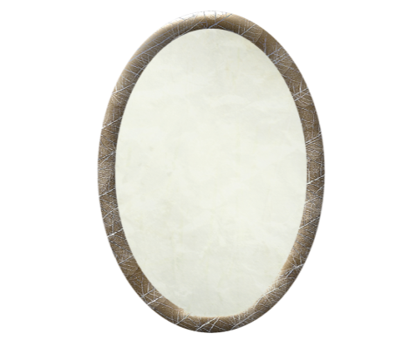

**Mirror:** The projector projects the output image on mirror that image reflected by mirror on desired surfaced.

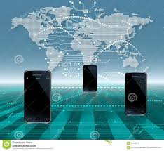

**Mobile Component:** The mobile devices like smartphones used to connect to internet. By using mobile internet data and voice can be transmitted and received across the world.

## Working

# How does sixth sense works?

The sixth sense technology uses different technologies like gesture recognition, image processing, etc. At present the commercial product isn’t launched but the prototype is prepared. The sixth sense prototype is made using very common and easily available equipment’s like pocket projector, a mirror, mobile components, color markers and a camera.

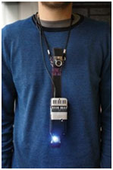

*Fig. 2: Image Showing Sixth Sense Technology Prototype Equipped With Pocket Projector, Mobile Components, Mirror, Colour Markers, and Camera*

The projector projects visual images on a surface. This surface can be wall, table, book or even your hand. Thus, the entire world is available on your screen now. When user moves their hands to form different movements with colored markers on the finger tips, the camera captures these movements. Both the projector and the camera are connected to the mobile computing device in the user’s pocket. Recognition is made using computer vision technique. These markers act as visual tracking fiducials. The software program processes this video stream data and interprets the movements into gestures. The gestures are different from one another and are assigned some commands. These gestures can act as input to application which is projected by the projector. Since, the projector is aligned downwards for compactness; therefore images would be formed at the user’s feet if mirror wasn’t used. The mirror reflects the image formed by the projector to front. The entire hardware is fabricated in the form of a pendent. The entire product cost around $ 350 and that also because of projector. It works very similar like a touch screen phone with entire world as the screen.

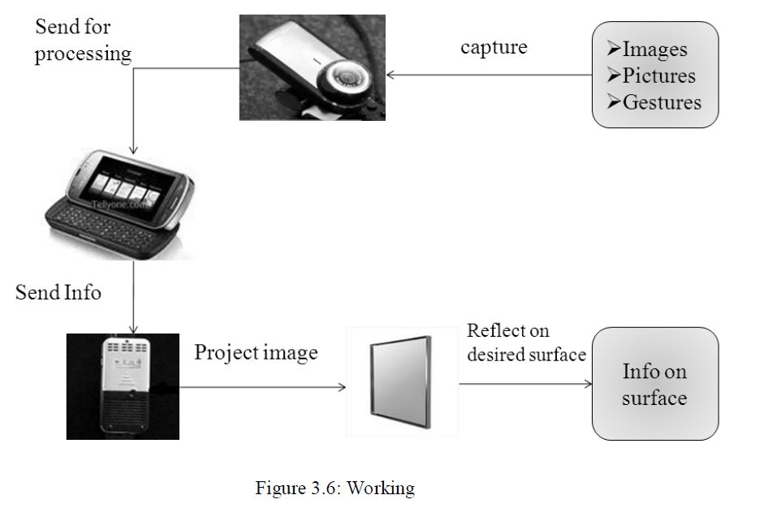

# Evolution of Sixth Sense Technology

Steve Mann is considered as the father of Sixth Sense technology who made a wearable computer in 1990. He implemented the Sixth Sense technology as the neck worn projector with a camera system. He was a media lab student at that time. Then his work was carried forward by Pranav Mistry, an Indian research assistant in MIT Media Lab. He came up with exciting new applications from this technology. Sixth sense technology was developed at media labs in MIT and coined as Wear Ur World (WUW). The inventors have filed patent under the name Wear Ur World (WUW) in February 2010.

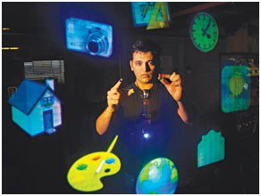

*Fig. 3: Image Showing Pranav Mistry Introducing New Applications from Sixth Sense Technology*

“Rather than waiting for that time to come, I want people to make their own system. Why not?” Mistry says in an article on Rediff Business. “People will be able to make their own hardware. I will give them instructions how to make it. And also provide them key software…give them basic key software layers…they will be able to build their own applications. They will be able to modify base level and do anything”.

So it can be expected that the software will be [open source](https://www.engineersgarage.com/articles/open-source-software-history-advantages) and there will be a wide market of apps too.

**Applications**

**Fingers as brush:**The user can draw anything on paint with the help of his fingers. This drawing can be 3D also. Hence, no need to use mouse.

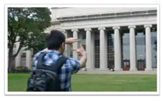

*Fig. 4: Image Showing User Capturing Photo Using Fingers with Sixth Sense Technology*

**Capture photos with fingers:** using the fingers the user can capture photos hence, no need to carry an additional gizmo. The box created by the fingers act as frame for capturing photo.

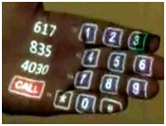

*Fig. 5: Image Showing Dialer Projected on Palm to Make Calls Using Sixth Sense Technology*

**Palm is the new dialler:** this technology enables the user to call without using the dialler. The dialler will be projected on palm and the user can dial the number using other hand.

**Read Books easily:**Check out the ratings of the Book you are going to buy, it checks the ratings from the internet. And another amazing thing is that it reads the book for you.

**Video Newspapers:**like the video newspapers of Harry Potter this technology identifies the news headline and then projects the relevant video.

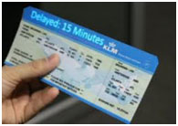

*Fig. 6: Image Showing Checking the Flight Status Using Sixth Sense Technology*

**Check your Flight Status:** Just place the ticket in front of the projector and it checks its status from the internet.

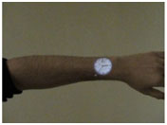

*Fig. 7: Image Showing Clock Projected On the User’s Hand Through Sixth Sense Technology*

**Clock:** the user just needs to make gesture of clock and the watch will be projected on the user’s hand.

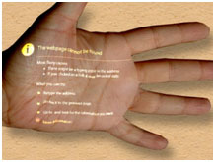

*Fig. 8: Image Showing Possibility to Access Internet On Any Surface Through Sixth Sense Technology*

**Access anywhere internet:**the users can browse internet  on any surface even on their palm.

# Related Technologies to Sixth Sense Devices

* Augmented Reality
* Gesture Recognition
* Computer Vision
* Radio Frequency Identification

Augmented Reality

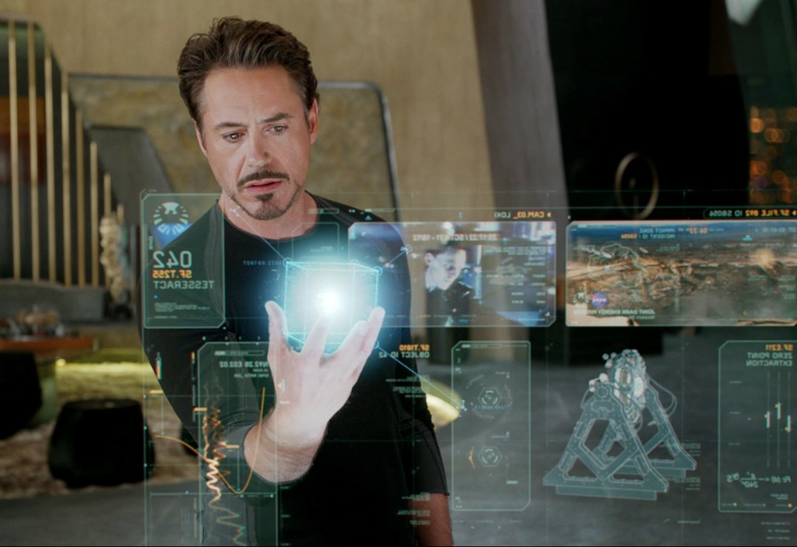

**Augmented reality** (**AR**) is an interactive experience of a real-world environment where the objects that reside in the real world are enhanced by computer-generated perceptual information, sometimes across multiple sensory [modalities](https://en.wikipedia.org/wiki/Modality_(human%E2%80%93computer_interaction)), including [visual](https://en.wikipedia.org/wiki/Visual), [auditory](https://en.wikipedia.org/wiki/Hearing), [haptic](https://en.wikipedia.org/wiki/Haptic_perception), [somatosensory](https://en.wikipedia.org/wiki/Somatosensory_system) and [olfactory](https://en.wikipedia.org/wiki/Olfactory). AR can be defined as a system that fulfils three basic features: a combination of real and virtual worlds, real-time interaction, and accurate 3D registration of virtual and real objects. The overlaid sensory information can be constructive (i.e. additive to the natural environment), or destructive (i.e. masking of the natural environment). This experience is seamlessly interwoven with the physical world such that it is perceived as an [immersive](https://en.wikipedia.org/wiki/Immersion_(virtual_reality)) aspect of the real environment. In this way, augmented reality alters one's on-going perception of a real-world environment, whereas [virtual reality](https://en.wikipedia.org/wiki/Virtual_reality) completely replaces the user's real-world environment with a simulated one.

Gesture Recognition

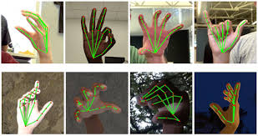

Gesture recognition is a topic in [computer science](https://en.wikipedia.org/wiki/Computer_science) and [language technology](https://en.wikipedia.org/wiki/Language_technology) with the goal of interpreting human [gestures](https://en.wikipedia.org/wiki/Gesture) via mathematical [algorithms](https://en.wikipedia.org/wiki/Algorithm). Gestures can originate from any bodily motion or state but commonly originate from the [face](https://en.wikipedia.org/wiki/Face) or [hand](https://en.wikipedia.org/wiki/Hand). Currentfocuses in the field include [emotion recognition](https://en.wikipedia.org/wiki/Emotion_recognition) from face and hand gesture recognition. Users can use simple gestures to control or interact with devices without physically touching them. Many approaches have been made using cameras and [computer vision](https://en.wikipedia.org/wiki/Computer_vision) algorithms to interpret [sign language](https://en.wikipedia.org/wiki/Sign_language). However, the identification and recognition of posture, gait, [proxemics](https://en.wikipedia.org/wiki/Proxemics), and human behaviours is also the subject of gesture recognition techniques. Gesture recognition can be seen as a way for computers to begin to [understand human body language](https://en.wikipedia.org/wiki/Computer_processing_of_body_language), thus building a richer bridge between machines and humans than primitive [text user interfaces](https://en.wikipedia.org/wiki/Text_user_interface) or even [GUIs](https://en.wikipedia.org/wiki/GUI) (graphical user interfaces), which still limit the majority of input to keyboard and mouse and interact naturally without any mechanical devices. Using the concept of gesture recognition, it is possible to point a finger at this point will move accordingly. This could make conventional input on devices such and even redundant.

Computer Vision

Computer vision is an [interdisciplinary scientific field](https://en.wikipedia.org/wiki/Interdisciplinarity) that deals with how [computers](https://en.wikipedia.org/wiki/Computer) can gain high-level understanding from [digital images](https://en.wikipedia.org/wiki/Digital_image) or [videos](https://en.wikipedia.org/wiki/Video). From the perspective of [engineering](https://en.wikipedia.org/wiki/Engineering), it seeks to understand and automate tasks that the [human visual system](https://en.wikipedia.org/wiki/Human_visual_system) can do.

Computer vision tasks include methods for [acquiring](https://en.wikipedia.org/wiki/Image_sensor), [processing](https://en.wikipedia.org/wiki/Image_processing), [analyzing](https://en.wikipedia.org/wiki/Image_analysis" \o "Image analysis) and understanding digital images, and extraction of [high-dimensional](https://en.wikipedia.org/wiki/High-dimensional) data from the real world in order to produce numerical or symbolic information, e.g. in the forms of decisions. Understanding in this context means the transformation of visual images (the input of the retina) into descriptions of the world that make sense to thought processes and can elicit appropriate action. This image understanding can be seen as the disentangling of symbolic information from image data using models constructed with the aid of geometry, physics, statistics, and learning theory.

The [scientific discipline](https://en.wikipedia.org/wiki/Scientific_discipline) of computer vision is concerned with the theory behind artificial systems that extract information from images. The image data can take many forms, such as video sequences, views from multiple cameras, multi-dimensional data from a 3D scanner or medical scanning device. The technological discipline of computer vision seeks to apply its theories and models to the construction of computer vision systems.

Radio Frequency Identification

**RFID** (**radio frequency identification**) is a form of **wireless** communication that incorporates the use of electromagnetic or electrostatic coupling in the **radio frequency** portion of the electromagnetic spectrum to uniquely identify an object, animal or person.

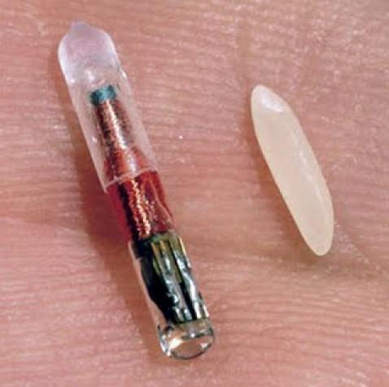

Educational Use

* Engagement
* Research
* Collaboration
* Cost-effectiveness

Engagement

* + Teachers may find that Sixth Sense, because of its unique ability to work with many of Gardner’s multiple intelligences, will be a catalyst for students who might otherwise remain unengaged in learning.
  + Sixth Sense uses the visual, kinesthetic, intrapersonal and interpersonal among others.
  + If this technology does nothing else, the idea that students can simply use their hands to draw images on walls and take pictures with their hands will be (at least initially) quite motivating

Research

* Sixth Sense will give new meaning to “looking something up.”
* Since we are essentially talking about the internet, students will be given the opportunity to portably research the world.
* They can all go on a virtual field trip and project the images on their own desks, for example.

Collaboration

* Students will be given an opportunity through this technology to feel more connected to others.
* Although there does seem to be the sense that individuals could walk through life wired and lonely, I like to think the classroom would serve as the environment in which students and teachers using Sixth Sense would want to share.

Cost effectiveness

* As mentioned earlier, this product currently costs only $350. From an educator’s stand point, this is minimum given the amount of money spent on textbooks, computer labs and LCD projectors.
* For educator’s, Sixth Sense would be a way to put technology (literally) into each student’s hands, because of its size and its cost.

Advantages

* **Portable:**  One of the main advantages of the sixth sense devices is its small size and portability.
* **Support multi touch and multi user interaction:** Multi touch and multi user interaction is another added feature of the sixth sense devices.
* **Cost effective:**The cost incurred for the construction of the sixth sense proto type is quiet low.
* **Connectedness between real world and digital world:** Forming a connection between the real world and the digital world was the main aim of the sixth sense technology.
* **Data access directly from the machines in real time:** With help of a sixth sense device the user can easily access data from any machine at real time speed.
* **Open source software:** The software that is used to interpret and analysis the data collected by the device is made open source.
* **Mind map the idea anywhere:** With the advent of the sixth sense device, requirement of a platform or a screen to analyze and interpret the data has become obsolete

Disadvantages

* We have to give correct instruction.
* The projectors runs on batteries for power where regularly have to place.

Current Status

* Although the Sixth Sense technology achieved wide press coverage in 2009, no commercial product had been released at that time.
* As of September 2013, the open source code published has not been updated since October 2012,and the Java development branch of the project was similarly stalled.

Future Scope

* Although the Sixth Sense technology achieved wide press coverage in 2009, no commercial product had been released at that time.
* As of September 2013, the open source code published has not been updated since October 2012,and the Java development branch of the project was similarly stalled.

**Conclusion**

This technology has seamless applications. This can be used as a replacement of the 5th senses for handicapped peoples. This can provide easy control over machineries in industry. This will have different application for different developers just depending upon how he imagines and what he wants. So, considering its widespread applications the inventor Pranav Mistry has decided to make its software open source. This will enable individuals to make their own application depending upon needs and imagination. As this technology will emerge may be new devices and hence forth new markets will evolve. Some existing devices and technologies will be discontinued but one thing is guaranteed it will write a new chapter in history of science and technology.