Day_3_MT_Network_Security_1
Network Security 1 Day 3 Notes
- Network Fundamentals

TCP/IP Model (4-Layer Architecture)
Application Layer: HTTP, FTP, DNS, SMTP (user-facing protocols)
Transport Layer: TCP, UDP (end-to-end communication)
Internet/Network Layer: IP, ICMP (routing between networks)
Network Access/Link Layer: Ethernet, Wi-Fi, ARP (physical transmission)

Network Communication Process
Encapsulation: Data wrapped with headers at each layer

Metadata at Each Layer:
Application: Port numbers
Transport: TCP/UDP headers (sequence numbers, ports)
Network: IP addresses, routing information
Link: MAC addresses, physical addressing

Data Journey Through Layers
Application Data → Transport Segment → Network Packet → Link Frame

2. Transport Layer Services
Transport vs. Network Layer
Transport Layer: Communication between processes (applications)
Network Layer: Communication between hosts (machines)

Analogy: 12 kids in Ann's house sending letters to 12 kids in Bill's house
Hosts = houses
Processes = kids
Transport protocol = Ann and Bill who deliver to correct sibling
Network protocol = postal service

Transport Protocols
TCP (Transmission Control Protocol):
Reliable, in-order delivery
Connection-oriented (3-way handshake)
Flow control, congestion control
Used for: web browsing, email, file transfer

UDP (User Datagram Protocol):
Unreliable, unordered delivery
Connectionless
Minimal overhead
Used for: streaming, DNS, VoIP

Multiplexing/Demultiplexing
Multiplexing (sender): Combine data from multiple sockets, add transport headers
Demultiplexing (receiver): Use headers to deliver segments to correct sockets
Key identifiers: Source/destination IP addresses + port numbers

3. TCP Connection Establishment
Three-Way Handshake
SYN: Client → Server (synchronize sequence numbers)
SYN-ACK: Server → Client (acknowledge, synchronize)
ACK: Client → Server (acknowledge)

Socket Programming Basics
// Client side
Socket clientSocket = new Socket("hostname", "port number");

// Server side
Socket connectionSocket = welcomeSocket.accept();

4. Network Security Challenges
Original Internet Design Flaws
Designed for "mutually trusting users"
No built-in security mechanisms
Security added as afterthought

Key Security Requirements
Confidentiality: Prevent unauthorized data access
Integrity: Ensure data isn't modified
Availability: Ensure services remain accessible
Authentication: Verify identities
Non-repudiation: Prevent denial of actions

5. Network Threats by Layer
Link/Network Access Layer Threats
ARP Spoofing/Poisoning:
Attack: Send fake ARP messages to associate attacker's MAC with legitimate IP
Impact: Man-in-the-middle attacks, traffic interception
Defense: Static ARP tables, DHCP snooping, dynamic ARP inspection

MAC Spoofing:
Attack: Change MAC address to impersonate another device
Impact: Bypass MAC filtering, network access control evasion

Physical Access Attacks:
Attack: Direct access to network cables/ports
Impact: Complete network compromise

Network (IP) Layer Threats
IP Spoofing:
Attack: Send packets with false source IP addresses
Impact: Bypass IP-based filtering, DDoS amplification

Routing Attacks (BGP Hijacking):
Attack: Advertise false routing information
Impact: Traffic interception, redirection

Packet Sniffing:
Attack: Capture packets on shared media (Ethernet, Wi-Fi)
Impact: Credential theft, data leakage
Defense: Encryption (IPSec, TLS), network segmentation

Transport (TCP/UDP) Layer Threats
TCP Session Hijacking:
Attack: Predict sequence numbers, inject malicious packets
Impact: Command execution, data manipulation
Defense: Random initial sequence numbers, encryption

TCP SYN Flooding:
Attack: Send many SYN packets without completing handshakes
Impact: Denial of service
Defense: SYN cookies, rate limiting

UDP Flood Attacks:
Attack: Send high volume of UDP packets
Impact: Bandwidth consumption, service disruption

Application Layer Threats
DNS Attacks:
DNS Poisoning: Corrupt DNS cache with false mappings
DNS Amplification: Use DNS servers in DDoS attacks
Impact: Phishing, traffic redirection, service disruption

Web Application Attacks:
SQL injection, XSS, CSRF
Broken authentication, insecure APIs

6. Address Translation and Routing
Address Resolution Protocol (ARP)
Purpose: Map IP addresses to MAC addresses
Message types: ARP Request, ARP Reply, ARP Announcement
Vulnerability: No authentication → ARP spoofing attacks

Domain Name System (DNS)
Purpose: Map domain names to IP addresses
Hierarchical structure: Root → TLD → Authoritative servers
Vulnerability: Cache poisoning, DDoS amplification

Routing Basics
Internet routing uses numeric IP addresses
Routes typically involve multiple hops
Protocols: BGP (external), OSPF/RIP (internal)

7. Attack Case Studies
Case Study 1: WannaCry Ransomware (May 2017)
Exploit: EternalBlue (SMBv1 vulnerability, port 445)
Impact: 300,000+ computers globally
Major Victims: NHS (UK), FedEx, Renault
Critical Lesson: Patch management is essential
Patch Available: MS17-010 (released 2 months before attack)

Case Study 2: Mirai Botnet (October 2016)
Attack Vector: Default credentials on IoT devices
Impact: DDoS attack on Dyn DNS provider (620 Gbps)
Affected: Netflix, Twitter, Reddit, GitHub
Critical Lesson: Change default credentials on IoT devices
Evolution: Variants reaching 29.7 Tbps by 2025

Case Study 3: SolarWinds Supply Chain Attack (2019-2020)
Method: SUNBURST backdoor in Orion software updates
Timeline: September 2019 - December 2020
Victims: 18,000+ organizations including US government
Attribution: APT29 (Russian state-sponsored)
Critical Lesson: Zero Trust Architecture needed, verify supply chain

8. Defense Strategies
Defense in Depth (Layered Security)
No single security control protects against all threats - implement multiple layers:
Application Layer Controls
Secure coding practices
Input validation and sanitization
Web Application Firewalls (WAF)
Authentication/authorization (MFA, OAuth)
Application logging and monitoring

Transport Layer Controls
TLS/SSL encryption (HTTPS)
Secure session management
Certificate validation
Rate limiting and DDoS protection

Network Layer Controls
IPsec (Authentication Header, Encapsulating Security Payload)
Network firewalls
Secure routing protocols
Network segmentation

Link Layer Controls
Network Access Control (NAC)
Port security
Dynamic ARP inspection
VLAN isolation
Physical security controls

Zero Trust Architecture
Principle: "Never trust, always verify"
Assumption: Breach has already occurred
Implementation: Verify every connection before granting access

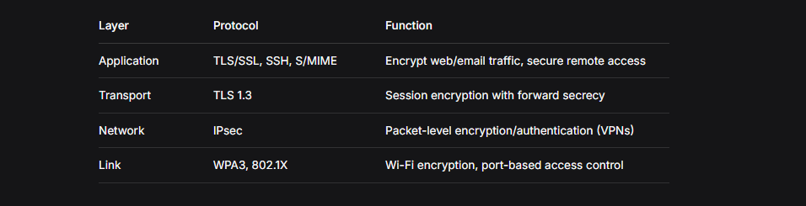

9. Operational Recommendations
Essential Security Practices
Patch Management: Apply security updates promptly
Network Segmentation: Use VLANs and microsegmentation
Encryption Everywhere: Default to TLS/IPsec for data in transit
Monitoring & Detection: Deploy IDS/IPS and SIEM systems
Strong Authentication: Enforce Multi-Factor Authentication (MFA)
Disable Unnecessary Services: Telnet, FTP, legacy protocols
Regular Testing: Penetration testing, vulnerability assessments
Incident Response: Maintain and test response plans
Security Awareness: Train users on threats and best practices

IoT Security Specific Recommendations
Change default credentials immediately
Segment IoT devices on separate networks
Disable unnecessary features and ports
Regularly update firmware
Monitor for unusual network activity

10. Future Considerations
Emerging Trends
IoT Expansion: Increasing attack surface with insecure devices
5G Networks: New vulnerabilities in high-speed mobile networks
Cloud Migration: Security responsibility sharing models
AI/ML in Security: Both for attack automation and defense
Quantum Computing: Future threat to current encryption

Zero Trust Implementation Challenges
Integrating with legacy systems
Performance impact of continuous verification
User experience considerations
Cost and complexity of deployment

11. Key Takeaways
Core Principles
TCP/IP was designed for connectivity, not security
Each layer has unique vulnerabilities requiring tailored defenses
Attackers chain exploits across multiple layers
Defense in depth is essential - no single control is sufficient
Assume breach mentality (Zero Trust)

Layer-Specific Defense Recap
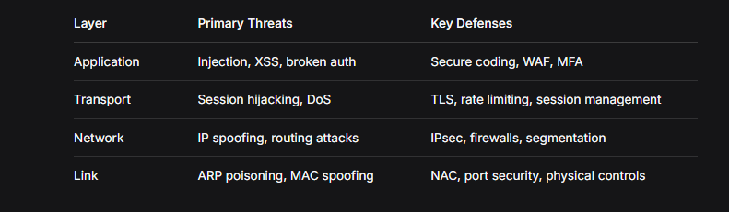
12. Discussion Topics
Critical Questions for Consideration
IoT & Attack Surface: How does the rise of insecure IoT devices change the threat model?
Zero Trust vs. Legacy: What challenges do organizations face adopting Zero Trust?
AI in Cybersecurity: How will AI-driven automation affect attack/defense dynamics?
Future Protocols: What security features should future network protocols include?

Recommended Resources
NIST Cybersecurity Framework (CSF): Risk management guidelines
OWASP Top 10: Web application security awareness
CIS Critical Security Controls: Prioritized protection actions
Books: "TCP/IP Illustrated" by W. Richard Stevens

13. Review Questions
Conceptual:
What are the four layers of the TCP/IP model and their main security concerns?
How does the three-way handshake work, and what attacks target it?
Explain the difference between ARP poisoning and IP spoofing.
Why is defense in depth necessary for network security?
What lessons can we learn from the WannaCry, Mirai, and SolarWinds attacks?
Practical:
How would you defend against ARP spoofing on a corporate network?
What security controls would you implement at each TCP/IP layer?
How does DNS amplification work, and how can it be prevented?
What are the steps to implement basic network segmentation?
How would you detect a TCP session hijacking attempt?
Analytical:
Why are IoT devices particularly vulnerable, and how does this affect overall network security?
Compare and contrast the security implications of TCP vs. UDP.
How does the SolarWinds attack demonstrate the limitations of traditional perimeter security?
What are the trade-offs between security and performance in network design?
How might quantum computing change network security fundamentals?

14. Summary of Key Points
Network Security Fundamentals:
TCP/IP architecture has inherent security weaknesses
Each protocol layer presents unique attack vectors
Modern threats often combine multiple attack types
Historical attacks provide valuable lessons for current defense

Critical Defenses:
Layered approach (defense in depth) is mandatory
Encryption at multiple layers protects data confidentiality
Authentication and access control prevent unauthorized access
Monitoring and detection enable rapid response to incidents
Regular updates and patches fix known vulnerabilities

Future Outlook:
Zero Trust is becoming the new security standard
IoT security requires special attention
Supply chain attacks are increasingly common
Automation in both attack and defense is accelerating
Continuous adaptation is necessary against evolving threats

