Таблици
1. TEACHER
CREATE TABLE TEACHER (
TEACHERID int NOT NULL AUTO_INCREMENT ,
FIRSTNAME varchar(20),
SECONDNAME varchar(20),
THIRDNAME varchar(20),
PRIMARY KEY (TEACHERID)
);
2. CLASS

CREATE TABLE CLASS (
CLASSID int NOT NULL AUTO_INCREMENT,
NAME varchar(3),
TEACHERID int NOT NULL,
PRIMARY KEY (CLASSID),
FOREIGN KEY (TEACHERID) REFERENCES TEACHER(TEACHERID) on delete cascade
);

3. SUBJECTS

CREATE TABLE SUBJECTS (
SUBJECTID int NOT NULL AUTO_INCREMENT,
NAME varchar(55),
PRIMARY KEY (SUBJECTID)
);

4. STUDENT

CREATE TABLE STUDENT (
STUDENTID int NOT NULL AUTO_INCREMENT,
FIRSTNAME varchar(20),
SECONDNAME varchar(20),
THIRDNAME varchar(20),
CLASSID int NOT NULL,
PRIMARY KEY (STUDENTID),
FOREIGN KEY (CLASSID) REFERENCES CLASS(CLASSID) on delete cascade
);

5.GRADE

CREATE TABLE GRADE (
GRADEID int NOT NULL AUTO_INCREMENT,
GRADE_VALUE float,
SUBJECTID int NOT NULL,
STUDENTID int NOT NULL,
PRIMARY KEY (GRADEID),
FOREIGN KEY (SUBJECTID) REFERENCES SUBJECTS(SUBJECTID) ON DELETE CASCADE,
FOREIGN KEY (STUDENTID) REFERENCES STUDENT(STUDENTID) ON DELETE CASCADE
);

6.SUBJEC_CLASS

CREATE TABLE SUBJECT_CLASS (
SUBJECTCLASSID int NOT NULL AUTO_INCREMENT,
SUBJECTID int NOT NULL,
CLASSID int NOT NULL,
PRIMARY KEY (SUBJECTCLASSID),
FOREIGN KEY (SUBJECTID) REFERENCES SUBJECTS(SUBJECTID) on delete cascade ,
FOREIGN KEY (CLASSID) REFERENCES CLASS(CLASSID) on delete cascade
);

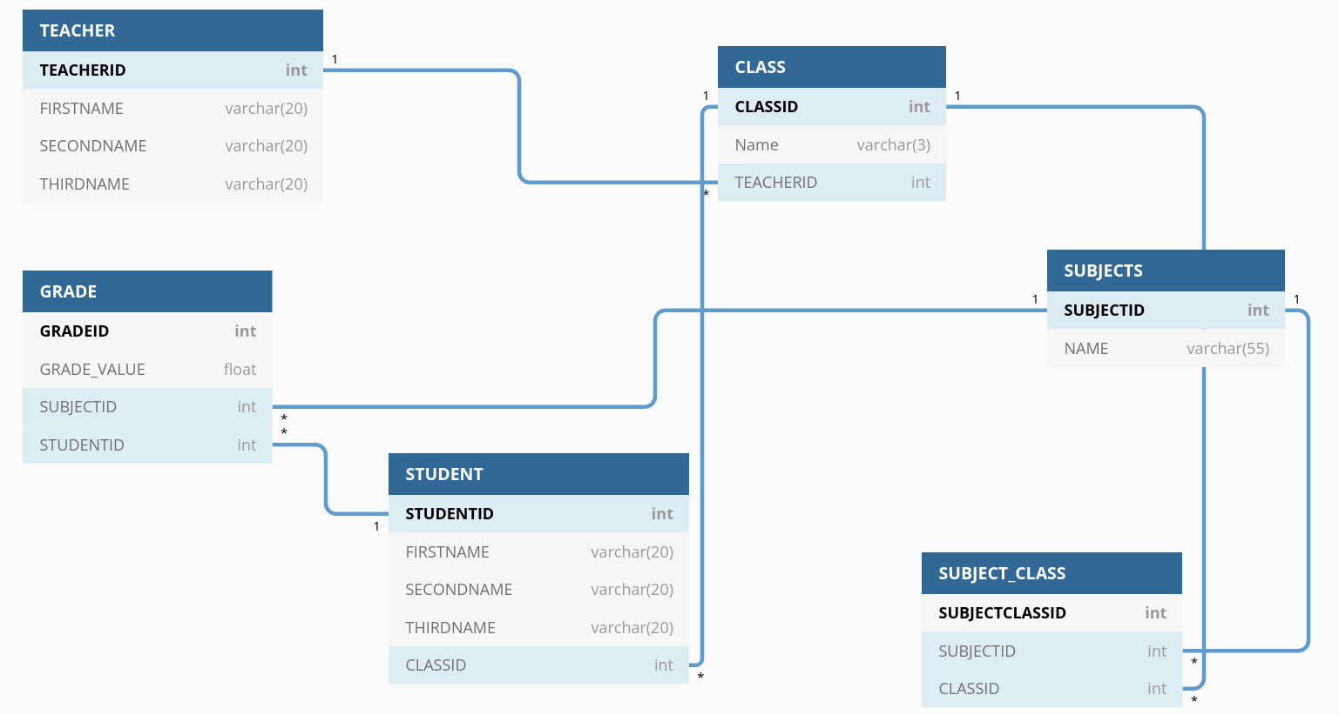

 | Insert | Update | Delete | Select
teacher | + | + | + | +
grade | + | + | + | +
subject_class | + | + | + | +
subjects | + | + | + | +
student | + | + | + | +
class | + | + | + | +

Първоначални данни

insert into teacher (FIRSTNAME, SECONDNAME, THIRDNAME) VALUES ('Tanya','Ivanova','Naydenova'),
('Petar','Sabev','Subev'), ('Em','Ivanova','Andreeva'), ('Petar','Ivanov','Beleganski'), ('Kiril','Kirilov','Kirilov');

insert into class (teacherid, name) values (1, ‘1А’), (2, ‘2A’), (3, ‘3A’), (4, ‘4A’), (5, ‘5A’);

insert into subjects (name) values ('math'), ('english'), ('bulgarian'), ('russian'), ('programming');

insert into student (FIRSTNAME, SECONDNAME, THIRDNAME, CLASSID) values ('Petar', 'Petrov', 'Petrov', 1), ('Ivan', 'Ivanov', 'Ivanov', 2),
('Iva', 'Todorova', 'Ioncheva', 3), ('Petkan', 'Petkanov', 'Petkanov', 4), ('Atanas', 'Atanasov', 'Atanasov', 5);

insert into grade (GRADE_VALUE, SUBJECTID, STUDENTID) values (2.00, 1, 1), (3.00, 2, 2), (4.00, 3, 3), (5.00, 4, 4), (6.00, 5, 5);

insert into subject_class (SUBJECTID, CLASSID) values (1,1), (2,2), (3,3), (4,4), (5,5) ;

