Requirements and Analysis Document for the Challenge Accepted project, (RAD)
– A digital version of ‘Upp till Bevis’.

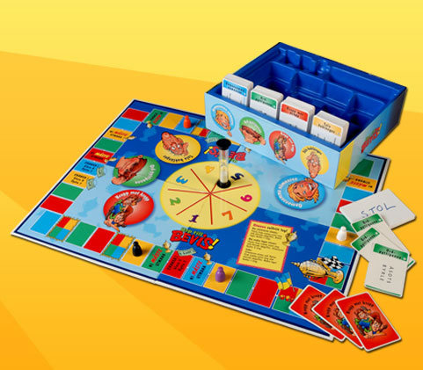

Contents
- Introduction
  - Purpose of application
  - General characteristics of application
  - Scope of application
  - Objectives and success criteria of the project
  - Definitions, acronyms and abbreviations

- Requirements
  - Functional requirements - Create a list of high level funtions here (from the use cases).
  - Non-functional requirements - Possible NA (not applicable).
    - Usability
    - Reliability
    - Performance
    - Supportability
    - Implementation
    - Packaging and installation
    - Legal
  - Application models
    - Use case model - UML and a list of UC names (text for all in appendix)
    - Use cases priority - A list
    - Domain model - UML, possible some text.
    - User interface - Text to motivate a picture.
  - References

APPENDIX
GUI
Domain model
Use case texts

Version: 1.0
Date: 2012-05-23
Authors: Cecilia Edwall 920223-5769
Isabelle Frölich 900831-2846
Johan Gustavsson 871024-7134
Madeleine Appert 891110-4845

This version overrides all previous versions.

- Introduction
  - Purpose of application
With our application we aim to construct a computer based version of a game called ‘Upp till bevis’, which is a board game requiring the teams playing to complete missions in order to continue forward on the board, towards the finish line.

  - General characteristics of application
This is a multi-player application which is to be used on a computer platform. It will not require a connection to a network and will be used in social home environments.
The application will require at least 2 teams of 2 players, but will be able to manage 8 teams. Any amount of players can be a part of a team, it will not affect the application at all. The game is turn based, and will require the teams to approve each other’s missions in order for the game to work. For completing a mission, the program will have a time limit of 30 seconds, but besides this, there will be no time constraints at all.
The game will end once a team has made it round the board, or if the game is cancelled manually.

  - Scope of application
System will allow 2-8 teams. There will be no computer-player.
Application will not keep track of highscore etc.
Possibility to choose level of game has been discussed but not yet decided upon.
Possibility to save game.

  - Objectives and success criteria of the project
The applications should function for a game which can be considered within the frame of what the game should manage.
The graphical user interface is to be of such quality that the user at all times knows who’s turn it is, what stage is present and what he/she is supposed to do.
LÄGGA TILL DET SOM PUNKT ATT OM SI OCH SÅ ÄR AVKLARAT kan vi lägga till levels, slumpade kategorier ist f bestämda, ge olika lag olika idsbegränsningar, ha ledtrådar etc etc

  - Definitions, acronyms and abbreviations

- Requirements
  - Functional requirements
The players/teams should be able to:
1. Read the game rules.
2. Start a new game.
- Select how many teams will take part in the turn.
3. Do a turn. During a turn the team will be able to:
- Choose how many steps they bet they will manage.
- Change that bet before the actual mission starts.
- Achieve the assignment cards.
4. At the end of a team’s turn the other playing team(s) will be able to approve/disapprove the mission accomplished by the team in turn.
3. Exit the application. Will end turn, round and game.

  - Non-functional requirements
    - Usability
Normal players are to understand how the game works without being forced to seek information elsewhere than in the application itself.
The language will be English, hence the game requires all participants to speak English.
    - Reliability
N/A
    - Performance
N/A
    - Supportability
    - Implementation
To achieve platform independence the application will use the Java environment.
    - Packaging and installation
The application will be delivered as a zip file containing all the packages and classes included in the program. To be able to run the program, the user will simply have to import the project into a Java based environment, like eclipse for example.
    - Legal
There could be legal issues regarding rights to the Monopoly game and trade mark. This is not covered here.
  - Application models
    - Use case model
See APPENDIX for UML diagram and textual descriptions.
    - Use case priority
- Dfgdfg
- Dfgdg
- dfgdfg
    - Domain Model
See APPENDIX.
    - User Interface
Application will use a fixed GUI (non themeable, non resizable)
  - References
General explanation of game (in Swedish).
http://www.braspel.com/?id=317
Thorough explanation of game rules (in Swedish).
http://www.braspel.com/filearchive/1/1917/rules_UTB%20new.pdf

Not now:
  - What can we do with the system
  - GUI, graphical user interface.
  - Java, platform independent programming language.
  - JRE, the Java Runtime Environment. Additional software needed to run a Java application.
  - Start new game.
  - Decide how many teams are participating.
  - Abort game in middle.
  - Save game and restart it at previous point
  - As it will be th users approval which will pass och fail the mission attempted by other team(s), a undo button
  - Other criteria to judge the operation of a system

