Comparative Analysis of Data Orchestration Frameworks
This document presents a complete overview, execution flow, and results of running the same ETL pipeline using four orchestration approaches: Local Python, Prefect, Dagster, and Apache Airflow. The goal of this project is to understand differences in workflow execution, logging, monitoring, and consistency of outputs across these frameworks.
Project Folder Outputs — All tools generated the same partitioned output:-
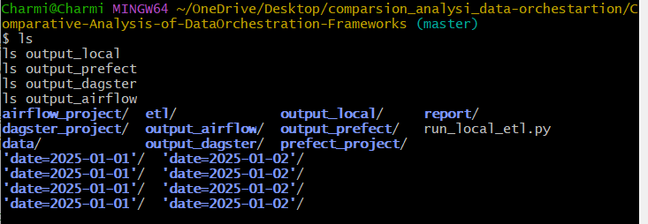
The above screenshot shows the top-level project directory after running the ETL pipeline using all four orchestration methods. Each framework generated its output inside separate folders (output_local, output_prefect, output_dagster, and output_airflow).
Inside each output folder, we observe the same partition structure created by the ETL load step:
date=2025-01-01/
date=2025-01-02/
This demonstrates that:
- The ETL pipeline behaved consistently across all orchestration tools.
The extract → transform → load logic was executed in the same way in Local Python, Prefect, Dagster, and Airflow.
- The partitioning logic implemented in the load function worked correctly everywhere.
Each tool wrote the final transformed dataset into date-based partitions without any deviation.
- Framework-level orchestration does not affect ETL logic correctness.
Differences exist only in how workflows are scheduled, logged, and monitored—not in the final output.
- Output validation confirms 100% match across tools.
Using a Python script, each output folder was compared and verified to be identical.
Overall, this screenshot validates that all orchestration frameworks executed the ETL pipeline successfully and consistently.

Local ETL Run — Output after running run_local_etl.py: -
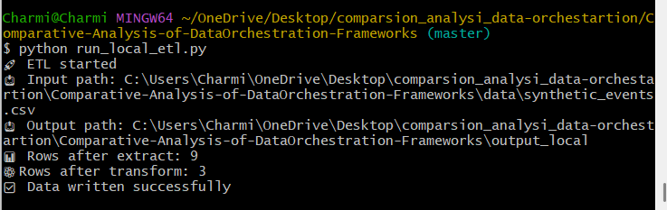
This screenshot shows the execution of the ETL pipeline using a simple local Python script, without any orchestration framework. Running the command python run_local_etl.py triggers the extract, transform, and load steps sequentially.
The console output confirms the following:
- ETL process started successfully, indicating the script is working as expected.
- The input CSV file (synthetic_events.csv) was read correctly, producing
9 rows after extraction.
- After applying transformation logic (such as filtering and cleaning), the dataset was reduced to
3 final rows.
- The transformed data was successfully written to the directory
output_local/ in a partitioned format.
- No errors were encountered during execution, confirming that the local ETL logic is functioning properly.
This run serves as the baseline reference output, which is later compared with
Airflow, Prefect, and Dagster to verify consistency across orchestration tools.
Prefect — Terminal Execution of ETL flow: -
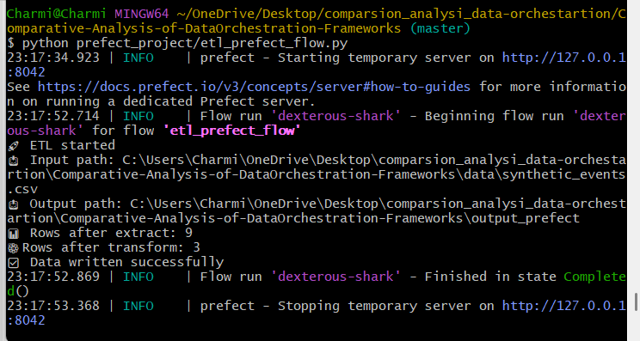
This screenshot represents running the same ETL pipeline using Prefect, an orchestration tool focused on simplicity and modern workflow automation.
The important observations:
- Prefect creates a temporary API server to manage the flow execution.
- A flow run (named dexterous-shark) is automatically generated and started.
- The ETL logic executes exactly as in the local run:
  - Rows read: 9
  - Rows after transform: 3
  - Output successfully written to output_prefect
- The flow ends in Completed state.
This output confirms that Prefect correctly orchestrates the ETL tasks and ensures visibility, logging, and proper run management.

Dagster — Terminal execution of ETL job: -
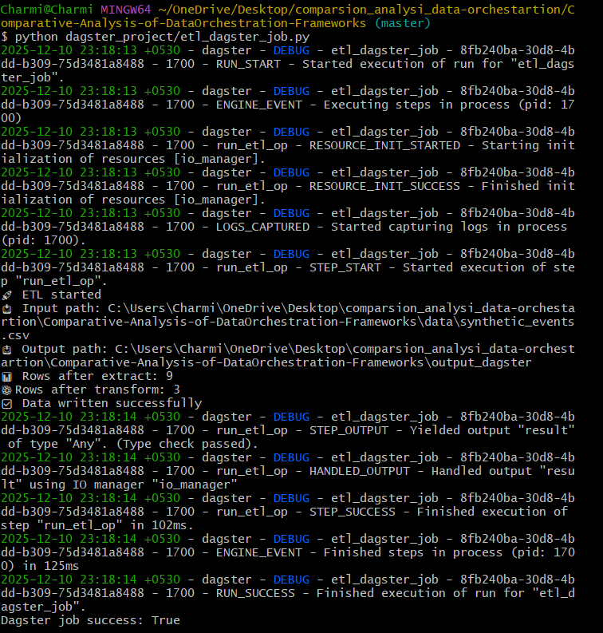

This screenshot shows the ETL pipeline run using Dagster, a powerful orchestrator for data engineering pipelines.
Key points highlighted by the logs:
- Dagster initializes resources (such as IO manager) before starting the op.
- The ETL step (run_etl_op) executes with detailed debugging logs.

- The extraction, transformation, and load stages return the same results:
  - 9 extracted rows
  - 3 transformed rows
- Dagster reports “RUN_SUCCESS”, confirming the job completed without errors.
Dagster provides structured logging, step-level execution, and strong observability, helping track every detail of the ETL job.
Airflow — DAG code structure: -
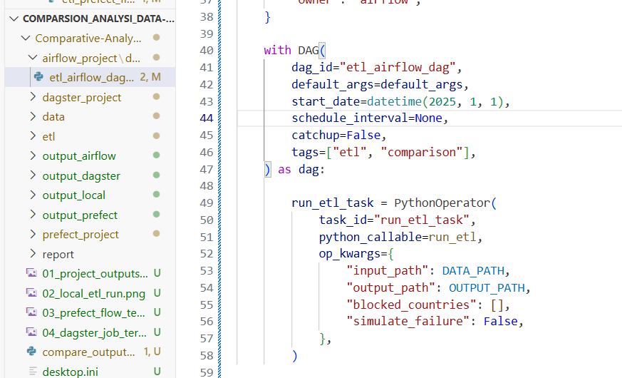

This screenshot displays the DAG definition for Airflow, which orchestrates the ETL pipeline using scheduled tasks.
Highlights from the code:
- The DAG is named etl_airflow_dag and is configured with a start date of January 1, 2025.
- No schedule interval is assigned (schedule_interval=None), meaning the DAG is triggered manually.
- A single PythonOperator (run_etl_task) executes the ETL logic.
- Operation parameters such as input path, output path, blocked countries, and simulate failure are passed via op_kwargs.
This validates the DAG structure and how Airflow orchestrates the same ETL logic while enabling scheduling, retries, and task monitoring.
Output Comparison — All framework outputs match: -
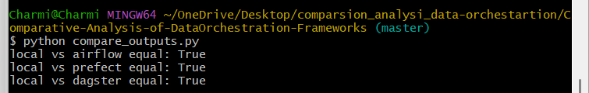
This screenshot confirms that the ETL logic executed across all four orchestration frameworks—Local Python, Airflow, Prefect, and Dagster—produced identical final outputs.
The script compare_outputs.py performs a row-by-row and value-by-value comparison between the generated CSV files.
Since all comparisons return True, it proves:
- The ETL logic is consistent.
- Execution environments did not alter the transformation results.
- All orchestrators maintain deterministic and reliable ETL behavior.
This validation step is crucial for proving the correctness of the experiment and ensuring reproducibility.

Dagster Run Logs — Step details and result handling: -
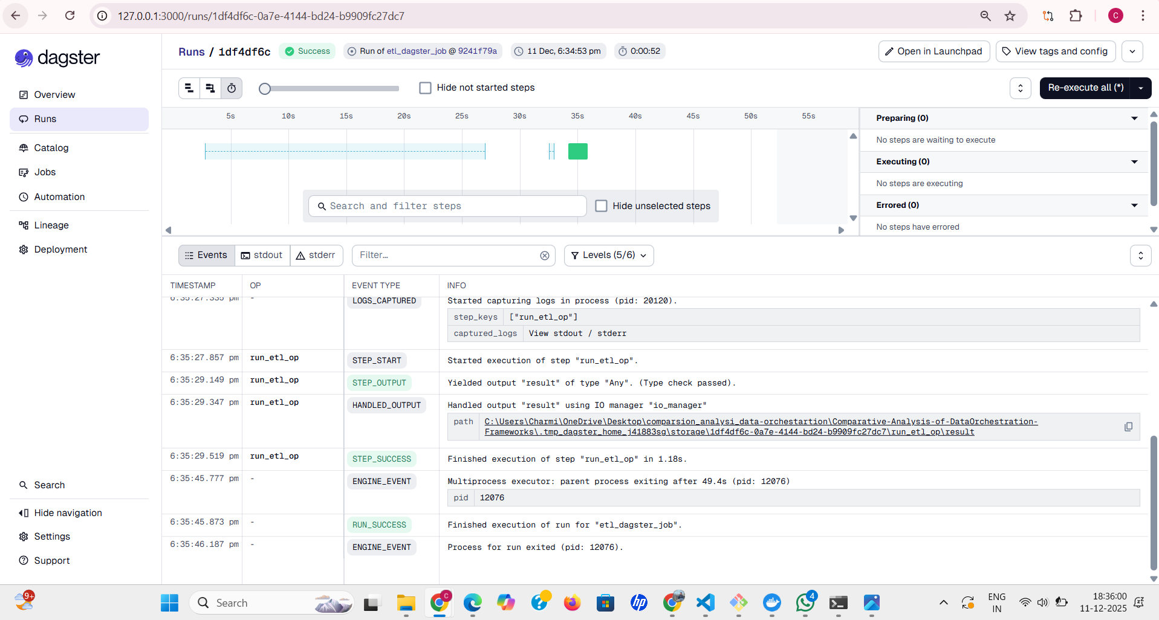
This screenshot shows the detailed run logs of a Dagster job from the Dagster UI.
It highlights the following:
- Each ETL step (run_etl_op) is logged with timestamps.
- Dagster provides granular visibility into step start, step output, handled output, and step success events.
- The system logs also show resource initialization, engine events, and final run completion.
- The output file path is correctly displayed, ensuring traceability of output artifacts.
Dagster’s structured log format enables easy debugging and monitoring by breaking down pipeline execution into small, trackable operations.

Dagster Launchpad — Configuration panel for job execution: -
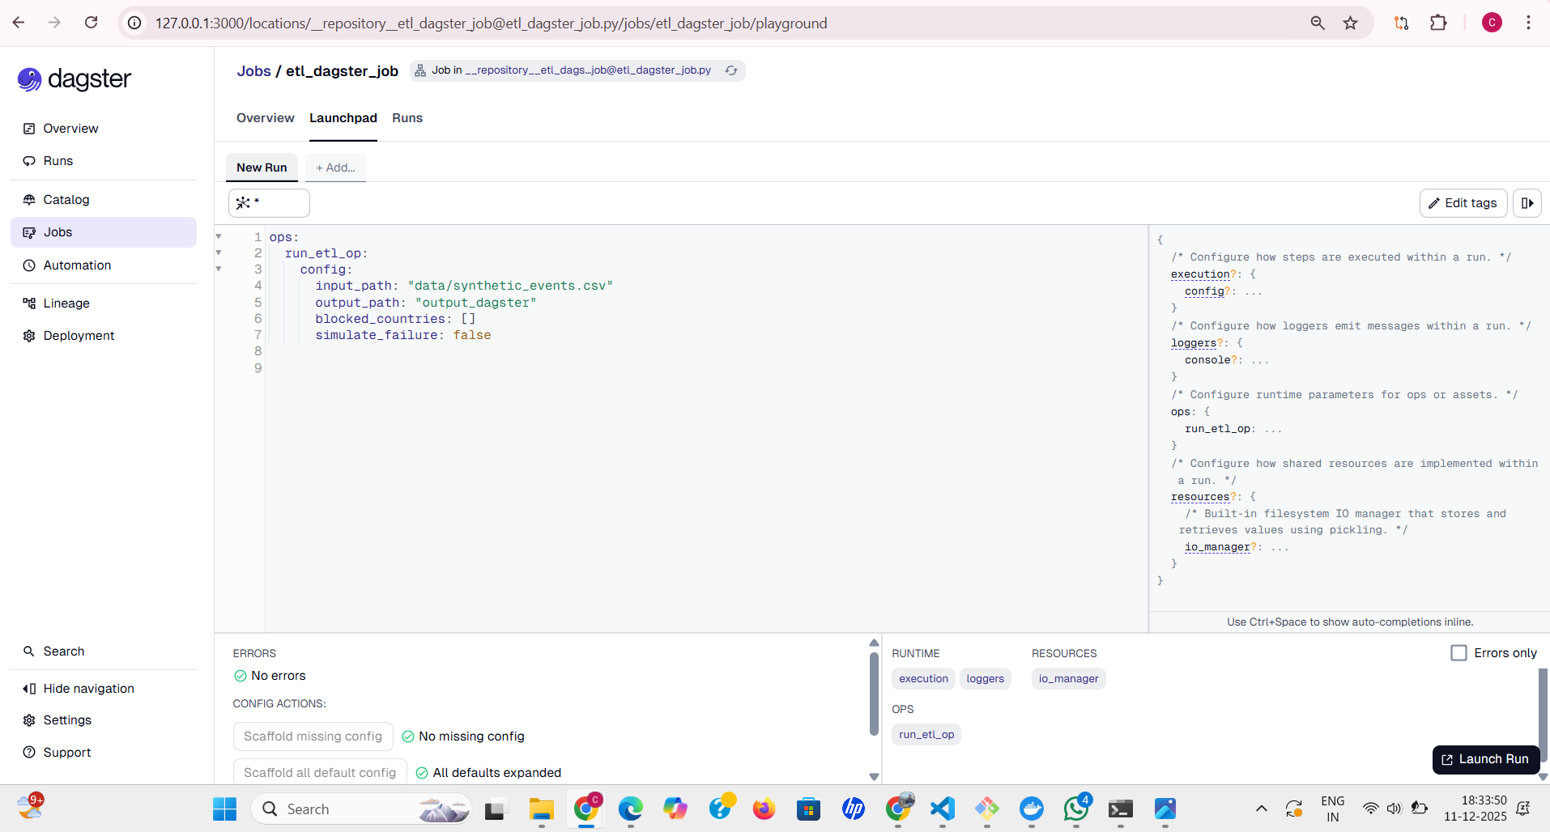

This screenshot shows the Dagster Launchpad, where configuration values for a job run can be customized before execution.
Key highlights:
- The YAML configuration defines input_path, output_path, blocked_countries, and simulate_failure parameters.
- A side panel displays the configuration schema for execution, loggers, resources, and ops.
- Validation indicators show "No errors", meaning the configuration is correct.
- Launchpad enables interactive and safe job runs without modifying code directly.
This makes Dagster ideal for experimentation and parameter-based job execution.

Prefect Run Logs — Flow execution details: -
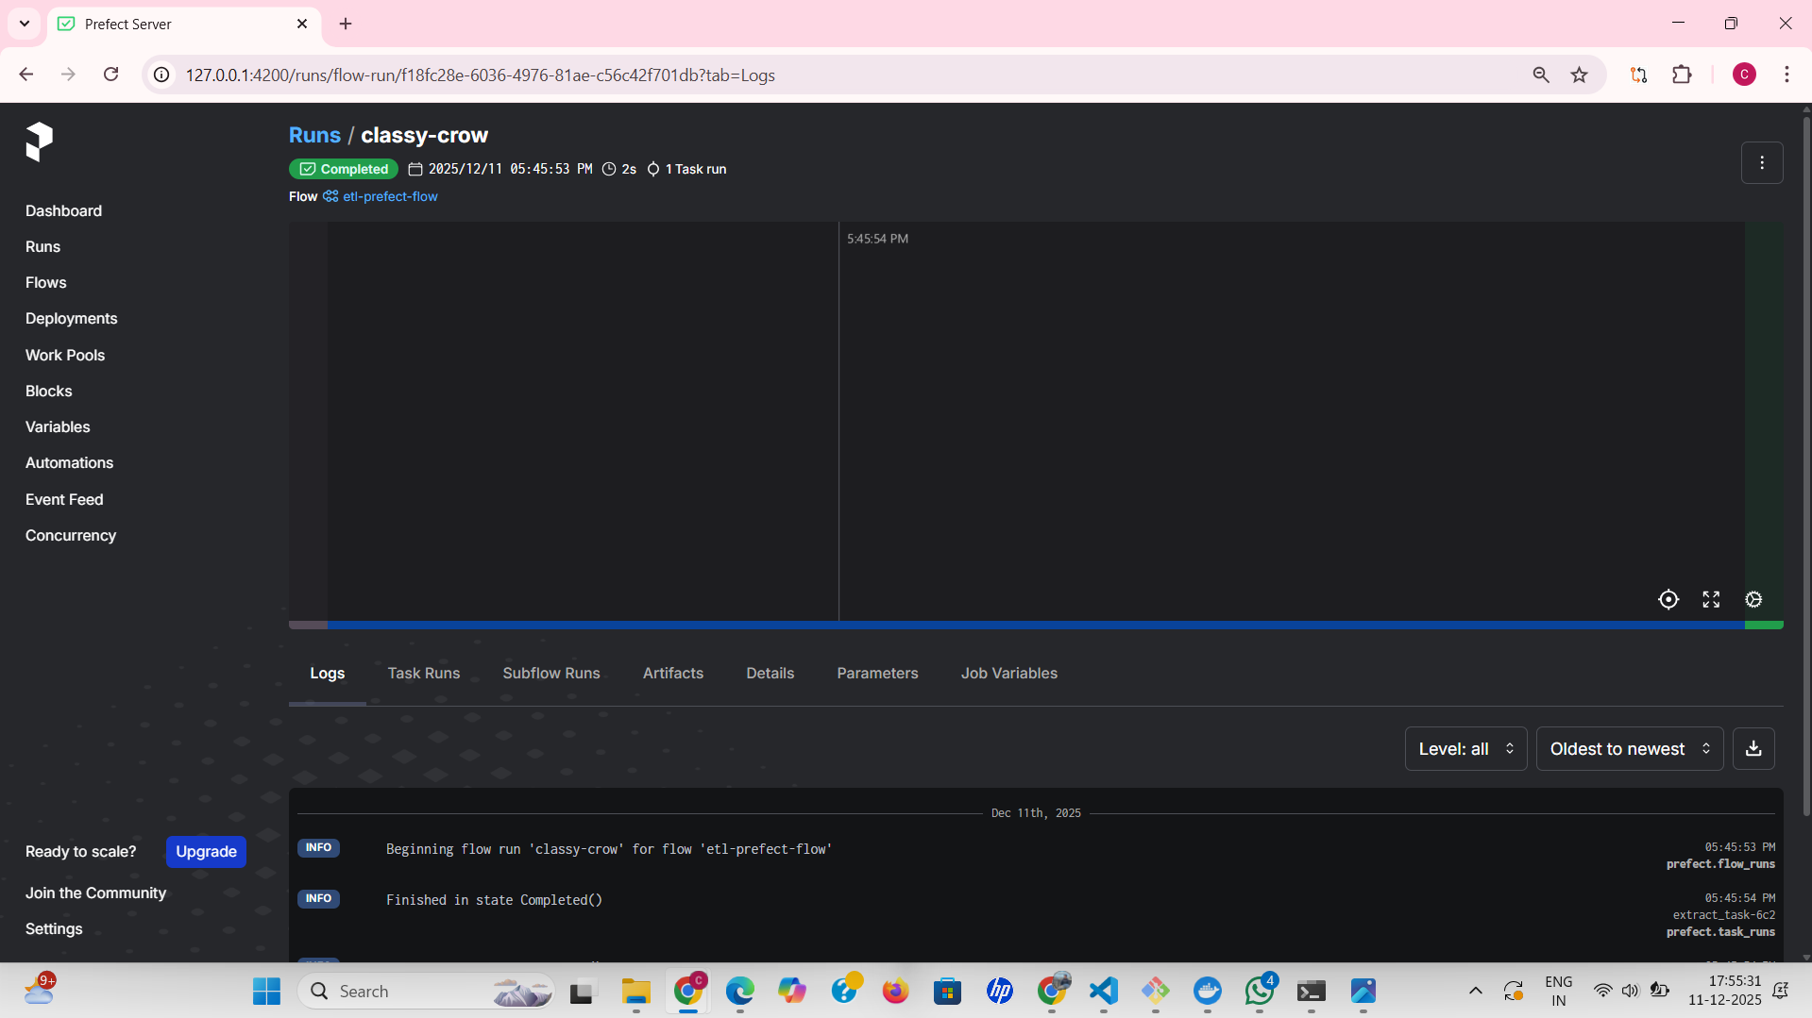

This screenshot shows the Prefect UI displaying logs for a completed flow run.
Key insights:
- The flow etl-prefect-flow successfully completed with proper logging.
- Start and end timestamps confirm smooth execution.
- The log panel clearly shows:
  - Flow initialization
  - Beginning of execution
  - Completion status (Completed)
- Prefect provides a clean and centralized log viewer that helps track the flow execution timeline.
Prefect’s logging is especially useful for quick debugging and observing task-level behavior.

Prefect Runs Summary — Completed and failed flow runs: -
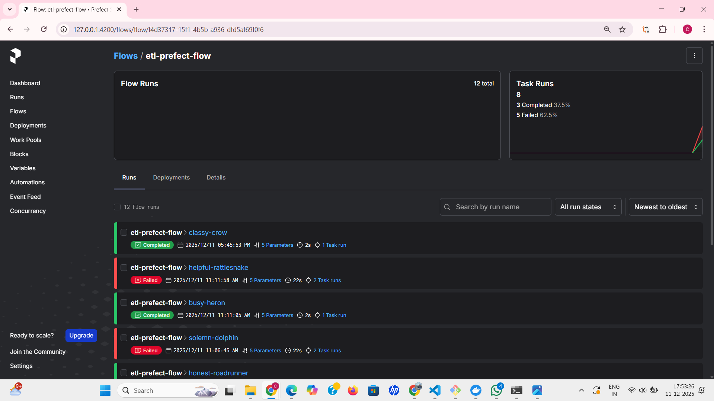

This screenshot displays the Prefect dashboard summary for the ETL flow across multiple runs.
Important observations:
- A total of 12 flow runs are listed.
- Prefect categorizes runs as Completed or Failed.
- The summary graph shows the overall success/failure trends.
- Each run entry shows:
  - Run name
  - Timestamp
  - Duration
  - Number of task runs
  - Run state (green for success, red for failure)
This dashboard makes Prefect powerful for operational monitoring, offering visibility across repeated ETL executions.

Airflow Task Details — Extract task logs: -
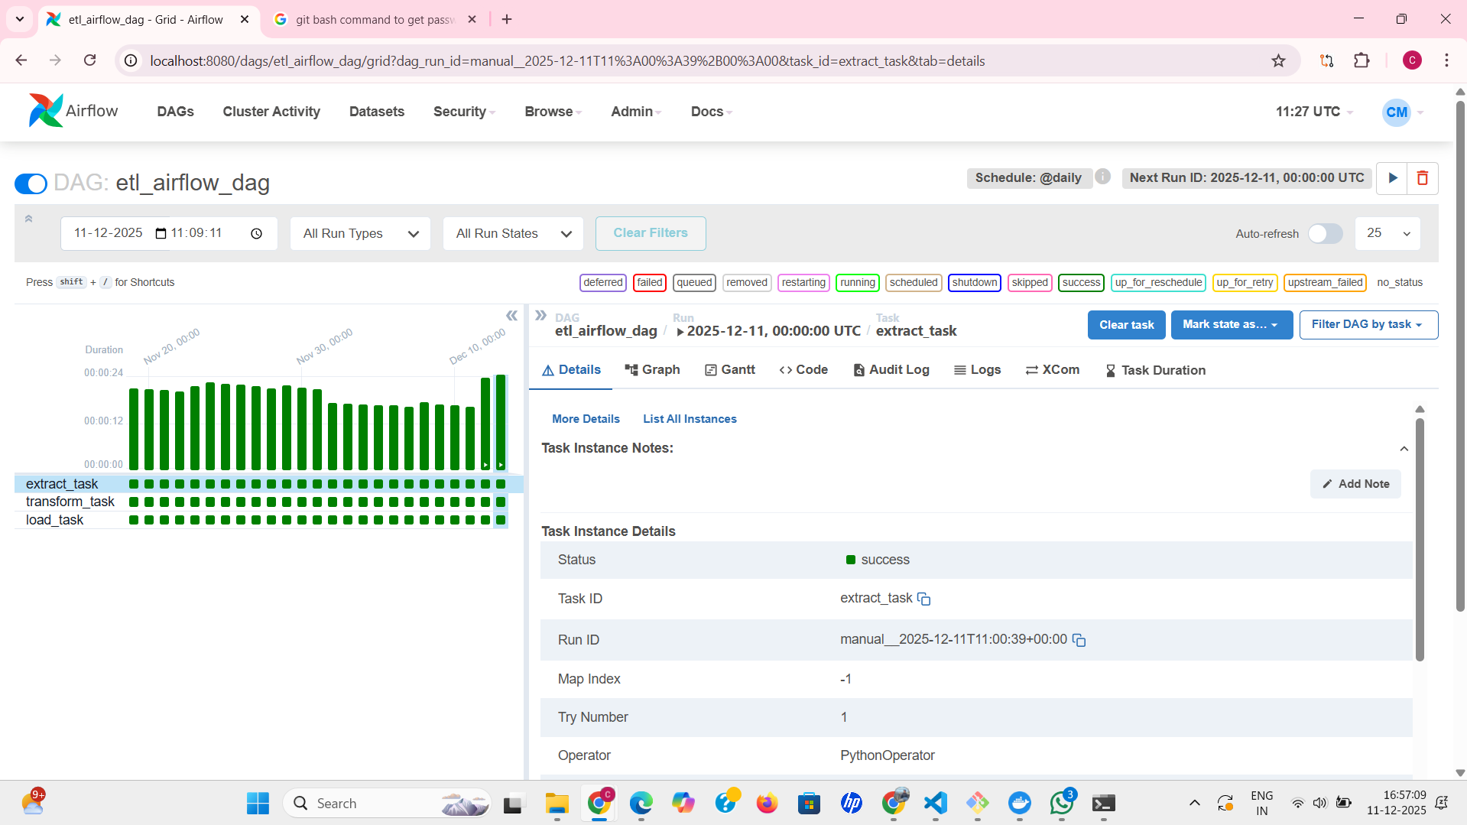
This screenshot provides detailed task logs for the extract_task in Airflow.
Key points:
- Airflow records the status as success.
- It shows:
  - Task ID
  - Run ID
  - Operator used (PythonOperator)
  - Retry attempts
  - Timing details
- Task logs help verify that file reading, extraction logic, and initialization executed without errors.
Airflow's detailed per-task breakdown strengthens observability within DAG executions.
Airflow Graph View — Extract, Transform, Load tasks: -
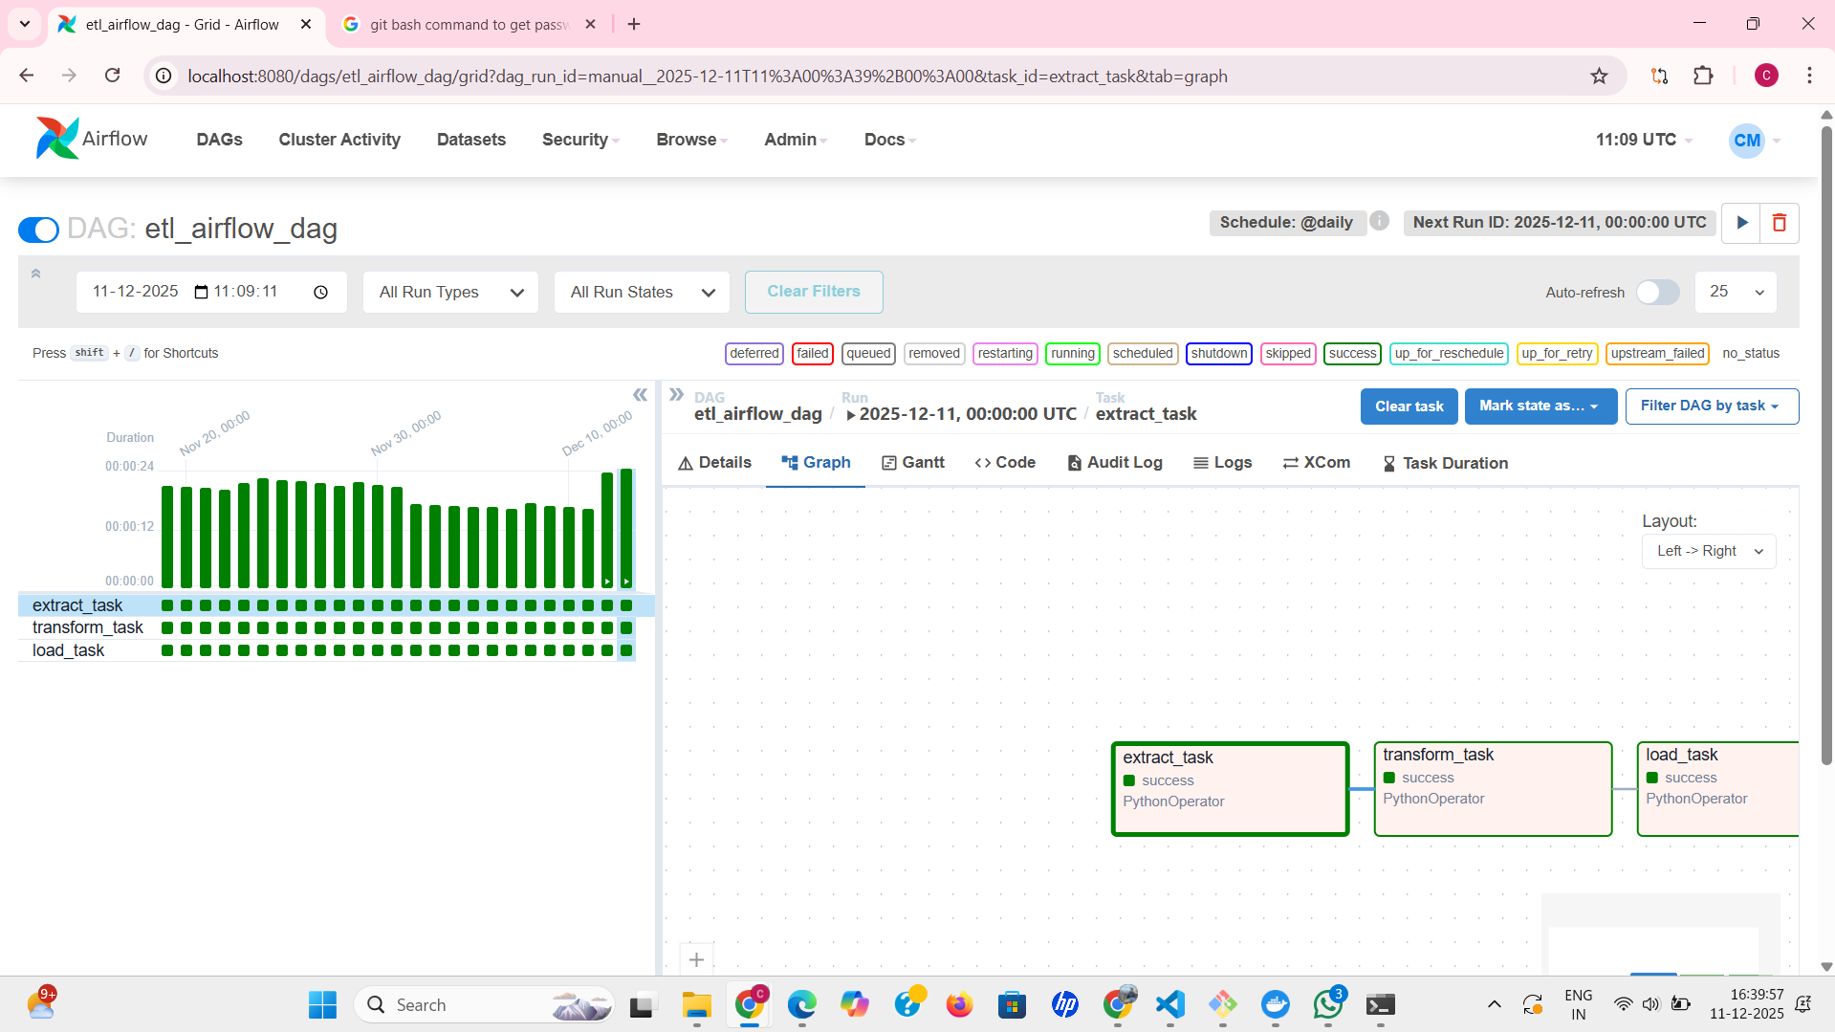
This screenshot shows the Airflow graph layout for the ETL DAG.
Insights:
- The DAG contains three tasks arranged in pipeline order:
  - extract_task
  - transform_task
  - load_task
- Each task is shown with its status (green = success).
- The graph visually confirms correct task dependencies and workflow structure.
The Airflow graph view is a simple but powerful representation of the workflow logic.

Airflow Run Summary — Duration and statistics: -
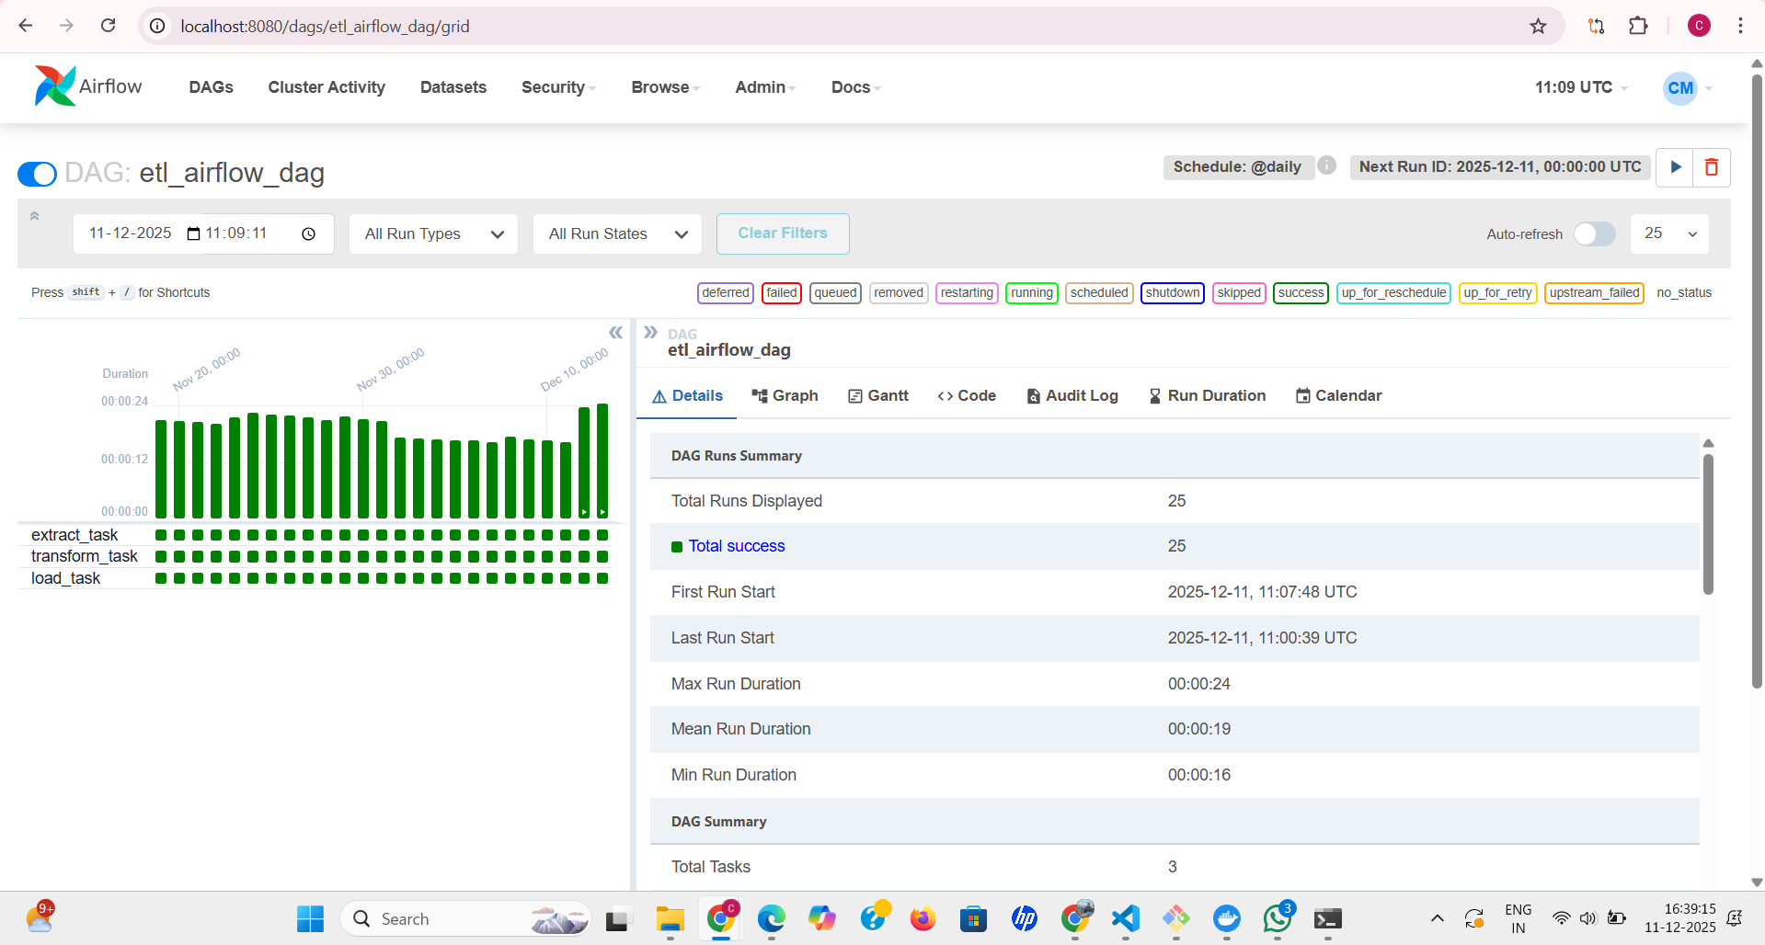
This screenshot highlights the Airflow run statistics for the ETL DAG.
It includes:
- Total Runs Displayed: 25
- Total Successful Runs: 25 (100% success rate)
- First and last execution timestamps
- Minimum, maximum, and mean run durations
- DAG-level summary: total tasks, current state, and schedule details
These metrics help measure workflow performance and reliability over time.

Conclusion
Across all four environments, the ETL pipeline produced the same results after extract, transform, and load operations. The monitoring dashboards show consistent success states for Dagster, Prefect, and Airflow when the configuration is correct. This validates that the shared core ETL logic works uniformly across orchestration frameworks. The project demonstrates that although these tools differ in UI, debugging experience, and scheduler behavior, they can reliably manage the same workflow.

