**Deployment4**

**Deploying Terraform with Jenkins**

# Step 1

**ssh into Jenkins Server**

* ssh to the current Jenkins server
* Check to see if GitHub token is still active
* If not connect GitHub to Jenkins server

# Step 2

**Install Terraform on Jenkins Server**

* Install Terraform:

wget -O- https://apt.releases.hashicorp.com/gpg | gpg --dearmor | sudo tee /usr/share/keyrings/hashicorp-archive-keyring.gpg

echo "deb [signed-by=/usr/share/keyrings/hashicorp-archive-keyring.gpg] https://apt.releases.hashicorp.com $(lsb_release -cs) main" | sudo tee /etc/apt/sources.list.d/hashicorp.list

sudo apt update && sudo apt install terraform

# Step 3

**Create a Terraform user on AWS**

* On AWS dashboard go to IAM
* Select add user:
  + User name
  + Check Access Key
  + Graphical user interface, text, application, email

    Description automatically generatedSet permissions: attach existing policies directly
  + Check Administrator access
  + Graphical user interface, application

    Description automatically generatedselect create user
  + Graphical user interface, text, application, email

    Description automatically generatedCopy Access Key ID and Secret access Key

# Step4

**Configure AWS Terraform user on Jenkins**

* In the Jenkins Dashboard, click on manage Jenkins and then select Manage Credentials
* Now select Global
* On the right-hand side, select Add Credentials
* Now enter the First credentials:

○ Select “Secret text” for Kind

○ Scope should be Global

○ Secret: Copy and Paste your aws access key

○ ID: AWS_ACCESS_KEY ○ Select Create

* Now enter the Second credentials:

○ Select “Secret text” for Kind

○ Scope should be Global

○ Secret: Copy and Paste your aws secret key

○ ID: AWS_SECRET_KEY

○ Select Create

# Step 5

Create a Pipeline build in Jenkins

* Terraform will create & deploy AWS resources



* 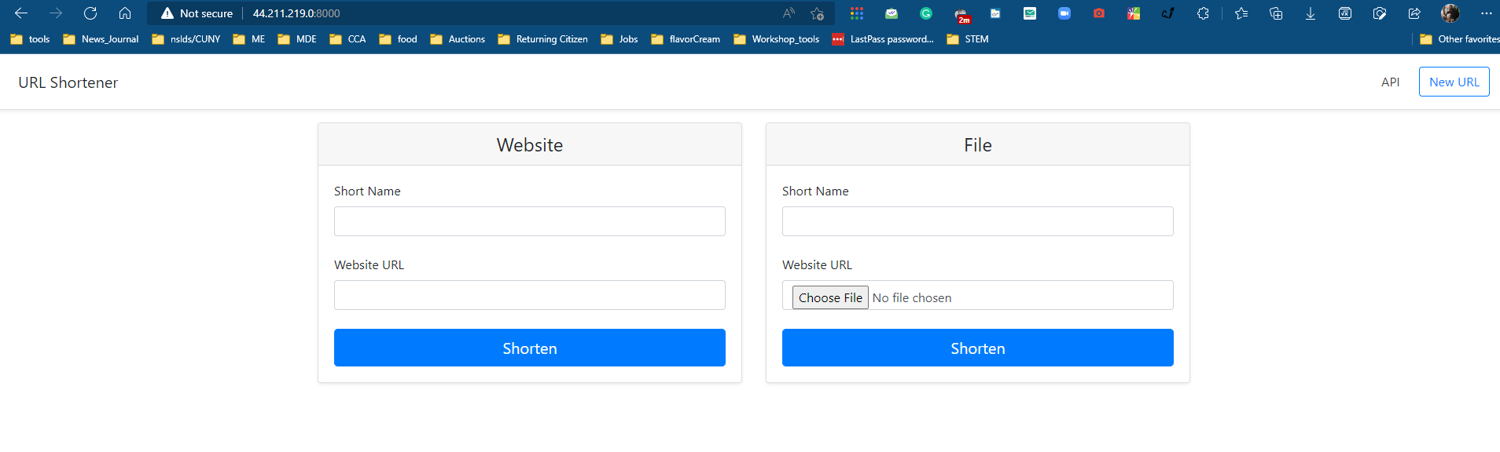The app is Deployed
* Add a Destroy stage to the Jenkins file on GitHub and rerun the build in Jenkins

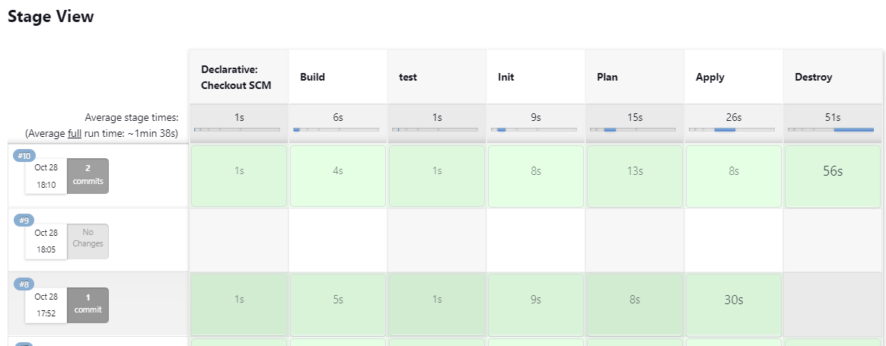



# Troubleshooting

* Jenkinsfile had to be fixed for syntax in the Destroy stage for Terraform

# Diagram

