# Troubleshooting Jenkins Pipeline

## 1. Email Notification

To troubleshoot and first test that sending an email works: go to Dashboard > Manage Jenkins > Configure Systems > Under “E-mail Notification”, configure the SMTP information and credential information:Graphical user interface, text, application, email

For password, you first need to [generate an app password on Google](https://stackoverflow.com/questions/35347269/javax-mail-authenticationfailedexception-535-5-7-8-username-and-password-not-ac) – to do so, enable 2-Step Authentication on Gmail, then generate an app password:

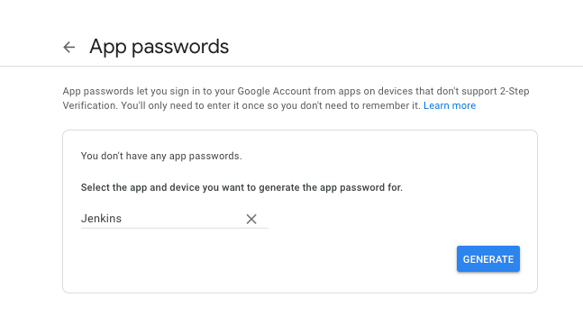

Save a copy of the generated password:

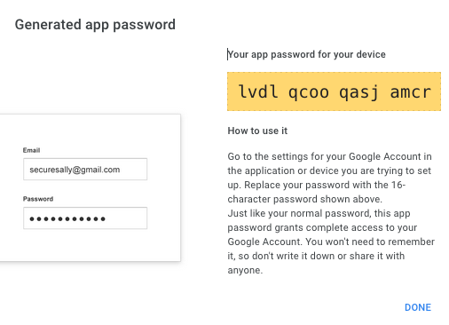

Check email:

To enable the email notification functionality in the pipeline, navigate to Dashboard > Manage Jenkins > Manage Plugins > Search and download “Email Extension Plugin” – confirm that it has been installed by checking the Installed Plugins tab:

Go to Dashboard > Manage Jenkins > Configure Systems > Under “Extended E-mail Notification”, configure the following SMTP info:

Rebuild the pipeline and confirm email receipt of build result:

## 2. Webhook

On GitHub, we set up a webhook to automate the pipeline build upon a push event:

However, we kept running into errors with the webhook setup:

Response Error:

At first, we thought it was related to the network setting of the server (since the Jenkins server exists in the private subnet). During brainstorming session, we thought of either opening up the security group to allow traffic from all IP addresses or putting the Jenkins server on the public subnet and opening up the ingress rules there as well. However, we knew that this would compromise the security and visibility of Jenkins server to potential threats.

Upon further research and checking [threads](https://stackoverflow.com/questions/44711696/jenkins-403-no-valid-crumb-was-included-in-the-request), we found out that there is a setting on Jenkins Server that allows proxy compatibility that needed to be set to allow webhook access:

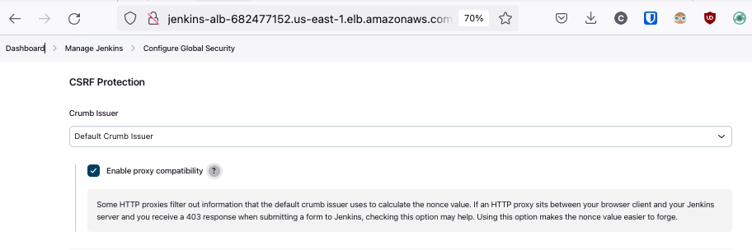

Redelivering a previously failed request succeeded:

Response with 200 code:

