# Terraform S3 Backend

“Stores the state as a given key in a given bucket on [Amazon S3](https://aws.amazon.com/s3/). This backend also supports state locking and consistency checking via [Dynamo DB](https://aws.amazon.com/dynamodb/)” (<https://developer.hashicorp.com/terraform/language/settings/backends/s3>).

***Resources used for the S3 backend and DynamoDB configuration:***

* [***https://technology.doximity.com/articles/terraform-s3-backend-best-practices***](https://technology.doximity.com/articles/terraform-s3-backend-best-practices)
* [***https://github.com/hashicorp/terraform/issues/17663***](https://github.com/hashicorp/terraform/issues/17663)
* [***https://jhooq.com/terraform-error-config-s3/***](https://jhooq.com/terraform-error-config-s3/)

Prior to configuring an S3 backend, terraform.tfstate and terraform.tfstate.backup files lived locally on the Jenkins Agent:



Followed the resources mentioned above to set up S3 bucket and DynamoDB in our infrastructure to configure a Terraform backend – S3 and associated resource blocks:

DynamoDB resource block: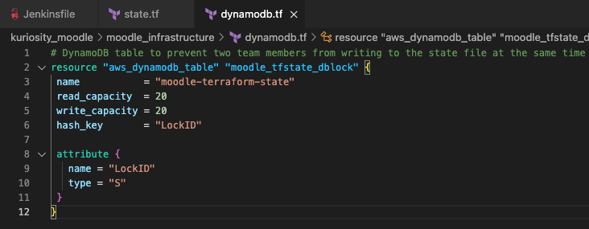

After committing the changes to the repository – first ran terraform init with just regular AWS access and secret keys, but that was not enough information to initialize the S3 backend:

Provided all backend config information but the terraform init command returned an error because it required user input of “yes” for copying existing state file to the new s3 bucket:

To address this, I echoed “yes” and piped it to the terraform init command and this worked: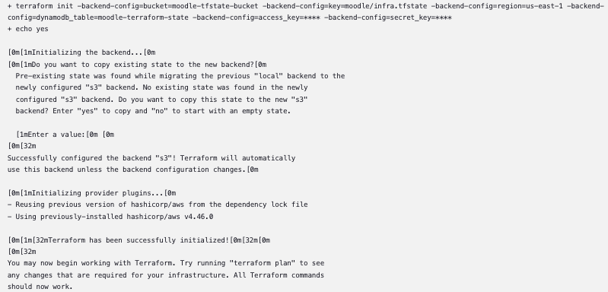

Confirm on AWS that the new S3 bucket has been created:

The infra.tfstate object contains the terraform.tfstate file for the infrastructure:

Content of the infra.tfstate object:

In DynamoDB > Items > moodle-terraform-state, you’ll see the LockID created:

DynamoDB item has updated as well:

Confirming that we were able to successfully store the terraform.tfstate file in S3, and lock down the infrastructure using DynamoDB, which keeps the metadata of resources and state file to lock in place.