FileMaster: Linux File Management System
A Project Based Learning Report Submitted in partial fulfilment of the requirements for the award of the degree

of

Bachelor of Technology
in The Department of Computer Science and Engineering
Operating System and System Programming (OSSP) [25CS2104E]

Submitted by
[2510030306] Katna Abhineshwar
[2510030246] Mallala Sri Charan
[2510030298] Abhilash Goud
[2510030412] Akhil Sagar

Under the guidance
Pavan Kumar Pagadala



Department of Computer Science and Engineering
Koneru Lakshmaiah Education Foundation (KLEF), Aziz Nagar, Hyderabad
Aziz Nagar – 500075
Academic Year: 2026-2027
Abstract
Linux is a powerful and widely used operating system for education, software development, servers, and many other applications. It provides several commands for managing files and directories through the terminal. However, beginners may find it difficult to remember different commands, options, and syntax for performing basic file management operations. To make file management easier and more user-friendly, we developed FileMaster, a simple menu-driven file management system using the C programming language on Ubuntu Linux.
FileMaster provides a single terminal menu through which users can perform common file and folder operations without remembering multiple Linux commands. The system allows users to navigate between directories, list files and folders, create files and folders, delete files and folders, write and preview text, copy and move files, rename files and folders, search for files, view file information, display the directory structure using a tree view, and change file permissions. These features provide a simple and organized way to manage files within a dedicated workspace.
The system is developed using C, GCC, Makefile, POSIX functions, and Linux system calls. The Search Files feature demonstrates important system programming concepts such as fork(), exec(), pipe(), dup2(), and waitpid(). These functions are used to create processes, execute commands, communicate between processes, redirect input and output, and synchronize parent and child processes.
The project connects practical file management with important Operating System and System Programming (OSSP) concepts, including processes, system calls, file descriptors, file handling, file permissions, process communication, and synchronization. Each implemented feature is tested to verify that it performs the expected operation correctly.
Overall, FileMaster provides a simple and practical way for beginners to manage files in Linux while helping students understand how operating system and system programming concepts are applied in a real-world C application.

List of Figures
Figure 1. FileMaster Project Motivation and Overview 6
Figure 2. FileMaster System Architecture 8
Figure 3. FileMaster Module Architecture 9
Figure 4. FileMaster Operation Workflow 12
Figure 5. FileMaster Main Menu 13
Figure 6. Directory Navigation in FileMaster 14
Figure 7. Creating a File and Folder 14
Figure 8. Writing and Previewing a File 14
Figure 9. Copy and Move File Operations 15
Figure 10. File Search Using Process and IPC Operations 15
Figure 11. File Information Display 16
Figure 12. FileMaster Tree View 16
Figure 13. File Permission Management 17
Figure 14. Error Handling and Operation Control 17
List of Tables
Table 1. FileMaster Modules and Their Functions 9
Table 2. Linux/POSIX System Calls Used in FileMaster 10
Table 3. Functional Test Cases 18
Table 4. Feature Implementation Results 20
Table 5. OSSP Concepts Demonstrated in FileMaster 20
Table of Contents
1. Introduction 6
1.1 Background 6
1.2 Motivation 6
1.3 Objectives 7
1.4 Scope of the Project 7
1.5 Relationship with OSSP and Linux System Calls 7
2. Methodology 7
2.1 Problem Analysis 7
2.2 System Design 7
2.3 System Architecture 8
2.4 Module Design 8
2.5 File and Directory Management 9
2.6 File Editing and Preview 10
2.7 Search and Process Management 10
2.8 File Permissions 11
2.9 Operation Control 11
2.10 Testing Methodology 12
3. Experiments 12
3.1 Development and Testing Environment 12
3.2 Workspace Structure 13
3.3 Main Menu 13
3.4 Directory Navigation 13
3.5 File and Folder Creation 14
3.6 Writing and Previewing a File 14
3.7 Copy and Move Operations 14
3.8 Search Files 15
3.9 File Information 16
3.10 Tree View 16
3.11 Permission Management 17
3.12 Error Handling and Operation Control 17
3.13 Functional Test Cases 18
4. Results 19
4.1 File and Directory Operations 19
4.2 File Editing and Preview 19
4.3 Search 19
4.4 File Information and Tree View 19
4.5 Permission Management 19
4.6 Error Handling and User Interface 19
4.7 Feature Implementation Results 19
4.8 OSSP Concepts Demonstrated 20
5. Conclusion and Future Work 21
5.1 Conclusion 21
5.2 Future Work 21
References 22
FileMaster: Linux File Management System

Introduction

Background
Linux is an open-source, multi-user operating system that is widely used on servers, development machines and in academic laboratories. Distributions such as Ubuntu have made Linux easy to install and use, and most coursework in operating systems and system programming is carried out in a Linux terminal. In Linux, almost every resource is represented as a file, and files are organised in a single hierarchical directory tree that starts at the root directory. Creating, reading, copying, moving, renaming, searching and protecting files and directories are therefore among the most frequent tasks that a user performs.
These tasks are normally carried out in the shell with commands such as ls, cd, mkdir, touch, cat, cp, mv, rm, find and chmod. Each command has its own syntax, options and behaviour. An experienced user combines them quickly, but a beginner must remember the command names, the order of the arguments and the meaning of the options. A small mistake, such as a wrong path or a using an inappropriate command option, can produce an unexpected result or remove data permanently.

Motivation
The main difficulty for new users is not the complexity of any single operation but the number of separate commands that have to be remembered. Memorising command syntax slows down learning and discourages exploration of the operating system. A centralised interface that lists the available operations and asks the user only for the required input can remove much of this difficulty. FileMaster was developed to provide such an interface. It collects the most common file and directory operations into one menu-driven program, so that the user selects an operation by its number and is then guided through the input that the operation needs. Figure 1 summarises the motivation for the project and the way FileMaster responds to it.
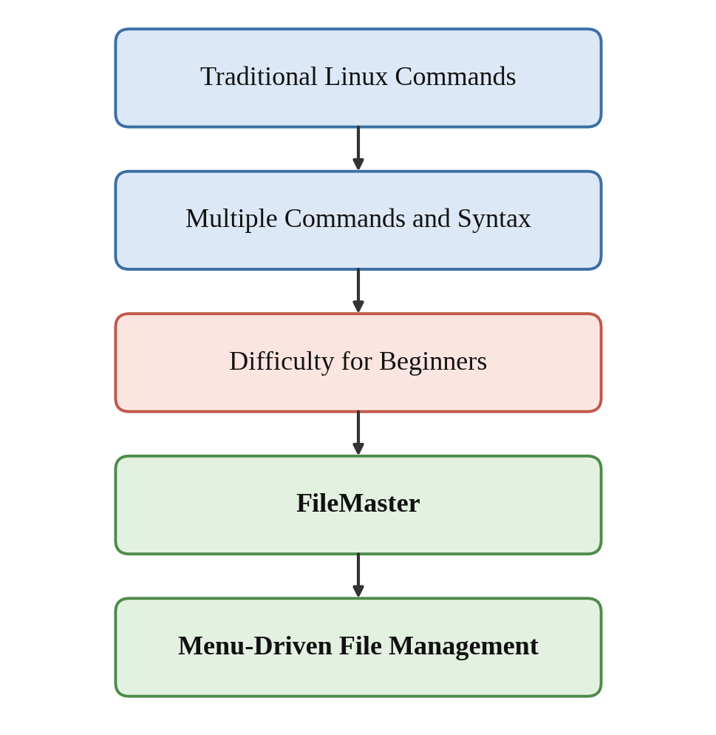
Figure 1. FileMaster Project Motivation and Overview

Objectives
The objectives of the project are as follows. The first objective is to design a menu-driven terminal application that simplifies common Linux file and directory management tasks. The second is to implement the application in the C programming language by using POSIX and Linux system calls. The third is to confine the operations to a dedicated workspace directory so that the user works in a controlled area. The fourth is to demonstrate process-control and inter-process communication concepts, namely fork(), exec(), pipe(), dup2() and waitpid(), through the Search Files operation. The final objective is to test every menu operation and to document the implementation and the results.

Scope of the Project
FileMaster is a terminal-based application for Linux and Ubuntu. It operates inside a workspace directory named FileMaster2/workspace, which currently contains the folders Documents, Downloads, images and project. The main menu lists seventeen entries: sixteen file and directory operations and an Exit option. The operations are directory navigation, listing files and folders, creating a folder, opening a folder, creating a file, writing text to a file, previewing a file, deleting a file, deleting a folder, copying files, moving files, renaming files or folders, searching files, viewing file information, tree view and changing permissions. The project does not include a graphical interface, network operations or user-account management. Any menu entry whose implementation is incomplete is reported as such in this document and is listed under future work.

Relationship with OSSP and Linux System Calls
Every request that a program makes to the operating system, such as opening a file, creating a directory or starting a new process, is made through a system call [1]. System calls form the boundary between user programs and the kernel, and learning to use them is the central aim of system programming [2]. FileMaster is a small but complete example of this idea. The menu and the input handling are written in C, while the actual work of creating, copying, moving, deleting and searching is delegated to the Linux kernel through POSIX and Linux interfaces. In this way the project connects the concepts studied in the Operating System and System Programming (OSSP) course, including processes, file descriptors, redirection, the Linux file system and file permissions, with a practical tool.
The overall contribution of the project is a working, menu-driven file manager that reduces the need to remember command syntax, together with a documented set of tests and a clear explanation of the operating-system concepts that lie behind each operation.

Methodology

Problem Analysis
The first step was to identify the file and directory operations that Linux users perform most often and the shell commands that are normally used for them. These operations were grouped into navigation, creation, editing, deletion, transfer, inspection and protection of files and directories. From this analysis the following requirements were set: the program must offer all the selected operations from one menu, it must guide the user through the input that each operation needs, it must report success or failure clearly, and it must limit its activity to a dedicated workspace directory.

System Design
FileMaster is designed as a modular C program built around a menu loop. The loop displays the title, the list of operations and the current directory, reads the choice entered by the user and calls the function that performs the selected operation. When an operation finishes, control returns to the menu until the user selects the Exit option. The program is compiled with GCC and built with a Makefile on Ubuntu.

System Architecture
FileMaster follows a layered architecture, which is shown in Figure 2. The user interacts only with the FileMaster menu in the terminal. The menu passes the selected operation to the corresponding operation module. The operation modules do not manipulate the disk directly; they request services from the kernel through POSIX and Linux system calls. The Linux kernel performs the requested action on the Linux file system, and the result is returned to the module, which then displays a success or error message to the user.
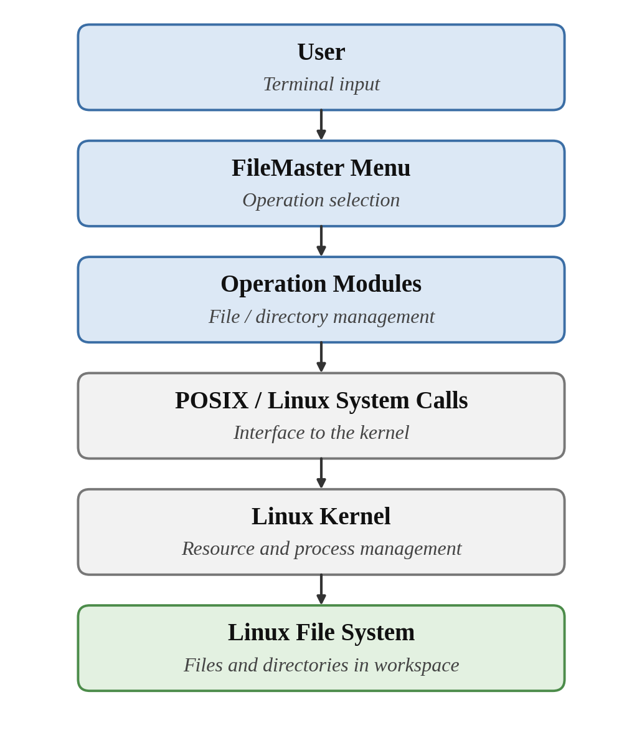
Figure 2. FileMaster System Architecture

Module Design
The functionality of FileMaster is divided into modules so that each module handles one group of related operations. Figure 3 shows the module structure and Table 1 lists the purpose of each module together with its operations. The menu module is responsible for displaying options and dispatching the user's choice. The directory operations module handles navigation and folder management. The file editor module handles creating, writing and previewing text files. The file operations module handles deleting, copying, moving, renaming and inspecting files. Search, permission management and tree view are separate units because they use different system-level mechanisms.
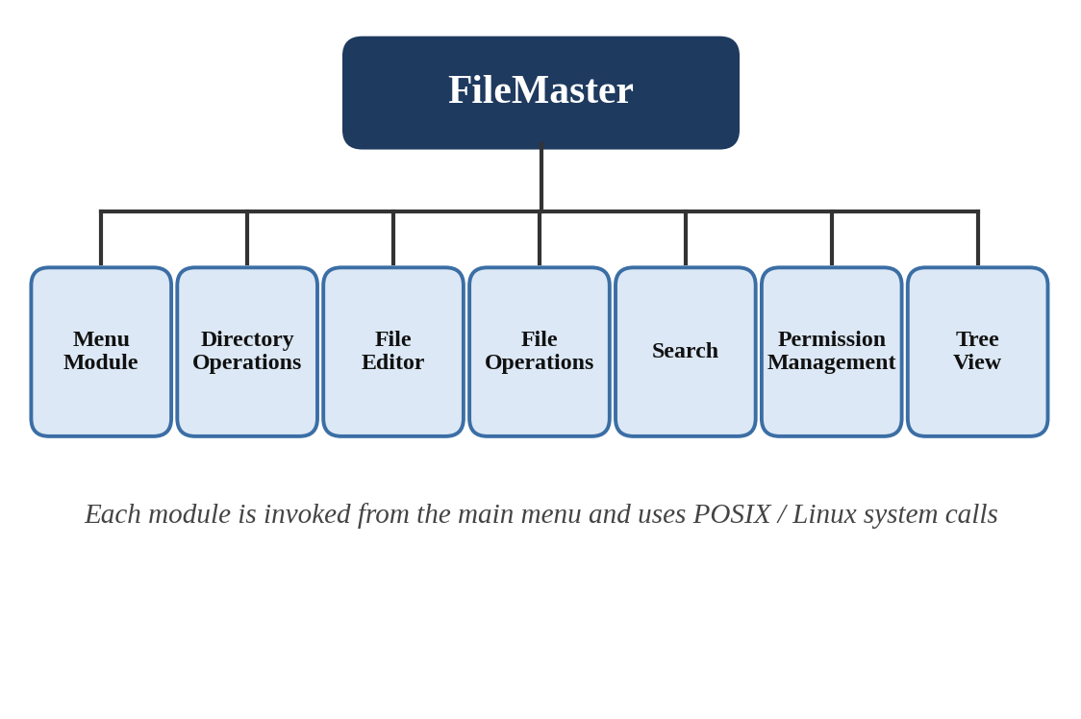
Figure 3. FileMaster Module Architecture
Table 1 summarises the modules. The operations listed for each module are taken from the FileMaster main menu.
Table 1. FileMaster Modules and Their Functions
Module | Main Responsibility | Important Operations
Menu Module | Displays the title, menu options and current directory; reads and dispatches the user choice | Main menu display, option selection, Exit
Directory Operations | Navigation and folder management inside the workspace | Directory navigation, list files and folders, create folder, open folder, delete folder
File Editor | Creation and text handling of files | Create file, write text to file, preview file
File Operations | Management of existing files and folders | Delete file, copy files, move files, rename files or folders, view file information
Search | Finds files by using child-process execution and a pipe | Search files
Permission Management | Changes the access permissions of files and folders | Change permission
Tree View | Displays the directory hierarchy of the workspace | Tree view
Testing Module | Supports verification of the operations | Supports verification of FileMaster operations through functional test cases and validation of expected results.

File and Directory Management
Directory navigation, listing, folder creation, opening a folder and deleting a folder form the directory-management part of the program. Deleting a file, copying, moving, renaming and viewing file information form the file-management part. In each case the program asks the user for the required name or path, checks the input, requests the operation from the operating system and displays the outcome. Tree view prints the hierarchy of directories and files in the workspace so that the user can see the complete structure in one screen. All of these operations act on the Linux file system, in which directories are special files that contain the names of the files they hold. The directory operations use POSIX/Linux system calls and library functions including opendir(), readdir(), and closedir() for directory reading; mkdir() for directory creation; rmdir() for directory deletion; rename() for renaming files and directories; and stat()/lstat() for obtaining file and directory information.

File Editing and Preview
The file editor part of FileMaster allows the user to create an empty file, write text into it and preview its contents without leaving the program. Creating and writing a file require the program to obtain a file descriptor from the kernel, which identifies the open file in all later read and write requests. Previewing a file reads its content and prints it on the terminal. File creation and editing use low-level POSIX file operations such as open(), write(), read(), and close(). Multi-line text input is entered line by line and is terminated when the user enters a blank line. Previewing a file uses open(), read(), and close() to display its contents in the terminal.

Search and Process Management
The Search Files operation is the part of FileMaster that is built directly on Linux process and inter-process communication concepts. It uses fork(), exec(), pipe(), dup2() and waitpid(), which work together in the following sequence.
First, the parent process, which is the running FileMaster program, creates a pipe by calling pipe(). The pipe is a one-way channel in the kernel with a read end and a write end, and each end is accessed through a file descriptor. Second, the parent calls fork(), which creates a child process that is a copy of the parent and inherits both pipe descriptors. Third, in the child process the standard output descriptor is redirected to the write end of the pipe by calling dup2(), and the unused pipe ends are closed. Fourth, the child calls a function of the exec() family, which replaces the child's program image with the search command, so the output that the command would normally print on the terminal is written into the pipe. Fifth, in the parent process the write end of the pipe is closed and the read end is used to receive the search result, which FileMaster then displays to the user. Finally, the parent calls waitpid() to wait for the child to terminate, collect its exit status and prevent a zombie process.This is the standard pattern for running an external command and capturing its output, and it describes how the five calls cooperate in the Search Files operation. In the current FileMaster source code, the Search Files operation does not use fork(), exec(), pipe(), dup2(), or waitpid(). Instead, it performs recursive directory traversal using opendir(), readdir(), and closedir(), and compares names using strcmp(). Therefore, no external command or exec() variant is used in the Search Files operation.The project documentation does not claim that threads or mutexes are used in the search operation. Table 2 lists the system calls that are used in FileMaster and their purposes.
Table 2. Linux/POSIX System Calls Used in FileMaster
System Call / Function | Purpose | FileMaster Application
fork() | Creates a new child process that is a copy of the calling process | Search Files: the parent creates a child process to run the search
exec() family | Replaces the current process image with a new program | Search Files: the child runs the search command
pipe() | Creates a one-way communication channel with a read end and a write end | Search Files: carries the search output from the child to the parent
dup2() | Duplicates a file descriptor onto a chosen descriptor number | Search Files: redirects the standard output of the child to the pipe
waitpid() | Waits for a child process to change state and collects its status | Search Files: the parent waits for the search child to finish
File and directory calls | Uses POSIX/Linux functions for creating, reading, deleting, renaming, and obtaining information about files and directories. | opendir()/readdir() read directories; mkdir()/rmdir() manage folders; unlink() deletes files; rename() renames items; stat()/lstat() provide file information; chmod() changes permissions.

File Permissions
Linux controls access to every file through permission bits for the owner, the group and other users, and each class can be given read, write and execute permission. The permissions are commonly written as a three-digit octal number such as 755 or 644. FileMaster includes a Change Permission option in its menu, which is intended to let the user modify these bits without typing a commandThe Change Permission option is implemented using chmod(). The user selects a file or folder, enters a three-digit octal value such as 755 or 644, and invalid values are rejected with an error message.Error Handling
A file manager must respond sensibly when an operation cannot be completed. The error conditions that FileMaster is designed to handle include a folder that does not exist, a file that does not exist, invalid menu input, a duplicate file or folder name and an invalid permission value. In such cases the program should display an explanatory message and return the user to a safe state instead of terminating. FileMaster checks errors using return values and perror() where appropriate. It handles missing files or folders, invalid menu input, duplicate names, and invalid permission values, displaying an error message and returning to the menu.

Operation Control
Operation control describes how the user moves between the main menu and the individual operations. Figure 4 shows the workflow of a typical FileMaster operation. The program displays the menu, the user selects an operation, and the input is validated. If the input is valid the operation is performed and a success or error message is shown, and if it is not valid an error message is shown. In both cases the program returns to the main menu. After each operation, FileMaster displays a Press Enter to continue... prompt. After the user presses Enter, the program returns to the main menu.
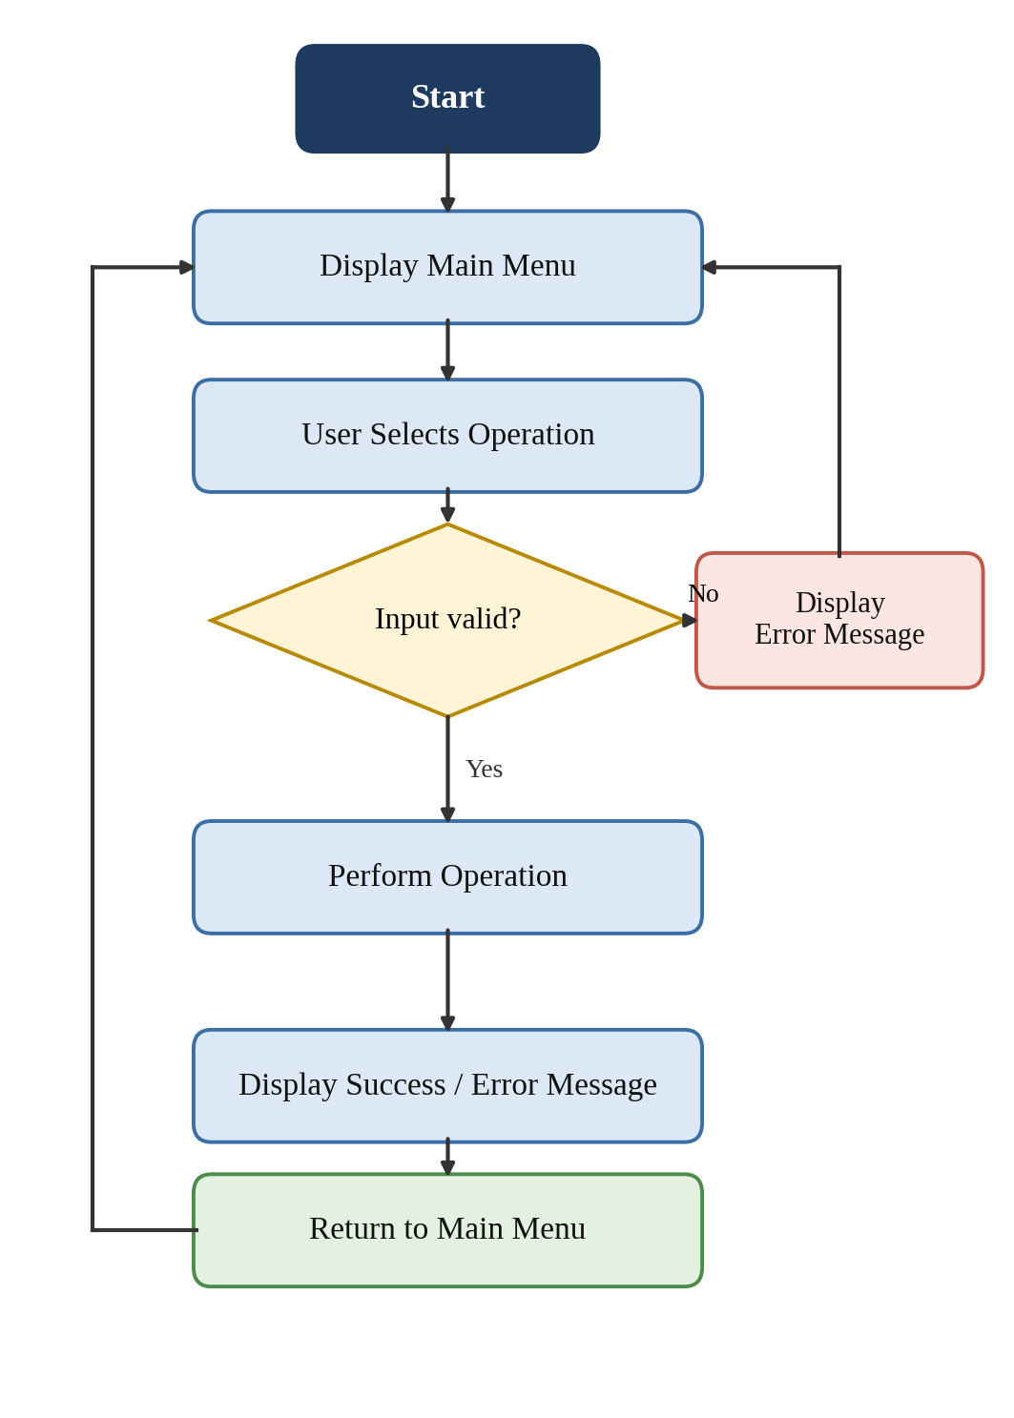
Figure 4. FileMaster Operation Workflow

Testing Methodology
FileMaster was tested by functional (black-box) testing. For every operation in the main menu, a test case was defined with a specific input and an expected result, as listed in Table 3 in Section 3. Each operation is run from the terminal inside the FileMaster2/workspace directory, and the observed behaviour is compared with the expected result. Both normal input and erroneous input, such as a missing file or an invalid choice, are used. A test case is marked PASS only when the observed behaviour matches the expected result.

Experiments

Development and Testing Environment
FileMaster was developed and tested on Ubuntu (Linux). The program is written in the C programming language and compiled with GCC, and the build process is automated with a Makefile. The code was edited in Visual Studio Code, and the program runs in the terminal. All experiments were carried out inside the project workspace FileMaster2/workspace. Hardware specifications of the test machine are not part of the supplied project information The project was developed and tested using Ubuntu Linux, GCC, and Visual Studio Code.

Workspace Structure
The workspace is the dedicated directory in which FileMaster performs its operations. Its current structure is shown below.
FileMaster2/
└── workspace/
├── Documents/
├── Downloads/
├── images/
└── project/

Main Menu
Figure 5 shows the main menu of FileMaster. It displays the program title, the numbered menu options from Directory Navigation to Exit, and the current directory.
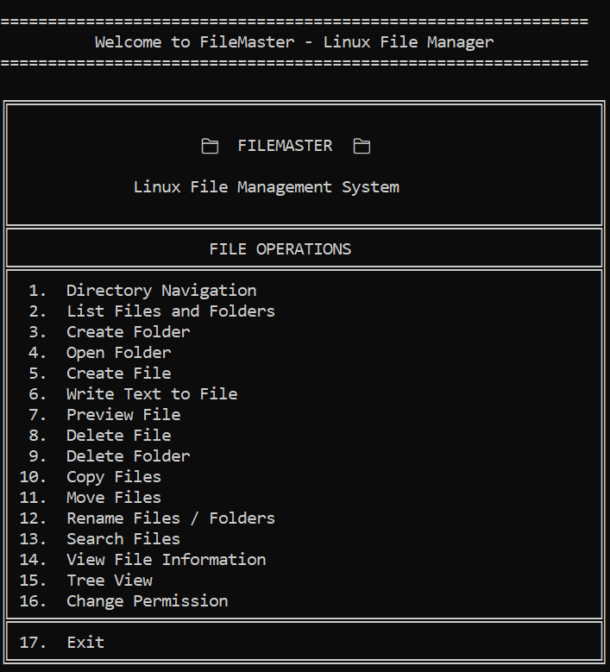

Figure 5. FileMaster Main Menu

Directory Navigation
Figure 6 shows navigation inside the workspace. The user enters a folder or path, the program changes the current directory, and the updated location is displayed.
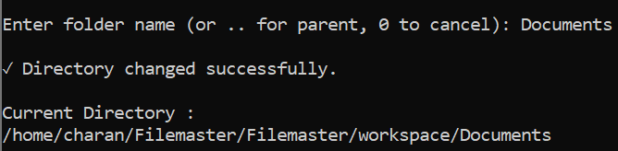
Figure 6. Directory Navigation in FileMaster

File and Folder Creation
Figure 7 shows the creation of a folder and a file. The program asks for the name, creates the item in the current directory and reports the result.
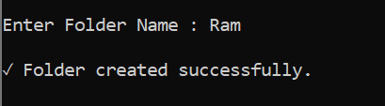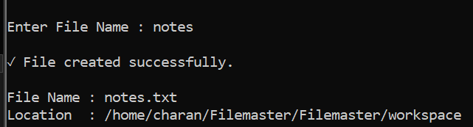
Figure 7. Creating a File and Folder

Writing and Previewing a File
Figure 8 shows text being written to a file and then displayed by the Preview File operation, which confirms that the content was saved.
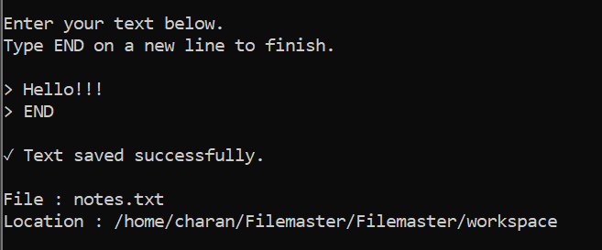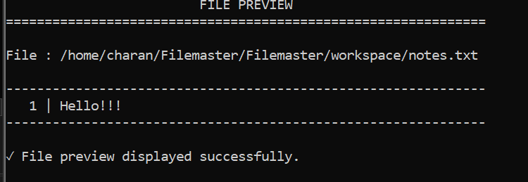
Figure 8. Writing and Previewing a File

Copy and Move Operations
Figure 9 shows the Copy Files and Move Files operations. After copying, the source file remains in its original location, while after moving it appears only in the destination.
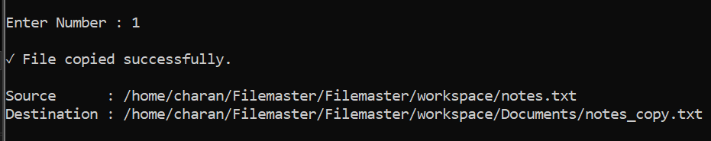
Figure 9. Copy and Move File Operations

Search Files
Figure 10 shows the output of the Search Files operation. The result is produced by a child process and returned to the parent through a pipe, as explained in Section 2.7.
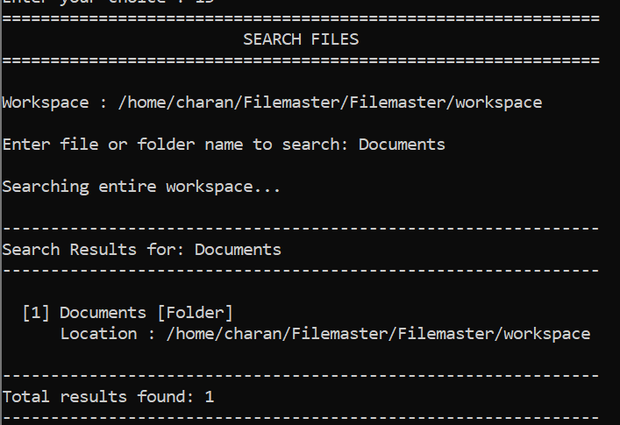
Figure 10. File Search Using Process and IPC Operations
The conceptual flow behind this output is as follows. The parent process creates a pipe and calls fork(). The child process redirects its standard output to the pipe by using dup2() and replaces itself with the search command by using exec(). The search command writes its results into the pipe, and the parent reads them from the other end of the pipe and displays them. Finally, the parent calls waitpid() so that the child is collected after it terminates. [

File Information
Figure 11 shows the File Information operation, which displays the details of a selected file or folder.
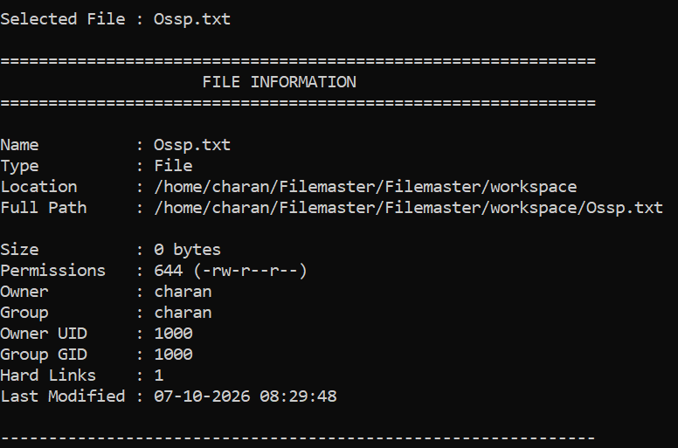
Figure 11. File Information Display

Tree View
Figure 12 shows the Tree View operation, which presents the directory hierarchy of the workspace.
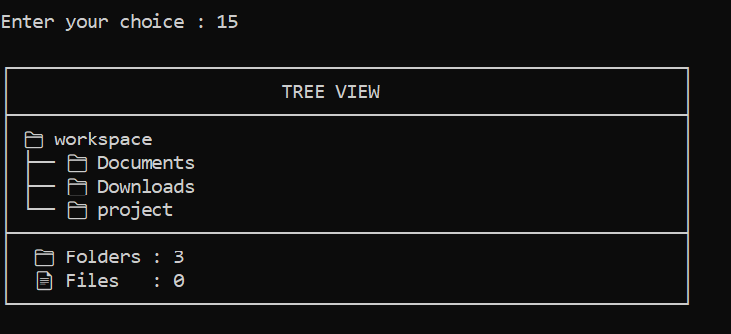
Figure 12. FileMaster Tree View

Permission Management
Figure 13 is intended to show the Change Permission operation, with the permissions of a file before and after the change. This figure is included only if the feature is confirmed to be implemented with chmod(); otherwise, Change Permission is reported as future work.
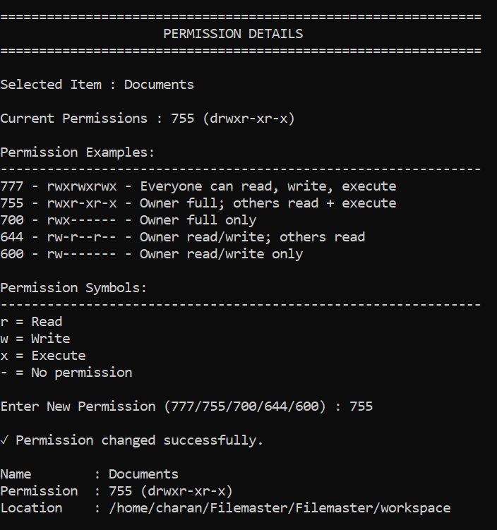
Figure 13. File Permission Management

Error Handling and Operation Control
Figure 14 shows an actual error case, such as a folder that is not found, a file that is not found, invalid input or a duplicate name, together with the way control returns to the user. A Continue/Cancel interface is shown only if it is confirmed in the source code.
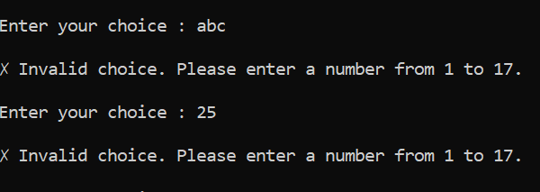
Figure 14. Error Handling and Operation Control

Functional Test Cases
Table 3 lists one functional test case for each menu operation. The Actual Result and Status columns must be completed from real test runs. No result has been entered in advance, and a test case is marked PASS only after it has been executed successfully.
Table 3. Functional Test Cases
Feature | Input | Expected Result | Status
Directory Navigation | Menu option 1; a valid workspace folder | Current directory changes to the selected folder | [IMPLEMENTED & TESTED]
List Files and Folders | Menu option 2 in a non-empty folder | Files and folders of the current directory are displayed | [IMPLEMENTED & TESTED]
Create Folder | Menu option 3; a new folder name | Folder is created and a success message is shown | [IMPLEMENTED & TESTED]
Open Folder | Menu option 4; an existing folder name | Folder is opened and its contents are shown | [IMPLEMENTED & TESTED]
Create File | Menu option 5; a new file name | Empty file is created and a success message is shown | [IMPLEMENTED & TESTED]
Write Text | Menu option 6; an existing file and some text | Text is saved in the file | [IMPLEMENTED & TESTED]
Preview File | Menu option 7; the file written above | Saved text is displayed | [IMPLEMENTED & TESTED]
Delete File | Menu option 8; an existing file | File is removed and a success message is shown | [IMPLEMENTED & TESTED]
Delete Folder | Menu option 9; an existing folder | Folder is removed and a success message is shown | [IMPLEMENTED & TESTED]
Copy Files | Menu option 10; a source file and a destination | Copy exists at the destination and the source remains | [IMPLEMENTED & TESTED]
Move Files | Menu option 11; a source file and a destination | File exists only at the destination | [IMPLEMENTED & TESTED]
Rename Files / Folders | Menu option 12; an item and a new name | Item appears under the new name | [IMPLEMENTED & TESTED]
Search Files | Menu option 13; a file name or pattern | Matching files are listed through the child process and pipe | [IMPLEMENTED & TESTED]
File Information | Menu option 14; an existing file | Details of the file are displayed | [IMPLEMENTED & TESTED]
Tree View | Menu option 15 in the workspace | Directory hierarchy is displayed | [IMPLEMENTED & TESTED]
Change Permission | Menu option 16; a file and a permission value | Permission of the file changes to the given value | [IMPLEMENTED & TESTED]

Results
This section reports the results obtained from testing FileMaster. Observed outcomes must be entered only after the test cases in Table 3 have been executed. The expected behaviour of each group of operations is described below, and the places where actual observations are required are marked.

File and Directory Operations
The directory operations (navigation, listing, folder creation, opening a folder and folder deletion) are expected to change or display the state of the workspace correctly. The file operations (file deletion, copying, moving and renaming) are expected to leave the workspace in the state described in the test cases. Observed results confirmed successful navigation, listing, creation, deletion, copying, moving, and renaming of files and folders.

File Editing and Preview
Creating a file, writing text and previewing it are expected to work together, so that the text entered by the user is displayed unchanged by the preview operation. Observed results confirmed successful file creation, text writing, and preview of saved file contents.

Search
The Search Files operation is expected to return the matching files through the pipe and to leave no unfinished child process behind. Observed results confirmed that matching files and folders are displayed with their locations, while no-match searches display an appropriate message.

File Information and Tree View
File Information is expected to display the details of the selected item, and Tree View is expected to display the hierarchy of the workspace. Observed results confirmed that file/folder information and the complete workspace tree hierarchy are displayed correctly.

Permission Management
Change Permission is expected to modify the permission bits of the selected fileObserved results confirmed that permissions can be changed using valid three-digit octal values, while invalid values are rejected with an error message.

Error Handling and User Interface
The program is expected to show clear messages for invalid input and failed operations and to return to the menu. The terminal menu lists every operation with a number, so the user can perform an operation without remembering command syntax.
Observed results confirmed that invalid inputs and failed operations display clear error messages, and the program returns safely to the main menu.

Feature Implementation Results
Table 4 summarises the implementation status of each feature. The status of every feature must be confirmed from the source code, and the observed result must be copied from the test runs. A feature that is present in the menu but incomplete should be described as incomplete.

Table 4. Feature Implementation Results
Feature | Observed Result
Directory Navigation | Directory changes to the selected folder.
List Files and Folders | Files and folders in the current directory are displayed.
Create Folder | New folder is created successfully.
Open Folder | Selected folder opens successfully.
Create File | New file is created successfully.
Write Text to File | Text is saved successfully to the file.
Preview File | Saved file contents are displayed.
Delete File | Selected file is deleted successfully.
Delete Folder | Selected folder and its contents are deleted.
Copy Files | File is copied to the selected destination.
Move Files | File is moved to the selected destination.
Rename Files / Folders | Selected item is renamed successfully.
Search Files | Matching files and folders are displayed with their locations.
View File Information | File/folder details and permissions are displayed.
Tree View | Workspace directory hierarchy is displayed.
Change Permission | Selected permissions are changed successfully.

OSSP Concepts Demonstrated
Table 5 relates the project to the OSSP concepts. The Search Files operation demonstrates process creation, program replacement, inter-process communication, redirection and process synchronisation. Because pipe ends and redirected standard streams are file descriptors, the same operation also demonstrates the Linux file abstraction. Threads, mutexes, signal handling, job management and virtual-memory demonstrations are not claimed in this report, because they are not part of the supplied project description.
Table 5. OSSP Concepts Demonstrated in FileMaster
OSSP Concept | Implementation | Application in FileMaster
fork() | Creates a child process | Search Files runs the search in a child process
exec() | Replaces the child program image | The child becomes the search command
pipe() | Kernel channel with read and write ends | Carries search output from child to parent
dup2() | Redirects a file descriptor | Child standard output is redirected to the pipe
waitpid() | Process synchronisation | Parent waits for the child and collects its status
Linux file abstraction and file descriptors | Files, pipes and standard streams are accessed through descriptors | Pipe ends and redirected output in Search; file access in the file editor
File permissions | Owner, group and other permission bits | Change Permission [confirm chmod() is implemented]
Directory operations | Directories managed in the Linux file system | Navigation, listing, creation, deletion and tree view of workspace folders

Conclusion and Future Work

Conclusion
This project developed FileMaster, a menu-driven Linux file management system written in C. It brings common file and directory operations together in one terminal menu and works inside a dedicated workspace, so a user can manage files without remembering the syntax of several shell commands. The program uses POSIX and Linux system calls to request services from the kernel, and its Search Files operation applies fork(), exec(), pipe(), dup2() and waitpid() to run a command in a child process and to receive its output in the parent.
Through the implementation and testing of FileMaster, the team learned how a user-level program interacts with the Linux kernel, how processes are created and synchronised, how file descriptors and redirection connect processes, and how directories and permissions are organised in the Linux file system. The project also showed the importance of input validation and clear error messages in a command-line tool. The conclusions about test outcomes must be completed after the results in Section 4 have been entered.

Future Work
The following improvements are proposed as future work. They are not part of the current implementation. A graphical user interface could make FileMaster easier to use than the terminal menu. The search could be extended with advanced options such as searching by size, date or file content. Permission management could be improved with symbolic permission input and clearer display of the current permission. Multithreaded operations could be added where they are appropriate, for example for copying large files. Background jobs and an operation history would allow the user to run long tasks and review previous actions. Error recovery could be improved, and further Linux system-call demonstrations and a better user interface could be added. Any menu feature that is found to be incomplete in the current version should also be completed.

References
- SquirrelFS: Using the Rust Compiler to Check File-System Crash Consistency — USENIX OSDI 2024
- Billion-files File Systems (BfFS): A Comparison — 2024
- Fast and Synchronous Crash Consistency with Metadata Write-Once File System — USENIX OSDI 2025
- Decentralized, Epoch-based F2FS Journaling with Fine-grained Crash Recovery — USENIX OSDI 2025
- ScaleLFS: A Log-Structured File System with Scalable Garbage Collection for Commodity SSDs — USENIX FAST 2025
- A Study of Linux File System Evolution — USENIX FAST 2013
- Linux/POSIX Documentation
- GCC Documentation
- Ubuntu/Linux Documentation

