## Unit 3- Greedy algorithms

|  |
| --- |
| **Topics** |
| 1. Interval Scheduling    1. Problem.    2. Natural approaches to solve the problem.    3. Designing algorithm based on greedy approach.    4. Analysis |
| 1. Scheduling to minimize lateness: An Exchange argument    1. Problem    2. Natural approaches to solve the problem.    3. Designing algorithm based on greedy approach.    4. Analysis |
| 1. Optimal Caching    1. Problem    2. Algorithm    3. Example |

## Greedy algorithm

An **algorithm is greedy** if it builds up a solution in small steps, choosing a decision at each step myopically to optimize some underlying criterion. One can often design many different greedy algorithms for the same problem, each one locally, incrementally optimizing some different measure on its way to a solution.

# Interval Scheduling problem

* + We have a set of requests {1, 2, . . . , *n*}; the *i*th request corresponds to an interval of time starting at *s(i)* and finishing at *f (i)*.
  + We’ll say that a subset of the requests is ***compatible*** if no two of them overlap in time, and our goal is to accept as large a compatible subset as possible. Compatible sets of maximum size will be called ***optimal***.

## Designing a Greedy Algorithm using natural approaches

The basic idea in a greedy algorithm for interval scheduling is to use a simple rule to select a first request *i*1. Once a request *i*1 is accepted, we reject all requests that are not compatible with *i*1. We then select the next request *i*2 to be accepted, and again reject all requests that are not compatible with *i*2 and so on.

Some of the most **natural rules** that can be used to solve the interval scheduling problem are:

* + The most obvious rule might be to always select the available request that starts earliest—that is, the one with **minimal start time *s(i)* earliest start time**. This way our resource starts being used as quickly as possible. This method does not yield an optimal solution.
    - If the earliest request *i* is for a very long interval, then by accepting request *i*

we may have to reject a lot of requests for shorter time intervals. Since our

goal is to satisfy as many requests as possible, we will end up with a suboptimal solution.

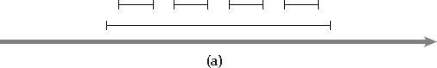

* + By accepting the request that requires the **smallest interval of time**—namely, the request for which *f (i)* − *s(i)* is as small as possible. As it turns out, this is a somewhat better rule than the previous one, but it still can produce a suboptimal schedule. For example, in Figure (b), accepting the short interval in the middle would prevent us from accepting the other two, which form an optimal solution.

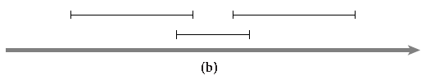

* + We could design a greedy algorithm that is based on this idea:
    - for each request, we count the number of other requests that are not compatible, and accept the request that has the fewest number of noncompatible requests. (In other words, we select the interval with the fewest “conflicts.”)
    - This greedy choice would lead to the optimum solution in the previous example
    - The unique optimal solution in this example shown in figure (c) is to accept the four requests in the top row. The greedy method suggested here accepts the middle request in the second row and thereby ensures a solution of size no greater than three.

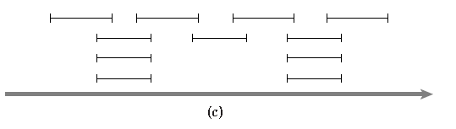

## A greedy rule that does lead to the optimal solution is based on a fourth idea:

* + - we should accept first the request that finishes first, that is, the request *I* for which *f (i)* is as small as possible.

## Interval Scheduling algorithm

Initially let *R* be the set of all requests, and let *A* be empty While *R* is not yet empty

Choose a request *i* ∈ *R* that has the smallest finishing time

Add request *i* to *A*

Delete all requests from *R* that are not compatible with request *i*

EndWhile

Return the set *A* as the set of accepted requests

## Interval scheduling example with smallest finish time (Greedy)

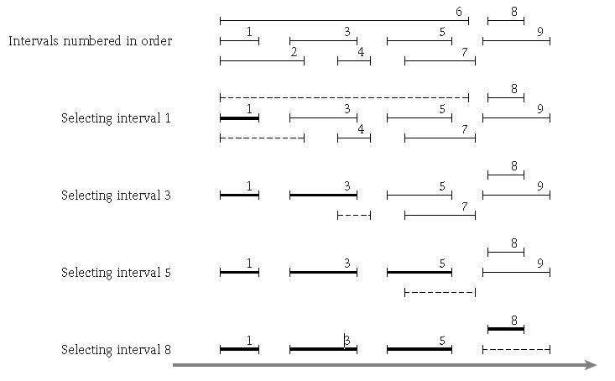

i=1

j=2,6

A={1}

i=1

j=9 A={1,3,5,8}

i=1 j=7 A={1,3,5}

i=3

j=4 A={1,3}

**Implementation and Running Time of Interval Scheduling**

The running time of the algorithm shown is *O(n* log *n)* as follows.

* We begin by sorting the *n* requests in order of finishing time and labeling them in this order; that is, we will assume that *f (i)* ≤ *f (j)* when *i < j*. This takes time *O(n* log *n)*.
* In an additional *O(n)* time, we construct an array *S*[1. . . *n*] with the property that *S*[*i*] contains the value *s(i)*. We now select requests by processing the intervals in order of increasing *f(i)*. We always select the first interval; we then iterate through the intervals in order until reaching the first interval *j* for which *s(j)* ≥ *f (*1*)*; we then select this one as well.
* More generally, if the most recent interval we’ve selected ends at time *f* , we continue iterating through subsequent intervals until we reach the first *j* for which *s(j)* ≥ *f* .
* In this way, we implement the greedy algorithm analyzed above in one pass through the intervals, spending constant time per interval. Thus this part of the algorithm takes time *O(n)*.

## Analysis

### The greedy algorithm returns an optimal set A.

* + In order to prove this we first have to prove that **set A contains a set of compatible requests.**
  + Let *i*1, . . . , *ik* be the set of requests in *A* in the order they were added to *A*. Note that

|*A*| = *k*. Similarly,

* + Let the set of requests in optimal set O be denoted by *j*1, . . . , *jm*. Our goal is to prove that *k* = *m*.
  + Our greedy rule guarantees that *f (i*1*)* ≤ *f (j*1*)*. This is the sense in which we want to show that our greedy rule “stays ahead”—that each of its intervals finishes at least as soon as the corresponding interval in the set O. Thus we now prove that for each *r* ≥ 1, the *r*th accepted request in the algorithm’s schedule finishes no later than the *r*th request in the optimal schedule.

i.e. *For all indices r* ≤ *k we have f (ir)* ≤ *f (jr).*

* + For *r* = 1 the statement is clearly true: the algorithm starts by selecting the request *i*1

with minimum finish time.

* + Now let *r >* 1. We will assume as our induction hypothesis that the statement is true for *r* − 1, and we will try to prove it for *r*. As shown in Figure 4.3, the induction hypothesis lets us assume that *f (ir*−1*)* ≤ *f (jr*−1*)*.

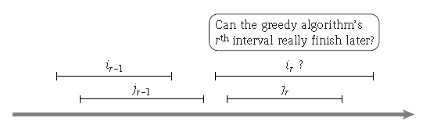

* + the greedy algorithm always has the option (at worst) of choosing *jr* and thus fulfilling the induction step. i.e. jr is compatible with ir-1 and jr-1.
  + We know (since O consists of compatible intervals) that *f (jr*−1*)* ≤ *s(jr)*. Combining this with the induction hypothesis ***f (ir*−1*)* ≤ *f (jr*−1*)*, we get *f (ir*−1*)* ≤ *s(jr)*.**
  + Thus the interval *jr* is in the set *R* of available intervals at the time when the greedy algorithm selects *ir* . The greedy algorithm selects the available interval with *smallest* finish time; since interval *jr* is one of these available intervals, we have ***f (ir)* ≤ *f (jr)*.**
  + Thus we have formalized the sense in which the greedy algorithm is remaining ahead of O: for each *r*, the *r*th interval it selects finishes at least as soon as the *r*th interval in O.

We will now prove the statement by contradiction.

* + If *A* is not optimal, then an optimal set O must have more requests, that is, we must have *m > k*.
  + With *r* = *k*, we get that *f (ik)* ≤ *f (jk)*. Since *m > k*, there is a request *jk*+1 in O.
  + This request starts after request *jk* ends, and hence after *ik* ends.
  + So after deleting all requests that are not compatible with requests *i*1, . . . , *ik*, the set of possible requests *R* still contains *jk*+1.
  + But the greedy algorithm stops with request *ik*, and it is only supposed to stop when *R*

is empty—a contradiction. Hence, the set A returned is optimal

# Scheduling to minimize lateness: An Exchange argument

## Problem

* + Consider again a situation in which we have a single resource and a set of *n* requests to use the resource for an interval of time. Assume that the resource is available starting at time *s*. In contrast to the previous problem, however, each request is now more flexible.
  + Instead of a start time and finish time, the request *i* has a deadline *di*, and it requires a contiguous time interval of length *ti*, but it is willing to be scheduled at any time before the deadline.

Each accepted request must be assigned an interval of time of length *ti*, and different requests must be assigned with no overlapping intervals.

Suppose that we plan to satisfy each request, but we are allowed to let certain requests run late. Thus, beginning at our overall start time *s*, we will assign each request *i* an interval of time of length *ti*;

let us denote this interval by [*s(i)*, *f (i)*], with *f (i)* = *s(i)* + *ti*. where, s(i)= start time of the interval i

f(i)=finish time of the interval i ti= time length of the interval i

Unlike the previous problem, then, the algorithm must actually determine a start time (and hence a finish time) for each interval.

We say that a request *i* is *late* if it misses the deadline, that is, if *f (i) > di*.

The *lateness* of such a request *i* is defined to be *li* = *f (i)* − *di*. We will say that *li* = 0 if request

*i* is not late.

The goal in our new optimization problem will be to schedule all requests, using nonoverlapping intervals, so as to minimize the *maximum lateness*, *L* = max*i li*.

## Example

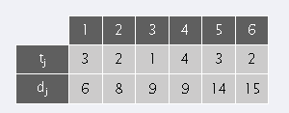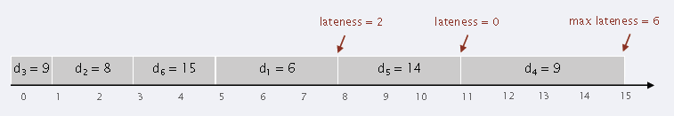

Compare finish time with deadline and then calculate lateness

f(i)=8 d(i)=6 l(i)=8-6=2

**Natural approaches to the problem**

* One approach would be to schedule the jobs in order of increasing length

*ti*, so as to get the short jobs out of the way quickly.

Example:

|  |  |  |
| --- | --- | --- |
|  | 1 | 2 |
| tj | 1 | 3 |
| dj | 2 | 5 |

|  |  |
| --- | --- |
| t1=1 | t2=3 |

0 1

3

## Counter Example:

|  |  |  |
| --- | --- | --- |
|  | 1 | 2 |
| tj | 1 | 10 |
| dj | 100 | 10 |

|  |  |  |
| --- | --- | --- |
|  | 1 | 2 |
| tj | 1 | 10 |
| dj | 100 | 10 |

|  |  |
| --- | --- |
| t2=10  d2=10 | t1=1  d1=100 |

0 10 11

If request 2 is scheduled first

|  |  |
| --- | --- |
| t1=1,  d1=100 | t2=10,  d2=10 |

0 1 11

Lateness for the request 2 is 1

Lateness for the request 2 is 0

* ***slack time*** *di* − *ti* is very small—they’re the ones that need to be started with minimal delay. So a more natural greedy algorithm would be to sort jobs in order of increasing slack *di* − *ti*.

Example:

|  |  |  |
| --- | --- | --- |
|  | 1 | 2 |
| tj | 1 | 3 |
| dj | 2 | 5 |
| sli | 1 | 2 |

|  |  |
| --- | --- |
| sl1=1  d1=2 | sl2=2  d2=5 |

0 1 4

## Counter Example:

If request 1 is scheduled first

|  |  |  |
| --- | --- | --- |
|  | 1 | 2 |
| tj | 1 | 10 |
| dj | 2 | 10 |
| sli | 1 | 0 |

|  |  |  |
| --- | --- | --- |
|  | 1 | 2 |
| tj | 1 | 10 |
| dj | 2 | 10 |
| sli | 1 | 0 |

|  |  |
| --- | --- |
| sl1=1  d1=2 | s2=0  d2=10 |

0 1 11

10

11

|  |  |
| --- | --- |
| sl2=0 d2=10 | sl1=1 d1=2 |

0

Lateness for the request 1 is 9

Lateness for the request 2 is 1

## Designing greedy algorithm

In the above discussions, the right hand side of the interval scheduling shows the earliest deadline first strategies.

## Algorithm

Order the jobs in order of their deadlines

Assume for simplicity of notation that *d*1 ≤ . . . ≤ *dn*

Initially, *f* = *s*

Consider the jobs *i* = 1, . . . , *n* in this order

Assign job *i* to the time interval from *s(i)* = *f* to *f (i)* = *f* + *ti*

Let *f* = *f* + *ti*

End

Return the set of scheduled intervals [*s(i)*, *f (i)*] for *i* = 1, . . . , *n*

## Example

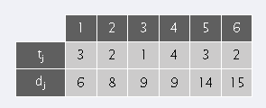

d1<d2<d3d4<d5<d6, f=0

1. i=1 Add Job J1 to the schedule.

s(1) = f =0

f(1)= s(1)+t(1)=0+3=3 f= f + t(1)=0+3=3

J1 d1=6

0 3

1. i=2 Add Job J2 to the schedule.

|  |  |
| --- | --- |
| J1 d1=6 | J2 d2=8 |

0 3 5

s(2) = f =3

f(2)= s(2)+t(2)=3+2=5 f= f + t(2)=3+2=5

1. i=3 Add Job J3 to the schedule.

s(3) = f =5

f(3)= s(3)+t(3)=5+1=6 f= f + t(3)=5+1=6

J3 d3=9

J2 d2=8

J1 d1=6

0

1. i=4 Add Job J4 to the schedule.

6

5

3

s(4) = f =6

f(4)= s(4)+t(4)=6+4=10 f= f + t(4)=6+4=10

|  |  |  |  |
| --- | --- | --- | --- |
| J1 d1=6 | J2 d2=8 | J3 d3=9 | J4 d4=9 |

Lateness=1

0 3 5 6 10

1. i=5 Add Job J5 to the schedule.

s(5) = f =10

f(5)= s(5)+t(5)=10+3=13 f= f + t(5)=10+3=13

|  |  |  |  |  |
| --- | --- | --- | --- | --- |
| J1  d1=6 | J2  d2=8 | J3  d3=9 | J4  d4=9 | J5  d5=14 |

0 3 5 6 10 13

1. i=6 Add Job J6 to the schedule.

s(6) = f =13

f(6)= s(6)+t(6)=13+2=15 f= f + t(6)=13+2=15

|  |  |  |  |  |  |
| --- | --- | --- | --- | --- | --- |
| J1  d1=6 | J2  d2=8 | J3  d3=9 | J4  d4=9 | J5  d5=14 | J6  d6=15 |

0 3 5 6

10

15

13

Max Lateness=1

## Analysis

**(4.9)** *There is an optimal schedule that has no inversions and no idle time.*

The main step in showing the optimality of our algorithm is to establish that there is an optimal schedule that has no inversions and no idle time.

To do this, **we will start with any optimal schedule having no idle time**; we will then **convert it into a schedule with no inversions** without increasing its maximum lateness. Thus the resulting scheduling after this conversion will be optimal as well. This method is known as “Exchange argument” where the optimal schedule is converted to the greedy schedule by exchanging.

* *There is an optimal schedule with no idle time.*

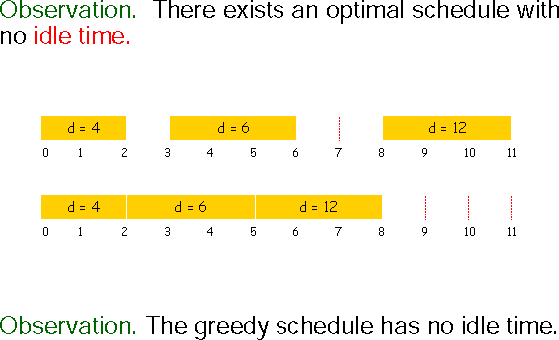

Idle time

* *There is an optimal schedule that has no inversions*
  + We first try characterizing schedules in the following way. We say that a schedule *A* has an ***inversion*** if a job *i* with deadline *di* is scheduled before another job *j* with earlier deadline *dj < di* as shown below.



* + Let us consider Optimal schedule O has an inversion, then there is a pair of jobs i and j such that j is scheduled immediately after i and has dj < di.
  + The pair *(i*, *j)* formed an inversion in O, this inversion can be eliminated by the swap, and no new inversions are created. Thus we have

1. *After swapping i and j we get a schedule with one less inversion.*
2. *The new swapped schedule has a maximum lateness no larger than that of* O*.* It is clear that if we can prove (c), then we are done.
   * Consider the jobs i and j in the optimal schedule before swap and after swap as shown below.

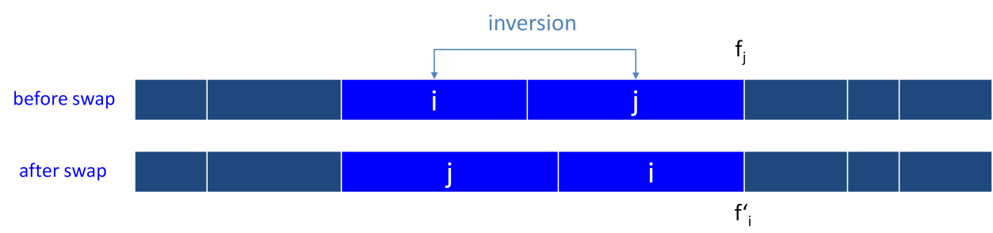

* + Let 𝑙 be the lateness before the swap, and let 𝑙 ' be it afterwards.
    - 𝑙 'k = 𝑙k for all k  i, j.
    - Also lj’ lj
    - If job i is late:

|  |  |  |
| --- | --- | --- |
| 𝑙*i*  | *fi* *di* | (definitio n) |
|  | *f j*  *di* | (*i* finishes at time *fj*) |
|  | *f j*  *d j* | ( *j*  *i*) |
|  | 𝑙 *j* | (definitio n) |

## Hence proved that “There is an optimal schedule with no idle time and no inversions”.

**3. Optimal Caching**

***Caching*** is a general term for the process of storing a small amount of data in a fast memory so as to reduce the amount of time spent interacting with a slow memory.

For caching to be as effective as possible, it should generally be the case that when you go to access a piece of data, it is already in the cache. To achieve this, a *cache maintenance* algorithm determines what to keep in the cache and what to evict from the cache when new data needs to be brought in.

* We consider a set *U* of *n* pieces of data stored in *main memory*.
* We also have a faster memory, the *cache*, that can hold *k < n* pieces of data at any one time.
* We will assume that the cache initially holds some set of *k* items.
* A sequence of data items *D* = *d*1, *d*2, . . . , *dm* drawn from *U* is presented to us—this is the sequence of memory references we must process— and in processing them we must decide at all times which *k* items to keep in the cache.
* When item *di* is presented, we can access it very quickly if it is already in the cache; otherwise, we are required to bring it from main memory into the cache and, if the cache is full, to *evict* some other piece of data that is currently in the cache to make room for *di*.
* This is called a *cache miss*, and we want to have as few of these as possible.
* *Goal is to produce Eviction schedule that minimizes number of cache misses.*

## Example

* k = 2, initial cache = ab, requests: a, b, c, b, c, a, a, b.
* Optimal eviction schedule: 2 cache misses.

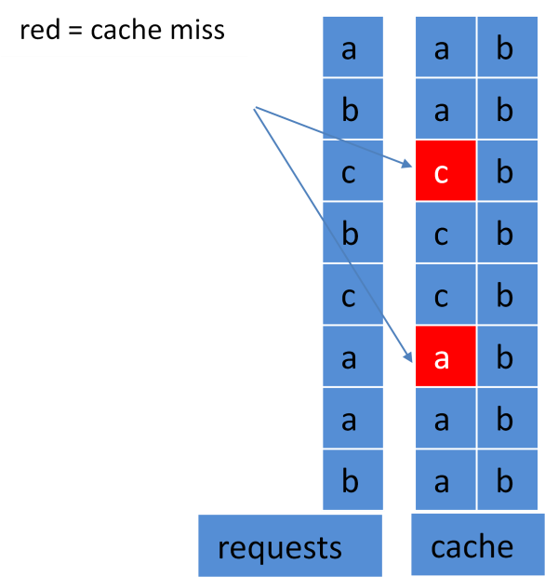

## Algorithm

When *di* needs to be brought into the cache,

evict the item that is needed the farthest into the future

## Example

### a, b, c, d, a, d, e, a, d, b, c k=3

