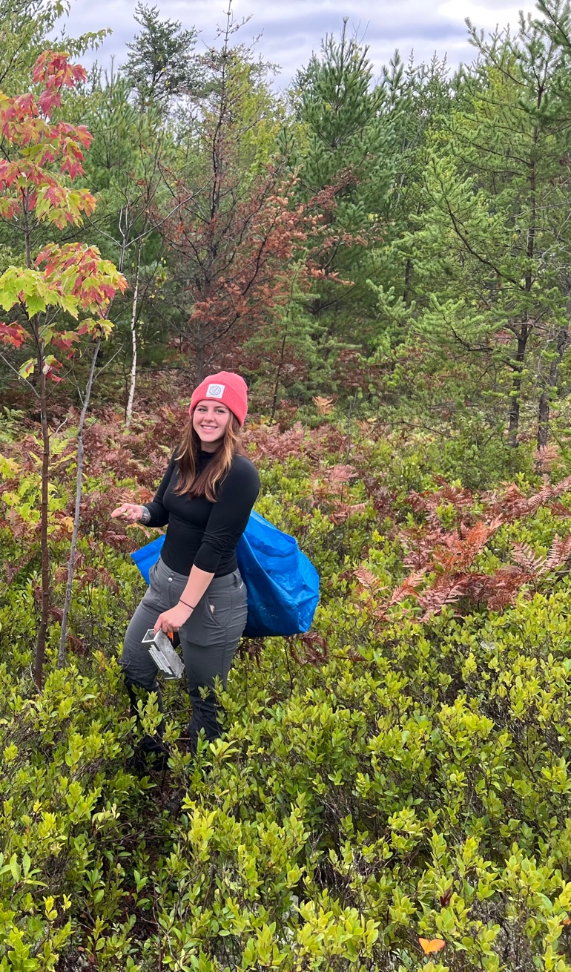

I am a senior ecology major in the Center for Earth and Environmental Science at SUNY Plattsburgh, working towards a master’s degree in ecology and natural resource management. My independent studies thus far have included tree encroachment into boreal peatlands at their southern range limits, and groundwater chemistry within the Lake Champlain basin. Growing up in a large city and having a love for wetland ecology drives my passion for perusing a career in coastal and urban wetland restoration.

When I’m not in class or working in the campus greenhouse, I’m working at the local coffee shop, reading, or hiking in the High Peaks.