ADITYA COLLEGE OF ENGINEERING
(UGC-AUTONOMOUS INSTITUTION & ACCREDITED WITH NAAC A+ GRADE)
Approved by AICTE, New Delhi & Affiliated to JNTUA, Anantapuramu
MADANAPALLE – 517325, ANNAMAYYA Dist., A.P.
www.acem.ac.in
DEPARTMENT OF COMPUTER SCIENCE ENGINEERING
PROJECT PROTOCOL
Mini Project Title: The Digital Blood Donor Directory
A sector-based, real-time blood donor search with automated 90-day eligibility
Detail | Value
Roll No | 258P5A0510
Name of the Student | M. OBUL REDDY
Class | II B.Tech – CSE – B
Document version | 1.0

Signature of the Faculty HOD CSE

1. Project at a Glance
Item | Description
Title | The Digital Blood Donor Directory
Domain | Health-tech and emergency response (web application)
Type of work | Mini project: design, implementation and testing of a working prototype
Student | M. Obul Reddy, Roll No 258P5A0510, II B.Tech CSE-B
Institution | Department of Computer Science Engineering, Aditya College of Engineering, Madanapalle
Central idea | Donors are stored under a city sector, so a recipient searches a neighbourhood instead of a whole city. A server-side 90-day rule hides anyone who donated recently.
Technology | Front end: HTML, CSS, JavaScript. Back end: Python 3 (standard library). Database: relational, third normal form (SQLite in the demo build, MySQL script provided).
Project period | January – March 2026 (12 weeks)
Deliverables | Working web application, database scripts, automated test suite (22 tests), this protocol

2. Background and Rationale
Blood is a critical resource in surgery, trauma care and obstetric emergencies. Hospital blood banks hold stock, but they regularly run short of particular groups, and in those moments voluntary donors are the only remaining source. Today most families reach donors through social-media broadcasts and messaging groups. These are fast, but they are unstructured: the same request is posted many times, old information keeps circulating, and the people who respond may live an hour away.
This project proposes a structured directory that treats location at the level of a city sector and medical eligibility as first-class data. Instead of returning a list for an entire city or state, the system returns only donors from the sector the recipient chooses, and only those who are currently allowed to donate.

3. Problem Statement
Existing blood donation websites and apps leave three practical gaps:
- The logistics gap. Most systems search by city. In a large urban area, travelling from one side of the city to the other can take one to two hours in traffic. During an emergency this delay can be fatal. No widely used directory filters donors by city sector so that a donor can realistically reach the hospital in 15–20 minutes.
- Information staleness. Static directories keep showing a donor as "Available" even if they gave blood yesterday. Recipients then phone dozens of ineligible people. Nothing automatically applies the three-month (90-day) cooling-off period.
- Privacy and trust. Donors hesitate to publish their phone numbers on open platforms. Current systems lack a request-and-response flow that protects donor data while still letting verified recipients make contact.
In short: there is no localised, real-time and privacy-respecting donor directory. The broad-search approach is inefficient for time-critical needs.

4. Aim and Objectives
Aim. To design, build and evaluate a web-based donor directory that shortens the time needed to find an eligible blood donor near a patient.
No. | Objective | How it will be judged
O1 | Return donors only from the sector the recipient selects. | Every result in test TC02 belongs to the chosen sector and city.
O2 | Apply the 90-day rule automatically, without trusting the donor to update their own status. | Donors inside the window never appear, even if they mark themselves Available (TC03–TC06, TC14).
O3 | Keep phone numbers private by default. | Guests and donors never receive a full number; every reveal by a recipient is logged (TC07–TC10).
O4 | Alert the right donors when an emergency request is posted. | Only eligible, blood-compatible donors in that sector are notified (TC16, TC17).
O5 | Keep search fast on an indexed relational database. | A sector search returns in under 2 seconds (TC21).
O6 | Be usable on a 6-inch phone in a stressful moment. | High-contrast, mobile-first layout with no sideways scrolling at 390 px width.

5. Scope

5.1 In scope
- Registration and sign-in for donors, recipients and an administrator, with hashed passwords.
- City-to-sector hierarchy managed by the administrator.
- Sector-based search by blood group, with an optional "include compatible groups" mode.
- Automatic 90-day eligibility, plus a donor-controlled Available / Busy / Traveling status.
- Emergency requests with in-app alerts to matching donors, donor responses and administrator verification.
- Donation history with a database trigger that keeps the last donation date current.

5.2 Out of scope for this version
- GPS live tracking and map-based routing (planned as a future enhancement).
- AI-based demand forecasting (future enhancement).
- SMS, WhatsApp or e-mail delivery. Alerts in this version are in-app notifications; a messaging gateway would be added later.
- Integration with national or hospital blood-bank inventory systems such as e-RaktKosh.
- Medical screening or verification of donor health claims. Final suitability is always decided at the collection centre.

6. Literature Survey
Four representative works were reviewed. Each solves part of the problem but leaves the gaps described in Section 3.
Work | What it offers | Limitation relevant to this project
e-RaktKosh: A Centralized Blood Bank Management System  Ministry of Health and Family Welfare, Government of India (2017) | Central registry of blood-bank stock across India; patients can search availability online. | Covers institutional stock only. No real-time tracking of individual voluntary donors and no donor-to-patient matching.
Mobile Application for Blood Donor Information Management System  R. Karthikeyan and P. Suresh, IJCA (2018) | Mobile database of donors searchable by blood group and location. | Does not confirm availability or eligibility at the time of the request, so many calls fail.
Social Media as a Tool for Blood Donation Campaigns  A. Ahmed and S. Khan, IEEE Conf. on Social Computing (2019) | Rapid, wide dissemination of requests on Facebook and WhatsApp. | Duplicate and outdated posts, no structured storage, weak geographic precision (city or region level).
Design of an Online Blood Donor Directory System  M. Patel and R. Verma, IJERT (2020) | Web directory of donors, searchable by blood group and state. | Needs manual filtering for nearby donors, many stale records, ignores last-donation-date constraints.
Summary. The surveyed systems lack real-time availability, fine-grained location filtering and structured data handling. Centralised registries focus on blood banks, while donor directories lack dynamic validation. This project combines sector-level location, automatic eligibility and structured storage.

7. Comparative Study
Feature | Traditional blood banks | Social-media requests | Proposed sector-based system
Search precision | Hospital level | City level | City-sector level (hyper-local)
Availability update | Manual and slow | None (static posts) | Automated (90-day rule, donor status)
Response time | Moderate | High and uncertain | Very low (real-time search)
Data integrity | High | Low | High (validated, structured profiles)
Phone privacy | Not applicable | Numbers posted publicly | Masked; revealed to signed-in recipients and logged
Ease of access | Physical visit | Digital | Digital, mobile-first

8. Proposed System and Methodology

8.1 Development approach
The project follows an iterative prototyping approach. Each iteration produced something that could be run and tested: (1) requirements and literature study, (2) database schema and sample data, (3) server and API with the business rules, (4) the browser interface, (5) testing and documentation. Rules that matter medically, such as the 90-day interval, are enforced on the server, so they cannot be bypassed from the browser.

8.2 System architecture
The system uses a three-tier architecture. The browser handles presentation. The Python server validates every request, applies the business rules and talks to the database. The relational database enforces integrity with keys, constraints, an index and a trigger.
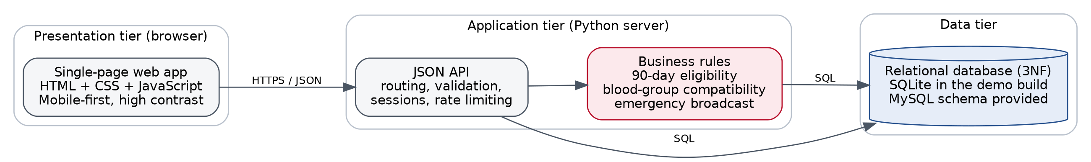
Figure 1: Three-tier architecture of the Digital Blood Donor Directory

8.3 Search and eligibility logic
A donor appears in a search only if both conditions below hold at the moment of the query:
- The donor's status is Available (the donor can switch to Busy or Traveling at any time).
- The donor has never donated, or the last donation date is on or before today minus 90 days.
Because the date comparison runs in the database query, the result is correct at every search with no scheduled job. A donor inside the window is counted in a "hidden" total shown to the recipient, which explains why the list may be shorter than the number of registered donors.
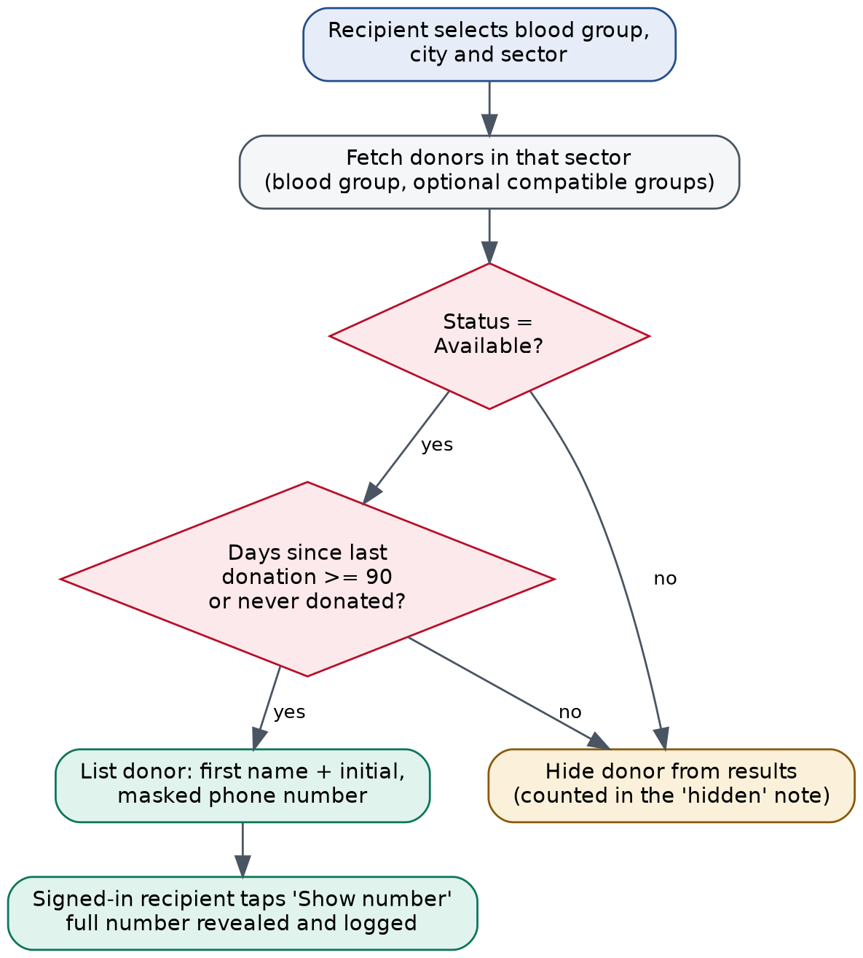
Figure 2: Search flow: eligibility filtering and controlled contact reveal
Pseudocode of the rule:
cutoff = today - 90 days
SELECT donors WHERE blood_group IN (requested or compatible groups)
AND sector IN (selected sector, or all sectors of the city)
AND status = "Available"
AND (last_donation_date IS NULL OR last_donation_date <= cutoff)
hidden = (donors matching group + sector) - (donors listed)

8.4 Blood-group compatibility
When the recipient ticks "also show compatible groups", the search widens to groups that can safely give red cells. The same table decides who receives an emergency alert and who may respond to a request.
Patient group | Donor groups that can give
O- | O-
O+ | O+, O-
A- | A-, O-
A+ | A+, A-, O+, O-
B- | B-, O-
B+ | B+, B-, O+, O-
AB- | AB-, A-, B-, O-
AB+ | All eight groups

8.5 User roles
Role | Responsibilities and permissions
Donor | Registers with blood group, sector, phone, age and weight; sets availability; records donations; responds to requests in a matching sector. Cannot see other donors' phone numbers.
Recipient | Searches donors; reveals one donor number at a time after signing in; posts emergency requests; sees which donors responded; marks requests fulfilled or closed.
Administrator | Verifies or closes emergency requests, manages the city and sector list (a sector with donors cannot be deleted), monitors donor and request statistics.

9. Requirements Specification

9.1 Functional requirements
ID | Requirement | Description
F1 | Registration and authentication | Users register as Donor or Recipient. Donors must be 18 or older and weigh at least 45 kg. Passwords are stored as salted PBKDF2 hashes.
F2 | City-sector hierarchy | Choosing a city loads only that city's sectors from the database, so no invalid address can be entered.
F3 | Automated eligibility (90-day rule) | Days since the last donation are calculated on every search. Inside the window the donor is hidden, even if the manual status is Available.
F4 | Sector-based search | Recipients choose blood group and sector. Results show first name and initial, sector, status and a masked number revealed only after sign-in.
F5 | Emergency broadcast | A recipient posts a requirement for a sector. Eligible, compatible donors in that sector receive an in-app alert.
F6* | Request and response flow | Donors respond to a request; the requester is notified and can then reveal that donor's number. Administrators verify requests.
F7* | Donation history | Donations are recorded with volume and place; a trigger updates the last donation date; donations closer than 90 days apart are rejected.
* F6 and F7 are additions to the original specification, made to implement the request-response privacy flow and the master/slave donor tables described in the project report.

9.2 Non-functional requirements
ID | Requirement | Target and how it is met
NF1 | Performance | Sector search returns in under 2 seconds. A composite index on (blood group, sector) supports the query; measured average is a few milliseconds on the demo data.
NF2 | Availability and reliability | Target 99.9% uptime in deployment. The server handles concurrent requests (threaded) and every request uses its own database connection.
NF3 | Security and privacy | Numbers masked by default; reveal restricted to recipients and logged; HttpOnly session cookie; lockout after 5 failed sign-ins; JSON-only writes; strict content-security policy; parameterised SQL.
NF4 | Usability | Minimal, high-contrast, mobile-first interface; keyboard focus visible; reduced-motion respected; usable at 390 px width.

9.3 Hardware and software requirements
Item | Minimum configuration
Processor / RAM / disk | Intel Core i3 or higher; 4 GB RAM (8 GB recommended); 250 GB disk
Operating system | Windows 10/11, Linux or macOS
Runtime | Python 3.8 or newer (no extra packages needed)
Browser | Current Google Chrome, Microsoft Edge, Mozilla Firefox or Safari
Database | SQLite (bundled, used by the demo); MySQL 8 using the supplied schema_mysql.sql
Editor | Visual Studio Code, PyCharm or any text editor
Network | Internet connection for a public deployment; none needed to run locally

10. Database Design
The database is normalised to third normal form (3NF). City, sector, blood group and user data live in their own tables, and every non-key column depends only on its table's primary key. A donor's location is always a valid sector-city pair because it is stored as a foreign key.
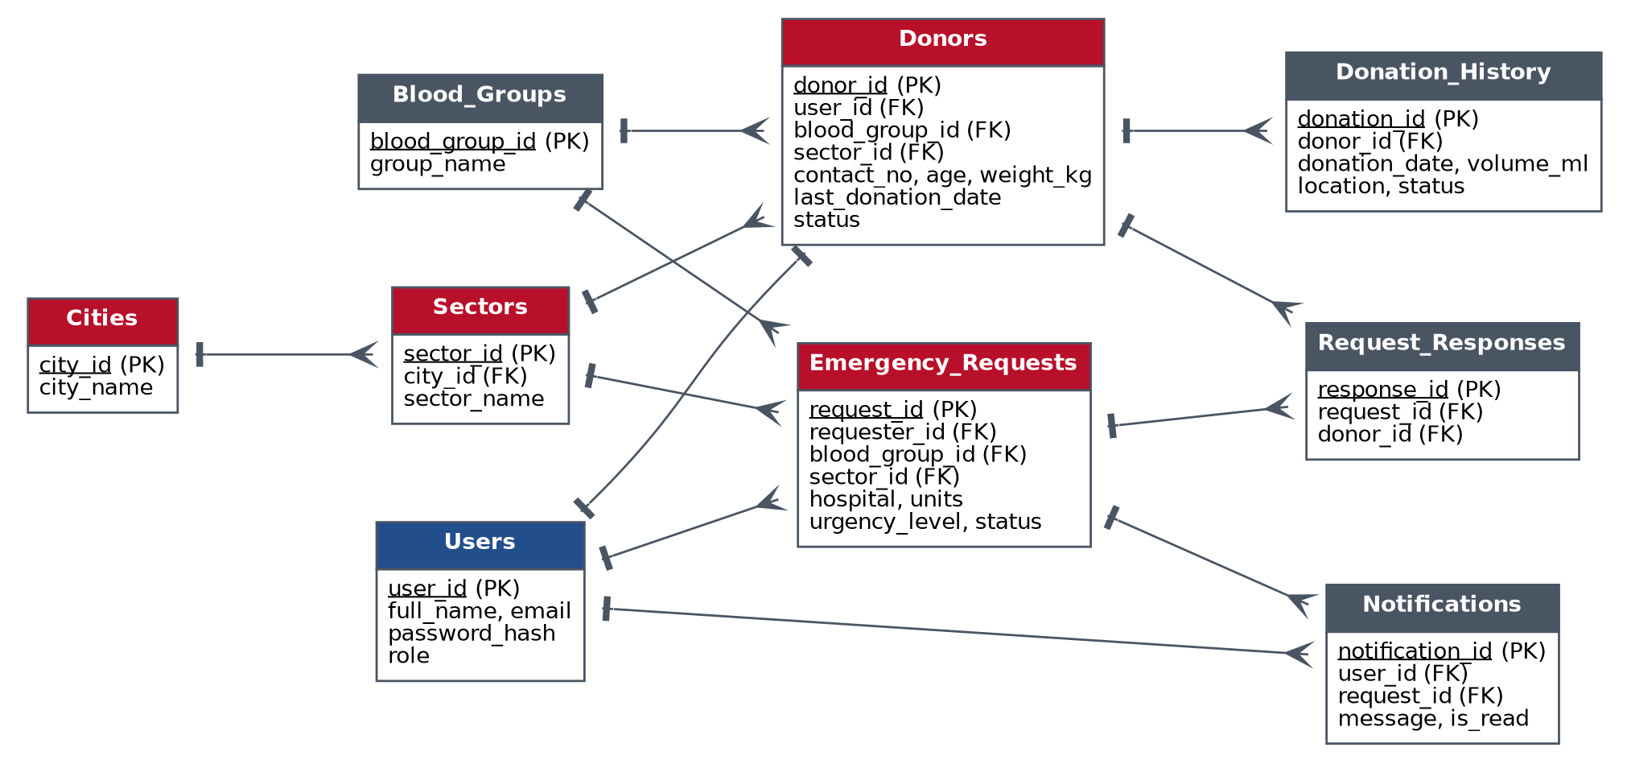
Figure 3: Entity-relationship diagram (crow's feet show the "many" side)

10.1 Relationships
- City to Sector: one-to-many. A city has many sectors; a sector belongs to one city.
- Sector to Donor and Sector to Emergency Request: one-to-many.
- Blood Group to Donor / Request: one-to-many.
- Donor (master) to Donation History (slave): one-to-many with ON DELETE CASCADE.
- Emergency Request to Request Response: one-to-many; a donor can respond to a request only once.

10.2 Core data dictionary
Donors (master table)
Column | Type | Constraints and purpose
donor_id | INT | Primary key, auto-increment
user_id | INT | Foreign key to Users, unique (one profile per account)
blood_group_id | TINYINT | Foreign key to Blood_Groups
sector_id | INT | Foreign key to Sectors; part of the search index
contact_no | VARCHAR(15) | NOT NULL, UNIQUE; shown masked to the public
age, weight_kg | INT | CHECK age >= 18 and weight >= 45
last_donation_date | DATE | NULL for first-time donors; maintained by the trigger
status | ENUM | Available, Busy or Traveling (manual toggle)
Donation_History (slave table)
Column | Type | Constraints and purpose
donation_id | INT | Primary key
donor_id | INT | Foreign key to Donors, ON DELETE CASCADE
donation_date | DATE | Date of the donation
volume_ml | INT | CHECK between 200 and 500
location, status | VARCHAR / ENUM | Place; Completed, Screened or Pending
Emergency_Requests
Column | Type | Constraints and purpose
request_id | INT | Primary key
requester_id, sector_id, blood_group_id | INT | Foreign keys to Users, Sectors, Blood_Groups
hospital, patient_name, contact_no | VARCHAR | Not shown publicly (patient name and phone stay private)
units | INT | CHECK between 1 and 10
urgency_level | ENUM | Critical, Urgent or Planned
status | ENUM | Pending, Verified, Fulfilled or Closed
Supporting tables are Users (credentials and role), Request_Responses, Notifications, Contact_Log (audit of number reveals) and Sessions. The full definitions are in database/schema_mysql.sql and app/database.py.

10.3 Trigger and index
A trigger keeps the eligibility date correct without any application code. When a completed row is added to Donation_History, the donor's last donation date is set to their latest completed donation. A composite index on (blood_group_id, sector_id) supports requirement NF1.
CREATE TRIGGER trg_donation_updates_last AFTER INSERT ON donation_history
WHEN NEW.status = 'Completed' BEGIN
UPDATE donors SET last_donation_date =
(SELECT MAX(donation_date) FROM donation_history
WHERE donor_id = NEW.donor_id AND status = 'Completed')
WHERE donor_id = NEW.donor_id;
END;
SQL for the DDL, DML, DCL and DQL operations, aggregate functions, joins and sub-queries used in the project report is provided in database/sample_queries.sql, written against this final schema.

11. Implementation

11.1 Software modules
Module | Responsibility
app/server.py | HTTP server and JSON API: routing, input validation, session cookies, sign-in lockout, role checks, security headers, static file serving.
app/database.py | Schema, seed data, password hashing, the 90-day rule, blood-group compatibility, search query and emergency broadcast.
app/static/js/app.js | Single-page interface: finder with sector tiles, results, registration with city-to-sector dropdown, donor, recipient and admin dashboards.
app/static/css/style.css | Responsive, high-contrast styling with visible keyboard focus and reduced-motion support.
database/*.sql | MySQL schema, trigger, search view and sample queries.
tests/test_api.py | Automated test suite with 22 test cases (Section 12).

11.2 Main API endpoints
Method | Endpoint | Purpose
GET | /api/meta | Cities, sectors, blood groups, compatibility table, totals
GET | /api/sector-stats | Available donors per sector (drives the sector tiles)
GET | /api/search | Sector-based donor search with hidden count
POST | /api/register, /api/login, /api/logout | Account creation and sessions
POST | /api/donors/{id}/contact | Reveal a donor number (recipient or admin; logged)
GET/PATCH/PUT/POST | /api/donor/me, /status, /profile, /donations | Donor self-service
GET/POST | /api/requests, /requests/open, /requests/mine | Emergency requests and the public live board
POST/GET | /api/requests/{id}/respond, /responses, /status | Donor responses, responder list, verification
GET/POST/DELETE | /api/admin/overview, /admin/sectors | Administration

11.3 Application screens
The screens below were captured from the running application with the demonstration data.
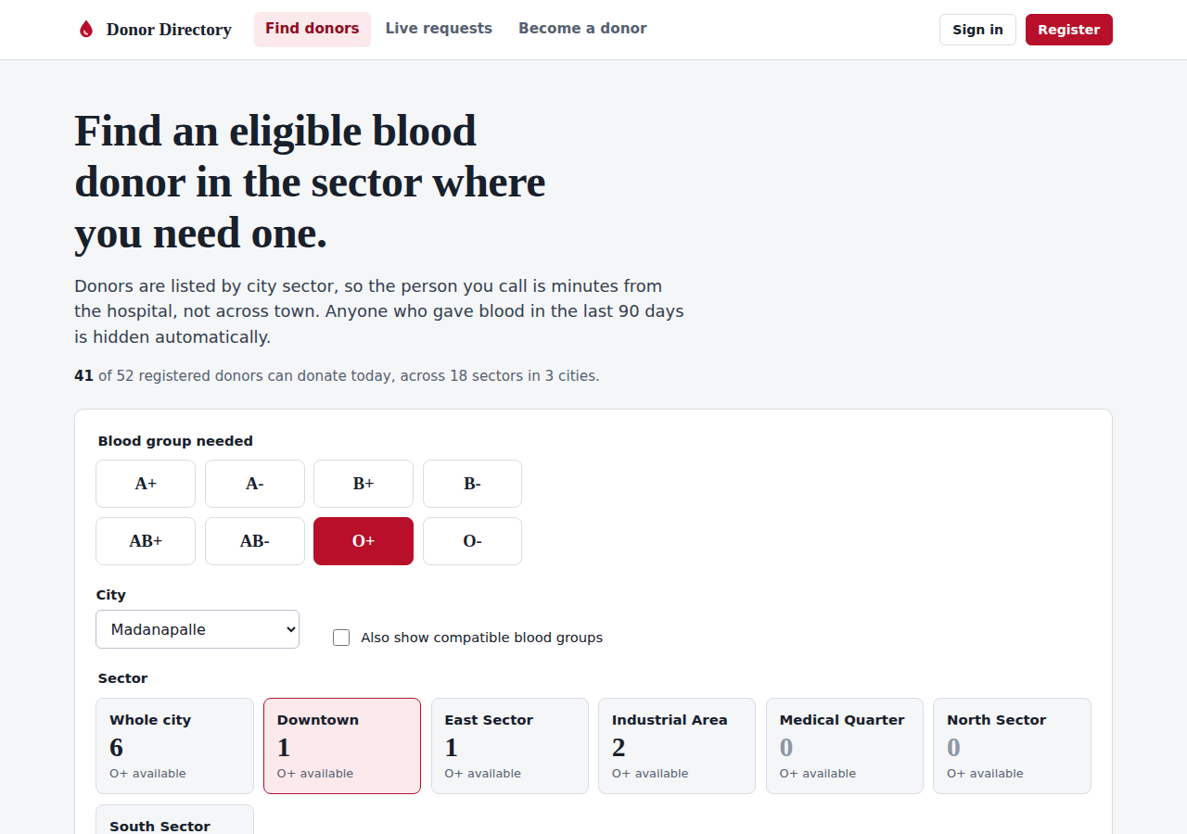
Figure 4: Home page: choose a blood group and a sector tile; each tile shows how many eligible donors are available
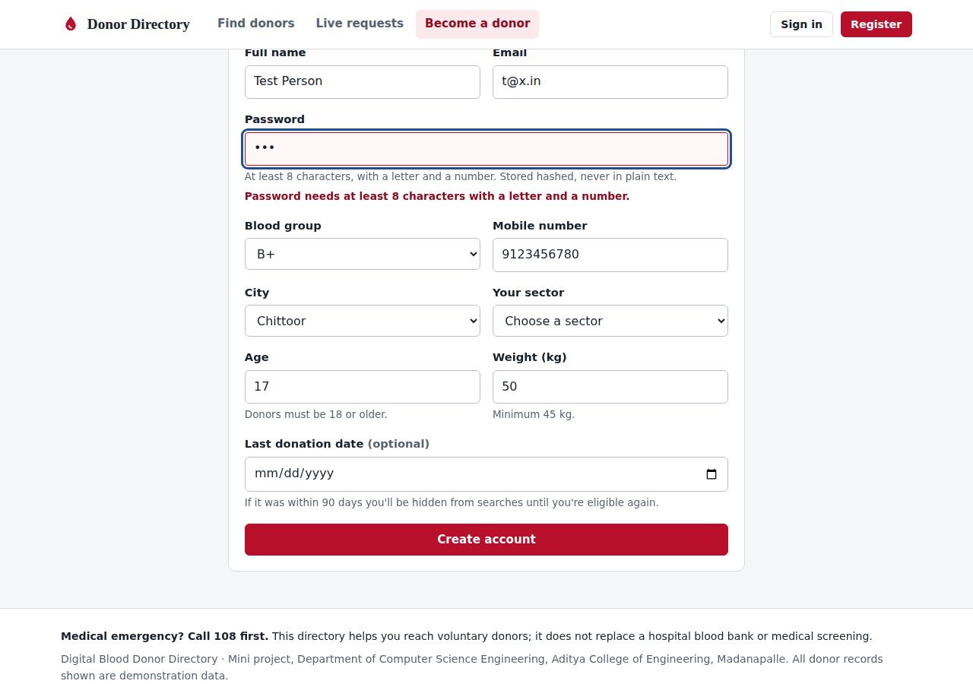
Figure 5: Registration with inline validation (weak password rejected; age and weight limits enforced)
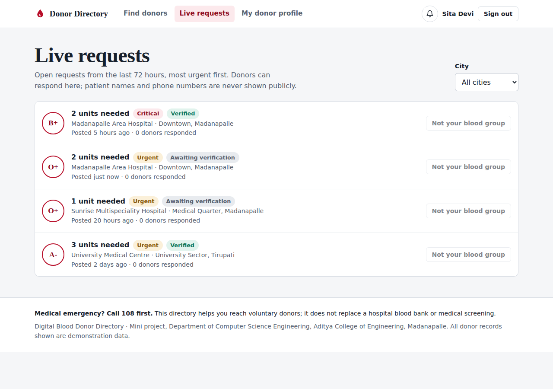
Figure 6: Live requests board: urgency, verification state and responders; patient details stay private
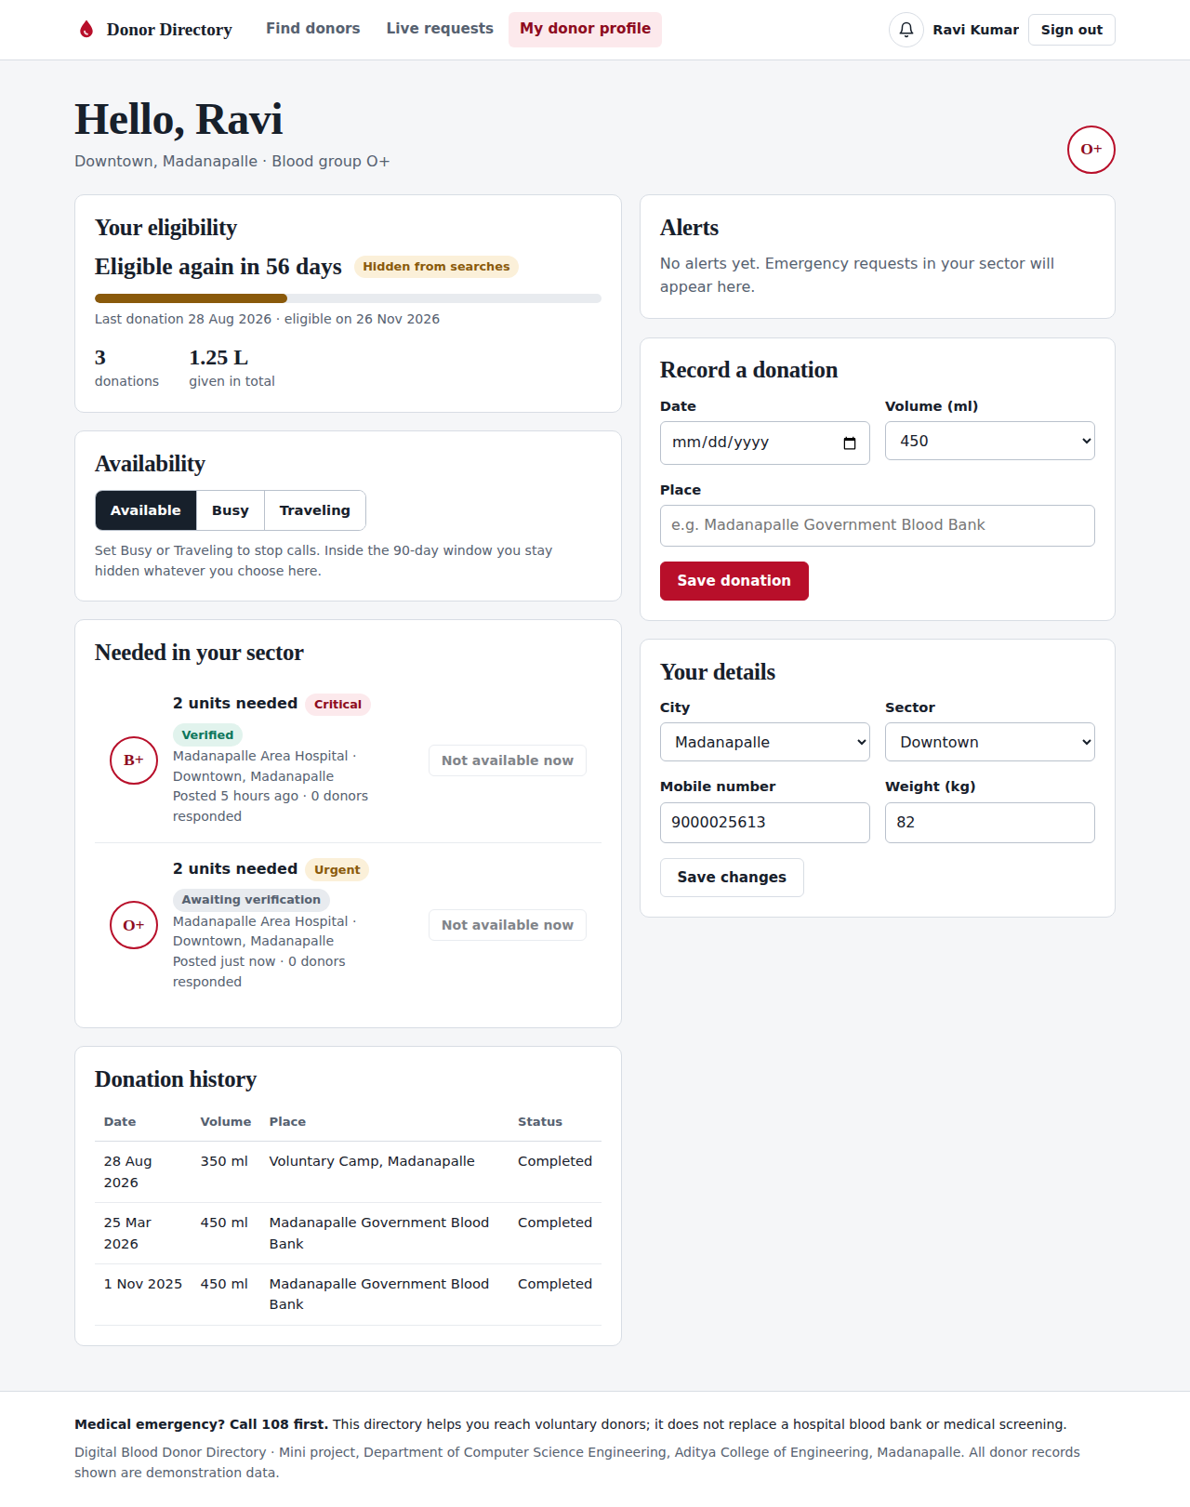
Figure 7: Donor dashboard: 90-day countdown, availability toggle, alerts, donation history
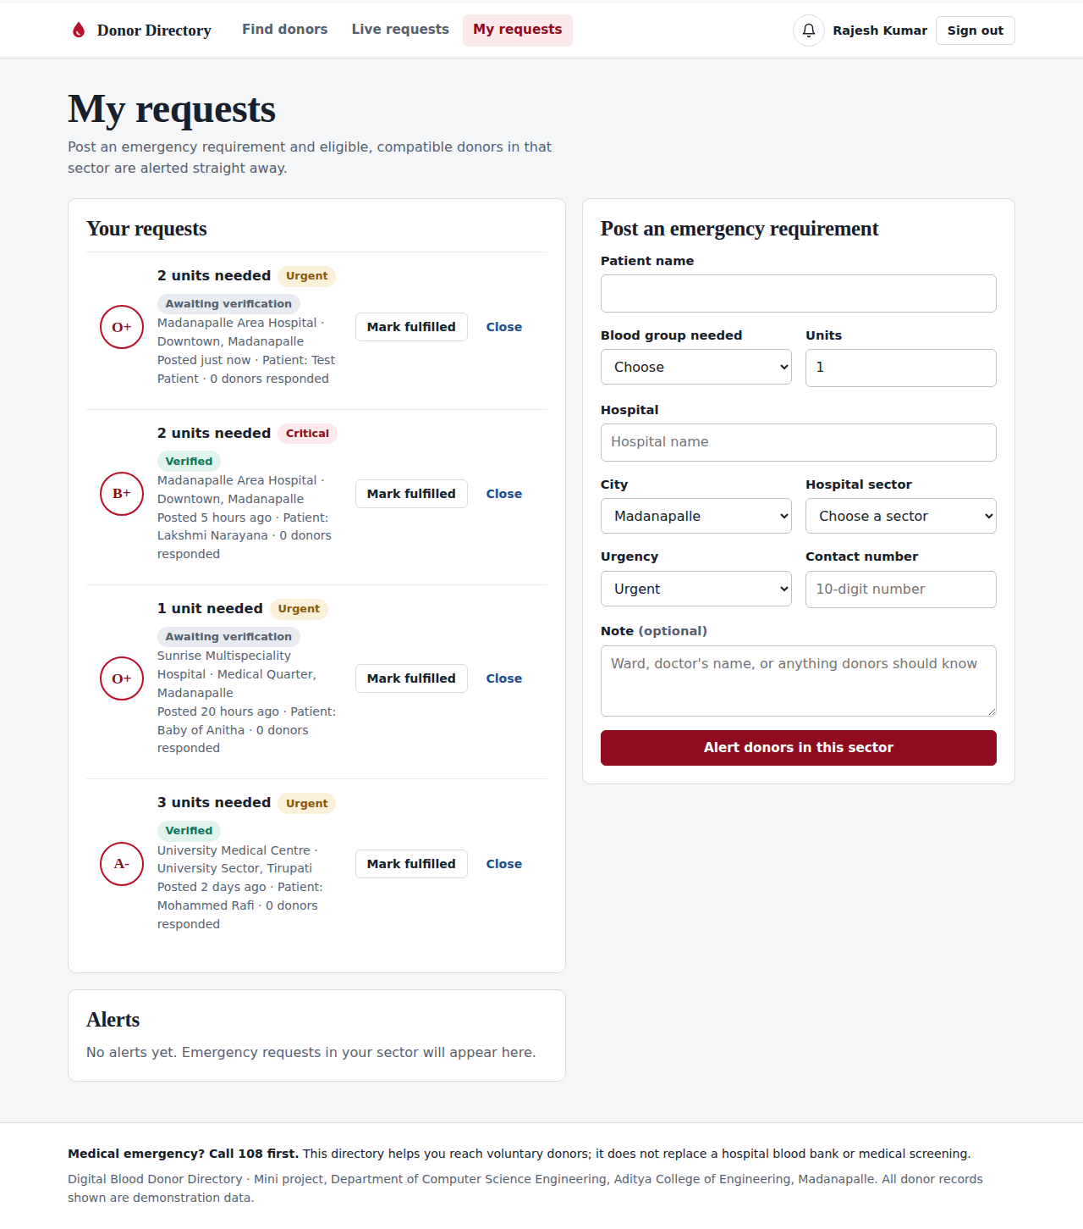
Figure 8: Recipient dashboard: post an emergency requirement and track responses
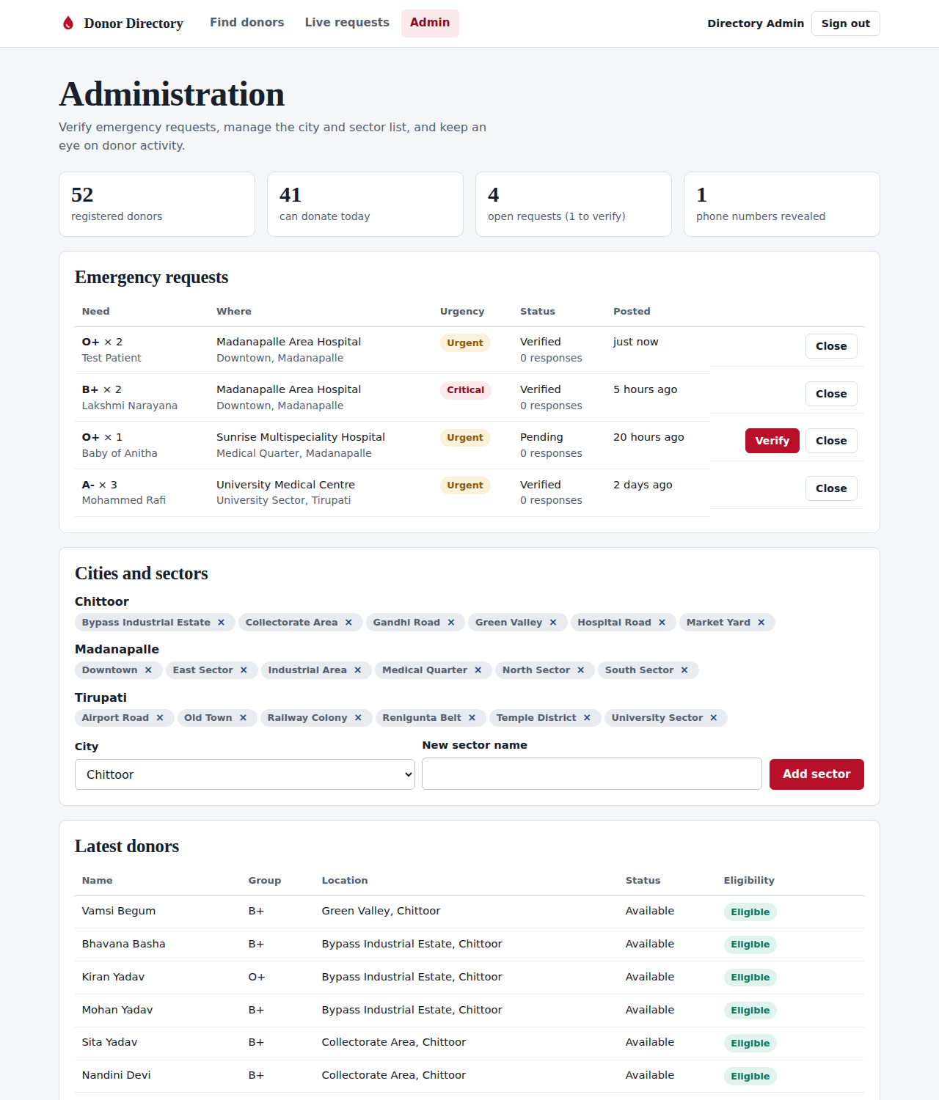
Figure 9: Administrator console: counters and request verification (top of page)
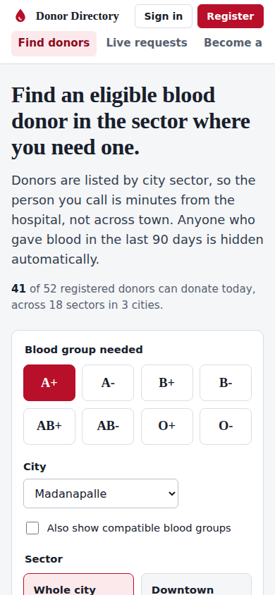
Figure 10: The same search on a 390 px phone screen

12. Testing Protocol

12.1 Strategy
Testing covers four levels: unit-level checks of the eligibility function, API tests against a live server with a throw-away database, browser walkthroughs of each role, and non-functional checks (response time, security headers, input safety). Each automated test is named after its test-case ID so results map directly to requirements.

12.2 Test environment
Python 3.12 on Linux, Chromium 141 for browser checks, fresh SQLite database seeded with 52 donors, 3 cities, 18 sectors and 3 emergency requests. Re-run at any time with python tests/test_api.py -v from the project folder.

12.3 Test cases and results
ID | Req. | Scenario | Expected result | Result
TC01 | F2 | Request the city and sector list | Downtown appears under Madanapalle only; Tirupati does not list it | Pass
TC02 | F4 | Search O+/B+ in the Downtown sector | Every donor returned belongs to Downtown, Madanapalle | Pass
TC03 | F3 | Search for a donor who gave blood 34 days ago | Donor absent from results; hidden count is at least 1 | Pass
TC04 | F3 | Donors with last donation 89 and 90 days ago | 89 days: hidden. 90 days: visible | Pass
TC05 | F3 | Donor inside the window sets status to Available | Still not visible in searches | Pass
TC06 | F3 | Eligible donor sets Busy, then Available | Hidden while Busy; visible again when Available | Pass
TC07 | NF3 | Guest runs a search | Only masked numbers in the response; no raw number field | Pass
TC08 | NF3 | Guest asks to reveal a number | HTTP 401 | Pass
TC09 | NF3 | Donor account asks to reveal a number | HTTP 403 | Pass
TC10 | NF3 | Recipient reveals a number | Full 10-digit number returned; one audit row added | Pass
TC11 | F1 | Register with age 17, weight 44, bad phone, weak password, bad email, invalid group | Each rejected with HTTP 400 naming the field | Pass
TC12 | F1 | Register, then register again with same email | Password stored as PBKDF2 hash (no plain text); duplicate gives HTTP 409 | Pass
TC13 | NF3 | Six wrong passwords in a row | First five give 401; the sixth gives 429 (locked) | Pass
TC14 | F3 | Donor records a donation dated today | Trigger sets last donation date; donor becomes hidden | Pass
TC15 | F3 | Record a donation within 90 days of an existing one | Rejected with HTTP 400 | Pass
TC16 | F5 | Post an A+ emergency request in Downtown | Alerts go to exactly the eligible, compatible donors in that sector; none to donors inside the window | Pass
TC17 | F6 | Donors respond to a B+ request | Incompatible group and ineligible donor rejected; eligible donor accepted once; requester sees the responder | Pass
TC18 | F6 | Recipient and admin try to verify a request | Recipient: 403. Admin: status becomes Verified. Admin overview needs sign-in | Pass
TC19 | Admin | Delete a sector that has donors; add and remove a new city and sector | Delete blocked (409); new sector created and removed | Pass
TC20 | F4 | Search AB+ with and without compatible groups | Wider result contains only compatible groups; O- search returns only O- | Pass
TC21 | NF1 | 25 consecutive city-wide searches | Average response under 2 s (measured about 2–3 ms) | Pass
TC22 | NF3 | Headers, non-JSON write, path traversal, injection string, cookie flags | nosniff and CSP present; 415 for form posts; traversal contained; injection rejected; HttpOnly cookie | Pass
Outcome: all 22 automated test cases passed in the latest run (22 of 22).

12.4 Browser walkthroughs
- Guest: choose blood group, city and sector; sector tile counts update; results show masked numbers; "Sign in to view" is offered.
- Registration: password, age and weight errors appear next to the field and focus moves to it.
- Recipient: reveal a number, post an emergency request, see the alert count in the confirmation message.
- Donor: view the 90-day countdown, change status, see the "too soon" error when recording a donation inside the window.
- Administrator: verify a pending request and see the status change.
- Phone width (390 px): no horizontal scrolling; header, finder and results remain usable.

12.5 Known limits of testing
Performance was measured on a 52-donor demonstration database, not on a city-scale data set. The MySQL script was written to mirror the SQLite design but was not executed against a MySQL server for this report. Alerts are in-app only; delivery over SMS or WhatsApp has not been tested because it is not implemented.

13. Ethical, Privacy and Medical Considerations
- Consent and minimal data. Only the data needed for matching is collected: name, blood group, sector, phone, age, weight and last donation date. Donors can pause visibility at any time with the Busy or Traveling status.
- Contact privacy. Phone numbers are masked for the public and for other donors. Revealing one requires a signed-in recipient account and is written to an audit log, which discourages scraping and misuse.
- Patient privacy. Public request listings show blood group, hospital and sector only. Patient names and phone numbers are visible to the requester and the administrator.
- Medical safety. The directory is not a medical service. The 90-day interval is a single configurable constant and follows the project specification. Eligibility is always confirmed by screening at the collection centre, and users are told to call 108 for emergencies.
- Verification. Administrators can mark a request as verified, so donors can tell confirmed needs from unconfirmed ones.
- Demonstration data. All donors, phone numbers and requests in the demo are fictional.

14. Project Schedule
Weeks | Phase | Output
1–2 | Problem study and literature survey | Problem statement, comparative study
3–4 | Requirements and system design | SRS, ERD, architecture
5–6 | Database and back end | Schema, trigger, API, business rules
7–8 | Front end | Search, registration, dashboards
9 | Integration | End-to-end working prototype
10 | Testing and fixes | Test report (Section 12)
11 | Documentation | Report and protocol
12 | Review and demonstration | Final presentation

15. Risks and Mitigation
Risk | Mitigation
Donors with outdated or false information | Server-side eligibility; donor-controlled status; administrator can review the donor list.
Misuse of phone numbers | Masking, recipient-only reveal, audit log, sign-in lockout.
Too few donors in a sector | Whole-city search, compatible-group search, and emergency broadcast with a public live board.
Wrong medical assumptions | Interval is a single constant; clear disclaimer that screening decides; call 108 notice.
Single-server failure | Stateless API over a relational database; the same design deploys on a managed host with MySQL and backups.
Scope creep | GPS, forecasting and messaging gateways are listed as future work, not part of this version.

16. Expected Outcomes and Future Enhancements
The project is expected to demonstrate that sector-level search combined with automatic eligibility reduces the number of calls needed to reach a usable donor and shortens the time between request and contact. The working prototype, schema and tests provide a base for a real deployment.
- GPS live tracking and map-based distance ranking within a sector.
- AI-based demand forecasting from historical request patterns to prompt donor drives in under-served sectors.
- SMS and WhatsApp alerts through a messaging gateway, with donor opt-in.
- Two-factor sign-in and one-time-password verification of phone numbers.
- Integration with blood-bank inventory systems so one search covers both stock and voluntary donors.

17. References
- Ministry of Health and Family Welfare, Government of India. "e-RaktKosh: A Centralized Blood Bank Management System." National Health Informatics Portal, 2017.
- R. Karthikeyan and P. Suresh. "Mobile Application for Blood Donor Information Management System." International Journal of Computer Applications (IJCA), 2018.
- A. Ahmed and S. Khan. "Social Media as a Tool for Blood Donation Campaigns." IEEE International Conference on Social Computing, 2019.
- M. Patel and R. Verma. "Design of an Online Blood Donor Directory System." International Journal of Engineering Research and Technology (IJERT), 2020.

Appendix A: Running the Application
- Install Python 3.8 or newer from python.org (tick "Add Python to PATH" on Windows).
- Open the project folder BloodDonorDirectory.
- Windows: double-click run.bat. macOS/Linux: run ./run.sh. Alternatively: cd app, then python server.py.
- Open http://localhost:8000 in a browser. The first start creates the database with demonstration data.
- To run the tests: python tests/test_api.py -v from the project folder.
Demonstration accounts
Role | Email | Password | Notes
Recipient | recipient@demo.in | Demo@123 | Reveal numbers, post requests
Donor (in window) | donor1@demo.in | Donor@123 | Donated 34 days ago
Donor (eligible) | donor2@demo.in | Donor@123 | Can respond to requests
Administrator | admin@blooddonor.local | Admin@123 | Verify requests, edit sectors

Appendix B: Folder Structure
BloodDonorDirectory/
README.md run.bat run.sh
app/
server.py web server and API
database.py schema, rules, seed data
static/ index.html, css/, js/, img/
data/ database file (created on first run)
database/
schema_mysql.sql MySQL 8 schema, trigger, view
sample_queries.sql DDL / DML / DCL / DQL examples
protocol/
Project_Protocol.docx
tests/
test_api.py 22 automated tests
docs/screenshots/ figures used in this protocol

