**Personal Accounting Application**

**Install the Personal Accounting Application:-**



* It is the Personal Accounting Application Installation File.
* By Double Clicking on it the File will Be start Installing.
* **Note:-** For the System where the external apps or not accepted. We should allow the application to Install.(Due to the security issues it ask the user permissions.)

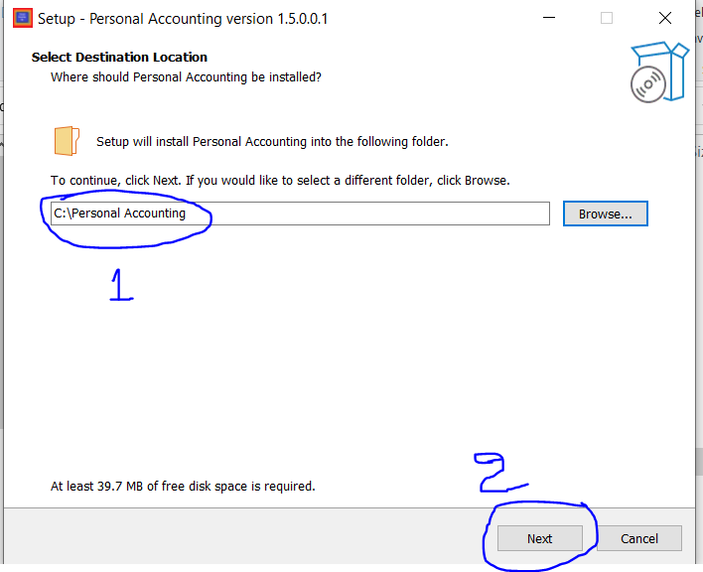

* After allowing the application the above window will be opened, Here we should select where the application should store,(**Here we should give the location where the user has access to read and write in that folder) (Preferred:-** For Best Result, application should install in “**C:\Personal Accounting**”.)
* Then Click “**Next”.**
* 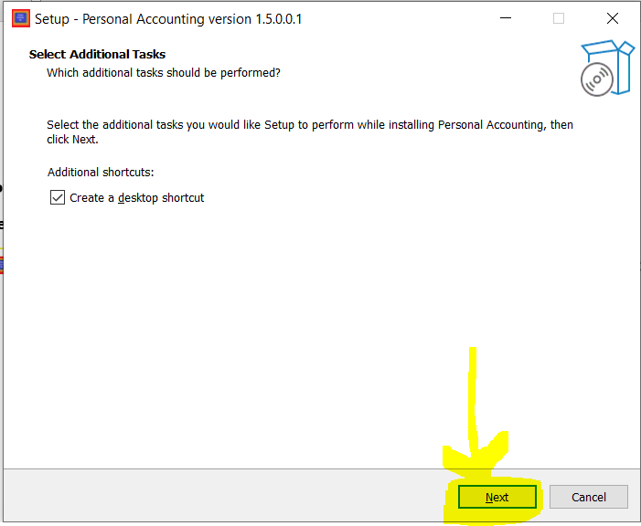
* Here, we can give access to Create a desktop shortcut by clicking check box(optional),after that we should click “**Next**”.

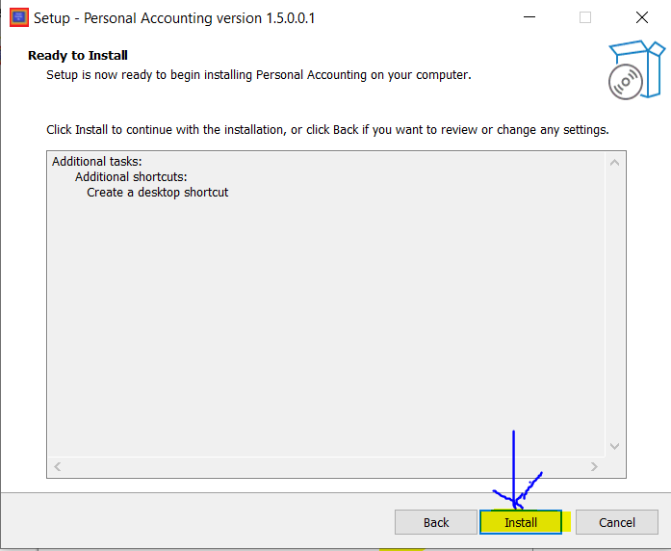

* Here we should Click “**Install**”.

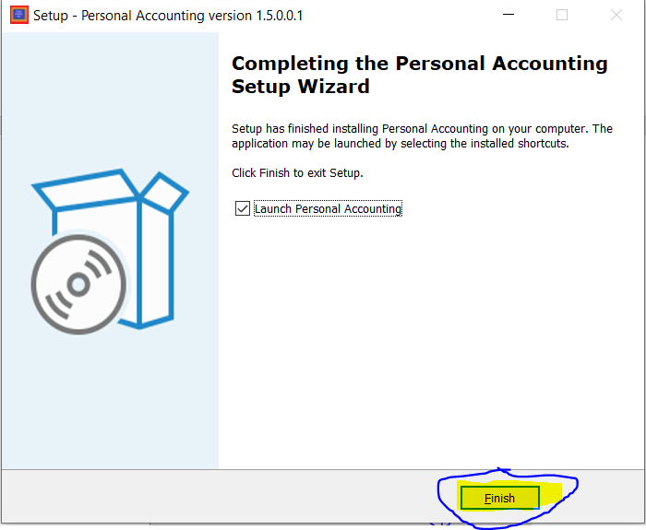

* In This window we should Click “Finish”.
* Finally the Installation of the **Personal Accounting Application** was done.

**Instructions to Use Personal Accounting Application:-**



* Select this app from Desktop of Start Menu. And Double Click on the App to Open.

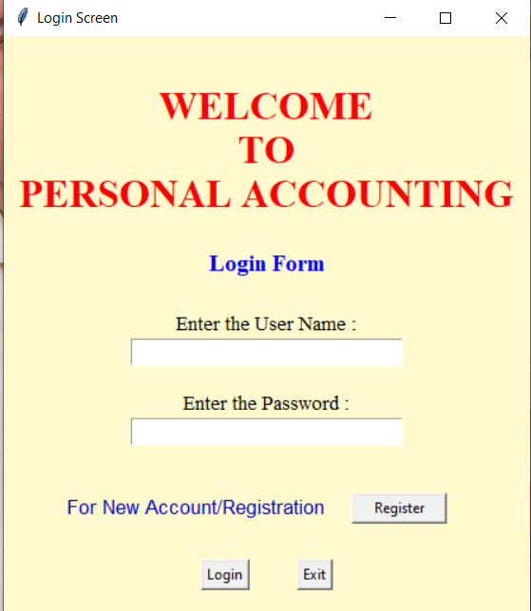

* After opening the application this screen will be appear.
* If you are an New user Click Register, or else give your respective User Name and Password to Login.
* **Registration Process:-**
  + For Registration Click Register.

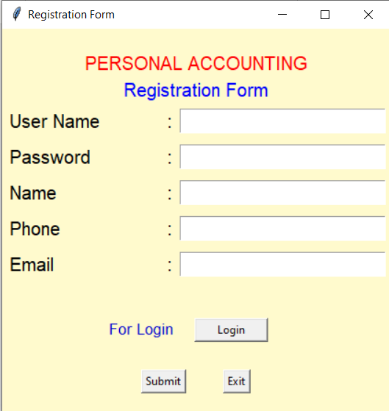

* + **Note:-**To go to Login Page Click “**Login**” Button.
  + Fill the Required Field’s (i.e. Username, Password, Name, Phone, Email) and then Press Submit.(**In Username, Space should be Avoid)**

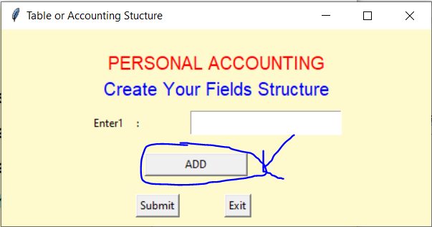

* + After Clicking Submit Table or Accounting Structure Window will open here Enter Field give Respective Bank Name, to increase the Entry Fields Click “ADD”. We can add any Number of Banks which we had.
  + Here, The Enter1 should be like(Recommended)
    - For State Bank of India – SBI
    - For Union Bank of India -- UBI
    - For Axis Bank -- AXIS

Etc..

* + **Note:-** We should not Enter Fields Like **Date and Total,** By default they were already created in the application.
  + After Entering the Fields should Submit by clicking “Submit” Button.