**A**

**Project Report**

**On**

**PERSONAL ACCOUNTING APPLICATION**

## Submitted By

M. Ram Sai Santhosh Kumar (1010-19-862-004)

**DEPARTMENT OF**

**COMPUTER SCIENCE**

**NATIONAL SMALL INDUSTRIES CORPORATION**



(A Govt. of India Enterprise Under Ministry of MSME)

TECHNICAL SERVICES CENTRE

Kamalanagar, Kushaiguda, ECIL P.O, HYDERABAD-500062 Ph: 040-27121422, 27126646, E Mail: ntschy@nsic.co.in

# CERTIFICATE

This is to certify that **Mr. MALLE RAM SAI SANTHOSH KUMAR, S/O.MALLEM BALAJI,** MCA Student of **UNIVERSITY POST GRADUATE COLLEGE O.U., SECUNDERABAD** with **PIN No. ________________**, He has undergone the Industrial Training during the period of August 2021 to January 2022, under the guidance and supervision of Faculty from National Small Industries Corporation, Technical Services Centre, Hyderabad.

He has successfully completed the assigned tasks well within the time frame.

He is sincere, hardworking and the conduct during the above period is commendable.

This has been issued upon the request of the trainee.

Dy.Manager



**UNIVERSITY POST GRADUATE COLLEGE OU, SECUNDERABAD**

**Sardar Patel Road,**

**Secunderabad - 500026, TELANGANA.**

**[2021-2022]**

**DEPARTMENT**

**OF**

**COMPUTER SCIENCE AND ENGINEERING**

**CERTIFICATE**

Certified that Project work entitled “**PERSONAL ACCOUNTING APPLICATION”** is a bonafide work carried out in the **VI** semester by “**MALLEM. RAM SAI SANTHOSH KUMAR(1010-19-862-004)”** in partial fulfillment for the award of MCA from OSMANIA UNIVERSITY.

### Guide Head of Department

**-------- ------**

**External Examiner Principal**

**Prof. B. Sudhakar Reddy**

**ACKNOWLEDGEMENT**

The completion of this Project work gives me an opportunity to convey my gratitude to all those who helped me to complete the project successfully.

First, I gratefully acknowledge my deep sense of gratitude to Almighty for spiritual Guidance blessings shown to complete the project. I thank my parents for unconditional support to improve myself throughout my life.

I owe my respectable thanks to **Shri. Prof B. Sudhakar Reddy, Principal of UPGC(OU) and Shri. -------------------Head of the Department CS, all the faculties of UPGC(OU)** for encouraging and providing necessary advises in enriching my knowledge, which were extremely valuable for my study both theoretically and practically.

I express my deepest gratitude and special thanks to **Shri. A. B. Prabhu Raj, General Manager(SG) and center head, NSIC-TSC, Hyderabad, and Shri. S. Kaushik, Dy. Manager, NSIC-TSC, Hyderabad and faculty member Shri. D. Sreeranjan Kumar- NSIC** for their encouragement and allowing me to carry out the project work at their esteemed institution (NSIC) during the Industrial Training.

My sincere thanks toall the faculty members of Department of Computer Science and administrative staff of UPGC(OU), who have rendered valuable help in making this project successful.

# INDEX

|  |  |
| --- | --- |
| **TOPIC** | **PAGENO.** |
| **ABSTRACT** | **8** |
| **1.INTRODUCTION** |  |
| *1.1 BACKGROUND* | **9** |
| *1.2 PROBLEM STATEMENT* | **10** |
| *1.3 PURPOSE OF PROJECT* | **10** |
| **2. EXISTING METHODOLOGIES** | **11** |
| **3.PROJECT ANALYSIS** |  |
| *4.1 PROJECT GOAL AND OBJECTIVES* | **13** |
| *4.2 PROJECT DESCRIPTION* | **13** |
| *4.3 PROJECT SCOPE* | **14** |
| **4.SYSTEM REQUIREMENTS** |  |
| *5.1 HARDWARE REQUIREMENTS* | **14** |
| *5.2 SOFTWARE REQUIREMENTS* | **14** |
| **5.SURVEY OF TECHNOLOGIES** |  |
|  |  |
|  |  |
| **6.WHY TO USE PAA(Personal Accounting Application)?** | **18** |
| **7.SCREENSHOTS** |  |
|  |  |
|  |  |
|  |  |
|  |  |
|  |  |
|  |  |
|  |  |
|  |  |
|  |  |
|  |  |
|  |  |
|  |  |
|  |  |
|  |  |
|  |  |
|  |  |
| **8.SYSTEM DESIGN** | **30** |
| **10.PROJECT SETUP** |  |
| **11.ADVANTAGES** | **32** |
| **12.FUTURE PROSPECTIVE** | **33** |
| **13.ACHIEVEMENTS** | **33** |
| **14.CONCLUSION** | **34** |
| **15.REFERENCE** | **34** |

**ABSTRACT**

This practical demonstration will help you to understand how to implement J.A.R.V.I.S (**Just A Rather** **Very Intelligent System** )

AI (**Artificial Intelligence**) VOICE ASSISTANT project in python with pycharm IDLE.

The project aims to develop a personal-assistant for Window-based systems. Jarvis draws its inspiration from virtual assistants like Cortana for Windows, and Siri for iOS. It has been designed to provide a user-friendly interface for carrying out a variety of tasks by employing certain well-defined commands. Users can interact with the assistant either through voice commands or using keyboard input. As a personal assistant, Jarvis assists the end-user with day-to-day activities like general human conversation, searching queries in google, searching for videos, retrieving images, tells jokes, temperature, make a note, about corona cases , can open facebook, instagram, calculator, command prompt, date and time. The user statements/commands are analysed with the help of machine learning to give an optimal solution.

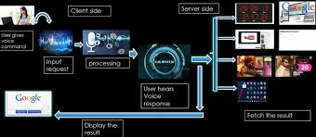

## INTRODUCTION

***1.1 Background***

A voice assistant or intelligent personal assistant is a software agent that can perform tasks or services for an individual based on verbal commands i.e. by interpreting human speech and respond via synthesized voices.

Users can ask their assistants’ questions, control home automation devices, and media playback via voice, and manage other basic tasks such as email, to-do lists, open or close any application etc with verbal commands.

Who doesn't want to have the luxury to own an assistant who always listens for your call, anticipates your every need, and takes action when necessary? That luxury is now available thanks to artificial intelligence-based voice assistants.

Voice assistants come in somewhat small packages and can perform a variety of actions after hearing your command. They can answer questions, play music, place online orders and do all kinds of AI-based stuff.

Voice assistants are not to be confused with virtual assistants, which are people who work remotely and can, therefore, handle all kinds of tasks. Rather, voice assistants are technology based. As voice assistants become more robust, their utility in both the personal and business realms will grow as well.

#### 

#### 1.2 Problem Statement

We are all well aware about Google Assistant and many other virtual assistants which are designed to aid the tasks of users .Voice Assistant is interactive mode and user-friendly.

#### 1.3 Purpose of project

A voice assistant is a digital assistant that uses voice recognition, natural language processing and speech synthesis to provide aid to users through desktop and voice recognition. Voice assistants are built on artificial intelligence (AI), machine learning and voice recognition technology. As the end user interacts with the digital assistant, the AI programming uses sophisticated algorithms to learn from data input and better itself at predicting the user's needs. Some assistants are built with more advanced cognitive computing technologies which will allow a digital assistant to understand and carry out multi-step requests with numerous interactions and perform more tasks Digital assistants can be contrasted with another application of consumer-facing AI called smart advisors. Smart advisor programs are knowledge-oriented, while digital assistants are taskoriented, although some perform both roles. Popular voice assistants currently include Apple's Siri, Amazon's Alexa, Google Now, Google Assistant and Microsoft's Cortana.

This Software aims at developing a personal assistant for Windows-based systems. The main purpose of the software is to perform the tasks of the user at certain commands, provided in either of the ways, speech or text. It will ease most of the work of the user as a complete task can be done on a single command. Jarvis draws its inspiration from Virtual assistants .Users can interact with the assistant either through voice commands or keyboard input. Artificial intelligence (AI) is the ability of a computer program or a machine to think and learn. They work on their own without being encoded with commands. These software components cover machine learning, image recognition, natural language processing, data mininig and more.

**2. EXISITING METHODOLOGIES**

* + - Send Gmail messages
    - Dynamic News reporting at any time
    - Open any website with just a voice command
    - Plays music
    - Tells time
    - Wikipedia powered AI
    - Dictionary with intelligent Sensing i.e auto checking if spell mistake
    - Weather report such as temp,wind
    - Speed,Humidity,Weather description
* Latitude and longitude

**3. FLOWCHART FOR VOICE FLOW ALGORITHM:**

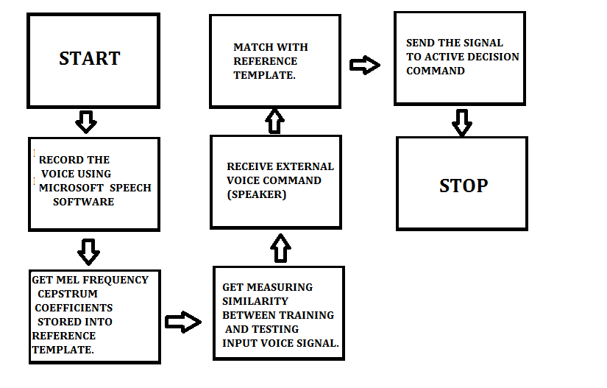

Voice recognition works based on the premise that a person voice exhibits characteristics are unique to different speaker. The signal during training and testing session can be greatly different due to many factors such as people voice change with time, health condition (e.g. the speaker has a cold), speaking rate and also acoustical noise and variation recording environment via microphone.

**4. PROJECT ANALYSIS**

#### 4.1 Project goal and objectives

Currently, the project aims to provide the Windows Users with a Virtual Assistant that would not only aid in their daily routine tasks like searching the web, extracting temperature data, vocabulary help and many others but also help in automation of various activities. In the long run, we aim to develop a complete Jarvis Voice assistant,.

* JARVIS is a personal desktop assistant that keeps users informed and productive, helping them get things done across devices and platforms.
* Skills define the tasks that Jarvis can accomplish.

You can extend Jarvis by adding your own skills that let your users interact with your service via Jarvis.

* Jarvis invokes the skills based on input from the user, spoken.
* Because Jarvis can be used in laptop or pc , some may have a screen, while others may have a speaker, and some may have both.
* You should ensure that your bot is capable of handling any of these devices. The bot framework provides device information to your skill.

#### 4.2 Project description

#### As a personal assistant, Jarvis assists the end-user with day-to-day activities like general human conversation, searching queries in various search engines like Google, Bing or Yahoo, searching for videos in youtube, retrieving images, live temperature conditions, word meanings, open face book and instagram,makes a note,tells a joke, tells corona cases. The user statements/commands are analysed with the help of machine learning to give an optimal solution

#### 

#### 4.3 Project scope

Presently, Jarvis is being developed as an automation tool and virtual assistant. Among the Various roles played by Jarvis are:

1. Open Google, YouTube with voice interactions.

2. Makes a note.

3. Tells a joke.

4. Can do calculations using calculator.

5. Extracting temperature Application.

6. Can open command prompt.

7. Tells corona cases in India and individual states.

8. Can open instagram and facebook.

9. Opens wikipedia.

10. Tells date and time.and interactive response like how are you? , who are you? , what is your name?

## 5.SYSTEM REQUIREMENTS

#### 5.1 Hardware Requirements

* + - PROCESSOR - INTEL i3 AND ABOVE
    - RAM
    - HARD DISK - 500 GB OR MORE
    - SPEED - 1.1 GHz

#### 5.2 Software Requirements

* + - OPERATING SYSTEM – WINDOWS 10,11
    - SOFTWARE – PYTHON
    - EDITOR / IDLE – PYCHARM
    - BACKEND STACK – MACHINE LEARNING

## 6.SURVEY OF TECHNOLOGIES

***6.1 Introduction to Python:***

**What is Python?**

Python is an interpreted high level general purpose programming language. It was created by Guido van Rossum, and released in 1991.

It is used for:

* web development (server-side),
* software development,
* mathematics,
* Systemscripting.

**What can Python do?**

* Python can be used on a server to create web applications.
* Python can be used alongside software to create workflows.
* Python can connect to database systems. It can also read and modify files.
* Python can be used to handle big data and perform complex mathematics.
* Python can be used for rapid prototyping, or for production-ready software development.
* Its design philosophy emphasizes [code readability](https://en.wikipedia.org/wiki/Code_readability) with its use of [significant indentation](https://en.wikipedia.org/wiki/Off-side_rule). Its [language constructs](https://en.wikipedia.org/wiki/Language_construct) as well as its [object-oriented](https://en.wikipedia.org/wiki/Object-oriented_programming) approach aim to help [programmers](https://en.wikipedia.org/wiki/Programmers) write clear, logical code for small and large-scale projects.
* It supports multiple programming paradigms,including structured (particularly,procedural),object-oriented and functional programming.
* It is often described as a "batteries included" language due to its comprehensive [standard library](https://en.wikipedia.org/wiki/Standard_library).

**Why Python?**

* Python works on different platforms (Windows, Mac, Linux, Raspberry Pi, etc).
* Python has a simple syntax similar to the English language.
* Python has syntax that allows developers to write programs with fewer lines than some other programming languages.
* Python runs on an interpreter system, meaning that code can be executed as soon as it is written. This means that prototyping can be very quick.
* Python can be treated in a procedural way, an object-orientated way or a functional way.

**Good to know !**

•The most recent major version of Python is Python 3, which we shall be using in this tutorial. However, Python 2, although not being updated with anything other than security updates, is still quite popular.  
  
 •In this tutorial Python will be written in a text editor. It is possible to write Python in an Integrated Development Environment, such as Thonny, Pycharm, Netbeans or Eclipse which are particularly useful when managing larger collections of Python files.

**Python Syntax compared to other programming languages :**

* Python was designed for readability, and has some similarities to the English language with influence from mathematics.
* Python uses new lines to complete a command, as opposed to other programming languages which often use semicolons or parentheses.
* Python relies on indentation, using whitespace, to define scope; such as the scope of loops, functions and classes. Other programming languages often use curly-brackets for this purpose.

***6.2 Introduction to Pycharm***

Pycharm is the most popular IDE used for Python scripting language. Pycharm mostly focusses on creating Integrated Development Environment for various web development languages like javaScript and PHP.

**Advantages:**

* + 1. Ability to view the entire source code with a single click.

2. Facilitates fast code development and easy-to-use.

**7.Why to use Jarvis?**

1. **Just A Rather** **Very Intelligent System** (J.A.R.V.I.S.)

2. Able to interact with human beings just as a living person

3. It accepts inputs even through voice or keyboard.

4. It automates tedious tasks like deployment, unit testing through a single command.

5. It gives live weather updates.

6. Anwersing complex questions.

7. Energy saving efficiency

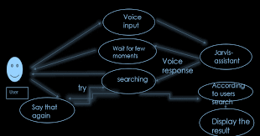

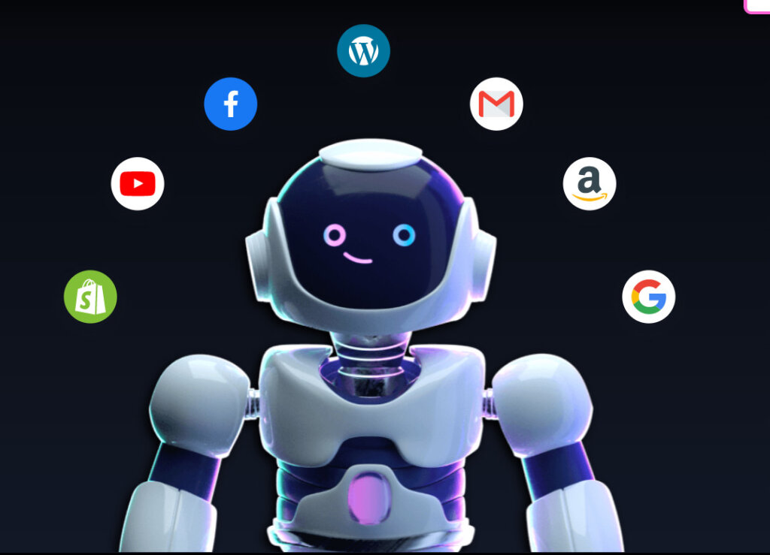

**8.SCREENSHOTS**

***8.1What is the time?***

Jarvis voice assistant recognizes the voice input (what is the time)and displays the present time.

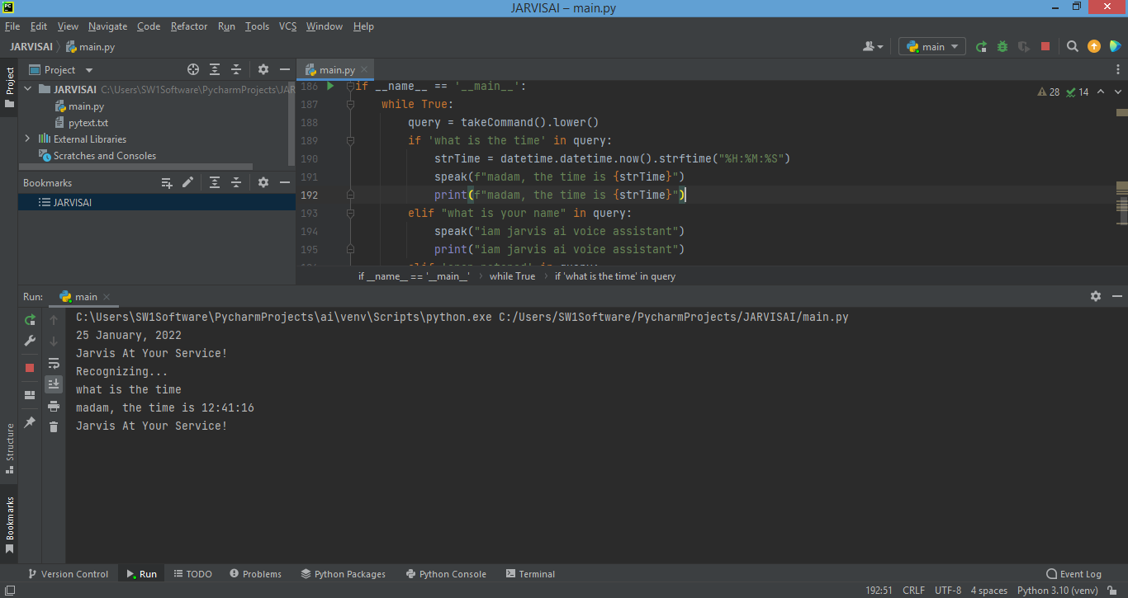

***8.2 What is your name?***

It displays its name as JARVIS AL voice assistant.

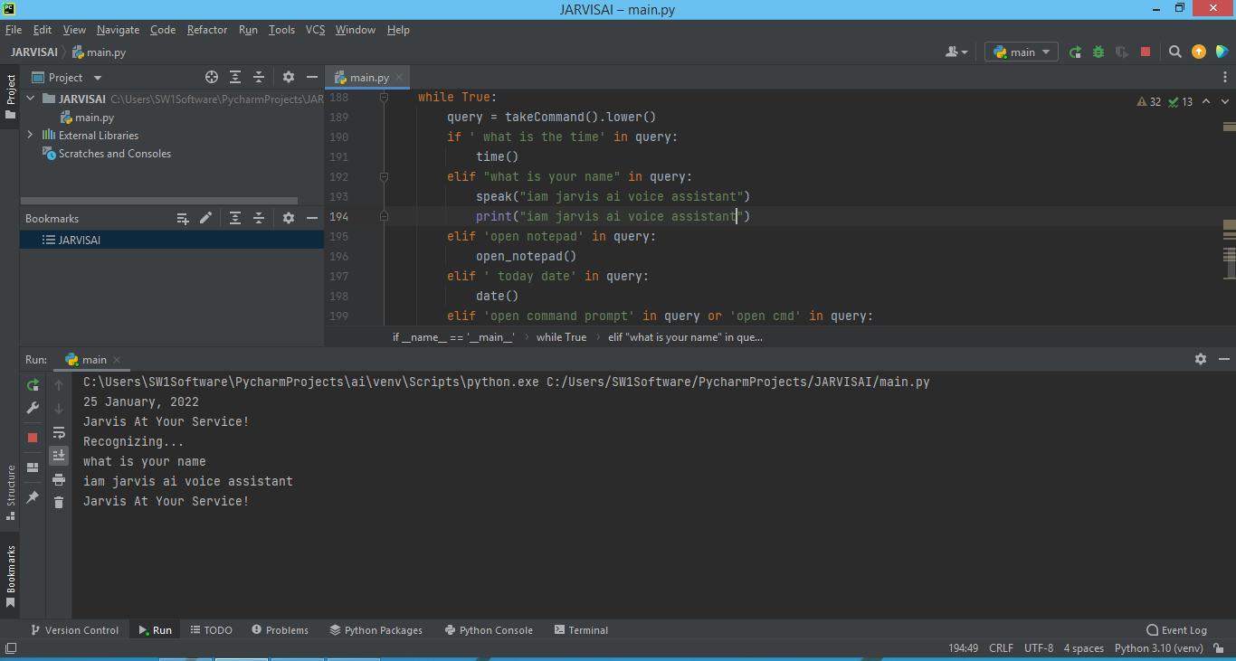

***8.3 Open notepad***

It opens the note which is displayed on the screen.

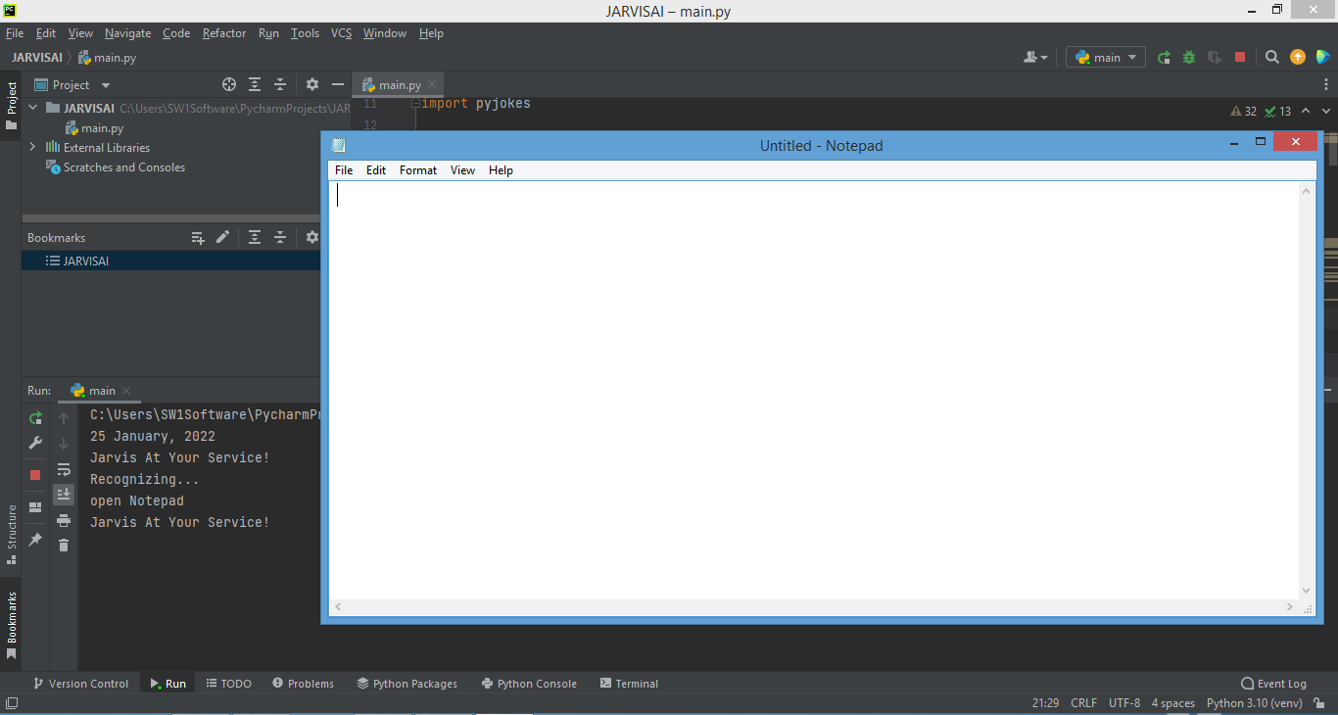

***8.4 Open Command prompt***

It recognize voice input (open command prompt).

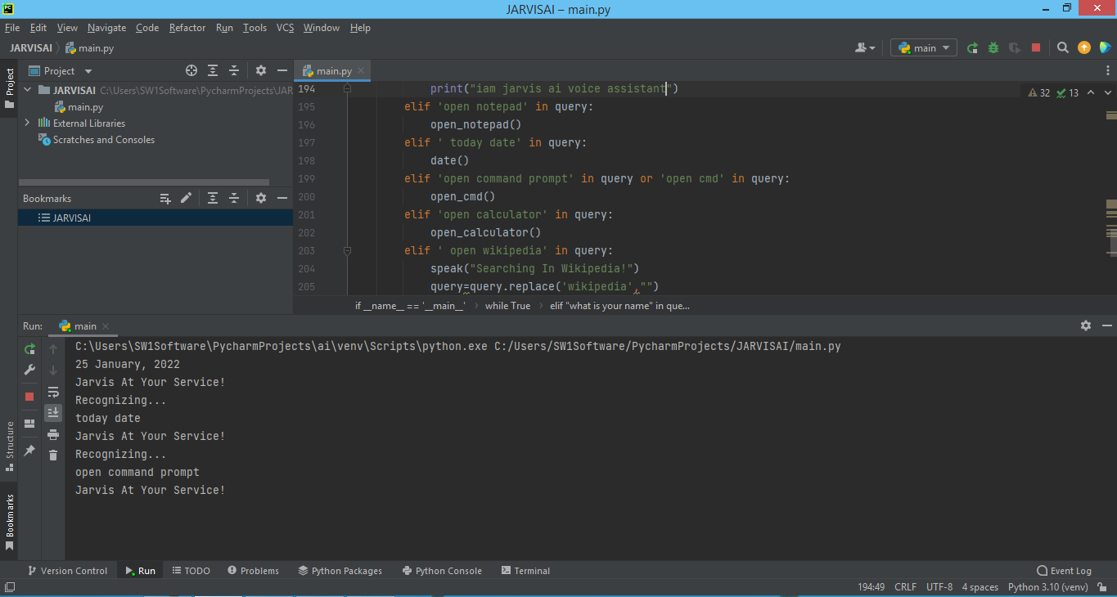

It displays the command prompt on the screen.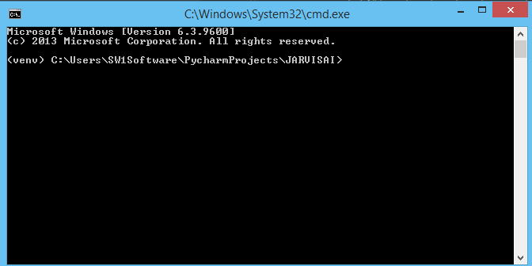

***8.5 Wikipedia***

If we give the voice input as Abdul Kalam Wikipedia then it returns the output as below.

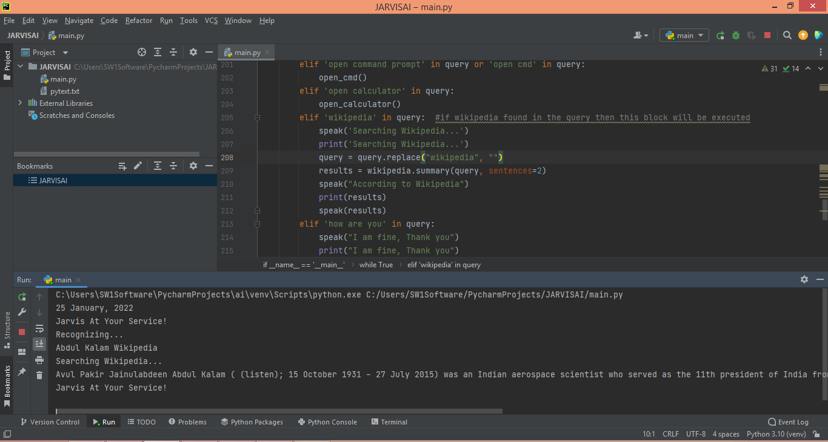

***8.6 Interactive Mode(Who are you?,How are you?)***

It interactively respond to our command.

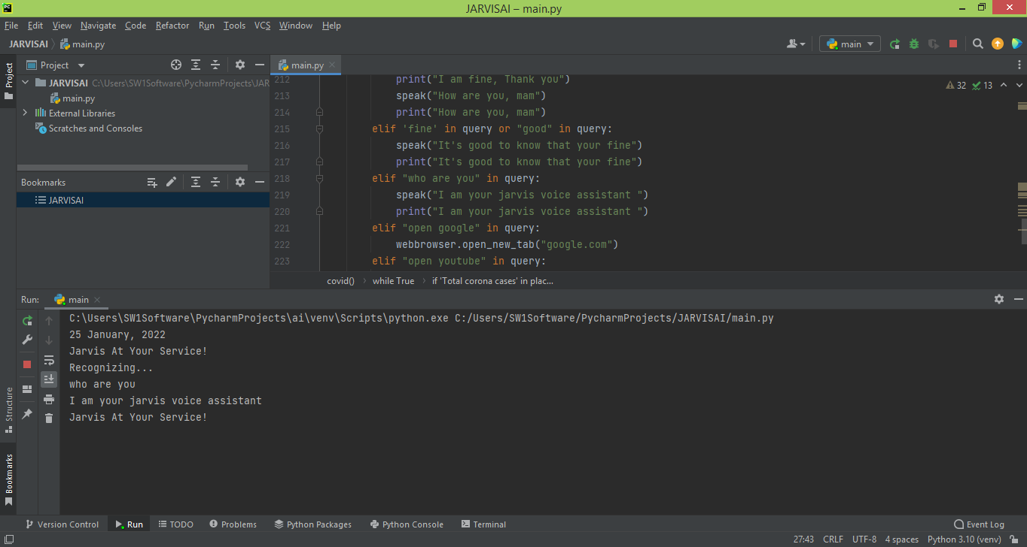

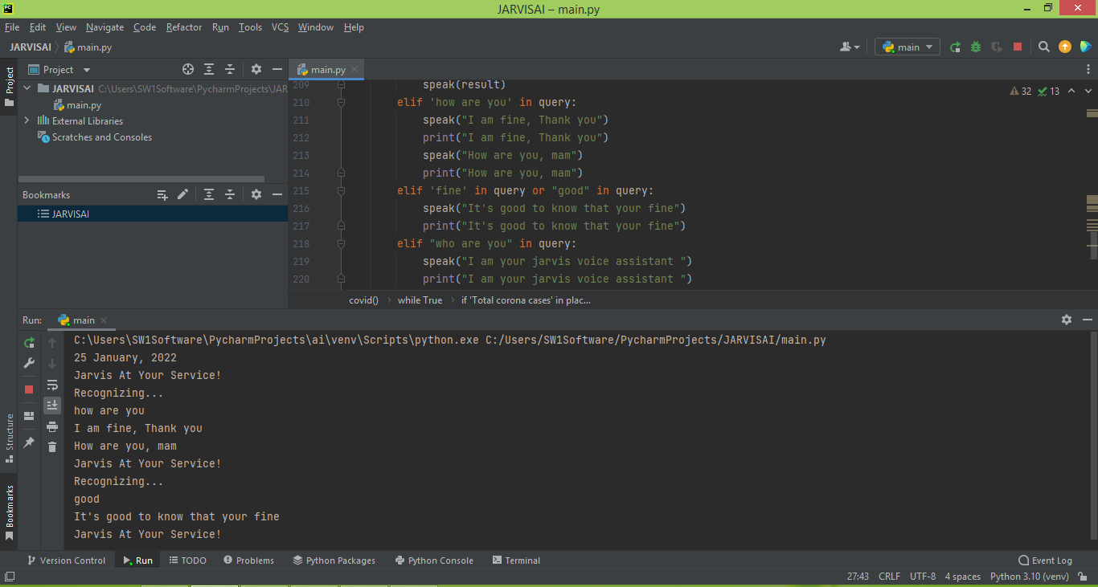

***8.7 Open Google***

It opens the Google.

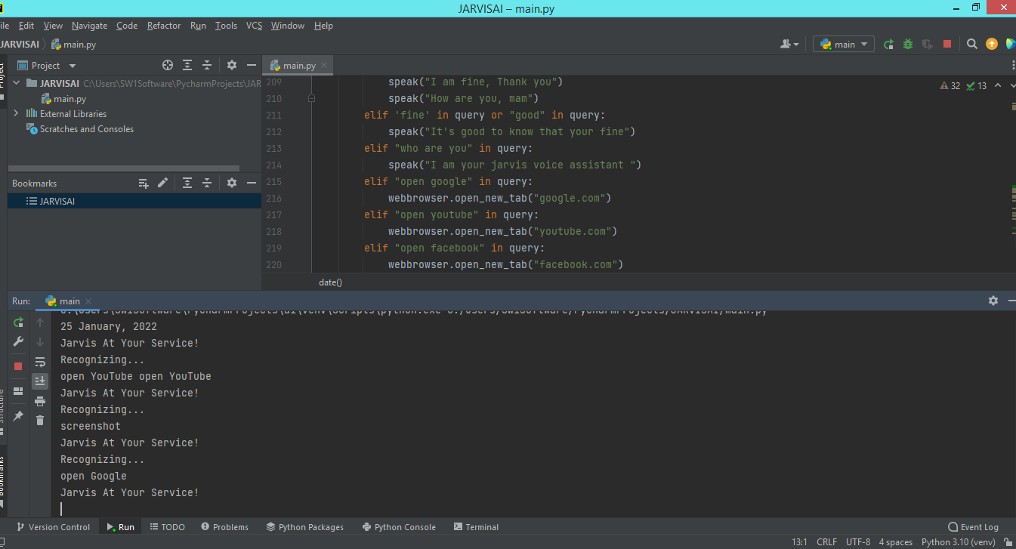

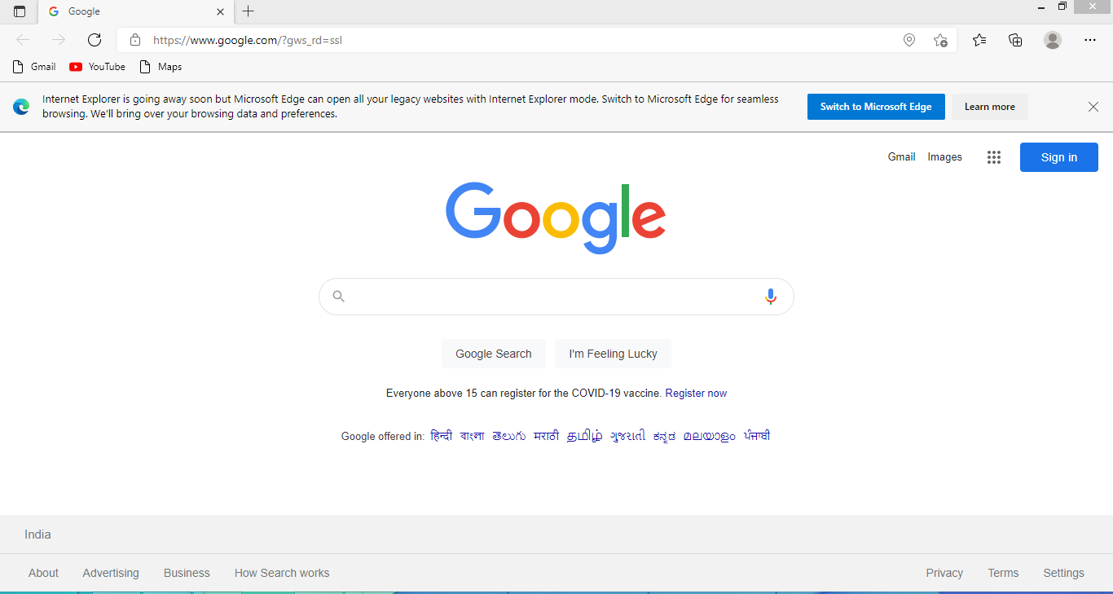***8.8 Open YouTube***

Using voice command it redirects to YouTube..

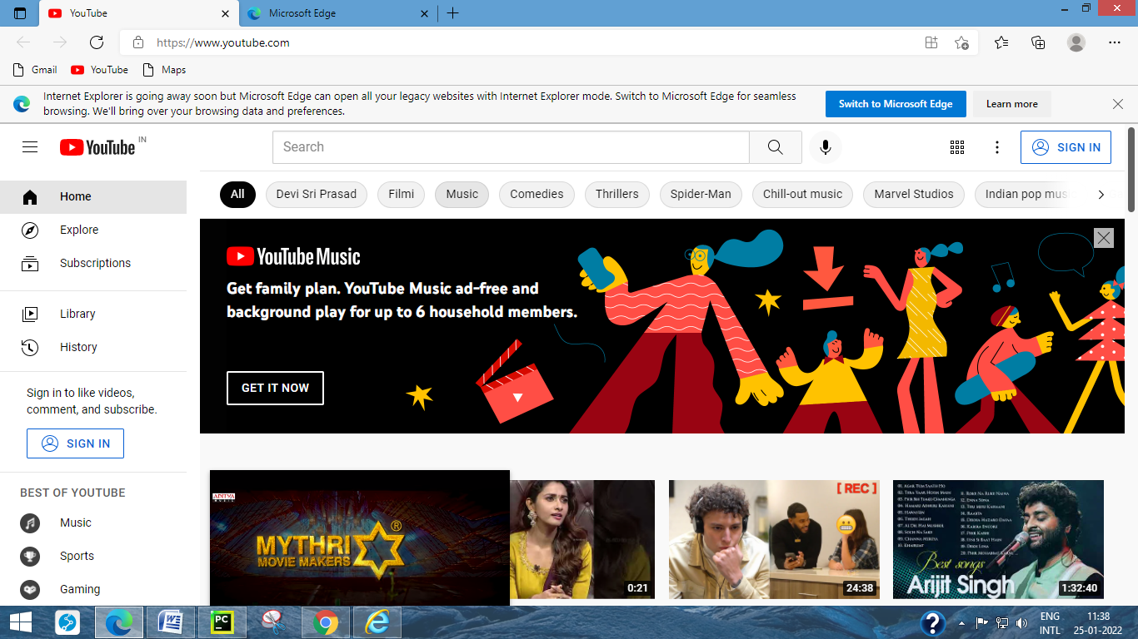

***8.9 Open face book***

When we give the command as open face book it directly opens the default facebook.com login page as displayed in the following figure.

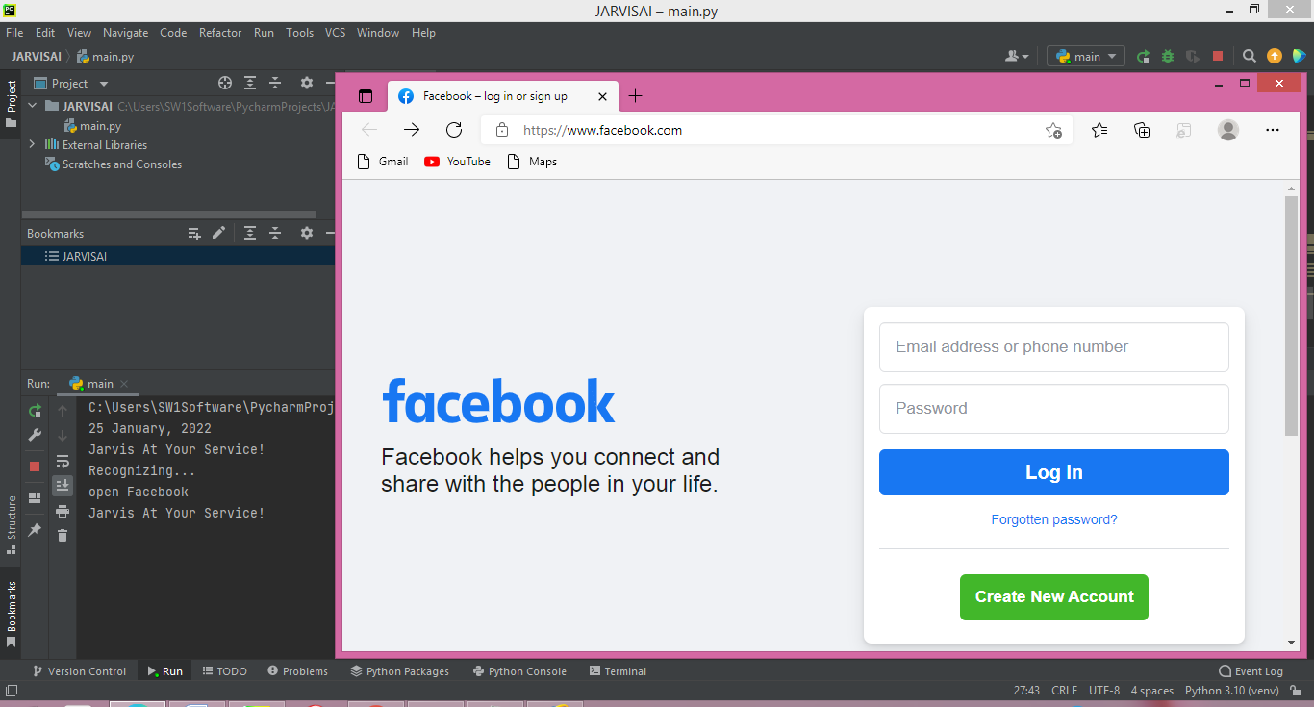

***8.10 Corona Cases***

It gives the details of total corona cases and active cases and cured cases and number of deaths in particular specified state.

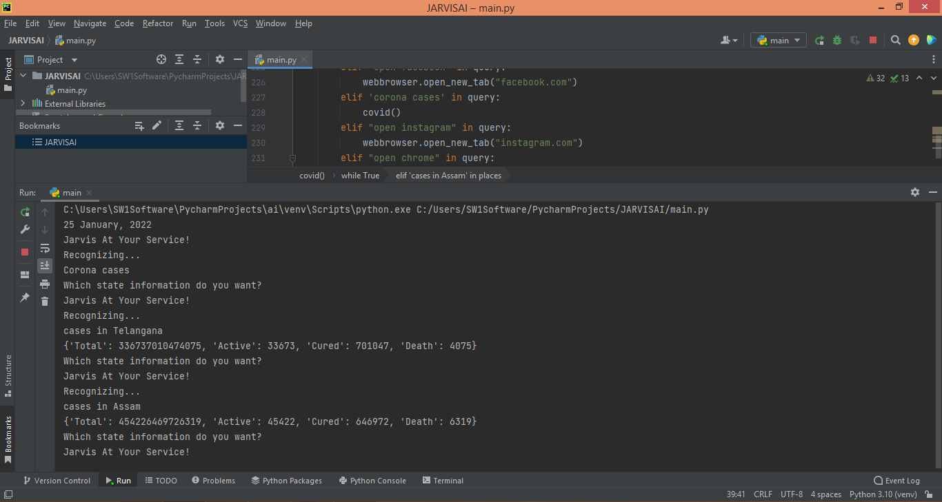

***8.11 Open Instagram***

It opens the instagram login page as shown in the following figure.

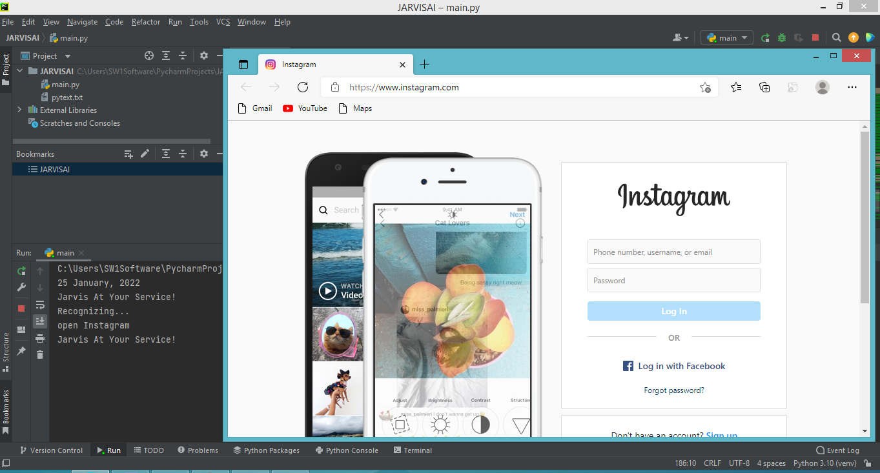

***8.12 Open chrome***

It redirects to chrome page

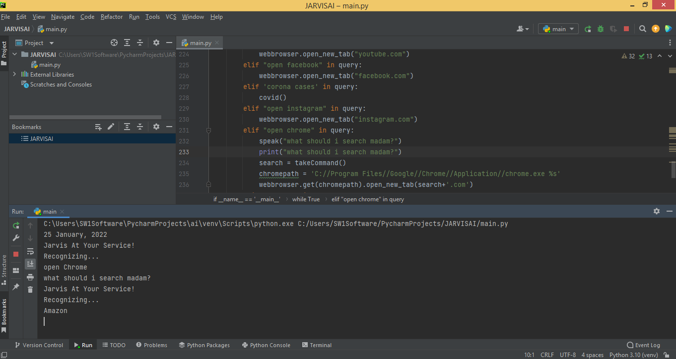

If we give command as “Amazon” it opens the amazon.in web page in the chrome.

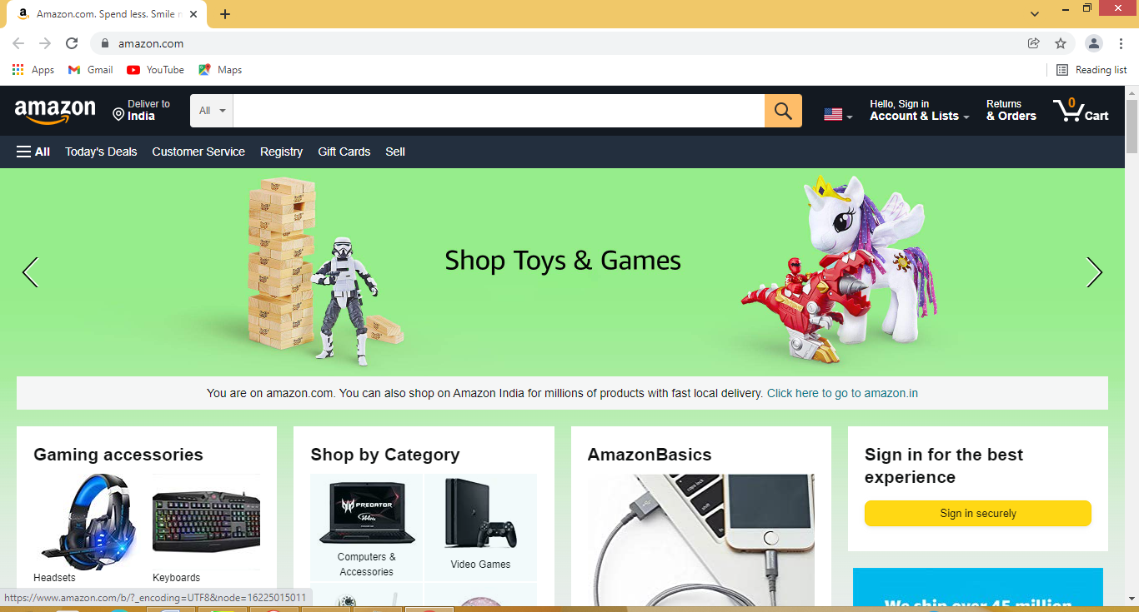

***8.13 Make a note***

If we want to make a note the Jarvis voice assistant firstly recognize and immediately makes a note as user input.

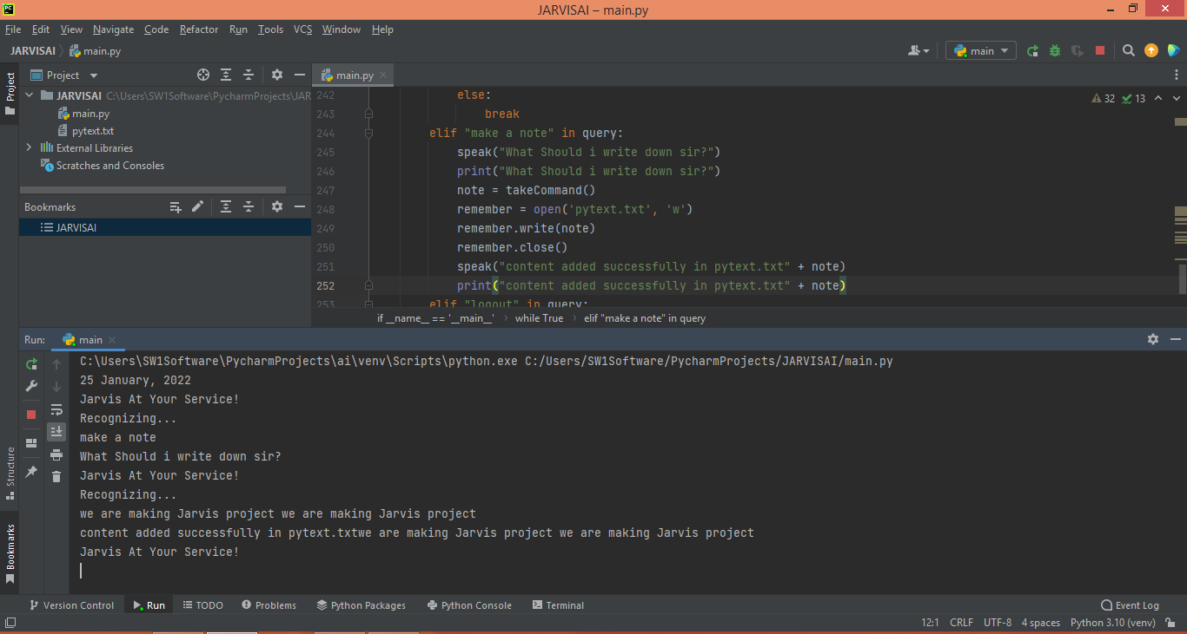

## *8.14 Temperature (get weather for a location).*

If we give the input as temperature it returns the current temperature in Hyderabad. Getting live weather conditions about a place remains an important task of virtual assistants. It helps the user charter the course of their action. Jarvis addresses this issue with the help of Python.

.

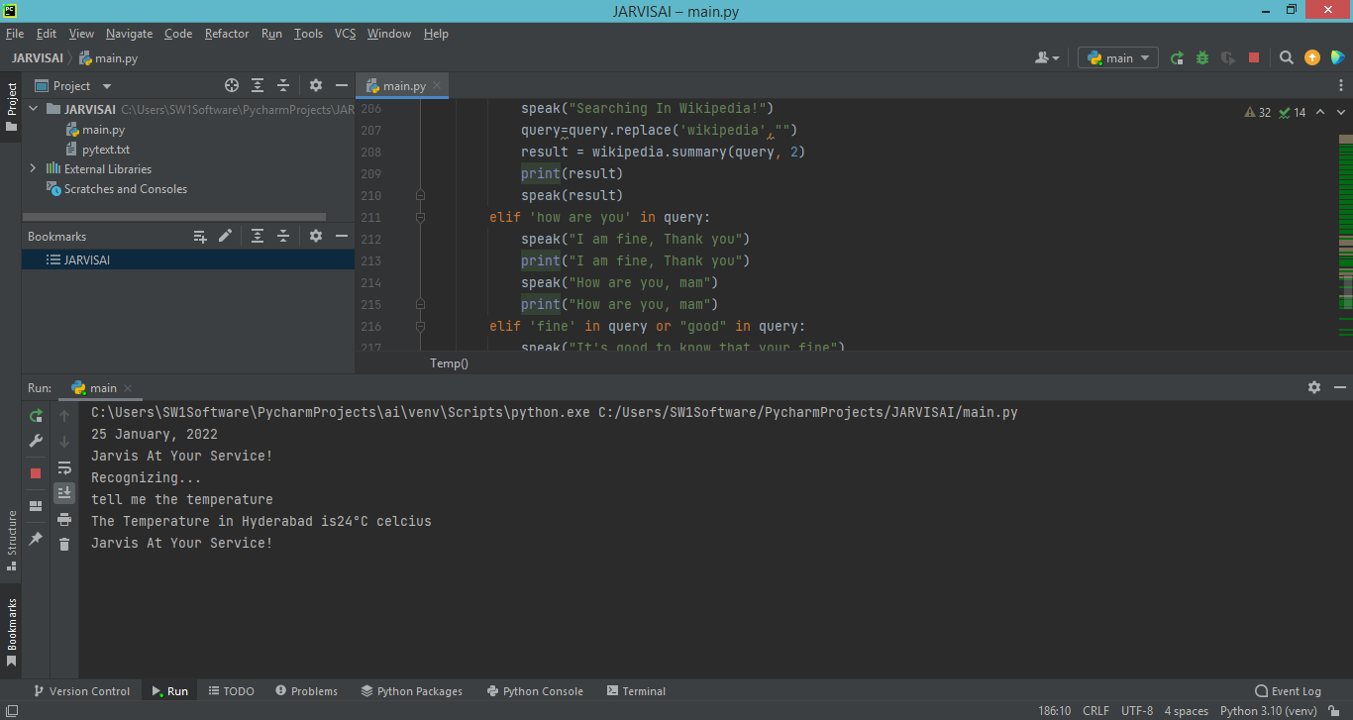

***8.15 Joke***

If we want to listen a joke .we can give command as tell me a joke ,the jarvis will recognise command and returns the jokes.

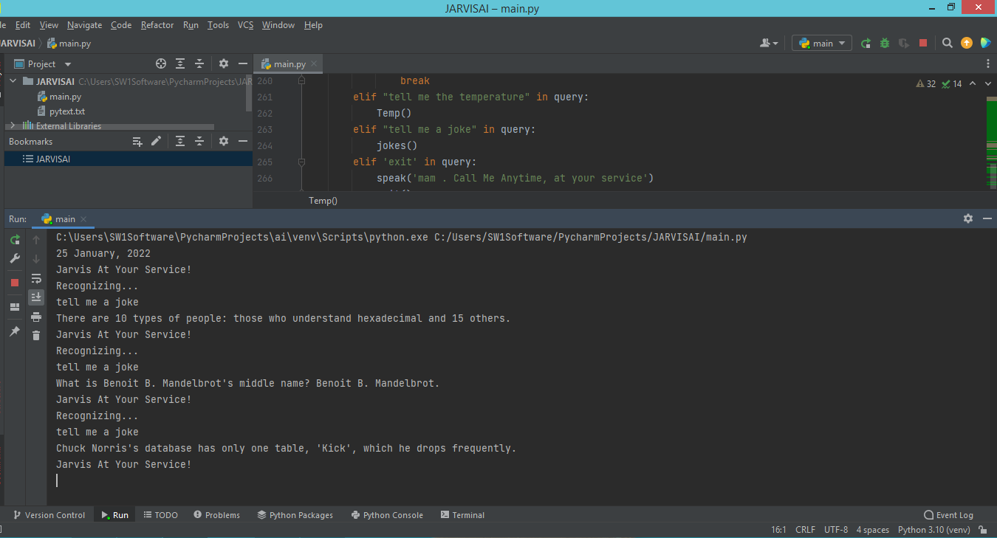

***8.16 Exit***

If we to end the communication with the jarvis we can simply use exit command .it displays the message as process finished with exit code.

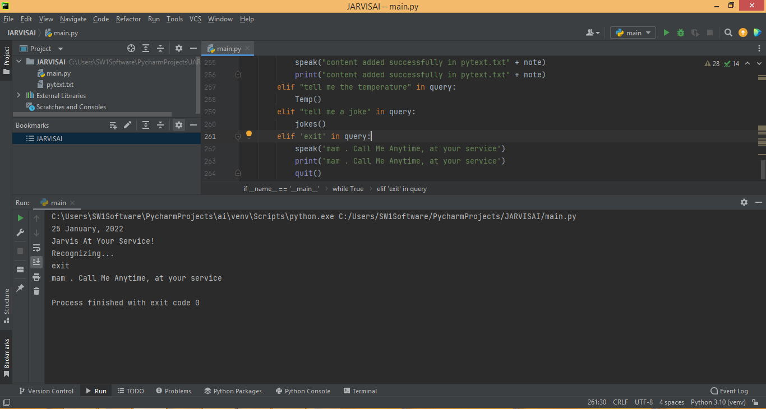

## 9. SYSTEMDESIGN Basic Modules:

## There are some following modules in Desktop Voice Assistant.

## 1.Pyttsx3:

1. Pyttsx3 is a text-to-speech conversion library in Python. Unlike alternative libraries, it works offline, and is compatible with both python 2 and pyttsx3 is a cross-platform text to speech library which is platform-independent. The major advantage of using this library for text-to-speech conversion is that it works offline. To install this module, type the below command in the terminal:

$ pip install pyttsx3

## 2.Speech Recognition :

## Speech Recognition is an important feature in several applications used such as home automation, artificial intelligence, etc. This article aims to provide an introduction on how to make use of the SpeechRecognition library of Python.

## *SpeechRecognition allows us to convert audio into text for further processing. To install this module, type the below command in the terminal:*

$ pip install SpeechRecognition

## 3.DateTime:

The datetime module supplies classes for manipulating dates and times in both simple and complex ways. While date and time arithmetic is supported, the focus of the implementation is on efficient attribute extraction for output formatting and manipulation.

$ pip install Datetime

**4.Wikipedia:**

Wikipedia is a Python library that makes it easy to access and parse data from Wikipedia. Search Wikipedia, get article summaries, get data like links and images from a page, and more. Wikipedia wraps the MediaWiki API so you can focus on using Wikipedia data, not getting it.

$ pip install Wikipedia

**5.Web browser:**  
The webbrowser module provides a high-level interface to allow displaying Web-based documents to users. Under most circumstances, simply calling the open() function from this module will do the right thing.  
  
**6.Os :**

This module provides a portable way of using operating system dependent functionality. If you just want to read or write a file see open(), if you want to manipulate paths, see the os.path module, and if you want to read all the lines in all the files on the command line see the fileinput module. For creating temporary files and directories see the tempfile module, and for high-level file and directory handling see the shutil module.

#### 10.PROJECT SETUP

#### Defining Speak Function

The first and foremost thing for an A.I. assistant is that it should be able to speak. To make our J.A.R.V.I.S. talk, we will make a function called speak().This function will take audio as an argument, and then it will pronounce it.

***def speak(audio):***

***speaking = Dispatch('SAPI.Spvoice')***

***speaking.speak(audio)***

***def date():***

***todayDate=datetime.datetime.now(tz=pytz.timezone('Asia/Kolkata'))***

***print(todayDate.strftime('%d %B, %Y'))***

***date()***

#### Defining greet function :

Now, we will make a greet() function that will make our J.A.R.V.I.S. wish or greet the user according to the time of computer or pc. To provide current or live time to A.I., we need to import a module called datetime. Import this module to your program by:

import datetime

Now, let's start defining the **greet()** function:

***def greet():***

***t_hour = datetime.datetime.now().hour***

***if 24> t_hour <4:***

***speak("Pleasant Night mam!, Jarvis at Your Command")***

***elif 12> t_hour >4:***

***speak("Good Morning mam, Jarvis at Your Command")***

***elif 18> t_hour >12:***

***speak("Good Afternoon mam!, Jarvis at Your Command")***

***else:***

***speak("Good Evening mam!, Jarvis at Your Command")***

***greet()***

* ***Defining Take command Function :***

The next most important thing for our A.I. assistant is that it should take command with the help of the microphone of the user's system. So, now we will make a **takeCommand()**function.  With the help of the takeCommand() function, our A.I. assistant will return a string output by taking microphone input from the user.

 Before defining the takeCommand() function, we need to install a module called **speechRecognition.**Install this module by:

pip install speechRecognition

After successfully installing this module, import this module into the program by writing an import statement

import speechRecognition as sr

Let's start coding the takeCommand() function :

***def takeCommand():***

***r = sr.Recognizer()***

***with sr.Microphone() as source:***

***print("Jarvis At Your Service!")***

***r.pause_threshold = 2***

***command = r.listen(source)***

***try:***

***print("Recognizing...")***

***recognized = r.recognize_google(command, language='en-in')***

***print(recognized)***

***except Exception as e:***

***print(e)***

***statement="Pardon mam.., I Couldn't Recognize Your Voice, If its nothing to command, i'll take a leave"***

***print(statement)***

***speak(statement)***

***return None***

***return recognized***

* ***To search something on Wikipedia***

  To do Wikipedia searches, we need to install and import the Wikipedia module into our program. Type the below command to install the Wikipedia module :

pip install wikipedia

After successfully installing the Wikipedia module, import it into the program by writing an import statement.

***elif 'wikipedia' in query: #if wikipedia found in the query then this block will be executed***

***speak('Searching Wikipedia...')***

***print('Searching Wikipedia...')***

***query = query.replace("wikipedia", "")***

***results = wikipedia.summary(query, sentences=2)***

***speak("According to Wikipedia")***

***print("According to Wikipedia")***

***print(results)***

***speak(results)***

* ***Creating Our main() function:***

***if _name_ == '_main_':***

***greet()***

***while True:***

***query = takeCommand().lower()***

***if 'what is the time' in query:***

***strTime = datetime.datetime.now().strftime("%H:%M:%S")***

***speak(f"madam, the time is {strTime}")***

***print(f"madam, the time is {strTime}")***

* ***To ask what is your name?***

***elif "what is your name" in query:***

***speak("iam jarvis ai voice assistant")***

***print("iam jarvis ai voice assistant")***

* ***To open notepad***

***elif 'open notepad' in query:***

***open_notepad()***

* ***To open command prompt***

***elif 'open command prompt' in query or 'open cmd' in query:***

***open_cmd()***

##### **To open Google site in a web-browser**

***elif "open google" in query:***

***webbrowser.open_new_tab("google.com")***

* ***To open calculator***

***elif 'open calculator' in query:***

***open_calculator()***

* ***Interactive mode***

***elif 'how are you' in query:***

***speak("I am fine, Thank you")***

***print("I am fine, Thank you")***

***speak("How are you, mam")***

***print("How are you, mam")***

***elif 'fine' in query or "good" in query:***

***speak("It's good to know that your fine")***

***print("It's good to know that your fine")***

***elif "who are you" in query:***

***speak("I am your jarvis voice assistant ")***

***print("I am your jarvis voice assistant ")***

* ***To open youtube***

***elif "open youtube" in query:***

***webbrowser.open_new_tab("youtube.com")***

* ***To open facebook***

***elif "open facebook" in query:***

***webbrowser.open_new_tab("facebook.com")***

* ***To know covid cases***

***elif 'corona cases' in query:***

***covid()***

* ***To open instagram***

***elif "open instagram" in query:***

***webbrowser.open_new_tab("instagram.com")***

* ***To open chrome***

***elif "open chrome" in query:***

***speak("what should i search madam?")***

***print("what should i search madam?")***

***search = takeCommand()***

***chromepath = 'C://Program Files//Google//Chrome//Application//chrome.exe %s'***

***webbrowser.get(chromepath).open_new_tab(search+'.com')***

* ***To make a note***

***elif "make a note" in query:***

***speak("What Should i write down sir?")***

***print("What Should i write down sir?")***

***note = takeCommand()***

***remember = open('pytext.txt', 'w')***

***remember.write(note)***

***remember.close()***

***speak("content added successfully in pytext.txt" + note)***

***print("content added successfully in pytext.txt" + note)***

* ***To know weather details***

***elif "tell me the temperature" in query:***

***Temp()***

* ***To tell some random jokes***

***elif "tell me a joke" in query:***

***jokes()***

* ***To exit***

***elif 'exit' in query:***

***speak('mam . Call Me Anytime, at your service')***

***print('mam . Call Me Anytime, at your service')***

***quit()***

**11.ADVANTAGES**

*•Easy to use*

*•Can work with variety of commands*

*•Custom commands*

*•Secure*

*•Artificial intelligent*

*•Single code base*

**12. FUTURE PROSPECTIVE**

We plan to Integrate Jarvis with mobile using react native, to provide a synchronized experience between the two connected devices. Further, in the long run, Jarvis is planned to feature auto deployment supporting elastic beanstalk, backup files, and all operations which a general Server Administrator does. The functionality would be seamless enough to replace the Server Administrator with Jarvis.

**13. ACHIEVEMENTS**

## The result of this project is an effective and efficient system that will help the user to save the data with the advantage of data backup. It makes the working a lot more easier. It has made the management system a lot more convenient than before. It also helps us to reduce the use of paper.It is also user- friendly. It provides access to data easily and very quick. It helps us to save time, efforts and resources.

**14.CONCLUSION**

Through this voice assistant, we have automated various services using a single line command. It eases most of the tasks of the user like searching the web, retrieving weather forecast details, opening various apps(instagram,facebook,calculator). The technique was able to authenticate the particular speaker based on the individual information that was included in the voice signal. We aim to make this project a complete server assistant and make it smart enough to act as a replacement for a general server administration. The future plans include integrating Jarvis with mobile using React Native to provide a synchronised experience between the two connected devices.

**15.REFERENCE**

1. https://www.freecodecamp.org/news/python-project-how-to-build-your-own-jarvis-using-python/amp/

*2.* [https://www.w3schools.com](https://www.w3schools.com/)

3. https://www.geeksforgeeks.org/voice-assistant-using-python/amp/

**********