TECHNICAL PROJECT REPORT
IRIS FLOWER CLASSIFICATION
A Comparative Study of Supervised Classification Models

Submitted in partial fulfilment of
CA-4 Use Case Based Continuous Assessment

Project | Iris Flower Classification
Problem type | Multiclass supervised classification
Dataset source | UCI Machine Learning Repository – Iris Data Set
Submission date (as specified in CA-4) | 12 November 2026

Prepared from the submitted Jupyter notebook and CA-4 assignment brief. All reported metrics and plots are taken from the notebook outputs; no unrecorded experimental results have been added.

Abstract
This project develops a supervised machine-learning workflow to classify Iris flowers into Iris-setosa, Iris-versicolor and Iris-virginica using four measured attributes: sepal length, sepal width, petal length and petal width. The submitted notebook loads the UCI Iris data, explores its structure and distributions, removes duplicate rows, encodes the target labels and uses a stratified 70:30 train–test split. Five classifiers are compared: Logistic Regression, Decision Tree, K-Nearest Neighbours (KNN), Random Forest and Gradient Boosting. Random Forest and Gradient Boosting are subsequently optimized with GridSearchCV using stratified five-fold cross-validation. The tuned Gradient Boosting classifier records the strongest held-out performance, with accuracy 0.9333, weighted precision 0.9345, weighted recall 0.9333 and weighted F1-score 0.9333. Its macro one-vs-rest ROC-AUC is 0.9926. Feature-importance output ranks petal width and petal length as the two dominant predictors. The report also identifies methodological gaps: no explicit SMOTE or class-weight treatment is implemented, and no separate cross_val_score analysis is recorded.

1. Introduction and problem definition
The Iris classification task is a three-class prediction problem. Given four continuous measurements for an individual flower, the model predicts its species label. This is a useful benchmark for evaluating classification algorithms because it combines numeric predictors, a categorical target and three related classes. The project objective is to compare interpretable baseline methods with ensemble methods, optimize selected models and justify a final model using test-set and ROC-AUC evidence.

1.1 Target classes and predictors
The target variable is Species, with the classes Iris-setosa, Iris-versicolor and Iris-virginica. The predictors are Sepal.Length, Sepal.Width, Petal.Length and Petal.Width; all four are numerical continuous measurements. Since the predictors are already numeric, feature encoding is not required. The notebook applies LabelEncoder to the target labels.

1.2 Project scope against CA-4
The CA-4 brief requires EDA, a 70:30 split, baseline classification models, accuracy/precision/recall/F1 and confusion matrices, Random Forest and Gradient Boosting, GridSearchCV, cross-validation, multiclass ROC/AUC, class-imbalance consideration, feature importance, final-model justification, business insights, limitations and future improvements. The report addresses each item and explicitly marks items that are not evidenced in the submitted notebook.

2. Dataset description and exploratory data analysis
The notebook reads the dataset directly from the UCI Machine Learning Repository Iris data URL and assigns five column names. After dropping rows with missing values at load time, the recorded dataset contains 150 rows and five columns: four float predictors and one object/string target. The statistical summary in the notebook reports sepal length from 4.3 to 7.9 (mean 5.843), sepal width from 2.0 to 4.4 (mean 3.054), petal length from 1.0 to 6.9 (mean 3.759) and petal width from 0.1 to 2.5 (mean 1.199).

2.1 Data quality and class distribution
The notebook reports zero missing values in every column. It identifies three excess duplicate records (five rows are shown when all members of duplicated groups are displayed) and removes duplicates, reducing the working dataset from 150 to 147 rows. The duplicate groups are repeated measurement/label combinations; no other data-cleaning operation is reported. The original data are class-balanced at 50 records per species. Following removal of duplicates, the classes are slightly uneven; the notebook does not print the post-deduplication class counts, so exact revised counts are not asserted here.

2.2 Distribution, outliers and relationships
The notebook produces a species count plot, histograms for the four numeric predictors, boxplots for outlier inspection, a Pearson-correlation heatmap and a pairplot coloured by species. The histograms and pairplot support visual inspection of feature distributions and class separation. The boxplots are used for detection only: the notebook does not document an outlier-removal or capping step. The correlation heatmap indicates strong positive association between petal length and petal width, and the pairplot visually shows that Iris-setosa is more clearly separated than the other two species.
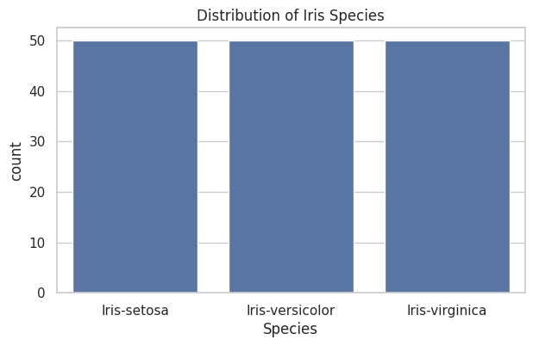
Figure 1. Species distribution in the original 150-row dataset (notebook output).
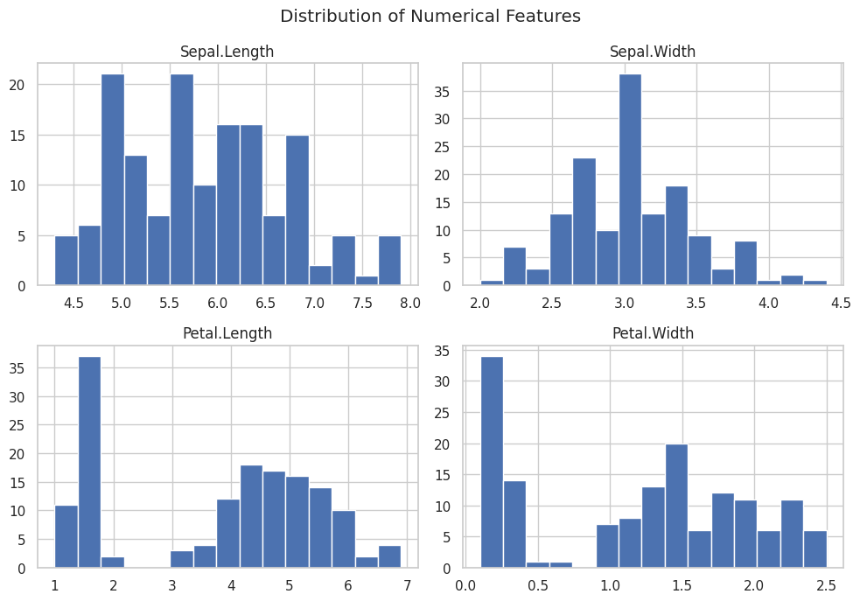
Figure 2. Histograms of the four numerical predictors (notebook output).

3. Data preprocessing and experimental design

3.1 Preprocessing
The preprocessing sequence is: (i) inspect duplicate observations, (ii) remove duplicate rows and reset the index, (iii) separate the four predictors from Species, (iv) encode the target with LabelEncoder, and (v) split the data. The final working data contain 147 observations and four predictor columns. No feature encoding is necessary for the numeric inputs. The notebook does not perform imputation because its missing-value check reports zero nulls.

3.2 Train–test split
A stratified train_test_split is used with test_size=0.30 and random_state=42. The recorded split contains 102 training observations and 45 test observations. Stratification preserves equal class representation in the test set: each species has 15 test observations, as shown in the classification reports. The fixed random seed makes the split reproducible.

3.3 Scaling and leakage control
StandardScaler is included in a Pipeline for Logistic Regression and KNN, so scaling is fitted as part of the model pipeline rather than applied globally before splitting. Decision Tree, Random Forest and Gradient Boosting are trained on the original measurement scales. This is appropriate for the distance-based KNN and scale-sensitive linear model, while tree-based methods do not require standardization.
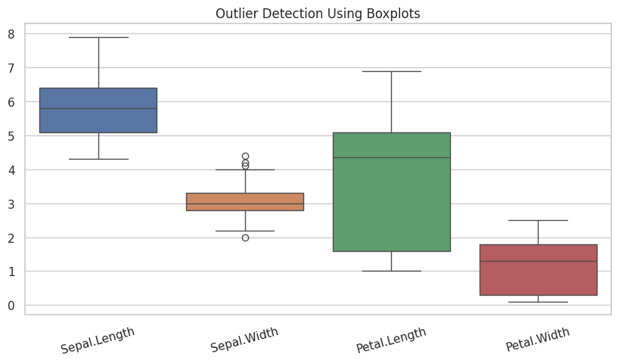
Figure 3. Boxplots used for outlier inspection; no outlier treatment is documented.
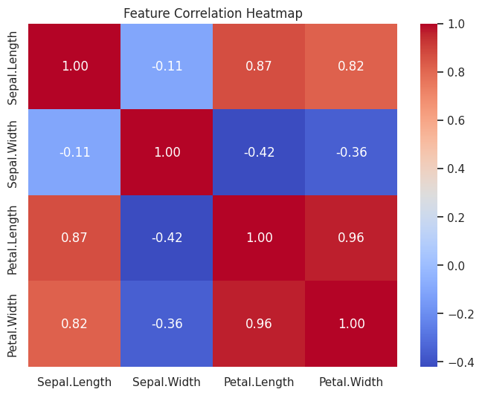
Figure 4. Correlation heatmap for the four measured attributes.

4. Baseline and ensemble model comparison
Five classifiers are fitted on the training set and evaluated on the same held-out test set. Precision, recall and F1-score are reported as weighted averages. This weighting accounts for class support when aggregating per-class values.
Classifier | Accuracy | Weighted precision | Weighted recall | Weighted F1
Logistic Regression | 0.9111 | 0.9155 | 0.9111 | 0.9107
Decision Tree | 0.8889 | 0.8899 | 0.8889 | 0.8888
KNN | 0.9111 | 0.9298 | 0.9111 | 0.9095
Random Forest | 0.9111 | 0.9155 | 0.9111 | 0.9107
Gradient Boosting | 0.9333 | 0.9345 | 0.9333 | 0.9333

4.1 Interpretation of baseline results
Gradient Boosting achieves the highest baseline test accuracy and weighted F1-score (0.9333). Logistic Regression, KNN and Random Forest each achieve 0.9111 accuracy, while the Decision Tree records 0.8889. The per-class reports show perfect setosa precision, recall and F1-score for all five models. The remaining errors occur between versicolor and virginica, which are less cleanly separated by the measurements. KNN obtains 1.00 recall for versicolor but only 0.73 recall for virginica; Gradient Boosting gives a more balanced result for these two classes (recall 0.93 and 0.87 respectively).

4.2 Confusion-matrix analysis
The notebook plots confusion matrices for all five models. These plots provide class-level error patterns alongside the aggregate metrics. The reports confirm that the setosa class is correctly classified throughout the test set, whereas some versicolor and virginica observations are confused with one another. This pattern is consistent with the overlapping feature distributions visible in the pairplot.
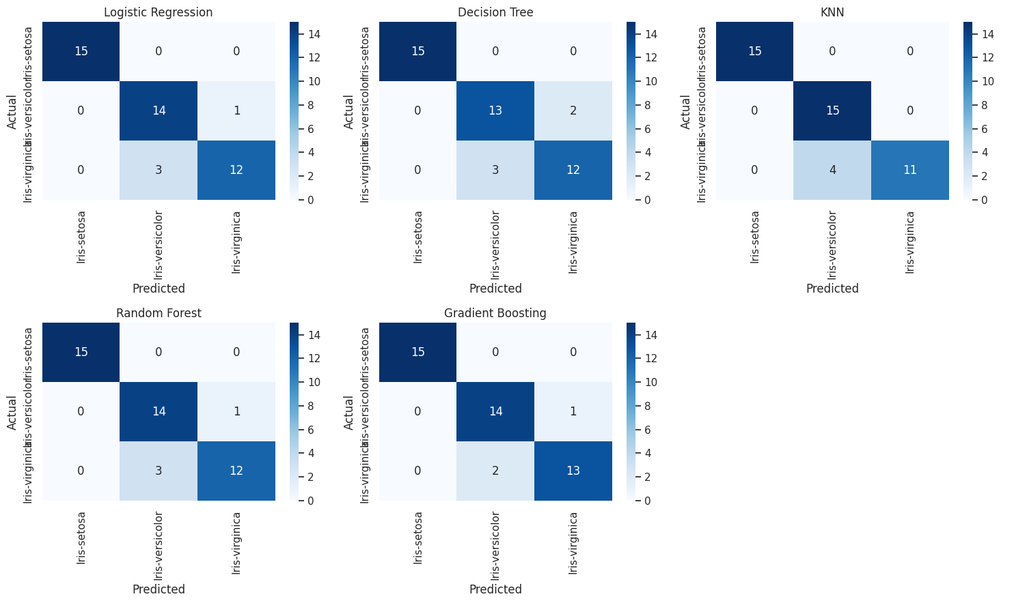
Figure 5. Confusion matrices for the five classifiers, generated from the 45-observation test set.

5. Hyperparameter optimization, cross-validation and ROC-AUC

5.1 GridSearchCV design
The notebook tunes Random Forest and Gradient Boosting separately using GridSearchCV. Both searches use StratifiedKFold with five splits, shuffling enabled and random_state=42; the optimization metric is accuracy. For Random Forest, the grid contains n_estimators = {50, 100, 200}, max_depth = {None, 3, 5, 10} and min_samples_split = {2, 5}. For Gradient Boosting, the grid contains n_estimators = {50, 100, 150}, learning_rate = {0.01, 0.1, 0.2} and max_depth = {2, 3, 4}.
Tuned model | Best parameters | Best mean CV accuracy
Random Forest | max_depth=None; min_samples_split=5; n_estimators=50 | 0.9600
Gradient Boosting | learning_rate=0.01; max_depth=2; n_estimators=50 | 0.960476 (≈0.9605)
The best Gradient Boosting configuration has the slightly higher cross-validation accuracy. The GridSearchCV process is the notebook's documented five-fold cross-validation procedure. Although cross_val_score is imported, the notebook does not execute a separate cross_val_score experiment; this distinction should be retained when describing the evidence.

5.2 Tuned test-set performance
Tuned classifier | Accuracy | Weighted precision | Weighted recall | Weighted F1
Tuned Random Forest | 0.9111 | 0.9155 | 0.9111 | 0.9107
Tuned Gradient Boosting | 0.9333 | 0.9345 | 0.9333 | 0.9333
Tuning does not improve the held-out test metrics relative to the corresponding untuned models in this run. The tuned Gradient Boosting estimator retains the best observed test accuracy, but its test-set performance is unchanged from baseline Gradient Boosting. The higher cross-validation score is evidence from the training folds, not a claim of improved test accuracy.

5.3 Multiclass ROC and AUC
The selected tuned Gradient Boosting model generates class probabilities using predict_proba. The notebook binarizes the three labels and plots one-vs-rest ROC curves for each species. The reported macro-average ROC-AUC is 0.9926. This indicates strong ranking discrimination across the three one-vs-rest tasks on the held-out set. The ROC-AUC complements, rather than replaces, the threshold-based accuracy, precision, recall and F1 metrics.
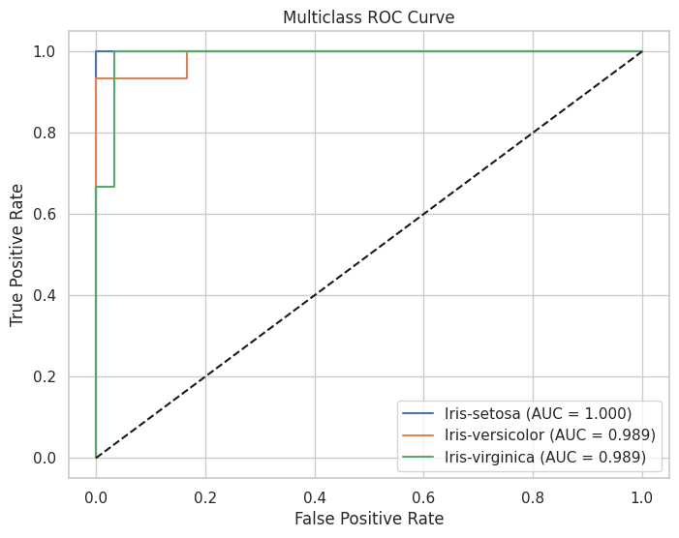
Figure 6. Multiclass one-vs-rest ROC curves for tuned Gradient Boosting.

6. Feature importance, model selection and implications

6.1 Feature importance
The final tuned Gradient Boosting estimator provides the following impurity-based feature-importance scores:
Feature | Importance | Relative interpretation
Petal.Width | 0.652498 | Largest contribution in the fitted ensemble
Petal.Length | 0.267702 | Second-largest contribution
Sepal.Width | 0.078644 | Smaller contribution
Sepal.Length | 0.001156 | Very small contribution
Petal width and petal length together account for approximately 92.02% of the reported importance (sum of the two notebook scores). This supports the practical interpretation that petal dimensions carry most of the predictive signal in this fitted model. Feature importance is model-specific and does not establish causality; correlated predictors can share or redistribute importance.
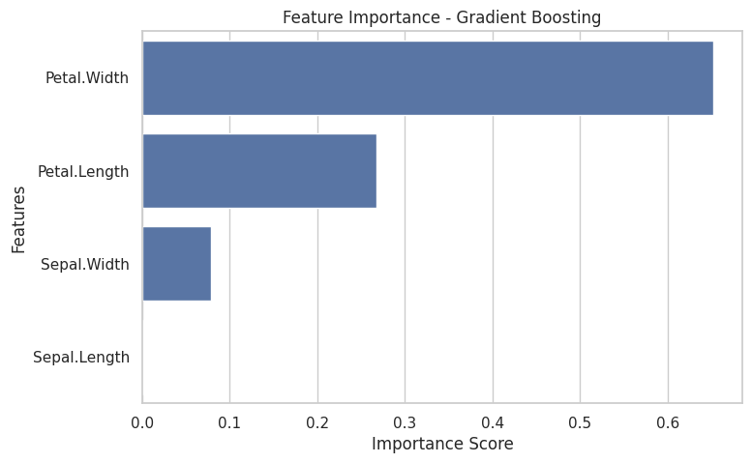
Figure 7. Feature importance from the tuned Gradient Boosting classifier.

6.2 Final model justification
Tuned Gradient Boosting is selected as the final model because it has the highest recorded test accuracy (0.9333), weighted precision (0.9345), weighted recall (0.9333) and weighted F1-score (0.9333) among the compared models, and the best GridSearchCV mean accuracy (approximately 0.9605) among the two tuned ensembles. Its macro one-vs-rest ROC-AUC is 0.9926. The tuning search does not increase test accuracy over baseline Gradient Boosting, so the justification is based on the combined evidence rather than a claimed test-set gain.

6.3 Business/scientific insights
In a botanical or specimen-screening workflow, the model could support preliminary species identification from standardized sepal and petal measurements, helping prioritize specimens for expert review or organize field/laboratory records. The strong importance assigned to petal dimensions suggests that measurement protocols should capture petal width and length carefully. Predictions should remain decision support rather than a substitute for taxonomic confirmation, especially for borderline versicolor/virginica specimens.

7. Limitations, future improvements and conclusion

7.1 Limitations and CA-4 compliance notes
First, the dataset is small (150 original records and 147 after duplicate removal), so estimates may vary with the particular split. Second, the notebook does not document external validation or repeated holdout evaluation. Third, class imbalance is not explicitly handled with SMOTE or class weights. The original dataset is balanced by design, and the stratified test set has 15 observations per class, but the CA-4 requirement to address imbalance is not explicitly demonstrated. Fourth, outliers are visualized but not quantitatively investigated or treated. Fifth, the notebook uses a single 70:30 split; the five-fold CV scores arise within GridSearchCV for the two ensemble models only. Sixth, feature importance is not a causal explanation and should be interpreted with care.
The report does not claim a separate standalone cross_val_score run, SMOTE experiment, class-weight experiment, or per-class numeric AUC values because these are not present in the submitted notebook outputs. No deployment demo is included; the CA-4 brief lists Streamlit/Flask as optional.

7.2 Future improvements
Future work should (i) add a formal class-count check after duplicate removal and document whether class weights are warranted; (ii) compare class_weight='balanced' and/or SMOTE within an imbalanced-learning pipeline if imbalance is observed; (iii) report repeated stratified cross-validation with mean and standard deviation for all candidate models; (iv) add per-class ROC-AUC and a macro/micro average comparison; (v) inspect outliers by class and assess robust alternatives without automatically deleting valid botanical observations; (vi) use permutation importance or SHAP for complementary interpretation; (vii) evaluate calibration and prediction confidence; and (viii) validate on an independently collected dataset before operational use.

7.3 Conclusion
The notebook implements the principal CA-4 classification workflow and demonstrates that Gradient Boosting is the strongest of the five evaluated classifiers on the supplied test split. The tuned Gradient Boosting model achieves 93.33% accuracy and a macro one-vs-rest ROC-AUC of 0.9926. Petal width and petal length dominate the fitted model's feature-importance ranking. These results are promising for the Iris benchmark, but the small dataset, single holdout split and unimplemented imbalance-handling experiment limit claims about generalization. The selected model is therefore a justified benchmark choice, not yet a validated production classifier.

References
1. UCI Machine Learning Repository. Iris Data Set. https://archive.ics.uci.edu/ml/machine-learning-databases/iris/iris.data (dataset URL used in the submitted notebook).
2. Fisher, R. A. (1936). The use of multiple measurements in taxonomic problems. Annals of Eugenics, 7(2), 179–188.
3. scikit-learn developers. scikit-learn documentation: model selection, preprocessing, ensemble methods and classification metrics. https://scikit-learn.org/stable/
4. CA-4 Use Case Based Continuous Assessment 4 Week: Continuous Assessment Structure, supplied assignment brief (submission date stated as 12/11/2026).
5. Submitted Jupyter notebook: iris (2).ipynb. Code, printed evaluation outputs and figures used as the primary evidence for this report.

