Filters

Exception Filter:
- First need to register in startup / Program.cs
- Its not middleware means need to register as service under config service method

- Builder.service.addcontroller(options=> option. Filters.add(<golbalExceptionFIlter>());
- Then go to the newly created exception filter class add exception filter attribute inheritance and then use the existing onexception (exceptioncontext context)
{
Context.Result= new obejectresult(new{message=”hi”,error=”error”}, {statuscode=200}

Optional
Context.exceptionhandled= true. // to cut the remaining exception filters are in order (usually having one only
}

Then anywhere use throw new exception(“message”);
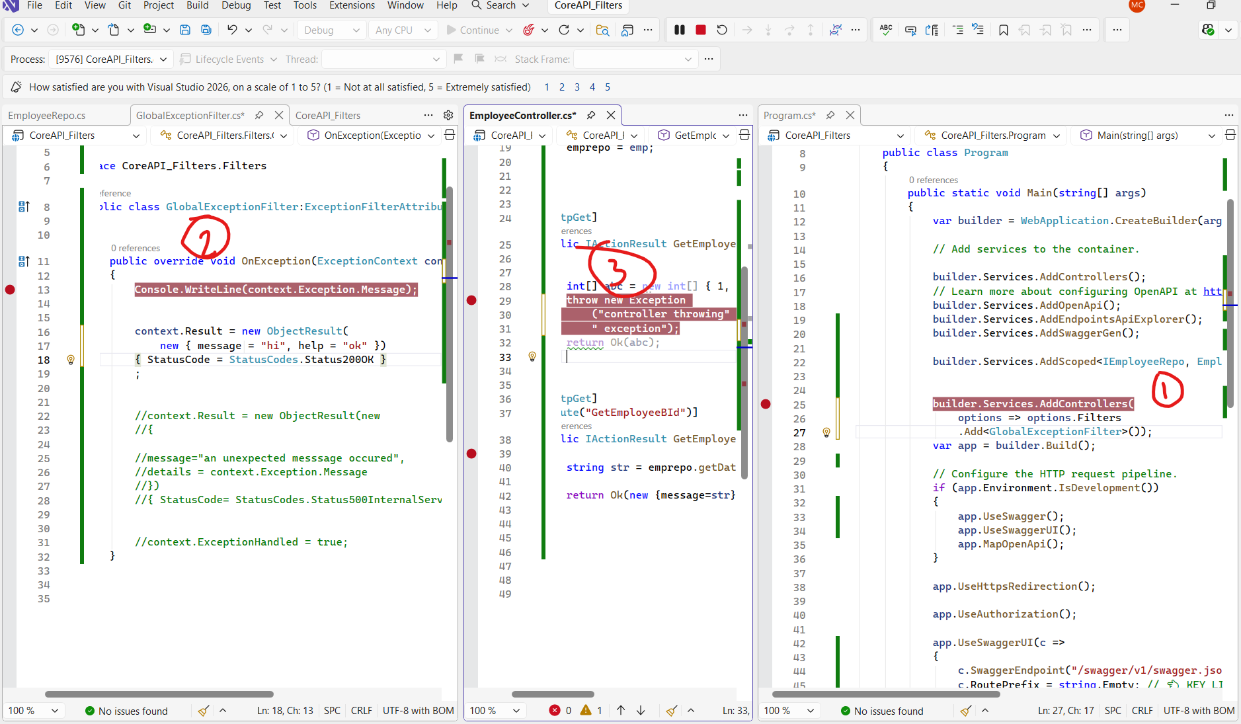

ChatGPT link for reference

https://chatgpt.com/c/6970a444-bc8c-8327-bd97-d81689a1d3e1

https://github.com/malleshch07/CoreAPI_Filters/tree/master/CoreAPI_Filters

Action filter:

- Action filter same like exception filter here no need throw anything just add a line program.cs for register and custom call to log the process before after action method in predefined virtual methods
- And no logic in anywhere except you want to add for one controller or action method with attribute.
- If want for specific then comment program .cs and add [action filter custom class] in controller or method
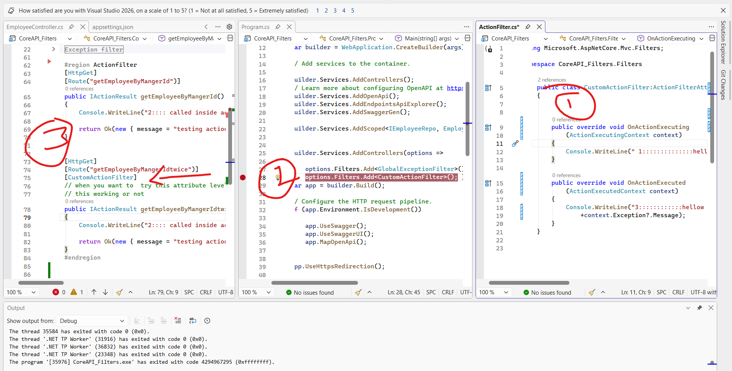

REAL EXECUTION ORDER (THIS IS THE KEY)
Request
↓
Authorization Filter
↓
Resource Filter (Before)
↓
Model Binding
↓
Action Filter (Before)
↓
Controller Action
↓
Action Filter (After)
↓
Result Filter (Before)
↓
Result Execution
↓
Result Filter (After)
↓
Resource Filter (After)
↓
ResponseResult/ Response filter:

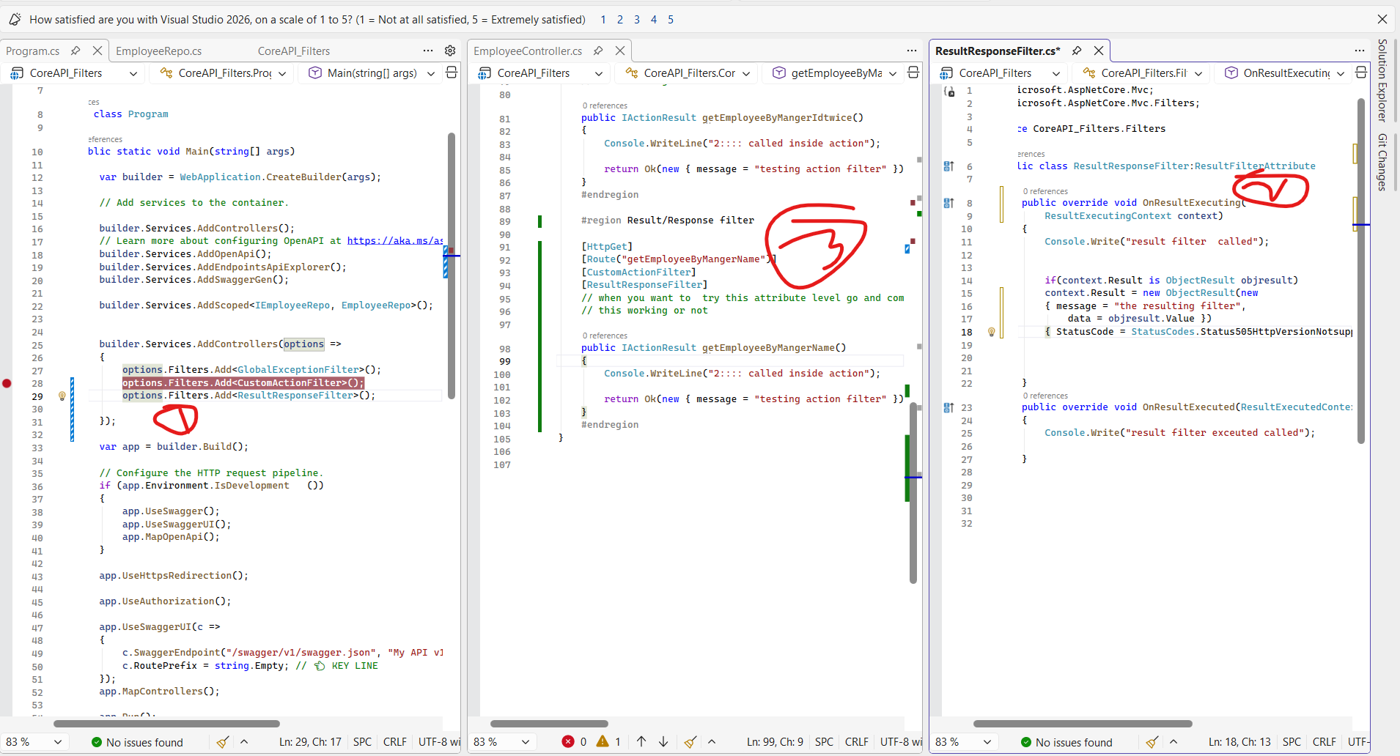

Here same process adding asme like action fitler only difrenrce we no need to add anything except program.cs & customresultfilter.
Every response after controller iactionresult the result filter will modify and sent.

Note: resource filter if we used resourcefilter then it’s a interface so need to implement all methods, but other filters are abstract class normal methods not abstract decorated methods so we can ignore if we don’t want to override or implement. So that s the reason resource has 2 methods and rest have based on need

Resource filter:
Same as the remaining fiter except below points

We need to add 2 lines in config service

One for custom class resgirationa and one for addcachmemory.
options.Filters.Add<CacheFilter>();
builder.Services.AddMemoryCache();
and then need to add chache logic where we wont respond over the resource filter because this cache not update always and works on previous request so keep it mind where we are using like in dell they used for storeconfig data that usually don’t use.

So Imemorycache main key need to use this in repository where we pull the data and add to chach first time ore new data and then next time form result filter it works and time specific and more over ram storage.

For to use in specific we need use service filter
[ServiceFilter(typeof(CacheFilter))]
For controller as imemroy chache wont work as DI create when loads

So we need to keep it scoped as DI

builder.Services.AddScoped<CacheFilter>();
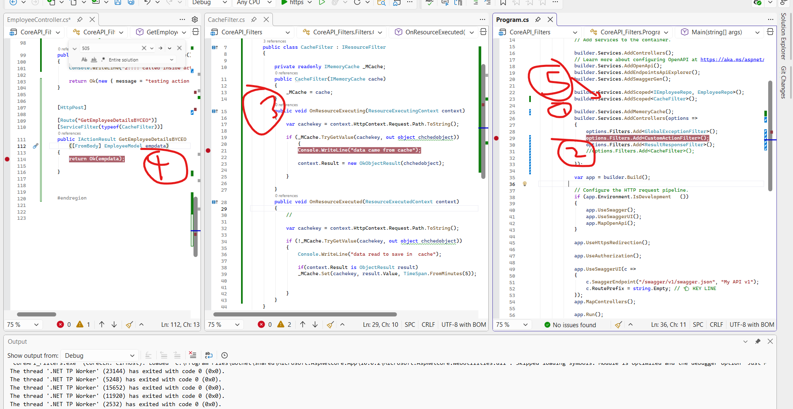

Authorize filter:
Usally we can make 3 ways with only filter , without filter and with filter+middleware
Below are the filter
We used strabucks. Aspnetcore 6.3
To use as swagger gen to add with x-api key reading from header, usally we take token
Ans rest same checking header for the fields and continue the flow or short circuit.
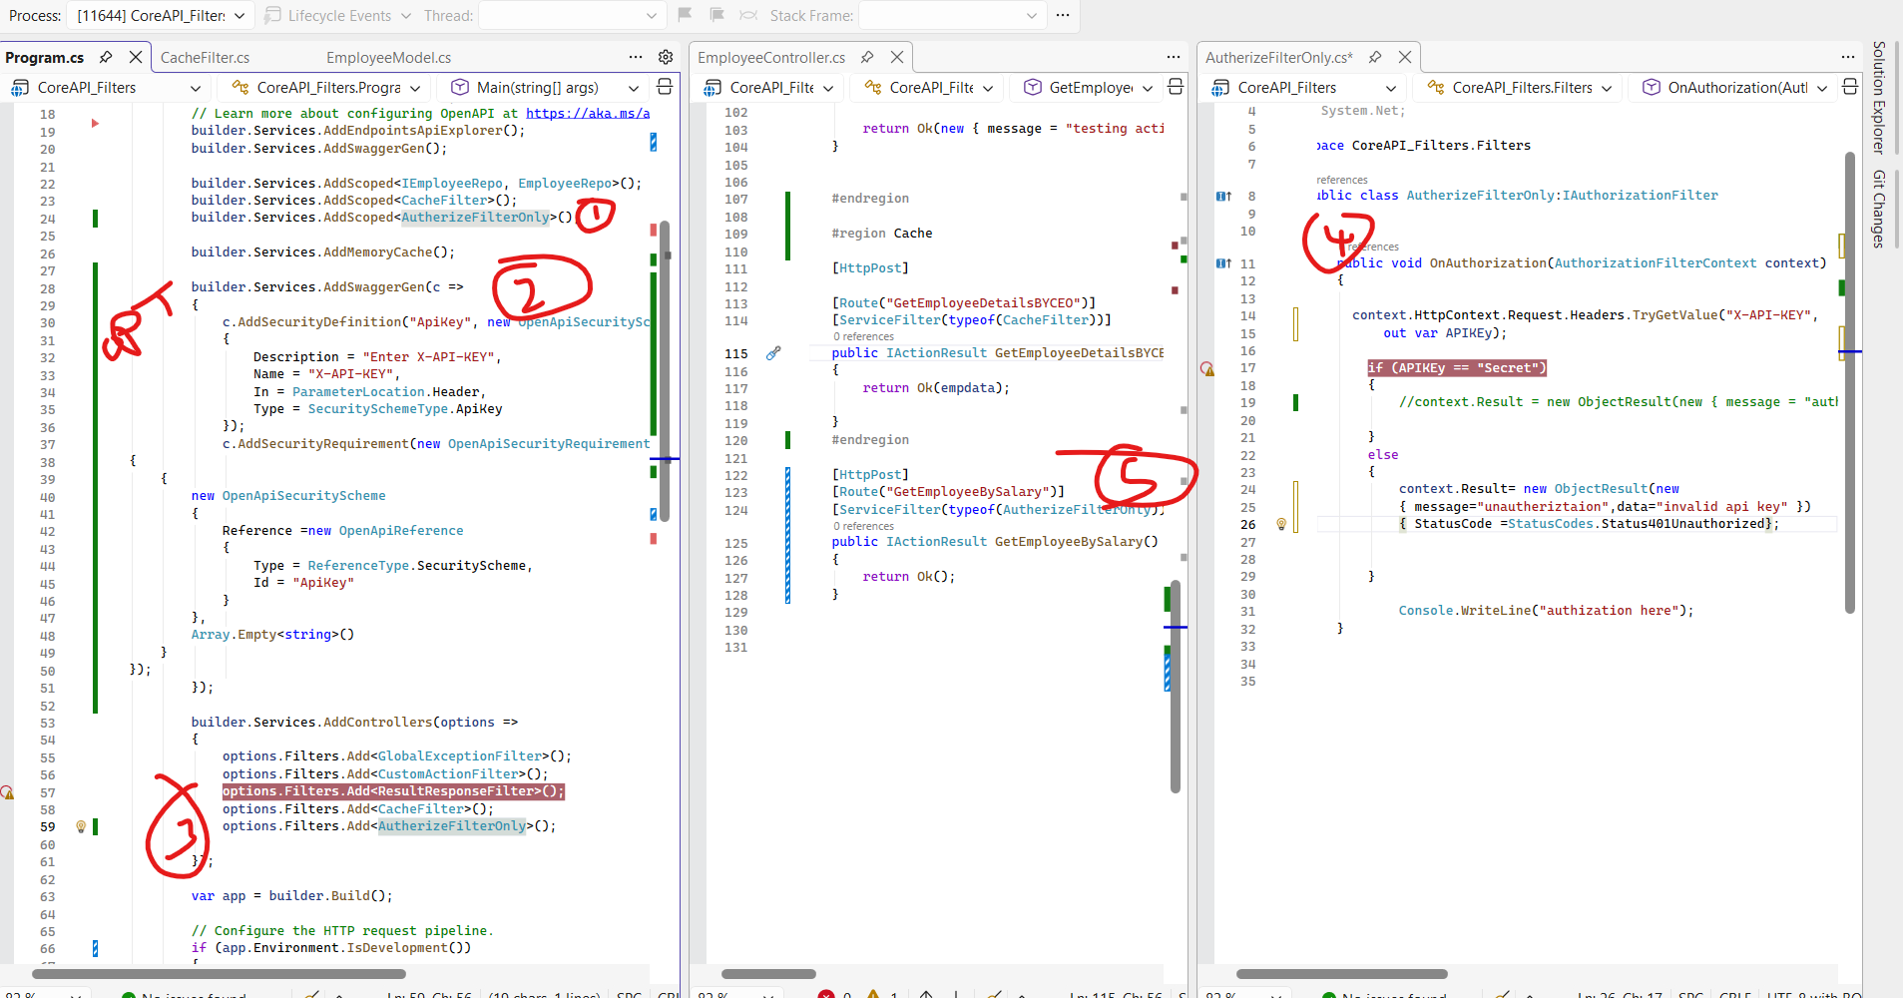
Filter Type | Purpose | Interface | Main Methods
Authorization | Allow / block request | IAuthorizationFilter | OnAuthorization
Resource | Cache / short-circuit early | IResourceFilter | OnResourceExecuting, OnResourceExecuted
Action | Before / after action logic | IActionFilter | OnActionExecuting, OnActionExecuted
Exception | Handle controller exceptions | IExceptionFilter | OnException
Result | Modify response | IResultFilter | OnResultExecuting, OnResultExecuted

