**Demonstration of my Project with screen shots**

This document will demonstrate my Deep Learning project which titled as “Text classification of 20 News Group Dataset using Deep learning approach”. The following steps will be perform as part of execution of the project.

**Step1**

The following screen will prompt “file Name” from the user. User will give the name of the file.

**Input Form**

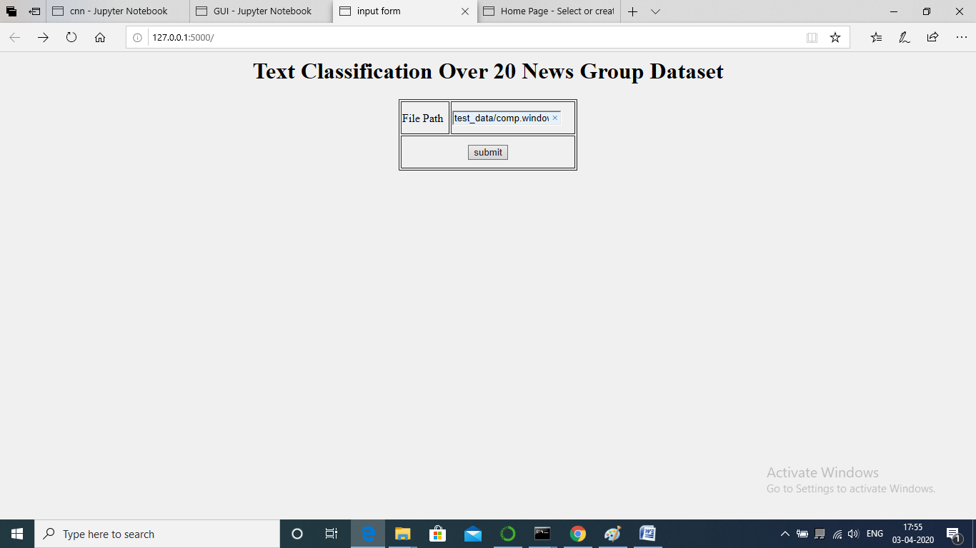

**Step-2**

The following screen will display the predicted class label for concern file which is specified by the user in the form of result.

**Result form**

