Jenkins:

1. create the jenkins server in aws account.

First i install java then i install maven after that i install tomcat.

2. pulgins : 1. green ball plugin

2.deploy to container

3. git

3. using helloworld program i created one job.using that git hub url i given in that job after that i build the job.

4. List of the file inside directory.

Workspace-helloworld-> helloworld.java, README.md, text.

5. i created one job like “hello” in this job using existing helloworld job clon e here

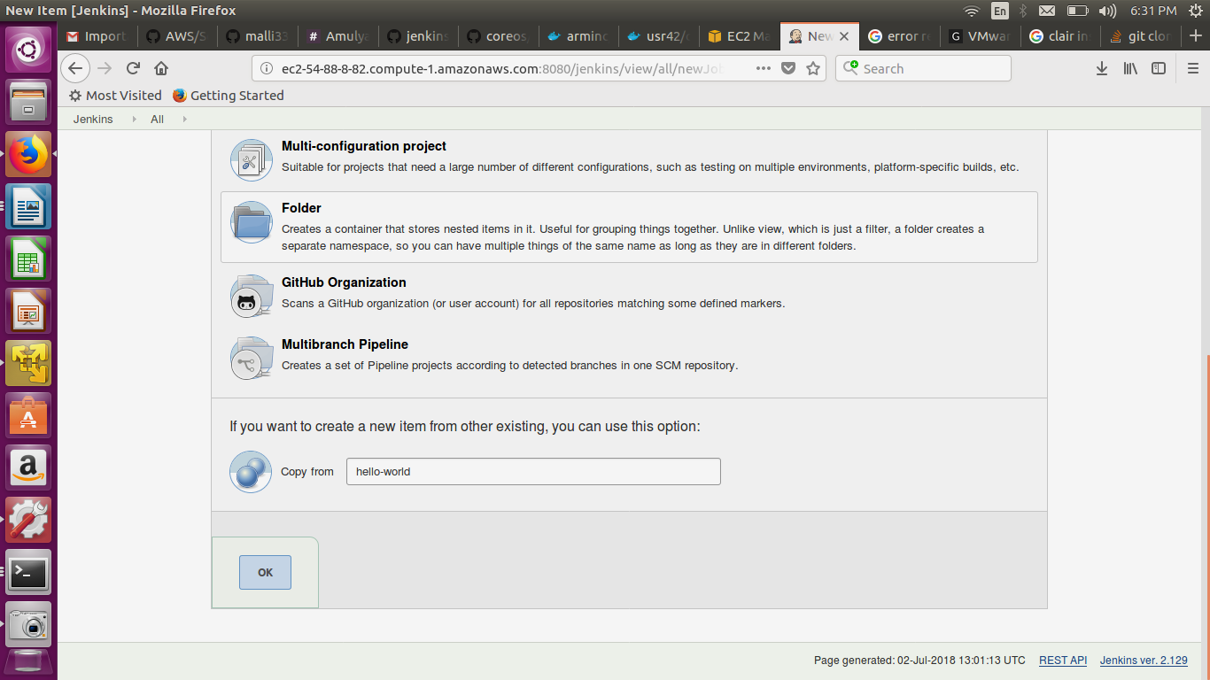

6. go to manage jenkins -> go to configure system -> build excutor (here we need to modified that excutor)

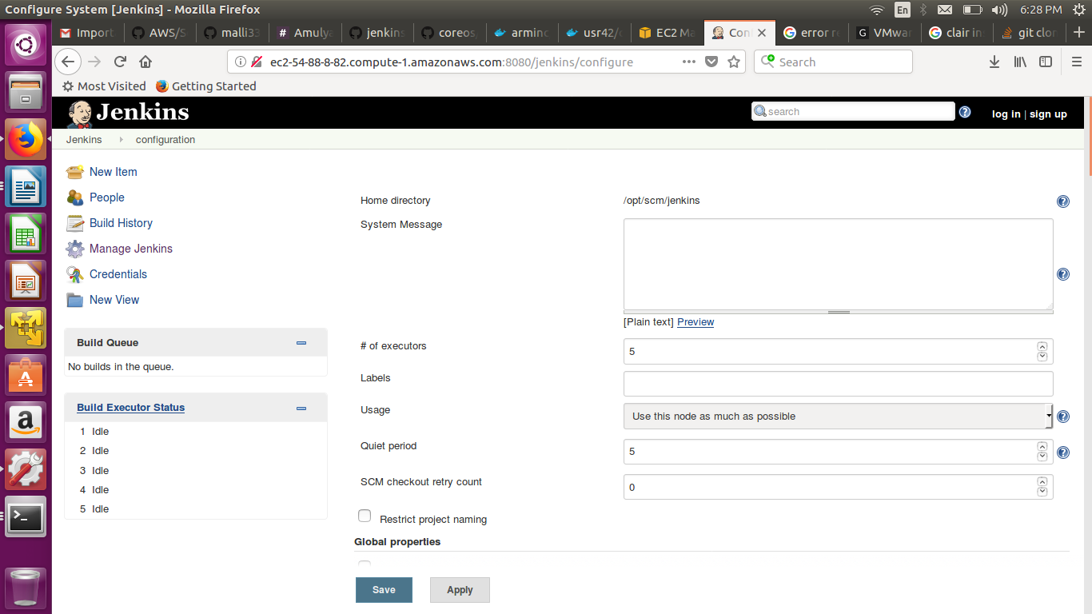

7. unix based autuhentication pupose.

Go to manage jenkins -> configure global security

8. matrix based authentication= for this i created one user after that go to manage jenkins -> go to configure global security -> here i selected that matrix based authentication here i added the user.

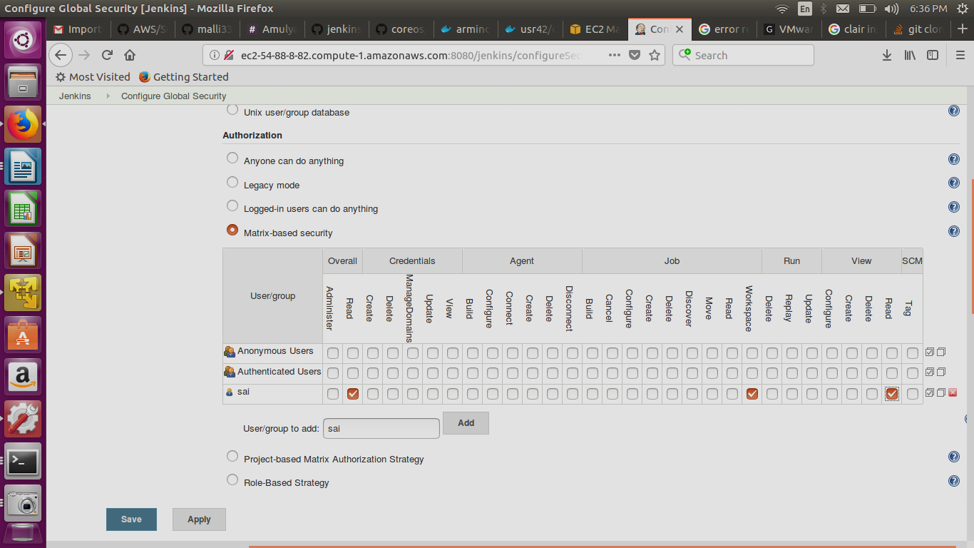

9. project based matrix= go to configure global security -> here select the “jenkins user own data base” again we need to select the “project based matrix autorization stratefy”.

We created one new job configure the job at that time we need to select the “enable project-based secutiry”

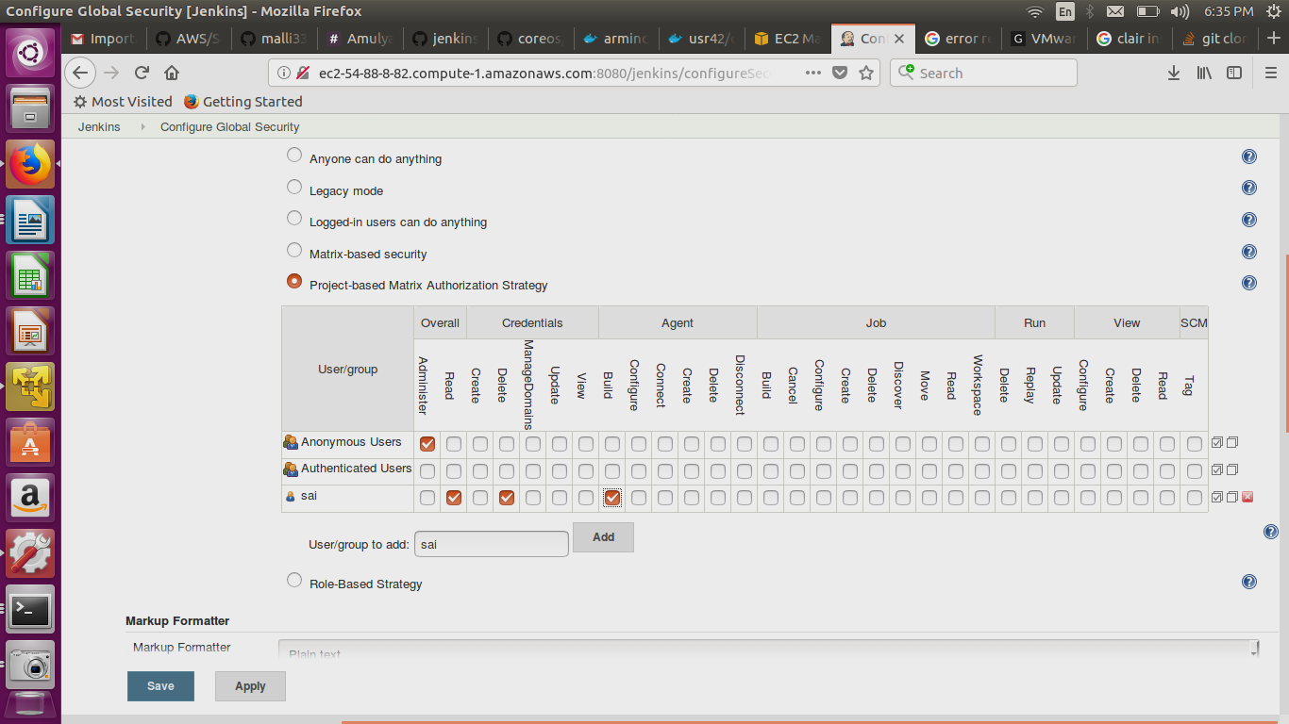

10.role based user authentication and autharization = for this we need to install the plugin “role based authorization strategy” then go to user

11. setup email notification.

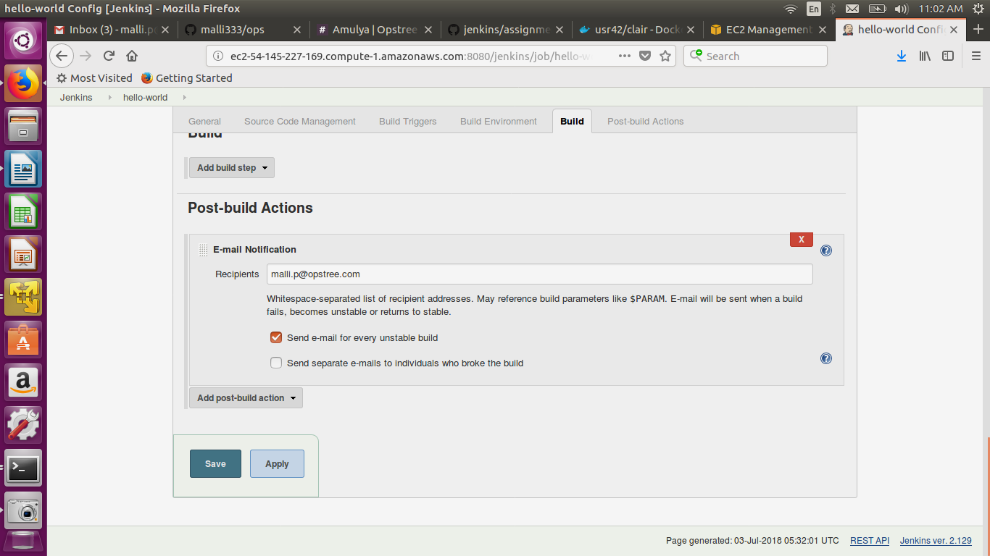

12. integrate the slack to jenkins.