Department of Computer Science

Institute of Business Administration, Karachi

Lab #1: Basic Linux command’s function

Parallel and Distributed Computing

**Objective:**

The objectives of this experiment are:

* To practice essential Linux commands for file management and permissions.
* To learn how to create batch files (shell scripts) to automate tasks.
* To compile a simple C program using the GCC compiler.

**Prerequisites:**

* A virtual machine with Linux installed (from the previous lab).
* Basic familiarity with the Linux terminal.

**Commands and Tasks:**

1. File Management:
   * ls: List files and directories in the current directory.
     + Practice listing files in different directories, using options like -l (long listing), -a (show hidden files), and -R (recursive listing).
   * mkdir: Create a new directory.
     + Create a directory structure for organizing files (e.g., mkdir documents pictures).
   * cp: Copy files and directories.
     + Copy files between directories (e.g., cp file1.txt documents/).
   * chmod: Change file permissions.
     + Experiment with modifying permissions using numerical or symbolic modes (e.g., chmod u+x myscript.sh to make a script executable).
   * tar: Create and extract archive files.
     + Create a compressed archive of a directory (e.g., tar -czvf myfiles.tar.gz documents/).
     + Extract the contents of an archive (e.g., tar -xzvf myfiles.tar.gz).
2. Batch Files (Shell Scripts):
   * Open a text editor (e.g., nano or vim) to create a script file.
   * Write a sequence of commands, one per line.
   * Save the file with a .sh extension (e.g., myscript.sh).
   * Make the script executable using chmod u+x myscript.sh.
   * Run the script by typing its name (e.g., ./myscript.sh).
3. GCC Compiler:
   * Create a simple C program (e.g., hello.c with a printf statement).
   * Compile the program using gcc hello.c -o hello.
   * Run the executable by typing. /hello.

**Tasks for Practice:**

1. Create a directory structure for organizing files (e.g., Documents, Pictures, Downloads).

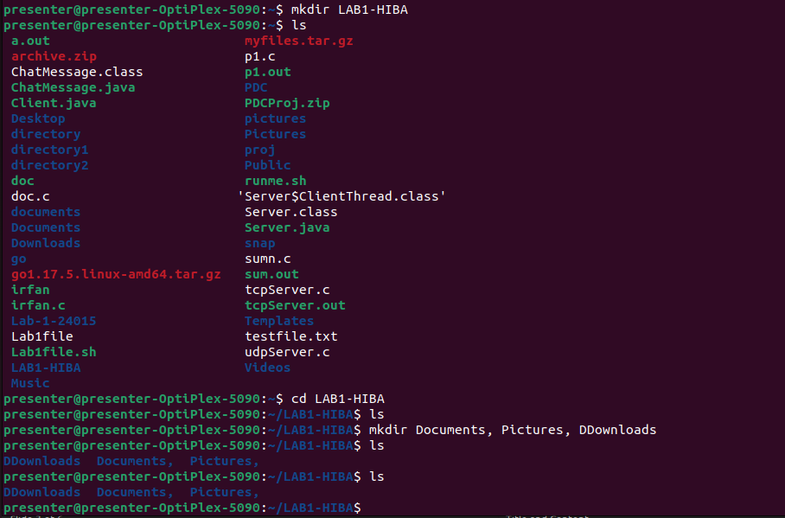

2. Copy files between directories.

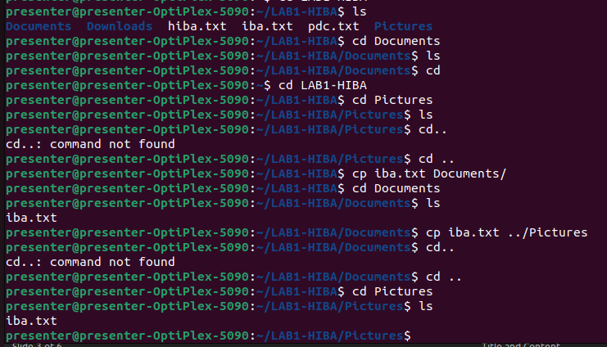

3. Change file permissions to make them readable, writable, or executable by different users.

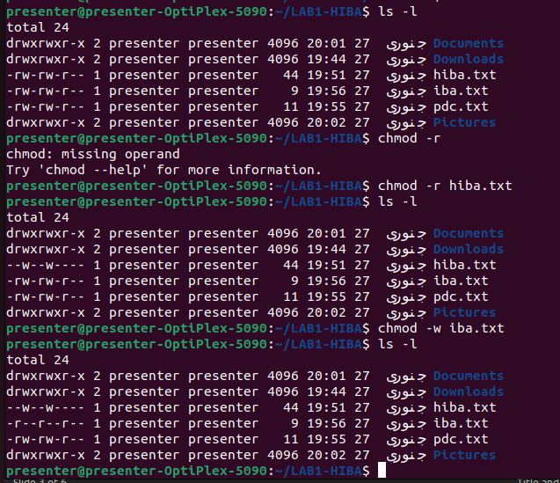

4. Create a compressed archive of a directory and extract its contents.

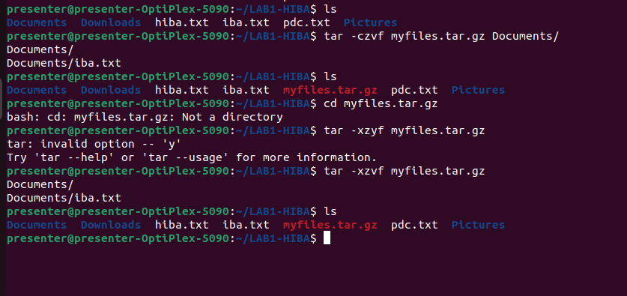

5. Write a batch file that performs multiple tasks, such as:

* + Creating directories
  + Copying files
  + Displaying file information
  + Printing a message to the screen

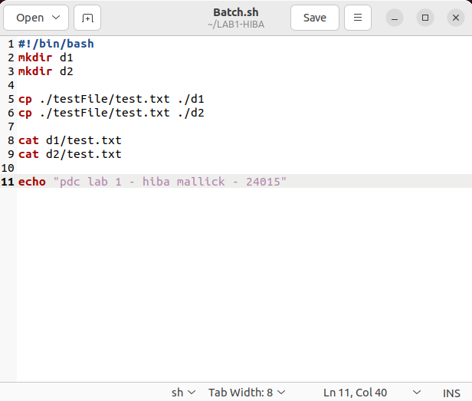

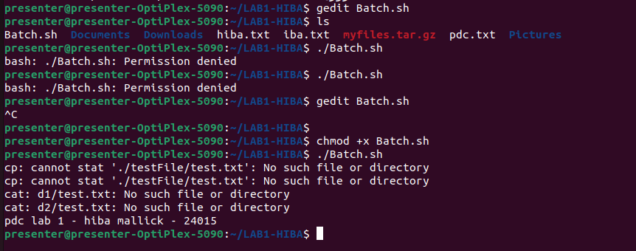

6. Write a simple C program and compile it using GCC.

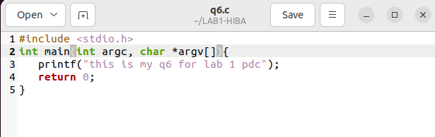

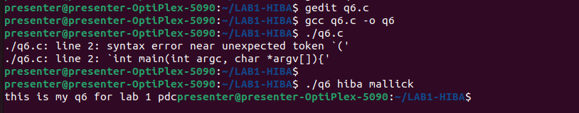

**Submission Rule:**

1. Paste your code here for each task and paste output screen shots related to that code.
2. Do use comments in your code to define what tasks you are trying to do.