**CSE467 - Parallel and Distributed Computing**

**Assignment 2**

**Hiba Mallick - 24015**

**Objective:** Find the impact of programming habits on data access time in various languages.

All programming languages from low level assembly to high-level C/C++/Java/Python/Go allow programmers to move data from RAM to registers without knowing the existence of cache memory or even the registers. And programmers also ignore how the programming languages store multidimensional arrays as linear array in RAM. In this assignment you need to explore the impact of coding on memory access time in various languages while cache hit, and miss occurred and how the locality of reference play its role to increase cache hits.

**-------------------------------------------------------------------------------------------------------------------------------**

**Input: Matrix:** assigned with random values

**Processing:** determine the memory access time of matrix stored in two-dimensional arrays or lists in different languages.

T1 = get clock cycle/system time

Perform M1 = M2 + M3

T2 = get clock cycle/system time

Time elapsed = T2 – T1

**Output:** Time elapsed - Tables show the comparison

|  |  |  |  |  |  |
| --- | --- | --- | --- | --- | --- |
| Execution Time | | | | | |
|  | C/C++ | Java | MATLAB | Python-list | Python-NumPy |
| Without loop  M1=M2+M3 | - | - | 0.000190973 | 0.000995 | 0.006833 |
| Row Major loops (R-C) | 0.000059 | 0.00041793 | 0.178039 | 0.008659 | 0.028718 |
| Column Major loops (C-R) | 0.000100 | 0.0009361 | 0.175542 | 0.012685 | 0.038929 |

# C/C++

Row Major in C:

# Java

Row Major in Java:

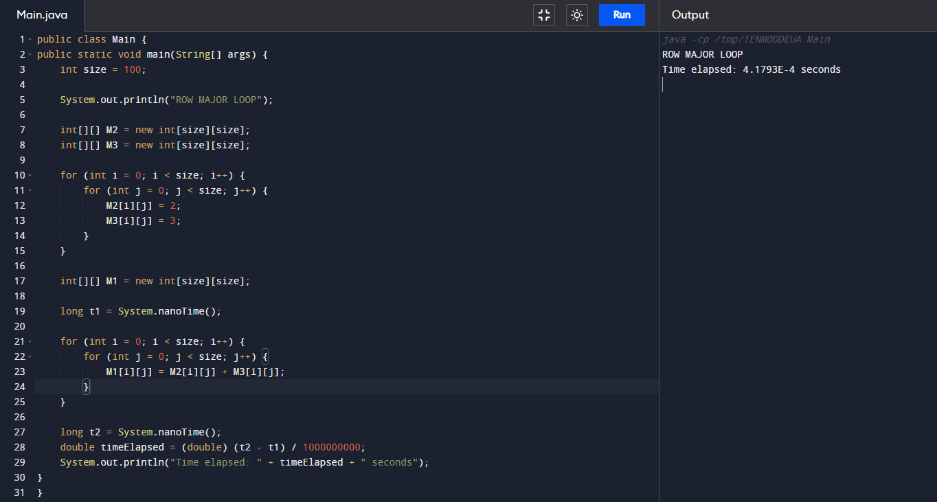

Column Major in Java:

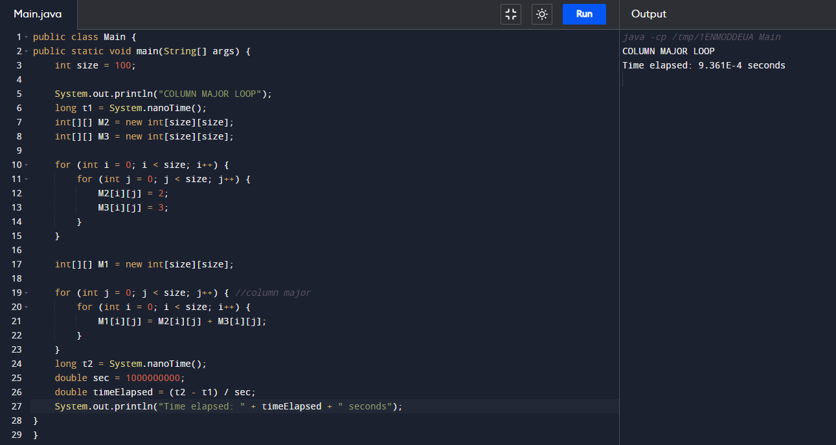

# MATLAB

Without Loop in MATLAB:

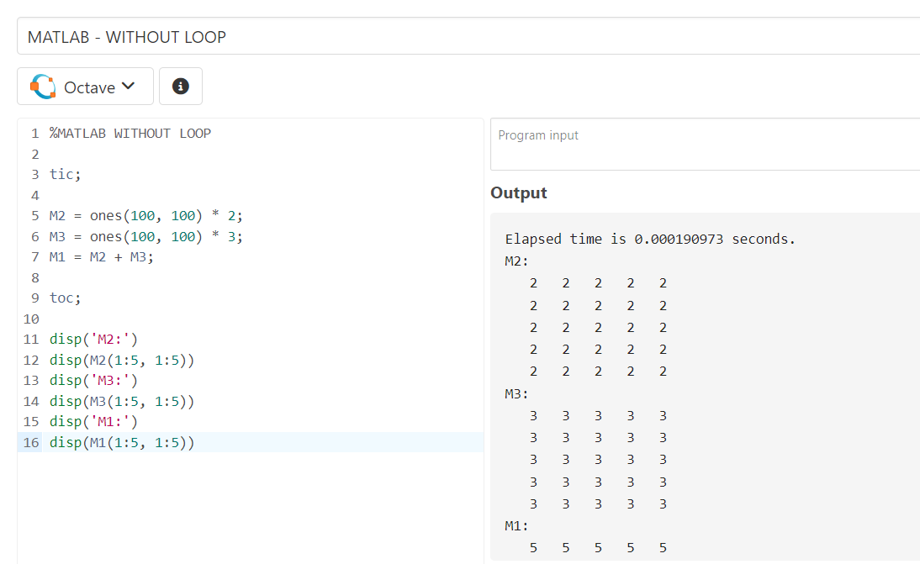

Row Major in MATLAB:

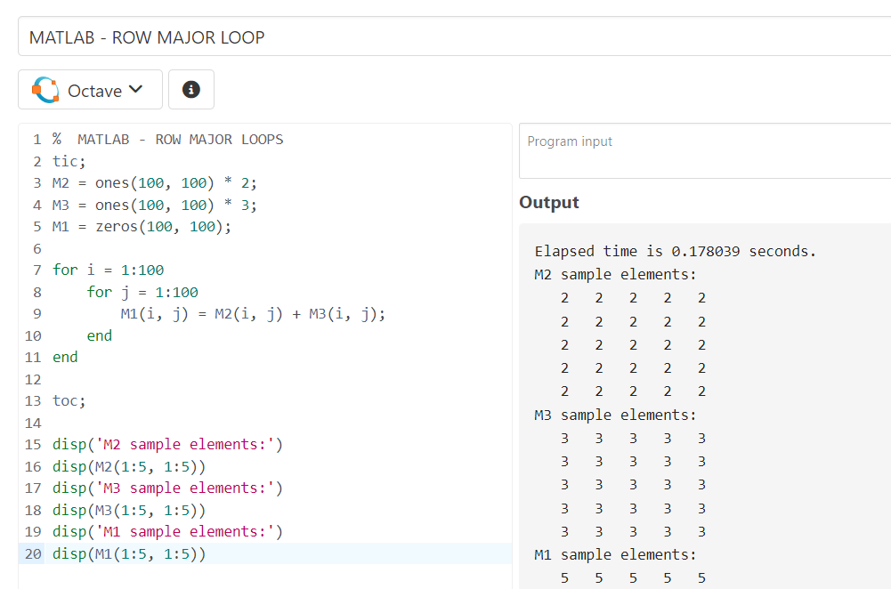

Column Major in MATLAB:

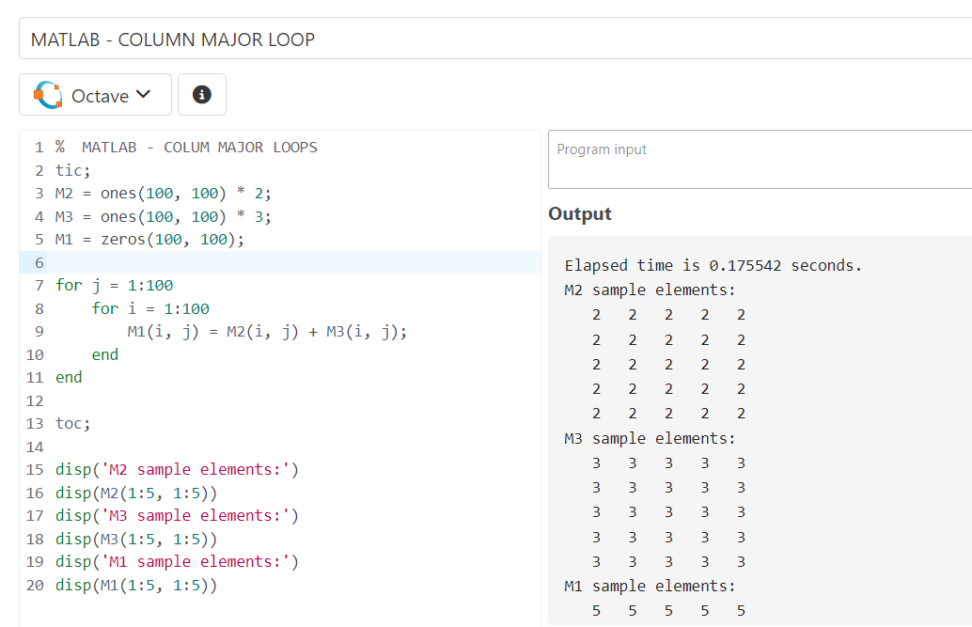

# Python – List

Without Loop in Python – List:

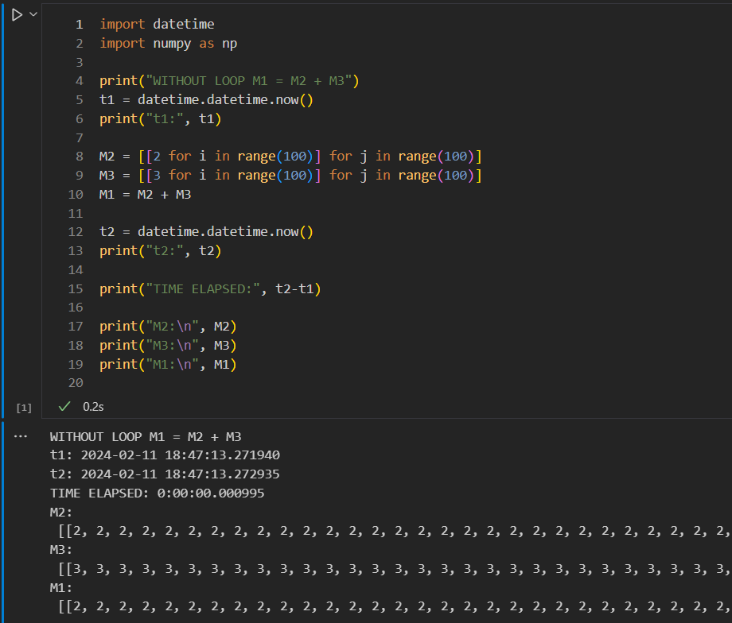

Row Major in Python – List:

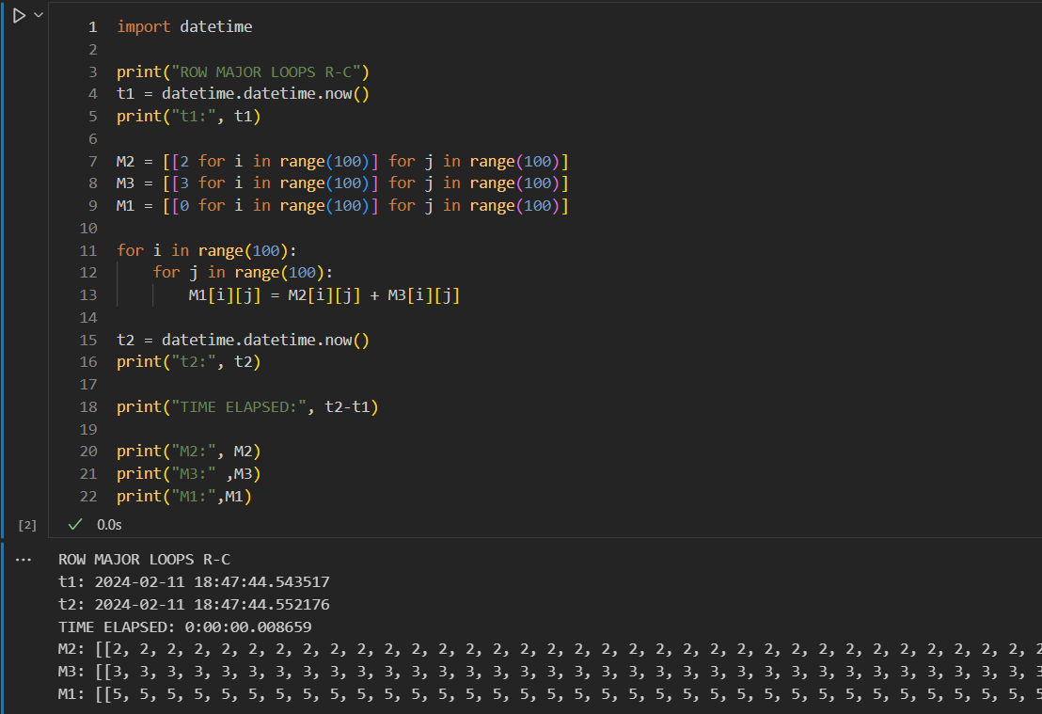

Column Major in Python – List:

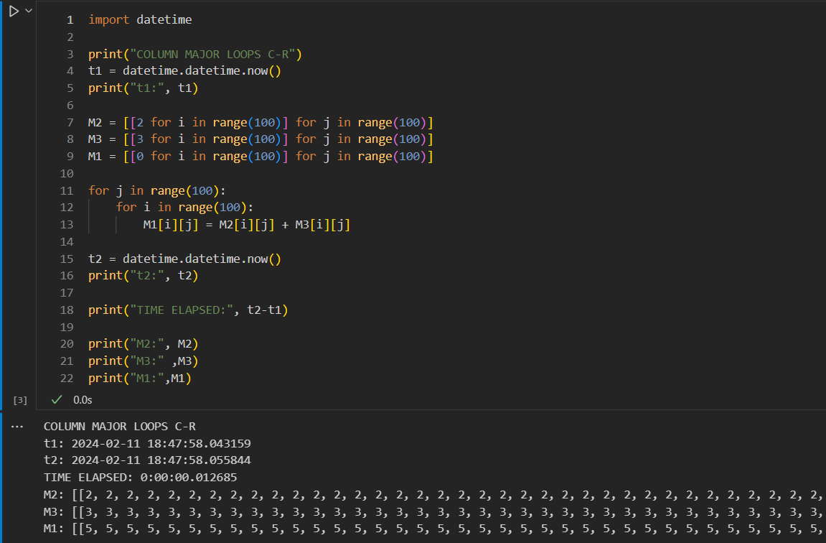

# Python – NumPy

Without Loop in Python – NumPy:

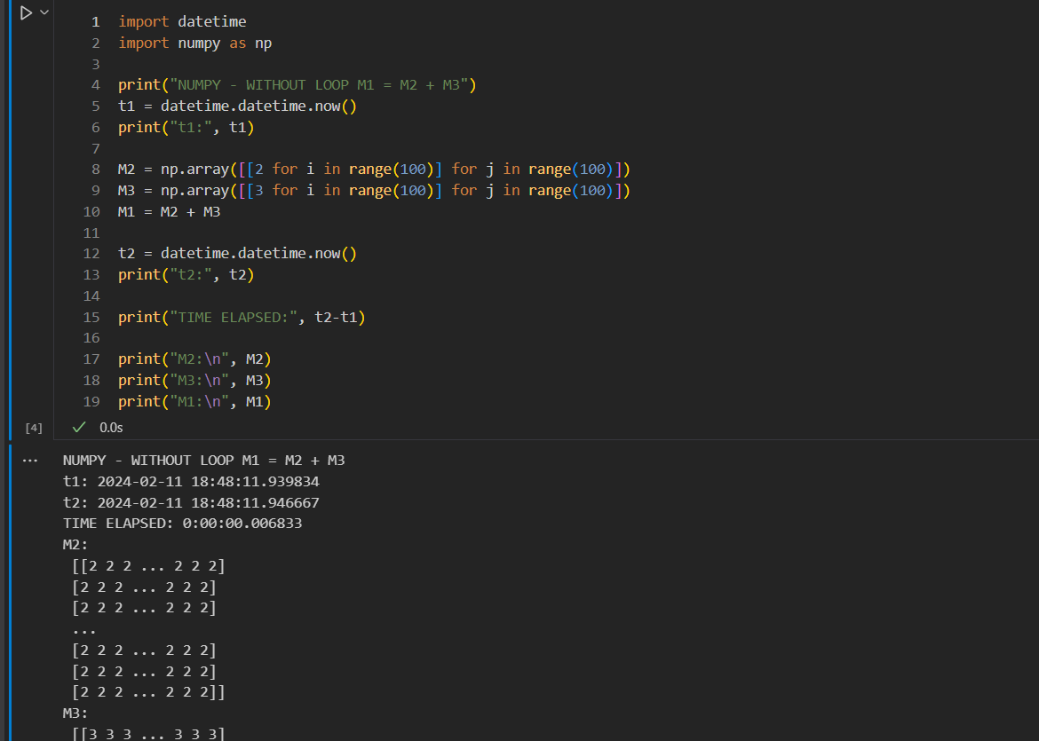

Row Major in Python – NumPy:

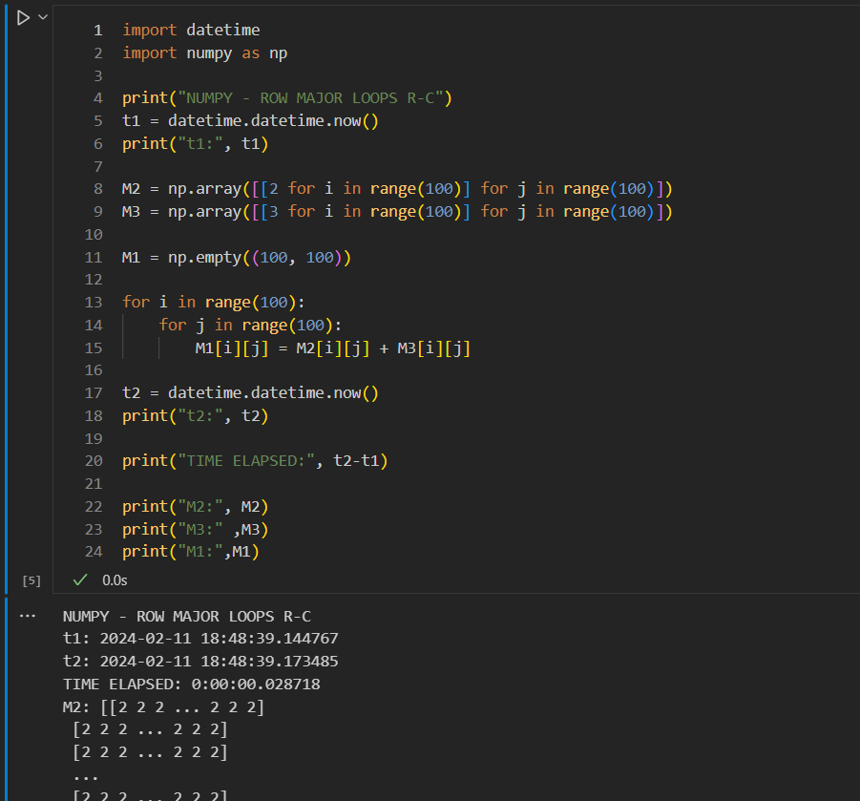

Column Major in Python – NumPy:

