III Year – I Semester

CONTINUOUS INTEGRATION AND CONTINUOUS DELIVERY USING DevOps
(Skill Oriented Course)

DEPARTMENT OF COMPUTER SCIENCE ENGINEERING

List of Exercises:

Note:Thereareonlinecoursesindicatedinthereferencelinkssection.Learnersneedtogothroughthecontentsinordertoperformthegivenexercises

Exercise1:
Referencecoursename:Softwareengineeringand Agilesoftwaredevelopment
Get an understanding of the stages in software development lifecycle, the process models, values andprinciples of agility and the need for agile software development. This will enable you to work in projectsfollowing anagileapproachtosoftwaredevelopment.
Solvethequestionsgiveninthereferencecoursenametogaugeyourunderstandingofthetopic

Exercise2:
Referencecoursename:Development&TestingwithAgile:ExtremeProgramming
GetaworkingknowledgeofusingextremeautomationthroughXPprogrammingpracticesoftestfirstdevelopment,refactoring andautomatingtestcasewriting.
Solvethequestionsinthe“Taketest”modulegivenin thereferencecoursenametogaugeyourunderstanding ofthetopic

Exercise3:
Modulename:DevOpsadoptioninprojects
It is important to comprehend the need to automate the software development lifecycle stages throughDevOps. Gain an understanding of the capabilities required to implement DevOps, continuous integrationand continuousdeliverypractices.
SolvethequestionsgiveninQuiz1, Quiz2, Quiz3

Exercise4:
Modulename:ImplementationofCICDwithJavaandopensourcestack
ConfigurethewebapplicationandVersioncontrolusingGitusingGitcommandsandversioncontroloperations.

Exercise5:
ModuleName:ImplementationofCICDwithJavaandopensourcestack
Configure a static code analyzer which will perform static analysis of the web application code andidentify the coding practices that are not appropriate. Configure the profiles and dashboard of the staticcode analysistool.

Exercise6:
ModuleName:ImplementationofCICDwithJavaandopensourcestack
Write a build script to build the application using a build automation tool like Maven. Create a folderstructure that will run the build script and invoke the various software development build stages. Thisscript should invoke the static analysis tool and unit test cases and deploy theapplication to a webapplicationserverlikeTomcat.

Exercise7:
ModuleName:ImplementationofCICDwithJavaandopensourcestack
ConfiguretheJenkinstoolwiththerequiredpaths,pathvariables, usersandpipelineviews.

Exercise8:
Modulename:ImplementationofCICDwithJavaandopensourcestack
Configure the Jenkins pipeline to call the build script jobs and configure to run it whenever there is achangemade to an application in the version control system. Make a change to the background color ofthe landing page ofthe webapplicationand checkifthe configuredpipeline runs.

Exercise9:
Modulename:ImplementationofCICDwithJavaandopensourcestack
CreateapipelineviewoftheJenkinspipelineusedinExercise8.Configureitwithuserdefinedmessages.

Exercise10:
Modulename:ImplementationofCICDwithJavaandopensourcestack
IntheconfiguredJenkinspipelinecreatedinExercise8and9,implementqualitygatesforstaticanalysisofcode.

Exercise11:
Modulename:ImplementationofCICD withJavaandopensourcestack
IntheconfiguredJenkinspipelinecreatedinExercise8and9,implementqualitygatesforstaticunittesting.

Exercise12:
IntheconfiguredJenkinspipelinecreatedinExercise8and9,implementqualitygatesforcodecoverage.
Modulename:Courseendassessment

Exercise1
Aim: Understanding of the stages in software development lifecycle, the process models, values and principles of agility and the need for agile software development.

Procedure:
Software Engineering:
Need of software engineering: -
- Vision of the project and outcomes
- Clarity on requirements
- Analysis and design
- Development
- Testing
- Deployment and maintenance. SoftwareEngineering Concept: -Software Crisis: -
- Time and cost slippage
- Failure at customer’s site
- Untraceable errors after delivery
- Difficulty in maintenance
- Information leak when multiple stakeholders at play. Definition:-
It is the application of a systematic, disciplined, quantifiable approach to the development, operation maintenance of software i.e., the application of engineering to software.
Lifecycle:-
1. Requirements:-capturerequirementsfromstakeholders2.Design: -Arrive at the high-level design of software3.Coding:-Translate design to code
4. Testing: -Validate requirements against code developed5.Deployment: -Deploy software in customer environment6.Maintenance:-Support customer on post-production issues

Models:-
A conceptual framework which describes activities in a project end-to-end
1.Waterfall
2.Prototyping3.Spiral
4.Rapid application Development
Project Roles:-
- Project Sponsor
- Business Team
- Developers
- Tester
- Support Team
- Designer
- Architect
- Project Manager

Agile software Development:
Why Agile:
- Responding to changes quickly with quality
- Quick time to market
- Develop software amidst requirements volatility

Benefits:
- Faster time to market
- Quality software
- Adopt to changes quickly
- Sustainable development admits uncertainty

Principles:
- Our highest priority is to satisfy the customer through early and continuous delivery of valuable software.
- Welcome changing requirements, even late in development. Agile process harness change for the customer’s competitive advantage.
- Delivery working software frequently, from a couple of weeks to a couple of months, with a preference to the shorter time scale.
- Businesspeopleanddevelopersmustworktogetherdailythroughouttheproject.
- The most efficient and effective method of conveying information to and within a development team is face-to-face conversation.
- Build project around motivated individuals give the environment and support they need and trust them to get the job done.
- Working software is the primary measure of progress.
- Agile processes promote sustainable development. The sponsors, developer’s and users should be able to maintain a constant pace indefinitely.
- Continuous attention to the technical excellence and good design enhances agility.
10. The best architecture, requirements and design merge from self-organizing teams.
- At regular intervals, the team reflects on how to become more effective, then tunes and adjusts its behavior accordingly’
- Simplicity — the art of maximizing the amount of the work not done-is essential.

Exercise2
Aim: Exploring the working knowledge of using extreme automation through XP programming practices of test first development, refactoring and automating test case writing.

Procedure:

Extreme Programming:
Get a working knowledge of using extreme automation through XP Programming practices of test first development, refactoring and automating test case writing.

Extreme Programming (XP):
Will use Git which is a source control tool to be using in Extreme Programming. It provides 12 practices such as code refactoring continuous Integration etc.
Methodology to integrate Agile into Software Development for an efficient and dynamic team.

Extreme Programming Concepts:
  - Quality Improvements
  - Process Improvement
  - Customer Satisfaction Improvements

Advantages:
- Focuses on Key activities
- Cost and time efficiencies
- Reduces risks
- Uncomplicated
- Transparency
- Ongoing feedback
- Focuses on customer needs
- Equal Accountability

Roles:

  - Customer: Asks for his requirements
  - Tracker: Checks whether the task is going on properly
  - Developer: Understand customer requirements and start coding
  - Coach: Guides the development team and customer to go in a proper way

Practices:
  - Communication: Communicating with customer properly
  - Simplicity: Easy to understand
  - Feedback
  - Courage: Discuss about a project to the company head
  - Respect

- Whole team
- Sir together
- Informative workspace
- Energized work
- Pair Programming
- Stories
- Weekly and quarterly cycles
- Slack
- Ten-minute build

Extreme Programming use case:
- All activities performed throughout the development
- Iteratively builds
- Resilience
- Enable changes

Planning:
  - Plan
  - Design
  - Code
  - Test

Feedback:
  - Customer acceptance tests
  - Project Manager

Planning Game Practices:
- Organized meeting
- Ensures quality improves design
- Promotes effective project management
- Two parts- release planning and iteration planning

Release Planning:
  - Customer
  - Software developer

Release Planning-Exploration Phase:
- What software
- How It works

Planning-Commitment phases:
    - Functionality
    - Release date

Game parts and phases
      - PLANNING GAME
- Release Planning
- Iteration Planning

Release Planning
  - Exploration

Commitment
  - Steering2.IterationPlanning

Exploration
- Commitment

Steering Planning-Steering phase
- Adding
- Reviewing
- Revising

Iteration Planning Exploration:
- Refine users to record requirements
- Translate requirements into tasks
- Create task cards

Iterative planning-Commitment phase:
- Assign tasks
- Determine duration

Iteration Planning-Steering phase:
- Complete tasks
- Validate design
- Evaluate design
- Adjust

Pair Programming
- Two programmers
- Shared workstation
- Regular role switching

Benefits
- Increase quality of code
- Grows collective team knowledge
- Enables skills transfer to more experienced development
- Reduce coordination efforts
- Improves coding resiliency

Skills level:
- Beginner
- Intermediate
- Advanced

Disadvantages:
  - Requires active engagement by both participant
  - Potential cost increase
  - Requires good communication
  - Requires good relationship between the participants

Code Check Options:
  - Pair Programming
  - Instant and regular code review
  - Require both programmers
  - Shared Understanding
  - Real-time correction
  - Reduces risks

Code Reviews
- Separate programmer looks at code at a later time
- Testing, quality, control

- Limited understanding after act

Effective of Pair Programming
- Can be advantageous if used correctly
- Requires understanding different styles and how they each work
- Different scenarios require different styles of Pair Programming
- Six common styles of Pair Programming

Back-Seat Navigation:
  - Tactical focus
  - Both tactical and strategic

Ping-Pong Pairing:
- One developer purposely writes a falling test
- Second developer focuses on getting it pass
- Then roles switch

Test Driven Development Benefits:
  - Design
  - Coding
  - Testing

Test Driven Development Benefits:
  - Helps you build every buy notification capability
  - Increased design efficiency
  - Provides re factor confidence
  - Enables collaboration
  - Reduces debugging and development time

Levels:
- Acceptance Test Driven Development
- Developer Test Driven Development

Comparing Testing Approaches:
- Ensures confirmatory-level testing
- Verifies system meets defined requirements
- Focuses on production code to verify testing
- Tests every lines of code

- Traditional Testing
- Focuses on test case design

Considerations:
  - Not fool proof
  - Requires full team collaboration
  - Slower process

Source Control Management (SCM) and Tools:
  - Tracking and managing
  - Ensuring version control

Benefits:

- Maintains single source
- Facilities collaboration
- Accelerates velocity

SCM Best practices:
  - Select the most appropriate system for your needs
  - Store your code directly in the system
  - Always pull latest versions of code
  - Ensures you commit code often, including details
  - Make use of branches for parallel work

SCM Tools:
  - GIT-Set of Commands-Github repository
  - Perforce Metrix core
  - Sub Version
  - Clear cases
  - Team foundation server
  - Mercurial

GitHub Steps:
- Openbrowserhttps://GitHub.com
- Creates repository of repository name is your name
- A repository with a name xxxxx will be created. Now, In this repository it haveonefilereadmemid..Readmefileslistsandallthefieldsincurrentdirectory

- In GitHub main branch will be the root branch. To this branch, any number of sub branch scan be created.
- Let's create a new application code and save it in repository
  - Clone to repository on the local machine
  - Now download GitHub desktop
  - Open GitHub desktop and click on clone repository from the internet
  - It asks which repository is to be cloned and select the repository and then click on "Clone".

Continuous Integration:
    - Prevent code overlap
    - Remote Integration issues

Benefits:

Risks:

Benefits:

- Rapid time to market
- Faster development lifecycles
- Increased quality
- Better risk mitigation

- Costs for maintaining and managing
- Requires established guidance before use
- Lack of experience
- Requires full test coverage
- May mid guide team focus

- Requires commit code
- Categorize developed tests
- Use a dedicated machine
- Integrate continuous feedback
- Stage your build

Continuous Integration in Actions

Coding standard practice and Benefits Coding Standards
  - Consistency
  - Manageability

Coding standards benefits:
  - Reduced rates of failures
  - Development time optimization
  - Simplified debugging
  - Cost controls

Coding standard categories:
  - Mandatory
  - Guidelines
  - Recommendations

Coding standard Elements:
  - Format
  - Code structure
  - Naming conventions
  - Error Handling
  - Comments

Coding standard Best Practices:
  - Understand the purpose
  - Consider your industry
  - Comply with rules and follow recommendations
  - Describe intent
  - Update carefully

  - Consider open vs. closed
  - Prioritize rules
  - Plan for deviations

Collective code Ownership:
  - Team produces quality product
  - Every team member quality responsible

Knowledge Sharing:
  - Eliminate critical knowledge silos
  - Promotes collective learning

Code Excellence:
  - Increased quality
  - Style efficiency

Remove dependencies on Individuals:
  - Eliminates the risk of the lottery "effect"
  - Promotes collective responsibilities

Efficient code Reviews:
One knows truly knows solution

Greater learning Scope:
  - Continuous learning
  - Shorter learning time

Collective code Ownership Disadvantages:
  - No Individual Ownership
  - Relies on team expertise
  - May hinder motivation
  - Not suited for Specialized functions

Code Refactoring:
  - Editing without changes to function
  - Code efficiency
  - Prevent bugs in future

  - Avoid code rot

Refactoring Benefits:
  - Maintainability
  - Extensibility

Refactoring Techniques:
  - Red/green
  - Refactoring by abstraction
  - Composing method
  - Simplifying method
  - Preparatory
  - Moving features between objects

Refactoring process:
  - Identify
  - Conduct
  - Test
  - Repeat

Refactoring Best Practices:
  - Decouple(test you know)
  - Consider infrastructure
  - Plan

Refactoring in Agile Software Development
  - Improves software consistency
  - Helps fix bad code
  - Increases time efficiencies
  - Increases Simplicity
  - Evolves iteratively

The problems
  - Older code with duplication
  - Updates by many developers over years
  - Multiple variations for similar products
  - Difficult to understand
  - Starting to experience unintended side effects with new updates

Restructuring:
  - Reduce duplication
  - Resize classes and methods

Addressing Duplication:
  - Extract
  - Replace

Simplifying
  - Adding new code in the future
  - Replacing code later

Small Releases:
  - Deliver value fast
  - Quick feed back
  - Quick wins for team
  - Reduces risks
  - Build adaptability

Prepare
  - How iteration occur
  - Time intervals

Meet & Discuss
  - Evaluate
  - Identify team goals and strategies

Iteration Details
  - Value to customer
  - Maximum two weeks between iterations
  - Quality

Apply Lessons Learned
  - Incorporate feedback
  - Experiment
  - Add new features

System Metaphor
Changing standard project architecture names to easily understood non –technical terms of phrases

System Metaphor Goals
  - Common vision
  - Generatively
  - Shared vocabulary
  - Architecture

Advantages
  - Enables easier system understanding
  - Enables model comprehension
  - Expands range

Disadvantages:
  - May break cultural protocols
  - May make users avoid systems
  - May create conflict
  - May lead to using bad designs

Best Practices:
  - Single view
  - One structure type
  - Clear design guidance
  - System properties focus
  - Shared experience

Applyingthe40-hourworkweek
- The practice of not requiring programmers or software developers to work morethan40 hours per week or work overtime two weeks in a row

Key Concepts
  - Team members work best when we'll- rested
  - Requires frequent code merging
  - Quality code is required
  - Frequent code development minimizes risk

Benefits
  - Creative thinking time
  - Time for quality
  - Cross-training
  - Problem exposure

Considerations
  - Development
  - Quality
  - Delivery
  - Improvement

Determining sustainable pace
  - Experiment
  - Increase slowly
  - Track

Course Summary
    - Extreme Programming
    - Planning Game Practices
    - Pair Programming
    - Test-Driven Development
    - Customer Role practice
    - Source Control Management and Coding standard
    - Continuous Code Ownership and Code Refactoring
    - Small Releases and System Metaphor
    - The40 –hour work week

Exercise3:
Aim: Comprehend the need to automate the software development lifecycle stagesthrough DevOps. Gain an understanding of the capabilities required to implementDevOps,continuousintegrationandcontinuousdeliverypractices.

Procedure:
Dev-opsAdoption inProjects:
It is the important to comprehend the need to automate the software developmentlifecycle stages through Devops, gain an understanding of the capabilities required toimplement Devops,CI,andCD

Devops:
Itisthecombinationofdevelopmentteamandoperational team.
- Versionsourcecode
- Codequalityanalysis
- Unittesting
- Codecoverage
- Createexecutable
- Baselinetheexecutable
These activities are done in continuous integration of pipeline.Testandtestdatamanagementautomation:
  - Functionalitytest
  - Testandtestdata management
  - Performancetest
  - Securitytest
They are the different test done by development and delivery pipeline.Continuousdeliveryandautomation:
CD allows constant flow of changes into production through automated softwareproductionpipelinecalledCDpipeline.
Infrastructurelayerandenvironment management:
This provides required infrastructure for development.Thisinfrastructurecanbe managedbytoolcalledaschef.
Chef:helpsinspinning of virtual machinesynchronizedthemand madechangesacrossmultipleservers.

Operationsteam:
Operational team contains 2 types of dash boards to measure devops adoption andhealthofpipeline.
- Businessperformancedashboard
  - Depicttherevenueand speedof deploymentdefectstatus.
- Enduserdashboard
  - ProvidecodeaswellasAPIto executable.

Toolsstackanditsimplementation:
1.Continuousintegrationandactivitiesinvolved.

Tools:Continuousintegrationlifecyclestage:
  - Versioncontrol: Git
It is an open-source tool which is free of cost, eclipsed IDE also open-source toolwhichcontaine-gitplug-in.
  - Staticcodeanalysis:SonarQube
ItisanOpensource,freeandpowerfultool.
  - Unittest: unit
Asitisintegratedwiththeeclipse IDE
  - Buildautomation:Maven
Very powerful, integrated with eclipse IDE used for coding and helps writeCompactscripts.It iscompactablewiththetools mentioned.
  - Artifactrepository: artifactrepositorysupportsMavenfreeandopensource.
  - ContinuousIntegration:Jenkinsfree,opensource,powerfuland
  - integrateswithallthetoolsmentioned.

Exercise4
Aim: Configure the web application and Version control using Git using Gitcommandsandversioncontroloperations.
Tools Required: Git, Github cloud account, Internet connection, browser, GithubDesktop(optional).

Theory:
Github: GitHub is a website and cloud-based service that helps developers store andmanagetheircode,aswellastrackandcontrolchangestotheircode.

Procedure:
Step-1:Openyourbrowserandsearchforgithubandclickonlink:https://github.com/
Step-2: Now sign with your existing GitHub credentials or sign up for a new GitHubaccount.
Step-3: After sign-in click on new to create a new repository. Add your name to yourrepository and check on add a readme file and click on create repository. It creates anewrepository.
Step-4: And then install Git in your Pc by using the link: https://www.git-scm.com/AndthenafterinstallationcompleteopentheGit-bash.
Typethesecommands:
Step-5: After login with your credentials and type these commands to commit the file.Step-6:Nowpushthefiletocloud repository.Soweusethecommand.

Step-7: Now open the github cloud and click on compare and pull request and then allfilesarestoredinmasterbranch.
Step-8: Now create a new branch and again step those files in that branch.Thecommandsare:

Nowwepushedthefilesintothe newbranch namedbranch1.
Letcheckitatgithubcloubwhetherthebranchiscreatedandfilesarepushedor not.

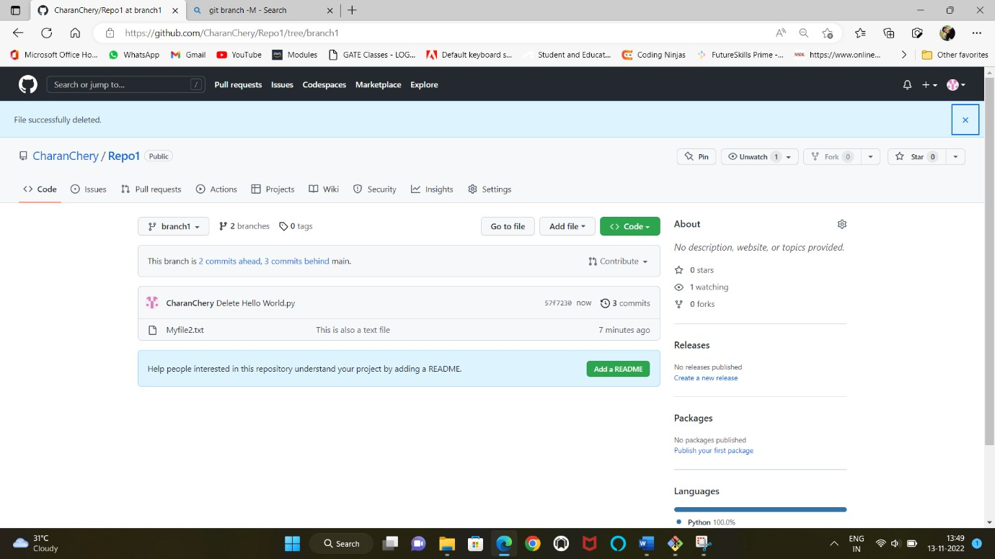
Thebranchiscreatedandthefileisalsopushed.
Step-9: Now we clone the files into a one new directory(i.e in Local repository) fromgithubcloudrepository
Thecommandsare:

Aftercloningthefiles checkthefileswhethertheyareopeningornot.

Conclusion:
We learned how to use the github cloud and their git commands to push the files tocloud repository, creating a new branch, and cloning the files from github cloud tolocalrepository.

Exercise5
Aim:Configureastaticcodeanalyzerwhich willperformstaticanalysisofthewebapplication code.
Tools Required: SonarQube 7.9.6 LTS, Java 11, Sonar Scanner 4.7, Eclipse IDE,InternetConnection.

Theory:
Static Code Analysis: Analysing the code without executing is called static codeanalysis.
- For performing static code analysis we are using SonarQube which is a webpageopensourcetooltomanagecodequality.
SonarQube: SonarQube checks the code whether the comments, coding rules arefollowedcorrectlyandproperlyornot.
- Checksforcodecomplexity.
- Checksforduplication incode.
- Itcoversonlythe C,C++,JavaLanguages only.
- It has a list of built-in rules for different programming languages and theserulesare called Profiles.

Procedure:
Step-1: Go to any search engine and type Download SonarQube 7.9.6 or go to thislink:https://binaries.sonarsource.com/Distribution/sonarqube/sonarqube-7.9.6.zip
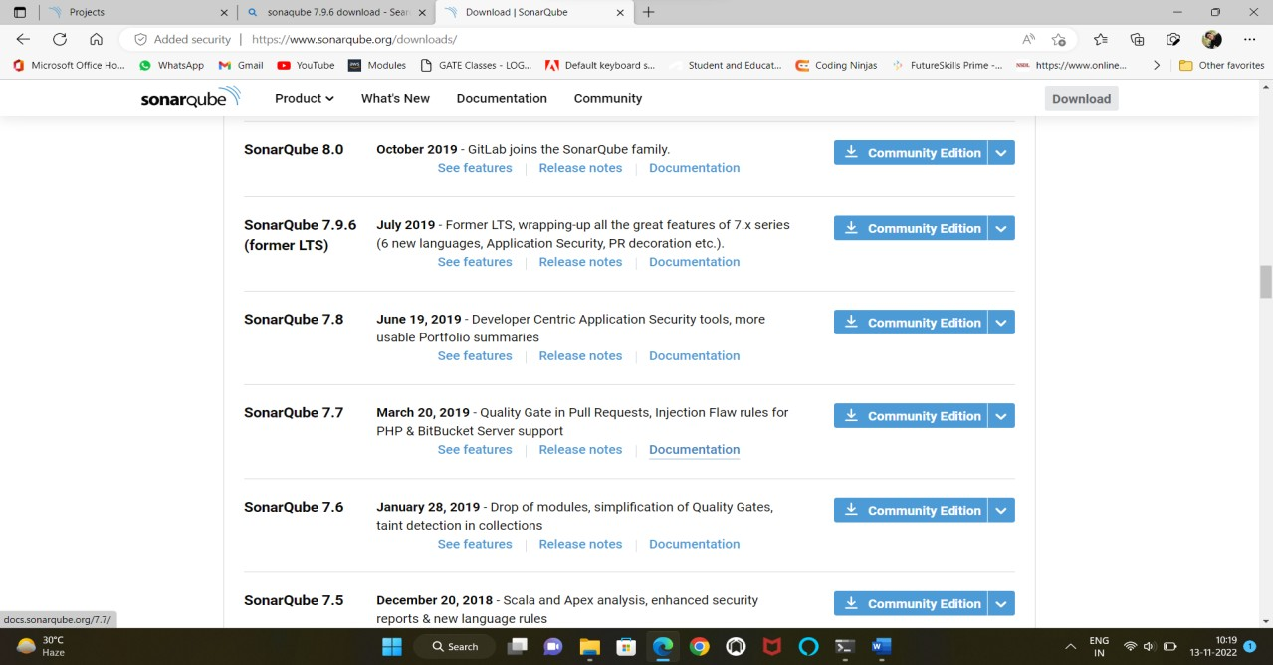

Step-2: After completion of downloading extract into a specified folder. And open theextracted SonarQube 7.9.6 folder and click on bin and copy the path of folder uptoBIN.
in mycase:E:\sonarqube-7.9.6\bin)
Step-3: Go to Settings (for Windows 10 or Windows 11) and click on System and goto about -click on Advanced System Settings and click on Environment variables andon system variables go and edit the path and add new path by clicking New and pastethepathofSonarQubeextractedfolder.
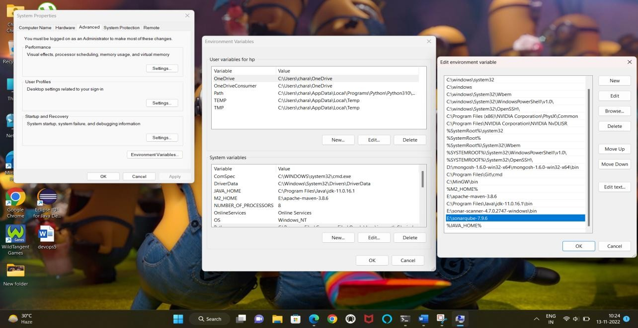
Step-4: Download Eclipse IDE from Official website:https://www.eclipse.org/downloads/
Andinstall the Eclipse IDEforJavaDevelopers.

Step-5: After installing open the Eclipse IDE and click on File and click New to createtheJavaProject.
Givetheprojectnameanddetails ofprojectandclickonfinish.
Step-6: After creating the java project and then right click on your project folder andclickonnew to createaClassfile.

Givethedetailsof classandclick onfinish.

InSrcfoldercontainsthemainclassfileandwriteyourcodeonthat fileandsaveit.

Step-7: Right click on SonarProj1 (or your project name) and click on properties andcopythepathofyourprojectworkspace.
And then again open the browser and search for SonarScanner 4.7 and download it.And extract the folder at one place (or you can extract the file where you have extractSonarQubefile).AndcopythepathofyourSonarScannerfolderuptoBinfolder.
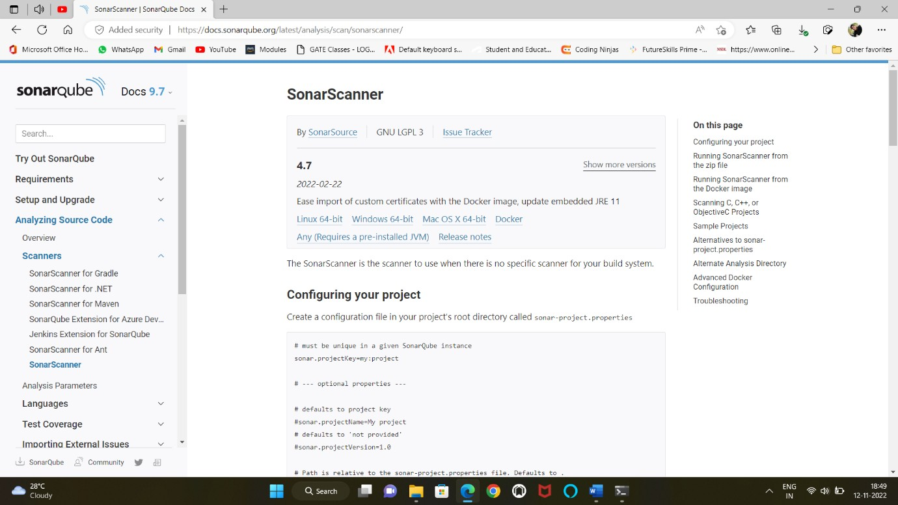

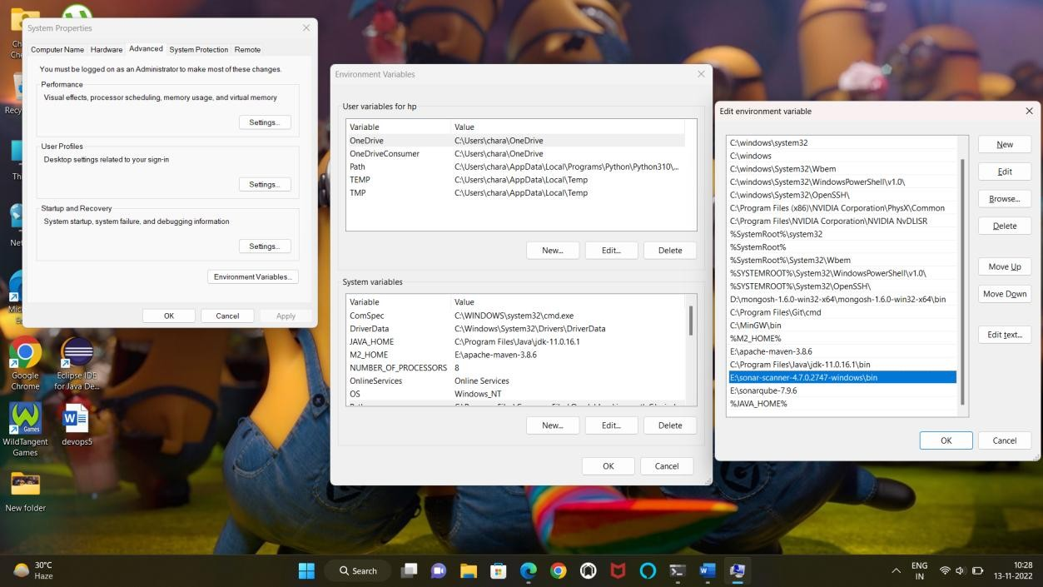
Step-8: And again open the Sonar-Scanner folder after that click on conf folder andtheneditthe“sonar-scanner”fileineithernotepadorVScode.
Addthesecontentstothatfilewithoutdeletinganycontentsinthatfile.
For myprojectmycredentialswill beaddedas:

Step-9: To run the Sonar-Scanner open the command prompt and change the directoryofSonarQubeuptobin/windows-x86-64/
Step-10: From here onwards we must run the SonarQube-7.9.6 on Jdk 11 (or) JavaSE11.Souninstalland deletethepathinenvironmentvariablesofhigherversionorlowerversionsofjava.
Java SE 11: https://www.oracle.com/in/java/technologies/javase/jdk11-archive-downloads.html#license-lightbox

AndafterinstallationofJavaSE11thensetuppathofjavainEnvironmentvariables.And then type in command prompt where the path is at SonarQube up-to windows-x86-64thentypethiscommand:
>StartSonar.bat
Step-11: After getting the script like Process[ce] is up and SonarQube is up andthenopenyourbrowserandtypethisURL:http://localhost:9000
- Where this URL was found in SonarScanner folder->conf folder->sonar-scannerfile.

- In that file it contains “sonar.host.url” where the URL was default to that filewherewecanchangewhenwewantinthatfile.
Step-12: And now open the another command prompt window and then change thedirectorytoyourprojectworkspacewhichislocatedateclipseworkspacedirectory.
Myprojectworkspacecanbeseenateclipsealsoi.e:
Andthenchangethedirectorytoprojectdirectoryincommandprompt:

Andthentypethis commandincommand prompt:sonar-scanner.bat

WaitfortillitgetsEXECUTIONSUCCESS.

Step-13:NowopenyourbrowserwhichispreviouslythatweopenedthatSonarQubeserver, refresh it and then see the projects and click on the project to see the status ofproject.
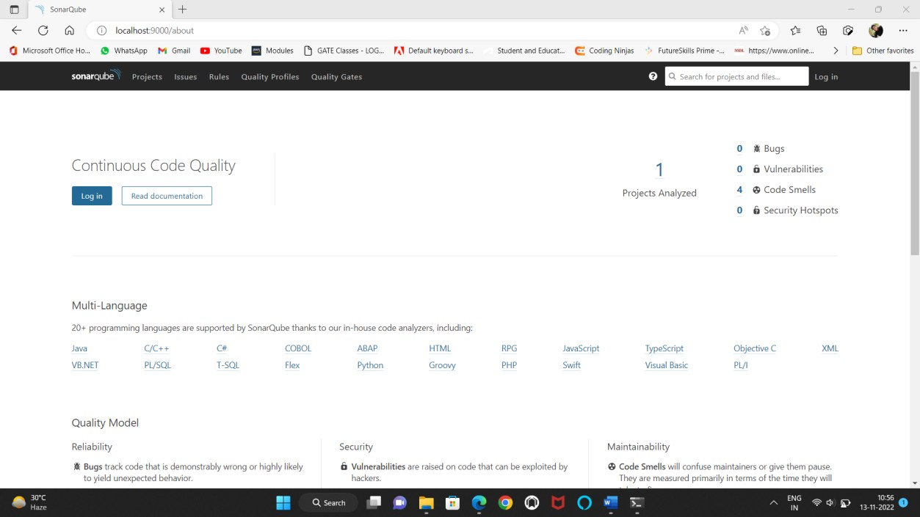
Step-14:AsthatIwashighlightedinaboxclickon1ofprojectsanalyzedtoseethestatus.Andclickonyourprojectnametoseethefullstatusasgivenbelow.

Step-15:Ifthereisanyerrorsareoccurredinprojectthenitdisplays aslike:
Ihavecreated anotherprojectnamed sonarProj2andIcreatedaclasswithnamed
smileyProj2with someerrors.
And I am following above same process upto opening of SonarQube. Now I amconfiguringthe sonar-scanner.propertiesfilewiththedetailsof project:
And I executed with sonar-scanner at sonarProj2 project directory and then nowcheckat SonarQubewhether itraises anyerrors or not:

And now open the SonarQube server webpage to see the project is added or not:Yestheanotherwassuccessfullyadded.Clickon2toopentheprojects.

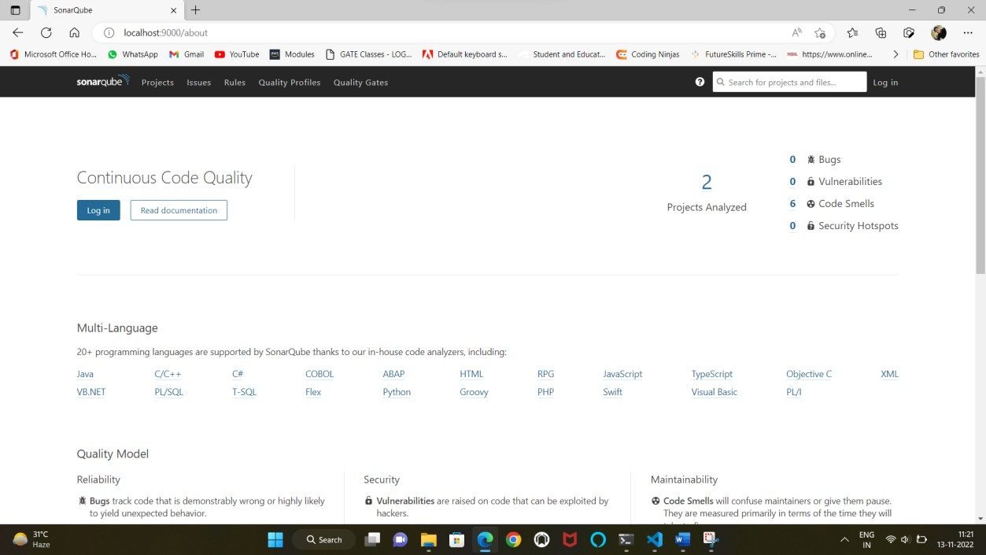
Clickonissuestocheckwhatissuesareraised.

Inthebelowphoto itshowsusissuesanderrorsinthefollowing code.

Conclusion:
We concluded that we had learn on how to do the static code analysis with SonarQubeandwithsonar scanner.

Exercise6:
Aim: Write a build script to build the application using a build automation tool likeMaven. Create a folder structure that will run the build script and invoke the varioussoftwaredevelopmentbuildstages.
Tools:EclipseIDE,ApacheMaven(version:3.8.6)

Theory:
Maven:Amavenisa buildtool thathelpsin project management. Thistoolhelpsinbuildinganddocumentingtheproject.
- Mavenisa buildautomationtool writteninJavaandC#andthisisbasedon

ProjectObjectModel(POM).
- POMisfundamentalunitin maven.ItisanXMLfilewhichresidesinthebasedirectoryofourproject.
- When we execute a maven project it searches for the POM in the currentworkingdirectory.
- POM contains:1.Project Dependencies2.Plugins
- Buildprofiles

MavenbuildLifecycles:
- Clean:Itcleansthetargetdirectoryfortodeploytheproject.
- Validate: It will checks whether the project is correct and by checking all thenecessaryinformation.
- Compile:Compilethesourcecodeofproject.
- Test:Testthecompiledsourcecodeusingasuitableunittestingframework.
- Package: Take the compiled code and package it in its distributable format, such asaJAR.
- Install:Installthepackageintothelocalrepository,foruseasadependencyin otherprojectslocally.
- Deploy:Doneinthe buildenvironment,copiesthefinalpackagetotheremoterepositoryforsharingwithotherdevelopersandprojects.
Eclipse:Eclipseisan IDE(IntegratedDevelopmentEnvironment)fordevelopingjavaprojects.

Procedure:

MavenInstallation:

  - It is an open-source and which can be downloaded from website:https://maven.apache.org/download.cgi
  - Gotofilesinthatlink givenaboveandcheckforthenameBinary ziparchive
andclickon thelink: apache-maven-3.8.6-bin.ziptodownloadit.
  - Afterdownloadingthe zipfileextractitinaspecifieddirectorypath.
  - Settingup EnvironmentVariables(Windows 10or11):
    - GotoSettings->Systemand then gotoAboutandthenclickon

AdvancedSystemSettings
    - And then it opens System properties and then click on Environmentvariables-> go to System Variables ->under system variables click onNewandGivethevariablenameandpath.

VariableName: M2_HOME
VariableValue:E:\apache-maven-3.8.6 //(asper mydriveisE)

    - And click on ok and then go to variable Path ->and click on new underpathvariabletabandandgivethenameas%M2_HOME%
    - And paste another path of maven up to bin folder: E:\apache-maven-3.8.6\bin

    - Andthen Clickok->ok->ok.
  - And then open command prompt to check if it correctly installed its path inenvironmentvariables.
  - Typethecommand incommandpromptas‘mvn-version’
  - Ifitdisplays asaboveformatthentheMavenissuccessfullyinstalled.

Deployinga Mavenproject:
Step-1: Open Eclipse IDE and click on File -> New -> Other -> MavenProject->Use defaultworkspace location->Next

Step-2:AfterclickingNext->Selectanarchetype ->Filteritby:
“org.apache.maven.archetypes” and select it with maven-archetype-quickstartasartifactid withversion1.4.
And give the group-id and and artifact id of project and click finish todemonstratethe maven projectin EclipseIDE.

Step-3:UnderMavenApplicationwehave2folders:
- src/main/java:Thisfoldercontainsallthejavafilesrequiretoruntheproject.
Bydefault it containsafilenamed asApp.java
- src/test/java:Thisfoldercontainstestfilestotestthejavaprogramswhicharethereinsrc/main/java.
- JRE System folder contains predefined libraries and packages to run the javaapplication.
- MavenDependencies:Itcontainsrequiredmavendependenciestorunaswellas totestthe app.
- Targetfoldercontains:1.Classfiles2.jarfiles

Step-4:ToruntheMavenApplication wemustensurewithlifecycles:
Right click on Project Name (i.e: MavenApplication in my case) -> click onoption Run As ->click on Maven Clean where it run and shows as BUILDSUCCESS

And then click 4th option in Run As i.e: Maven Build and give the goals asvalidatetovalidate and clickrun

After that again click on 4th option in Run As i.e: Maven Build and give thegoals as compiletocompile it andclickrun.

Aftercompleting3lifecyclemethodswithBUILDSUCCESSthenclick
RunAs->MavenInstall ->Andthenitgeneratesthe.jarfileintargetfolder.
Before the maven install lifecycle the target folder is empty where as bylifecycle of install the target contains files of built project with “projectname-0.0.1-SNAPSHOT.jar”

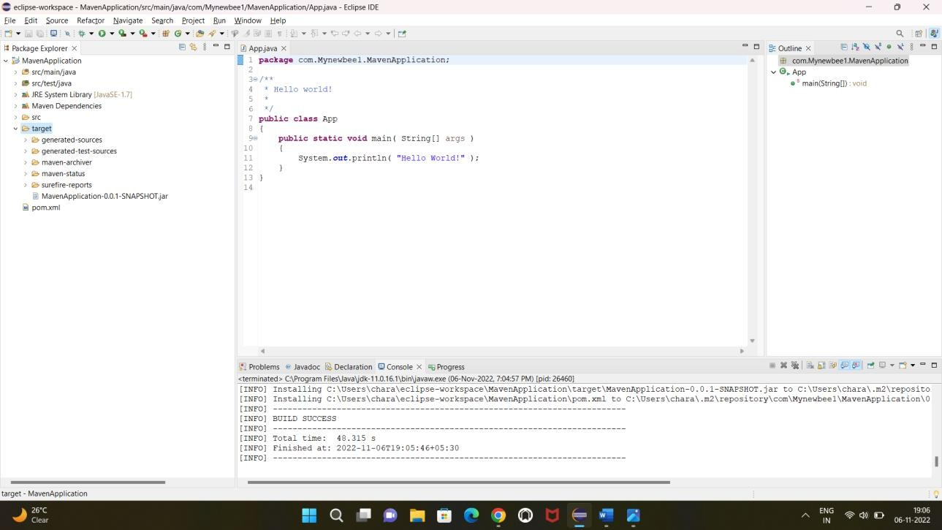

Step-5:Toruntheclassfilewhichislocatedattargetfoldernamedwithclassesdirectory.
Paste the path upto classes directory in command prompt and click thecommand torunthe classfile as
>javacom.Mynewbee1.MavenApplication.App

The.jarfileunderthetargetfolderaftermaveninstallis:
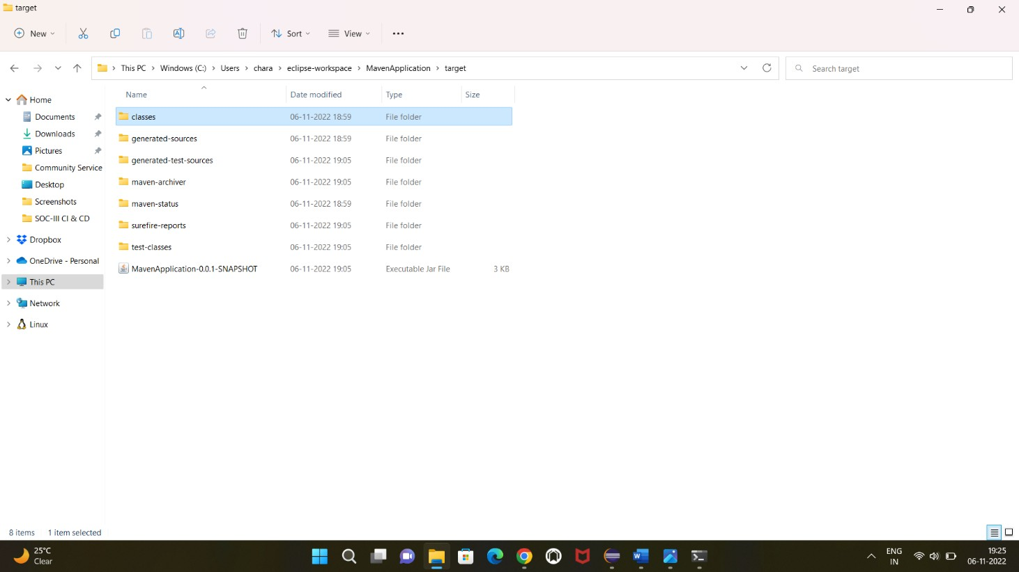

Conclusion:
After performing all maven build lifecycles it creates class file and jarfilesintargetfolder of certainproject.

Exercise7
Aim: Configure the Jenkins tool with the required paths, path variables, users andpipelineviews.
Toolsrequired:JDK-11,Jenkins2.361.3LTS

Theory:
Jenkins: Jenkins is an open source automation server. It helps automate the parts ofsoftware development related to building, testing, and deploying, facilitatingcontinuous integrationand continuousdelivery.
- It is a server-based system that runs in servlet containers such as ApacheTomcat.

Procedure:
Step-1:FirstgotowebsiteofJenkinsdownload:https://www.jenkins.io/download/
Step-2: Download the Jenkins 2.361.x LTS of Generic Java Package with theextension of .war file. Save that file in a particular directory for easy accessing(in mycase the filed isstoredinE:drive).
Step-3: Java version will be JDK 11 only. Install the JDK 11 and remove higherversionsor lower versionsof Java.
Step-4:Setthepath ofJDK11inEnvironmentvariables.

Step-5:OpenthecommandpromptandmakesurethepathwillbeyourJenkinsfilesavedpath.
ChangethepathtoJenkinsfilepathandthenclickthiscommand:

>java-jarJenkins.war
Then it will extract its file into windows system and then it executes itsoperation.
On first time using of jenkins it generates a random password which is stored atc:\users\hp\.jenkins\secrets\initialAdminPasswordpath.Copythepassword.

Step-6: Open your default browser and then the Address as:http://localhost:8080
ItwillredirectstothispageforfirsttimeusingofJenkins.
PastethecopiedpasswordfrominitialAdminPasswordfile
Step-7: After successfully entering the password it redirects to this page whichisshownbelow.
Ifyouhavegoodinternetconnectivitytheninstallsuggestedplugins.

AfterthenchangeyourAdminpasswordasadminandemailis
admin@admin.com of Jenkins. And click start Jenkins.Step-8: Then itopenstheJenkinshome page.

Conclusion:
We learnedhowtoinstall theJenkinsanditsplugins.

Exercise8
Aim:CreateaFreestyleprojectin jenkinsbyintegratingMavenProjectandexecutingthe projectinJenkins IDE.
ToolsRequired:JenkinsLTS,JavawithJDK11,Apachemaven.

Procedure:
Step-1: Open Jenkins tool in which we discussed in Exercise -7. And click onNew Item to create a new item with “freestyleproject” and give the name fortheprojectandthenclickOk.
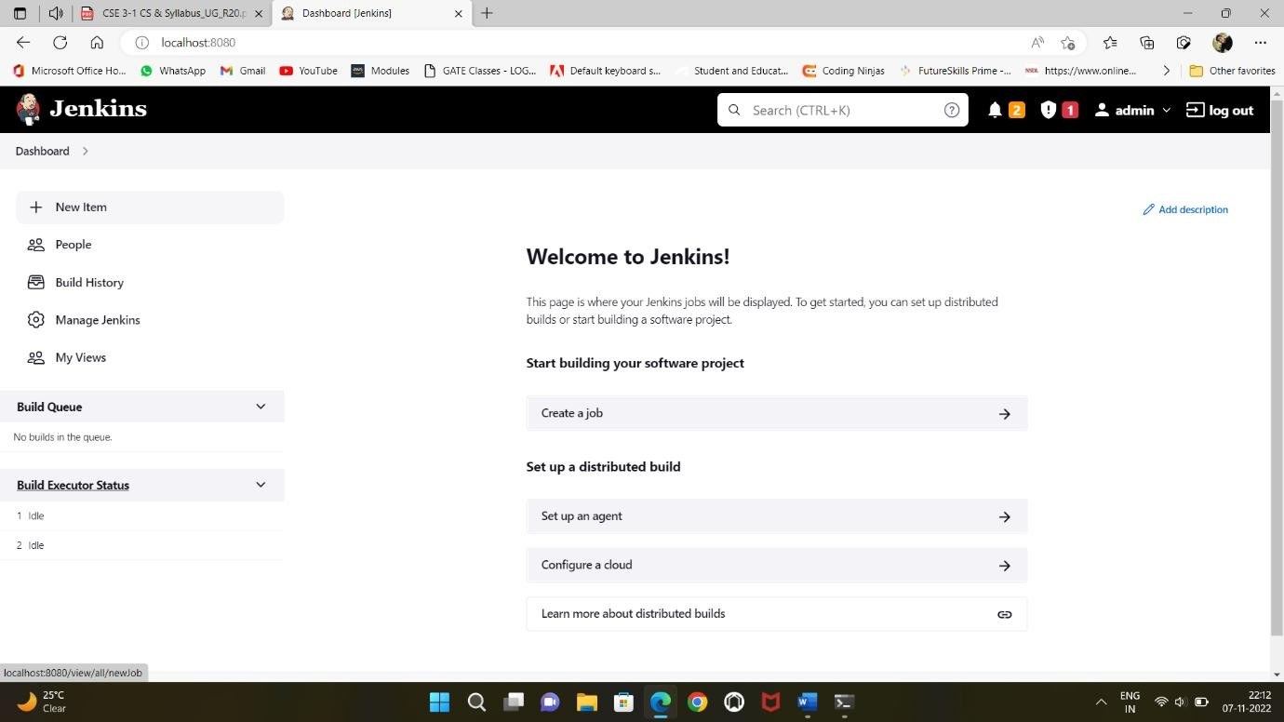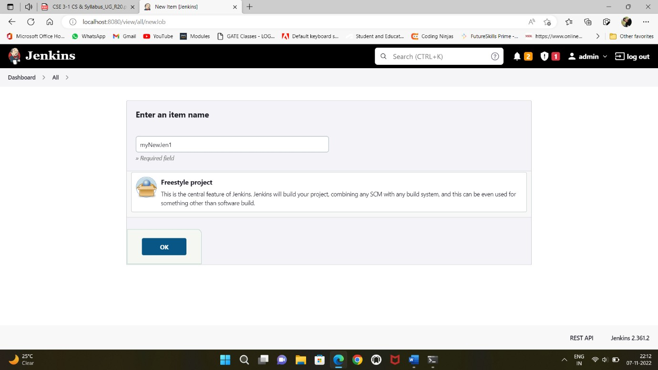

Step-2: After creating the item it redirects into another configuration menu. Inthisconfigurationmenuunder Generalgiveyourdescriptionandclickapply.
Step-3:

InstallationofPluginsorDependencies:
For the installation of plug-ins, First go to homepage of Jenkins and go toDashboard and click Manage Jenkins and then click on Global ToolConfigurationundermanage Jenkins.

Step-3.1:AddingtheJDKinGlobalToolConfigurationbygivingthecertain informationofJavainstalledin your pc.
(in mycase JDK11 So)
JDK
NAME:JDK11
JAVA_HOME:C:\ProgramFiles\Java\jdk-11.0.16.1
Step-3.2: Adding the Maven in Global Tool Configuration by giving thecertain information of ApacheMaveninstalledinyourpc.
Maven
Name:M2_HOME
MAVEN_HOME:E:\apache-maven-3.8.6

AndthenclickonApplyandSave.
Step-4: After saving then go to Dashboard. At there select your Project (at mycaseitismyNewJen1).
And then go to configure and click on go to build steps and add build step asInvoke top-level Maven targets and then maven version will be select asM2_HOMEandunder goals givecleaninstall asagoal.

Step-5: On Build Steps by clicking on advanced button and Enter the POM pathunderPOMin whichthepathwillbeprojectofjava:
C:\Users\chara\eclipse-workspace\MavenApplication\pom.xmlAnd thenclickonapplyandSaveit.
Step-6:Onyourprojecttherearesomeoptionsareatleftsideandclickon
BuildNow optiontorunthemaven projectonJenkins.
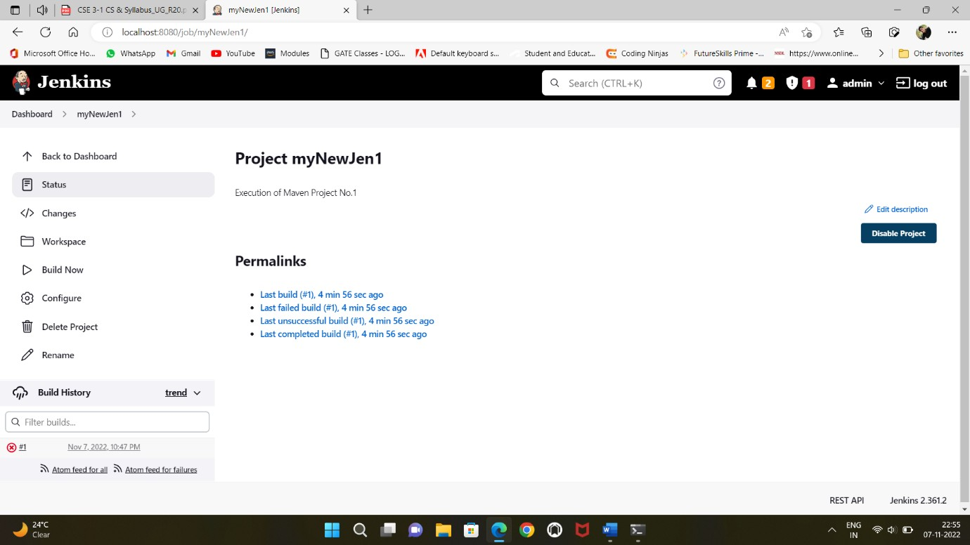

Step-7:Clickonconsoleoutputtoseetheoutputscreen.

Conclusion:
Wefinallyconcludethat wehavelearnedhowtocreateafreestyleproject.

Exercise9
Aim:DevelopajenkinsapplicationthatwillintegratewiththecodeinGithub.
Tools Required: Jenkins, Github desktop or Git-bash, Integrated Browser(Edge orChrome).

Theory:
Jenkins: Jenkins is an open-source automation server. It helps automate theparts of software development related to building, testing, and deploying,facilitatingcontinuous integration andcontinuous delivery.

Procedure:
Step-1: Create a Hello world program in Python or Java language and save it on onepath(atmycaseIhadusedthepythonlanguage).
Step-2: Open the Git-bash to push the file into github repository. Create a repositorynamedJenkins-Git-Integration.
And then change the directory to where the python file is saved. And initialize therepositorytothat directory.

And then apply the commands of git which will be discussed at exercise-4 for up-topushingafiletoglobalrepository.
Step-3: Open the Jenkins by typing java -jar Jenkins.war and then go to Jenkinshomepage and click on new item and named it as “Jenkins git integration” as afreestyleprojectandclickonOk.
Step-4:To executegithubprojectunderJenkinsthengotoDashboardandclickon
ManageJenkinsandclickonManageplugin.

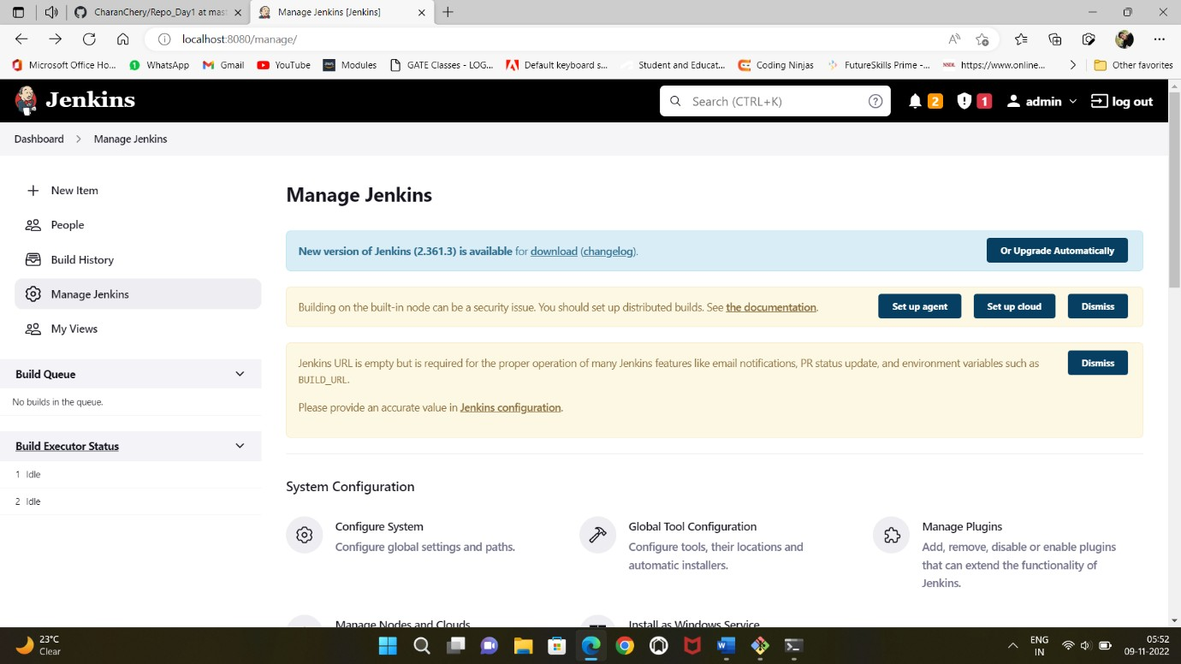

Step-5: At available search for “git plugin” and click on Install without restart.Againsearchfor“GitHubintegration”andclickon Installwithoutrestart.
Forgitplugin:

Forgithub integration:
Step-6: Go to the jenkins project and click on configure(Configuration) and click onSource code management and click on Git. Copy the path of repository in Githubcloud.

PastetherepositoryURLpathinRepositoryURL.
Step-7: Go to Build Triggers and check the Poll SCM and under Schedule input itas*****
It meansthatithas pollseveryminute.

GotoBuildsteps andselectunderBuildstepsasExecutewindowsBatchCommand
Under Command, type your command to compile and execute the program. For eachprogramminglanguagesthereisadifferencecommandtorunthecode.

ForJava:
javac program_name.javajavaprogram_name

Forpython:
pythonprogram_name.py

Andclickonapplyandsave.
Step-8:it directlyredirectstoyourprojectthereitcontainssomeoptions,clickonthe
BuildNowoptiontoexecuteitsprocess.
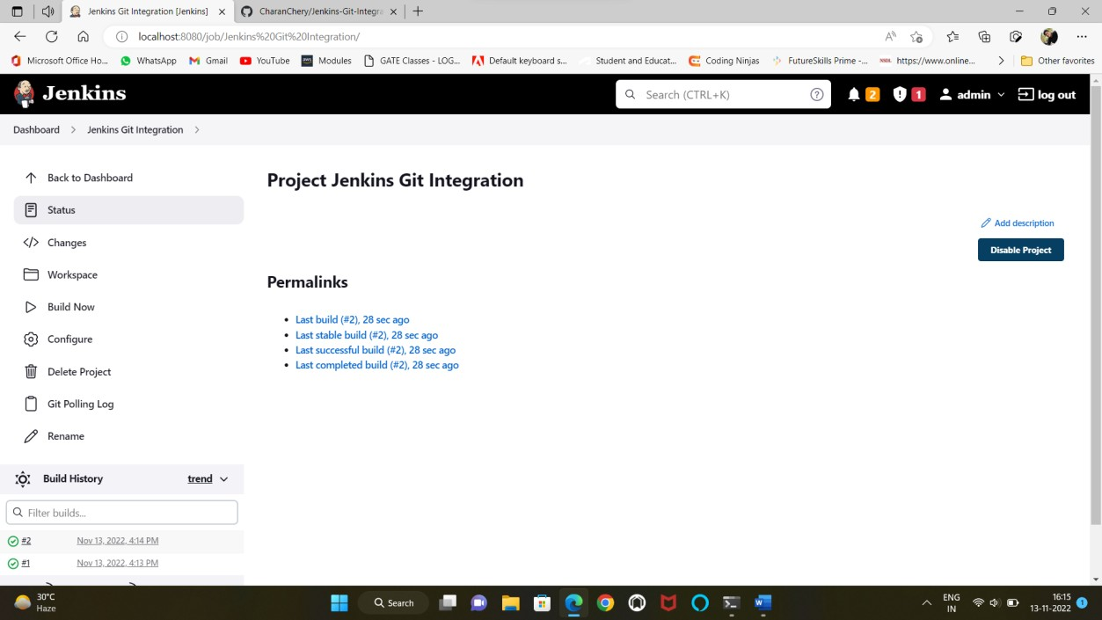
Andchecktheoutputof projectcodebyright clickingit displays some options andclickonconsole outputto displayitsbriefoutput.

Conclusion:
we finally conclude that we had learned how to integrate the Jenkins and github andhow to build and test our software projects continuously making it easier for us tointegratechangesto theproject,and makingiteasiertoobtainafreshbuild.

Exercise10
Aim:
- Create Jenkins pipeline by creating Pipeline script as well as DeclarativeScript.
- Configure Jenkins pipeline setup by executing the declarative script that isstored inGithubcloud.
ToolsRequired:Jenkins,Java11,Githubcloudaccount.

Theory:
Jenkins: Jenkins is an open-source automation server. It helps automate theparts of software development related to building, testing, and deploying,facilitatingcontinuous integration andcontinuous delivery.

Procedure:
Step1: First download the Jenkins file from the webpage:https://www.jenkins.io/download/of version 2.361.3 with LTS (Long termsupport)ofextensionwarfile.This wasdiscussed on exercise-7.
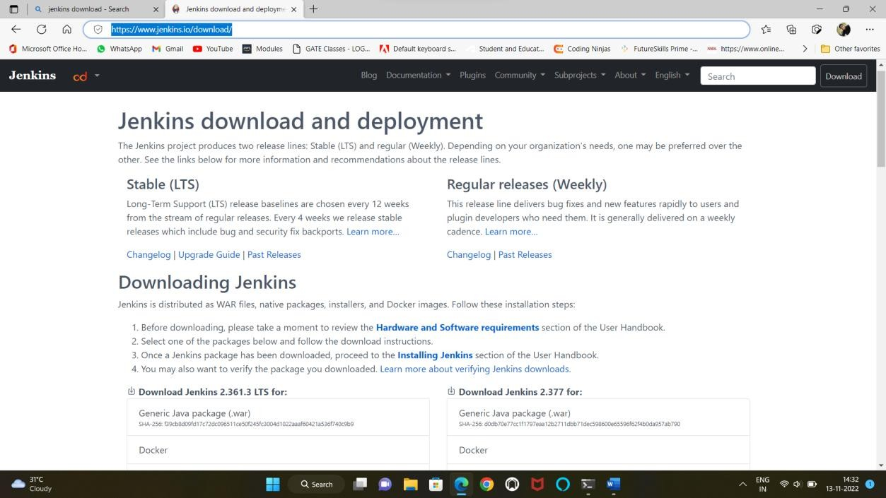
Step-2: Now open the command prompt and change the directory to Jenkinsfolderandtype the commandas:
>java-jarJenkins.war
Andthenclickenter.Itexecutesitsoperationasshowninbelow:

Step-3:Andthennowopenthebrowserandtypetheaddressas:http://localhost:8080/
Step-4: Clickonnewitemand name youritem(inmycaseInamed it as JenPipeline)andselectas apipeline project.

Step-5: Go to Dashboard, under it click on Manage Jenkins and click manageplugins in it. So at available search for stage view and check it and install itwithout restart.

InstallJobandstageMonitoringpluginalsoasaboveprocess.

Anotherpluginnamed pipelineAPIinstallitasaboveprocess.
Step-5: Now in dashboard click on configure and in it click on pipeline underdefinition select it as Pipeline script and in script select it as Hello World andclickonapplyandsave.
Step-6: Now click on Build Now and then click on the output number to seeconsoleoutput.

Nowcheckitforconsoleoutput.

Stageview:

DeclarativePipeline:
Ithaslimitedpredefinedstructure.

Step-1: Go to github cloud and create a new repository named Jenkins-Declarative-Pipeline and add a new file in that repository and named it as Jenkins file or yourownname.Pastethiscodeintothatfileandcommitthefile.

Thecodeis:
pipeline
{
agentanystages
{
stage('Check Validate'){steps{
echo'ValidatingtheProgram'
}
}
stage('Compilation'){steps{
echo'CompilingtheProgram'
}
}
stage('Installation'){steps{
echo'InstallingtheProgram'
}
}
stage('Deploy'){steps{
echo'DeployingtheProgram'
}
}
}

}

Copythecodeintogithubfile.

Step-2:Go toJenkinshomepageandcreateapipelineprojectnamedas
Jen_Declarative.Now gotoconfigurationunderitgotoAdvanced ProjectOptions.
In it go to pipeline under Definition select Pipeline script from SCM ->under SCMselectGitinitpasterepositoryurlofgithub.

Atcredentialsclick onAddselectJenkins.So itopensboxasbelow pic.
Selectkind asusernamewithpasswordoryourwish.
If usernamewithpasswordgive usernameandpasswordof Github. Andthenclickonadd.
AndselectCredentials asyouraddedgithubcredentials,andselectit.

Step-3: Under Branches to build at branch specifier type the branch name in whichthefileisexisted.Atmycaseitismainbranch.
Step-4:Clickon Applyandsave.AndclickBuildNow.

Thefullstageviewis:

Andtochecktheconsoleoutputclickonoutputfileandclickconsoleoutput.

Conclusion:
We conclude that we learn how to implement pipelines in Jenkins and how todeclarea Declarativepipelinewithstages.

