GENERIC JAVASCRIPT VALIDATION

ABOUT :
In this application any HTML5 form to validate by using GENERIC JAVASCRIPT. Here it can check each field By using user defined attribute named as validate that attribute take values like 'not_empty', 'phone','email' etc. This js file validating all any HTML form elements.

Containts

The Repository consists of one folder thast is validations the folder consists of the following files ,

Index.html:- This consists of Html elements like Textbox , radio button, combobox, Checkbox,etc.

Style.css:- This had been existed in the css folder which is an external style sheet that has been linked in the html for applying styles to the elements in the html file.

Validation.js :- This had been existed in the js folder of the Repository that is linked through the html file. This consists of the generic validation functions that have been applied to any of the form elements.

SCREENSHOT FOR FORM1 :-

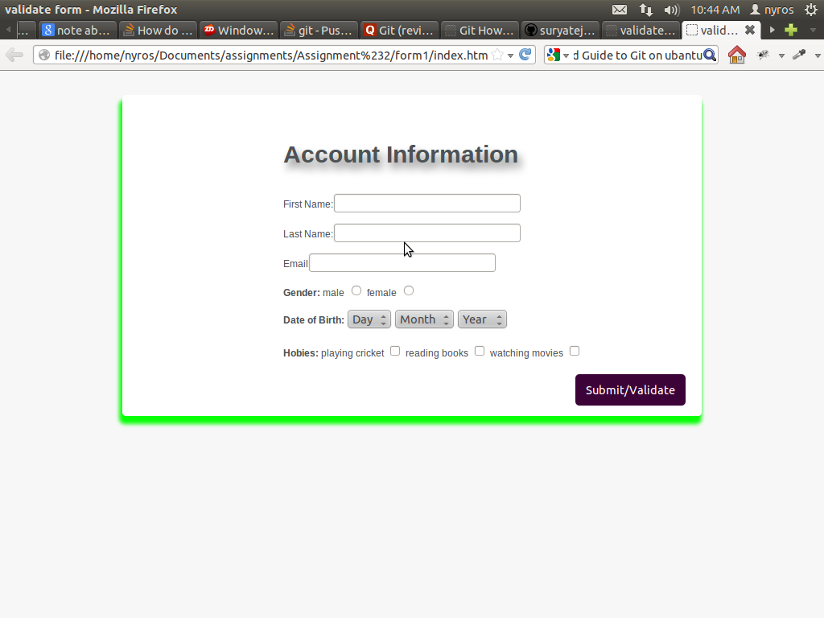
SCREENSHOT FOR FORM2 :-

