E-Commerce Website Development – Week 01 Report
Name: Mallika Devi Kerla
Project Title: E-Commerce Website using React + Vite

Objective
Develop a static multi-page e-commerce website using React and Vite based on the provided Figma design.

Technologies Used
- React.js
- Vite
- HTML5
- CSS3
- React Router DOM

Pages Developed
- Home Page
- Product Listing Page
- Product Grid Page
- Product Details Page
- Cart Page

Features Implemented
- Responsive page layout (basic)
- Reusable React Components
- Navigation using React Router
- Product cards
- Product details page
- Shopping cart page
- Header, Footer, Breadcrumb, Sidebar components

Folder Structure
src/
├── assets/
├── components/
├── pages/
├── App.jsx
└── main.jsx

Project Output
- Home Page Screenshot

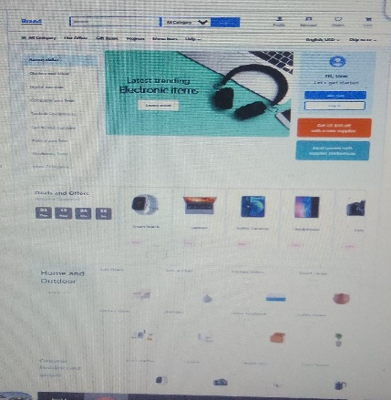
- Product Listing Screenshot
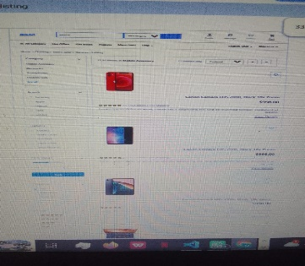
- Product Grid Screenshot
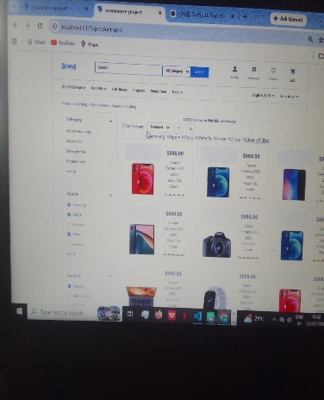

- Cart Screenshot
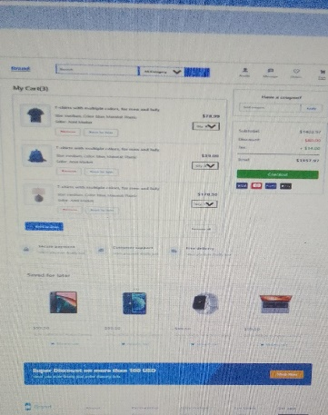

GitHub Repository
https://www.linkedin.com/posts/kerla-mallika-devi-6bb595327_reactjs-frontenddevelopment-webdevelopment-activity-7478696628544016384-EQ1V?utm_source=social_share_send&utm_medium=android_app&rcm=ACoAAFJ9aq8BQ_Q0l8DHxMH275JMNhYvE3x2TUw&utm_campaign=copy_link

Conclusion
Successfully developed a multi-page e-commerce website using React, Vite, CSS, and React Router by following a component-based architecture.

