IT-Simplera Solutions

Frontend Web Development Internship

Week 05 Report

Project Title:
Ecommerce Web Application – Backend Integration using Node.js, Express.js and MongoDB

Submitted By:
Mallika Devi

1. Introduction
During Week 05 of the Frontend Web Development Internship at IT-Simplera Solutions, the existing React Ecommerce application was enhanced by integrating a backend system.
A backend server was developed using Node.js and Express.js. MongoDB Atlas was used as the database to store product information. RESTful APIs were created to fetch product data and connect the frontend React application with the backend.
This integration enabled dynamic product loading instead of using static local data.

2. Objectives
The main objectives of Week 05 were:
- To create a backend server using Node.js and Express.js.
- To connect the application with MongoDB Atlas.
- To create product APIs.
- To fetch product data from the backend in React.
- To replace local JSON data with API-based data.
- To implement loading and error handling states.
- To test APIs using Postman/Thunder Client.

3. Technologies Used

Frontend:
- React.js
- Vite
- Axios
- React Router
- CSS

Backend:
- Node.js
- Express.js

Database:
- MongoDB Atlas
- Mongoose

Tools:
- VS Code
- Thunder Client / Postman
- GitHub

4. Backend Project Setup
A new backend folder was created inside the ecommerce project.
The Node.js project was initialized using:
npm init -y
Required dependencies were installed:
- express
- mongoose
- cors
- dotenv
The Express server was created using server.js and configured to run on port 5000.
Backend Server URL:
http://localhost:5000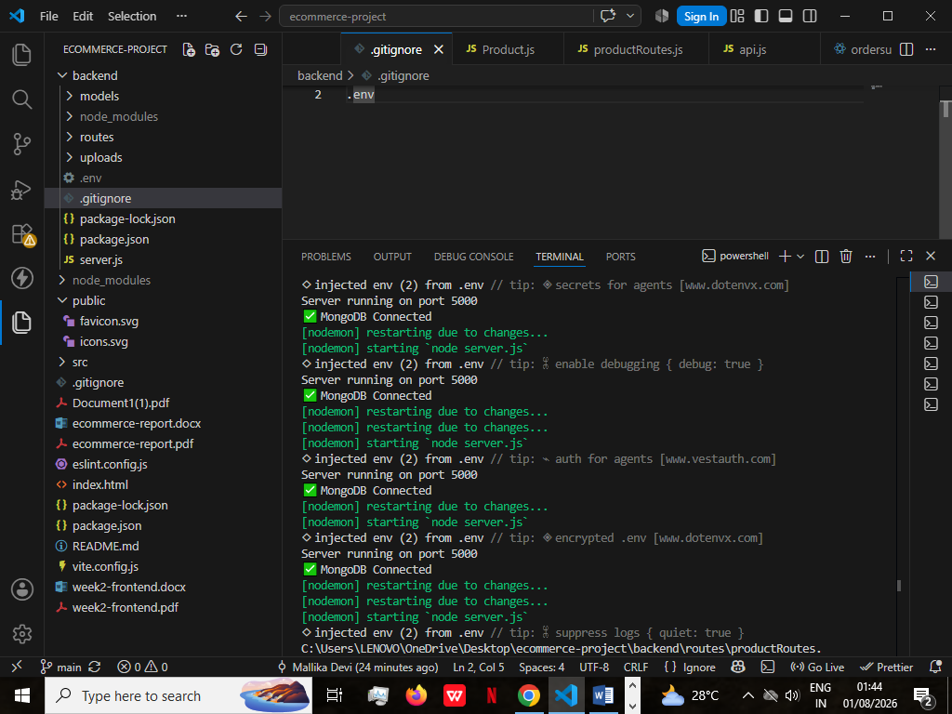

MongoDB Database Setup
MongoDB Atlas was configured as the database.
Database created:
ecommerce
Collection created:
products
Sample product documents were added with the following fields:
- name
- price
- image
- description
- category
- stock

6. Product API Development
REST APIs were created using Express.js.

Get All Products
Endpoint:
GET /api/products
Purpose:
Fetches all available products from MongoDB.
Example URL:
http://localhost:5000/api/products
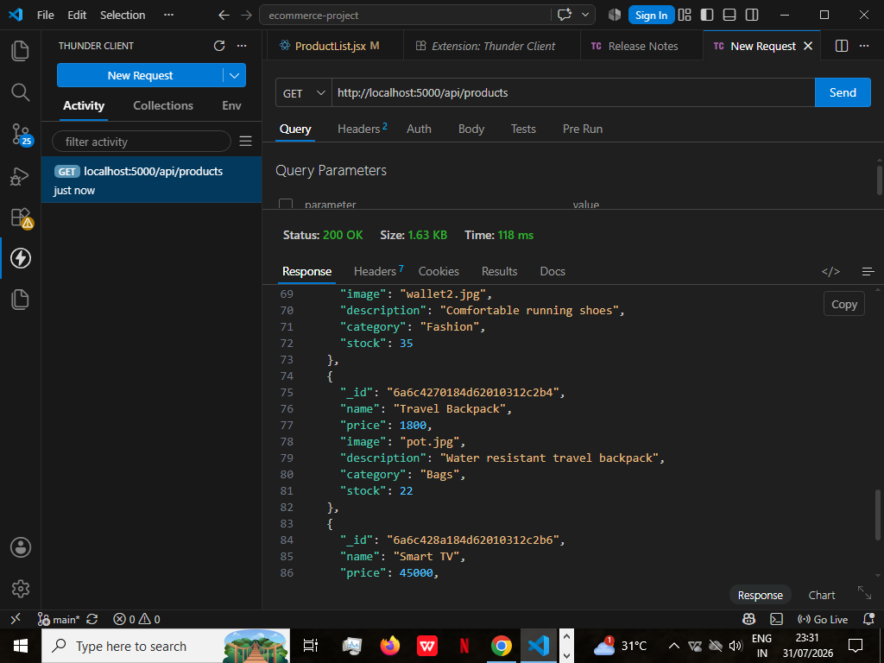

Get Single Product
Endpoint:
GET /api/products/:id
Purpose:
Fetches details of a specific product using product ID.
Example:
http://localhost:5000/api/products/6a6c3f42184d62010312c2a4
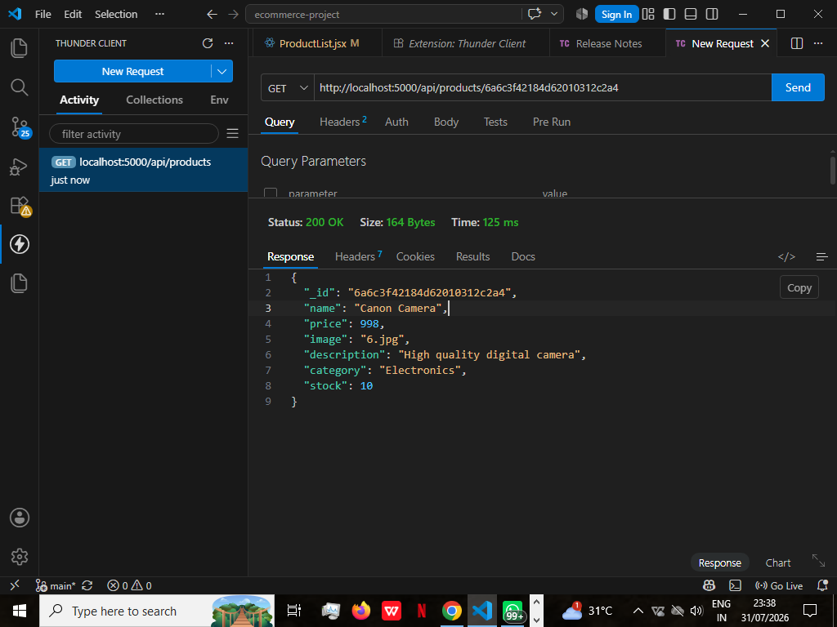

7. Frontend and Backend Integration
The React frontend was connected with the backend API.
Previously, products were loaded from:
products.json
After integration, product data is fetched from:
GET /api/products
using Axios.
The Product Listing page displays data received from MongoDB.

Implemented Features:
- Dynamic product loading
- Product listing from database
- Product details using product ID
- API communication using Axios
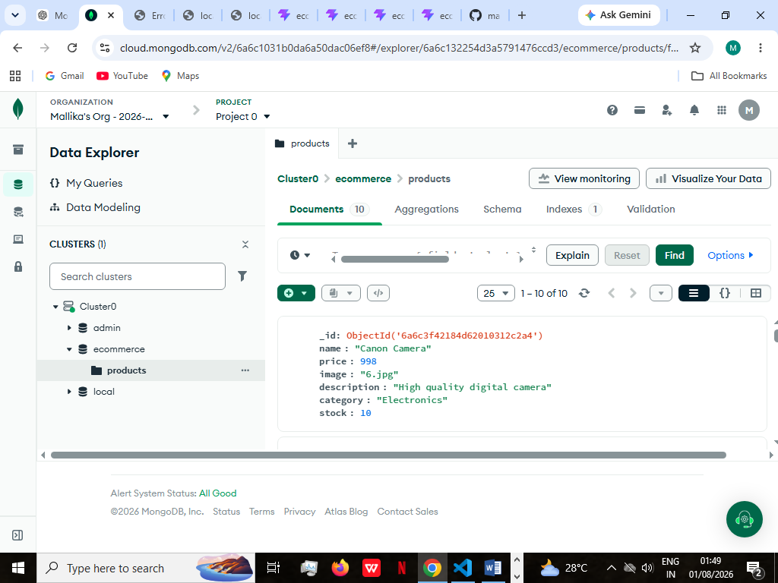

8. Product Details Integration
The Product Details page was updated to fetch individual product information from the backend.
When a user clicks on "View Details", the product ID is passed through the URL.
Example:
/product-details/:id
The corresponding product information is retrieved from MongoDB.
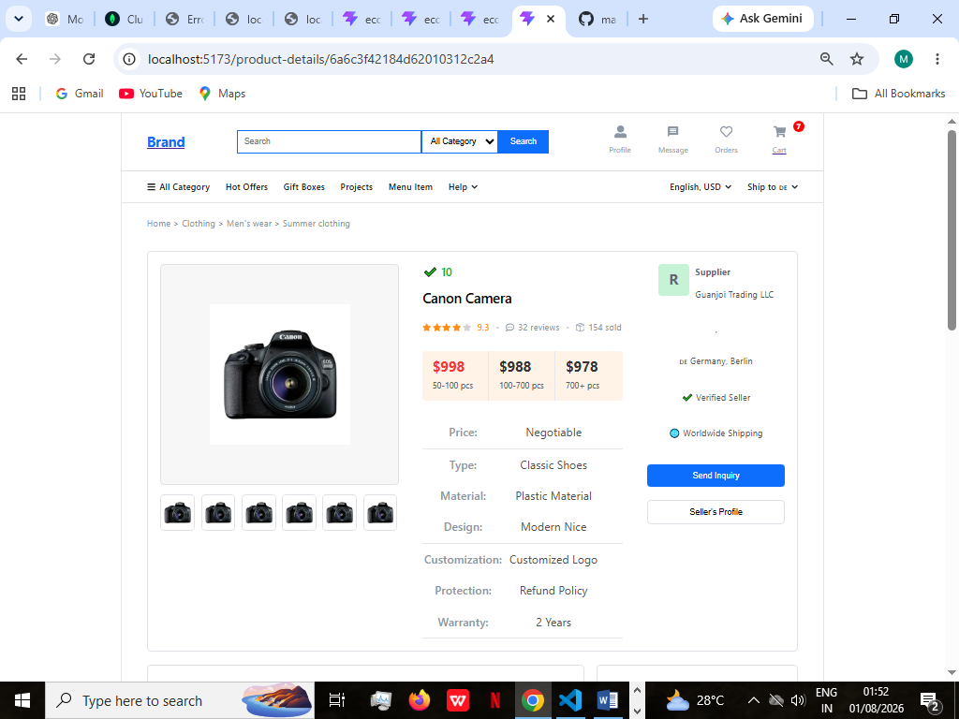

9. Loading and Error Handling
Loading state was implemented to show a message while fetching product data.
Example:
Loading products...
Error handling was added to display a user-friendly message if the API request fails.
Example:
Failed to load products
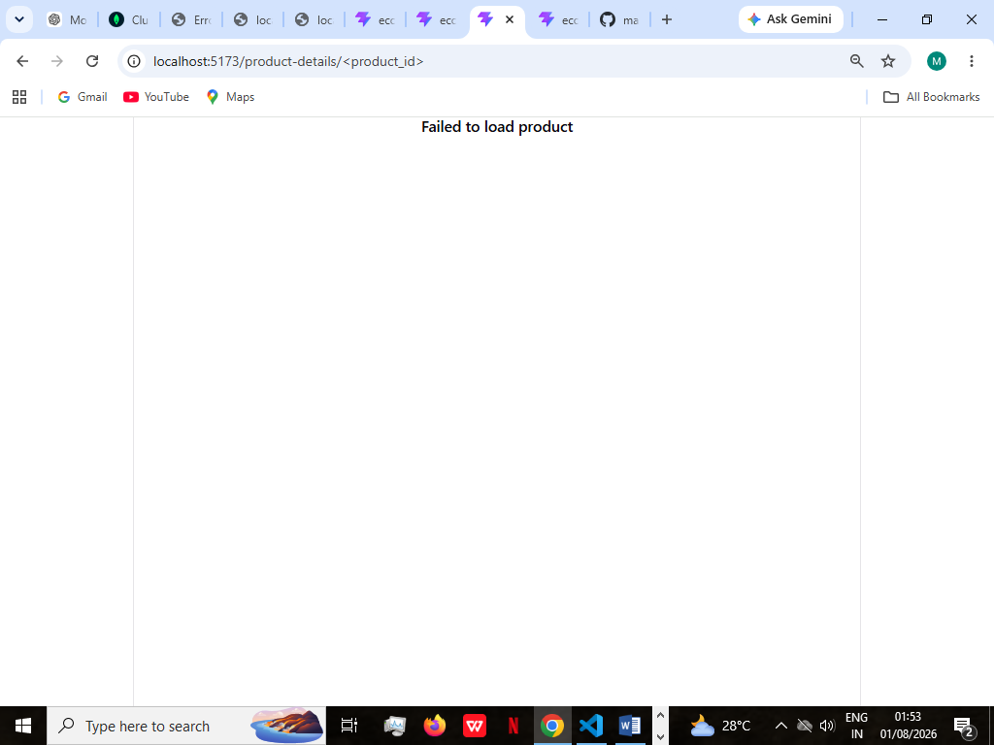

10. Image Handling
Product images were stored inside the backend uploads folder.
Images were served using Express static middleware.
Frontend accesses images through:
http://localhost:5000/uploads/image_name
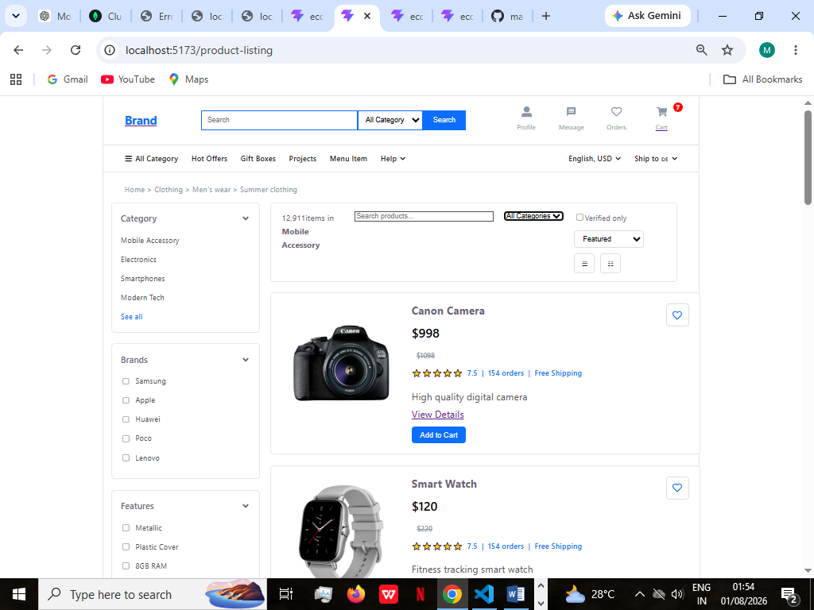

11. GitHub Integration
All Week 05 changes were committed and pushed to GitHub.
Included:
- Backend code
- API implementation
- MongoDB integration
- React API connection
- README documentation
https://github.com/mallika-1727/ecommerce-react-frontend

2. Conclusion
In Week 05, the Ecommerce application was successfully converted from a static frontend application into a full-stack application.
The React frontend was connected with a Node.js and Express.js backend. MongoDB Atlas was integrated for storing product information, and REST APIs were developed for retrieving product data.
This task provided practical experience in backend development, database integration, API creation, and frontend-backend communication.

