WEEK 2 INTERNSHIP REPORT

Title
Week 2 – Dynamic Data Integration & React Routing in E-Commerce Frontend

Submitted By
Name: Mallika Devi
Internship: Frontend React Development Internship
Week: 2

Objective
The objective of this week's task was to convert the static React e-commerce website into a dynamic application using local JSON data. The project also focused on implementing React Router navigation, dynamic product rendering, search functionality, and category-based filtering while maintaining a responsive user interface.

Technologies Used
- React JS
- Vite
- JavaScript (ES6)
- CSS3
- React Router DOM
- JSON
- Git
- GitHub
- VS Code

Week 2 Requirements
- Create products.json file
- Render products dynamically
- Create Product Listing page
- Create Product Details page
- Implement Search Feature
- Implement Category Filter
- Configure React Router
- Upload project to GitHub

Features Implemented

Dynamic Product Rendering
A products.json file containing multiple sample products was created. All product cards are now generated dynamically using the map() function instead of hardcoded data.

Home Page Integration
The Recommended Products section was converted from static cards into dynamically rendered cards using products.json.
Displayed fields:
- Product Image
- Product Name
- Product Price

Product Listing Page
The Product Listing page dynamically displays all products from products.json.
Displayed information includes:
- Product Image
- Product Name
- Product Price
- Product Description
- View Details Button

Search Functionality
A real-time search feature was implemented using React useState().
The search instantly filters products while typing.
Example:
Searching "Lap"
Displays only
Laptop

Category Filter
Products can now be filtered according to category.
Example Categories:
- Electronics
- Clothing
- Accessories

Product Details Page
The Product Details page was converted into a fully dynamic page.
Dynamic information displayed:
- Product Image
- Product Name
- Product Price
- Product Description
- Category
- Stock Status

React Router
Navigation between pages was implemented using React Router.
Routes Created:
- Home
- Product Listing
- Product Grid
- Product Details
- Cart

GitHub Integration
The completed project was uploaded successfully to GitHub using Git commands.
Git Commands Used:
- git init
- git add .
- git commit
- git push

Folder Structure
src
│
├── assets
├── components
├── data
│ └── products.json
├── pages
│ ├── Home
│ ├── ProductListing
│ ├── ProductGrid
│ ├── ProductDetails
│ └── Cart
├── App.jsx
└── main.jsx

Screenshots
- Home Page
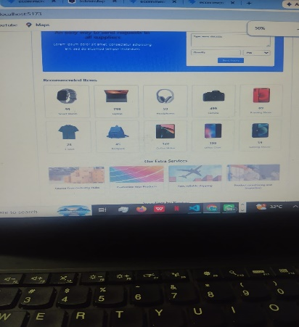
- Product Listing Page
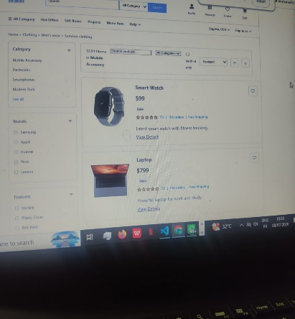
- Search Functionality
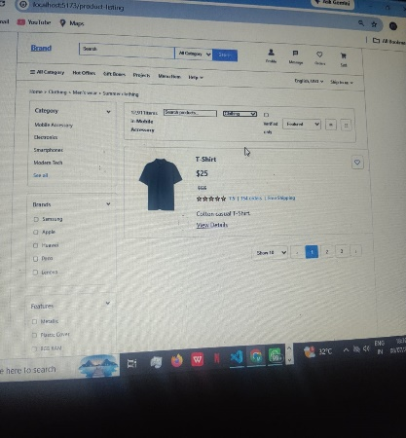
- Product Details Page
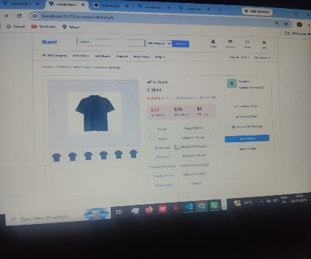
- Cart Page
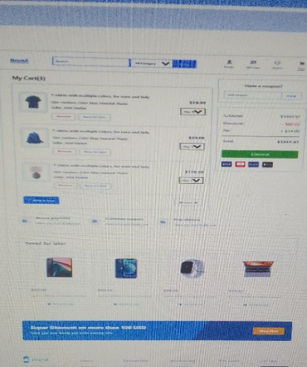

Challenges Faced
- Converting static components into dynamic components.
- Mapping product images from assets using JSON.
- Configuring React Router.
- Implementing real-time search functionality.
- Uploading the complete project to GitHub.

Learning Outcomes
During Week 2, I learned:
- Dynamic Rendering using JSON
- React Components
- React Router Navigation
- useState Hook
- Search and Filter Logic
- Git Commands
- GitHub Repository Management

Conclusion
The Week 2 React E-Commerce project was successfully completed by implementing dynamic product rendering, routing, search functionality, category filtering, and GitHub integration. This project improved my understanding of React fundamentals and component-based application development.

GitHub Repository
Repository Name
ecommerce-react-frontend
Repository Link
https://github.com/mallika-1727/ecommerce-react-frontend

