Mallika 25-07-2024 Executing git commands

1. To Check the Version of git .
   * Using **git --version**

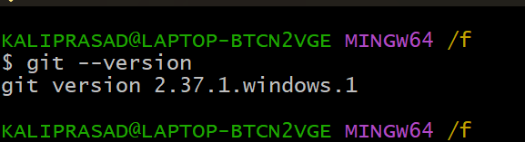

1. To List the configuration
   * We use **git config –list**

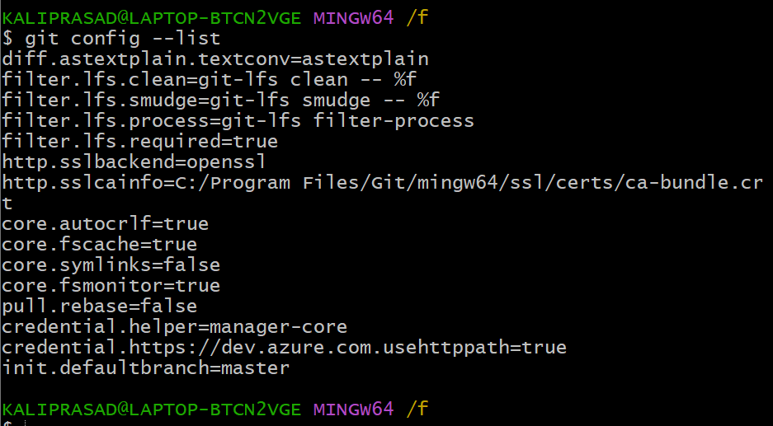

1. Cretating Directory and files created in directory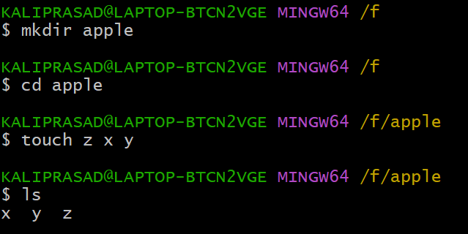
2. Initializing a new git repository
   * Using **git init**

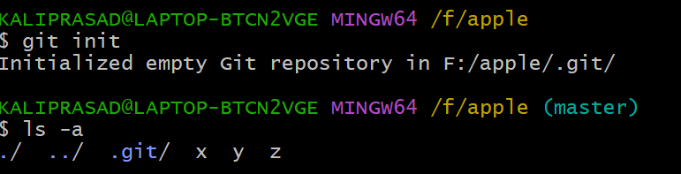

1. Adding file to tracking area
   * Using **git add**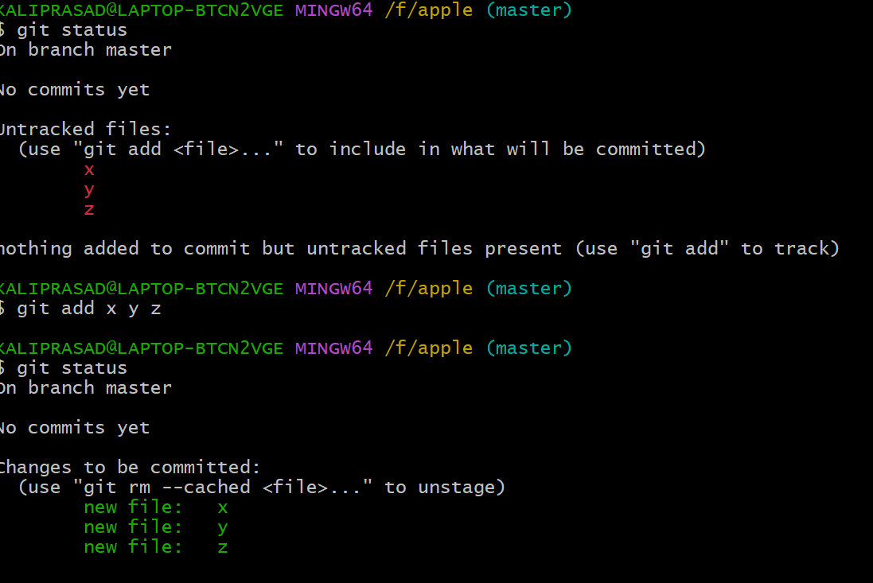
2. Giving Default user Identity
   * Using git config --global user.email “mailid”
   * Using git config --global user.name “name”
3. Commit the file
   * Using git commit -m “describe commit”
4. Checking Logs of a file
   * Using **git log**

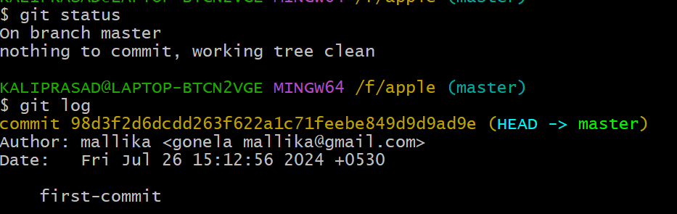

1. Connecting To github (central repository)
   * Using git remote add origin <url>
   * Using git remote -v to check the connectivity

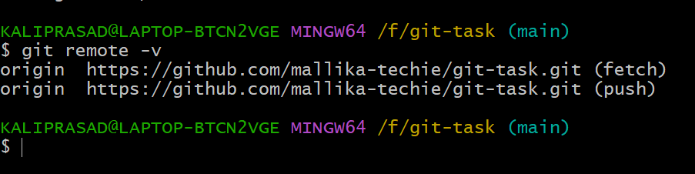

1. Push the file to central repository
   * Using git push –set-upstream origin master

