1. Install jenkins and run jenkins on port number 8081.

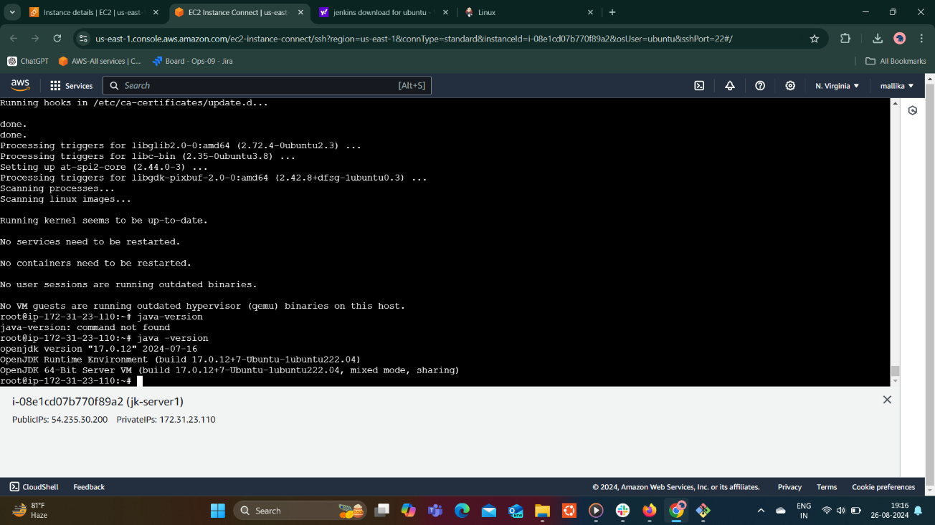

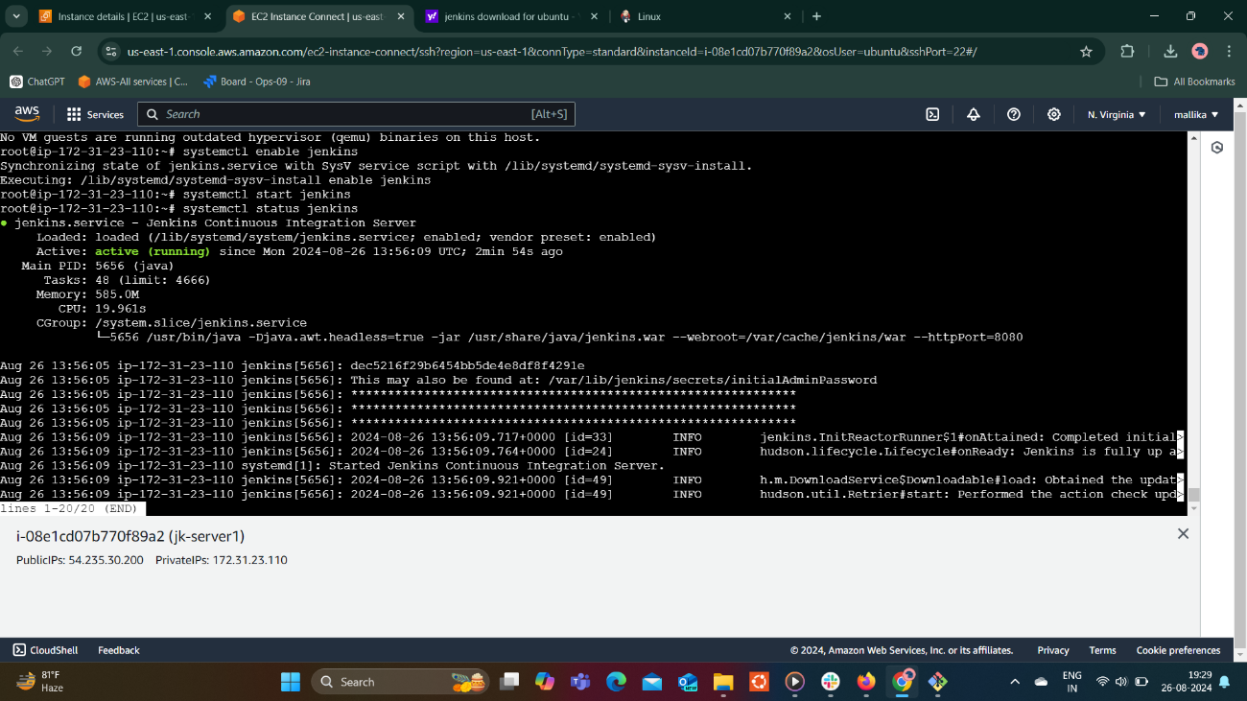

Changed port to 8081 in /lib/systemd/system /Jenkins.service Environment=Jenkins_port=8081

After changing file run command systemctl daemon-reload and then systemctl start Jenkins.service

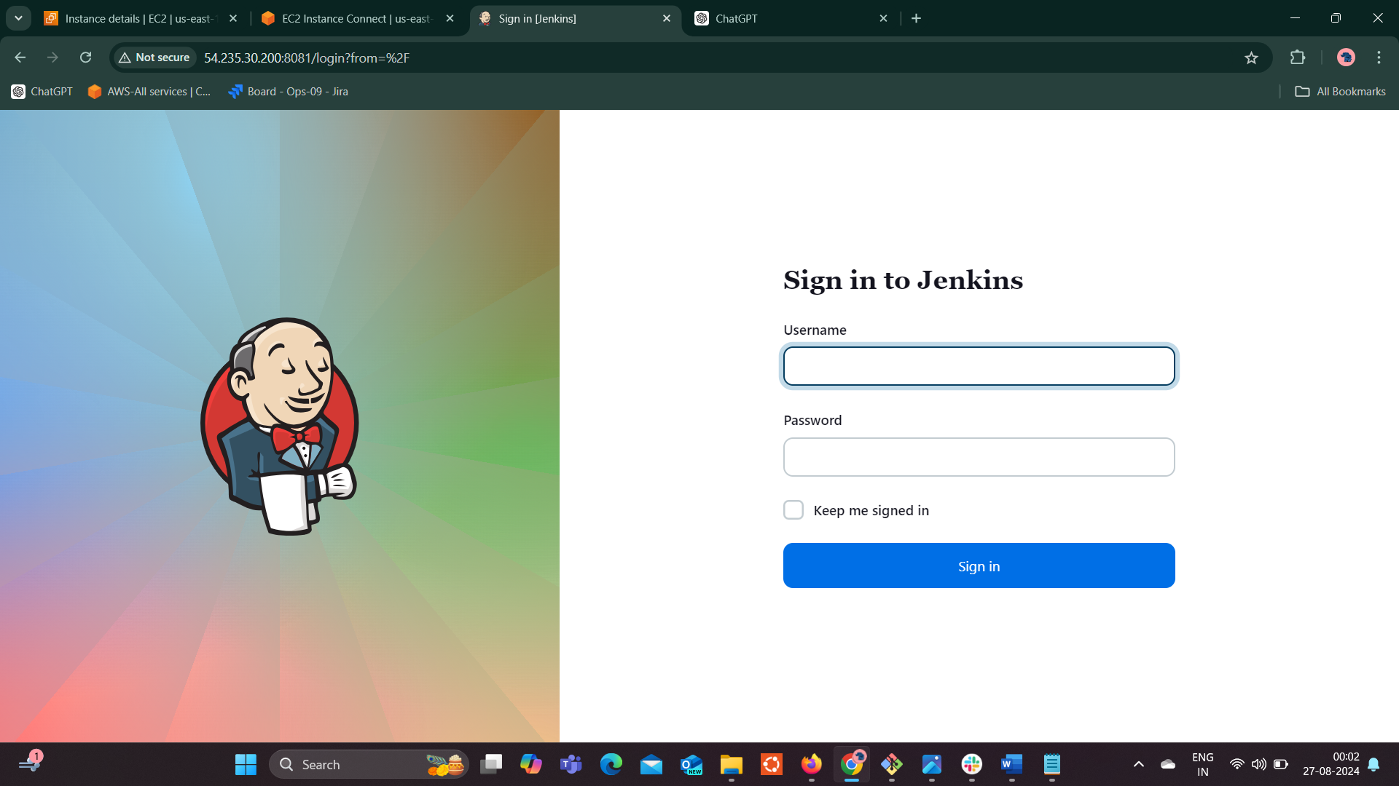

2) Secure Jenkins server

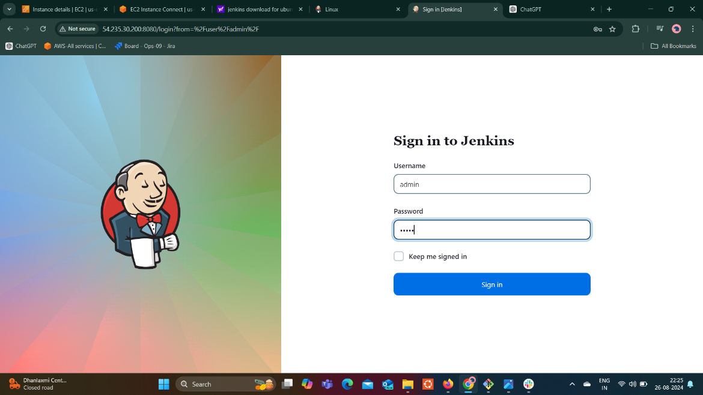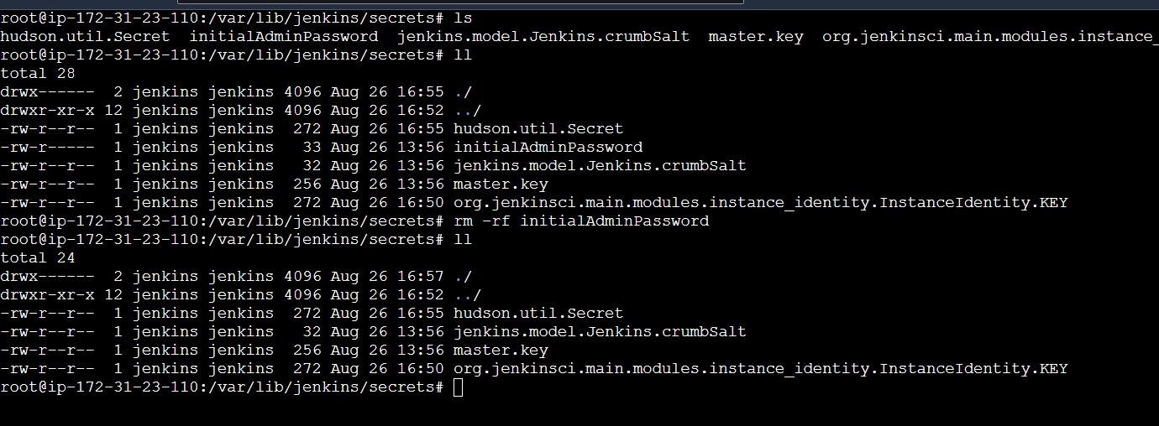

3) Create users called Devops, Testing in Jenkins with Limited access.

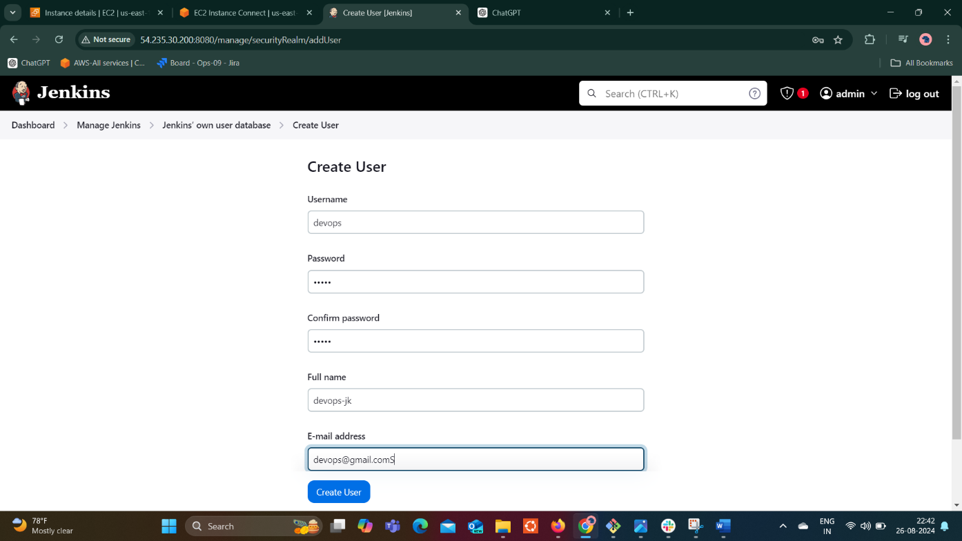

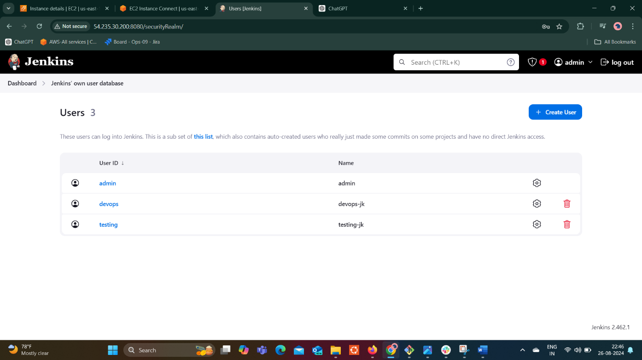

4) Configure labels and restrict the jobs to execute based on label only.

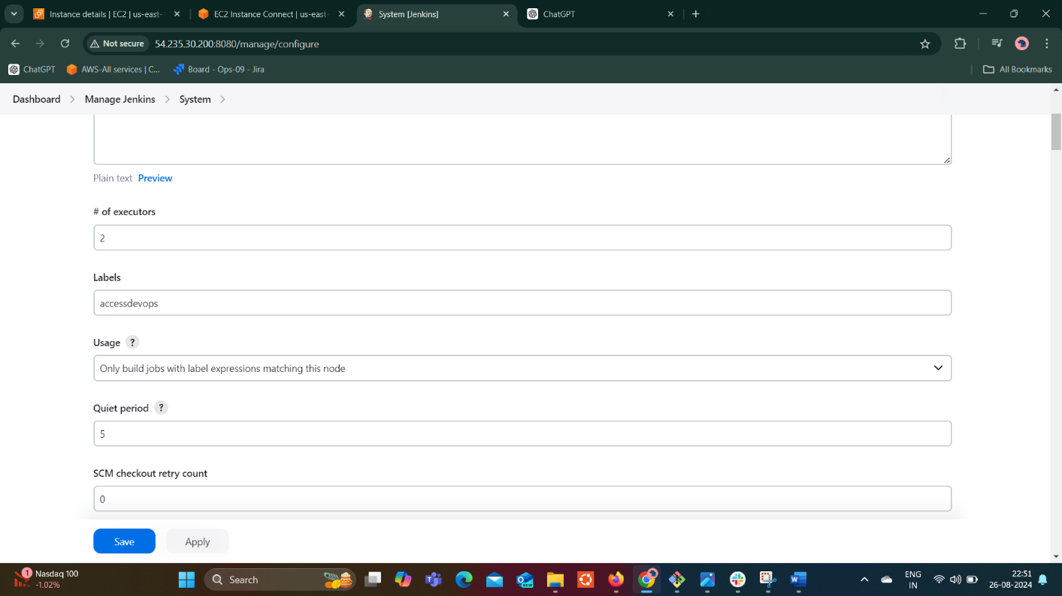

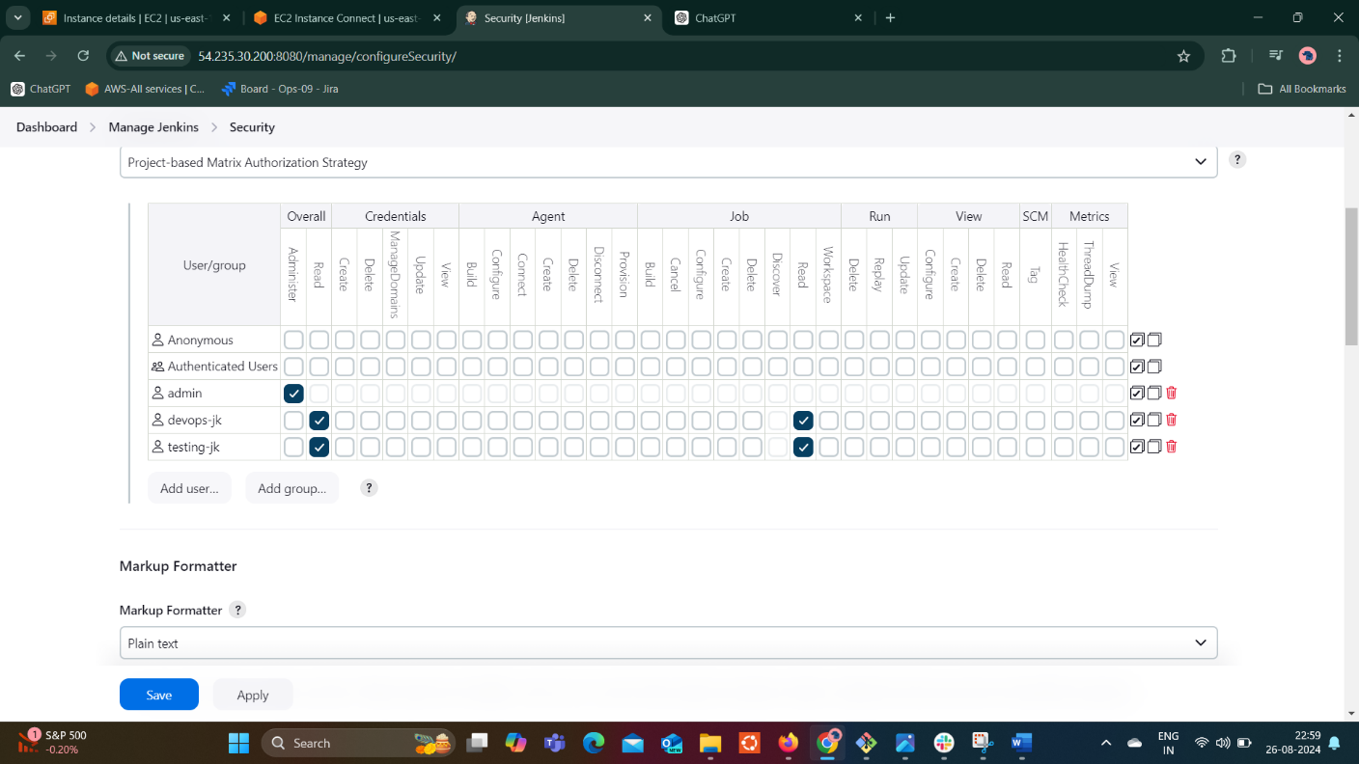

5) Create Three sample jobs using the below URL. <https://github.com/betawins/Techie_horizon_Login_app.git>

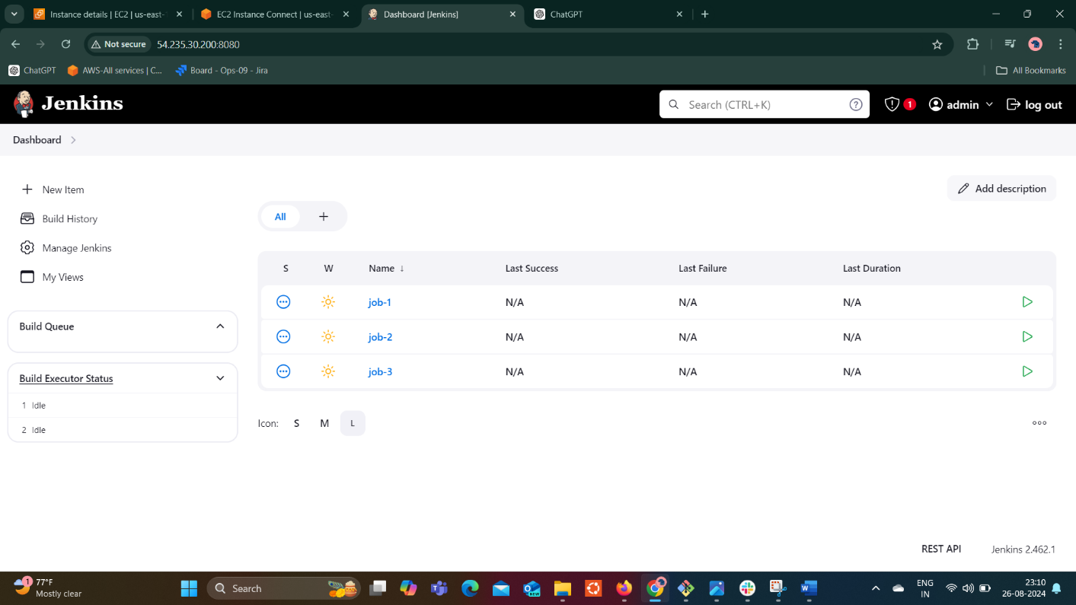

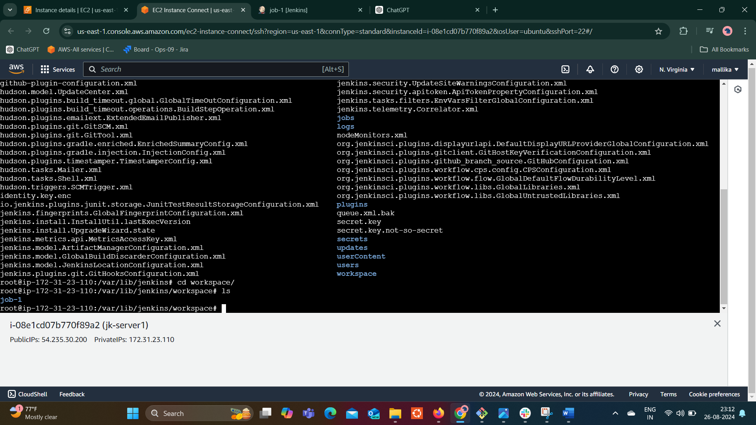

6) Create one jenkins job using git hub Private repository.

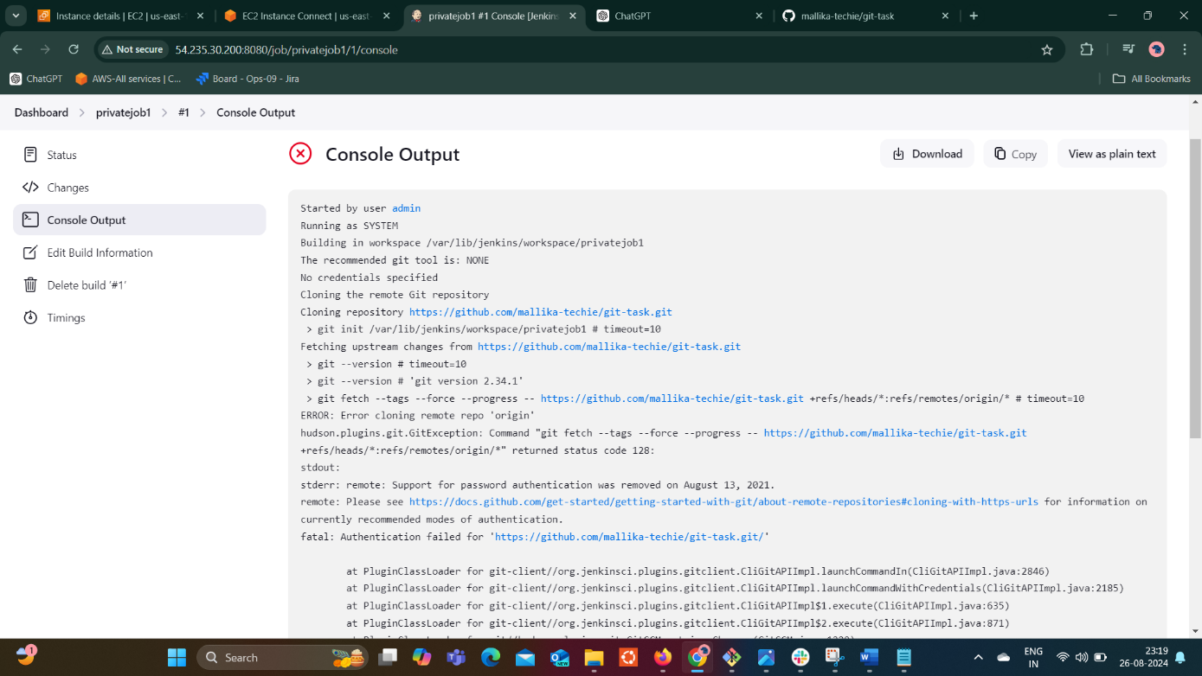

As given url is of github private repository, jenkins requires credentials to access the repository.

In github went to settings > developer settings > personel access tokens > Tokens(classic) > generate new token. generated new token by giving limited access controls.

Added user name and generated new token to Jenkins and saved. So that executed and error resolved.

