MALLIKA-27-08-24-jenkins2

1. Configure 2 slave machines in jenkins master.

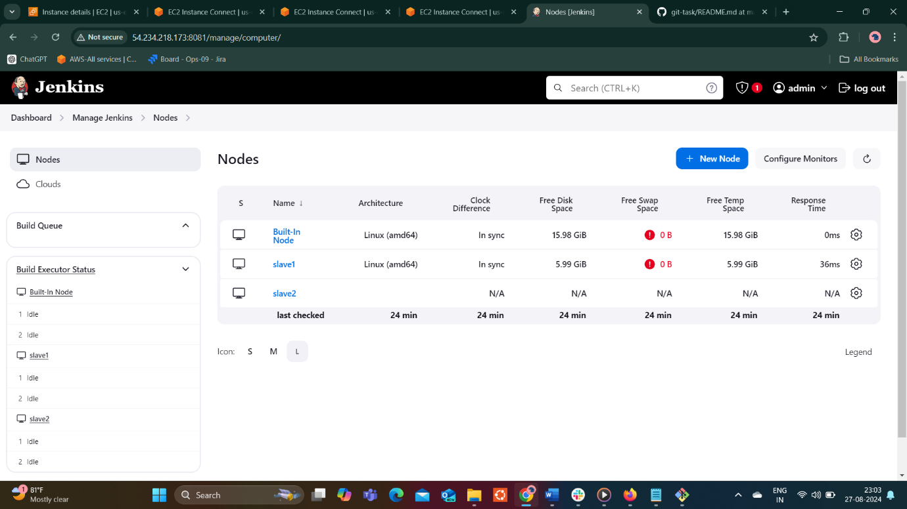

2) Configure webhooks to jenkins job.

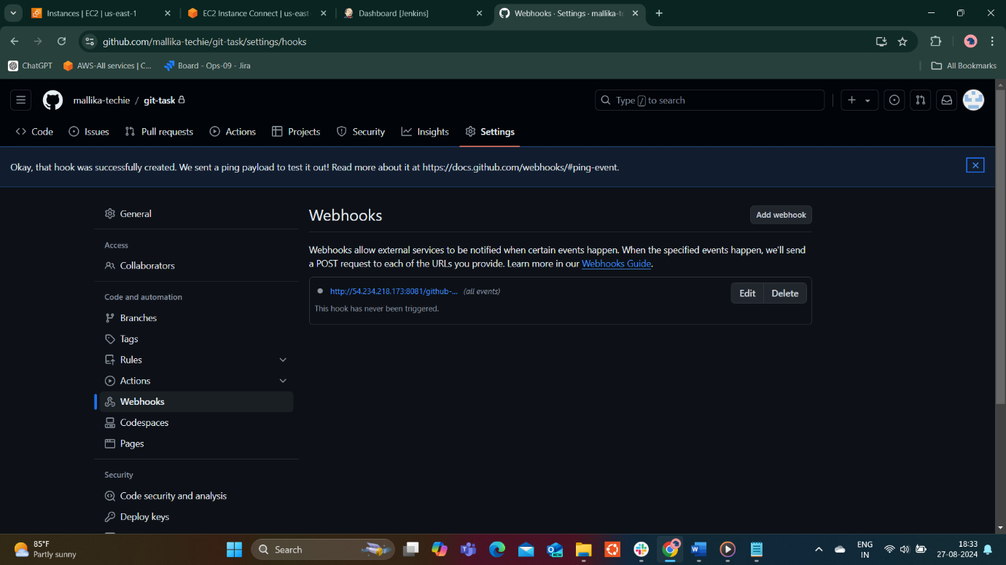

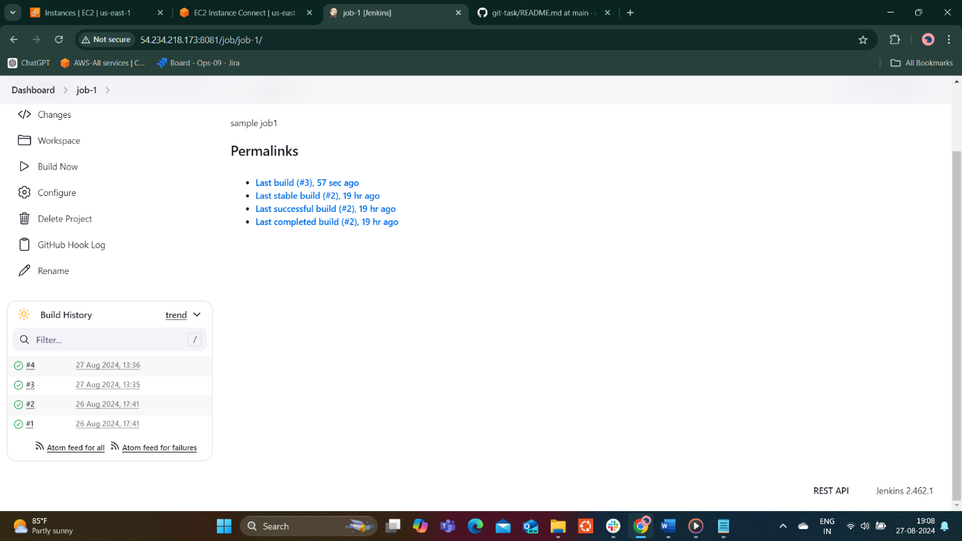

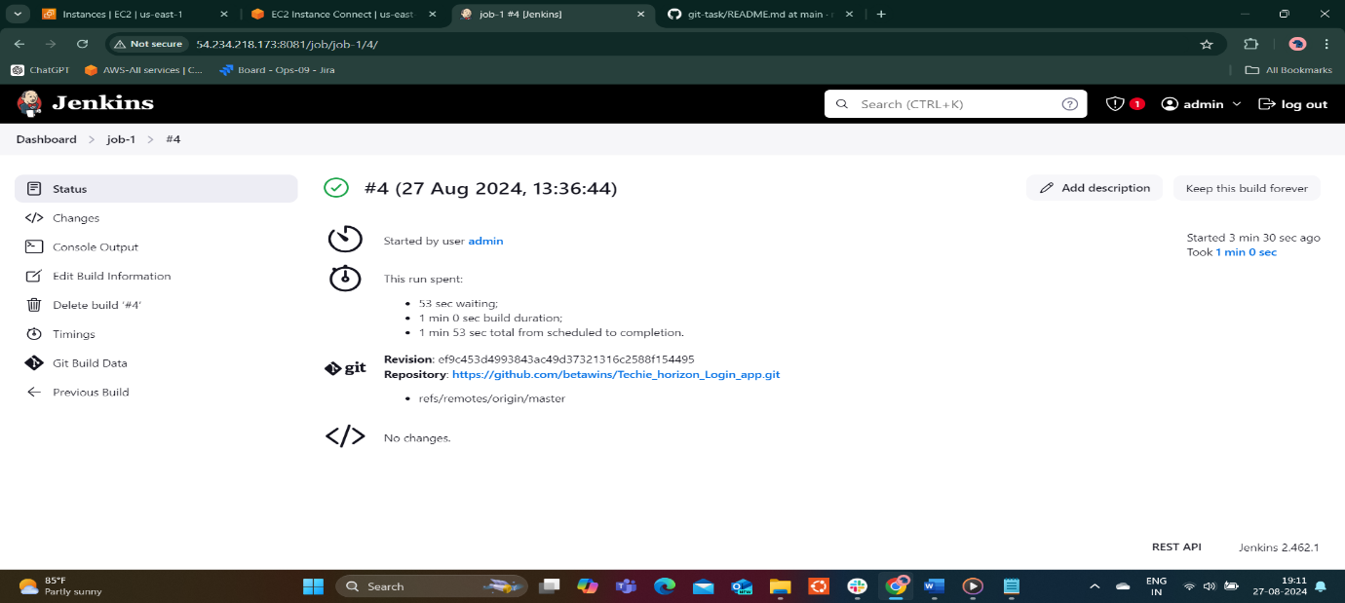

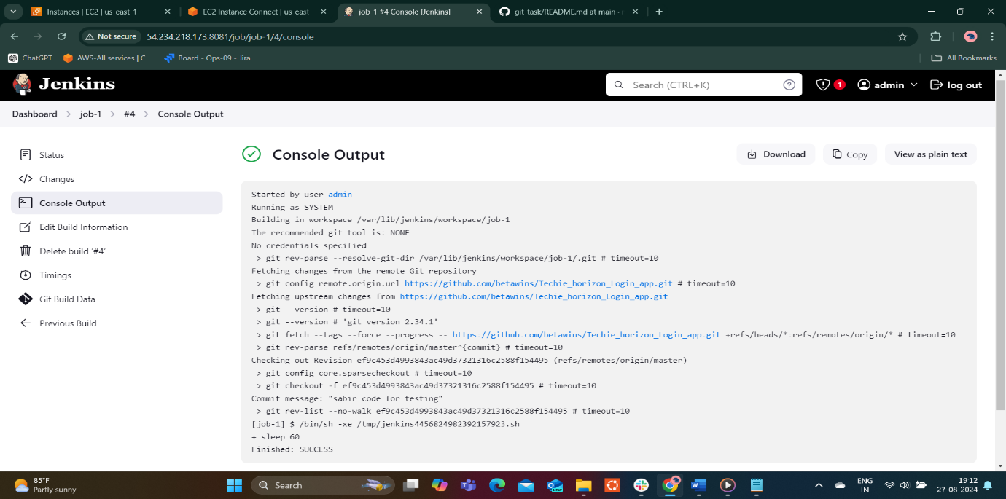

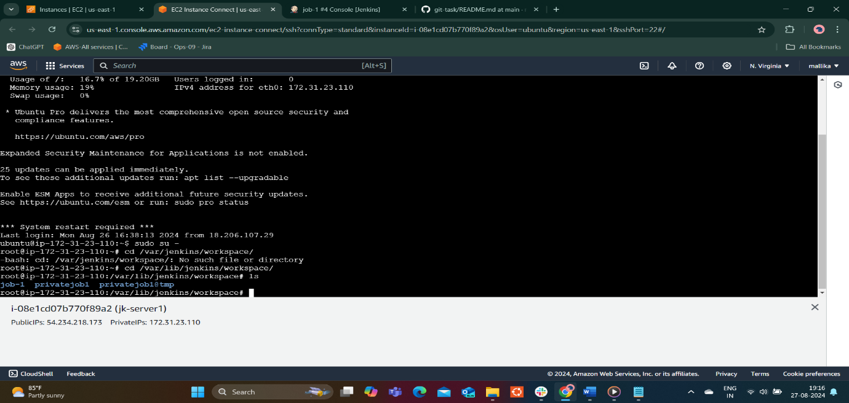

3) Configure poll scm and build periodical options in jenkins job.

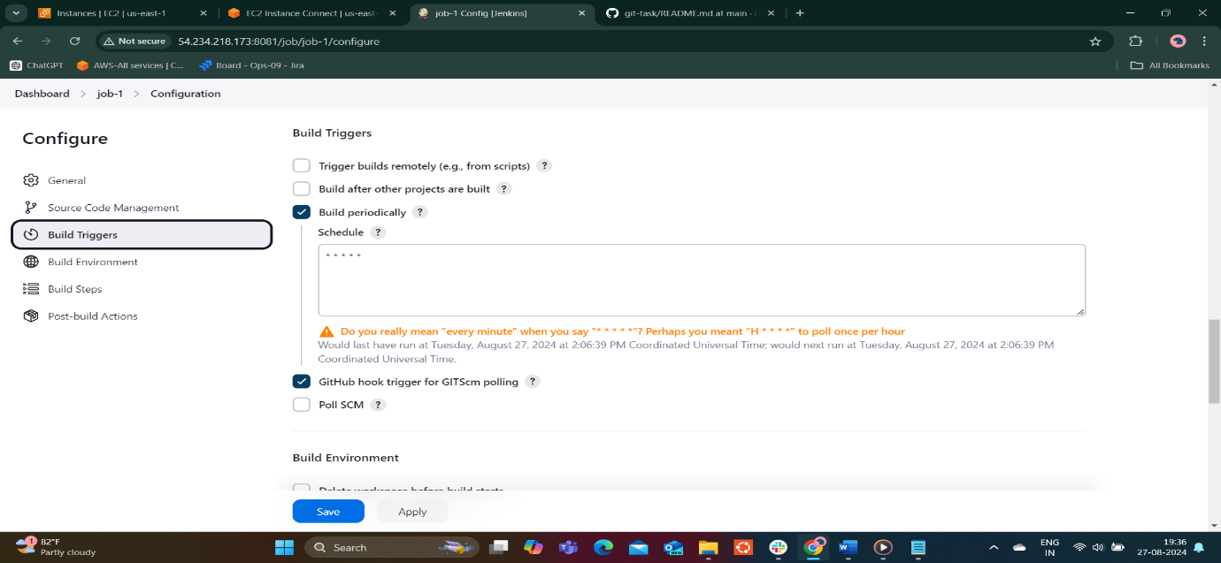

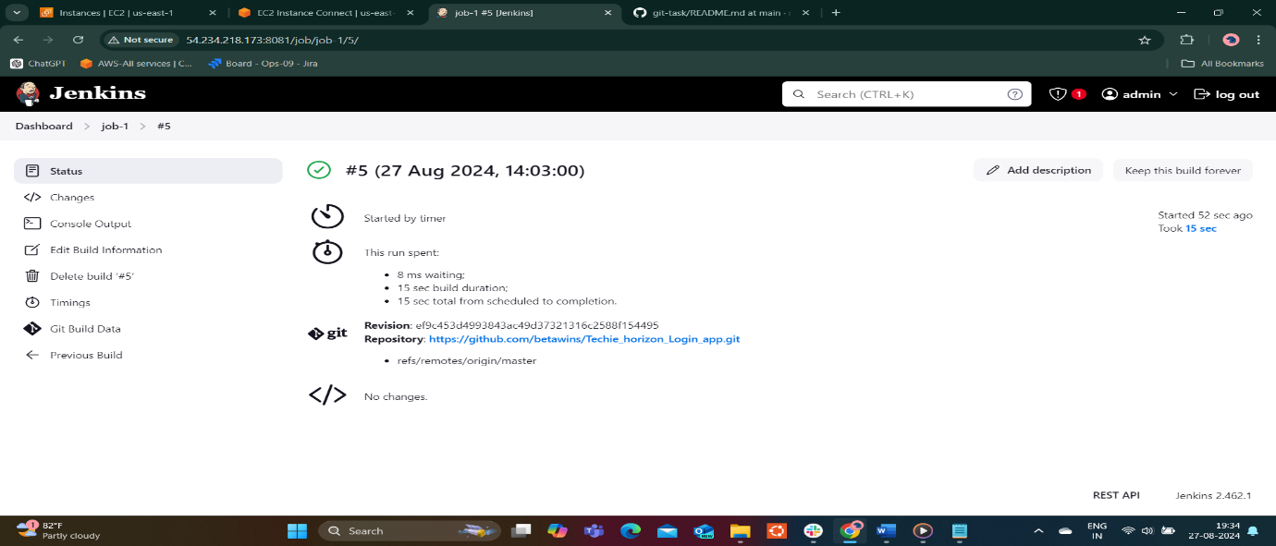

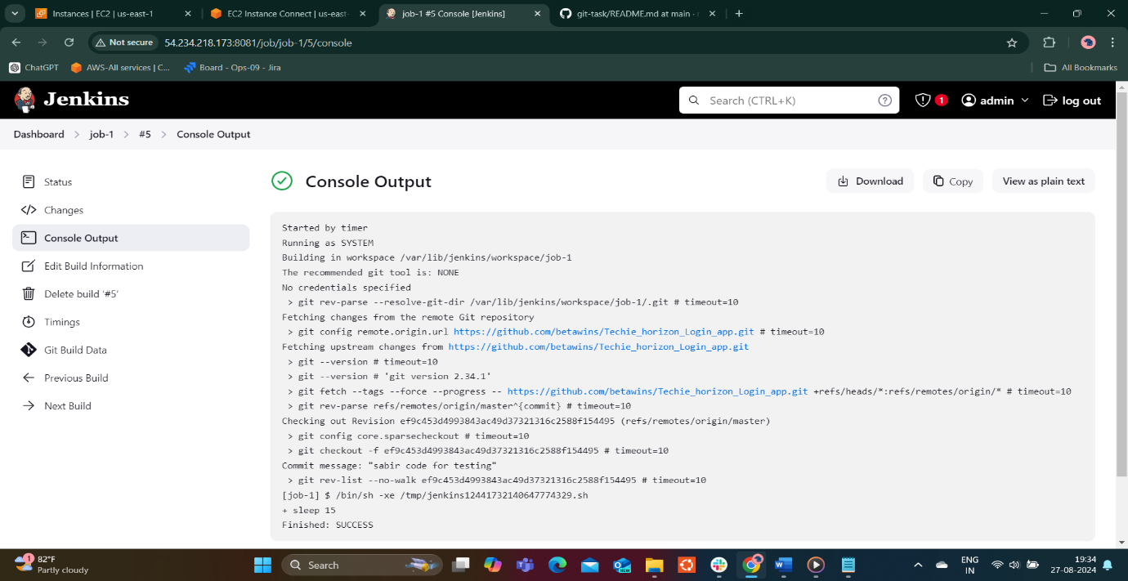

Poll scm build triiger is selected and provide schedule \*\*\*\*\*

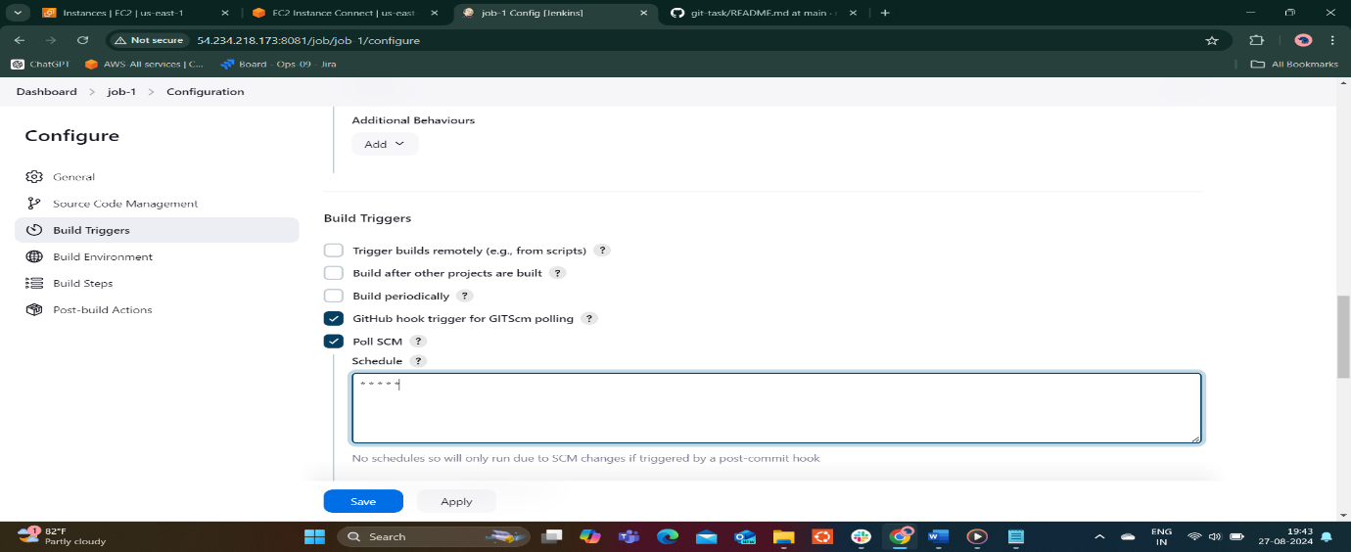

After that make changes in github by adding new word to readme.md file

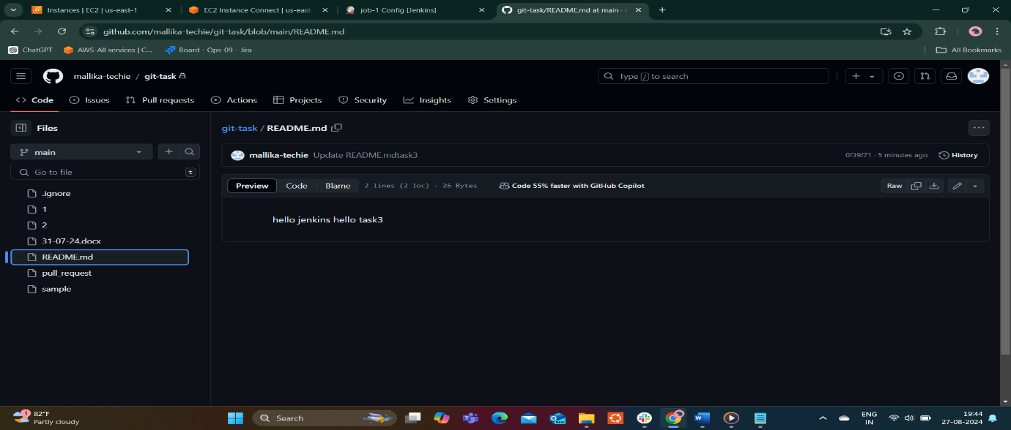

Build periodically and poll scm options are similer but poll scm checks the git repository,there any changes made,it responding other wise job is note trigger.

In case of build periodically job triggered based on time.

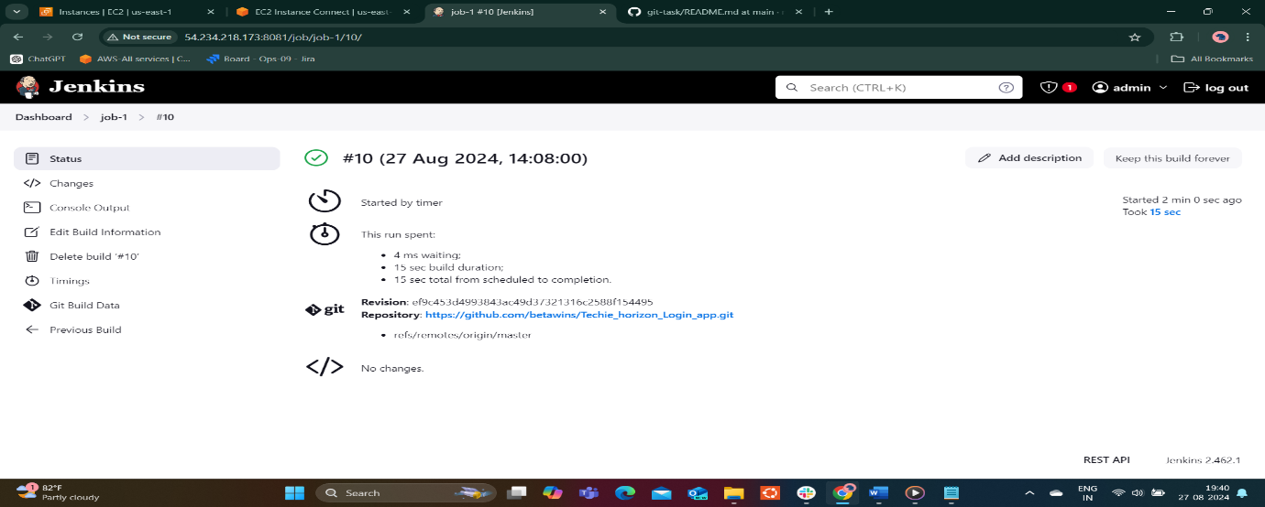

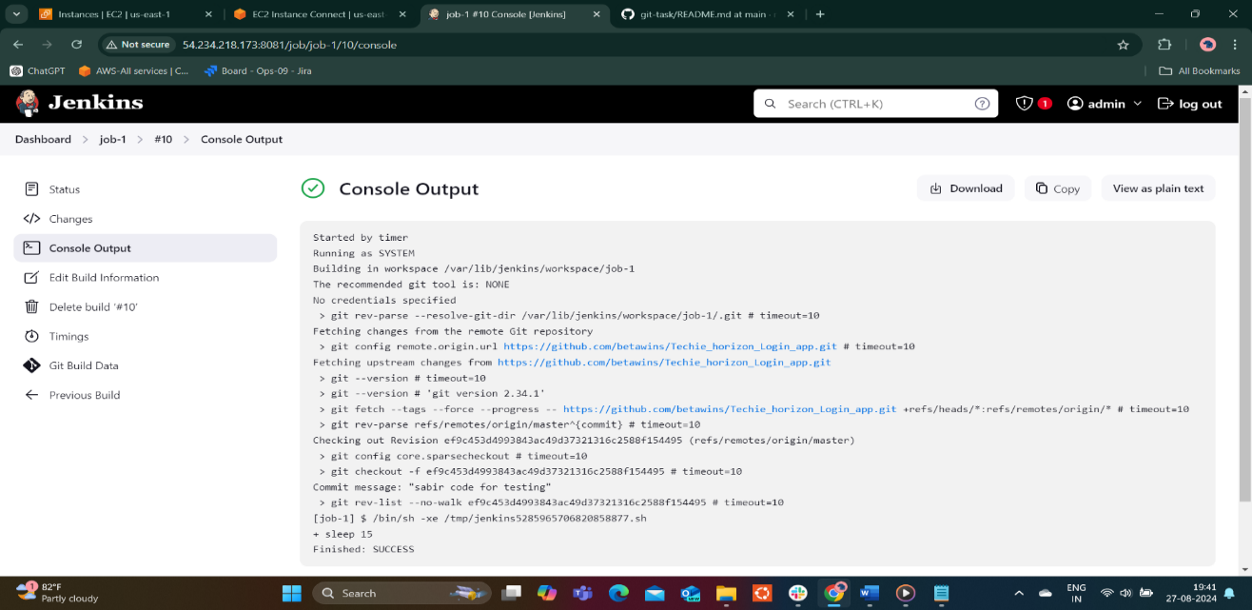

4) Take backup of Jenkins server by using bash script.

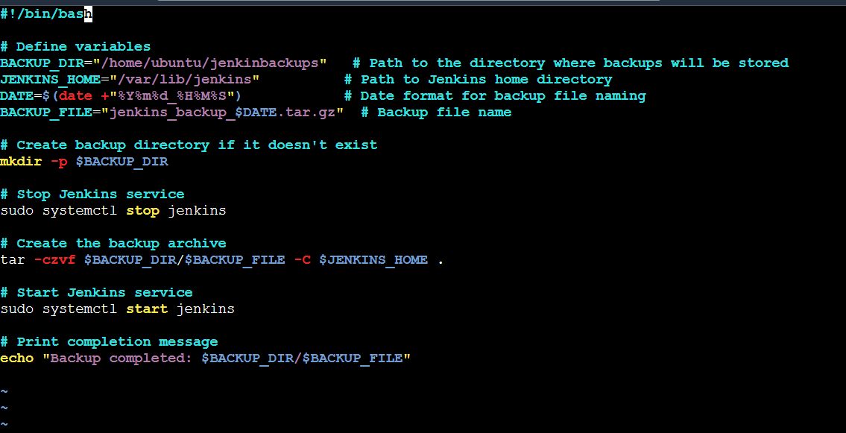

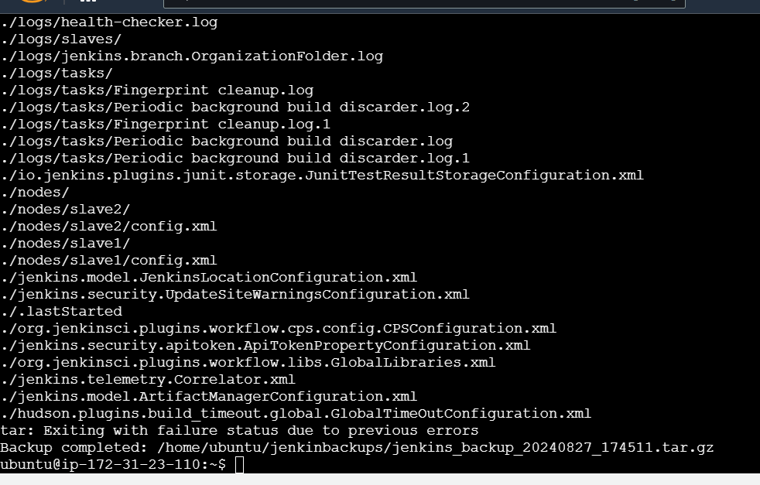

5) Take backup of Jenkins using rethin backup plugin.



6) Setup a new Jenkins server and dump the backup taken in task4.

https://github.com/mallika-techie/git-task.git