MALLIKA-29-8-24-jenkins4

Task for today:

==============

1) Setup jenkins CICD pipeline using freestyle job using below code.

<https://github.com/betawins/hiring-app.git>

Stages:

1. Git Clone

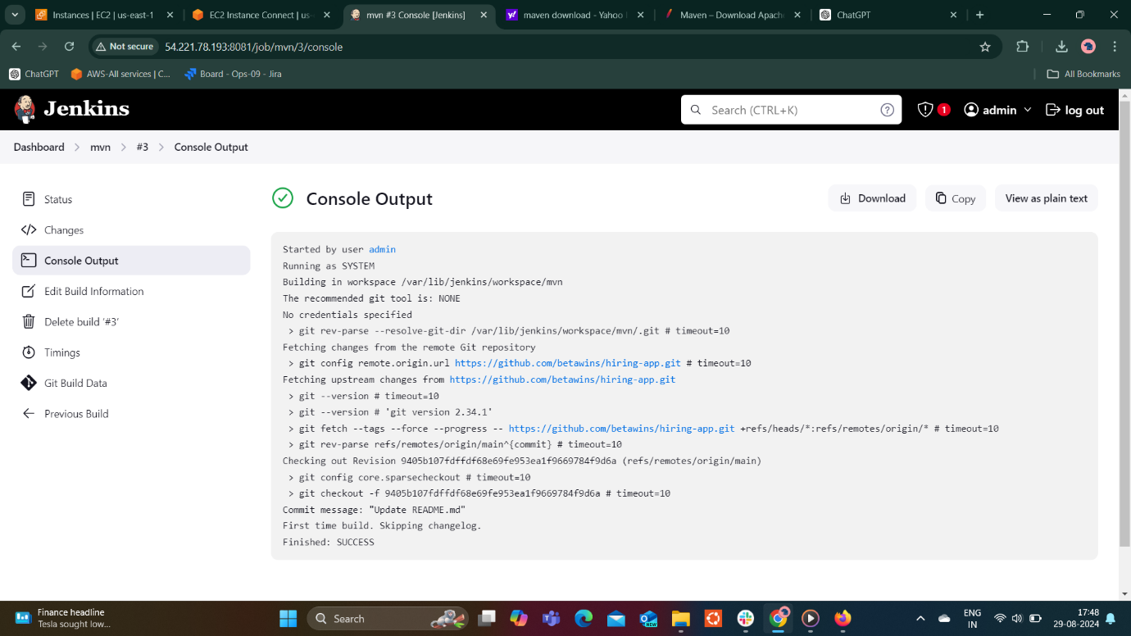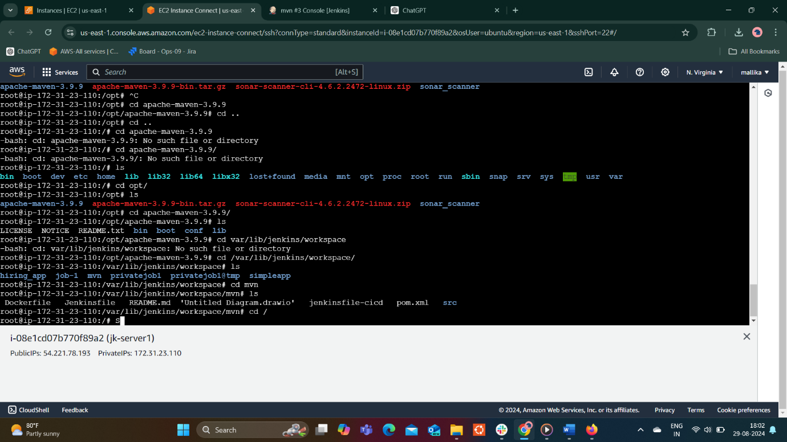

1. Sonarqube Integration

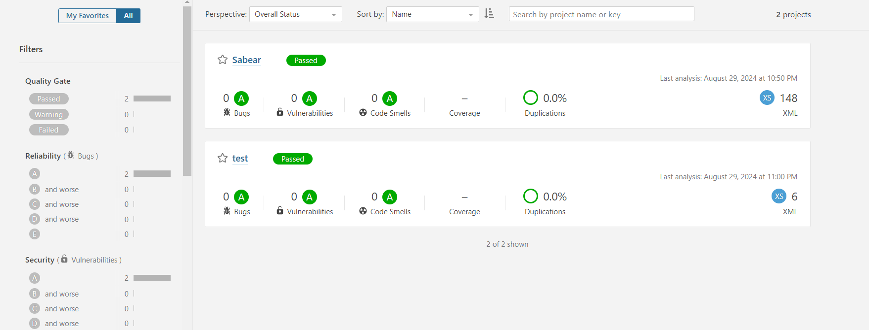

1. Maven Compilation

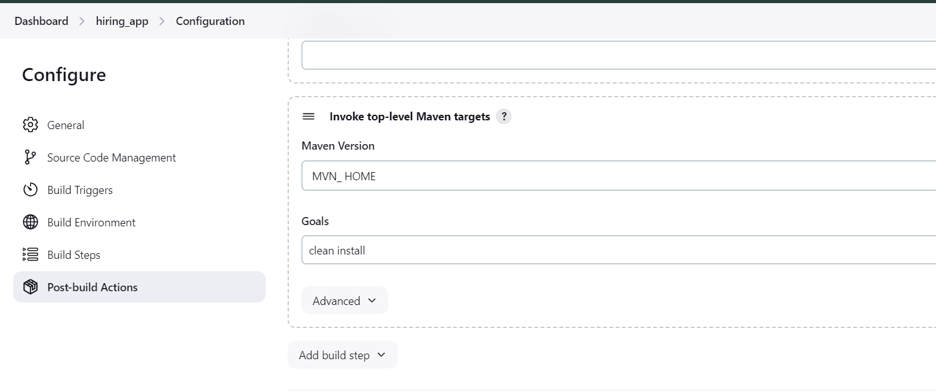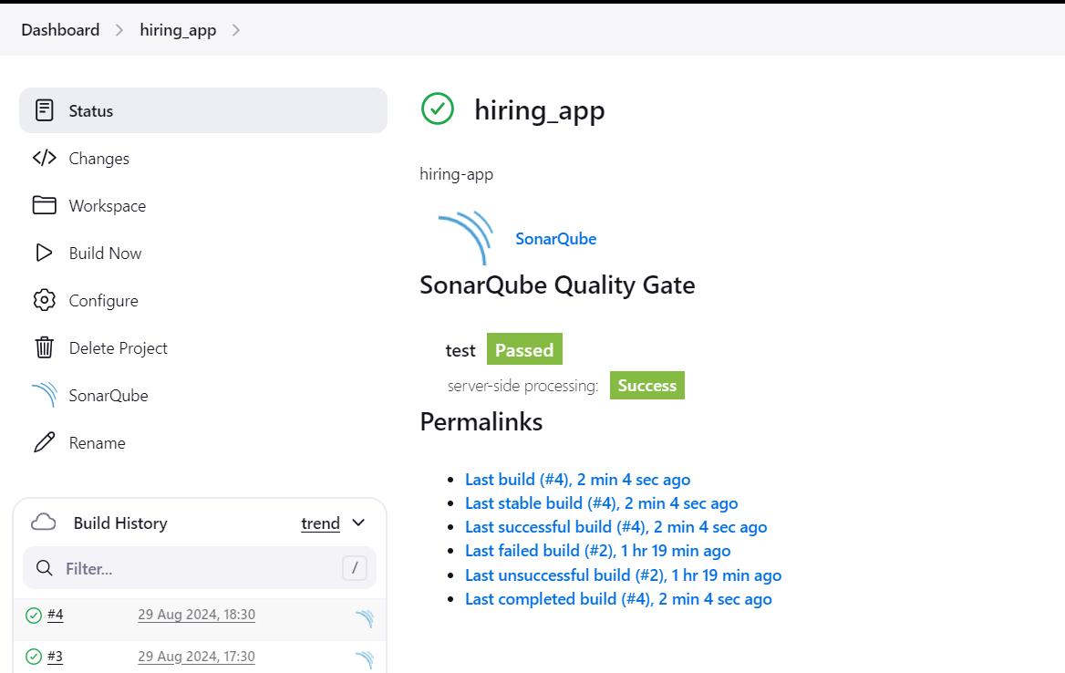

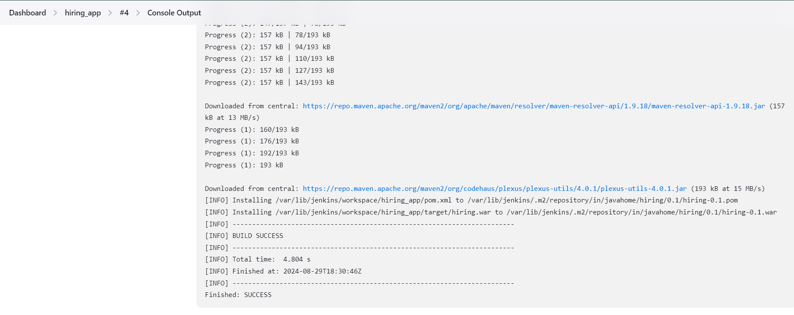

1. Nexus Artifactory

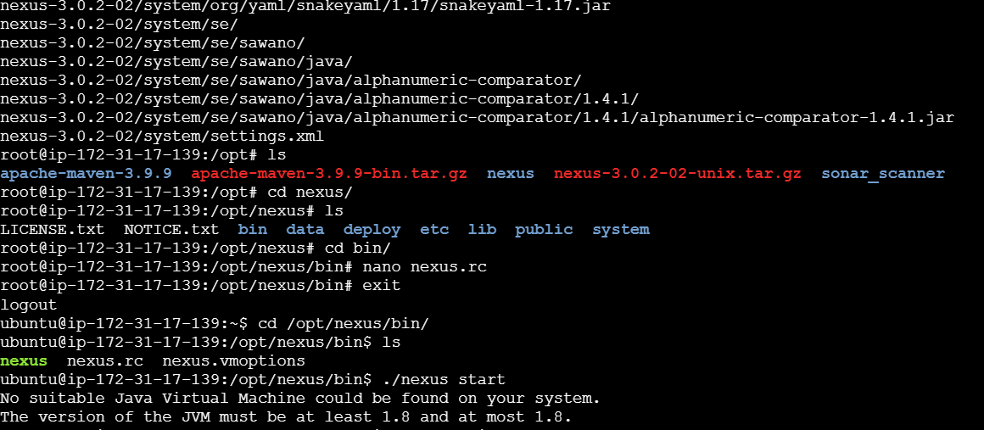

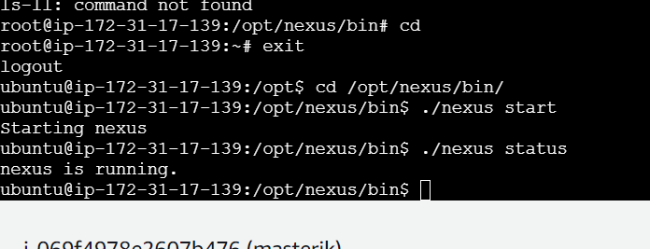

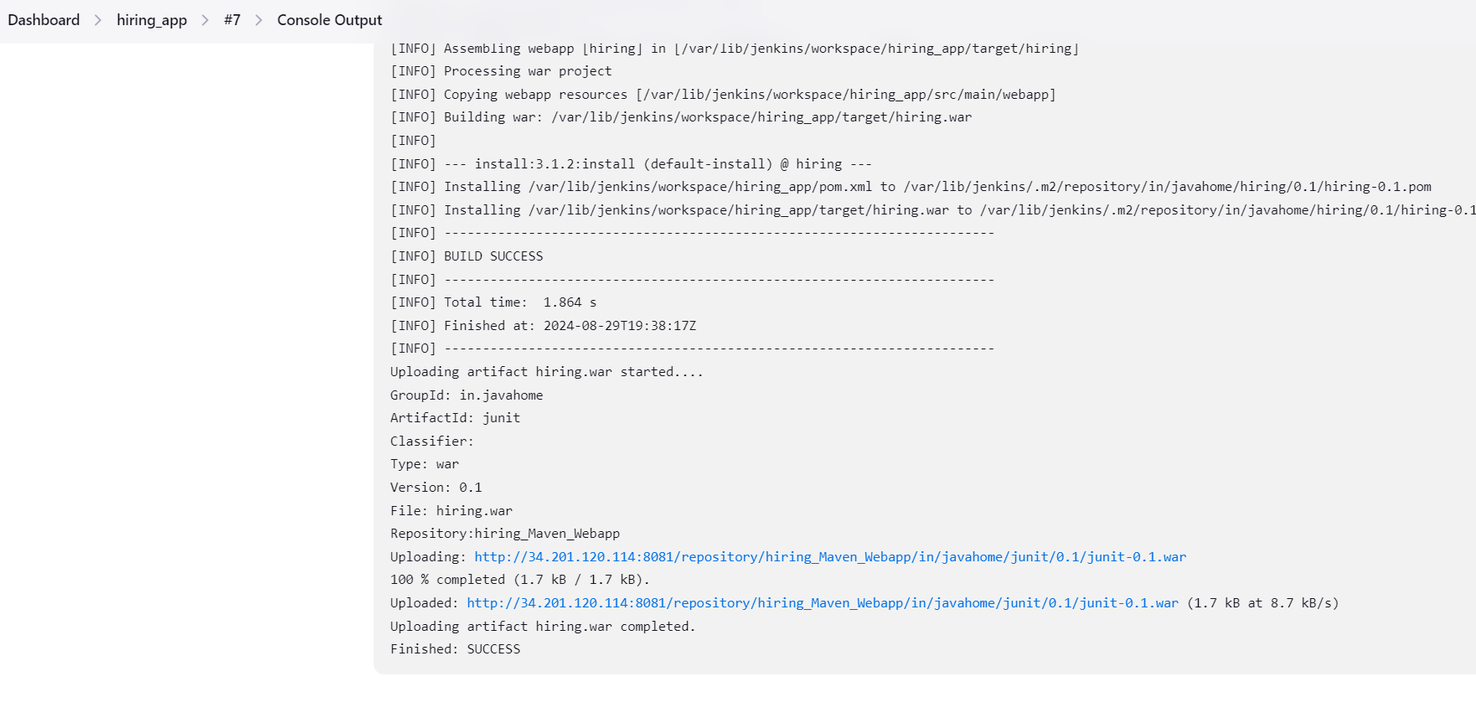

1. Slack Notification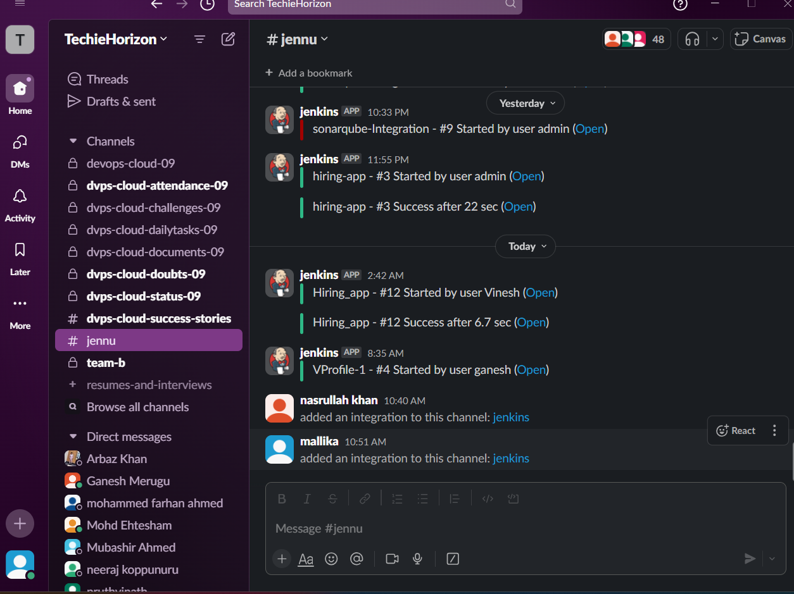
2. Deploy On tomcat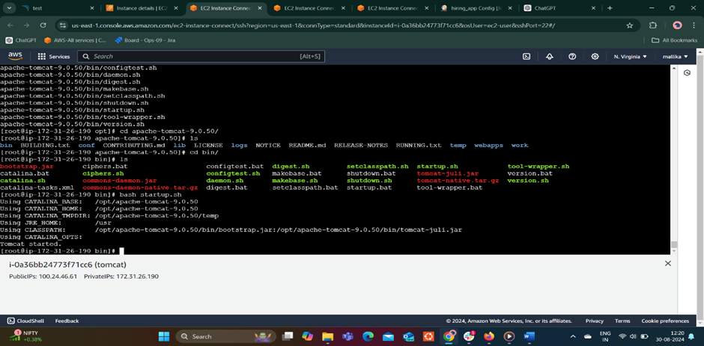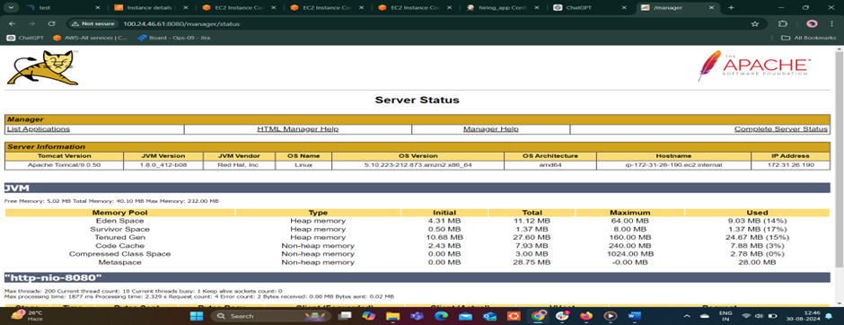
3. 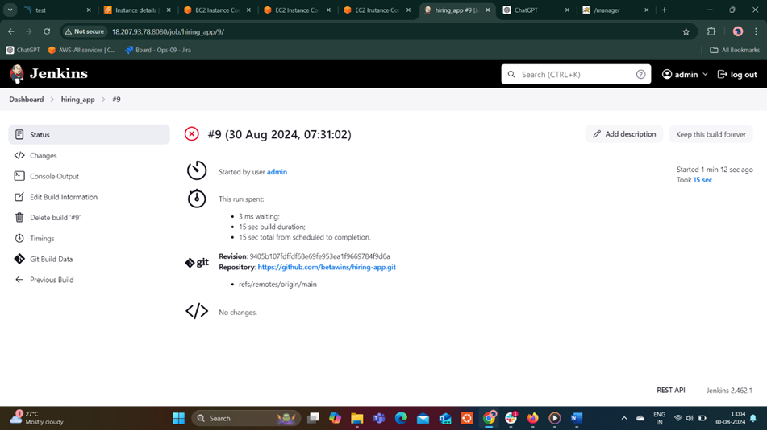

2) Setup jenkins job using freestyle job using below code.

<https://github.com/betawins/Techie_horizon_Login_app.git>

Stages:

1. Git Clone

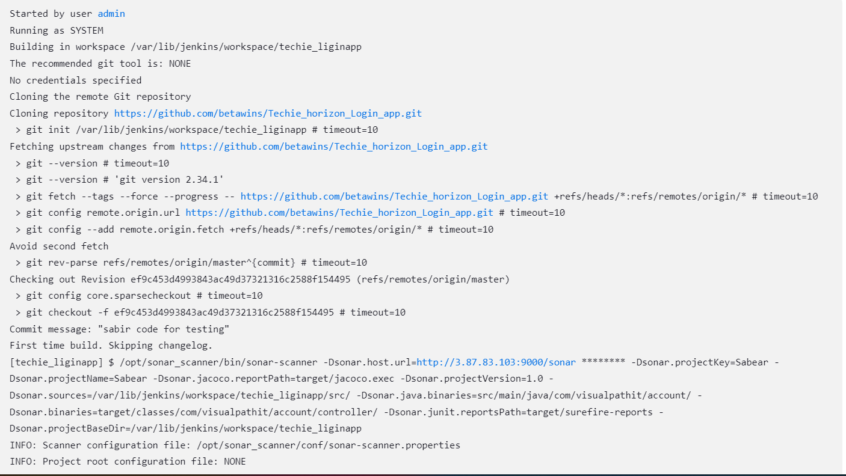

1. Sonarqube Integration

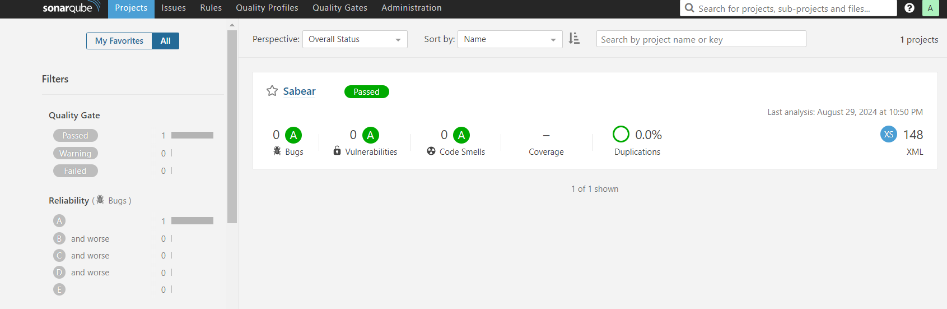

1. Maven Compilation

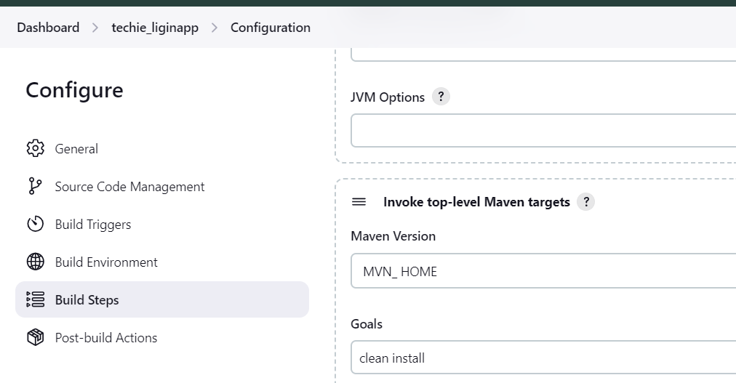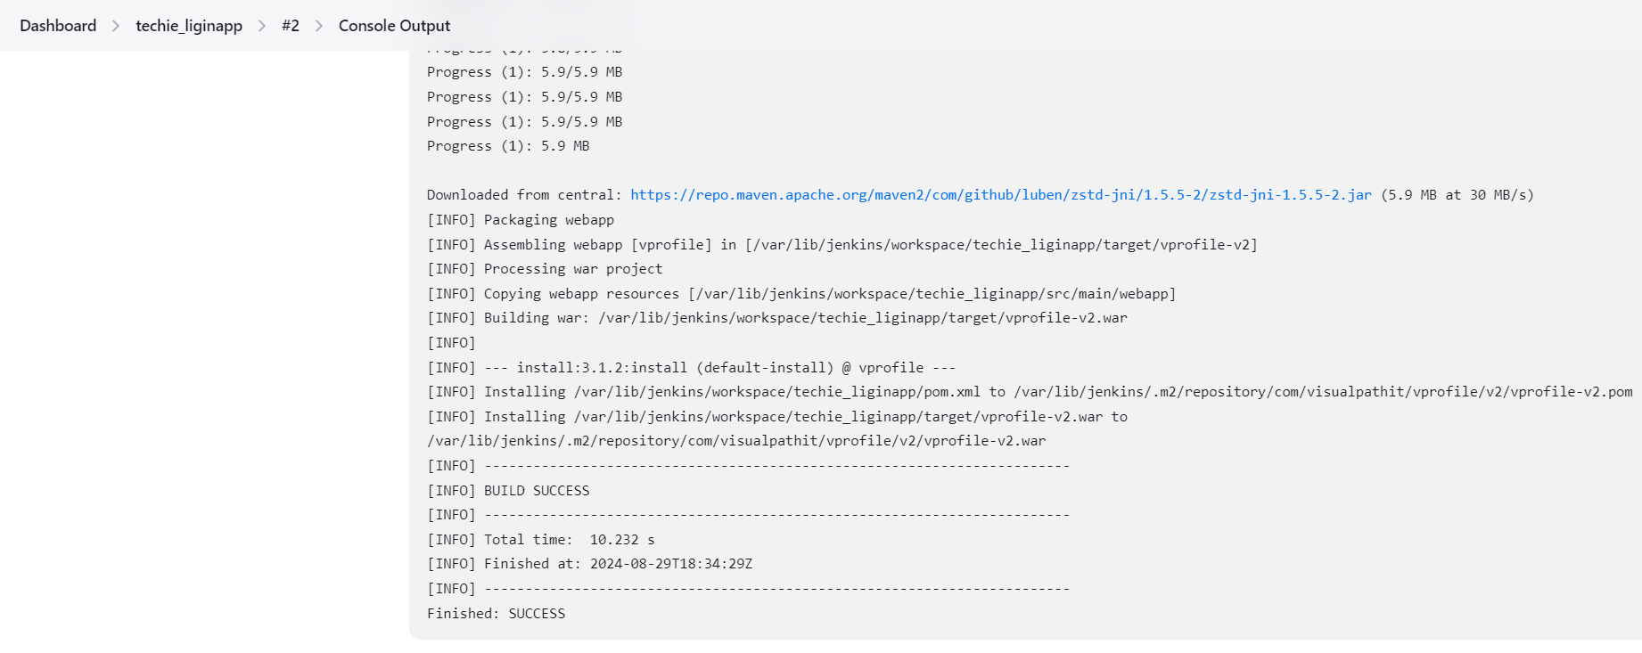

1. Nexus Artifactory

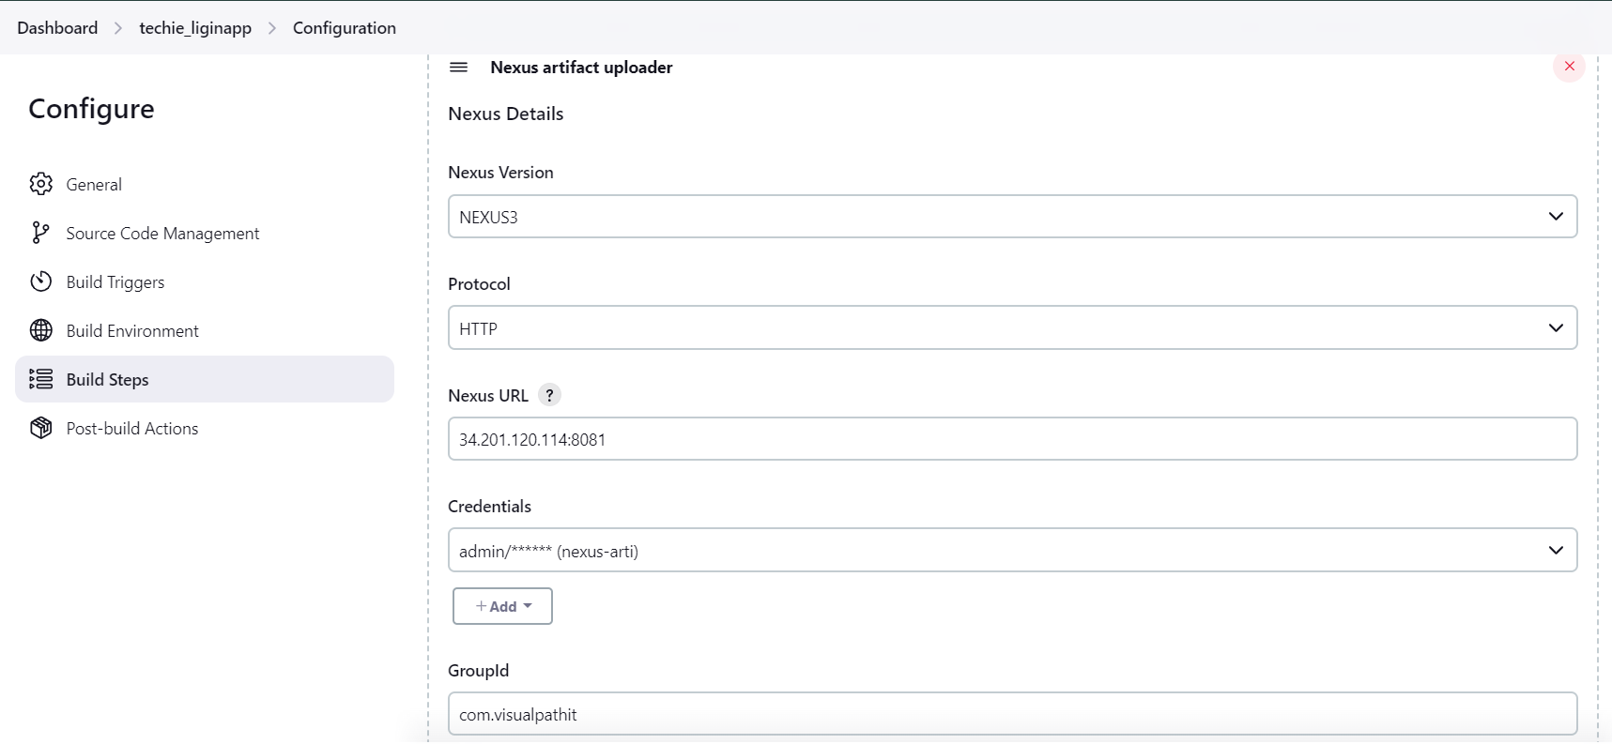

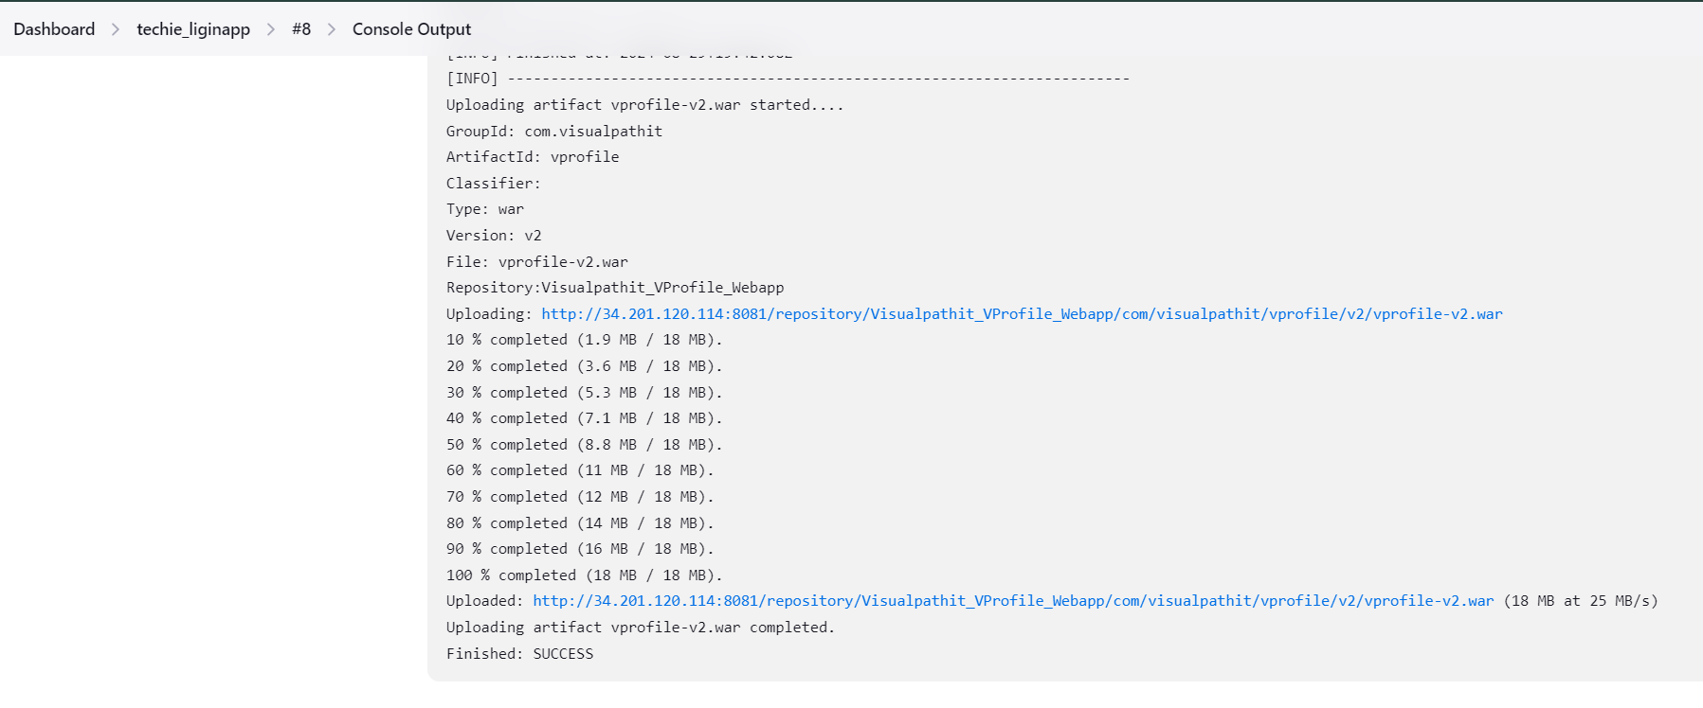

1. Slack Notification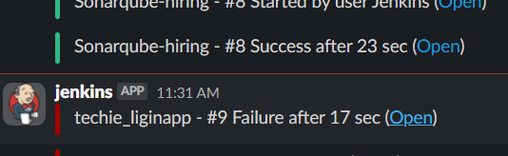
2. Deploy On tomcat

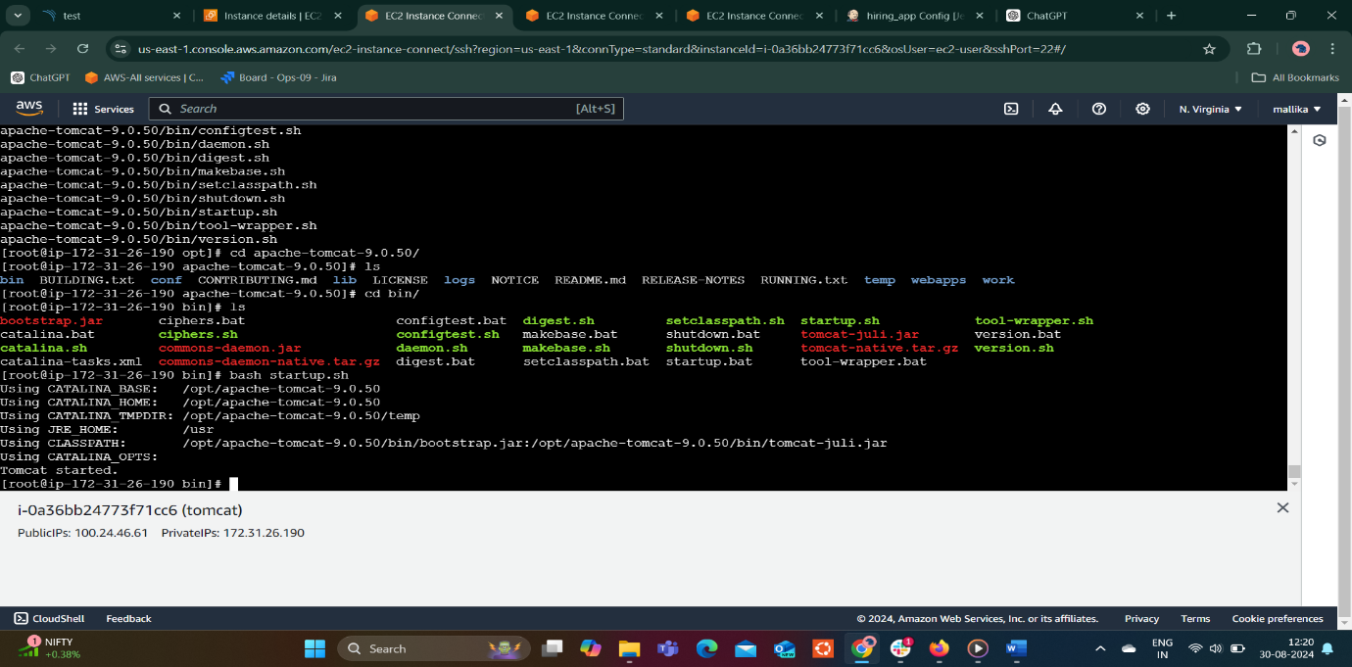

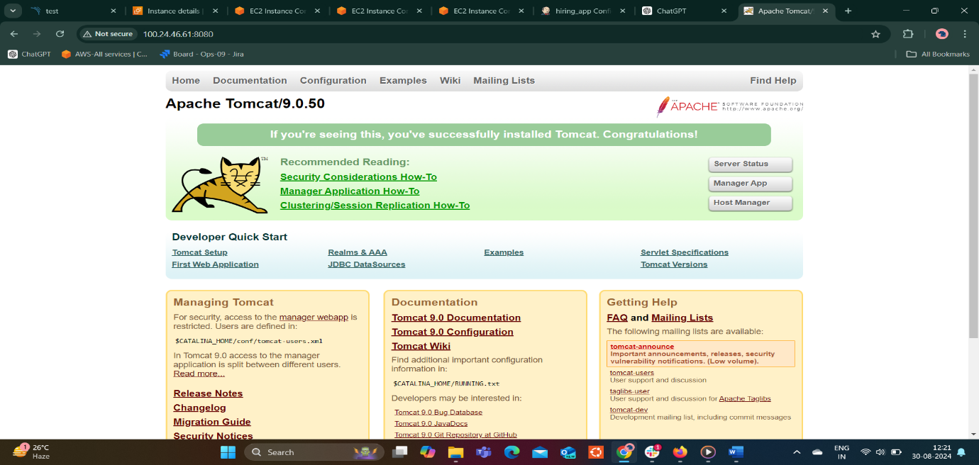

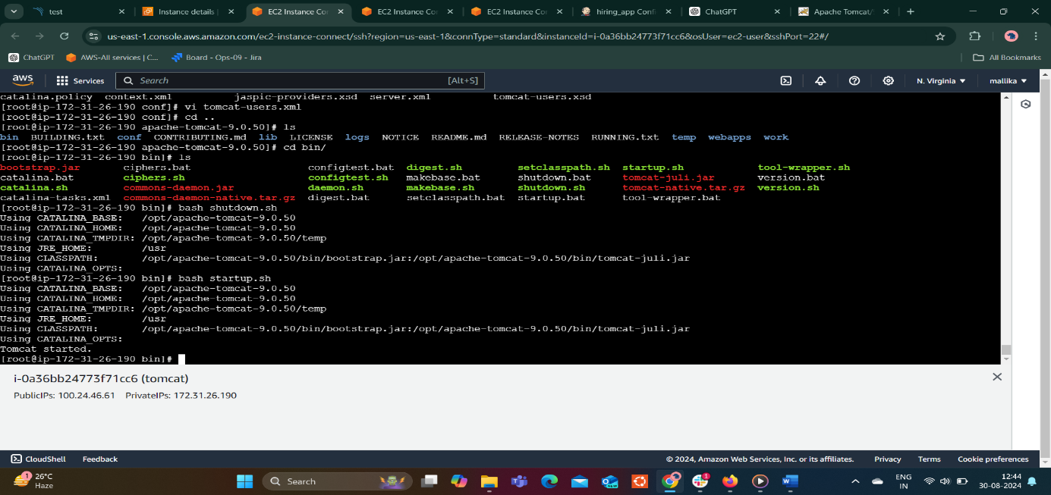

GitHubGitHub

[GitHub - betawins/hiring-app](https://github.com/betawins/hiring-app.git)

Contribute to betawins/hiring-app development by creating an account on GitHub. (33 kB)

<https://github.com/betawins/hiring-app.git>

GitHubGitHub

[GitHub - betawins/Techie_horizon_Login_app](https://github.com/betawins/Techie_horizon_Login_app.git)

Contribute to betawins/Techie_horizon_Login_app development by creating an account on GitHub. (33 kB)