**Hosting Static Website on Amazon S3**

This document explains how to use Amazon S3 to host a static website and connect it to a custom domain using Amazon Route 53.

**Following are the Steps to host a Static website on Amazon S3 with custom domain:**

Step 1: Using Amazon Route 53, register a custom domain.

Step 2: Setup Amazon S3 bucket and design a website.

Step 3: Direct domain to S3 bucket.

**AWS Services:**

1. Route 53: Amazon Route 53 is a highly available and scalable [Domain Name System (DNS)](https://aws.amazon.com/route53/what-is-dns/) web service. Route 53 connects user requests to internet applications running on AWS or on-premises. It facilitates domain registration, DNS routing, and resource health checking for your infrastructure. You have access to the DNS records on Route 53 that translate domain names (like example.com) into IP addresses for other resources.
2. Amazon S3: Amazon Simple Storage Service (Amazon S3) is an object storage service that offers industry-leading scalability, data availability, security, and performance. You can use Amazon S3 to store and retrieve any amount of data at any time, from anywhere.

**Overview of the Deployment:**

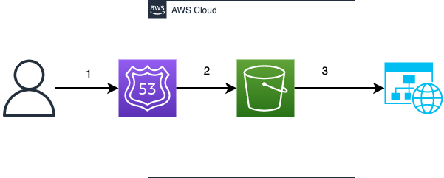

Step 1: Using Amazon Route 53, register a custom domain.

* Open Amazon Route 53 console.

* Choose Domains and then click on Register domains. Enter the name of your custom domain (surveyform.click) and check the availability.

* Purchase your custom domain by following all the prompts.

Step 2: Setup Amazon S3 bucket and design a website.

* Open Amazon S3 console.

* Click on Create bucket and enter a unique bucket name.

Bucket name: same as your custom domain name(surveyform.click)

AWS Region: Region close to your location.

Block all public access: uncheck

Keep all the others as defaults and click on create S3 bucket

* Upload your website files to the bucket.

* Under Properties section, enable Static Website Hosting.

* Under Permission section attach a bucket policy

We have now configured the S3 bucket that host a static website which is publicly accessible to the viewers.

Open the bucket, and you can view our static website. This URL was provided by Amazon. However, it is not hosted on the custom domain.

Step 3: Direct domain to S3 bucket.

* In the Route 53 choose Hosted zones click on custom domain and create a new record set.

* Enter alias target field with endpoint of your S3 bucket.

Record Type: A-Route traffic to an IPV4 address and some AWS resources.

Route traffic to: Alias to S3 website endpoint, and your hosted AWS region.

Routing policy: Simple Routing

Evaluate target health: No

Then, click on create record.

Now you can view static website on the custom domain.

