PROJECT DOCUMENTATION — Neighborhood Tools Rental Analysis
DATA ANALYSIS & BUSINESS INSIGHTS PROJECT

Project By:
MALLIKA.M
Data Analytics Enthusiast
(Personal Project – 2025 Edition)

Contact Information:
Email: malliksivarao@gmail.com
Phone: 8555986385
Location: Hyderabad

Tools & Technologies Used:
SQL • Python • Power BI • Excel • CSV

Project Type:
Independent Personal Project

Date:
November 2025

NEIGHBORHOOD TOOLS SHARING PLATFORM
A SQL + Power BI End-to-End Data Project
PROJECT OVERVIEW
Neighborhood Tools is a community-driven tool-sharing platform where users can borrow, lend, review, and track tools.
This project includes:
- SQL Database (7 Tables)
- Cleaned Dataset (CSV Files)
- ER Diagram (MySQL Workbench)
- Power BI Dashboard & Data Model
- Documentation + Screenshots
This project demonstrates database design, data cleaning, real-time data correction, Power BI modeling, and reporting skills.

RELATIONAL DATABASE STRUCTURE (SQL)
Tables:
Users • Tools • Categories • Locations • Reservations • Reviews • Transactions
KEY FEATURES
1. RELATIONAL DATABASE (SQL)
Includes normalized tables:
- Users
- Tools
- Categories
- Locations
- Reservations
- Reviews
- Transactions

2. DATA CLEANING (Power BI Query Editor)
Several corrections were made to improve data consistency:
Table | What Was Cleaned | Method
Locations | Replaced fake values (CityA, CityB, Area1…) with real city/area data | Power BI Query Editor – Replace Values
Transactions | Updated dates from 2023 → 2025 to match reservation timeline | Transform → Replace Values
Reservations | Checked date consistency (start < end) | Validation
Tools | Ensured category & location IDs match updated lookup tables | Foreign key validation
- Cleaned tables were exported back to CSV
- Old CSVs were replaced in the project folder

3. ER DIAGRAM (MySQL Workbench)
Includes:
- Primary keys
- Foreign keys
- Relationships
- Cardinality

POWER BI DASHBOARD
The dashboard includes:
- Total Borrowed Tools
- Category-wise Borrowing
- Tool Availability
- User Activity
- Reservations Timeline
- Reviews & Ratings
- City-wise Tool Distribution
Relationship View is included in the project folder.

PAGE 1 — OVERVIEW DASHBOARD
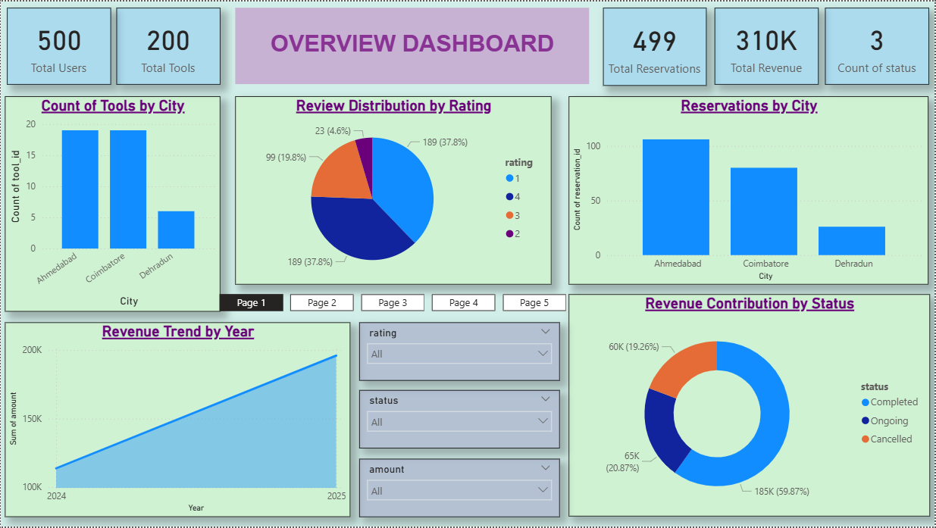

PAGE 2 — CATEGORY-WISE TOOLS & CONDITION OVERVIEW
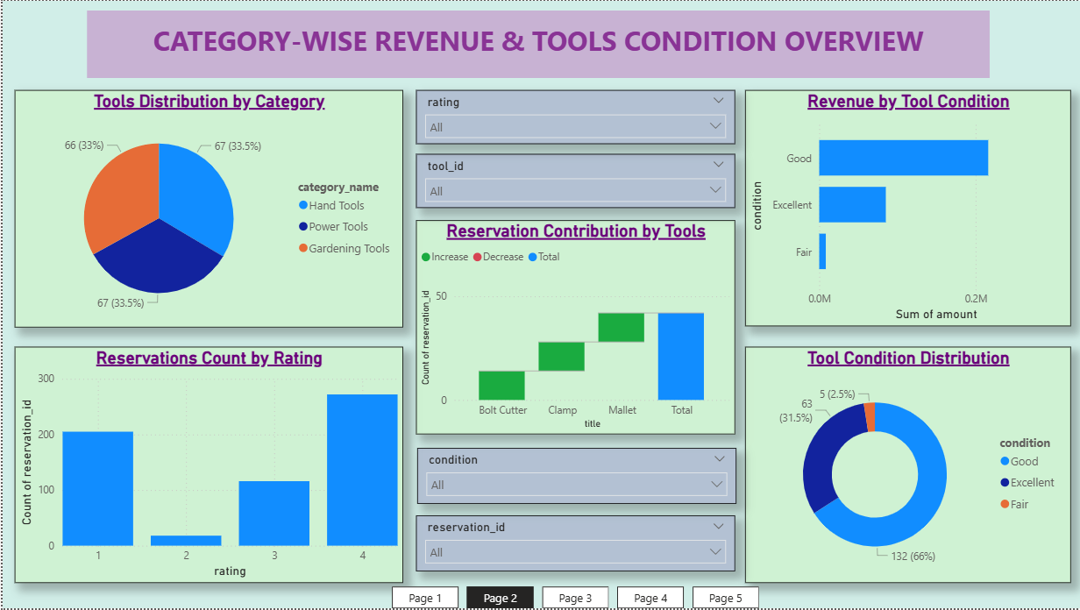

PAGE 3 — CUSTOMER SATISFACTION & LOCATION ANALYSIS
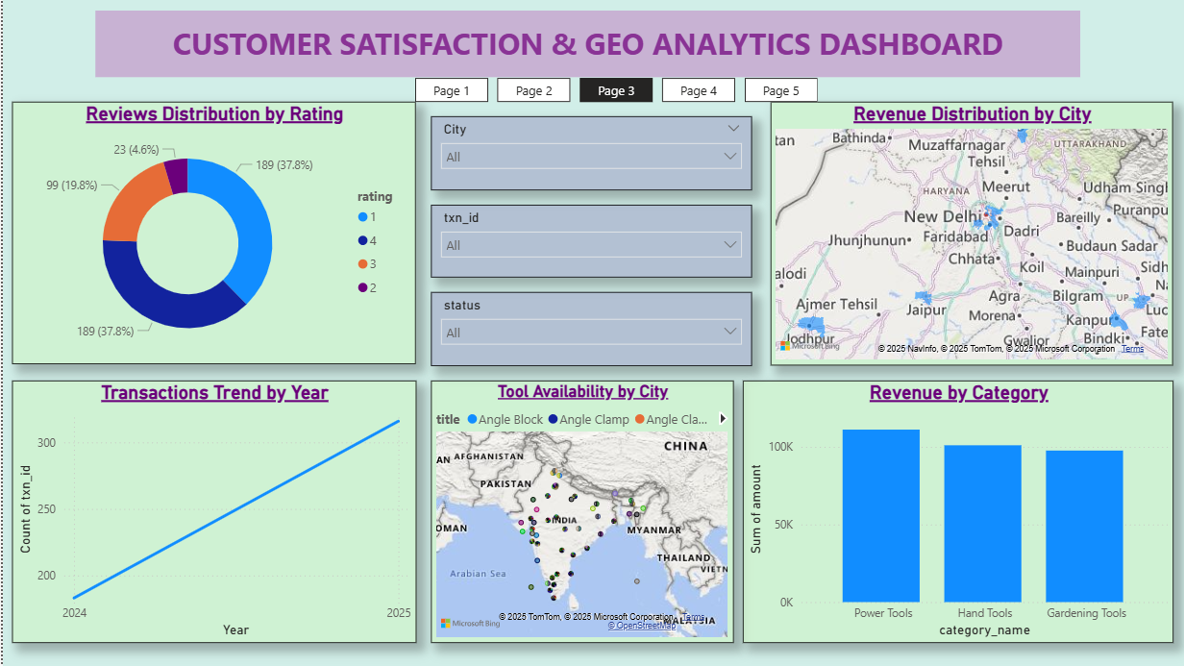
📄PAGE 4 — FINANCIAL & OPERATIONS DASHBOARD
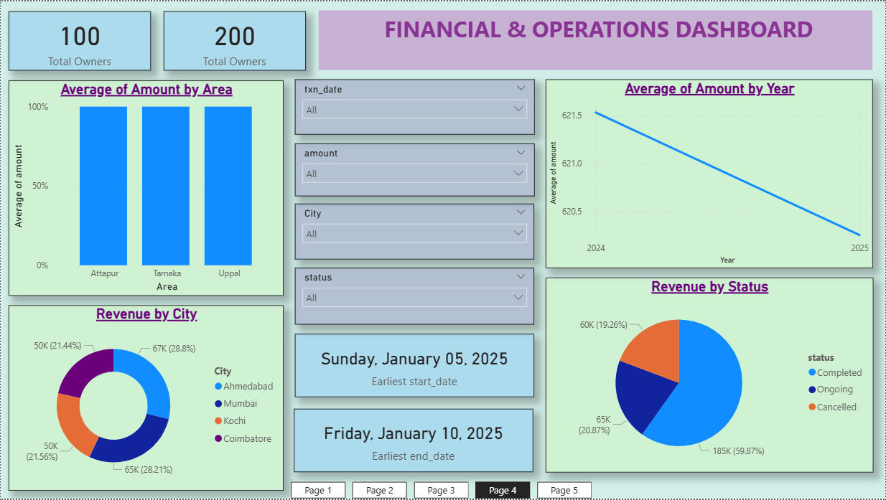

PAGE 5 — ADVANCED INSIGHTS & TREND ANALYSIS
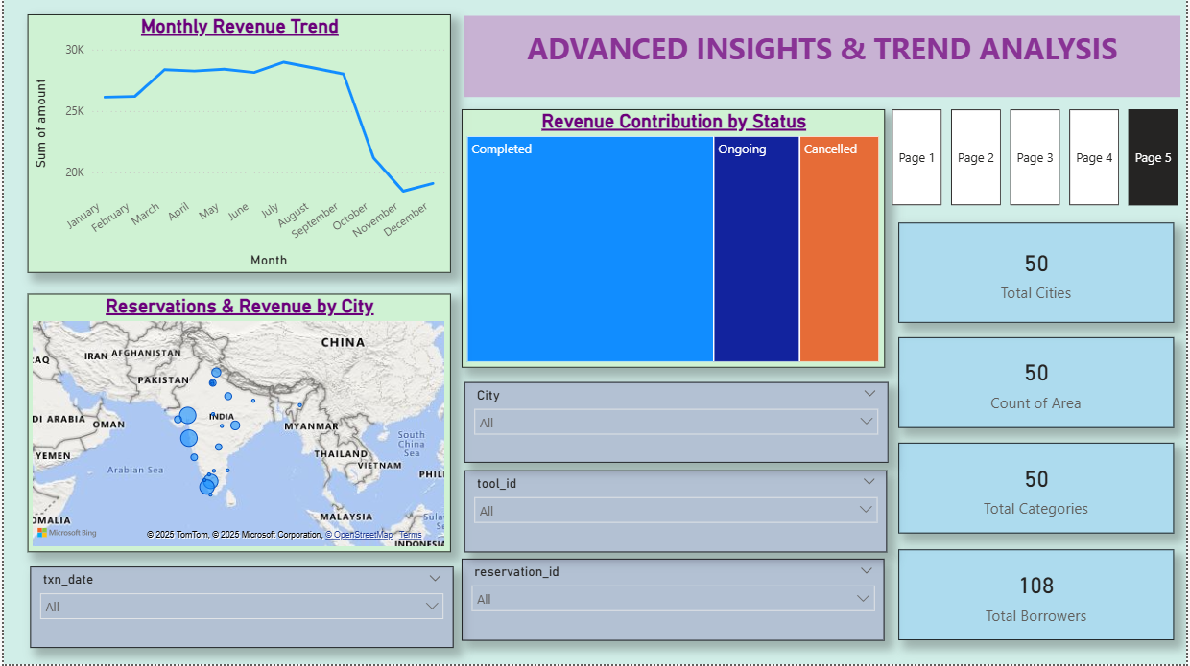
Power BI Relationship View Image Placement
POWER BI DATA MODEL
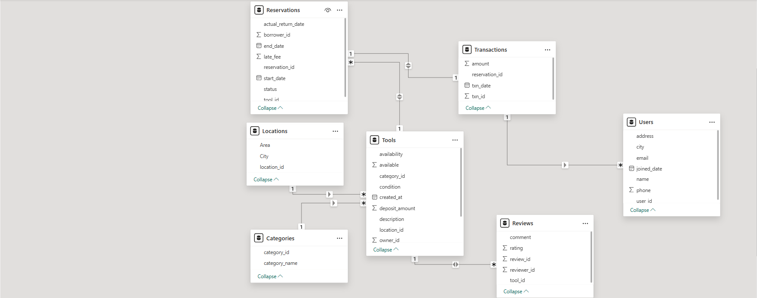

PROJECT STRUCTURE
Neighborhood_Tools_SQL/
│── Data/ → Cleaned CSVs
│── dump/ → SQL table exports
│── ER/ → ER.mwb + ER.png
│── Power BI/ → Dashboard (pbix)
│── ss/ → Screenshots
│── Documentation.docx → Project report

TOOLS & TECHNOLOGIES
- SQL (MySQL) – Database creation & data modeling
- Power BI – Data cleaning, modeling & dashboarding
- Power Query – Data transformation
- MySQL Workbench – ER Diagram

IMPROVEMENTS MADE DURING THE PROJECT
- Cleaned inconsistent city & area data
- Fixed year inconsistencies in transaction dates
- Removed unused/old SQL dump (reservations_old.sql)
- Improved location table realism
- Made data analysis-ready (no missing foreign keys, no invalid IDs)

NEXT STEPS
- Add tool inventory forecasting
- Integrate real-time availability
- Add user authentication & role-based permissions
- Deploy the SQL database with a front-end app

CONCLUSION
This project demonstrates strong skills in:
- SQL schema design
- Data modeling
- Data cleaning
- Power BI reporting
- Professional documentation
Perfect for Resume, GitHub, Interviews, and Portfolio.

