**INNOVATE. CREATE. SOLVE**

 Bengaluru, Karnataka, India

AN INTERNSHIP REPORT

ON

“STORE MY RESULTS”

Bachelor of Engineering

**In**

#### Computer Science and Engineering

#### Submitted by: FAZAL UR REHAMAN (1BY19CS402)

#### NIKHIL M (1BY19CS407)

#### PAVAN V (1BY19CS408)

#### MALLIKARJUN (1BY19CS405)



## B.M.S. Institute of Technology & Management

**ABOUT THE COMPANY**

IC Solution (ICS) is a digital service provider that aims to provide software, designing and marketing solutions to individuals and businesses. At ICS, we believe that service and quality is the key to success

We provide all kinds of technological and designing solutions from Billing Software to Web Designs or any custom demand that you may have. Experience the service like none other!

Some of our services include:

Development - We develop responsive, functional and super-fast websites.

We keep User Experience in mind while creating websites. A website should load quickly and should be accessible even on a small view-port and slow internet connection.

Mobile Application - We offer a wide range of professional Android, iOS & Hybrid app development services for our global clients, from a start up to a large enterprise.

Design - We offer professional Graphic design, Brochure design & Logo design. We are experts in crafting visual content to convey the right message to the customers.

Consultancy - We are here to provide you with expert advice on your design and development requirement.

Videos - We create a polished professional video that impresses your audience.

**TABLE OF CONTENTS**

Table of contents i

Overview of the Project 3-4

Tool 5

Implementation 6-21

Snapshots 22-29

Bibliography 30

**OVERVIEW OF THE PROJECT**

**Project Name:** **STORE MY RESULTS**

**Team Members:** **Fazal Ur Rehaman**

**Nikhil M**

**Pavan V**

**Mallikarjuna Halagali**

This project is based on Web Development And its Applications. The main objective of this project is to learn the implementation of HTML, CSS and JavaScript. The basic webpage of this project is created using HTML and styling of the webpage is done using CSS.

Engineering Students Nowadays do not have the habit of remembering their marks of the previous semester or the work rating of the last project in the company, this can actually cause a huge problem to students in their final year of Engg/if switching companies is taking place, in order to solve this, we here at storemyresults.com would love to provide a platform to students/Graduates to store their results of the previous/current semester thereby making it comfortable to access results and marks accessible whenever required, fun fact, Majority of students don’t even remember the marks of their current semester and the sophisticated design of result websites make it a little difficult to access the same.

The most important part of making this site is the user experience, which results in specific university websites do not focus on design as functionality outweighs design in these specific websites, which can further ruin the user experience, here the focus

lies on functionality and design.

The Working Process is pretty simple here we ask students to create an account with us and we tend to store the data that they enter, the data might include USN, NAME and SUBJECT NAMES with their finalized marks, once that is done we keep a submit option wherein the users/Students can submit their responses.

The content of the web page at the time of submission should be downloadable in pdf form for their reference, the data of the user should be completely secured and (s)he has to make an account and set their password to access their account at any point in time. This will make it easier for the students to retrieve their results or marks of any subject of any semester anytime.

**TOOLS USED**

**Software Requirements**

* Visual Studio Code 2019.
* Google Chrome or Microsoft Edge of latest version.
* Front End: HTML, CSS, JS (optional)
  + XAAMP
  + Apache:
    - (Application Server) Apache , often referred to as Server, is an open-source Java Servlet Container developed by the Apache Software Foundation.
  + MySqlServer:
    - It handles largest databases much faster than existing solutions.
    - It consists of multi-threaded SQL server that supports different back ends, several different client programs and libraries, administrative tools, and application programming interfaces (APIs)
    - Its connectivity, speed, and security make MySQL Server highly suited for accessing databases on the Internet.
* **Git Hub**: GitHub Inc. is a web-based hosting service for version control using Git. It is mostly used for computer code. It offers all of the distributed version control and source code management functionality of Git as well as adding its own features.
* Linux 7.1 or Windows XP/7/8/10 OS or Mac OS

**Hardware Requirements**

* Pentium 200-MHz computer with a minimum of 64 MB of RAM (128 MB of RAM recommended).
* Monitor with a refresh rate of at least 40Hz for a smooth GUI experience (optional).

**IMPLEMENTATION**

**Source Code (PHP):**

**Signup.php**

<!DOCTYPE html>

<html >

<head>

<meta charset="UTF-8">

<title>Signup</title>

<link rel="stylesheet" href="css/styles.css">

<meta charset="utf-8">

<meta name="viewport" content="width=device-width, initial-scale=1">

</head>

<body>

<div id="clouds" style="padding-top:14px;">

<div class="head1" style="padding-top: 0px; padding-bottom: 200px;">

<img src = "css/logo.png" width = "130px" height = "120px"/>

<h1> Store My Results</h1>

</div>

</div>

<div class="container">

<h2>SignUp</h2>

</br></br>

<div id="login">

<form name="f2" action="" onsubmit = "return validation()" method="post">

<fieldset class="clearfix">

<p><span class="fontawesome-user"></span><input type="text" id="name" name="name" placeholder="Full Name">

<p><span class="fontawesome-user"></span><input type="text" id="user" name="user" placeholder="Email/Username">

<p><span class="fontawesome-lock"></span><input type="password" id="pass" name="pass" placeholder="Password">

<p><span class="fontawesome-lock"></span><input type="password" id="pass2" name="pass2" placeholder="Re-Enter Password">

<p><input type="submit" name="sub" value="SignUp"></p>

</fieldset>

</form>

</div> <!-- end login -->

<div> <p style="color: #b7c4d1; font-size: 19px"> Already have an account? <a style="font-weight: bold" href ="login.php"> Login </a> </div>

</div>

<script>

function validation()

{

var id=document.f2.user.value;

var ps=document.f2.pass.value;

var ps2=document.f2.pass2.value;

if(id.length=="" && ps.length=="") {

alert("User Name and Password fields are empty");

return false;

}

else

{

if(id.length=="") {

alert("User Name is empty");

return false;

}

if (ps.length < 8) {

alert("Password must be atleast 8 character long");

return false;

}

if (ps!=ps2) {

alert("Passwords entered do not Match");

return false;

}

}

}

</script>

</body>

</html>

<?php

include('dbcon.php');

session_start();

if (isset($_POST['user']) && isset($_POST['pass'])) {

$name = $_POST['name'];

$usrname = $_POST['user'];

$password = $_POST['pass'];

//to prevent from mysqli injection

$name = stripcslashes($name);

$usrname = stripcslashes($usrname);

$password = stripcslashes($password);

$name = mysqli_real_escape_string($conn, $name);

$usrname = mysqli_real_escape_string($conn, $usrname);

$password = mysqli_real_escape_string($conn, $password);

$sql = "select * from users where email = '$usrname'";

$result = mysqli_query($conn, $sql);

$row = mysqli_fetch_array($result, MYSQLI_ASSOC);

$count = mysqli_num_rows($result);

if($count == 1){

echo '<script> alert("User Already Exists")</script>';

}

else{

$sql = "INSERT INTO users(name, email, pass)

VALUES ('$name', '$usrname' , '$password')";

if ($conn->query($sql)) {

echo '<script> alert("SignUp Successful, Click OK to Login")</script>';

header("Refresh:0.5; url=login.php");

} else {

echo 'Error: '.$sql.'<br>'.$conn->error;

}

exit;

}

}

?>

**Index.php**

<?php

include('dbcon.php');

if(isset($_GET['user'])){

$username = $_GET['user'];

}

if(isset($_POST['usn']))

{

$name =$_POST['name'];

$usn = $_POST['usn'];

$sem = $_POST['sem'];

$branch = $_POST['branch'];

$sub1 = $_POST['sub1'];

$mrk1 = $_POST['mrk1'];

$sub2 = $_POST['sub2'];

$mrk2 = $_POST['mrk2'];

$sub3 = $_POST['sub3'];

$mrk3 = $_POST['mrk3'];

$sub4 = $_POST['sub4'];

$mrk4 = $_POST['mrk4'];

$sub5 = $_POST['sub5'];

$mrk5 = $_POST['mrk5'];

$sub6 = $_POST['sub6'];

$mrk6 = $_POST['mrk6'];

$sub7 = $_POST['sub7'];

$mrk7 = $_POST['mrk7'];

$sub8 = $_POST['sub8'];

$mrk8 = $_POST['mrk8'];

$sub9 = $_POST['sub9'];

$mrk9 = $_POST['mrk9'];

$name = stripcslashes($name);

$usn = stripcslashes($usn);

$sem = stripcslashes($sem);

$branch = stripcslashes($branch);

$sub1 = stripcslashes($sub1);

$mrk1 = stripcslashes($mrk1);

$sub2 = stripcslashes($sub2);

$mrk2 = stripcslashes($mrk2);

$sub3 = stripcslashes($sub3);

$mrk3 = stripcslashes($mrk3);

$sub4 = stripcslashes($sub4);

$mrk4 = stripcslashes($mrk4);

$sub5 = stripcslashes($sub5);

$mrk5 = stripcslashes($mrk5);

$sub6 = stripcslashes($sub6);

$mrk6 = stripcslashes($mrk6);

$sub7 = stripcslashes($sub7);

$mrk7 = stripcslashes($mrk7);

$sub8 = stripcslashes($sub8);

$mrk8 = stripcslashes($mrk8);

$sub9 = stripcslashes($sub9);

$mrk9 = stripcslashes($mrk9);

$name = mysqli_real_escape_string($conn, $name);

$usn = mysqli_real_escape_string($conn, $usn);

$sem = mysqli_real_escape_string($conn, $sem);

$branch = mysqli_real_escape_string($conn, $branch);

$sub1 = mysqli_real_escape_string($conn, $sub1);

$mrk1 = mysqli_real_escape_string($conn, $mrk1);

$sub2 = mysqli_real_escape_string($conn, $sub2);

$mrk2 = mysqli_real_escape_string($conn, $mrk2);

$sub3 = mysqli_real_escape_string($conn, $sub3);

$mrk3 = mysqli_real_escape_string($conn, $mrk3);

$sub4 = mysqli_real_escape_string($conn, $sub4);

$mrk4 = mysqli_real_escape_string($conn, $mrk4);

$sub5 = mysqli_real_escape_string($conn, $sub5);

$mrk5 = mysqli_real_escape_string($conn, $mrk5);

$sub6 = mysqli_real_escape_string($conn, $sub6);

$mrk6 = mysqli_real_escape_string($conn, $mrk6);

$sub7 = mysqli_real_escape_string($conn, $sub7);

$mrk7 = mysqli_real_escape_string($conn, $mrk7);

$sub8 = mysqli_real_escape_string($conn, $sub8);

$mrk8 = mysqli_real_escape_string($conn, $mrk8);

$sub9 = mysqli_real_escape_string($conn, $sub9);

$mrk9 = mysqli_real_escape_string($conn, $mrk9);

$qry1 = "select id from users where email = '$username'";

$re = mysqli_query($conn, $qry1);

while($row=mysqli_fetch_array($re))

{

$uid =$row['id'];

}

$uid = stripcslashes($uid);

$uid = mysqli_real_escape_string($conn, $uid);

$qry = "select * from marks where usn = '$usn' and sem='$sem'";

$result = mysqli_query($conn, $qry);

$row = mysqli_fetch_array($result, MYSQLI_ASSOC);

$count = mysqli_num_rows($result);

if($count == 1){

echo '<script> alert("Marks for this Semester already Exists!")</script>';

} else{

if($sem==1 || $sem==2 || $sem==6)

$sql = "INSERT INTO marks(uid, name, usn, sem, branch, sub1, mrk1, sub2, mrk2, sub3, mrk3, sub4, mrk4, sub5, mrk5, sub6, mrk6, sub7, mrk7, sub8, mrk8)

VALUES ('$uid', '$name', '$usn', '$sem', '$branch', '$sub1', '$mrk1', '$sub2', '$mrk2', '$sub3', '$mrk3', '$sub4', '$mrk4', '$sub5', '$mrk5', '$sub6', '$mrk6', '$sub7', '$mrk7', '$sub8', '$mrk8')";

elseif($sem==3 || $sem==4 || $sem==5)

$sql = "INSERT INTO marks(uid, name, usn, sem, branch, sub1, mrk1, sub2, mrk2, sub3, mrk3, sub4, mrk4, sub5, mrk5, sub6, mrk6, sub7, mrk7, sub8, mrk8, sub9, mrk9)

VALUES ('$uid', '$name', '$usn', '$sem', '$branch', '$sub1', '$mrk1', '$sub2', '$mrk2', '$sub3', '$mrk3', '$sub4', '$mrk4', '$sub5', '$mrk5', '$sub6', '$mrk6', '$sub7', '$mrk7', '$sub8', '$mrk8', '$sub9', '$mrk9')";

elseif($sem==7)

$sql = "INSERT INTO marks(uid, name, usn, sem, branch, sub1, mrk1, sub2, mrk2, sub3, mrk3, sub4, mrk4, sub5, mrk5, sub6, mrk6, sub7, mrk7)

VALUES ('$uid', '$name', '$usn', '$sem', '$branch', '$sub1', '$mrk1', '$sub2', '$mrk2', '$sub3', '$mrk3', '$sub4', '$mrk4', '$sub5', '$mrk5', '$sub6', '$mrk6', '$sub7')";

else

$sql = "INSERT INTO marks(uid, name, usn, sem, branch, sub1, mrk1, sub2, mrk2, sub3, mrk3, sub4, mrk4, sub5, mrk5)

VALUES ('$uid', '$name', '$usn', '$sem', '$branch', '$sub1', '$mrk1', '$sub2', '$mrk2', '$sub3', '$mrk3', '$sub4', '$mrk4', '$sub5', '$mrk5')";

if (mysqli_query($conn, $sql)) {

echo '<script> alert("Marks inserted Successfully!")</script>';

} else {

echo 'Error: '.$sql.'<br>'.$conn->error;

}

}

}

?>

<!DOCTYPE html>

<html lang="en">

<head>

<title>Home</title>

<link rel="stylesheet" href="css/style2.css">

<meta charset="utf-8">

<meta name="viewport" content="width=device-width, initial-scale=1">

</head>

<body>

<header>

<div class="head1">

<img src = "css/logo.png" width = "130px" height = "120px"/>

<h1> Store My Results</h1>

</div>

</header>

<section>

<nav>

<p> Add New Result:</br>

<ul>

<li><a href="">Click here</a></li></p>

</ul>

<span>Semester Results:</span>

</br>

<ul>

<?php

include('dbcon.php');

if(isset($_GET['user'])){

$username = $_GET['user'];

}

$qry1 = "select id from users where email = '$username'";

$re = mysqli_query($conn, $qry1);

while($row=mysqli_fetch_array($re))

{

$uid =$row['id'];

}

?>

<li><a href="validate.php?uid=<?php echo $uid; ?>&amp;sem=<?php echo '1'; ?>">1st Semester</a></li>

<li><a href="validate.php?uid=<?php echo $uid; ?>&amp;sem=<?php echo '2'; ?>">2nd Semester</a></li>

<li><a href="validate.php?uid=<?php echo $uid; ?>&amp;sem=<?php echo '3'; ?>">3rd Semester</a></li>

<li><a href="validate.php?uid=<?php echo $uid; ?>&amp;sem=<?php echo '4'; ?>">4th Semester</a></li>

<li><a href="validate.php?uid=<?php echo $uid; ?>&amp;sem=<?php echo '5'; ?>">5th Semester</a></li>

<li><a href="validate.php?uid=<?php echo $uid; ?>&amp;sem=<?php echo '6'; ?>">6th Semester</a></li>

<li><a href="validate.php?uid=<?php echo $uid; ?>&amp;sem=<?php echo '7'; ?>">7th Semester</a></li>

<li><a href="validate.php?uid=<?php echo $uid; ?>&amp;sem=<?php echo '8'; ?>">8th Semester</a></li>

</ul>

</nav>

<article>

<div id="login">

<P>Enter the Details:</br>

<span style="font-size: 20px; padding-top: 5px; padding-left: 10px">Note: Leave the extra subject fields empty!</span></p>

<form name="f2" action="" onsubmit = "return validation()" method="post">

<table>

<tr>

<td>Name:<input type="text" id="name" name="name" placeholder="Full Name" required pattern="[A-Z* 0-9*]{1,}" title="Enetr your Name"></td>

<td> USN:<input type="text" id="usn" name="usn" placeholder="USN" required pattern="[A-Z* 0-9*]{10}" title="Invalid USN, Must be 10 characters in UpperCase"></td>

</tr>

<tr>

<td>Semester:<select name="sem" id="sem">

<option value="" disabled selected>Select Sem</option>

<option value= 1>1</option>

<option value= 2>2</option>

<option value= 3>3</option>

<option value= 4>4</option>

<option value= 5>5</option>

<option value= 6>6</option>

<option value= 7>7</option>

<option value= 8>8</option>

</select>

</td>

<td>Branch:<input type="text" id="branch" name="branch" placeholder="Branch" required pattern="[A-Z a-z]{1,}" title="Enter Branch"></td>

</tr>

<tr>

<td>Subject 1:<input type="text" id="sub1" name="sub1" placeholder="Subject Name" required pattern="[A-Z* a-z*]{1,20}" title="Enter Subject1, MAX 20"></td>

<td>Marks:<input type="text" id="mrk1" name="mrk1" placeholder="Marks Obtained" required pattern="[0-9]{1,3}" title="Enter Marks between 0-100"></td>

</tr>

<tr>

<td>Subject 2:<input type="text" id="sub2" name="sub2" placeholder="Subject Name" required pattern="[A-Z* a-z*]{1,20}" title="Enter Subject2, MAX 20"></td>

<td>Marks:<input type="text" id="mrk2" name="mrk2" placeholder="Marks Obtained" required pattern="[0-9]{1,3}" title="Enter Marks between 0-100"></td>

</tr>

<tr>

<td>Subject 3:<input type="text" id="sub3" name="sub3" placeholder="Subject Name" required pattern="[A-Z* a-z*]{1,20}" title="Enter Subject3, MAX 20"></td>

<td>Marks:<input type="text" id="mrk3" name="mrk3" placeholder="Marks Obtained" required pattern="[0-9]{1,3}" title="Enter Marks between 0-100"></td>

</tr>

<tr>

<td>Subject 4:<input type="text" id="sub4" name="sub4" placeholder="Subject Name" required pattern="[A-Z* a-z*]{1,20}" title="Enter Subject4, MAX 20"></td>

<td>Marks:<input type="text" id="mrk4" name="mrk4" placeholder="Marks Obtained" required pattern="[0-9]{1,3}" title="Enter Marks between 0-100"></td>

</tr>

<tr>

<td>Subject 5:<input type="text" id="sub5" name="sub5" placeholder="Subject Name" required pattern="[A-Z* a-z*]{1,20}" title="Enter Subject5, MAX 20"></td>

<td>Marks:<input type="text" id="mrk5" name="mrk5" placeholder="Marks Obtained" required pattern="[0-9*]{1,3}" title="Enter Marks between 0-100"></td>

</tr>

<tr>

<td>Subject 6:<input type="text" id="sub6" name="sub6" placeholder="Subject Name"></td>

<td>Marks:<input type="text" id="mrk6" name="mrk6" placeholder="Marks Obtained" required pattern="[0-9]{0,3}" title="Enter Marks between 0-100"></td>

</tr>

<tr>

<td>Subject 7:<input type="text" id="sub7" name="sub7" placeholder="Subject Name"></td>

<td>Marks:<input type="text" id="mrk7" name="mrk7" placeholder="Marks Obtained"></td>

</tr>

<tr>

<td>Subject 8:<input type="text" id="sub8" name="sub8" placeholder="Subject Name"></td>

<td>Marks:<input type="text" id="mrk8" name="mrk8" placeholder="Marks Obtained"></td>

</tr>

<tr>

<td>Subject 9:<input type="text" id="sub9" name="sub9" placeholder="Subject Name"></td>

<td>Marks:<input type="text" id="mrk9" name="mrk9" placeholder="Marks Obtained" minlength="0" maxlength="12" title="Enter Marks between 0-100"></td>

</tr>

</table>

<p><input type="submit" name="sub" value="Submit">

<a href="print.php?usn=<?php echo $usn; ?>&amp;sem=<?php echo $sem; ?>"> <input type="button" onclick="validation()" value="Print"></a>

</p>

</form>

</div>

</article>

</section>

<script>

function validation()

{

var usn=document.f2.usn.value;

var sem=document.f2.sem.value;

var sub5=document.f2.sub5.value;

var sub7=document.f2.sub7.value;

var sub8=document.f2.sub8.value;

var sub9=document.f2.sub9.value;

if(usn.length<1){

alert("Enter the Details!");

return false;

}

if(sem==0){

alert("Select Semester");

return false;

}

if((sem==1 || sem==2 || sem==6) && (sub8.length<1)) {

alert("Semester: "+sem+" has 8 subjects, Fill all the required feilds");

return false;

}

else if((sem==3 || sem==4 || sem==5) && (sub9.length<1))

{

alert("Semester: "+sem+" has 9 subjects, Fill all the required feilds");

return false;

}

else if((sem==7) && (sub7.length<1))

{

alert("Semester: "+sem+" has 7 subjects, Fill all the required feilds");

return false;

}

else if((sem==8) && (sub5.length<1))

{

alert("Semester: "+sem+" has 5 subjects, Fill all the required feilds");

return false;

}

}

</script>

</body>

</html>

**Style.css:**

* {

box-sizing: border-box;

}

body {

font-family: Arial, Helvetica, sans-serif;

}

/* Style the header */

header {

padding: 10px 0;

text-align: center;

background: #c9dbe9;

background: -webkit-linear-gradient(top, #c9dbe9 0%, #fff 100%);

background: -linear-gradient(top, #c9dbe9 0%, #fff 100%);

background: -moz-linear-gradient(top, #c9dbe9 0%, #fff 100%);

}

.head1 {

display: flex;

align-items: center;

width: auto;

margin-left: 29%;

}

.head1 img{

float: left;

padding-right: 7px;

}

.head1 h1{

position: relative;

padding-left: 10px;

font-size: 65px;

}

/* Container for flexboxes */

section {

display: -webkit-flex;

display: flex;

}

/* Style the navigation menu */

nav {

-webkit-flex: 0.6;

-ms-flex: 0.6;

flex: 0.6;

background: rgb(177, 175, 175);

padding: 20px;

width: 20%;

position: absolute;

height: 200%;

overflow: auto;

}

/* Style the list inside the menu */

nav span {

font-weight: bold;

font-style: italic;

padding-top: 20px;

}

nav p {

font-weight: bold;

font-style: italic;

padding-top: 5px;

}

nav li {

padding-bottom: 8px;

}

/* Style the content */

article {

-webkit-flex: 3;

-ms-flex: 3;

flex: 3;

display: block;

background-color: rgb(145, 142, 142);

padding: 10px;

margin-left: 20%;

padding-right: 65%;

position: absolute;

height: 200%;

width: 79%;

overflow: auto;

}

/* Style the footer */

/* Responsive layout - makes the menu and the content (inside the section) sit on top of each other instead of next to each other */

@media (max-width: 600px) {

section {

-webkit-flex-direction: column;

flex-direction: column;

}

}

#login{

width: 100%;

}

#login form{

padding-left: 140%;

}

#login p{

width: 600px;

font-size: 50px;

margin-left: 190%;

font-weight: bold;

}

#login td{

font-size: 20px;

padding-right: 80px;

padding-bottom: 10px;

}

#login button{

padding-right: 10px;

}

#login form input[type="text"], input[type="password"] {

background-color: #3b4148;

border-radius: 5px 5px 5px 5px;

color: #fbffff;

font-size: 16px;

margin-bottom: 0.6em;

padding: 0 16px;

height: 45px;

width: 250px;

}

#login form select {

background-color: #3b4148;

border-radius: 5px 5px 5px 5px;

color: #fbffff;

font-size: 16px;

margin-bottom: 0.6em;

padding: 0 16px;

height: 45px;

width: 250px;

}

#login form input[type="submit"] {

background-color: #ea4c88;

color: #eee;

font-weight: bold;

margin-left: 25%;

margin-top: 0px;

text-transform: uppercase;

width: 130px;

height: 40px;

}

#login form input[type="button"] {

background-color: #5418e0;

color: #eee;

font-weight: bold;

margin-top: 0px;

padding-left: 5px;

text-transform: uppercase;

width: 130px;

height: 40px;

}

#login form input[type="submit"]:hover {

background-color: #d44179;

}

**ProjectDB.sql:**

DROP DATABASE IF EXISTS PROJECTDB;

SET SQL_MODE = "NO_AUTO_VALUE_ON_ZERO";

START TRANSACTION;

SET time_zone = "+00:00";

CREATE DATABASE IF NOT EXISTS `ProjectDB` DEFAULT CHARACTER SET utf8mb4 COLLATE utf8mb4_general_ci;

USE `ProjectDB`;

CREATE TABLE `users` (

`id` int(10) NOT NULL,

`name` varchar(50) NOT NULL,

`email` varchar(50) NOT NULL,

`pass` varchar(10) NOT NULL

) ENGINE=InnoDB DEFAULT CHARSET=latin1;

CREATE TABLE `marks` (

`uid` int(10) NOT NULL,

`Name` varchar(50) DEFAULT NULL,

`USN` varchar(11) DEFAULT NULL,

`sem` int(2) NOT NULL,

`Branch` int(2) NOT NULL,

`SUB1` varchar(30) DEFAULT NULL,

`MRK1` int(3) DEFAULT 0,

`SUB2` varchar(30) DEFAULT NULL,

`MRK2` int(3) DEFAULT 0,

`SUB3` varchar(30) DEFAULT NULL,

`MRK3` int(3) DEFAULT 0,

`SUB4` varchar(30) DEFAULT NULL,

`MRK4` int(3) DEFAULT 0,

`SUB5` varchar(30) DEFAULT NULL,

`MRK5` int(3) DEFAULT 0,

`SUB6` varchar(30) DEFAULT NULL,

`MRK6` int(3) DEFAULT 0,

`SUB7` varchar(30) DEFAULT NULL,

`MRK7` int(3) DEFAULT 0,

`SUB8` varchar(30) DEFAULT NULL,

`MRK8` int(3) DEFAULT 0,

`SUB9` varchar(30) DEFAULT NULL,

`MRK9` int(3) DEFAULT 0

) ENGINE=InnoDB DEFAULT CHARSET=latin1;

ALTER TABLE `users`

ADD PRIMARY KEY (`id`);

ALTER TABLE `users`

MODIFY `id` int(10) NOT NULL AUTO_INCREMENT;

**IMPLEMENTATION**

**Snapshots:**

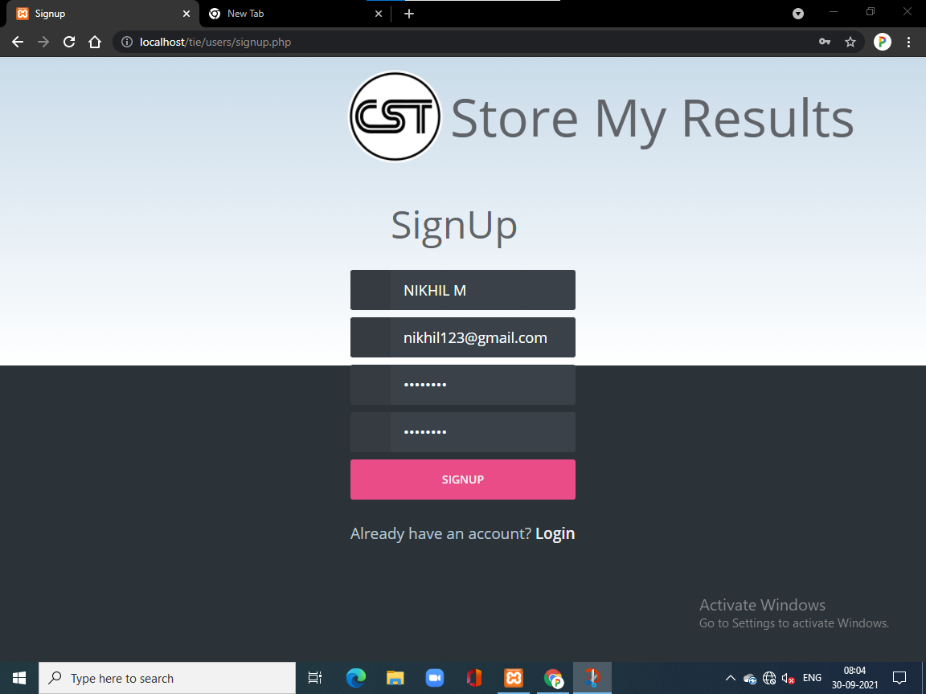

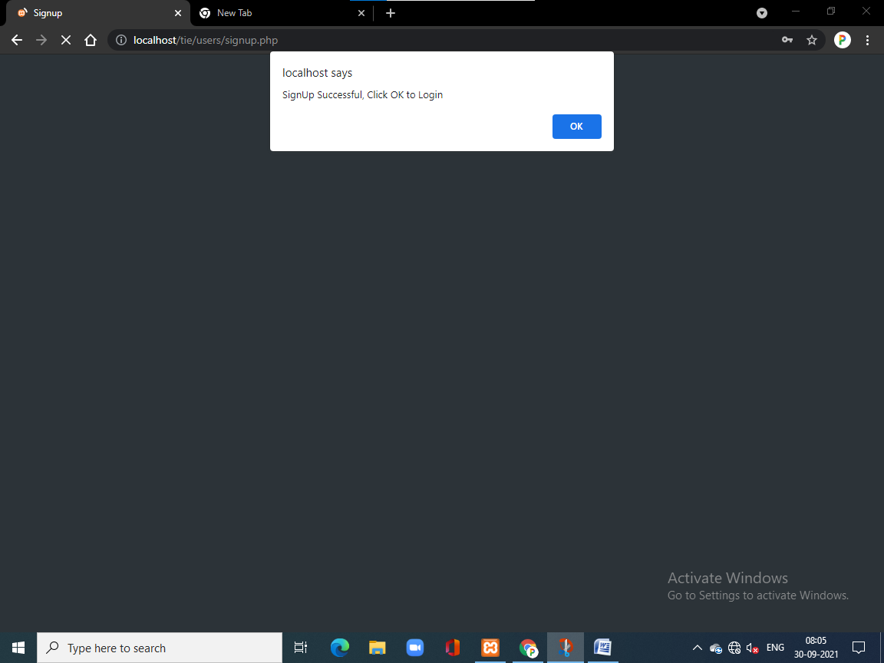

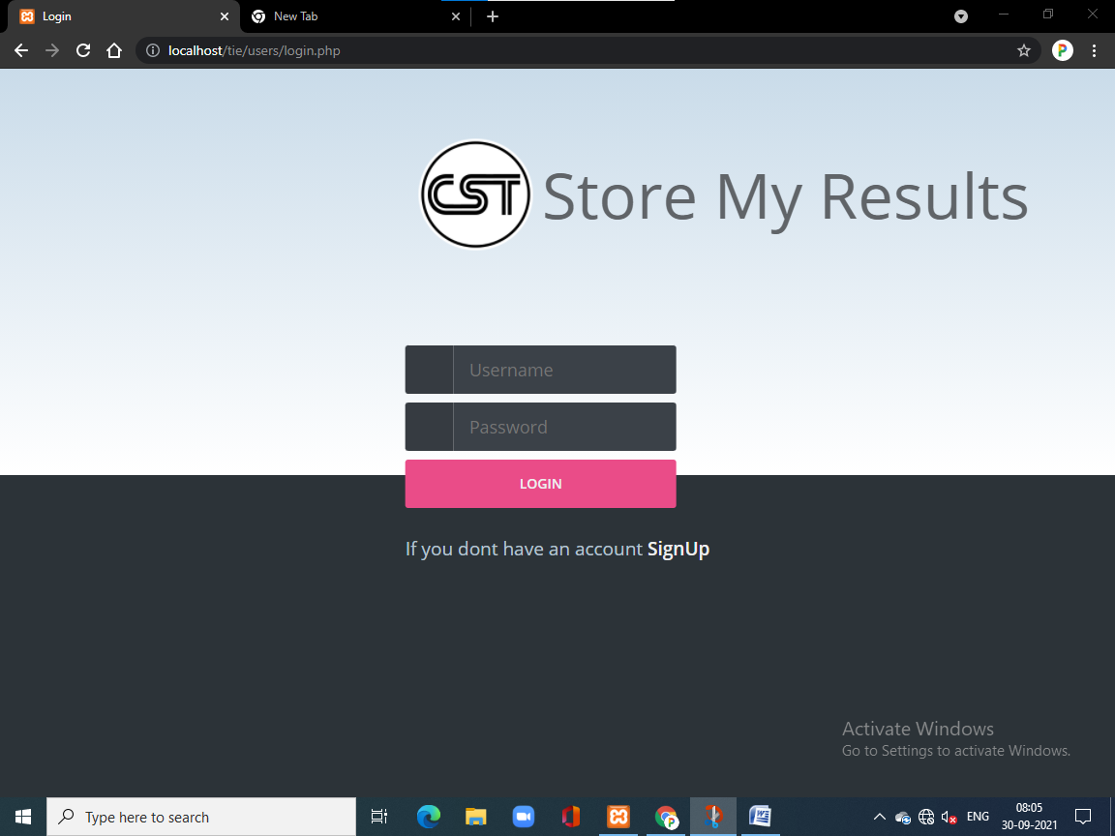

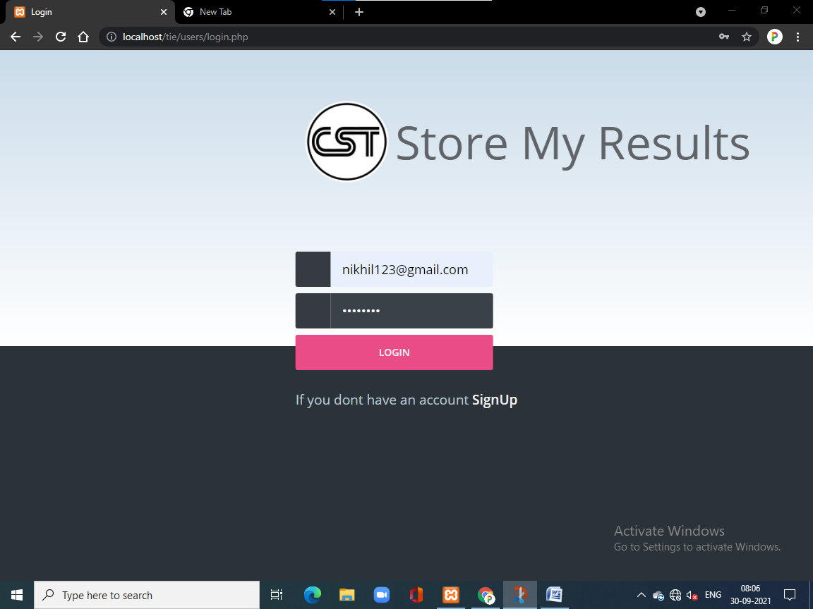

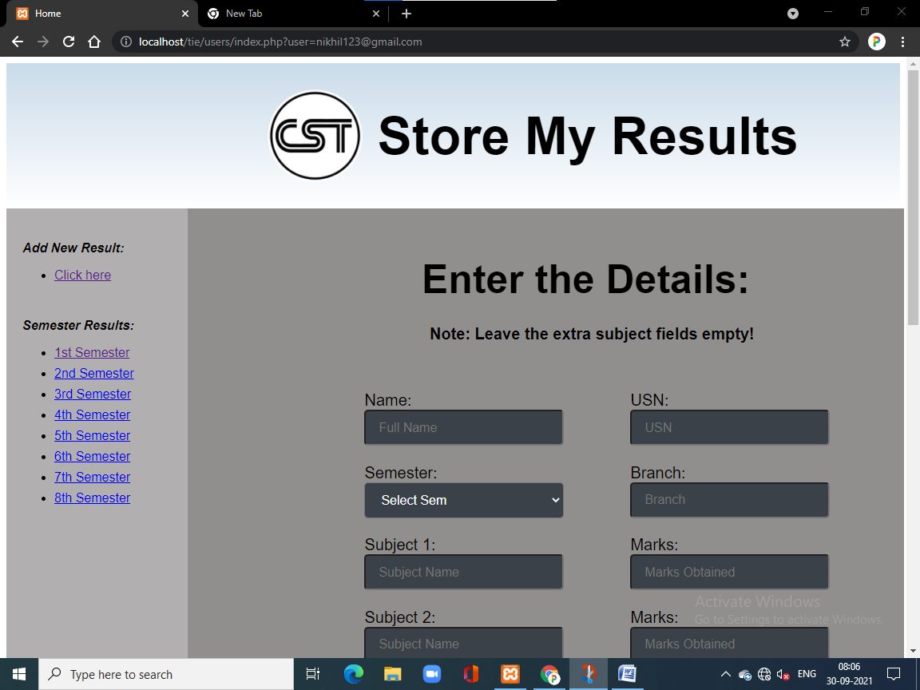

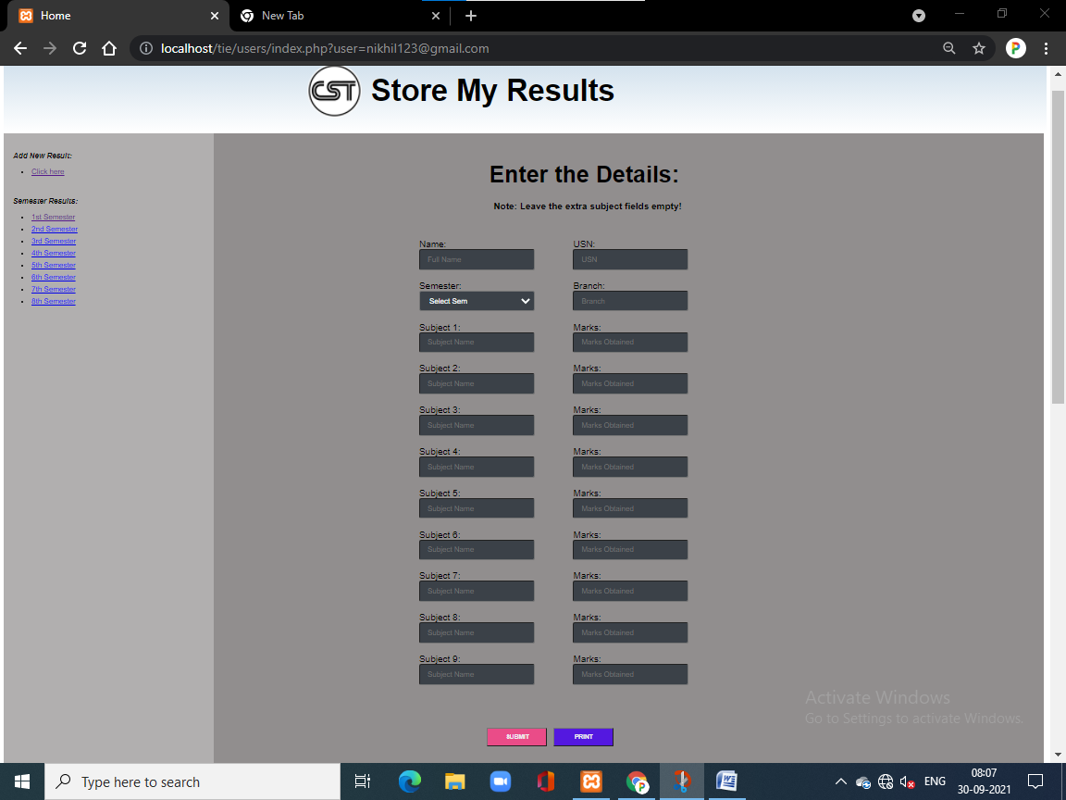

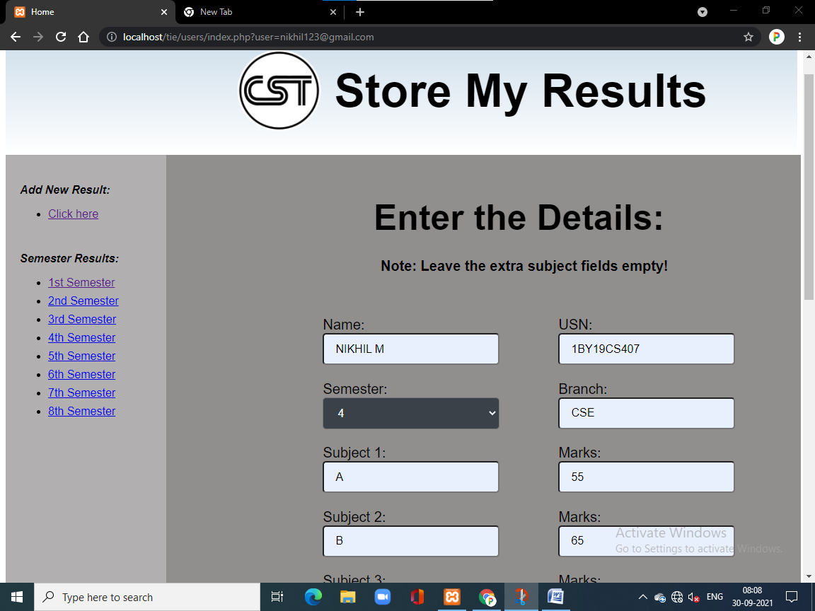

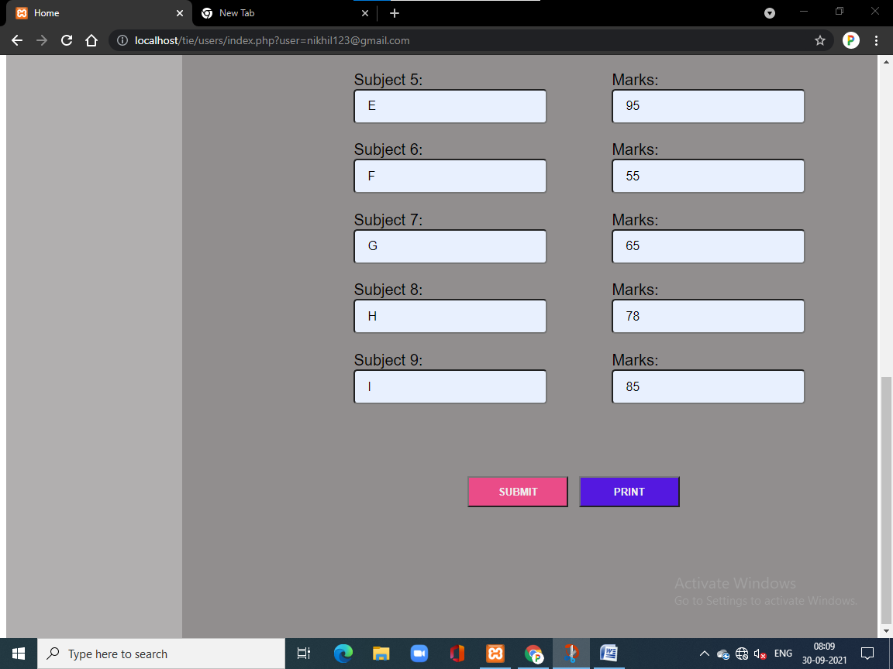

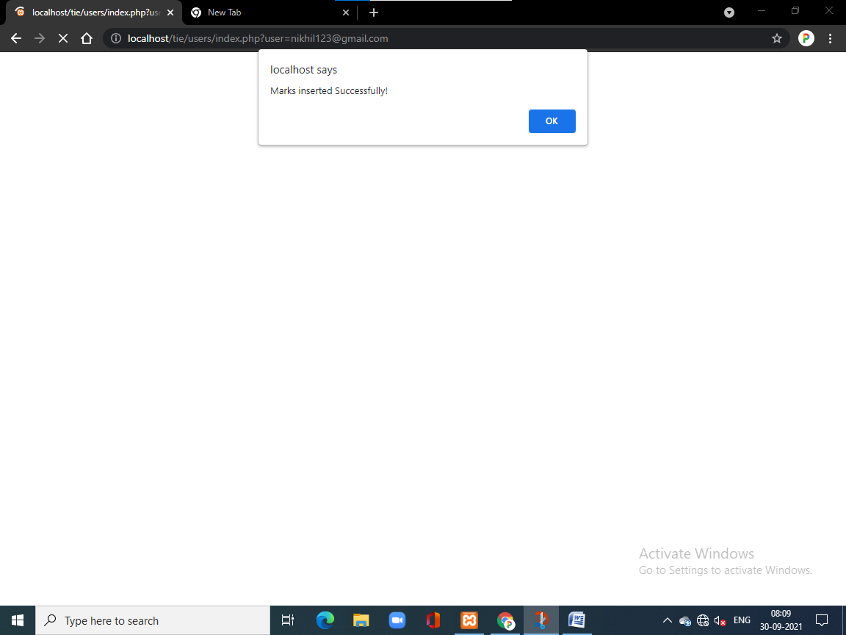

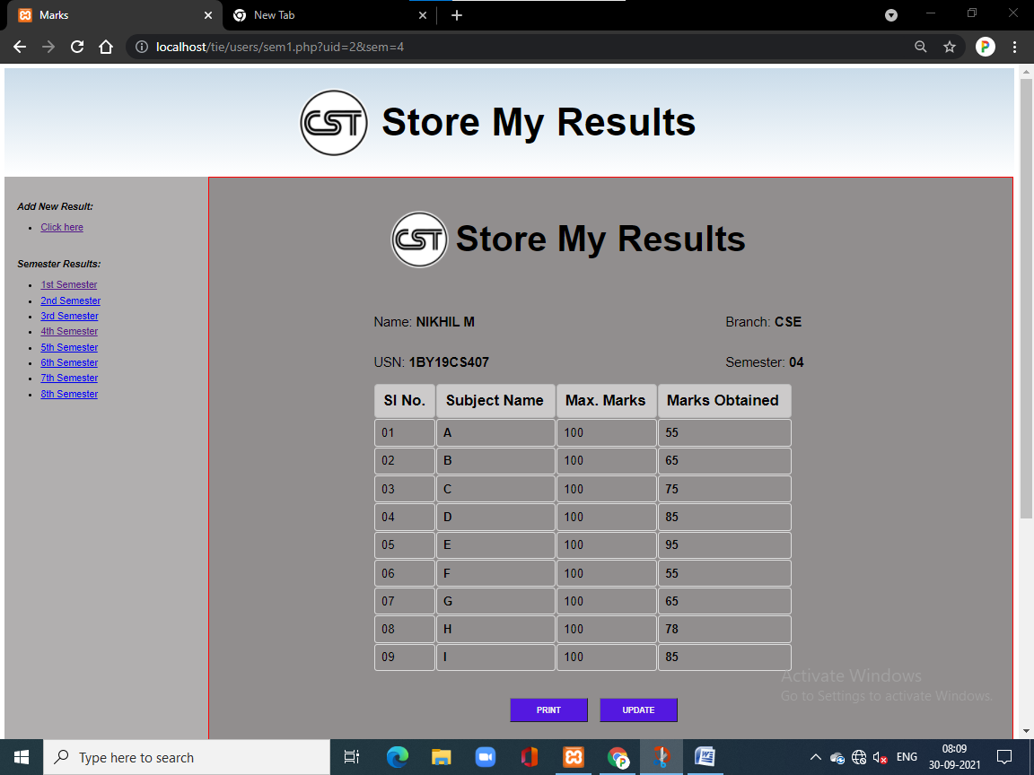

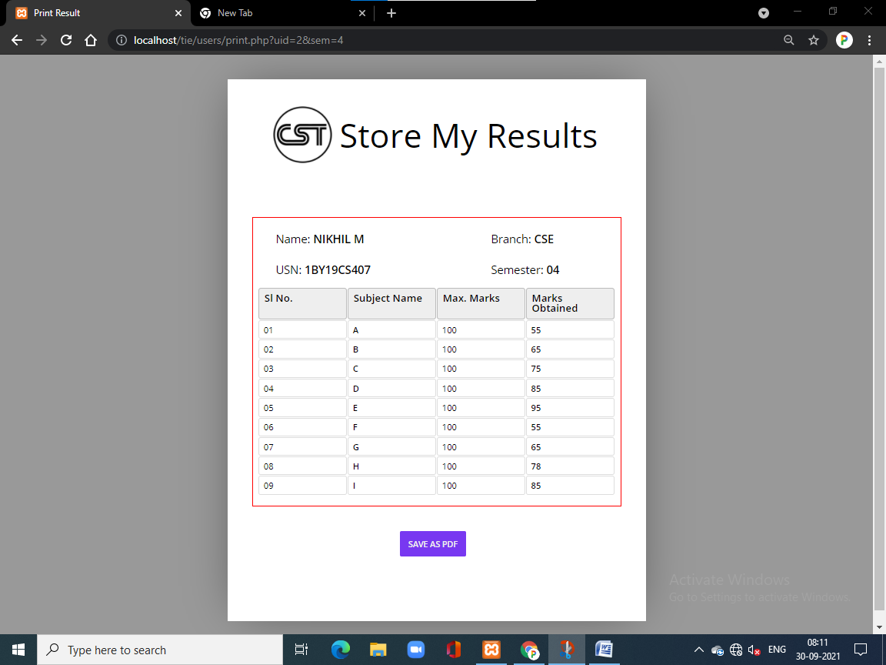

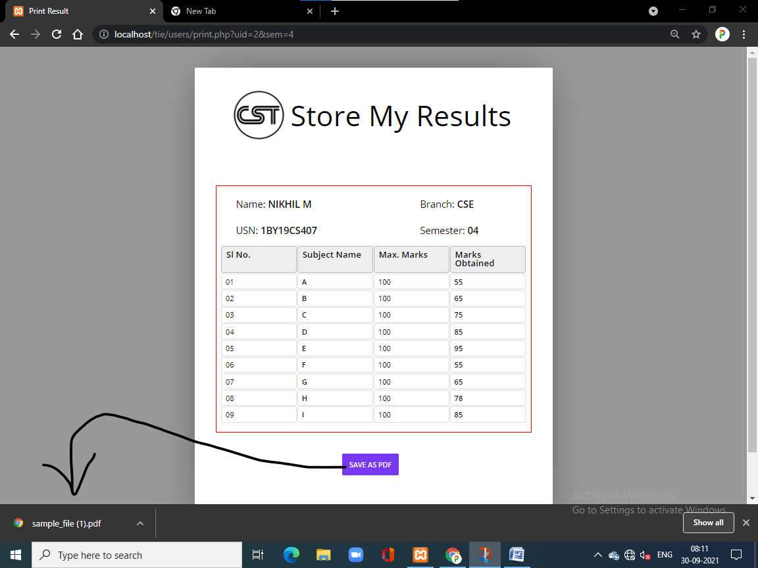

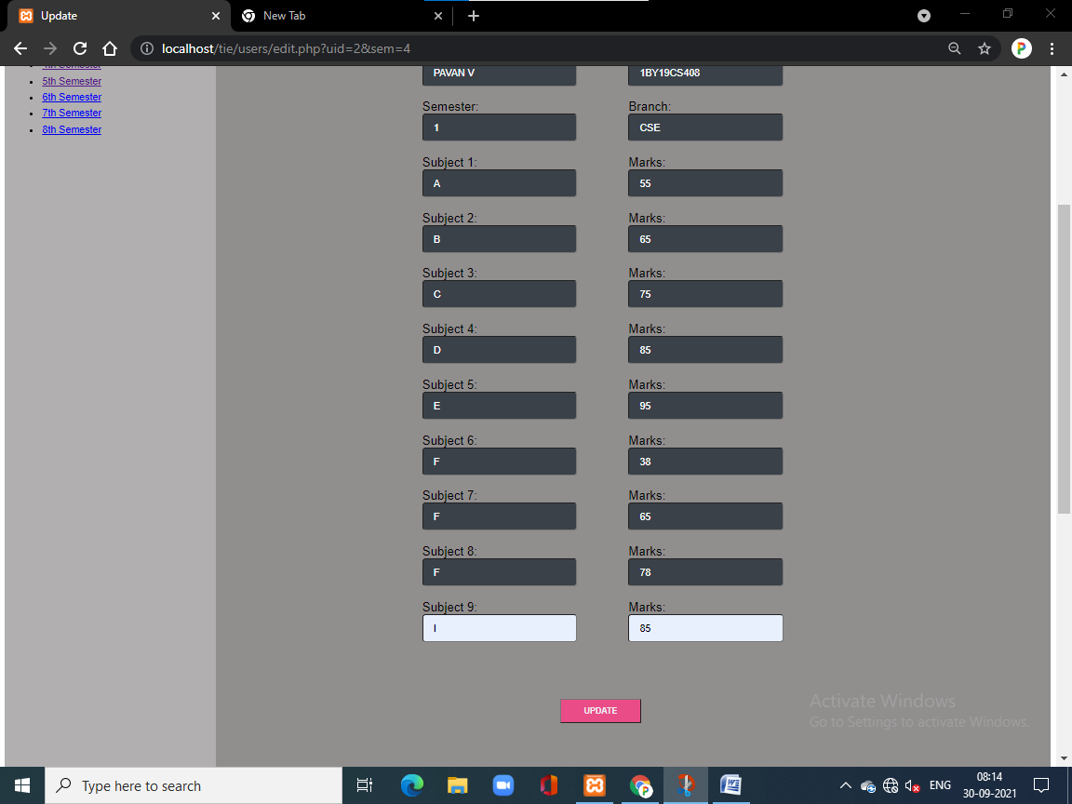

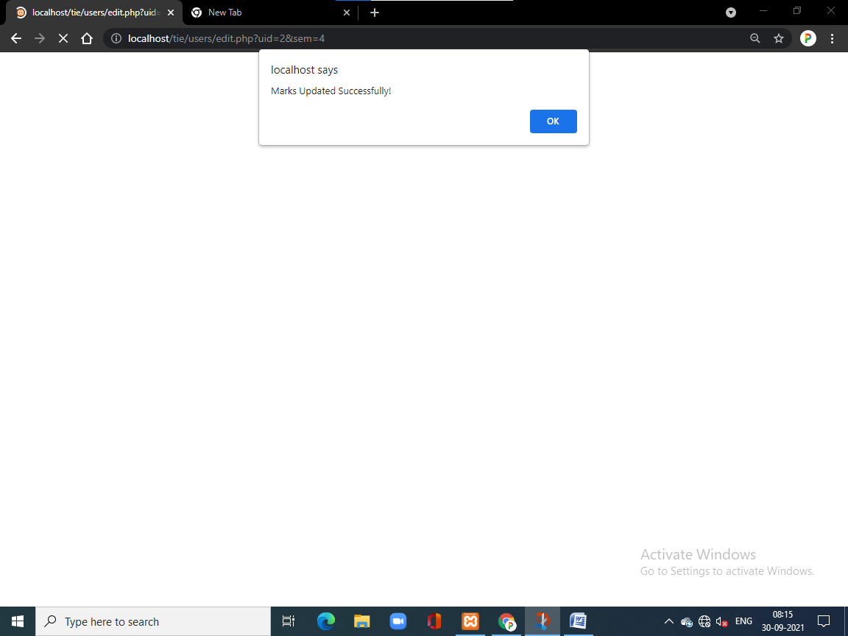

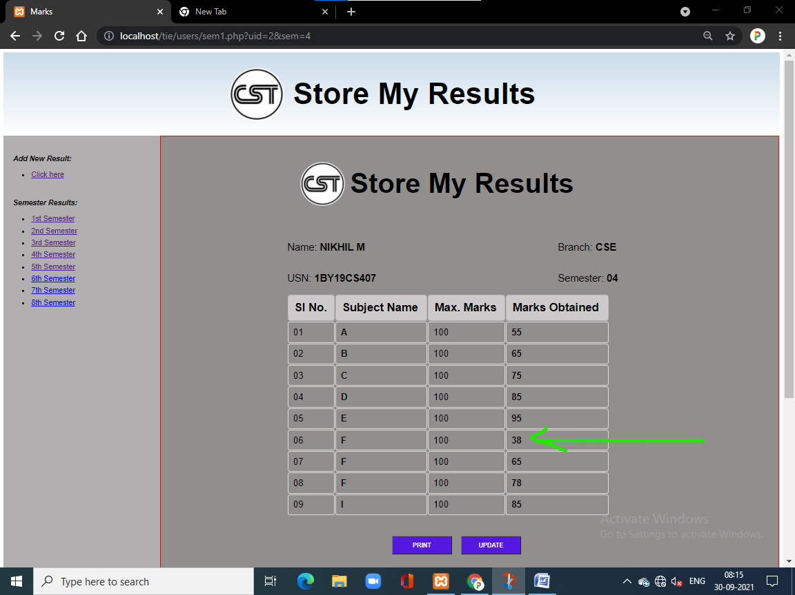

**BIBLIOGRAPHY**

* https://[www.w3schools.com](http://www.w3schools.com/)
* https://[www.geeksforgeeks.org](http://www.geeksforgeeks.org/)
* https://freefrontend.com

**About my Team**

**Nikhil M, Pavan V: FRONTEND**

**Fazal Ur Rehaman, Mallikarjuna Halagali: BACKEND**