YUVAINTERN
Virtual Data Science with Python Trainee

WEEK 1 PROJECT REPORT

Data Acquisition, Cleaning, and
Preprocessing of Telco Customer Churn Data Using Python

Submitted By: Mallikarjun Revi
Internship: Virtual Data Science with Python Trainee
Organization: YuvaIntern / NSDC
Task: Week 1: Data Acquisition, Cleaning, and Preprocessing

1. Introduction
Data acquisition, cleaning, and preprocessing are essential stages in every data science project. Real-world datasets can contain missing values, duplicate records, incorrect data types, blank entries, inconsistent formats, and unusual observations. If these issues are not identified and handled correctly, later analysis and machine learning models may produce unreliable results. This project demonstrates a practical data preparation workflow using Python and the Telco Customer Churn dataset.

2. Objective
The objective of this task was to acquire a publicly available dataset, explore its structure and quality, identify data-quality problems, handle missing or erroneous entries, investigate outliers, and preprocess the dataset for future analysis and machine learning applications.

3. Dataset Acquisition
The Telco Customer Churn dataset was selected for this project. It contains customer demographic information, subscribed services, contract details, billing information, and customer churn status. The original CSV file was preserved separately, while the processed dataset was saved as a new file after cleaning.

4. Tools and Technologies Used
Python was used as the programming language. Google Colab was used as the development environment. Pandas was used for data manipulation and preprocessing, while Matplotlib was used for visualization and outlier analysis.

5. Initial Data Exploration
The dataset was loaded into a Pandas DataFrame using read_csv(). The first five records were displayed using df.head() to understand the available information and dataset structure.
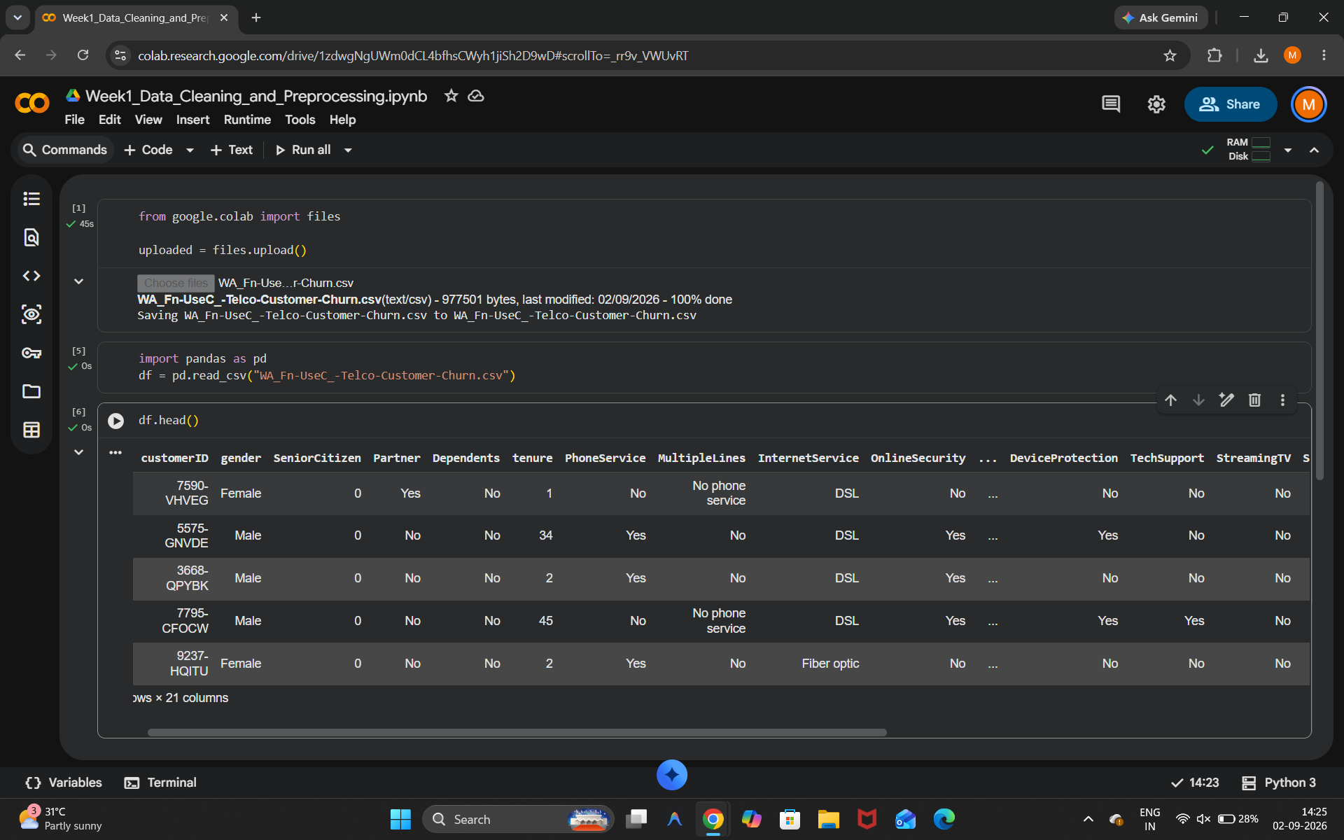
Figure 1: Dataset loading and preview
The dataset shape and information were inspected using df.shape and df.info(). The dataset contains 7,043 rows and 21 columns. Initial inspection also revealed that TotalCharges was stored as an object type even though it represents numerical monetary values.
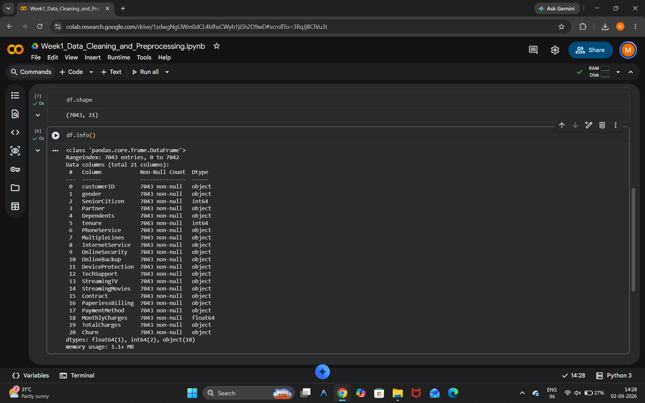
Figure 2: Dataset shape and information

6. Missing Value Analysis
The initial missing-value analysis using df.isnull().sum() showed zero standard NaN values. However, this did not guarantee that the dataset was completely clean because blank strings and whitespace values may not be detected as standard missing values.
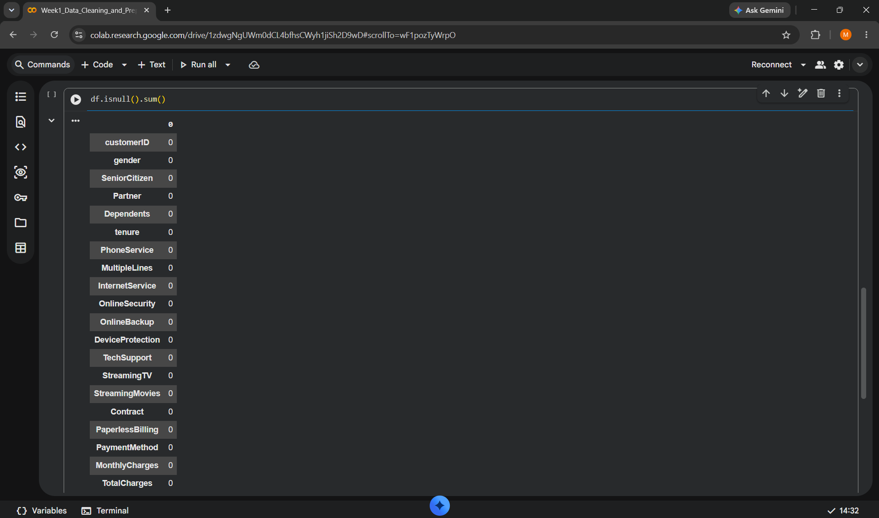
Figure 3: Missing-value analysis

7. Duplicate Record Analysis
Duplicate records were checked using df.duplicated().sum(). The result showed that there were no completely duplicated rows in the dataset, so no records needed to be removed due to duplication.
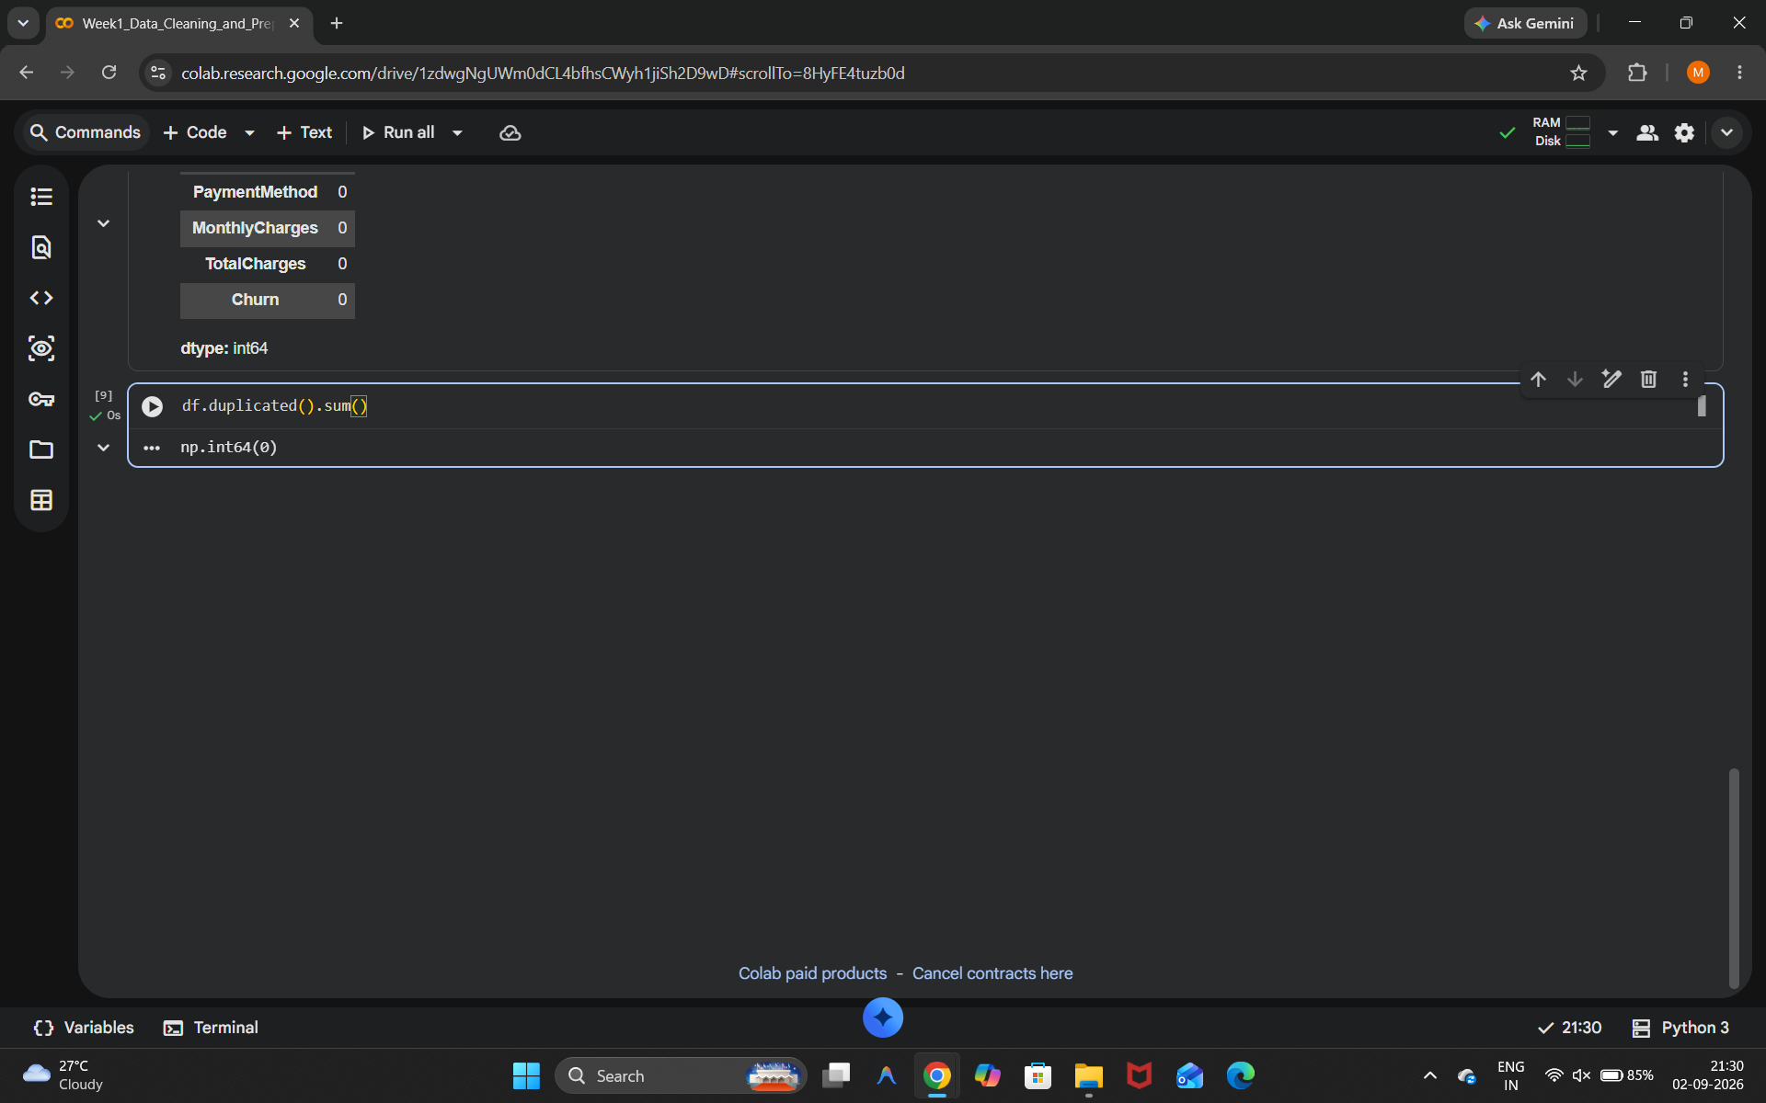
Figure 4: Duplicate record check

8. TotalCharges Data Quality Issue
Further investigation of the TotalCharges column revealed an important hidden data-quality issue. Although the initial null-value analysis showed no missing values, the column contained 11 blank or whitespace-only entries. These entries also caused the column to be stored as an object rather than a numeric data type.
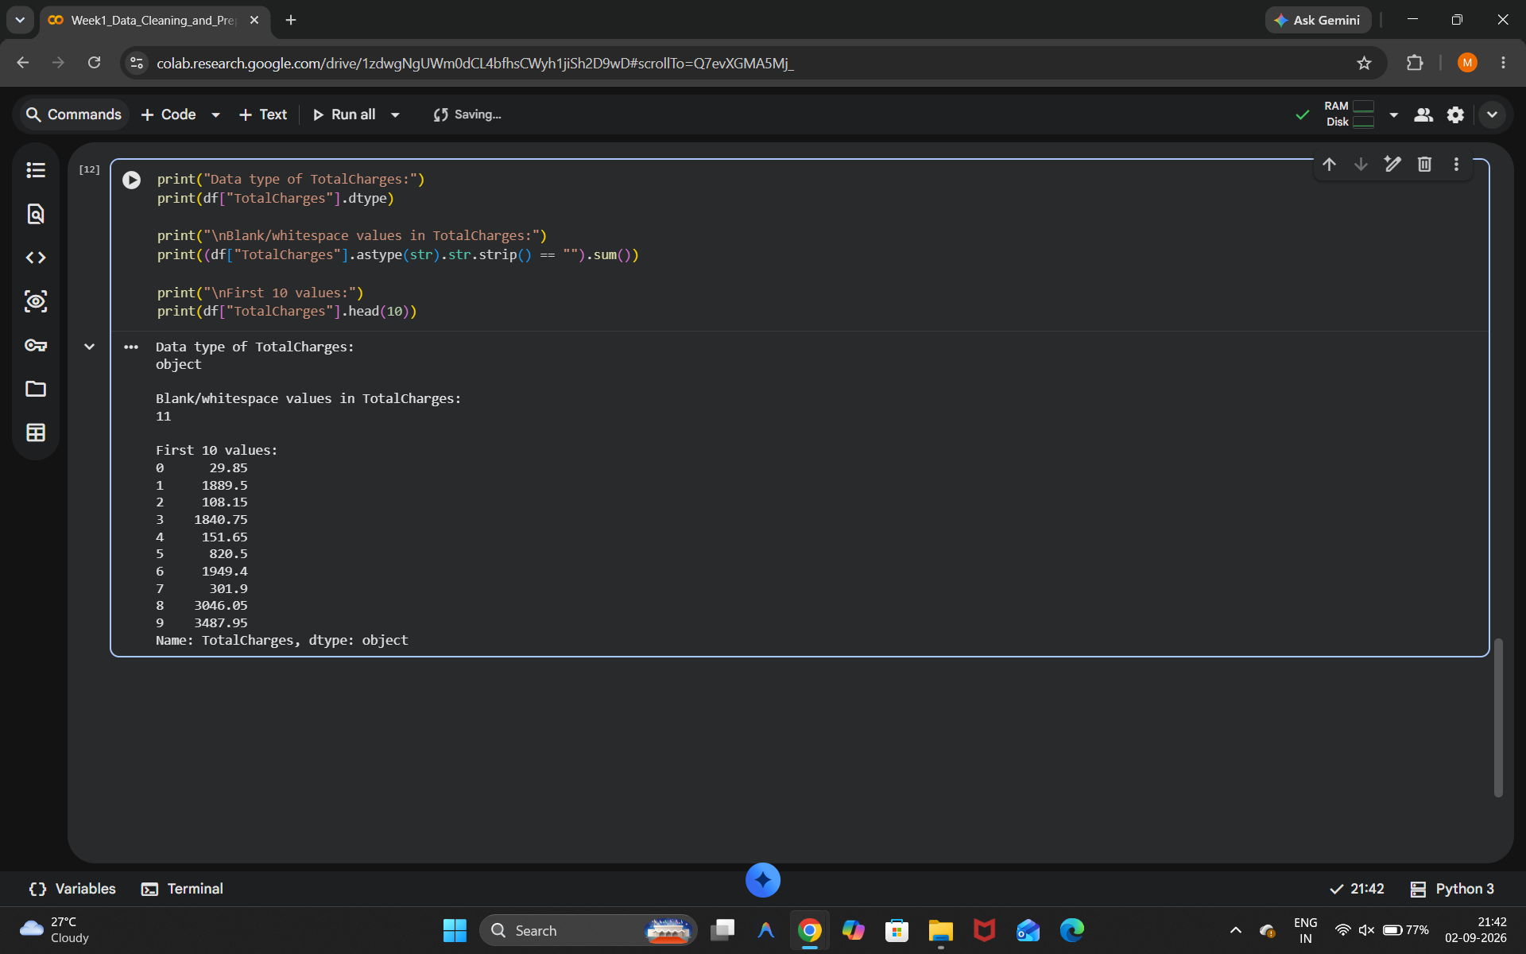
Figure 5: Identification of the TotalCharges issue

9. Data Type Conversion
The TotalCharges column was converted into numeric format using pd.to_numeric() with errors='coerce'. Invalid or blank entries were converted into NaN values, allowing the column to become a float64 numerical variable.
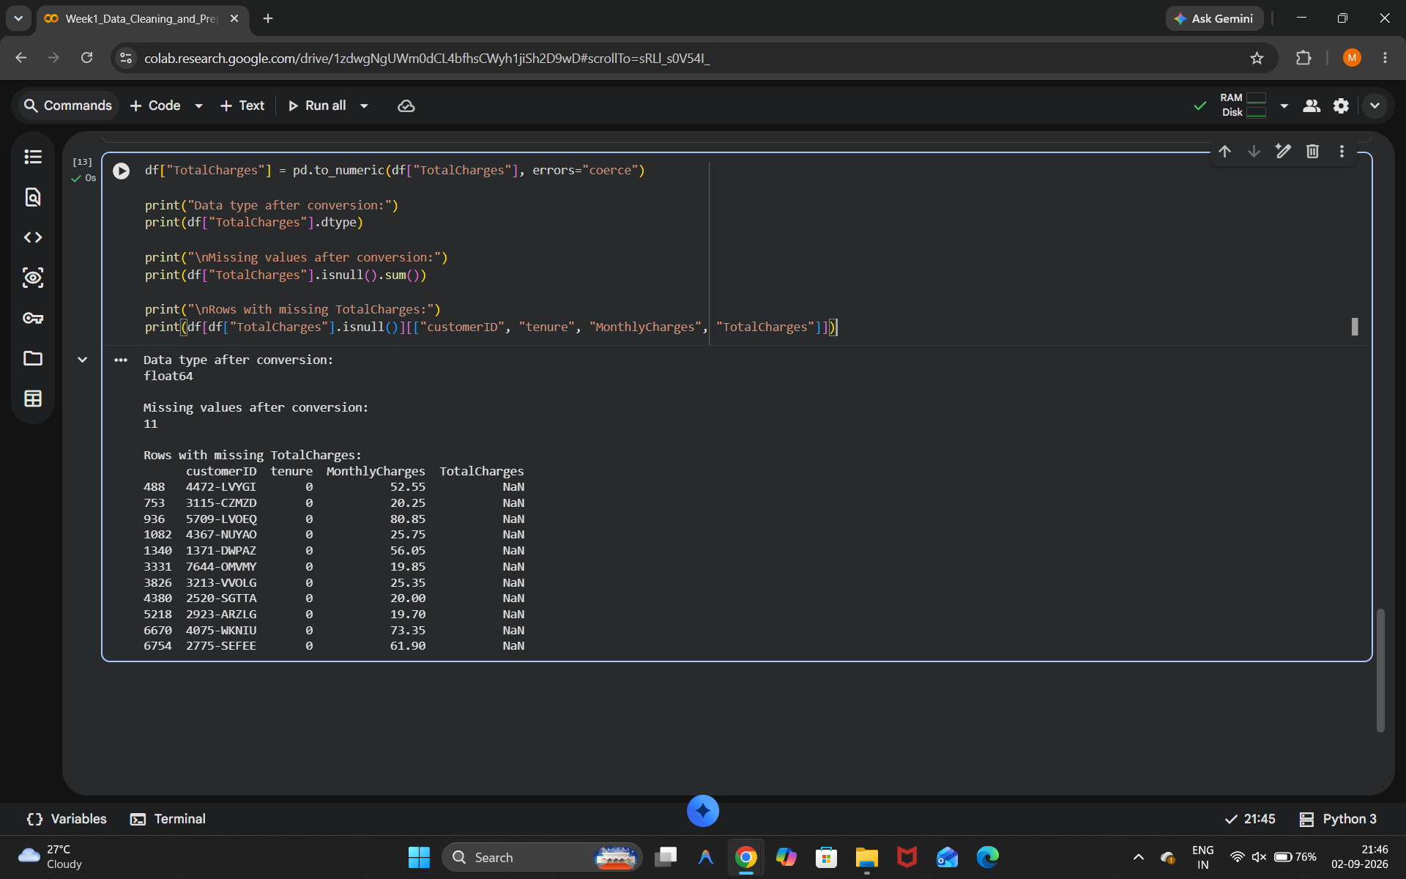
Figure 6: Conversion of TotalCharges to numeric format

10. Handling Missing Values
After conversion, the 11 missing values in TotalCharges were handled by replacing them with 0. A final check confirmed that the column contained no remaining missing values and had the correct float64 data type.
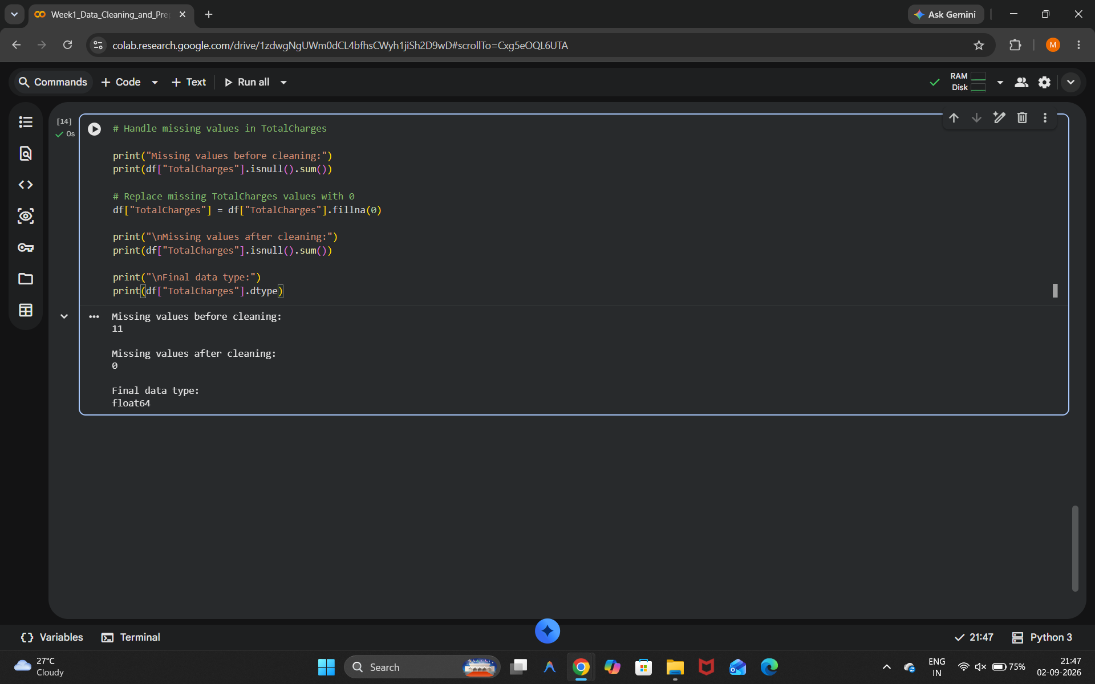
Figure 7: Missing values handled

11. Outlier Detection
Boxplots were created for tenure, MonthlyCharges, and TotalCharges to inspect their distributions and identify possible outliers. Potential extreme values were examined carefully rather than automatically removed because high values may represent legitimate customer behavior.
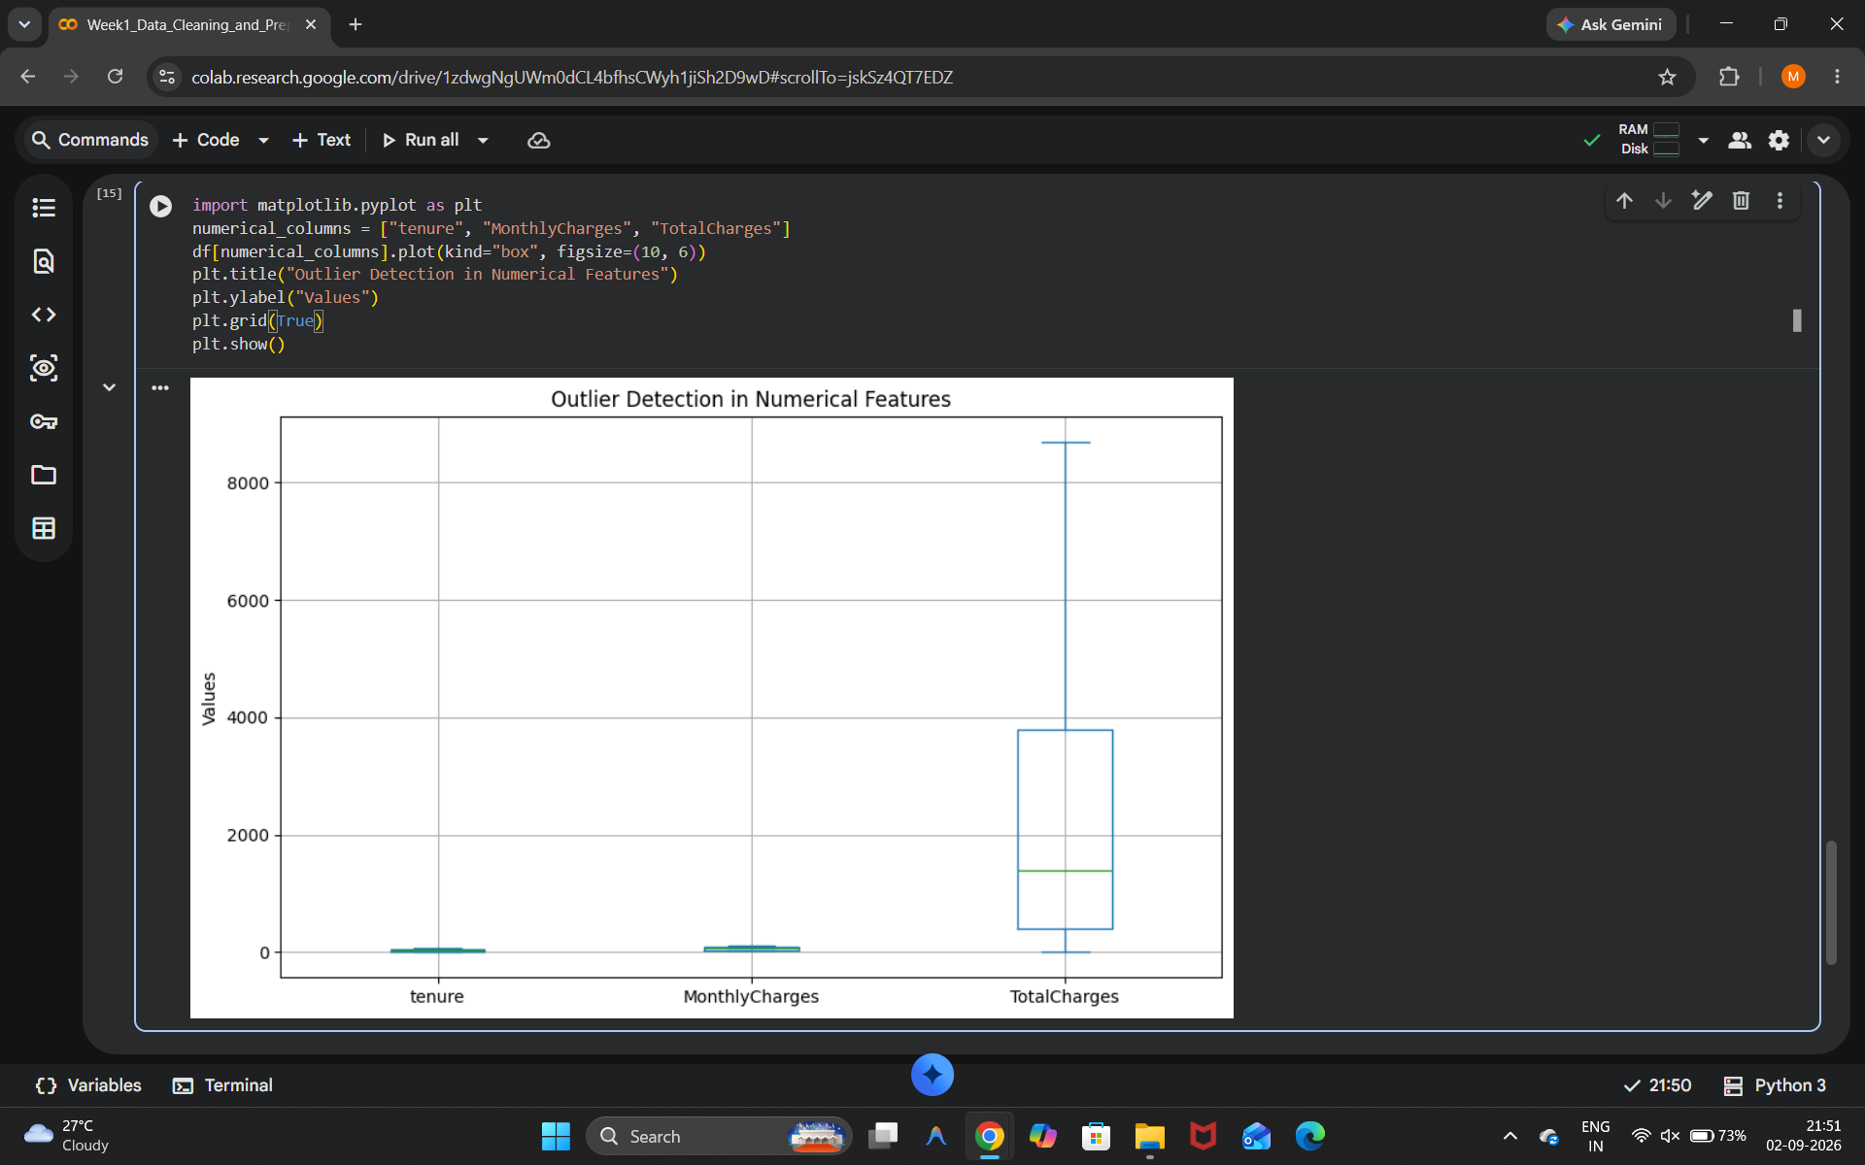
Figure 8: Outlier detection using boxplots

12. Data Preprocessing
The customerID column was removed because it is an identifier rather than a useful analytical feature. Categorical variables were converted into numerical features using one-hot encoding with Pandas get_dummies(). This transformation prepares the dataset for machine learning algorithms.
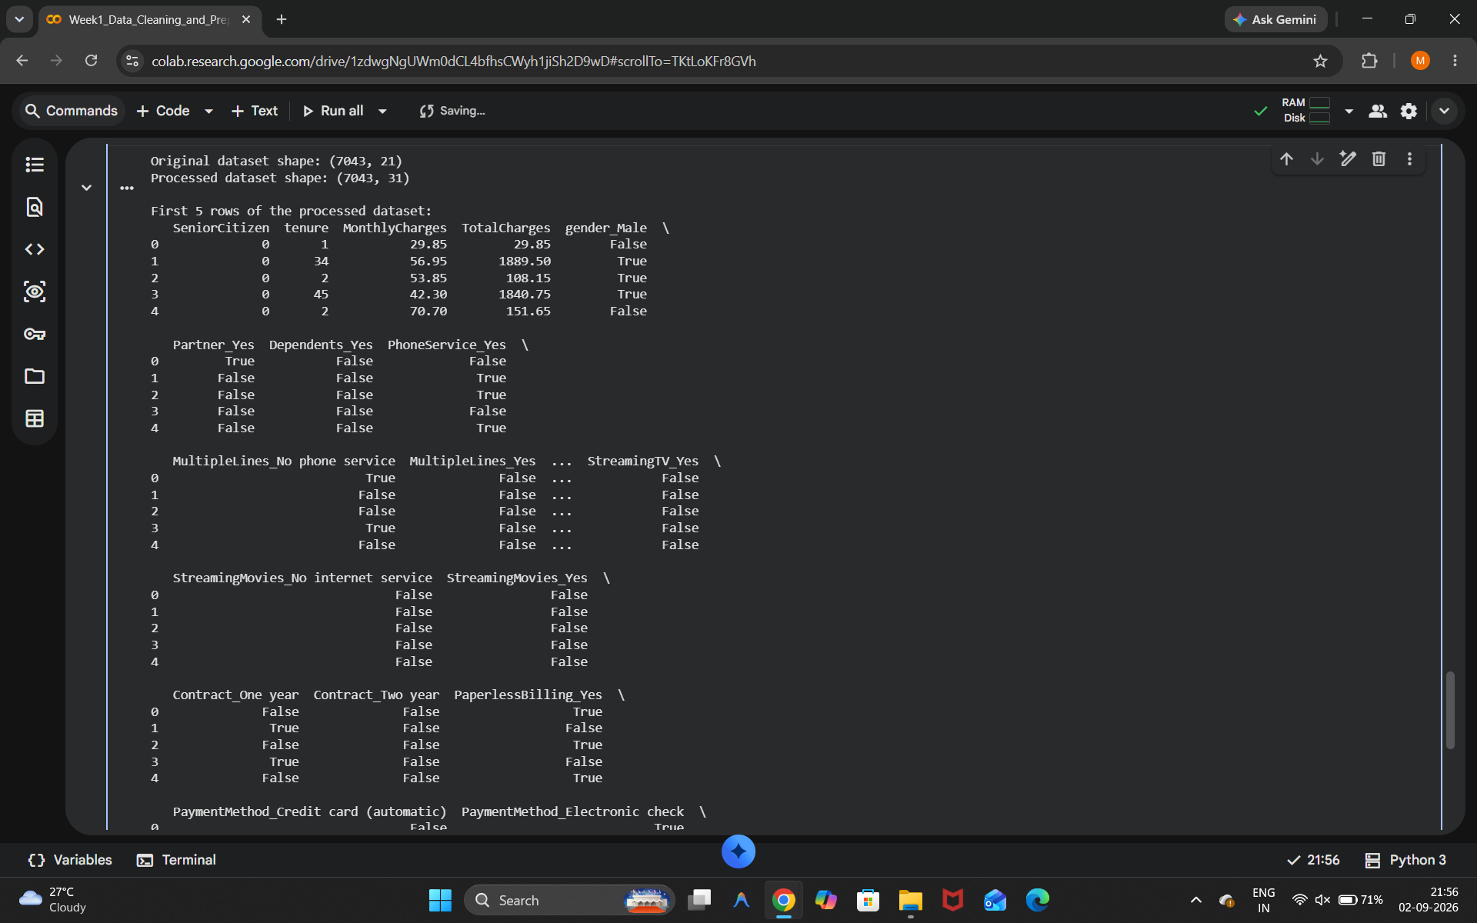
Figure 9: Categorical data preprocessing and encoding

13. Final Dataset Validation
The final processed dataset was checked for its shape, missing values, and data types. The final validation confirmed that the cleaned dataset contained no missing values and was successfully saved as Telco_Customer_Churn_Cleaned.csv.
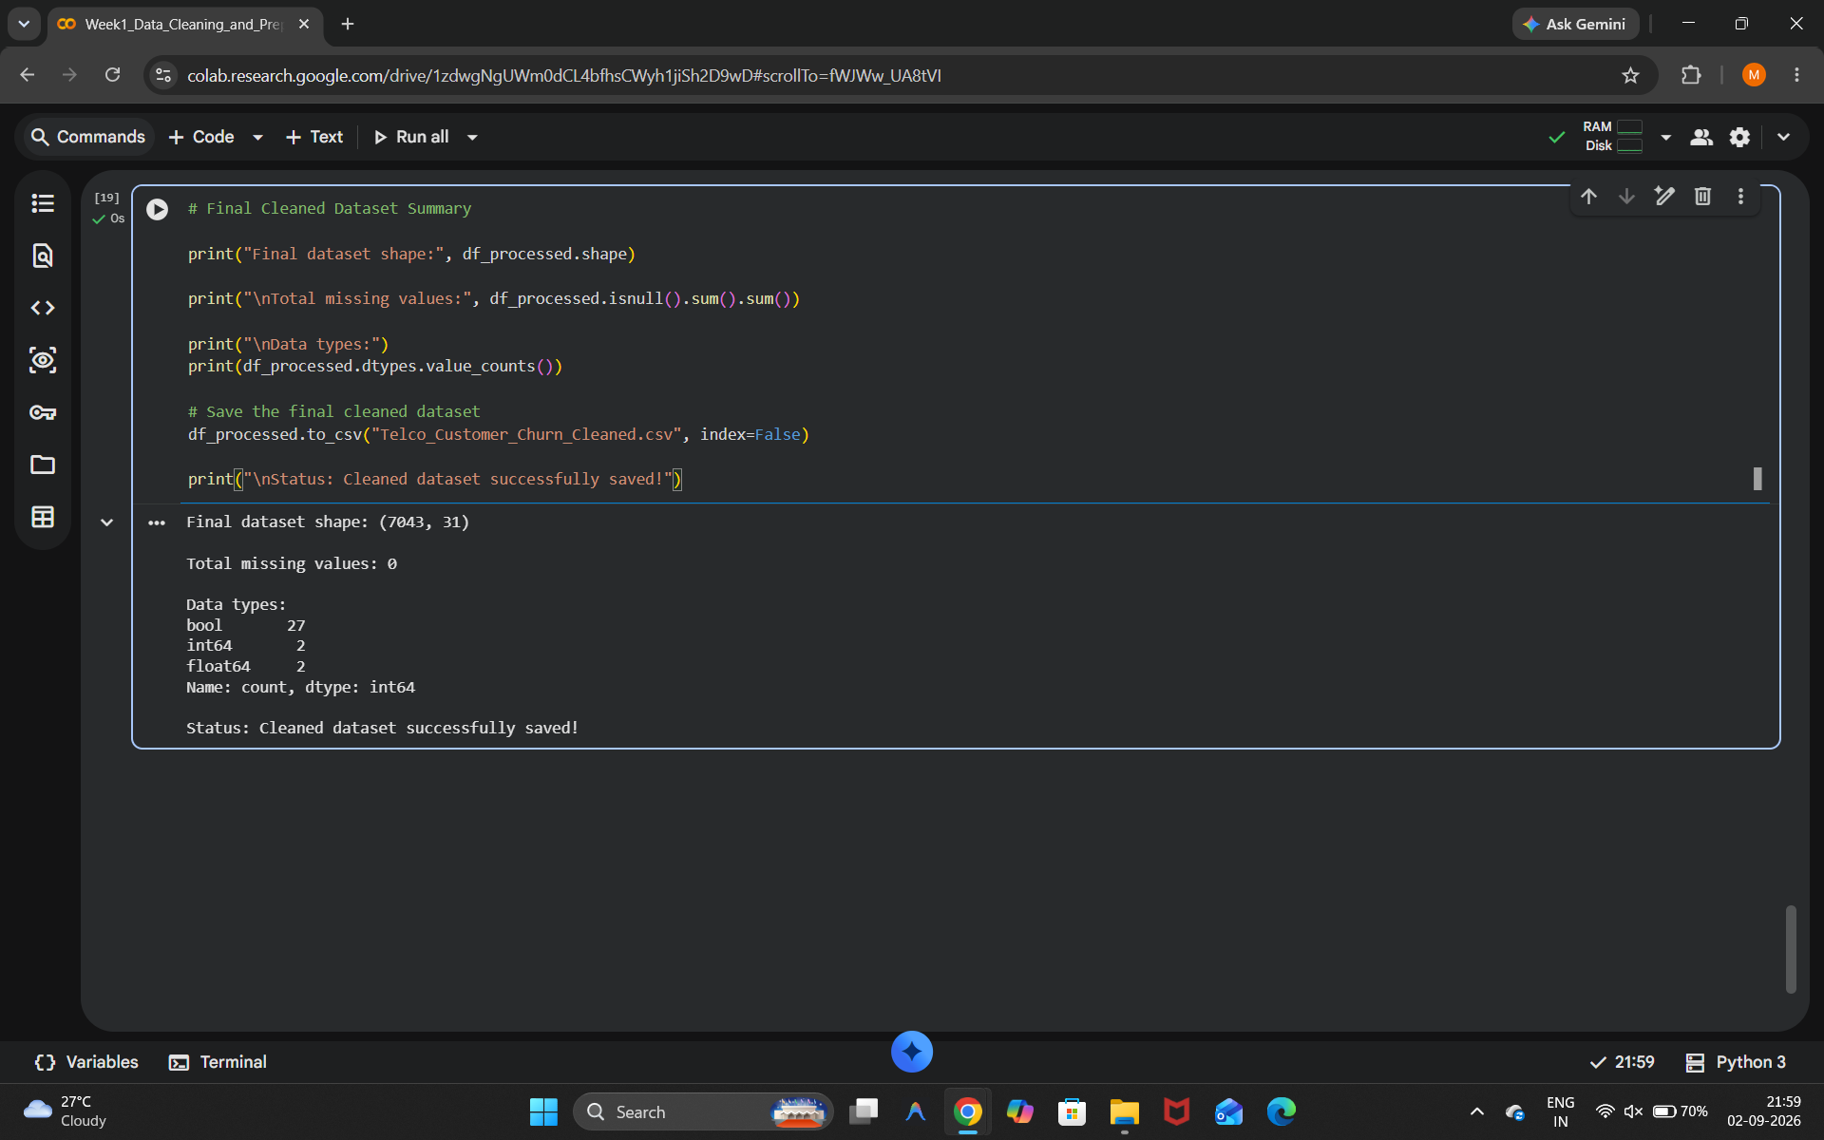
Figure 10: Final cleaned dataset summary

14. Challenges Faced and Solutions
The main challenge was that the initial missing-value analysis showed zero missing values while TotalCharges still had a data-quality problem. Additional investigation revealed 11 whitespace-only values. This problem was solved by identifying blank strings, converting the column to numeric format, and handling the resulting missing values. Another challenge was interpreting possible outliers carefully so that legitimate customer records were not unnecessarily removed.

15. Impact on Further Analysis
The preprocessing performed in this task creates a reliable foundation for future analysis. Numerical conversion enables correct calculations, missing-value handling prevents errors during modeling, and categorical encoding makes the dataset suitable for machine learning algorithms. The cleaned dataset can be used in later tasks involving exploratory data analysis, clustering, supervised learning, deep learning, and the final capstone project.

16. Conclusion
This project successfully completed the acquisition, exploration, cleaning, and preprocessing of the Telco Customer Churn dataset using Python. The dataset contained 7,043 records and 21 columns. No duplicate records were found, but deeper investigation identified 11 hidden blank values in TotalCharges. The column was converted to numeric format, missing values were handled, numerical variables were examined for outliers, and categorical features were encoded. The final cleaned dataset is ready for further data science and machine learning analysis.

