**Assignment_16.11438 - Statistics 2**

**Problem 1:**

A test is conducted which is consisting of 20 MCQs (multiple choices questions) with every MCQ having its four options out of which only one is correct. Determine the probability that a person undertaking that test has answered exactly 5 questions wrong.

**Answer:**

Here, n = 20

n - k= 5,

k= 20 - 5 = 15

Here the probability of success = probability of giving a right answer = p= 1/4

Hence, the probability of failure = probability of giving a wrong answer = (1 – p) = 1 – ¼ = 3/4

When we substitute these values in the formula for Binomial distribution we get,

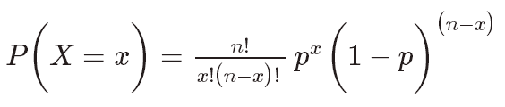

So, P (5 out of 20) = 20! (1/4)15 * (3/4)5

15!5!

P (5 out of 20) = (20*19*18*17*16)/(5*4*3*2*1) ) * (1/4) 15 * (3/4)5

= 0.0000034 (approximately)

Probability that a person undertaking that test has answered exactly 5 questions wrong is 0.0000034

**Problem 2:**

A die marked A to E is rolled 50 times. Find the probability of getting a “D” exactly 5

times.

**Ans :**

Here, n = 50, k = 5, n -k =15

Here the probability of success = probability of getting “D” = 1/5

Hence, the probability of failure = probability of not getting a “D” = 1 - s = 1 - 1/5 = 4/5.

**Problem 3:**

Two balls are drawn at random in succession without replacement from an urn containing 4 red balls and 6 black balls. Find the probabilities of all the possible outcomes.

**Ans :**

Probabilities of all the possible outcomes.

RR (4/10)(3/9) = **2/15**

RB (4/10)(6/9) = **4/15**

BR (6/10)(4/9) = **4/15**

BB (6/10)(5/9) = **1/3**

**Red Balls**

The probability of 0 Red balls (BB) = **1/3**

The probability of 1 Red ball is (RB or BR) is 4/15+4/15 = **8/15**

The probability of 2 Red balls (BB) = **2/15**

**Black balls**

The probability of 0 black balls (RR) = **2/15**

The probability of 1 black ball is (RB or BR) is 4/15+4/15 **= 8/15**

The probability of 2 black balls (BB) = **1/3**