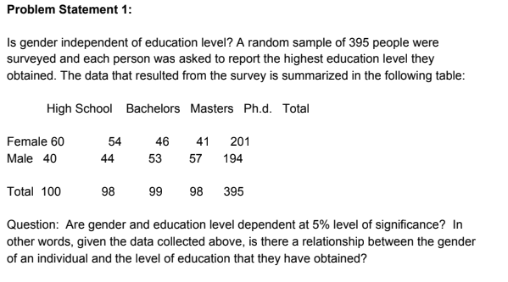

**Ans:**

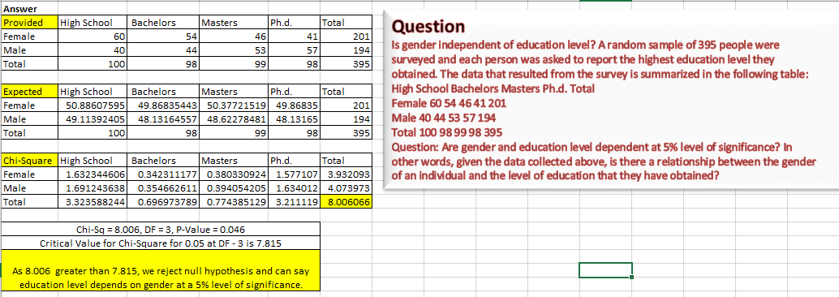

|  |
| --- |
| As chi-square of 8.006 greater than critical value of 7.815, we reject null hypothesis and can say education level depends on gender at a 5% level of significance. |
|
|

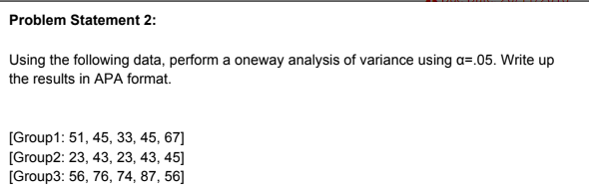

Ans:

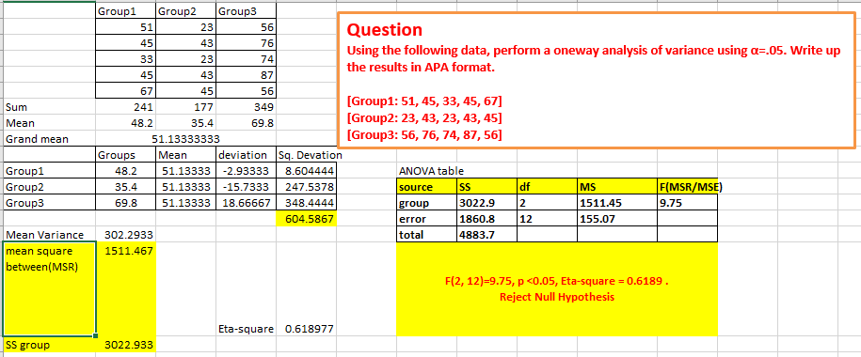

**F(2, 12)=9.75, p <0.05, Eta-square = 0.6189 .  
Reject Null Hypothesis**

