Mallikarjuna K O
261100690030

Part A — Ownership Investigation (10 Minutes)

Create a directory named ownership_lab.
Inside it, create:
incident_report.txt
network.log
credentials.txt
Display the detailed information for these files.

For each file, identify:
Owner
Group
Owner permissions
Group permissions
Others permissions

: mkdir ownership_lab
cd ownership_lab
touch incident_report.txt network.log credentials.txt
ls -l

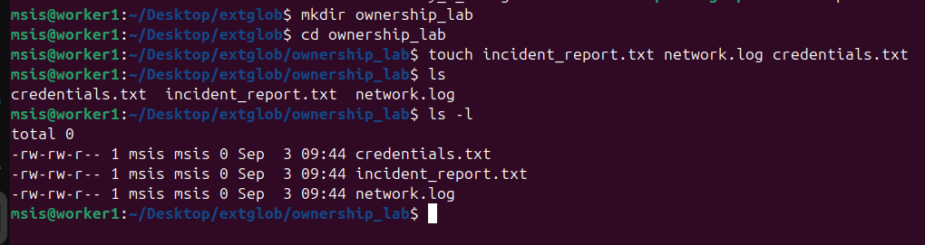

Determine the UID and GID of the current user.
Compare the UID/GID information with the ownership displayed for the newly created files.

: id
id -u
id -g
compare with : ls -ln incident_report.txt network.log credentials.txt

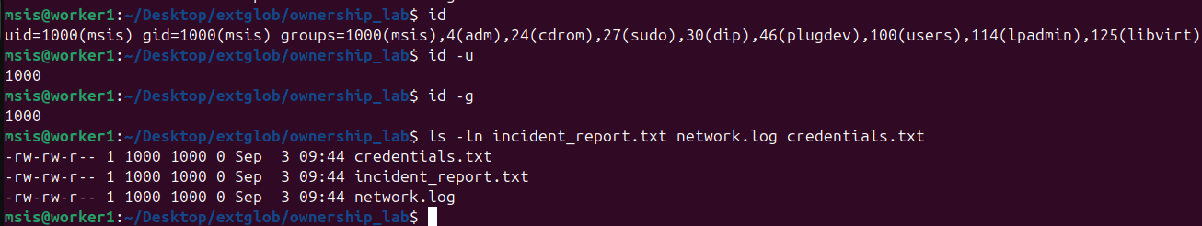

Explain the difference between file ownership and file permissions.
: Ownership determines which identity/group a permission class applies to, while permissions determine what that identity is allowed to do.

Part B — chown: Changing Ownership (15 Minutes)

Change the owner of incident_report.txt to alice.
Change the owner of network.log to bob.
Change the owner of credentials.txt to charlie.

: sudo chown alice incident_report.txt
sudo chown bob network.log
sudo chown charlie credentials.txt

Verify each change.
: ls -l

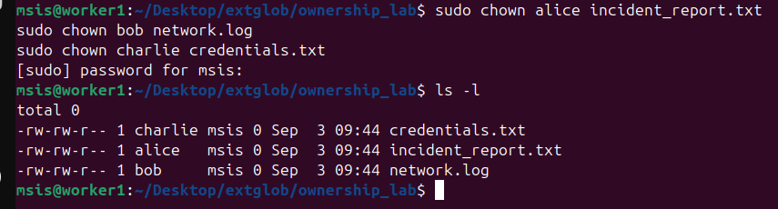

Try changing the owner of a file to another user without using sudo. Record the result.
: chown alice network.log

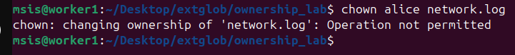
Explain why an ordinary user is generally not permitted to transfer file ownership to another user.

: An ordinary user generally cannot give their file away to another user because unrestricted ownership transfer could be abused to bypass accountability, security controls, or other administrative policies.

Using a single command, configure:
incident_report.txt
Owner : alice
Group : security
Verify the resulting ownership.

: sudo chown alice:security incident_report.txt
ls -l
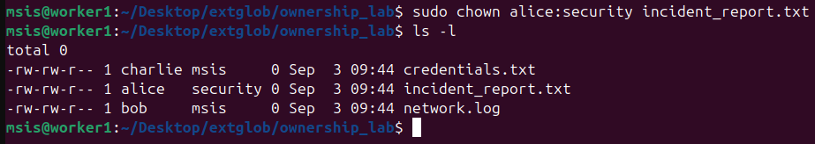

Part C — chgrp: Changing Group Ownership (15 Minutes)

Change the group ownership of network.log to developers.
Change the group ownership of credentials.txt to security.
Verify the changes.

: sudo chgrp developers network.log
sudo chgrp security credentials.txt
ls -l
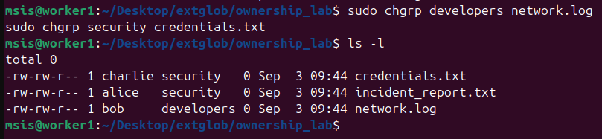
Display the group memberships of alice, bob, and charlie.
: groups alice
groups bob
groups charlie

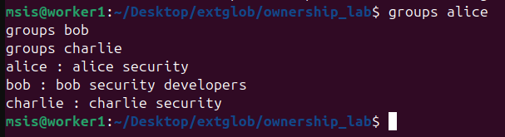

Log in as alice and create a file named alice_report.txt.
Attempt to change the group of alice_report.txt to security.
Attempt to change its group to developers.
Compare the results.
Explain how a user's group membership affects their ability to change the group ownership of a file they own.
: su – alice
touch alice_report.txt
ls -l
chgrp security alice_report.txt
chgrp developers alice_report.txt
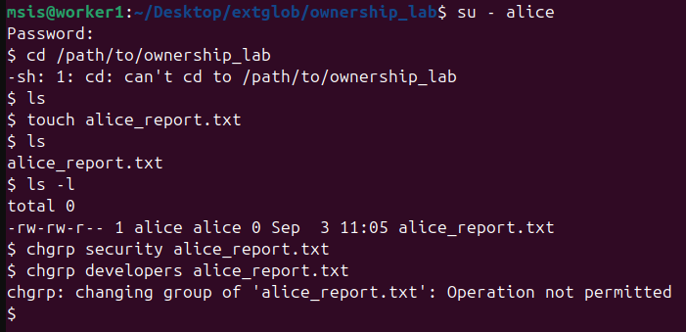

Part D — Ownership + Permission Investigation (20 Minutes)

Configure:

-rw-r----- alice security incident_report.txt
Identify what operations are available to:
alice
charlie
bob

: sudo chown alice:security incident_report.txt
sudo chmod 640 incident_report.txt
ls -l

A user who belongs to neither security nor the file owner
charlie belongs to security. Test whether Charlie can:
Read incident_report.txt
Modify incident_report.txt
Delete incident_report.txt
: File deletion is controlled primarily by the parent directory's permissions, not by the permissions displayed on the file itself.
If the directory is owned by your original user and is not writable by Charlie/Bob, they won't be able to delete the file regardless of the file's own rw permissions.

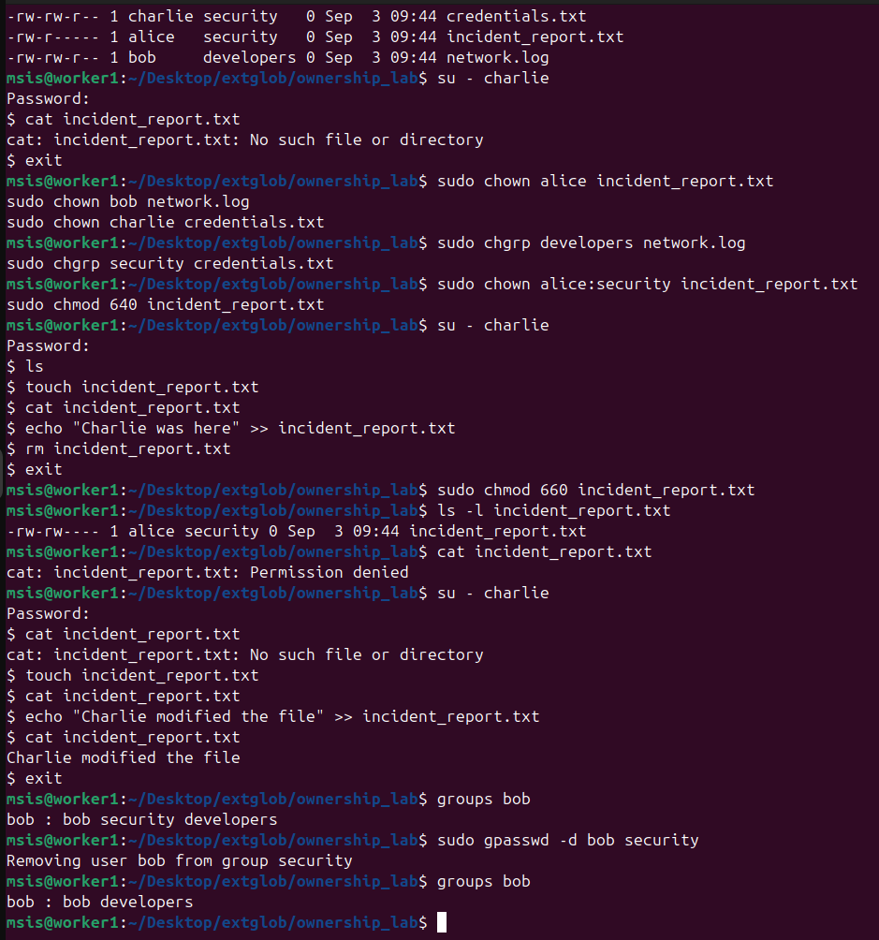

Bob's group membership changed, so Linux stopped treating him as a member of the security group. His effective access consequently fell from the group's rw- permissions to the others permissions of ---

