Mallikarjuna K O
261100690030

Part A — User and System Investigation (10 minutes)

Determine the username of the account you are currently using.
: whoami (or) id -un

Display your UID, primary GID, and supplementary groups.
: id (id -u) (id -g) (id -G)

Display all users currently logged in to the system.
: who

Determine what activities the currently logged-in users are performing.
: w

Examine /etc/passwd and identify the following information for your current account:
Username
UID
GID
Home directory
Login shell
: grep "^$(whoami):" /etc/passwd
username:password:UID:GID:gecos:home_directory:login_shell
msis:x:1000:1000:MSIS:/home/msis:/bin/bash

Determine how many user-account entries are present in /etc/passwd.
: wc -l /etc/passwd
57 /etc/passwd

Display only the username and UID fields from /etc/passwd.
: cut -d: -f1,3 /etc/passwd

Find all accounts whose UID is 0. Explain the security significance of UID 0.
: awk -F: '$3 == 0 {print $1}' /etc/passwd
root

Compare /etc/passwd and /etc/shadow. Why are password hashes stored in /etc/shadow instead of /etc/passwd?
: cat /etc/passwd
sudo cat /etc/shadow
ls -l /etc/passwd /etc/shadow

/etc/passwd traditionally needed to be readable by many system programs and users, so storing password hashes there would expose those hashes to every user who could read the file.

/etc/shadow has much more restrictive permissions. This limits access to password hashes and makes offline password-cracking attacks more difficult.

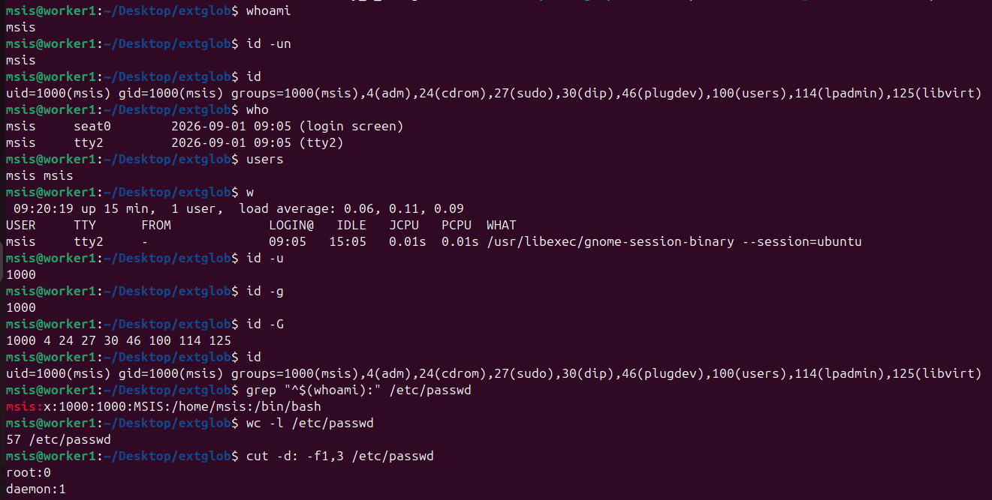

Part B — Creating and Verifying Users (20 Minutes)
Create the following users and ensure that a home directory is created for each:

alice, bob, charlie

: sudo useradd -m alice
sudo useradd -m bob
sudo useradd -m charlie

Verify that all three accounts have been added to /etc/passwd.
: grep -E '^(alice|bob|charlie):' /etc/passwd

Determine the UID assigned to each newly created user.
: id -u alice
id -u bob
id -u charlie

Determine the home directory and default shell assigned to alice.
: getent passwd alice

Inspect /home and verify that the required home directories were created.
: ls -la /home
ls -ld /home/alice /home/bob /home/charlie

Set passwords for all three accounts.
: sudo passwd alice
sudo passwd bob
sudo passwd charlie

Switch from your current account to alice using a login shell. Verify the change using an appropriate command, and then return to your original account.
: su – alice
whoami
id
pwd
exit

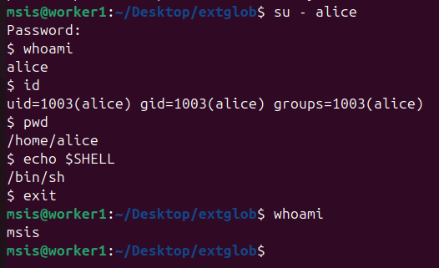

Part C — Group Management and Access Control (30 Minutes)
Create two groups:

security and developers

sudo groupadd security
sudo groupadd developers

verify
getent group security
getent group developers

Add alice and charlie to the security group.
: sudo usermod -aG security alice
sudo usermod -aG security charlie

Add bob to the developers group.
: sudo usermod -aG developers bob

Without switching accounts, verify the group membership of all three users.
: id -Gn alice
id -Gn bob
id -Gn charlie

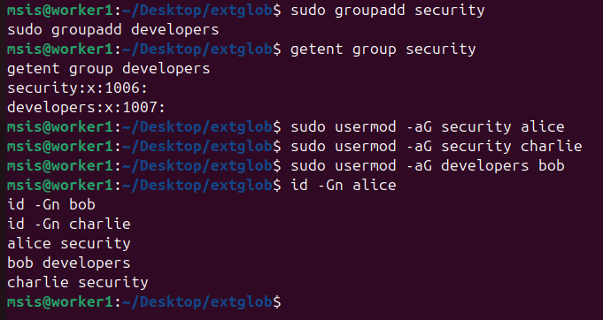

Display the entries corresponding to security and developers from /etc/group.
: grep -E '^(security|developers):' /etc/group

Format : groupname:password:GID:members
security:x:1006:alice,charlie
developers:x:1007:bob

Add bob to the security group without removing him from the developers group.
: sudo usermod -aG security bob

Verify that bob now belongs to both groups.
: id -Gn bob
bob security developers

