GLOBAL SUPERSTORE
Sales, Profitability & Regional Performance Analysis

- Project Overview

Global Superstore Sales, Profitability & Regional Performance Analysis is an interactive Power BI business intelligence project designed to analyze sales performance, profitability, regional performance, product performance and customer segment contribution across the Global Superstore dataset.
The project transforms transactional sales data into an interactive analytical solution using Power Query, a star-schema data model and DAX. The analysis focuses on both revenue generation and profitability to identify key performance drivers, loss-making orders, regional opportunities and product-level performance.

- Business Problem

The business operates across multiple markets, regions, product categories and customer segments. However, sales revenue alone does not provide a complete view of business performance.
The purpose of this analysis is to understand where revenue is generated, where profit is created or lost, which markets and regions perform strongly, which products contribute to profitability, and where management should focus to improve overall business performance.

- Project Objectives

- Analyze overall sales and profitability performance.
- Track sales trends and year-over-year performance.
- Evaluate market and regional sales performance.
- Analyze category and sub-category performance.
- Evaluate customer segment contribution.
- Identify high-performing and loss-making products.
- Measure profit margins and loss-making orders.
- Identify key business performance drivers.
- Develop actionable, data-driven recommendations.

- Dataset

Dataset Source: Global Superstore dataset obtained from Kaggle.
Data Type: Transaction-level sales data.
Primary Fact Table: Orders
Orders Table: 51,290 transaction-level records.
Supporting Tables: Dim_Date, Dim_Customer, Dim_Product, People and Returns.
Key Fields: Order ID, Order Date, Customer ID, Customer Name, Product, Category, Sub-Category, Sales, Quantity, Profit, Discount, Region, Market and Segment.
Date Dimension: A dedicated Dim_Date table was created covering 1 January 2014 to 31 December 2017 to support time-based analysis and demonstrate proper dimensional data modeling and time-intelligence concepts.
Data Grain: The Orders table contains transaction/product-level records, meaning a single Order ID can contain multiple records. Therefore, unique orders and customers are calculated using distinct counts where appropriate.

- Data Preparation & Transformation

Power Query was used to transform the raw Global Superstore dataset into analysis-ready tables.
Orders Table: The source data was imported into Power BI, headers were promoted, appropriate data types were assigned, and unnecessary columns were removed to retain the fields required for analysis.
Customer Dimension: A dedicated Dim_Customer table was created by retaining the required customer attributes and removing duplicate customer records to establish unique customer-level information.
Product Dimension: A dedicated Dim_Product table was created by retaining the required product attributes, including Product ID, Product Name, Sub-Category and Category, and removing duplicate product records.
Date Dimension: A Dim_Date table was prepared using the available Order Date and Ship Date information. The date-related fields were transformed and supporting attributes including Year, Month, Month Name, Quarter, Day and Day Name were created for time-based analysis.
Data Preparation Outcome: The transformed tables were prepared for relationship creation and analytical reporting in Power BI. The resulting structure supports analysis across sales, profitability, customers, products, regions and time.

Key Power Query transformations:
- Promoted headers
- Changed data types
- Removed unnecessary columns
- Removed duplicate customer records
- Removed duplicate product records
- Restructured date information
- Created Year, Month, Month Name, Quarter, Day and Day Name fields
- Sorted date-related data for analysis

- Data Model

A relational data model was created in Power BI to organize the Global Superstore data into a central transaction table and supporting dimension tables. The Orders table acts as the primary fact table containing transaction-level sales, quantity and profit information.
Supporting dimension tables were created for Date, Customer, Product and People, while the Returns table was incorporated to support return-related analysis. The model uses one-to-many relationships from the relevant dimension tables to the Orders fact table, allowing filters and analytical calculations to flow from the dimensions to the transactional data.
The model follows a star-schema approach, separating transactional measures from descriptive attributes. This structure improves data organization, filtering, DAX calculations and dashboard performance while supporting analysis across time, customers, products, geography and business performance.

Table | Role | Purpose
Orders | Fact | Sales, quantity, profit and transaction-level analysis
Dim_Date | Dimension | Time-based analysis and time intelligence
Dim_Customer | Dimension | Customer-level analysis
Dim_Product | Dimension | Product, category and sub-category analysis
People | Supporting Dimension | Regional/people-related analysis
Returns | Supporting Table | Return-related analysis
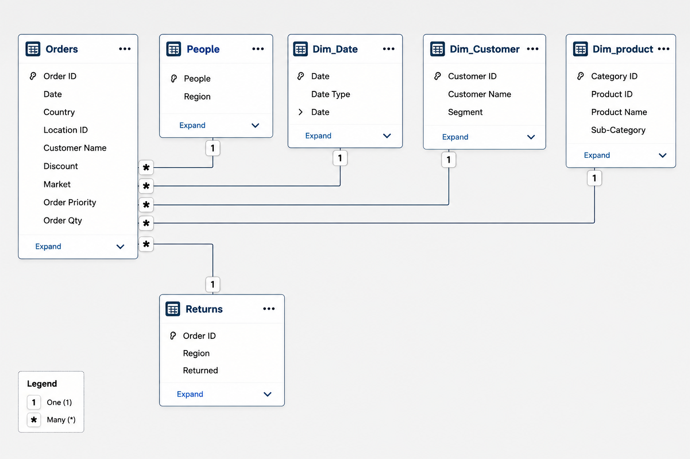

- DAX Measures

DAX (Data Analysis Expressions) was used to create reusable measures for KPI calculation, profitability analysis, time intelligence, ranking and business-specific analysis. The measures support interactive filtering and provide decision-ready metrics across the dashboard pages.

Category | Key Measures
Core KPIs | Total Sales, Total Profit, Total Orders, Total Customers, Total Quantity, Average Order Value
Profitability | Profit Margin, Total Loss, Loss Making Orders, Loss Making Sales, High Profit Sales
Time Intelligence | Previous Year Sales, Sales YTD, YOY Growth %
Ranking & Contribution | Top Market Name, Top Market Sales, Top Region Sales, Category Sales %, Region Sales %
Business-Specific | Technology Sales, Western US Technology Sales

Profit Margin =
DIVIDE(
[Total Profit],
[Total Sales])
Loss Making Orders =
COUNTROWS(
FILTER(
VALUES(Orders[Order ID]),
CALCULATE([Total Profit]) < 0))

Previous Year Sales =
CALCULATE(
[Total Sales],
SAMEPERIODLASTYEAR(Dim_Date[Date]))

YOY Growth % =
DIVIDE(
[Total Sales] - [Previous Year Sales],
[Previous Year Sales])

Top Market Name =
VAR MarketTable =
ADDCOLUMNS(
VALUES(Orders[Market]),
"MarketSales",
CALCULATE(SUM(Orders[Sales])))
RETURN
MAXX(
TOPN(
1,
MarketTable,
[MarketSales],
DESC),
Orders[Market])

- Dashboard Overview

The Power BI report consists of three interactive dashboard pages designed to provide a structured view of overall business performance, regional and segment performance, and detailed profitability and product performance. The dashboards use common filters and DAX measures to allow users to explore the data interactively.

  - Executive Overview
Purpose: Provides a high-level view of overall business performance.
Key areas covered:
- Total Sales
- Total Profit
- Profit Margin
- Total Orders
- Total Customers
- Quarterly Sales Trend
- Regional Sales
- Category Sales
- Category Profit
- Key Business Insights
Business Question:
How is the business performing overall, and which regions and product categories are driving sales and profitability?

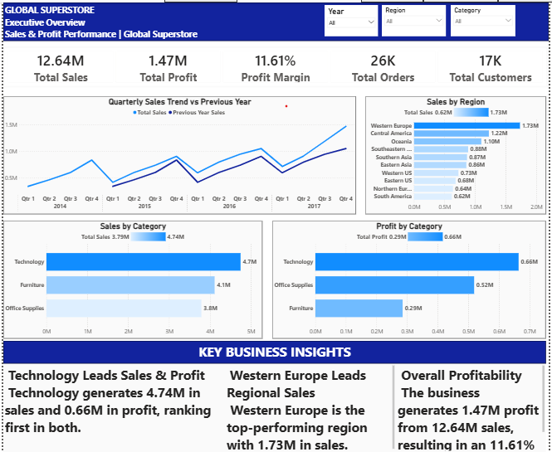
8.2 Sales & Regional Analysis
Purpose: Analyzes sales performance across markets, regions and customer segments.

Key areas covered:
- Total Sales
- Total Profit
- Top Region Sales
- Top Regions by Sales
- Sales by Market
- Sales by Customer Segment
- Regional and Segment Performance
- Key Business Insights
Business Question:
Which markets, regions and customer segments contribute most to overall sales performance?

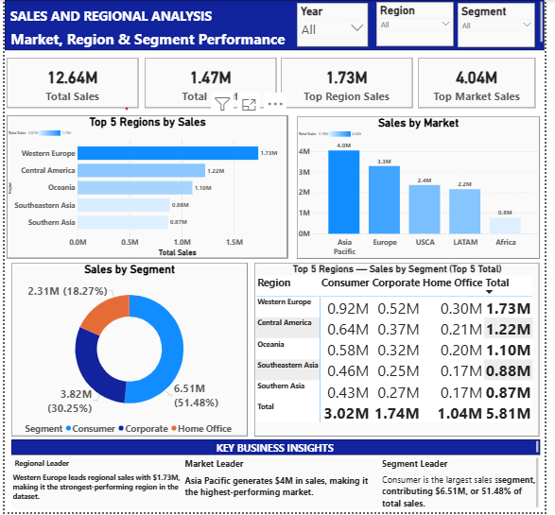
8.3 Profitability & Product Analysis

Purpose: Evaluates profitability at category, sub-category and product levels and identifies areas contributing to financial losses.

Key areas covered:
- Total Profit
- Profit Margin
- Loss-Making Orders
- Loss-Making Sales
- Total Loss
- Sales vs Profit by Category
- Profit Margin by Category
- Profit by Sub-Category
- Top 10 Products by Sales
- Bottom 10 Products by Profit
Business Question:
Where is the business generating profit, and which products, sub-categories or orders are creating profitability risks?
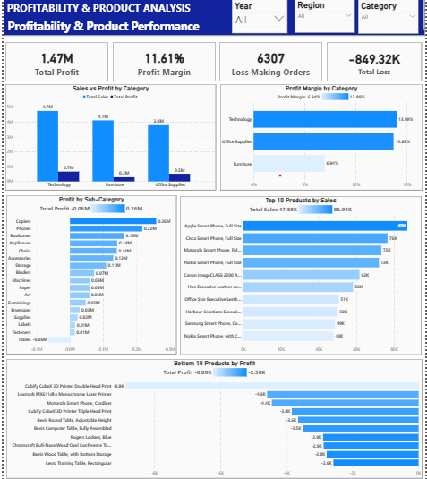
9. Key Business Insights
Insight 1 — Overall Revenue & Profitability
Global Superstore generated $12.64M in sales and $1.47M in profit, resulting in an overall profit margin of 11.61%. While the business generates strong revenue, profitability needs to be evaluated alongside sales performance rather than focusing on revenue alone.
Insight 2 — Market & Regional Performance
Asia Pacific is the leading market, generating approximately $4.0M in sales, while Western Europe is the highest-performing individual region with $1.73M in sales. This indicates that both markets and regions contribute differently to overall revenue performance, highlighting Asia Pacific as a key market for growth and Western Europe as a strong regional performer.
Insight 3 — Category Performance
Technology is the highest-performing product category, generating approximately $4.7M in sales and making it the largest contributor to overall category revenue. Its strong revenue contribution makes Technology a key driver of business performance, while its profitability should be evaluated alongside sales to determine whether this revenue is translating into sustainable returns.
Insight 4 — Segment Performance
The Consumer segment is the largest contributor to overall sales, generating $6.51M and accounting for 51.48% of total sales. Corporate contributes $3.82M (30.25%), while Home Office contributes $2.31M (18.27%). The strong concentration of revenue in the Consumer segment indicates that overall sales performance is significantly influenced by Consumer demand.
Insight 5 — Category Profitability
Technology is the strongest category in both revenue and absolute profit, generating approximately $4.7M in sales and $0.7M in profit. Office Supplies generates approximately $3.8M in sales and $0.5M in profit, while Furniture generates $4.1M in sales but only $0.3M in profit. This indicates that Furniture generates substantial revenue but converts a smaller portion of that revenue into profit, making its profitability an area that warrants further investigation.
Insight 6 — Loss-Making Orders
Approximately 24% of orders are loss-making, with 6,307 orders generating a combined loss of $849.32K. These loss-making orders were associated with $2.37M in sales, highlighting that a significant portion of revenue does not necessarily translate into profitable performance. This indicates an opportunity to identify the products, sub-categories and regions contributing to these losses and improve overall profitability.
Insight 7 — Product-Level Profitability
Product-level analysis reveals a significant gap between sales performance and profitability. The Motorola Smart Phone, Cordless generated approximately $73K in sales, placing it among the top-selling products, but recorded approximately $4.4K in negative profit. This indicates that strong product sales do not necessarily translate into profitable performance and highlights the need to investigate pricing, discounts and other cost drivers for high-sales, loss-making products.
Insight 8 — Sales Growth & Seasonal Trend
Sales show a clear upward trend from 2014 to 2017, with total sales consistently tracking above the previous-year comparison in the available periods. The business also shows a recurring seasonal pattern, with sales generally peaking in Q4 and declining in Q1. This suggests sustained growth alongside quarterly seasonality, which should be considered when planning sales targets, inventory and promotional activities.

10. Business Recommendations

Recommendation #1 — Reduce Loss-Making Orders
Conduct a detailed review of the 6,307 loss-making orders to identify the products, sub-categories, regions and customer segments contributing most to the $849.32K loss. Prioritize corrective actions such as pricing, discount and cost optimization in the highest-impact loss areas while protecting profitable sales.

Recommendation #2 — Improve Furniture Profitability
Conduct a profitability deep-dive on the Furniture category by comparing historical performance across regions, sub-categories and products. Evaluate sales, profit margins, discounts and relevant cost drivers to identify the factors behind Furniture's relatively low profit contribution. Based on the findings, optimize pricing, discounting and product-level strategy in the lowest-margin areas while protecting high-performing products.

Recommendation #3 — High-Sales, Loss-Making Products
Identify high-sales products that generate negative profit and evaluate their pricing, discount levels, and associated costs at the product and regional level. For consistently loss-making products, management should consider pricing or discount adjustments and assess whether continued promotion is financially justified.

Recommendation #4 — Regional Opportunity
Evaluate regional performance using both sales and profitability before allocating additional resources. Prioritize regions that demonstrate strong revenue together with healthy profit margins, while investigating regions where high sales are not translating into comparable profitability.

Recommendation #5 — Consumer Segment
The Consumer segment contributes 51.48% of total sales and should remain a key focus of revenue planning. Management should analyze Consumer purchasing patterns, product preferences and regional performance to identify opportunities for sustainable growth while avoiding excessive dependence on a single customer segment.

Recommendation #6 — Seasonal Planning
Use the observed Q4 sales peak and Q1 decline to improve seasonal planning. Management should align inventory, sales targets and promotional activity with historical demand patterns while monitoring whether the seasonal pattern remains consistent in future periods.

11. Conclusion
This project transformed the Global Superstore transactional dataset into an interactive Power BI business intelligence solution covering sales, profitability, regional performance, customer segments and product performance.
The analysis demonstrated that strong sales performance does not always translate into strong profitability. The project identified key revenue drivers such as Technology, Asia Pacific and the Consumer segment, while also highlighting profitability risks including loss-making orders, lower-margin categories and high-sales products generating negative profit.
The resulting analysis provides management with a structured view of business performance and data-driven recommendations for improving profitability, managing regional and product performance, and planning around seasonal demand patterns.

12. Tools & Skills Demonstrated
Tools
- Microsoft Power BI
- Power Query
- DAX
- Microsoft Excel — supporting analysis where applicable
- GitHub — project documentation and portfolio publishing
Technical Skills
- Data Cleaning & Transformation
- Power Query
- Data Modeling
- Star-Schema Design
- Relationships & Cardinality
- DAX Measures
- Time Intelligence
- KPI Development
- Filter Context
- CALCULATE
- FILTER
- VALUES
- ADDCOLUMNS
- TOPN
- MAXX
- DIVIDE
- SAMEPERIODLASTYEAR
- TOTALYTD
Analytical & Business Skills
- Sales Analysis
- Profitability Analysis
- Regional Analysis
- Product Analysis
- Customer Segment Analysis
- Loss-Making Order Analysis
- Trend & Seasonality Analysis
- Business Insight Generation
- Data Storytelling
- Business Recommendations

