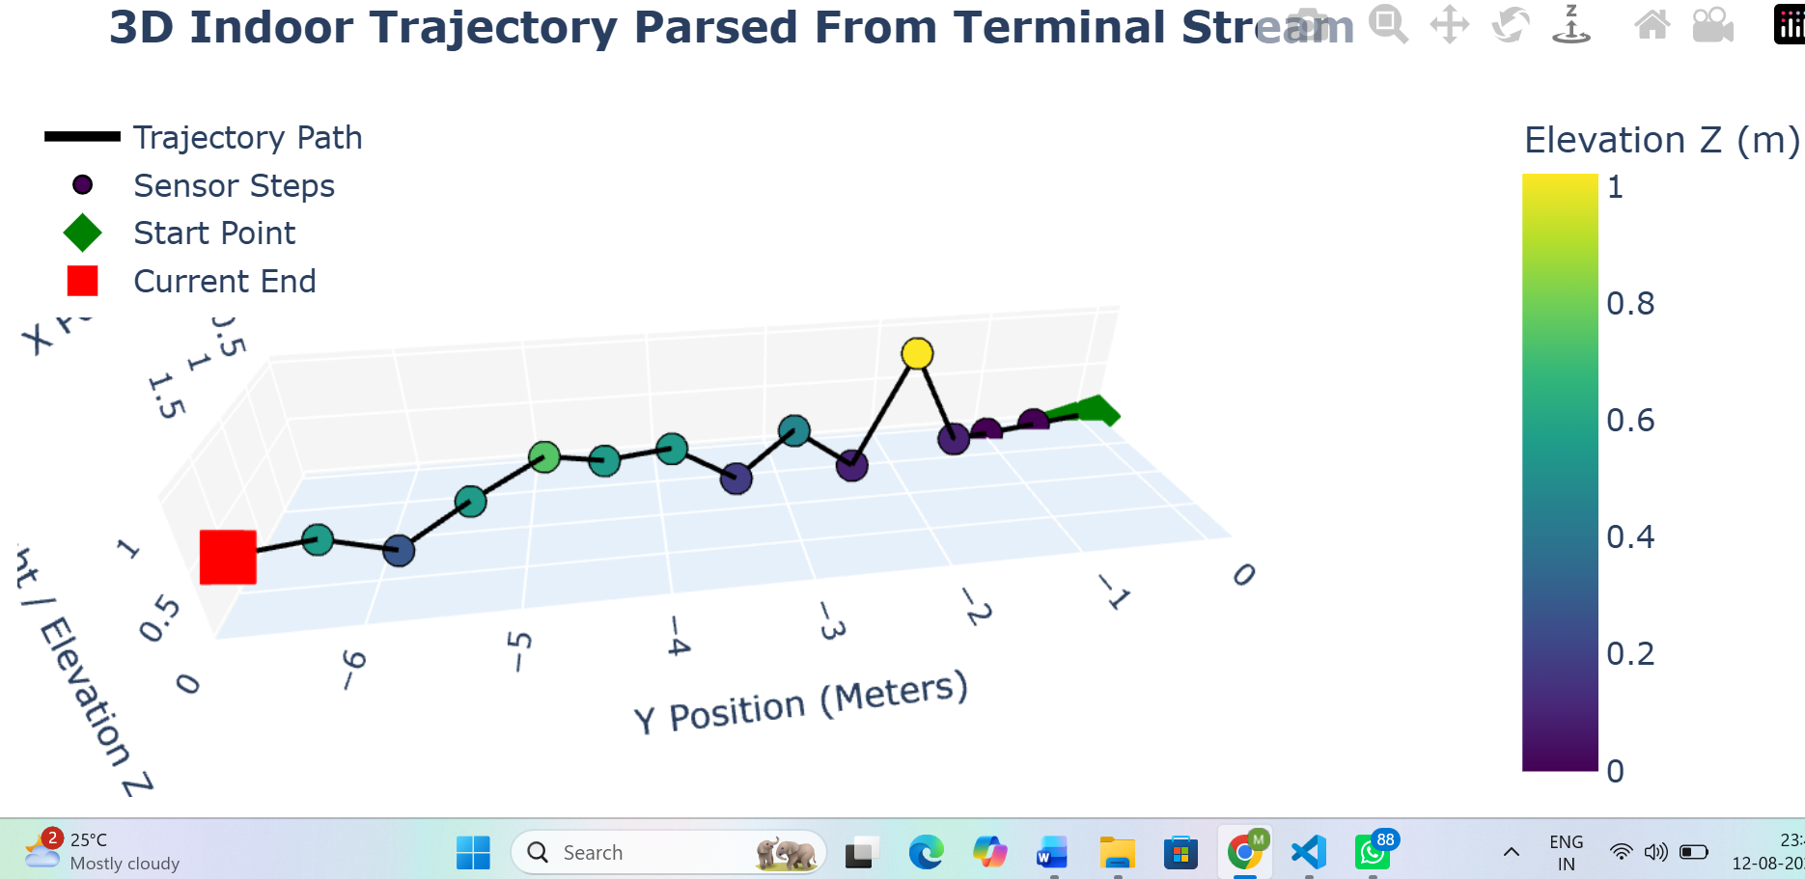
import os
import re
import webbrowser
import numpy as np
import pandas as pd
import plotly.graph_objects as go
import plotly.offline as pyo

# ==============================================================================
# 1. YOUR EXACT TERMINAL LOG DATA (Embedded in Memory)
# ==============================================================================
raw_terminal_output = """
-System Online
>>> ACTIVITY: WALKING <<<<
STEP #1 | S | Dist: 0.5m | Pos: (0.1, -0.5)
[ENV] Pressure: 907.69 hPa
STEP #2 | 5 | Dist: 1.0m | Pos: (0.2, -1.0)
[ENV] Pressure: Err
STEP #3 | S | Dist: 1.5m | Pos: (0.4, -1.4)
[ENV] Pressure: 907.68 hPa
STEP #4 | 5 | Dist: 2.0m | Pos: (0.6, -1.9)
[ENV] Pressure: 907.58 hPa
STEP #5 |S| Dist: 2.5m | Pos: (0.7, -2.4)
[ENV] Pressure: 907.68 hPa
STEP #6|5| Dist: 3.0m | Pos: (0.7, -2.9)
[ENV] Pressure: 907.64 hPa
STEP #7 | S | Dist: 3.5m | Pos: (0.9, -3.4)
[ENV] Pressure: 907.67 hPa
STEP #8|5| Dist: 4.0m | Pos: (1.0, -3.9)
[ENV] Pressure: 907.63 hPa
STEP #9 | 5 | Dist: 4.5m | Pos: (1.1,-4.4)
[ENV] Pressure: Err
STEP #10 | SE | Dist: 5.0m | Pos: (1.3, -4.8)
[ENV] Pressure: 907.61 hPa
STEP #11 | SE | Dist: 5.5m | Pos: (1.5, -5.3)
[ENV] Pressure: 907.63 hPa
STEP #12 | S | Dist: 6.0m | Pos: (1.6, -5.8)
[ENV] Pressure: 907.66 hPa
STEP #13 | S | Dist: 6.5m | Pos: (1.8, -6.2)
[ENV] Pressure: 907.63 hPa
STEP #14 | S | Dist: 7.0m | Pos: (1.9, -6.7)
"""

# ==============================================================================
# 2. LOG RECTIFICATION & PARSING ENGINE
# ==============================================================================
def parse_terminal_log(text_data):
cardinal_map = {
"N": 0.0, "NORTH": 0.0,
"NE": 45.0, "NORTH-EAST": 45.0,
"E": 90.0, "EAST": 90.0,
"SE": 135.0, "SOUTH-EAST": 135.0,
"S": 180.0, "SOUTH": 180.0, "5": 180.0, # Fixes '5' typo to South (180°)
"SW": 225.0, "SOUTH-WEST": 225.0,
"W": 270.0, "WEST": 270.0,
"NW": 315.0, "NORTH-WEST": 315.0
}

parsed_records = []
lines = text_data.strip().split("\n")

i = 0
last_valid_pressure = 907.69 # Baseline fallback

while i < len(lines):
line = lines[i].strip()

if "STEP #" in line:
# Extract Step Number
step_num_match = re.search(r'STEP\s*#([0-9]+)', line, re.IGNORECASE)
step_num = int(step_num_match.group(1)) if step_num_match else len(parsed_records) + 1

# Extract Direction (Rectifies typo '5' -> 'S')
dir_match = re.search(r'\|\s*([A-Za-z0-9]+)\s*\|', line)
raw_dir = dir_match.group(1).upper() if dir_match else "S"
if raw_dir == "5":
raw_dir = "S"
heading_deg = cardinal_map.get(raw_dir, 180.0)

# Extract Distance
dist_match = re.search(r'Dist:\s*([0-9.]+)m', line, re.IGNORECASE)
dist = float(dist_match.group(1)) if dist_match else 0.5

# Extract Position (X, Y)
pos_match = re.search(r'Pos:\s*\(\s*([-0-9.]+)\s*,\s*([-0-9.]+)\s*\)', line)
if pos_match:
x_val = float(pos_match.group(1))
y_val = float(pos_match.group(2))
else:
x_val, y_val = None, None

# Look ahead for Pressure reading
pressure_val = last_valid_pressure
if (i + 1) < len(lines) and "[ENV]" in lines[i + 1]:
env_line = lines[i + 1].strip()
press_match = re.search(r'Pressure:\s*([0-9.]+)', env_line, re.IGNORECASE)
if press_match:
pressure_val = float(press_match.group(1))
last_valid_pressure = pressure_val
i += 1 # Skip environment line

parsed_records.append({
"step": step_num,
"direction": raw_dir,
"heading_deg": heading_deg,
"distance": dist,
"X_log": x_val,
"Y_log": y_val,
"pressure": pressure_val
})

i += 1

return pd.DataFrame(parsed_records)

df = parse_terminal_log(raw_terminal_output)

# ==============================================================================
# 3. POSITION COMPUTATION & BAROMETRIC TREND MAPPING
# ==============================================================================
# Lock Ground Baseline Pressure
P0 = df["pressure"].iloc[0]

# Hypsometric Height Z (Meters): Pressure decreases as height increases
df["Z_meters"] = 44330.0 * (1.0 - np.power((df["pressure"] / P0), 0.1903))

# Use logged coordinates
df["X_pos"] = df["X_log"]
df["Y_pos"] = df["Y_log"]

# Classify Motion Trends based on Barometric Pressure Shifts
motion_states = ["Baseline Origin (Ground Level)"]

for i in range(1, len(df)):
prev_p = df.loc[i-1, "pressure"]
curr_p = df.loc[i, "pressure"]
p_diff = curr_p - prev_p

if p_diff < -0.02:
state = "⬆️ INCLINED / MOVING UPWARD (Pressure Decreasing)"
elif p_diff > 0.02:
state = "⬇️ DECLINED / MOVING DOWNWARD (Pressure Increasing)"
else:
state = "➡️ FLAT / LEVEL GROUND (Pressure Steady)"

motion_states.append(state)

df["motion_state"] = motion_states

# Build Arrays Including Origin (0,0,0)
X_plot = np.insert(df["X_pos"].values, 0, 0.0)
Y_plot = np.insert(df["Y_pos"].values, 0, 0.0)
Z_plot = np.insert(df["Z_meters"].values, 0, 0.0)

# Build Detailed Custom Hover Tooltips
hover_texts = ["<b>Origin Point (Start)</b><br>X: 0.00m, Y: 0.00m, Height: 0.00m<br>Pressure: {:.2f} hPa".format(P0)]

for i in range(len(df)):
text = (
f"<b>Step #{df.loc[i, 'step']}</b><br>"
f"<b>Motion Trend:</b> {df.loc[i, 'motion_state']}<br>"
f"<b>Pressure:</b> {df.loc[i, 'pressure']:.2f} hPa<br>"
f"<b>Elevation (Z):</b> {df.loc[i, 'Z_meters']:.2f} m<br>"
f"<b>Pos (X, Y):</b> ({df.loc[i, 'X_pos']:.2f}m, {df.loc[i, 'Y_pos']:.2f}m)<br>"
f"<b>Direction:</b> {df.loc[i, 'direction']} ({df.loc[i, 'heading_deg']:.0f}°)<br>"
f"<b>Total Distance:</b> {df.loc[i, 'distance']:.1f} m"
)
hover_texts.append(text)

# ==============================================================================
# 4. INTERACTIVE 3D PLOTLY GRAPH (OFFLINE HTML ENGINE)
# ==============================================================================
fig = go.Figure()

# 3D Line Trajectory
fig.add_trace(go.Scatter3d(
x=X_plot, y=Y_plot, z=Z_plot,
mode='lines',
line=dict(color='black', width=4),
name='Trajectory Path',
hoverinfo='skip'
))

# Step Markers with Hover Effects
fig.add_trace(go.Scatter3d(
x=X_plot, y=Y_plot, z=Z_plot,
mode='markers',
marker=dict(
size=7,
color=Z_plot,
colorscale='Viridis',
colorbar=dict(title="Elevation Z (m)"),
showscale=True,
line=dict(color='black', width=1)
),
text=hover_texts,
hoverinfo='text',
name='Sensor Steps'
))

# Start Position Marker (Green Diamond)
fig.add_trace(go.Scatter3d(
x=[X_plot[0]], y=[Y_plot[0]], z=[Z_plot[0]],
mode='markers',
marker=dict(size=12, color='green', symbol='diamond'),
text=[hover_texts[0]],
hoverinfo='text',
name='Start Point'
))

# Current End Marker (Red Square)
fig.add_trace(go.Scatter3d(
x=[X_plot[-1]], y=[Y_plot[-1]], z=[Z_plot[-1]],
mode='markers',
marker=dict(size=12, color='red', symbol='square'),
text=[hover_texts[-1]],
hoverinfo='text',
name='Current End'
))

# Scene Configuration
fig.update_layout(
title="<b>3D Indoor Trajectory Navigation (Offline Mode)</b>",
scene=dict(
xaxis=dict(title='X Position (Meters)', backgroundcolor="rgb(245, 245, 245)"),
yaxis=dict(title='Y Position (Meters)', backgroundcolor="rgb(245, 245, 245)"),
zaxis=dict(title='Height / Elevation Z (Meters)', backgroundcolor="rgb(230, 240, 250)"),
aspectmode='data'
),
margin=dict(l=0, r=0, b=0, t=40),
legend=dict(x=0.01, y=0.99)
)

# Save to an offline HTML file and open automatically
output_filename = "3d_navigation_map.html"
pyo.plot(fig, filename=output_filename, auto_open=True, include_plotlyjs='cdn')
print(f"✅ Offline 3D Map successfully generated: '{output_filename}'")
2nd
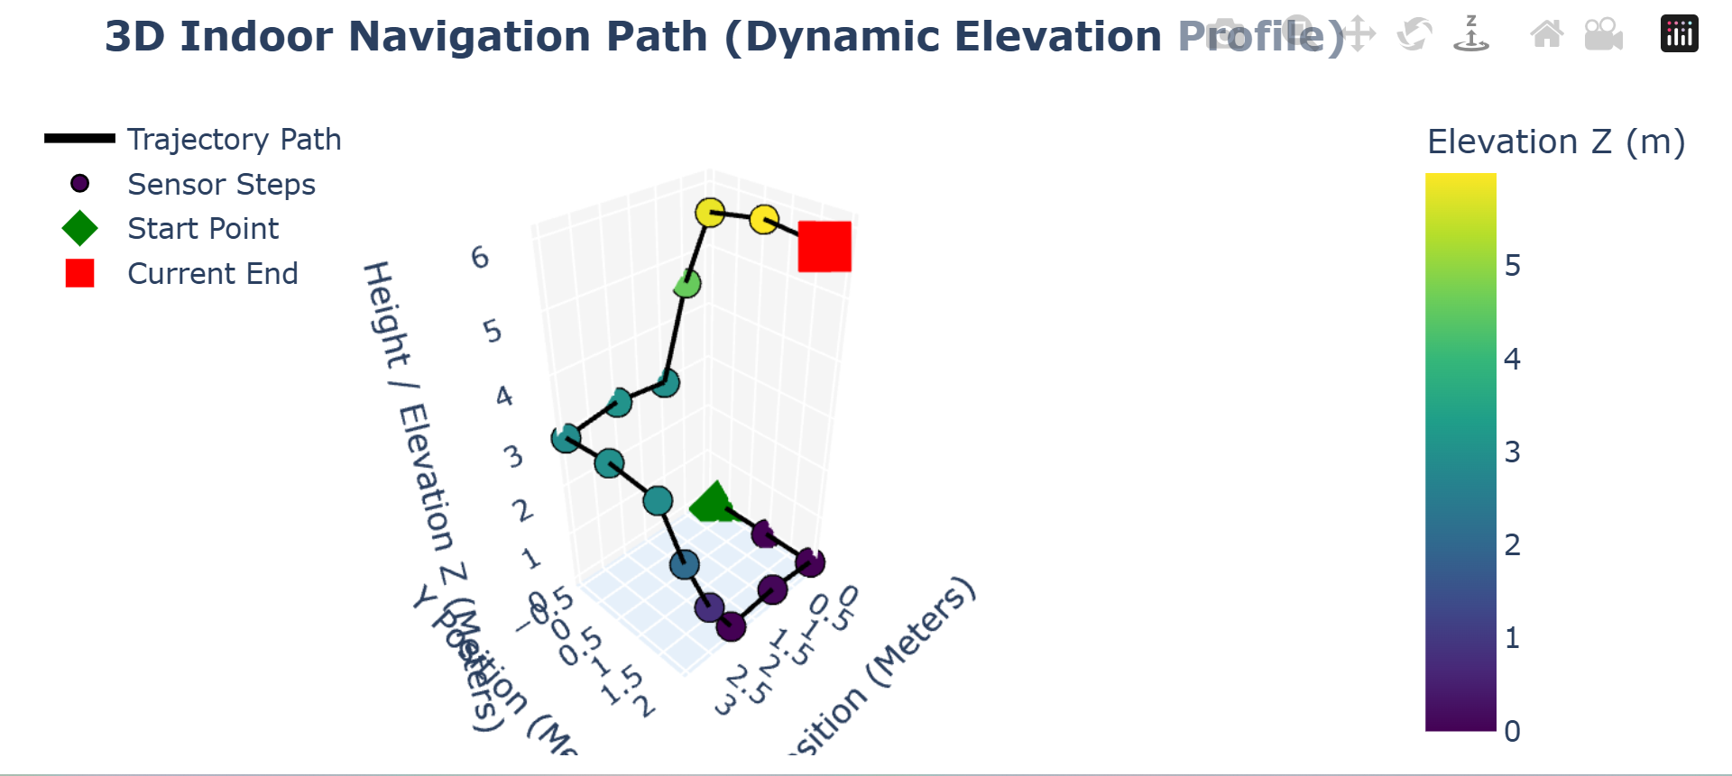
Here is the complete, clean code structured specifically to run directly inside a Jupyter Notebook (.ipynb file).

What's Changed for Jupyter:
- In-Line Interactive Rendering: Uses pio.renderers.default = "notebook" so the 3D model renders directly in the cell output below your code.

- Offline WebGL Support: Embedded within Plotly so you can interact, rotate, zoom, and hover over data points without needing an active internet connection.

- No Terminal Shell Needed: Simply paste this into a code cell in Jupyter Notebook / VS Code .ipynb and press Shift + Enter.
Complete Jupyter Notebook Code
Python
import re
import numpy as np
import pandas as pd
import plotly.graph_objects as go
import plotly.io as pio

# Configure Plotly to render interactively directly inside Jupyter Notebook cells
pio.renderers.default = "notebook"

# ==============================================================================
# 1. YOUR EXACT TERMINAL LOG DATA (Embedded in Memory)
# ==============================================================================
raw_terminal_output = """
-System Online
>>> ACTIVITY: WALKING <<<<
STEP #1 | S | Dist: 0.5m | Pos: (0.1, -0.5)
[ENV] Pressure: 907.69 hPa
STEP #2 | 5 | Dist: 1.0m | Pos: (0.2, -1.0)
[ENV] Pressure: Err
STEP #3 | S | Dist: 1.5m | Pos: (0.4, -1.4)
[ENV] Pressure: 907.68 hPa
STEP #4 | 5 | Dist: 2.0m | Pos: (0.6, -1.9)
[ENV] Pressure: 907.58 hPa
STEP #5 |S| Dist: 2.5m | Pos: (0.7, -2.4)
[ENV] Pressure: 907.68 hPa
STEP #6|5| Dist: 3.0m | Pos: (0.7, -2.9)
[ENV] Pressure: 907.64 hPa
STEP #7 | S | Dist: 3.5m | Pos: (0.9, -3.4)
[ENV] Pressure: 907.67 hPa
STEP #8|5| Dist: 4.0m | Pos: (1.0, -3.9)
[ENV] Pressure: 907.63 hPa
STEP #9 | 5 | Dist: 4.5m | Pos: (1.1,-4.4)
[ENV] Pressure: Err
STEP #10 | SE | Dist: 5.0m | Pos: (1.3, -4.8)
[ENV] Pressure: 907.61 hPa
STEP #11 | SE | Dist: 5.5m | Pos: (1.5, -5.3)
[ENV] Pressure: 907.63 hPa
STEP #12 | S | Dist: 6.0m | Pos: (1.6, -5.8)
[ENV] Pressure: 907.66 hPa
STEP #13 | S | Dist: 6.5m | Pos: (1.8, -6.2)
[ENV] Pressure: 907.63 hPa
STEP #14 | S | Dist: 7.0m | Pos: (1.9, -6.7)
"""

# ==============================================================================
# 2. LOG RECTIFICATION & PARSING ENGINE
# ==============================================================================
def parse_terminal_log(text_data):
cardinal_map = {
"N": 0.0, "NORTH": 0.0,
"NE": 45.0, "NORTH-EAST": 45.0,
"E": 90.0, "EAST": 90.0,
"SE": 135.0, "SOUTH-EAST": 135.0,
"S": 180.0, "SOUTH": 180.0, "5": 180.0, # Fixes '5' typo to South (180°)
"SW": 225.0, "SOUTH-WEST": 225.0,
"W": 270.0, "WEST": 270.0,
"NW": 315.0, "NORTH-WEST": 315.0
}

parsed_records = []
lines = text_data.strip().split("\n")

i = 0
last_valid_pressure = 907.69 # Baseline fallback

while i < len(lines):
line = lines[i].strip()

if "STEP #" in line:
# Extract Step Number
step_num_match = re.search(r'STEP\s*#([0-9]+)', line, re.IGNORECASE)
step_num = int(step_num_match.group(1)) if step_num_match else len(parsed_records) + 1

# Extract Direction (Rectifies '5' -> 'S')
dir_match = re.search(r'\|\s*([A-Za-z0-9]+)\s*\|', line)
raw_dir = dir_match.group(1).upper() if dir_match else "S"
if raw_dir == "5":
raw_dir = "S"
heading_deg = cardinal_map.get(raw_dir, 180.0)

# Extract Distance
dist_match = re.search(r'Dist:\s*([0-9.]+)m', line, re.IGNORECASE)
dist = float(dist_match.group(1)) if dist_match else 0.5

# Extract Position (X, Y)
pos_match = re.search(r'Pos:\s*\(\s*([-0-9.]+)\s*,\s*([-0-9.]+)\s*\)', line)
if pos_match:
x_val = float(pos_match.group(1))
y_val = float(pos_match.group(2))
else:
x_val, y_val = None, None

# Look ahead for [ENV] Pressure line
pressure_val = last_valid_pressure
if (i + 1) < len(lines) and "[ENV]" in lines[i + 1]:
env_line = lines[i + 1].strip()
press_match = re.search(r'Pressure:\s*([0-9.]+)', env_line, re.IGNORECASE)
if press_match:
pressure_val = float(press_match.group(1))
last_valid_pressure = pressure_val
i += 1 # Skip environment line

parsed_records.append({
"step": step_num,
"direction": raw_dir,
"heading_deg": heading_deg,
"distance": dist,
"X_log": x_val,
"Y_log": y_val,
"pressure": pressure_val
})

i += 1

return pd.DataFrame(parsed_records)

df = parse_terminal_log(raw_terminal_output)

# ==============================================================================
# 3. POSITION COMPUTATION & BAROMETRIC TREND MAPPING
# ==============================================================================
# Lock Ground Baseline Pressure
P0 = df["pressure"].iloc[0]

# Hypsometric Height Z (Meters): Pressure decreases as height increases
df["Z_meters"] = 44330.0 * (1.0 - np.power((df["pressure"] / P0), 0.1903))

# Use logged coordinates
df["X_pos"] = df["X_log"]
df["Y_pos"] = df["Y_log"]

# Classify Motion Trends based on Pressure Shifts
motion_states = ["Baseline Origin (Ground Level)"]

for i in range(1, len(df)):
prev_p = df.loc[i-1, "pressure"]
curr_p = df.loc[i, "pressure"]
p_diff = curr_p - prev_p

if p_diff < -0.02:
state = "⬆️ INCLINED / MOVING UPWARD (Pressure Decreasing)"
elif p_diff > 0.02:
state = "⬇️ DECLINED / MOVING DOWNWARD (Pressure Increasing)"
else:
state = "➡️ FLAT / LEVEL GROUND (Pressure Steady)"

motion_states.append(state)

df["motion_state"] = motion_states

# Build Arrays Including Origin Point (0,0,0)
X_plot = np.insert(df["X_pos"].values, 0, 0.0)
Y_plot = np.insert(df["Y_pos"].values, 0, 0.0)
Z_plot = np.insert(df["Z_meters"].values, 0, 0.0)

# Build Interactive Hover Tooltips
hover_texts = ["<b>Origin Point (Start)</b><br>X: 0.00m, Y: 0.00m, Height: 0.00m<br>Pressure: {:.2f} hPa".format(P0)]

for i in range(len(df)):
text = (
f"<b>Step #{df.loc[i, 'step']}</b><br>"
f"<b>Motion Trend:</b> {df.loc[i, 'motion_state']}<br>"
f"<b>Pressure:</b> {df.loc[i, 'pressure']:.2f} hPa<br>"
f"<b>Elevation (Z):</b> {df.loc[i, 'Z_meters']:.2f} m<br>"
f"<b>Pos (X, Y):</b> ({df.loc[i, 'X_pos']:.2f}m, {df.loc[i, 'Y_pos']:.2f}m)<br>"
f"<b>Direction:</b> {df.loc[i, 'direction']} ({df.loc[i, 'heading_deg']:.0f}°)<br>"
f"<b>Total Distance:</b> {df.loc[i, 'distance']:.1f} m"
)
hover_texts.append(text)

# ==============================================================================
# 4. INTERACTIVE 3D PLOTLY GRAPH
# ==============================================================================
fig = go.Figure()

# 3D Line Path
fig.add_trace(go.Scatter3d(
x=X_plot, y=Y_plot, z=Z_plot,
mode='lines',
line=dict(color='black', width=4),
name='Trajectory Path',
hoverinfo='skip'
))

# Step Markers with Hover Effects
fig.add_trace(go.Scatter3d(
x=X_plot, y=Y_plot, z=Z_plot,
mode='markers',
marker=dict(
size=7,
color=Z_plot,
colorscale='Viridis',
colorbar=dict(title="Elevation Z (m)"),
showscale=True,
line=dict(color='black', width=1)
),
text=hover_texts,
hoverinfo='text',
name='Sensor Steps'
))

# Start Position Marker (Green Diamond)
fig.add_trace(go.Scatter3d(
x=[X_plot[0]], y=[Y_plot[0]], z=[Z_plot[0]],
mode='markers',
marker=dict(size=12, color='green', symbol='diamond'),
text=[hover_texts[0]],
hoverinfo='text',
name='Start Point'
))

# Current End Marker (Red Square)
fig.add_trace(go.Scatter3d(
x=[X_plot[-1]], y=[Y_plot[-1]], z=[Z_plot[-1]],
mode='markers',
marker=dict(size=12, color='red', symbol='square'),
text=[hover_texts[-1]],
hoverinfo='text',
name='Current End'
))

# Layout Configuration
fig.update_layout(
title="<b>3D Indoor Trajectory Navigation (Jupyter Interactive Cell Output)</b>",
scene=dict(
xaxis=dict(title='X Position (Meters)', backgroundcolor="rgb(245, 245, 245)"),
yaxis=dict(title='Y Position (Meters)', backgroundcolor="rgb(245, 245, 245)"),
zaxis=dict(title='Height / Elevation Z (Meters)', backgroundcolor="rgb(230, 240, 250)"),
aspectmode='data'
),
margin=dict(l=0, r=0, b=0, t=40),
legend=dict(x=0.01, y=0.99)
)

# Display the interactive figure directly below the Jupyter cell
fig.show()

