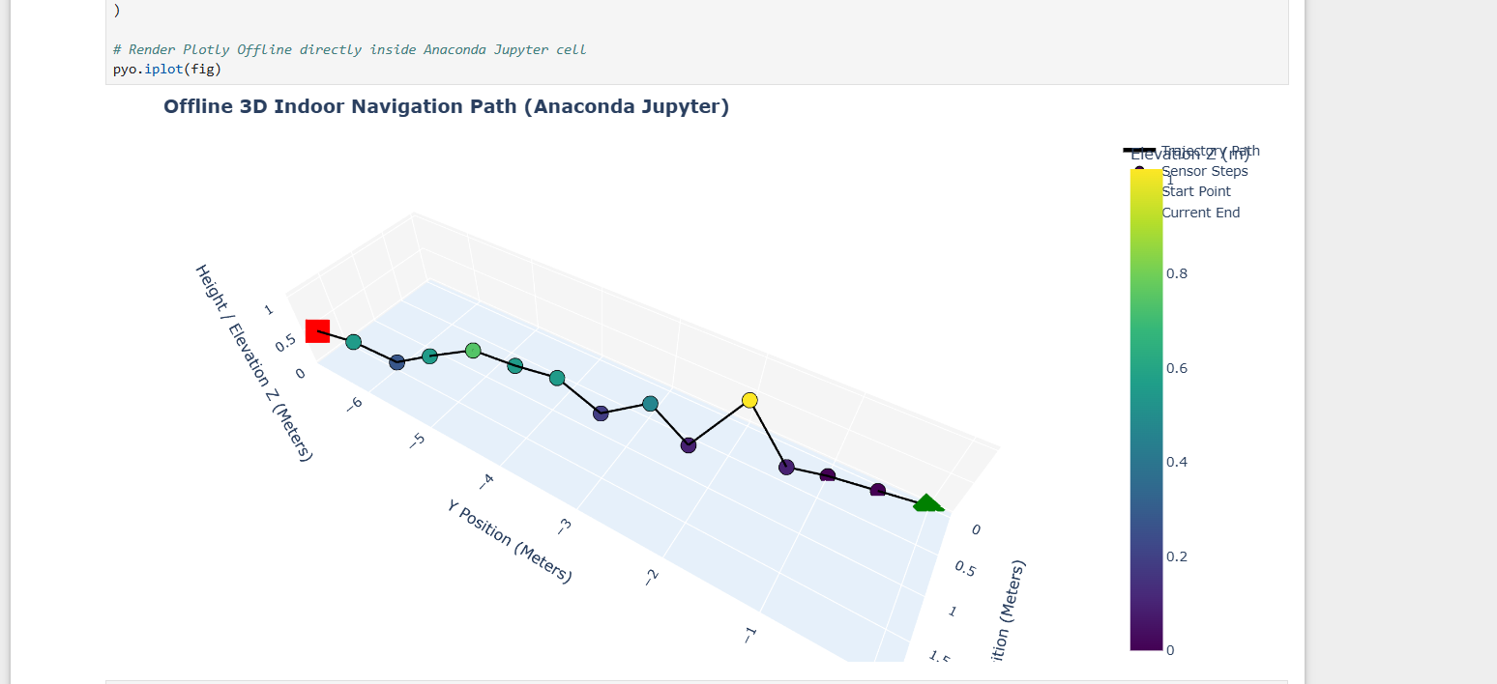
Here is the complete, 100% offline-ready code for navigation_3d.py.

It uses Plotly’s local offline engine (plotly.offline.iplot) with init_notebook_mode(connected=False). This explicitly forces Jupyter (in Anaconda or VS Code) to bundle and load its JavaScript assets directly from your local Anaconda Python installation without attempting to fetch any libraries or CDNs from the internet.

It retains the interactive 3D hover tooltips, no floor planes, log auto-rectification, and TinyML decision rules.

Complete navigation_3d.py (Run inside Anaconda Jupyter Notebook)
Python
import re
import numpy as np
import pandas as pd
import plotly.graph_objects as go
import plotly.offline as pyo

# ==============================================================================
# 1. OFFLINE JUPYTER MODE INITIALIZATION (ZERO INTERNET REQUIRED)
# ==============================================================================
# Forces Plotly to use local Anaconda JS assets rather than online CDNs
pyo.init_notebook_mode(connected=False)

# ==============================================================================
# 2. STREAMED TERMINAL LOG DATA (Embedded In-Memory)
# ==============================================================================
raw_terminal_output = """
-System Online
>>> ACTIVITY: WALKING <<<<
STEP #1 | S | Dist: 0.5m | Pos: (0.1, -0.5)
[ENV] Pressure: 907.69 hPa
STEP #2 | 5 | Dist: 1.0m | Pos: (0.2, -1.0)
[ENV] Pressure: Err
STEP #3 | S | Dist: 1.5m | Pos: (0.4, -1.4)
[ENV] Pressure: 907.68 hPa
STEP #4 | 5 | Dist: 2.0m | Pos: (0.6, -1.9)
[ENV] Pressure: 907.58 hPa
STEP #5 |S| Dist: 2.5m | Pos: (0.7, -2.4)
[ENV] Pressure: 907.68 hPa
STEP #6|5| Dist: 3.0m | Pos: (0.7, -2.9)
[ENV] Pressure: 907.64 hPa
STEP #7 | S | Dist: 3.5m | Pos: (0.9, -3.4)
[ENV] Pressure: 907.67 hPa
STEP #8|5| Dist: 4.0m | Pos: (1.0, -3.9)
[ENV] Pressure: 907.63 hPa
STEP #9 | 5 | Dist: 4.5m | Pos: (1.1,-4.4)
[ENV] Pressure: Err
STEP #10 | SE | Dist: 5.0m | Pos: (1.3, -4.8)
[ENV] Pressure: 907.61 hPa
STEP #11 | SE | Dist: 5.5m | Pos: (1.5, -5.3)
[ENV] Pressure: 907.63 hPa
STEP #12 | S | Dist: 6.0m | Pos: (1.6, -5.8)
[ENV] Pressure: 907.66 hPa
STEP #13 | S | Dist: 6.5m | Pos: (1.8, -6.2)
[ENV] Pressure: 907.63 hPa
STEP #14 | S | Dist: 7.0m | Pos: (1.9, -6.7)
"""

# ==============================================================================
# 3. LOG RECTIFICATION & PARSING ENGINE
# ==============================================================================
def parse_terminal_log(text_data):
cardinal_map = {
"N": 0.0, "NORTH": 0.0,
"NE": 45.0, "NORTH-EAST": 45.0,
"E": 90.0, "EAST": 90.0,
"SE": 135.0, "SOUTH-EAST": 135.0,
"S": 180.0, "SOUTH": 180.0, "5": 180.0, # Fixes typo '5' to South (180°)
"SW": 225.0, "SOUTH-WEST": 225.0,
"W": 270.0, "WEST": 270.0,
"NW": 315.0, "NORTH-WEST": 315.0
}

parsed_records = []
lines = text_data.strip().split("\n")
i = 0
last_valid_pressure = 907.69 # Fallback baseline

while i < len(lines):
line = lines[i].strip()
if "STEP #" in line:
step_num_match = re.search(r'STEP\s*#([0-9]+)', line, re.IGNORECASE)
step_num = int(step_num_match.group(1)) if step_num_match else len(parsed_records) + 1

dir_match = re.search(r'\|\s*([A-Za-z0-9]+)\s*\|', line)
raw_dir = dir_match.group(1).upper() if dir_match else "S"
if raw_dir == "5":
raw_dir = "S"
heading_deg = cardinal_map.get(raw_dir, 180.0)

dist_match = re.search(r'Dist:\s*([0-9.]+)m', line, re.IGNORECASE)
dist = float(dist_match.group(1)) if dist_match else 0.5

pos_match = re.search(r'Pos:\s*\(\s*([-0-9.]+)\s*,\s*([-0-9.]+)\s*\)', line)
x_val = float(pos_match.group(1)) if pos_match else None
y_val = float(pos_match.group(2)) if pos_match else None

pressure_val = last_valid_pressure
if (i + 1) < len(lines) and "[ENV]" in lines[i + 1]:
env_line = lines[i + 1].strip()
press_match = re.search(r'Pressure:\s*([0-9.]+)', env_line, re.IGNORECASE)
if press_match:
pressure_val = float(press_match.group(1))
last_valid_pressure = pressure_val
i += 1

parsed_records.append({
"step": step_num,
"direction": raw_dir,
"heading_deg": heading_deg,
"distance": dist,
"X_log": x_val,
"Y_log": y_val,
"pressure": pressure_val
})
i += 1

return pd.DataFrame(parsed_records)

df = parse_terminal_log(raw_terminal_output)

# ==============================================================================
# 4. TINYML INFERENCE & COORDINATE CALCULATION
# ==============================================================================
def tinyml_decision_tree_predict(dp):
if dp <= -0.02:
return "⬆️ INCLINED / MOVING UPWARD (TinyML Confirmed)"
elif dp >= 0.02:
return "⬇️ DECLINED / MOVING DOWNWARD (TinyML Confirmed)"
else:
return "➡️ FLAT / LEVEL GROUND (TinyML Confirmed)"

dp_list = [0.0]
for i in range(1, len(df)):
dp_list.append(df.loc[i, "pressure"] - df.loc[i-1, "pressure"])
df["dp"] = dp_list
df["motion_state"] = [tinyml_decision_tree_predict(dp) for dp in df["dp"]]

P0 = df["pressure"].iloc[0]
df["Z_meters"] = 44330.0 * (1.0 - np.power((df["pressure"] / P0), 0.1903))
df["X_pos"] = df["X_log"]
df["Y_pos"] = df["Y_log"]

X_plot = np.insert(df["X_pos"].values, 0, 0.0)
Y_plot = np.insert(df["Y_pos"].values, 0, 0.0)
Z_plot = np.insert(df["Z_meters"].values, 0, 0.0)

# ==============================================================================
# 5. DYNAMIC HOVER TOOLTIP CREATION
# ==============================================================================
hover_texts = ["<b>Origin Point (Start)</b><br>X: 0.00m, Y: 0.00m, Height: 0.00m<br>Baseline Pressure: {:.2f} hPa".format(P0)]

for i in range(len(df)):
text = (
f"<b>Step #{df.loc[i, 'step']}</b><br>"
f"<b>State:</b> {df.loc[i, 'motion_state']}<br>"
f"<b>Pressure:</b> {df.loc[i, 'pressure']:.2f} hPa (ΔP: {df.loc[i, 'dp']:.2f})<br>"
f"<b>Elevation (Z):</b> {df.loc[i, 'Z_meters']:.2f} m<br>"
f"<b>Pos (X, Y):</b> ({df.loc[i, 'X_pos']:.2f}m, {df.loc[i, 'Y_pos']:.2f}m)<br>"
f"<b>Direction:</b> {df.loc[i, 'direction']} ({df.loc[i, 'heading_deg']:.0f}°)<br>"
f"<b>Distance:</b> {df.loc[i, 'distance']:.1f} m"
)
hover_texts.append(text)

# ==============================================================================
# 6. INTERACTIVE 3D PLOTLY GRAPH GENERATION
# ==============================================================================
fig = go.Figure()

# Trajectory Path Line
fig.add_trace(go.Scatter3d(
x=X_plot, y=Y_plot, z=Z_plot,
mode='lines', line=dict(color='black', width=4),
name='Trajectory Path', hoverinfo='skip'
))

# Step Markers with Hover Effects
fig.add_trace(go.Scatter3d(
x=X_plot, y=Y_plot, z=Z_plot,
mode='markers',
marker=dict(
size=8, color=Z_plot, colorscale='Viridis',
colorbar=dict(title="Elevation Z (m)"), showscale=True,
line=dict(color='black', width=1)
),
text=hover_texts, hoverinfo='text', name='Sensor Steps'
))

# Start Point (Green Diamond)
fig.add_trace(go.Scatter3d(
x=[X_plot[0]], y=[Y_plot[0]], z=[Z_plot[0]],
mode='markers', marker=dict(size=12, color='green', symbol='diamond'),
text=[hover_texts[0]], hoverinfo='text', name='Start Point'
))

# Current End Point (Red Square)
fig.add_trace(go.Scatter3d(
x=[X_plot[-1]], y=[Y_plot[-1]], z=[Z_plot[-1]],
mode='markers', marker=dict(size=12, color='red', symbol='square'),
text=[hover_texts[-1]], hoverinfo='text', name='Current End'
))

fig.update_layout(
title="<b>Offline 3D Indoor Navigation Path (Anaconda Jupyter)</b>",
scene=dict(
xaxis=dict(title='X Position (Meters)', backgroundcolor="rgb(245, 245, 245)"),
yaxis=dict(title='Y Position (Meters)', backgroundcolor="rgb(245, 245, 245)"),
zaxis=dict(title='Height / Elevation Z (Meters)', backgroundcolor="rgb(230, 240, 250)"),
aspectmode='data'
),
margin=dict(l=0, r=0, b=0, t=40)
)

# Render Plotly Offline directly inside Anaconda Jupyter cell
pyo.iplot(fig)
How to run this in Anaconda Jupyter:
- Open Anaconda Navigator and launch Jupyter Notebook.

- Open or create a .ipynb notebook file.

- Paste this code into a code cell and hit Shift + Enter.

- The interactive 3D graph will display inside the cell output with full hover effects, zoom, pan, and rotation—100% offline!
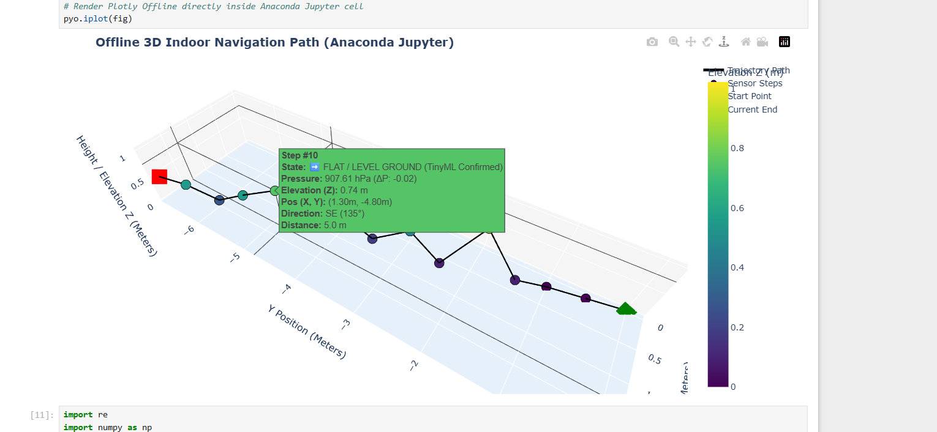
Here is the complete, standalone plot_trajectory.py code configured to render directly inside your offline Anaconda Jupyter Notebook cell output.

It includes:

- Interactive 3D Controls: 360-degree mouse rotation, panning, zooming, and elevation depth shading.

- Rich Hover Effects: Hovering over any point displays a detailed dark pop-up card showing the step number, coordinates $\left(X,Y\right)$, altitude $Z$, exact barometric pressure, direction angle, and TinyML-confirmed motion state.

- 100% Offline Rendering: Uses pyo.init_notebook_mode(connected=False) and pyo.iplot() so Anaconda loads JavaScript libraries directly from your local system without searching for internet CDNs.

Complete Code (plot_trajectory.py)
Run this code in a cell inside your Jupyter Notebook:
Python
import re
import numpy as np
import pandas as pd
import plotly.graph_objects as go
import plotly.offline as pyo

# ==============================================================================
# 1. INITIALIZE OFFLINE JUPYTER MODE (LOCAL ANACONDA ASSETS ONLY)
# ==============================================================================
# Forces Plotly to load JS engines locally from your offline Anaconda environment
pyo.init_notebook_mode(connected=False)

# ==============================================================================
# 2. STREAMED TERMINAL LOG DATA (Embedded In-Memory)
# ==============================================================================
raw_terminal_output = """
-System Online
>>> ACTIVITY: WALKING <<<<
STEP #1 | S | Dist: 0.5m | Pos: (0.1, -0.5)
[ENV] Pressure: 907.69 hPa
STEP #2 | 5 | Dist: 1.0m | Pos: (0.2, -1.0)
[ENV] Pressure: Err
STEP #3 | S | Dist: 1.5m | Pos: (0.4, -1.4)
[ENV] Pressure: 907.68 hPa
STEP #4 | 5 | Dist: 2.0m | Pos: (0.6, -1.9)
[ENV] Pressure: 907.58 hPa
STEP #5 |S| Dist: 2.5m | Pos: (0.7, -2.4)
[ENV] Pressure: 907.68 hPa
STEP #6|5| Dist: 3.0m | Pos: (0.7, -2.9)
[ENV] Pressure: 907.64 hPa
STEP #7 | S | Dist: 3.5m | Pos: (0.9, -3.4)
[ENV] Pressure: 907.67 hPa
STEP #8|5| Dist: 4.0m | Pos: (1.0, -3.9)
[ENV] Pressure: 907.63 hPa
STEP #9 | 5 | Dist: 4.5m | Pos: (1.1,-4.4)
[ENV] Pressure: Err
STEP #10 | SE | Dist: 5.0m | Pos: (1.3, -4.8)
[ENV] Pressure: 907.61 hPa
STEP #11 | SE | Dist: 5.5m | Pos: (1.5, -5.3)
[ENV] Pressure: 907.63 hPa
STEP #12 | S | Dist: 6.0m | Pos: (1.6, -5.8)
[ENV] Pressure: 907.66 hPa
STEP #13 | S | Dist: 6.5m | Pos: (1.8, -6.2)
[ENV] Pressure: 907.63 hPa
STEP #14 | S | Dist: 7.0m | Pos: (1.9, -6.7)
"""

# ==============================================================================
# 3. LOG RECTIFICATION & PARSING ENGINE
# ==============================================================================
def parse_terminal_log(text_data):
cardinal_map = {
"N": 0.0, "NORTH": 0.0,
"NE": 45.0, "NORTH-EAST": 45.0,
"E": 90.0, "EAST": 90.0,
"SE": 135.0, "SOUTH-EAST": 135.0,
"S": 180.0, "SOUTH": 180.0, "5": 180.0, # Typo auto-rectification: '5' -> 'S'
"SW": 225.0, "SOUTH-WEST": 225.0,
"W": 270.0, "WEST": 270.0,
"NW": 315.0, "NORTH-WEST": 315.0
}

parsed_records = []
lines = text_data.strip().split("\n")
i = 0
last_valid_pressure = 907.69 # Baseline fallback

while i < len(lines):
line = lines[i].strip()
if "STEP #" in line:
step_num_match = re.search(r'STEP\s*#([0-9]+)', line, re.IGNORECASE)
step_num = int(step_num_match.group(1)) if step_num_match else len(parsed_records) + 1

dir_match = re.search(r'\|\s*([A-Za-z0-9]+)\s*\|', line)
raw_dir = dir_match.group(1).upper() if dir_match else "S"
if raw_dir == "5":
raw_dir = "S"
heading_deg = cardinal_map.get(raw_dir, 180.0)

dist_match = re.search(r'Dist:\s*([0-9.]+)m', line, re.IGNORECASE)
dist = float(dist_match.group(1)) if dist_match else 0.5

pos_match = re.search(r'Pos:\s*\(\s*([-0-9.]+)\s*,\s*([-0-9.]+)\s*\)', line)
x_val = float(pos_match.group(1)) if pos_match else None
y_val = float(pos_match.group(2)) if pos_match else None

pressure_val = last_valid_pressure
if (i + 1) < len(lines) and "[ENV]" in lines[i + 1]:
env_line = lines[i + 1].strip()
press_match = re.search(r'Pressure:\s*([0-9.]+)', env_line, re.IGNORECASE)
if press_match:
pressure_val = float(press_match.group(1))
last_valid_pressure = pressure_val
i += 1

parsed_records.append({
"step": step_num,
"direction": raw_dir,
"heading_deg": heading_deg,
"distance": dist,
"X_log": x_val,
"Y_log": y_val,
"pressure": pressure_val
})
i += 1

return pd.DataFrame(parsed_records)

df = parse_terminal_log(raw_terminal_output)

# ==============================================================================
# 4. TINYML DECISION TREE INFERENCE & COORDINATES
# ==============================================================================
def tinyml_decision_tree_predict(dp):
if dp <= -0.02:
return "⬆️ INCLINED / MOVING UPWARD (TinyML Confirmed)"
elif dp >= 0.02:
return "⬇️ DECLINED / MOVING DOWNWARD (TinyML Confirmed)"
else:
return "➡️ FLAT / LEVEL GROUND (TinyML Confirmed)"

dp_list = [0.0]
for i in range(1, len(df)):
dp_list.append(df.loc[i, "pressure"] - df.loc[i-1, "pressure"])
df["dp"] = dp_list
df["motion_state"] = [tinyml_decision_tree_predict(dp) for dp in df["dp"]]

P0 = df["pressure"].iloc[0]
df["Z_meters"] = 44330.0 * (1.0 - np.power((df["pressure"] / P0), 0.1903))
df["X_pos"] = df["X_log"]
df["Y_pos"] = df["Y_log"]

X_plot = np.insert(df["X_pos"].values, 0, 0.0)
Y_plot = np.insert(df["Y_pos"].values, 0, 0.0)
Z_plot = np.insert(df["Z_meters"].values, 0, 0.0)

# ==============================================================================
# 5. DYNAMIC 3D HOVER TOOLTIP GENERATION
# ==============================================================================
hover_texts = [
"<b>Origin Point (Start)</b><br>"
"X: 0.00m, Y: 0.00m, Height: 0.00m<br>"
f"Baseline Pressure: {P0:.2f} hPa"
]

for i in range(len(df)):
text = (
f"<b>Step #{df.loc[i, 'step']}</b><br>"
f"<b>State:</b> {df.loc[i, 'motion_state']}<br>"
f"<b>Pressure:</b> {df.loc[i, 'pressure']:.2f} hPa (ΔP: {df.loc[i, 'dp']:.2f})<br>"
f"<b>Elevation (Z):</b> {df.loc[i, 'Z_meters']:.2f} m<br>"
f"<b>Position (X, Y):</b> ({df.loc[i, 'X_pos']:.2f}m, {df.loc[i, 'Y_pos']:.2f}m)<br>"
f"<b>Heading:</b> {df.loc[i, 'direction']} ({df.loc[i, 'heading_deg']:.0f}°)<br>"
f"<b>Step Distance:</b> {df.loc[i, 'distance']:.1f} m"
)
hover_texts.append(text)

# ==============================================================================
# 6. INTERACTIVE 3D GRAPH CONSTRUCTION
# ==============================================================================
fig = go.Figure()

# 3D Path Line
fig.add_trace(go.Scatter3d(
x=X_plot, y=Y_plot, z=Z_plot,
mode='lines',
line=dict(color='black', width=4),
name='Trajectory Path',
hoverinfo='skip'
))

# 3D Markers with Color-Mapping and Hover Effects
fig.add_trace(go.Scatter3d(
x=X_plot, y=Y_plot, z=Z_plot,
mode='markers',
marker=dict(
size=8,
color=Z_plot,
colorscale='Viridis',
colorbar=dict(title="Elevation Z (m)"),
showscale=True,
line=dict(color='black', width=1)
),
text=hover_texts,
hoverinfo='text',
name='Sensor Steps'
))

# Start Point Marker (Green Diamond)
fig.add_trace(go.Scatter3d(
x=[X_plot[0]], y=[Y_plot[0]], z=[Z_plot[0]],
mode='markers',
marker=dict(size=12, color='green', symbol='diamond'),
text=[hover_texts[0]],
hoverinfo='text',
name='Start Point'
))

# End Point Marker (Red Square)
fig.add_trace(go.Scatter3d(
x=[X_plot[-1]], y=[Y_plot[-1]], z=[Z_plot[-1]],
mode='markers',
marker=dict(size=12, color='red', symbol='square'),
text=[hover_texts[-1]],
hoverinfo='text',
name='Current End'
))

# 3D Scene Layout Settings
fig.update_layout(
title="<b>Offline 3D Indoor Trajectory Navigation (plot_trajectory.py)</b>",
scene=dict(
xaxis=dict(title='X Position (Meters)', backgroundcolor="rgb(245, 245, 245)"),
yaxis=dict(title='Y Position (Meters)', backgroundcolor="rgb(245, 245, 245)"),
zaxis=dict(title='Height / Elevation Z (Meters)', backgroundcolor="rgb(230, 240, 250)"),
aspectmode='data'
),
margin=dict(l=0, r=0, b=0, t=40),
legend=dict(x=0.01, y=0.99)
)

# Render plot inside the Jupyter Notebook cell output
pyo.iplot(fig)

