Software Architecture and Design Specification
Project: Automated Parking Management System
Project | Automated Parking Management System (APMS)
Version | 1.0
Authors | <Team name / Member names and SRNs>
Date | 26-10-2026
Status | Draft for initial submission

Revision History
Version | Date | Author | Change summary
1.0 | 26-10-2026 | <Team> | Initial architecture and design

Approvals
Role | Name | Signature / Date
Course Coordinator
Project Guide / Instructor

Table of Contents
1. Introduction
2. Document overview
3. Architecture
4. Design
4.2 UML sequence diagrams
4.3 API design
5. Appendices

1. Introduction

1.1 Purpose
This document specifies the architecture and design of the Automated Parking Management System (APMS), a simulated smart parking system that manages vehicle entry and exit, slot allocation, payment processing and automated billing.

1.2 Scope
Covers the user-facing services (entry, exit, availability, billing, payment), administration and reporting, and the supporting security, data and monitoring design. Physical devices (camera, barrier, display, payment terminal) are simulated.

1.3 Audience
Developers, QA engineers, security reviewers, the project guide and evaluators, and future maintainers.

1.4 Definitions
APMS, ANPR, PCI-DSS, TLS, RBAC, ADR (Architecture Decision Record), API, STRIDE (Spoofing, Tampering, Repudiation, Information disclosure, Denial of service, Elevation of privilege).

2. Document overview

2.1 How to use this document
Section 3 describes the architecture (components, pattern, technology, risks, security). Section 4 describes the detailed design (data model, sequence diagrams, APIs, error handling, UX). Appendices hold the glossary, references and tools.

2.2 Related documents
APMS Software Requirements Specification v1.0 (SRS), APMS Software Test Plan v1.0 (STP) and the Requirements Traceability Matrix (RTM) inside the SRS.

3. Architecture

3.1 Goals and constraints
- Goals: correct and consistent slot state; fast entry/exit decisions (3 s or less); accurate automated billing; secure staff access and payment data; real-time availability (2 s or less); easy replacement of simulators by real devices.
- Constraints: hardware and payment network are simulated; student team and semester timeline; open-source tools only; no real cardholder data (PCI-DSS exposure avoided by design).

3.2 Stakeholders and concerns
Stakeholder | Concerns
Drivers | Fast entry/exit, clear fee, reliable payment
Attendants | Simple exception handling, accurate live availability
Parking Admin / Operator | Configurable tariffs, trustworthy reports, auditability
Developers | Modularity, testability, clear interfaces
Evaluators / Guide | Traceability to requirements, quality of design and testing
Security reviewers | Access control, data protection, audit trail

3.3 Component (UML) diagram
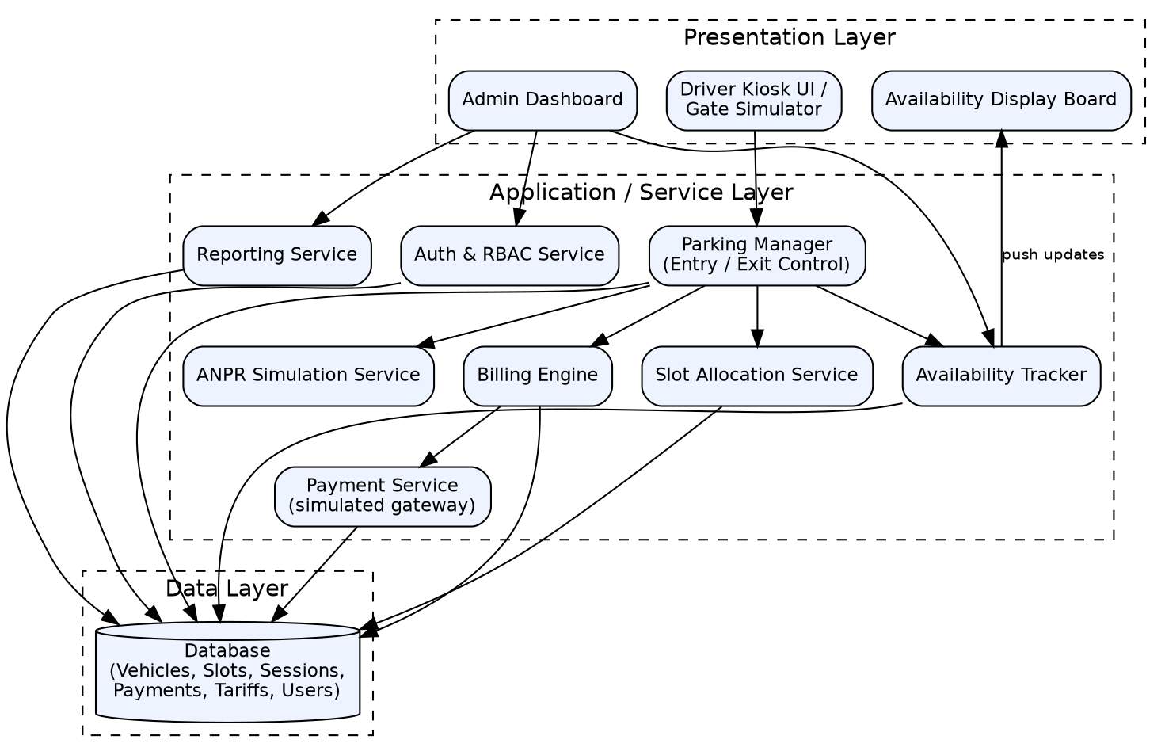
Figure 1: APMS component diagram (layered architecture)

3.4 Component descriptions
Component | Responsibility
Driver Kiosk UI / Gate Simulator | Driver-facing screens and simulated gate/camera input for entry and exit.
Admin Dashboard | Web UI for tariffs, zones, reports and live availability.
Availability Display Board | Shows live free-slot counts; receives push updates.
Parking Manager (Entry / Exit Control) | Orchestrates entry and exit flows, creates and closes sessions, enforces pay-before-exit and overrides.
ANPR Simulation Service | Returns plate number and confidence for an image/identifier; pluggable interface for a real engine.
Slot Allocation Service | Finds the nearest free slot of the right type and updates slot state atomically.
Availability Tracker | Maintains per-zone/type counts and publishes updates.
Billing Engine | Computes fees (grace period, slabs, daily cap) and builds receipts.
Payment Service (simulated gateway) | Executes payments via the simulated gateway, handles success/failure/timeout, records attempts.
Reporting Service | Revenue and occupancy reports with CSV export.
Auth & RBAC Service | Login, password hashing, role checks, lockout and session expiry; writes audit entries.
Database | Stores vehicles, slots, sessions, payments, tariffs, users and audit log.

3.5 Chosen architecture pattern and rationale
A layered architecture (Presentation, Service, Data) is used, deployed as a modular monolith: each service is a separate module with a defined interface, but all run in one deployable backend. This gives clear separation of concerns and easy testing while keeping deployment simple. Microservices were rejected as unnecessarily complex for the scale of this project and the team size; module boundaries keep the option open.
ADR | Decision | Rationale
ADR-001 | Layered modular monolith | Simple to build, test and deploy; clear boundaries; fits team size.
ADR-002 | ANPR behind an interface with a simulator and manual fallback | Real engine can replace the simulator without changing callers.
ADR-003 | Relational database with transactions | Slot allocation and payment need atomic, consistent updates.
ADR-004 | WebSocket (or SSE) push for availability, polling fallback | Meets the 2 s refresh requirement with low overhead.
ADR-005 | Token-based login with server-side RBAC | Simple, stateless, and enforceable on every API call.

3.6 Technology stack and data stores
Proposed stack (the team can change it; update ADRs if so):
Concern | Choice
Backend | Python 3 with FastAPI (REST + WebSocket)
Frontend | React (or server-rendered templates) for kiosk and dashboard
Database | PostgreSQL (SQLite acceptable for development)
ANPR simulation | Mock service driven by test images/inputs; optional OpenCV/OCR demo
Security libraries | bcrypt/Argon2 for hashing, JWT for tokens, HTTPS/TLS 1.2+
Testing | pytest, Postman, Selenium/Playwright, Locust, OWASP ZAP
Tooling | Git/GitHub, draw.io or PlantUML, Swagger/OpenAPI

3.7 Risks and mitigations
Risk | Mitigation
Two vehicles allocated the same slot under concurrent entry | Allocate and mark Occupied inside one database transaction with row locking; add concurrency tests.
ANPR simulation too optimistic | Confidence threshold with manual fallback; test with unreadable inputs.
Payment gateway timeout leaves session in unclear state | Idempotent payment requests keyed by session; status only set Paid on confirmed success; retry path.
Service failure at the gate | Health checks, graceful error messages, attendant override with audit.
Scope creep and limited time | Prioritise High requirements; keep extras in the Open Issues list.

3.8 Traceability to requirements
Requirement IDs | Area | Components
APMS-F-001 to APMS-F-003 | Vehicle Entry and Number Plate Recognition | Entry Gate Controller, ANPR Service, Parking Manager, Database
APMS-F-004 to APMS-F-006 | Slot Allocation and Availability Tracking | Slot Allocation Service, Database, Availability Tracker, Display Board
APMS-F-007 to APMS-F-009 | Vehicle Exit | Exit Gate Controller, ANPR Service, Parking Manager, Slot Allocation Service, Auth & RBAC
APMS-F-010 to APMS-F-011 | Billing and Tariff Configuration | Billing Engine, Admin Dashboard
APMS-F-012 to APMS-F-013 | Payment Processing | Payment Service, Billing Engine, Database
APMS-F-014 to APMS-F-015 | Reporting and Access Control | Reporting Service, Auth & RBAC Service
APMS-NF-001 to NF-007 | Non-functional requirements | All components; Availability Tracker and Parking Manager for performance; Database for retention
APMS-SR-001 to SR-007 | Security requirements | Auth & RBAC Service, API layer (TLS, validation), Database, audit log

3.9 Security architecture
Threat modelling uses STRIDE:
Threat | Example in APMS | Control
Spoofing | Stolen staff credentials; fake plate | Salted password hashing, lockout, token expiry; ANPR confidence check and manual verification
Tampering | Altering a fee, session or tariff | Server-side RBAC, parameterised queries, database constraints, append-only audit log
Repudiation | Attendant denies an override | Audit entry with user, reason and timestamp for every override
Information disclosure | Sniffing traffic; leaked card data | TLS 1.2+, no card data stored (masked reference only), no secrets in logs
Denial of service | Flooding the gate API | Rate limiting, request timeouts, input size limits, health checks
Elevation of privilege | Attendant calls admin API | Role checks on every endpoint, least-privilege database account

4. Design

4.1 Design overview
APMS is designed as layered modules with narrow interfaces. The Parking Manager orchestrates flows and calls the ANPR, Slot Allocation, Billing and Payment services. All state lives in the database; services remain stateless so they can be tested in isolation.

Key data entities
Entity | Main attributes
Vehicle | plate (PK), vehicle_type
Zone | zone_id (PK), name, vehicle_type
Slot | slot_id (PK), zone_id (FK), slot_type, distance_from_gate, status (FREE/OCCUPIED)
Session | session_id (PK), plate (FK), slot_id (FK), entry_time, exit_time, status (ACTIVE/PAID/CLOSED), fee, override_reason
Payment | payment_id (PK), session_id (FK), amount, mode, status, txn_ref, masked_ref, created_at
Tariff | vehicle_type (PK), grace_minutes, first_hour_fee, extra_hour_fee, daily_cap
User | user_id (PK), username, password_hash, role (ADMIN/ATTENDANT), failed_logins, locked_until
AuditLog | audit_id (PK), user_id, action, details, timestamp (append-only)

4.2 UML sequence diagrams
Two key flows are shown: vehicle entry and vehicle exit with payment.
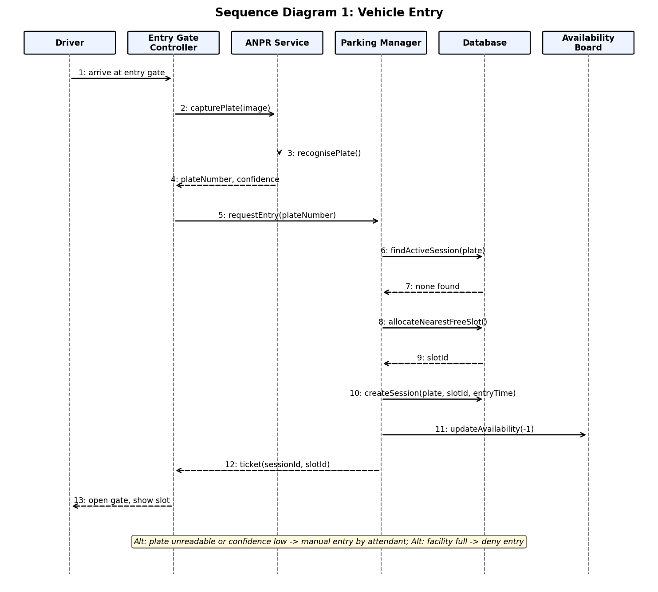
Figure 2: Sequence diagram - Vehicle entry

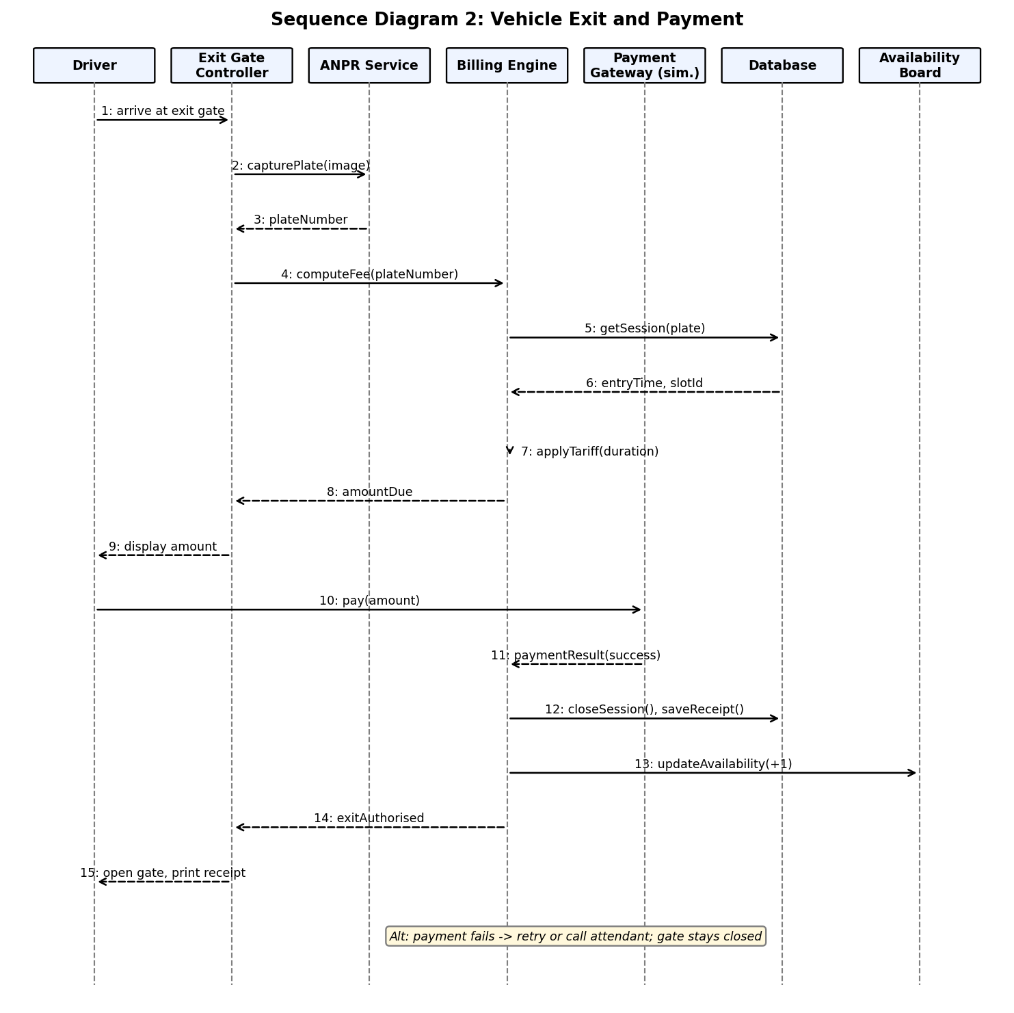
Figure 3: Sequence diagram - Vehicle exit and payment

4.3 API design
Interfaces are defined for the Parking Manager, Billing and Payment, and Availability components. All endpoints use JSON over HTTPS; protected endpoints need a bearer token. Errors use the format in section 4.4.

Parking Manager API
Endpoint | Method | Request | Response | Errors
/api/v1/entries | POST | {imageRef or plate, vehicleType} | 201 {sessionId, plate, slotId, entryTime, ticketNo} | 409 DUPLICATE_SESSION; 409 NO_SLOT_AVAILABLE; 422 INVALID_PLATE; 503 ANPR_UNAVAILABLE
/api/v1/exits | POST | {imageRef or plate} | 200 {sessionId, amountDue, status} | 404 SESSION_NOT_FOUND; 422 INVALID_PLATE
/api/v1/exits/{sessionId}/authorise | POST | (none) | 200 {gate: "OPEN", exitTime} | 402 PAYMENT_REQUIRED; 404 SESSION_NOT_FOUND
/api/v1/exits/{sessionId}/override | POST (Attendant) | {reason} | 200 {gate: "OPEN", auditId} | 401/403 NOT_AUTHORISED; 422 REASON_REQUIRED

Billing and Payment API
Endpoint | Method | Request | Response | Errors
/api/v1/sessions/{sessionId}/fee | GET | (none) | 200 {sessionId, durationMin, amountDue, breakdown} | 404 SESSION_NOT_FOUND
/api/v1/payments | POST | {sessionId, mode (CASH/CARD/UPI), amount} | 200 {paymentId, status, txnRef, receiptNo} | 402 PAYMENT_FAILED; 409 ALREADY_PAID; 422 AMOUNT_MISMATCH; 504 GATEWAY_TIMEOUT
/api/v1/receipts/{receiptNo} | GET | (none) | 200 {receipt fields} | 404 RECEIPT_NOT_FOUND

Availability and Administration API
Endpoint | Method | Request | Response | Errors
/api/v1/availability | GET | ?zone=optional | 200 {zone, byType: {type: {total, free}}, updatedAt} | 404 ZONE_NOT_FOUND
/ws/availability | WebSocket | subscribe | push {zone, byType, updatedAt} on every change | 401 NOT_AUTHORISED (if enabled)
/api/v1/auth/login | POST | {username, password} | 200 {token, role, expiresIn} | 401 INVALID_CREDENTIALS; 423 ACCOUNT_LOCKED
/api/v1/admin/tariffs/{vehicleType} | PUT (Admin) | {graceMinutes, firstHourFee, extraHourFee, dailyCap} | 200 {updated tariff} | 403 FORBIDDEN; 422 INVALID_TARIFF
/api/v1/reports/revenue | GET (Admin) | ?from&to&format=csv | 200 report data or CSV | 403 FORBIDDEN; 422 INVALID_RANGE

ANPR Service interface (simulated)
Endpoint | Method | Request | Response | Errors
/anpr/recognise | POST | {imageRef} | 200 {plate, confidence} | 503 ANPR_UNAVAILABLE; 422 UNREADABLE_IMAGE

4.4 Error handling, logging and monitoring
- Standard error format: {code, message, requestId}; messages are user-safe and never expose stack traces, SQL or personal data.
- Gate safety rule: on any unexpected error the gate stays closed and the attendant screen shows the failure so staff can use the override.
- Logging: structured logs with timestamp, requestId, component and level; no passwords, tokens or card data; audit log kept separately and append-only.
- Monitoring: health endpoint per service; metrics for entry/exit decision time, payment failure rate, availability update delay, error rate and uptime.
- Alerts (proposed): decision time above 3 s, payment failure spike, availability update delay above 2 s.

4.5 UX design
- Entry screen: plate detected, slot number and direction, ticket; clear "Parking full" message.
- Exit screen: plate detected, duration, fee breakdown, payment mode choice (cash/card/UPI), receipt; at most 4 screens.
- Attendant screen: manual plate entry, override with reason, live availability.
- Admin dashboard: live availability tiles, tariff and zone editor, revenue and occupancy reports.
- Accessibility: large fonts (16 pt or more), high-contrast mode, clear error messages and optional voice prompts.

4.6 Open issues and next steps
- Confirm the technology stack and record any change in the ADR table.
- Finalise the sample tariff and zone layout used as seed data.
- Decide how the ANPR simulator receives input (image upload, file name or typed plate).
- Future enhancements: real ANPR engine, mobile app and pre-booking, EV charging management, dynamic pricing, multi-facility support.

5. Appendices

5.1 Glossary
APMS, ANPR, RBAC, TLS, API, ADR, STRIDE, PCI-DSS, UPI, RTM.

5.2 References
- IEEE 42010 (Architecture description)
- OWASP Application Security Verification Standard and OWASP Top 10
- NIST SP 800-160 (Systems security engineering)
- APMS SRS v1.0 and APMS Test Plan v1.0

5.3 Tools
draw.io or PlantUML (UML), Swagger/OpenAPI (API documentation), Git/GitHub (version control).

