Software Requirements Specification (SRS)
Project: Automated Parking Management System
Project | Automated Parking Management System (APMS)
Version | 1.0
Authors | <Team name / Member names and SRNs>
Date | 26-10-2026
Status | Draft for initial submission

Revision History
Version | Date | Author | Change summary | Approval
1.0 | 26-10-2026 | <Team> | Initial SRS with embedded UML diagrams

Approvals
Role | Name | Signature / Email | Date
Course Coordinator
Project Guide / Instructor

Table of Contents
1. Introduction
2. Overall description
3. External interface requirements
4. System features (detailed)
5. Non-functional requirements (detailed)
5.1 Security (objectives and requirements)
6. Quality attributes and acceptance tests
7. System models and diagrams (UML use-case diagrams)
8. Requirements Traceability Matrix (RTM)

1. Introduction

1.1 Purpose
This document is the Software Requirements Specification (SRS) for the Automated Parking Management System (APMS). It defines the functional and non-functional requirements, security requirements, interfaces and verification criteria for a software simulation of a smart parking facility that manages vehicle entry and exit, slot allocation, payment processing and automated billing.

1.2 Scope
APMS covers: (a) vehicle entry and exit control with a simulated Automatic Number Plate Recognition (ANPR) service; (b) real-time tracking of parking slot availability; (c) slot allocation; (d) automated fee calculation and receipts; (e) simulated payment processing; and (f) an admin dashboard for configuration and reports. Real cameras, barrier hardware and real payment networks are out of scope; they are replaced by software simulators with well-defined interfaces so that they can be substituted later.

1.3 Audience
Developers, testers, the project guide and evaluators, and any future maintainers of the system.

1.4 Definitions, acronyms and abbreviations
Term | Meaning
APMS | Automated Parking Management System
ANPR | Automatic Number Plate Recognition (simulated in this project)
Session | A record of one vehicle stay, from entry to exit
Slot | A single parking space belonging to a zone and vehicle type
Zone | A group of slots (for example, Level 1 cars)
Tariff | The pricing rule used to compute the parking fee
RBAC | Role-Based Access Control
UPI | Unified Payments Interface (simulated)
RTM | Requirements Traceability Matrix
TLS | Transport Layer Security
AC | Acceptance Criteria

2. Overall description

2.1 Product perspective
APMS is a self-contained software system made of a driver-facing entry/exit kiosk simulator, an admin dashboard, a set of backend services (parking management, ANPR simulation, slot allocation, availability tracking, billing, payment, reporting, authentication) and a database. The ANPR camera, availability display board and payment gateway are external actors that are simulated in this project.

2.2 Major product functions
- Recognise vehicle number plates at entry and exit (simulated ANPR with manual fallback)
- Allocate parking slots by vehicle type and proximity to the gate
- Track and display real-time slot availability
- Create and close parking sessions
- Calculate parking fees automatically from duration and tariff
- Process simulated payments (cash, card, UPI) and issue receipts
- Let the admin configure tariffs, zones and slot counts
- Provide revenue and occupancy reports and role-based access

2.3 User roles and characteristics
Role | Characteristics and needs
Driver | General public, no training. Wants fast entry/exit, clear instructions and an accurate fee.
Attendant | On-site staff. Handles exceptions (lost ticket, ANPR failure) and monitors availability. Needs simple screens and limited privileges.
Parking Admin | Manager. Configures tariffs, zones and slot counts, and reviews reports.
ANPR Camera (simulated) | External actor that supplies a plate number and confidence score.
Payment Gateway (simulated) | External actor that returns success, failure or timeout for a payment request.
Availability Display Board | External actor that receives live availability counts.

2.4 Operating environment
Web-based application running on a standard laptop/desktop (Windows, Linux or macOS), accessed through a modern browser (Chrome, Edge or Firefox). Backend services and database run on a single development server or containers on the same machine.

2.5 Constraints
- Hardware (camera, barrier, display) and payment network are simulated, not real.
- ANPR is simulated; the interface must allow a real ANPR engine to be plugged in later.
- No real cardholder data is processed; all payment data is test data.
- The project must be completed within the semester timeline by a small student team.
- Only open-source tools and libraries are used.

2.6 Assumptions and dependencies
- Each vehicle has one readable number plate in a standard Indian format (for example KA01AB1234) in simulation inputs.
- Slot layout (zones, slot IDs, distance from the gate) is provided as seed data.
- System time is synchronised and trusted for billing.

3. External interface requirements

3.1 User interfaces
- Driver kiosk / gate simulator: large touch-friendly buttons, shows ticket, slot number, fee and payment options.
- Attendant screen: manual plate entry, override with reason and live availability.
- Admin dashboard: tariff and zone configuration, reports, live availability and audit entries.
- Availability display board: large counters per zone and vehicle type.
- Accessibility: high-contrast mode and minimum 16 pt kiosk text (see APMS-NF-005).

3.2 Hardware interfaces (simulated)
- Entry and exit cameras: replaced by an image/plate input simulator.
- Barrier gates: replaced by software open/close signals.
- Display board: replaced by a web page subscribed to availability updates.
- Receipt printer: replaced by an on-screen/PDF receipt.

3.3 Software interfaces
- ANPR Service API: input image or identifier, output plate number and confidence (JSON over HTTPS).
- Payment Gateway API (simulated): input amount, mode and session reference; output status (SUCCESS, FAILED, TIMEOUT) and transaction reference.
- Database: relational database accessed through parameterised queries.
- Reporting export: CSV files.

3.4 Communications
All client-server communication uses HTTPS with TLS 1.2 or higher. Availability updates are pushed to display clients using WebSocket or server-sent events, falling back to polling every 2 seconds.

4. System features (detailed)
Each requirement below includes acceptance criteria and a reference test case. Requirement IDs follow the pattern APMS-F-###. Priorities are High, Medium or Low. The project contains 15 functional requirements, 7 non-functional requirements, 4 security objectives and 7 security requirements.

4.1 Vehicle Entry and Number Plate Recognition
Description: Detect the arriving vehicle, obtain its plate through the ANPR simulation (with manual fallback), validate entry and create a parking session.
Req ID | Requirement (shall...) | Type | Priority | Source / Stakeholder | Acceptance criteria / Test case ref | Comments / Dependencies
APMS-F-001 | The system shall capture the vehicle at the entry gate, obtain the number plate and a confidence score from the ANPR simulation, and let an attendant enter the plate manually when confidence is below the configured threshold (default 80%) or recognition fails. | Functional | High | Operations | AC-F-001: Plate and confidence returned for at least 95% of valid test inputs; low confidence triggers manual entry and the entered plate is used. Test: TC-ENT-01 | ANPR Service
APMS-F-002 | The system shall deny entry and display a message when no slot of the vehicle type is free or when the plate already has an active session. | Functional | High | Business | AC-F-002: Gate stays closed, message shown, no session created. Test: TC-ENT-02 | F-004
APMS-F-003 | The system shall create a parking session (session ID, plate, vehicle type, slot, entry time) and issue a ticket on successful entry. | Functional | High | Business | AC-F-003: Exactly one session record with all fields is stored and the ticket is displayed. Test: TC-ENT-03 | F-001, F-004

4.2 Slot Allocation and Availability Tracking
Description: Assign suitable slots, keep slot state consistent and publish live availability.
Req ID | Requirement (shall...) | Type | Priority | Source / Stakeholder | Acceptance criteria / Test case ref | Comments / Dependencies
APMS-F-004 | The system shall allocate the free slot nearest to the entry gate that matches the vehicle type (two-wheeler, car, EV, accessible). | Functional | High | Operations | AC-F-004: Allocated slot type equals vehicle type and is the lowest-distance free slot. Test: TC-SLT-01 | Slot seed data
APMS-F-005 | The system shall mark a slot Occupied on entry and Free on exit as a single atomic update. | Functional | High | Operations | AC-F-005: In a concurrent-entry test no slot appears in two active sessions. Test: TC-SLT-02 | Database transactions
APMS-F-006 | The system shall maintain free-slot counts per zone and vehicle type, refresh them within 2 seconds of any slot change, and show identical counts on the entry display board and admin dashboard. | Functional | High | Business | AC-F-006: Counts update within 2 s in 100% of test events and board and dashboard match. Test: TC-SLT-03 | F-005

4.3 Vehicle Exit
Description: Identify the exiting vehicle, enforce payment before exit, and release the slot.
Req ID | Requirement (shall...) | Type | Priority | Source / Stakeholder | Acceptance criteria / Test case ref | Comments / Dependencies
APMS-F-007 | The system shall recognise the plate at the exit gate (ANPR simulation or manual entry) and retrieve the matching active session. | Functional | High | Operations | AC-F-007: The correct active session is retrieved for the recognised plate. Test: TC-EXT-01 | F-001
APMS-F-008 | The system shall authorise exit only when the fee is paid or zero, and then close the session, free the slot and update availability. | Functional | High | Business | AC-F-008: Gate opens only for Paid or zero-fee sessions; afterwards session is Closed, slot Free and count incremented. Test: TC-EXT-02 | F-010, F-013
APMS-F-009 | The system shall allow an authenticated attendant to override exit (lost ticket, ANPR failure) by entering a reason, and shall record the override in the audit log. | Functional | Medium | Operations | AC-F-009: Override requires attendant login and reason; an audit entry is created. Test: TC-EXT-03 | F-015

4.4 Billing and Tariff Configuration
Description: Calculate the parking fee from duration and tariff, and let the admin configure pricing and zones.
Req ID | Requirement (shall...) | Type | Priority | Source / Stakeholder | Acceptance criteria / Test case ref | Comments / Dependencies
APMS-F-010 | The system shall compute the fee from entry time, exit time, vehicle type and the configured tariff (free grace period, hourly slabs, daily cap). | Functional | High | Business | AC-F-010: Fee matches the tariff table for at least 10 boundary-value cases, including the grace period. Test: TC-BIL-01 | F-011
APMS-F-011 | The system shall let an admin configure tariffs, grace period, zones and slot counts per vehicle type. | Functional | High | Operations | AC-F-011: Changes take effect for new sessions without restart. Test: TC-BIL-02 | F-015

4.5 Payment Processing
Description: Collect payment through a simulated gateway and record the outcome.
Req ID | Requirement (shall...) | Type | Priority | Source / Stakeholder | Acceptance criteria / Test case ref | Comments / Dependencies
APMS-F-012 | The system shall support simulated payment by cash, card and UPI through a simulated gateway, and handle success, failure and timeout while allowing the driver to retry. | Functional | High | Business | AC-F-012: Each mode completes a simulated payment; failure or timeout keeps the gate closed and allows retry. Test: TC-PAY-01 | Simulated gateway
APMS-F-013 | The system shall record every payment attempt (session, amount, mode, status, transaction reference), mark the session Paid on success and generate a receipt with session ID, plate, times, duration, fee and payment mode. | Functional | High | Business | AC-F-013: One payment record per attempt; session becomes Paid only on success; receipt fields are complete and totals correct. Test: TC-PAY-02 | F-012

4.6 Reporting and Access Control
Description: Provide revenue and occupancy reports and control access by role.
Req ID | Requirement (shall...) | Type | Priority | Source / Stakeholder | Acceptance criteria / Test case ref | Comments / Dependencies
APMS-F-014 | The system shall generate daily and weekly revenue and occupancy reports with CSV export. | Functional | Medium | Business | AC-F-014: Report totals equal the sum of stored payments for the period. Test: TC-ADM-01 | F-013
APMS-F-015 | The system shall authenticate Admin and Attendant users by username and password and enforce role-based access. | Functional | High | Security | AC-F-015: Valid credentials grant only the permissions of the role. Test: TC-ADM-02 | Database

5. Non-functional requirements (detailed)
Non-functional requirements are measurable and tied to test cases. IDs follow the pattern APMS-NF-###.
Req ID | Requirement | Category | Priority | Acceptance criteria / Measurement
APMS-NF-001 | Time from plate capture to gate-open/deny decision shall be 3 seconds or less for 95% of vehicles under normal load. | Performance | High | 95th percentile <= 3 s in load test. Test: TC-PERF-01
APMS-NF-002 | Availability changes shall be visible on the board and dashboard within 2 seconds. | Performance | High | Maximum observed delay <= 2 s over 100 events. Test: TC-PERF-02
APMS-NF-003 | Core entry and exit services shall reach 99.5% availability during the test period, excluding planned maintenance. | Reliability | High | Uptime log shows >= 99.5%. Test: TC-REL-01
APMS-NF-004 | The system shall support at least 500 parking slots and 10 concurrent gate events without errors. | Scalability | Medium | No failed requests in the 10-concurrent-event test with 500 seeded slots. Test: TC-PERF-03
APMS-NF-005 | A driver shall complete exit and payment in at most 4 screens, with high-contrast text of at least 16 pt on the kiosk. | Usability | Medium | Usability walkthrough passes with 5 testers. Test: TC-UX-01
APMS-NF-006 | Business logic shall be modular and covered by unit tests with at least 70% line coverage. | Maintainability | Medium | Coverage report >= 70% on business-logic modules. Test: TC-MNT-01
APMS-NF-007 | Session and payment records shall be retained for at least 1 year and backed up daily. | Data retention | Medium | Backup job log and restore test succeed. Test: TC-OPS-01

5.1 Security

5.1.1 Security objectives
Objective | Description
SO-1 Confidentiality | Protect vehicle, user and payment data from unauthorised disclosure.
SO-2 Integrity | Ensure session, billing and payment records cannot be altered without authorisation or trace.
SO-3 Availability | Keep entry/exit and payment services resilient to misuse and overload.
SO-4 Accountability | Attribute every privileged action (login, override, tariff change) to a user.

5.1.2 Security requirements
Req ID | Requirement (shall...) | Objective | Priority | Acceptance criteria / Test case ref
APMS-SR-001 | All client-server traffic shall use TLS 1.2 or higher. | SO-1 | High | Plain HTTP is refused or redirected; TLS scan shows >= 1.2. Test: TC-SEC-01
APMS-SR-002 | Passwords shall be stored only as salted hashes (bcrypt or Argon2) and never logged. | SO-1 | High | Database and logs contain no plaintext passwords. Test: TC-SEC-02
APMS-SR-003 | Role-based access control shall be enforced on the server; attendants cannot reach tariff, user or report functions. | SO-1, SO-2 | High | Direct API calls by an attendant to admin endpoints return 403. Test: TC-SEC-03
APMS-SR-004 | An append-only audit log shall record logins, overrides, tariff changes and payment status changes with user and timestamp. | SO-2, SO-4 | High | Each listed action produces one audit entry that cannot be edited via the UI/API. Test: TC-SEC-04
APMS-SR-005 | Full card numbers, CVV and PINs shall never be stored; payment records keep only a masked reference or token. | SO-1 | High | Database inspection shows only masked values (e.g. last four digits). Test: TC-SEC-05
APMS-SR-006 | All inputs (plate, amounts, dates, search filters) shall be validated and database access shall use parameterised queries. | SO-2, SO-3 | High | SQL-injection and malformed-input tests are rejected without errors or data leakage. Test: TC-SEC-06
APMS-SR-007 | User sessions shall expire after 15 minutes of inactivity and an account shall lock for 5 minutes after 5 failed logins. | SO-3, SO-4 | Medium | Session expiry and lockout occur as specified. Test: TC-SEC-07

6. Quality attributes and acceptance tests
- Exit criteria for acceptance: all High-priority functional requirements are implemented and verified, no critical NFR or security test fails, and the RTM shows all mapped test cases passed.
- Acceptance test suites: Entry, Slot Management, Exit, Billing, Payment, Administration, Performance, Reliability, Usability and Security.
- Quality attributes emphasised: correctness of billing, consistency of slot state, responsiveness of entry/exit, and security of staff access and payment data.

7. System models and diagrams

7.1 UML use-case diagrams
Two use-case diagrams are provided. Diagram 1 covers the driver-facing journey (entry, availability, exit and payment). Diagram 2 covers administration, monitoring and exception handling.
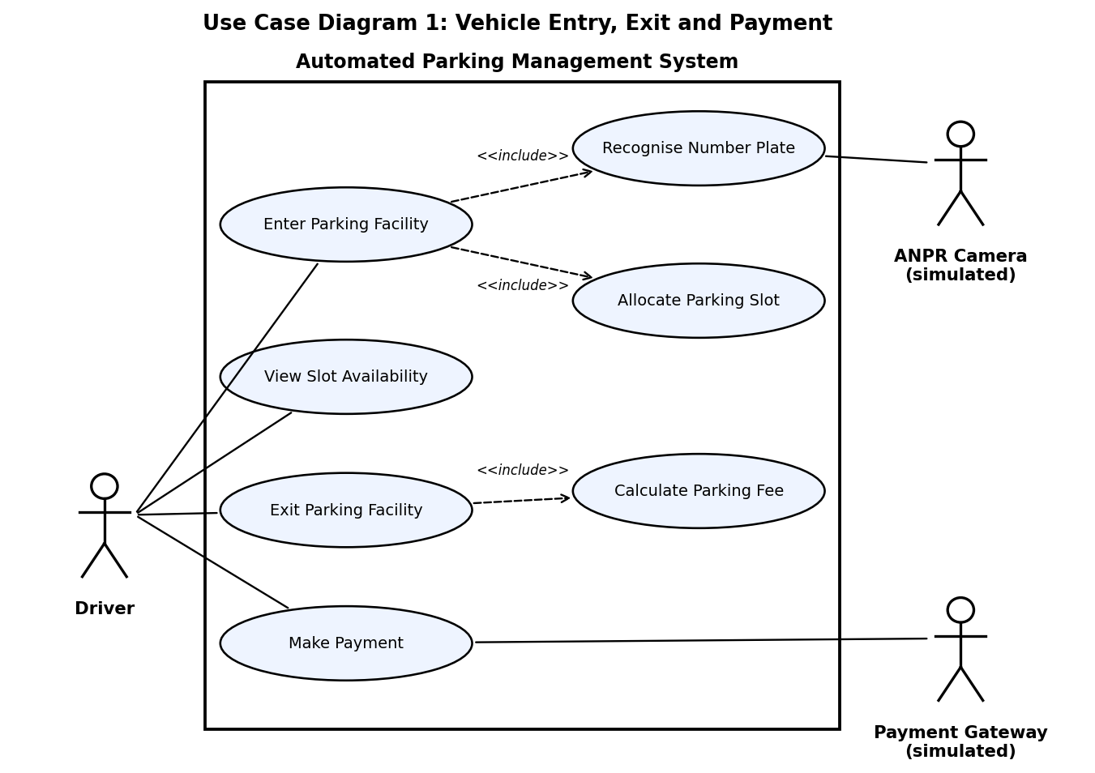
Figure 1: Use Case Diagram 1 - Vehicle Entry, Exit and Payment

Use case summary (Diagram 1)
Use case | Primary actor | Summary
Enter Parking Facility | Driver | Driver arrives; system recognises the plate, allocates a slot and opens the gate. Includes Recognise Number Plate and Allocate Parking Slot.
Recognise Number Plate | ANPR Camera (simulated) | Returns plate and confidence; low confidence triggers manual entry.
View Slot Availability | Driver | Driver sees free slots per zone before or at entry.
Exit Parking Facility | Driver | System identifies the session, computes the fee (Calculate Parking Fee) and requires payment before opening the gate.
Make Payment | Driver, Payment Gateway | Driver selects cash, card or UPI; gateway returns the result; receipt is issued.

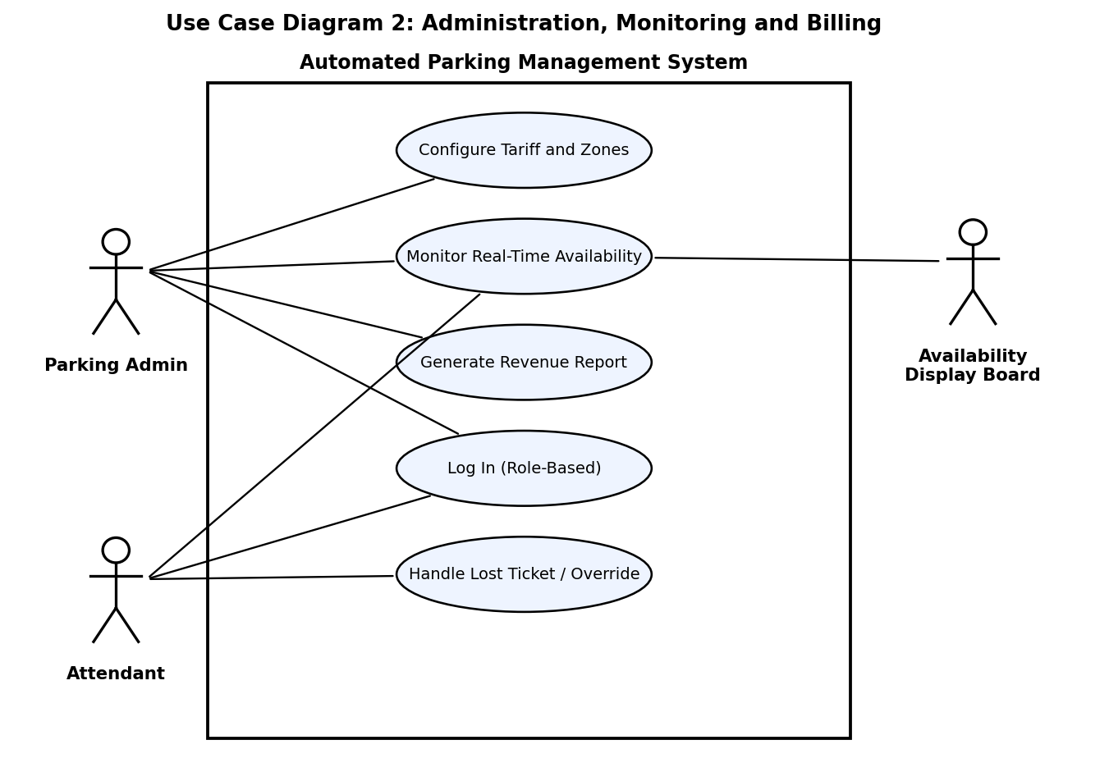
Figure 2: Use Case Diagram 2 - Administration, Monitoring and Billing

Use case summary (Diagram 2)
Use case | Primary actor | Summary
Log In (Role-Based) | Admin, Attendant | Authenticate and receive role-specific permissions.
Configure Tariff and Zones | Parking Admin | Maintain tariff slabs, grace period, zones and slot counts.
Monitor Real-Time Availability | Admin, Attendant, Display Board | View live counts per zone and vehicle type.
Generate Revenue Report | Parking Admin | Produce daily/weekly revenue and occupancy reports with CSV export.
Handle Lost Ticket / Override | Attendant | Authorise exit after an exception, with reason and audit entry.

8. Requirements Traceability Matrix (RTM)
Status: N = Not started, P = In progress, A = Achieved/verified. Module names match the component diagram in the Software Architecture and Design document.
Req ID | Requirement short | Section ref / Design spec | Module | Test case(s) | Status (N/P/A)
APMS-F-001 | Plate capture with manual fallback | 4.1 / DS-F001 | Entry Gate Controller, ANPR Service | TC-ENT-01 | N
APMS-F-002 | Deny entry (full / duplicate) | 4.1 / DS-F002 | Parking Manager | TC-ENT-02 | N
APMS-F-003 | Create session and ticket | 4.1 / DS-F003 | Parking Manager, Database | TC-ENT-03 | N
APMS-F-004 | Allocate nearest matching slot | 4.2 / DS-F004 | Slot Allocation Service | TC-SLT-01 | N
APMS-F-005 | Atomic slot state update | 4.2 / DS-F005 | Slot Allocation Service, Database | TC-SLT-02 | N
APMS-F-006 | Real-time availability and display | 4.2 / DS-F006 | Availability Tracker, Display Board | TC-SLT-03 | N
APMS-F-007 | Recognise plate at exit | 4.3 / DS-F007 | Exit Gate Controller, ANPR Service | TC-EXT-01 | N
APMS-F-008 | Pay before exit; close session | 4.3 / DS-F008 | Parking Manager, Slot Allocation Service | TC-EXT-02 | N
APMS-F-009 | Attendant override with audit | 4.3 / DS-F009 | Parking Manager, Auth & RBAC | TC-EXT-03 | N
APMS-F-010 | Compute parking fee | 4.4 / DS-F010 | Billing Engine | TC-BIL-01 | N
APMS-F-011 | Configure tariff, zones, slots | 4.4 / DS-F011 | Admin Dashboard, Billing Engine | TC-BIL-02 | N
APMS-F-012 | Simulated payment and gateway outcomes | 4.5 / DS-F012 | Payment Service | TC-PAY-01 | N
APMS-F-013 | Record payment and issue receipt | 4.5 / DS-F013 | Payment Service, Billing Engine, Database | TC-PAY-02 | N
APMS-F-014 | Revenue and occupancy reports | 4.6 / DS-F014 | Reporting Service | TC-ADM-01 | N
APMS-F-015 | Login with roles | 4.6 / DS-F015 | Auth & RBAC Service | TC-ADM-02 | N
APMS-NF-001 | Entry decision time | 5 / DS-NF001 | Entry/Exit flow | TC-PERF-01 | N
APMS-NF-002 | Availability refresh time | 5 / DS-NF002 | Availability Tracker | TC-PERF-02 | N
APMS-NF-003 | Service availability | 5 / DS-NF003 | Core services | TC-REL-01 | N
APMS-NF-004 | Capacity | 5 / DS-NF004 | All services | TC-PERF-03 | N
APMS-NF-005 | Simple, readable UI | 5 / DS-NF005 | Kiosk UI | TC-UX-01 | N
APMS-NF-006 | Modularity and tests | 5 / DS-NF006 | Codebase | TC-MNT-01 | N
APMS-NF-007 | Retention and backup | 5 / DS-NF007 | Database | TC-OPS-01 | N
APMS-SR-001 | TLS for all traffic | 5.1.2 / DS-SR001 | Security controls | TC-SEC-01 | N
APMS-SR-002 | Salted password hashing | 5.1.2 / DS-SR002 | Security controls | TC-SEC-02 | N
APMS-SR-003 | Server-side RBAC | 5.1.2 / DS-SR003 | Security controls | TC-SEC-03 | N
APMS-SR-004 | Append-only audit log | 5.1.2 / DS-SR004 | Security controls | TC-SEC-04 | N
APMS-SR-005 | No card data stored | 5.1.2 / DS-SR005 | Security controls | TC-SEC-05 | N
APMS-SR-006 | Input validation, safe queries | 5.1.2 / DS-SR006 | Security controls | TC-SEC-06 | N
APMS-SR-007 | Session timeout and lockout | 5.1.2 / DS-SR007 | Security controls | TC-SEC-07 | N

