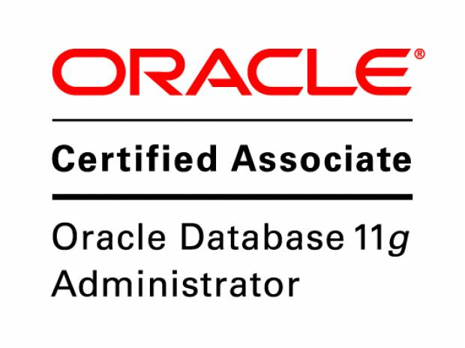

**RESUME**

**M Naveen Kumar** E- Mail: naveen.murukuri[@gmail.com](mailto:vramakrishnareddy.s@gmail.com)

**Linux System Administrator** Phone No: +91-9866367218

**Objective**

Seeking a position to utilize my skills and abilities in the field of System Administration that offers Professional Growth and satisfaction.

**Professional Experience**

September 2012 to till date

Job title: Linux Administrator

Duration: September 2012 till date

Organization: will way solutions (P) Ltd Bangalore.

**Job profile**

* Installation, Configuration and Administration of RedHat 5 & 6.
* User and Group management, Securities and System Policy Administration.
* Installation, Configuration and Maintenance of LVM.
* Configuration of FTP and SSH protocols.
* Installation and Configuration of NFS for servers and clients.
* Installation and Configuration of Samba Servers.
* Installing, Configuring and trouble shooting of Web Servers.
* Hands on experience in Package Management like RPM, YUM.
* Backup and Restore Management TSM.
* Configuring TSM and scheduling a backup.
* Troubleshooting server down issues and other server related issues.
* System monitoring CPU, Disk, Memory utilization etc.
* Daily Server monitoring & health checking and log file analysis.
* Proactively monitored, administered 1000 + LINUX servers remotely and taken initiatives to solve issues (L1 & L2) against the challenges and documented WI's.
* Adding CPU, Memory and harddisk in VM machine.
* Creating and deletion of VMware machines and troubleshooting.

**Academic Qualifications:**

* BTech in CSE from VNR VJIET Hyderabad.

**Redhat Linux Skills:**

* Installing and configuring Redhat.
* Quota configuration for Users and Groups.
* Server monitoring using various tools like top, ps, vmstat, free etc
* Installing and configuring SAMBA and sharing files from Linux to windows.
* File system management using fdisk, mkfs, fsck, mount etc.
* File compression using zip, gzip and tar.
* Setting up LAN connectivity between server and client.
* Troubleshooting Linux operating system with rescue mode and single usermode.
* Reviewing System log file for errors.
* Monitored Linux server for CPU Utilization and Disk Utilization for performance monitoring.
* Performed day-to-day troubleshooting for the end users on Linux based applications.
* Backup and Restore data in Linux.
* Configuration of NFS and FTP Server and maintaining the shared folders in the organization.
* Package management using RPM and YUM. Installation of packages and checking the integrity of packages.
* Handling, attending and resolving the issues raised by users.
* Managing user accounts, groups and quotas.
* Monitoring the server’s performance, File System usage in Linux.
* File system management using File/directory permissions, ownership and ACLs.
* Scheduling jobs using at and crontab.

**Technical Skills:**

* Server Operating Systems :Redhat Linux 5/6,Ubuntu Linux.
* Client Operating System :Windows7, Windows8
* Database :Oracle 10g/11g
* Scripting languages :SQL , Shell Scripting(Bash).
* Certification :Oracle Certified Associate (OCA-OC1352152)

**Personal Details:**

Name : M Naveen Kumar

Father’s Name : M Komuraiah

Date of Birth : 13th Oct 1989

Sex : Male

Nationality : Indian

Marital status : Unmarried.

Mother tongue : Telugu

Languages Known : Telugu, English and Hindi.