1. Creating basic Employee data Angular JS application with Spring Boot and Mongo Database.
2. User interface is creating using angular JS.
   1. Creation of Employee Record
   2. Clear Employee data which is entered in form
   3. Edit employee data
   4. Delete employee data
   5. Load all employees’ data available.
3. I am Using Spring Boot application to run the application with default Server Tomcat.
4. Defined required dependencies in pom.xml
5. I am using maven to build the application.
6. index.html file for User Interface(Angular JS)
7. main.js file to define the angular module and controller
8. Defined the rest controller to handle the submitted Requests.
9. Defined Service class to handle the business logic. This service class is injected using @autoWired Spring Annotation for dependency.
10. Defined a repository class to handle the DAO logic.
11. Below is the User Interface form

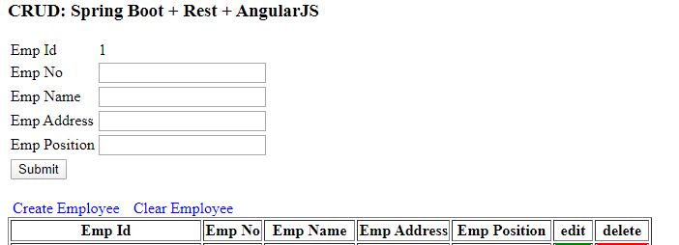

1. Load All employees available data form

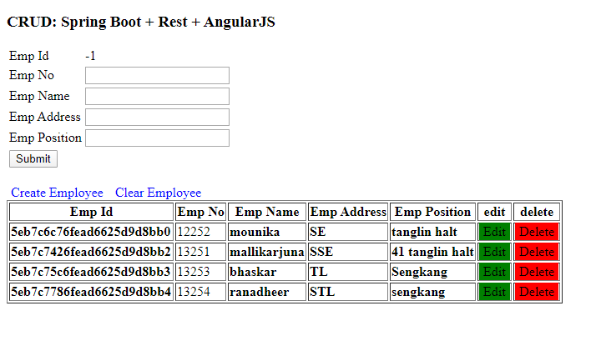

1. Edit Employee data Screen.

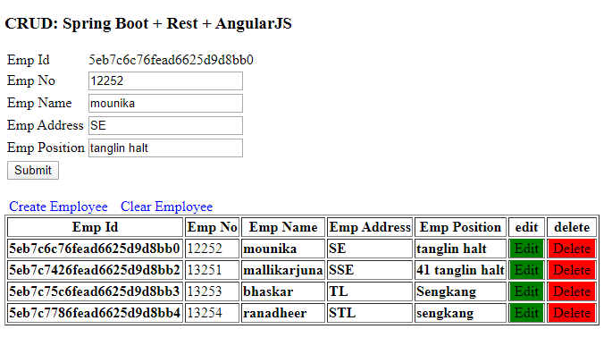

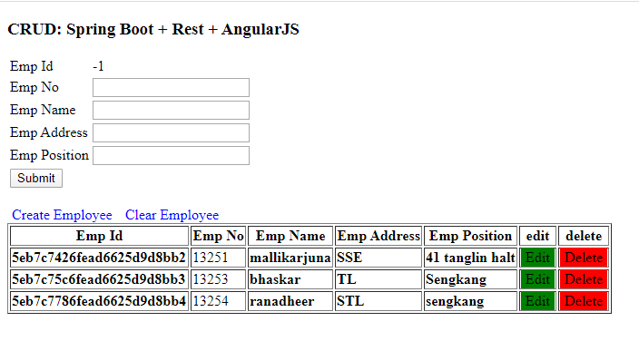

1. Below is the sample Employee data which is entered and saved in Mongo database.

