External tables allow Oracle to query data that is stored outside the database in flat files. The ORACLE_LOADER driver can be used to access any data stored in any format that can be loaded by SQL*Loader. No DML can be performed on external tables but they can be used for query, join and sort operations.

External tables are used when we need to just generate report and after sending report to client ,data is not required .

Sent to client

Generate reports

External table

Data File

External table uses oracle loader to load data to external table.

Loading of data is minimized compared to sqlloader and creation of control file s saved.

First directory needs to be created .

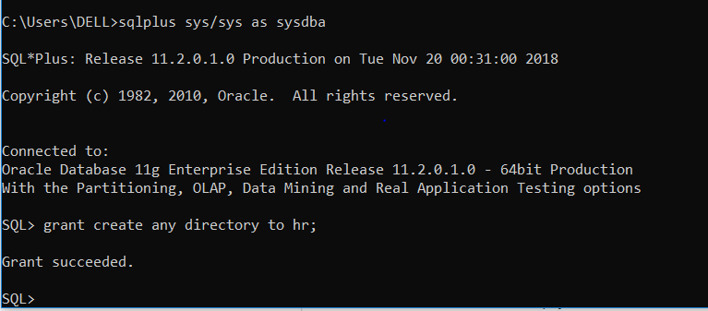

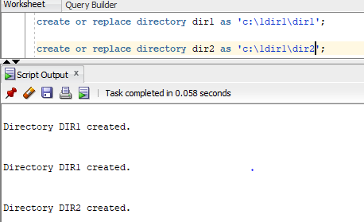

Need to create folder locally as well.

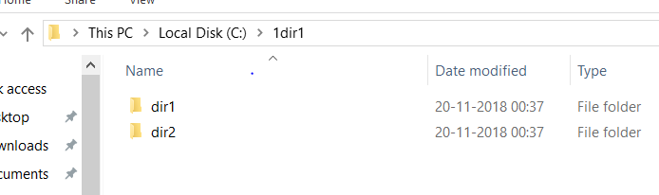

Creating table

create table emp_Ext

(eno number,

ename varchar2(30),

sal number,

comm number)

organization external

(default directory dir1

access parameters (records delimited by ':'

fields terminated by ','

)

location('abc.txt')

);

Important parameters

Directory

Access parameters

Location

If file is not exists table creation will not fail.

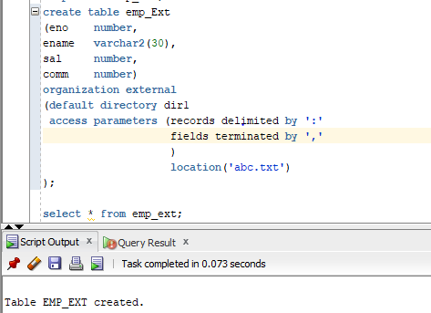

Since data file is not present .. if we try to access table we will get below error.

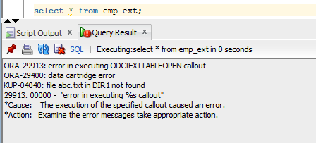

And in the directory path log file will be created with error

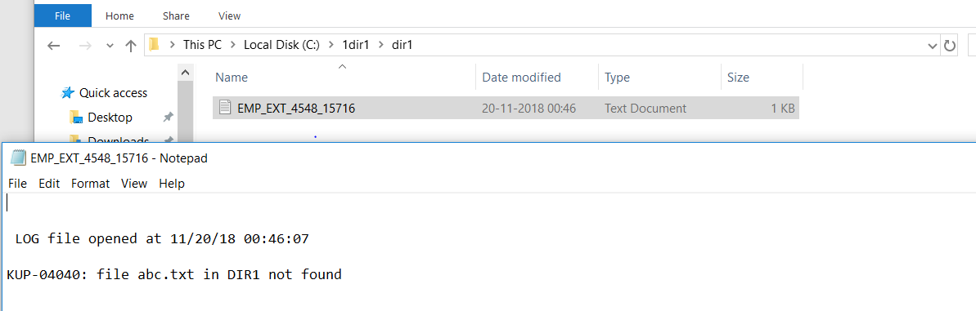

Now we will just place the file with no data .. it will not display any records but load will be successful

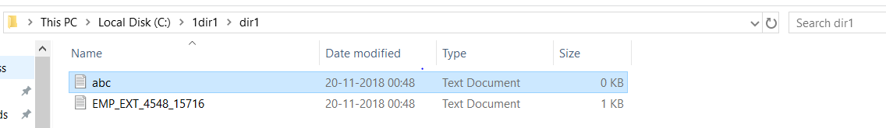

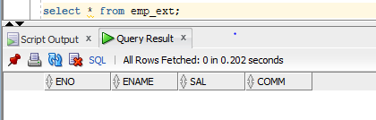

We will place data in data file and check data by quering data

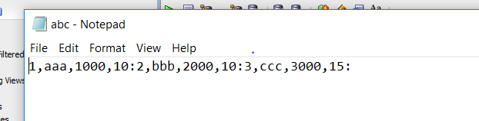

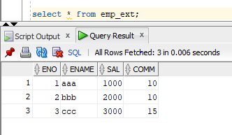

We will modify data file to see rejection and generation of bad file. Adding two ,, instead of one ,

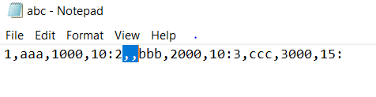

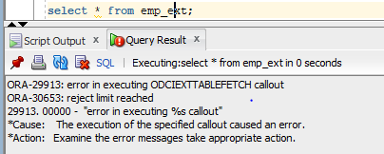

Bad file will be generated in same path

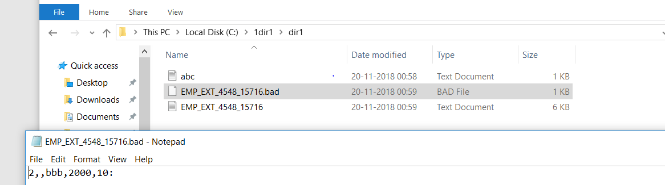

We can perform all below commands on external tables.

Where calues

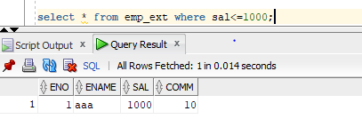

Group function

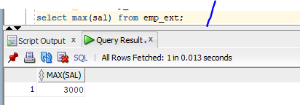

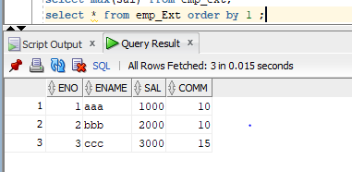

We cannot perform DML operations on external tables.

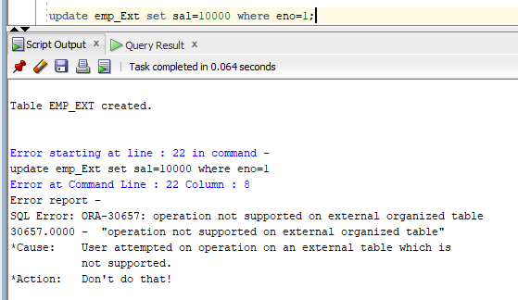

Now we can specify the reject limit, it can reject max 2 records

create table emp_Ext1

(eno number,

ename varchar2(30),

sal number,

comm number)

organization external

(default directory dir1

access parameters (records delimited by ':'

fields terminated by ','

)

location('abc1.txt')

) **reject limit 2**;

We can specify the dir in file loction as well

create table emp_Ext1

(eno number,

ename varchar2(30),

sal number,

comm number)

organization external

(default directory dir1

access parameters (records delimited by ':'

fields terminated by ','

)

location(**dir2**:'abc1.txt')

) **reject limit 2**;

Reading more than 1 file from same table.

create table emp_Ext2

(eno number,

ename varchar2(30),

sal number,

comm number)

organization external

(default directory dir1

access parameters (records delimited by ':'

fields terminated by ','

)

**location('abc1.txt','abc3.txt')**

) reject limit unlimited;

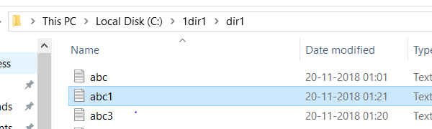

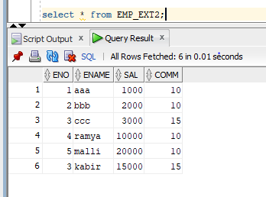

We can access 2 files from different directory

create table emp_Ext2

(eno number,

ename varchar2(30),

sal number,

comm number)

organization external

(default directory dir1

access parameters (records delimited by ':'

fields terminated by ','

)

**location(dir1:'abc1.txt',dir2:'abc3.txt')**

) reject limit unlimited;

We can use skip command to skip number of lines.usually used to skip header.

create table emp_Ext2

(eno number,

ename varchar2(30),

sal number,

comm number)

organization external

(default directory dir1

access parameters (records delimited by newline

**skip 1**

fields terminated by ','

)

location(dir1:'abc1.txt',dir2:'abc3.txt')

) reject limit unlimited;

**We cannot perform below commands on ET.**

Truncate

Comment

Update

Delete

Insert

Merge

**We can perform**

Alter

Drop

Flashback

Purge

Rename

**We cannot define constraint on any columns**

Default

Not null

Check

Unique

Primary key

Foreign key

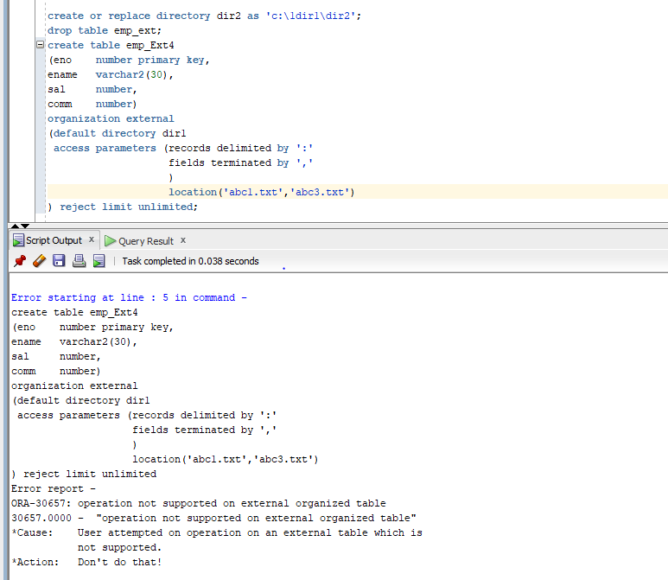

**We cannot create index on ET.**

We can create view on ET

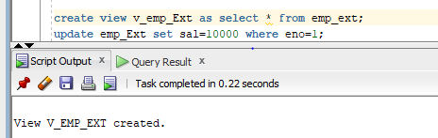

Now writing data from external table to file.

create table emp_Ext_Datadump

organization external

(**type oracle_datapump**

default directory dir1

location('xyz.dmp')

)

as select * from emp_Ext;

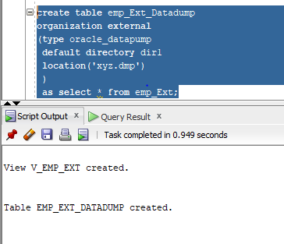

Dump file will be created during table creation only.

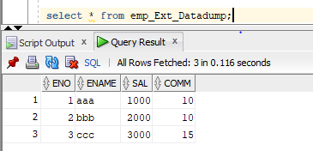

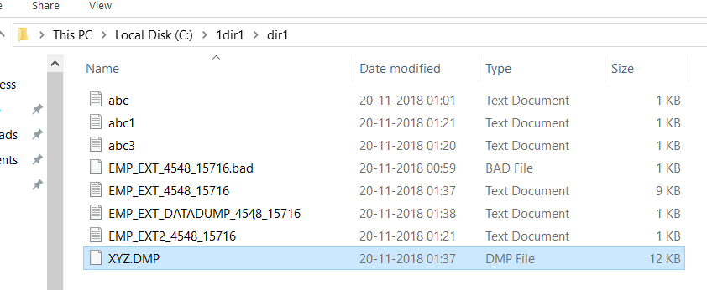

We can create ET for data file using normal table as well

create table emp_Ext_Datadump1

organization external

(type oracle_datapump

default directory dir1

location('xyz1.dmp')

)

**as select * from employees;**

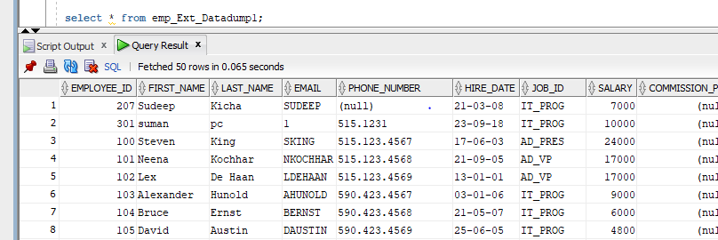

Data dictionary to view ET details

user_External_Tables

USER_EXTERNAL_LOCATIONS

