**DBMS_CHANGE_NOTIFICATION**

The DBMS_CHANGE_NOTIFICATION package is part of the database change notification feature that provides the functionality to create registration on queries designated by a client application and so to receive notifications in response to DML or DDL changes on the objects associated with the queries. The notifications are published by the database when the DML or DDL transaction commits.

The DBMS_CHANGE_NOTIFICATION package provides PL/SQL based registration interfaces. A client can use this interface to create registrations on queries based on objects of interest and specify a PL/SQL call back handler to receive notifications.

When a registration is created through the PL/SQL interface, a unique registration ID is assigned to the registration by the RDBMS. The client application can use the registration ID to keep track of registrations created by it. When a notification is published by the RDBMS, the registration ID will be part of the notification.

The DBMS_CHANGE_NOTIFICATION package requires that the user have the CHANGE NOTIFICATION system privilege to receive notifications and be granted EXECUTE privilege on the DBMS_CHANGE_NOTIFICATION package.

**The DBMS_CHANGE_NOTIFICATION package uses the following OBJECT types**

SYS.CHNF$_DESC Object Type

**Syntax**

TYPE SYS.CHNF$_DESC IS OBJECT(

registration_id NUMBER,

transaction_id RAW(8),

dbname VARCHAR2(30),

event_type NUMBER,

numtables NUMBER,

table_desc_array CHNF$_TDESC_ARRAY)

|  |  |
| --- | --- |
| Qosflags | Table level operation flags. This is a flag field (bit-vector) which describes the operations that occurred on the table. It can be an OR of the following bit fields - INSERTOP, UPDATEOP, DELETEOP, DROPOP, ALTEROP, ALL_ROWS. If the ALL_ROWS (0x1) bit is set it means that either the entire table is modified (for example, DELETE * FROM t) or row level granularity of information is not requested or not available in the notification and the receiver must conservatively assume that the entire table has been invalidated. |

**QOS_RELIABLE** - Reliable or persistent notification. Also implies that the notifications will be inserted into the persistent storage atomically with the committing transaction that results in an object change.

create or replace procedure tables_Changed_chnt(ntfnds IN sys.chnf$_desc)

is

l_regid NUMBER;

l_table_name VARCHAR2(60);

l_Even_type NUMBER;

l_numtables NUMBER;

l_operation_types NUMBER;

l_numrows NUMBER;

l_row_id VARCHAR2(20);

l_operation VARCHAR2(20);

l_message VARCHAR2(4000);

begin

l_regid:=ntfnds.registration_id;

l_numtables:=ntfnds.numtables;

l_Even_type:=ntfnds.Event_type;

if l_Even_type=dbms_change_notification.event_objchange then

for i in 1 .. l_numtables loop

l_table_name:=ntfnds.table_desc_array(i).table_name;

l_operation_types:=ntfnds.table_desc_array(i).Opflags;

If (bitand(l_operation_types,dbms_change_notification.all_rows)=0) then

l_numrows:=ntfnds.table_desc_array(i).numrows;

else

l_numrows:=0;

end if;

l_row_id := ntfnds.table_desc_array(i).row_desc_array(i).row_id;

case when BITAND(l_operation_types,dbms_change_notification.INSERTOP)!=0 then

l_operation:='records inserted';

when BITAND(l_operation_types,dbms_change_notification.updateop)!=0 then

l_operation:='records updated';

when BITAND(l_operation_types,dbms_change_notification.deleteop)!=0 then

l_operation:='records deleted';

when BITAND(l_operation_types,dbms_change_notification.alterop)!=0 then

l_operation:='table altered';

when BITAND(l_operation_types,dbms_change_notification.dropop)!=0 then

l_operation:='table droped';

when BITAND(l_operation_types,dbms_change_notification.insertop)!=0 then

l_operation:='unkown operation';

else

l_operation:='?';

end case;

l_message:='Table('||l_table_name||')-'||l_operation||'.Rows='||l_numrows;

insert into notifications(id,message,notification_date)

values(notification_seq.nextval,l_message,sysdate);

commit;

end loop;

end if;

end;

/

DECLARE

l_regds SYS.CHNF$_REG_INFO;

l_regid NUMBER;

l_qosflags NUMBER;

l_id emp.empno%TYPE;

begin

l_qosflags:=dbms_change_notification.QOS_RELIABLE+dbms_change_notification.QOS_ROWIDS;

l_regds:=SYS.CHNF$_REG_INFO('tables_changed_chnt',l_qosflags,0,0,0);

l_regid:=DBMS_CHANGE_NOTIFICATION.new_reg_Start(l_regds);

select empno into l_id from emp where rownum=1;

dbms_change_notification.reg_end;

end;

/

**NEW_REG_START** Function

This procedure begins a new registration block. Any objects referenced by queries executed within the registration block are considered interesting objects and added to the registration. The registration block ends upon calling the REG_END procedure.

**Syntax**

DBMS_CHANGE_NOTIFICATION.NEW_REG_START (

regds IN sys.chnf$_reg_info)

RETURN NUMBER;

### REG_END Procedure

This procedure marks the end of the registration block. No newly executed queries are tracked.

**Syntax**

DBMS_CHANGE_NOTIFICATION.REG_END;

select * from notifications;

select * from user_change_notification_regs;

table created for storing information

Below operations are performed

alter table emp modify (ename varchar2(20));

select * from emp;

insert into emp1 values(7938,'TEST2','TESTING2',7782,sysdate-30,1100,null,20);

commit;

select * from notifications;

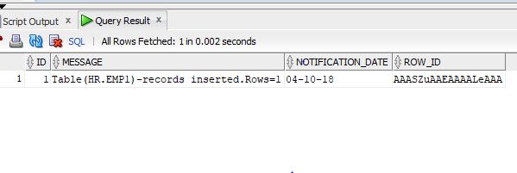

We can see same rowed inserted into table;

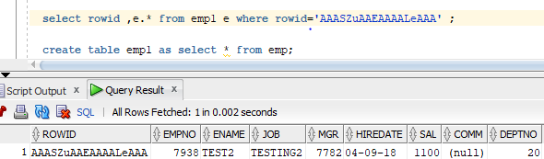

update emp1 set sal=3500 where empno=7936;

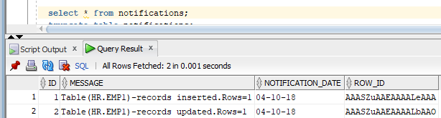

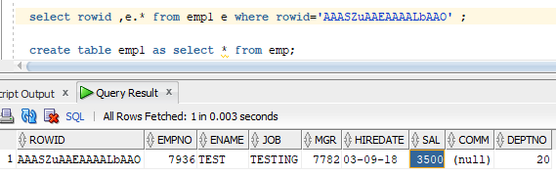

delete from emp where empno=7938;

