PROJECT

REPORT ON

**PERSONAL FINANCE TRACKER SYSTEM**



**CCL**

**A MINI RATNA COMPANY**

**SUBMITTED BY:**

**NAME: SHREYA MALLIK**

**ROLL NO.: 2228062**

**DEPARTMENT: SCHOOL OF COMPUTER ENGINEERING**

**SESSION: 2022-2026**

**COLLEGE: KALINGA INSTITUTE OF**

**INDUSTRIAL TECHNOLOGY**

**BHUBANESWAR**

**TRAINING CONDUCTED AT**

**CENTRAL COALFIELDS LIMITED**

**(SYSTEM DEPARTMENT)**

**DURATION:6 WEEKS**

**CERTIFICATE**

This is to certify that the project on PERSONAL FINANCE TRACKER SYSTEM has been submitted by SHREYA MALLIK, ROLL NO. 2228062 from KALINGA INSTITUTE OF INDUSTRIAL TECHNOLOGY, BHUBANESWAR, ODISHA. Training period was from 15.05.2025 to 30.06.2025.

(GM/HRD)

**CCL,HQ**

Ranchi

Guided By:-

**Dr. Karishma Varshney**

AM(System)

CCL,HQ

Ranchi

**ACKNOWLEDGEMENT**

In the accomplishment of completion of my project on Personal Finance Tracker System, I would like to convey my special gratitude to Dr. Karishma Varshney, Asst. Manager (system) and as well as our teachers of Kalinga Institute Of Industrial Technology for allowing me the opportunity to do this project.

I am especially thankful to the Systems Department and HRD Department for their continuous support, guidance, and encouragement throughout the development of this project

I also extend my heartfelt thanks to all mentors and staff at CCL who provided their time and expertise during the internship. This project has not only enhanced my technical skills but also improved my understanding of how IT systems function in a large-scale organizational setup.

Your valuable guidance and suggestions helped me in various phases of the completion of this project. I will always be thankful to you in this regard.

I am ensuring that this project was finished by me and not copied.

**DECLARATION**

I hereby declare that the project work titled "Personal Finance Tracker System" is genuine research work undertaken by me under the guidance of Dr. Karishma Varshney. The report is being submitted in partial fulfillment of BACHELOR OF TECHNOLOGY (COMPUTER SCIENCE AND SYSTEM ENGINEERING) from Kalinga Institute of Industrial Technology, Bhubaneswar.

Shreya Mallik

**ABOUT THE COMPANY**

**Central Coalfields Limited** is a Category-I **Mini-Ratna Company** since October 2007.

During 2023-24, coal production of the company reached its highest-ever figure of 86.054 million tones. Formed on **1st November 1975**, CCL (formerly National Coal Development Corporation Ltd) was one of the five subsidiaries of Coal India Ltd. which was the first holding company for coal in the country (CIL now has 8 subsidiaries). During 2023-24, coal production of the company reached its highest-ever figure of 86.054 million tones. Formed on 1st November 1975, CCL (formerly National Coal Development Corporation Ltd) was one of the five subsidiaries of Coal India Ltd. which was the first holding company for coal in the country (CIL now has 8 şubsidiaries).

**Central Coalfields Limited (CCL)** is a **subsidiary of Coal India Limited (CIL)**, which operates under the **Ministry of Coal**, Government of India. It was established in **1975** following the nationalization of coal mines in India. Headquartered in **Ranchi, Jharkhand**, CCL is one of the major coal-producing companies in the country.

CCL operates across various districts in **Jharkhand,** including **Ranchi, Hazaribagh, Bokaro, Dhanbad,** and **Chatra**. The company is engaged in the production and supply of non- coking coal to various sectors such as power generation, steel manufacturing, cement production, and other industrial uses.

With a strong focus on safety, environmental sustainability, and technological advancement, CCL has contributed significantly to meeting India's energy demands. The company emphasizes community development, skill development, healthcare, and education through its CSR initiatives.

**ABSTRACT**

This report presents the design and implementation of a **Personal Finance Tracker System**, a dynamic web-based application developed to help users efficiently manage and analyze their financial activities. The system allows users to securely upload bank statements in PDF or Excel format, from which transactions are automatically extracted, parsed, and intelligently categorized using rule-based and heuristic methods. It then visualizes key financial metrics—such as income, expenses, savings trends, and category-wise spending—through interactive charts and summary reports. Built using the MERN (MongoDB, Express.js, React, Node.js) stack, the application ensures responsive design, robust user authentication, and scalable data handling. The ultimate goal is to enable users to gain deeper insights into their financial habits, improve budgeting practices, track long-term goals, and make more informed financial decisions with confidence and ease.

**TABLE OF CONTENTS**

|  |  |  |
| --- | --- | --- |
| Sr.no. | Content | Page-no. |
| 01 | Main Page | 01-02 |
| 02 | Certificate | 03 |
| 03 | Acknowledgement | 04 |
| 04 | Decalartion | 05 |
| 05 | About the Company | 06 |
| 06 | Abstract | 07 |
| 07 | Table of Contents | 08 |
| 08 | About the Project | 09-12 |
| 09 | Result | 13-22 |
| 10 | Conclusion | 23 |
| 11 | References | 24 |

**ABOUT THE PROJECT**

**1.Introduction**

In this project, we introduce the design and implementation of a Personal Finance Tracker—a full-stack web application aimed at helping individuals effectively monitor and manage their financial activities. In today’s digital economy, people engage in a variety of transactions across multiple platforms, often leading to difficulty in tracking spending habits, budgeting efficiently, and planning savings. This application addresses those issues by allowing users to upload their bank statements in PDF or Excel format, from which transactions are automatically extracted, categorized, and stored in a secure database.

The system is built using the MERN stack (MongoDB, Express.js, React.js, and Node.js), providing a responsive and modern user experience. It includes secure user authentication, real-time data processing, and dynamic visualization features. Users can view their income, expenses, and savings through interactive dashboards and graphical reports such as pie charts, bar graphs, and trend lines.

By automating the process of transaction management and delivering clear financial insights, the application empowers users to make informed decisions, track their financial goals, and build better money habits. Ultimately, this project demonstrates how modern web technologies can be leveraged to simplify complex personal finance tasks, offering users a powerful yet user-friendly financial planning tool.

It bridges the gap between raw financial data and meaningful decision-making through automation, security, and clarity.

1. **System Requirements**

### ****Software Requirements****

* React.js
* Node.js with Express.js
* MongoDB
* JSON Web Token (JWT)
* bcrypt.js
* Multer
* pdf-parse / xlsx
* Visual Studio Code
* Chrome browser

### ****Hardware Requirements****

* Dual-core CPU or higher
* Minimum 4 GB RAM
* Minimum 500 MB free disk space
* Stable internet connection
* 14” or larger display screen

**3.Functionalities of the System**

The **Personal Finance Tracker system** is a comprehensive web-based platform developed to help individuals manage their personal finances effectively.  
It is structured to support two distinct user roles: **Users** and **Administrators**, each with a well-defined set of functionalities and access controls.

This dual-role architecture ensures that both day-to-day usage and system-level operations are handled efficiently and securely.  
The goal is to make financial tracking accessible to end users while giving administrators the tools to maintain and monitor the system.

**User Functionalities**

* **User Registration and Login**  
  Users can create accounts and log in securely using email and password. JWT tokens are used to protect routes and maintain session security.
* **Profile Management**  
  Users can update their personal details such as full name and email. They also have the option to change their password securely within the app.
* **Upload Bank Statements**  
  Users can upload their bank statements in PDF or Excel formats. The system supports standard formats from multiple banks.
* **Automatic Transaction Extraction**  
  Upon upload, the system extracts transaction data using parsing libraries (pdf-parse/xlsx) and saves it in the database.
* **Auto-Categorization of Transactions**  
  Each transaction is automatically tagged under predefined categories like Food, Travel, Rent, Salary, etc., using keywords and patterns.
* **View, Edit, and Delete Transactions**  
  Users can see a detailed list of transactions, and are able to manually correct or remove any entry if necessary.
* **Filter and Search Transactions**  
  Users can filter their transaction history by date range, type (income/expense), and category, enabling deeper financial analysis.
* **Dashboard View**  
  A dynamic dashboard shows key metrics like total income, total expenses, and net savings for the selected time period.
* **Charts and Visualizations**  
  Interactive charts (pie, bar, line) help users visually understand their financial trends and spending behavior.
* **Monthly and Category Reports**  
  The system provides monthly breakdowns and category-wise reports to help users track and improve their financial habits over time.
* **Logout**  
  Users can safely log out of the system, and the token is invalidated to protect their data.

**Admin Functionalities**

* **Admin Login**  
  Admins have a separate secure login portal with credentials to access system-level controls.
* **User Account Management**  
  Admins can view all user accounts, activate or deactivate them, and delete accounts in cases of misuse or inactivity.
* **Monitor Uploaded Files**  
  Admins can view a log of all uploaded PDF and Excel bank statements for system monitoring or debugging.
* **View All User Transactions**  
  Admins can access and review the transaction data of all users, useful for troubleshooting or audits.
* **Generate Global Reports**  
  Admins can create system-wide financial reports showing usage statistics, overall income/expense trends, and data summaries.
* **Manage Categories and Rules**  
  The admin panel allows adding, editing, or deleting transaction categories or rules used for auto-tagging.
* **System Monitoring and Logs**  
  Admins have access to backend logs, allowing them to monitor performance, handle errors, and track suspicious behavior.
* **Data Integrity and Backups**  
  Admins are responsible for backing up user and transaction data, ensuring that the database remains consistent and recoverable.
* **User Support Handling**  
  Admins can manage and respond to support tickets or user complaints submitted through the platform.

**RESULT**

The **Personal Finance Tracker** system successfully fulfills its intended purpose of helping users manage their financial data with ease and automation.  
Core functionalities including user registration, secure login, profile management, and password updates operate smoothly.  
Users can upload bank statements in PDF and Excel formats, which are accurately parsed and converted into structured transaction data.

The system performs reliable **auto-categorization** of transactions and supports manual edits, ensuring flexibility.  
Users can view, search, edit, delete, and filter transactions by category, date, and type.  
Real-time calculation of total income, expenses, and savings is accurate and dynamically updated.

The **dashboard** displays financial data clearly using interactive charts such as pie, bar, and line graphs.  
Reports for monthly summaries and category-wise spending are generated correctly.  
Frontend responsiveness and cross-browser compatibility are well-optimized using React and Tailwind CSS.

Backend APIs handle concurrent requests efficiently, with MongoDB storing all user and transaction data securely.  
The admin module supports user monitoring, transaction oversight, and report management.  
Validation, error handling, and security checks ensure robustness and a smooth user experience.

The system delivers a complete, secure, and user-friendly solution for automated personal finance management.

* **This is the **SignUp** page, where new users create their account.**

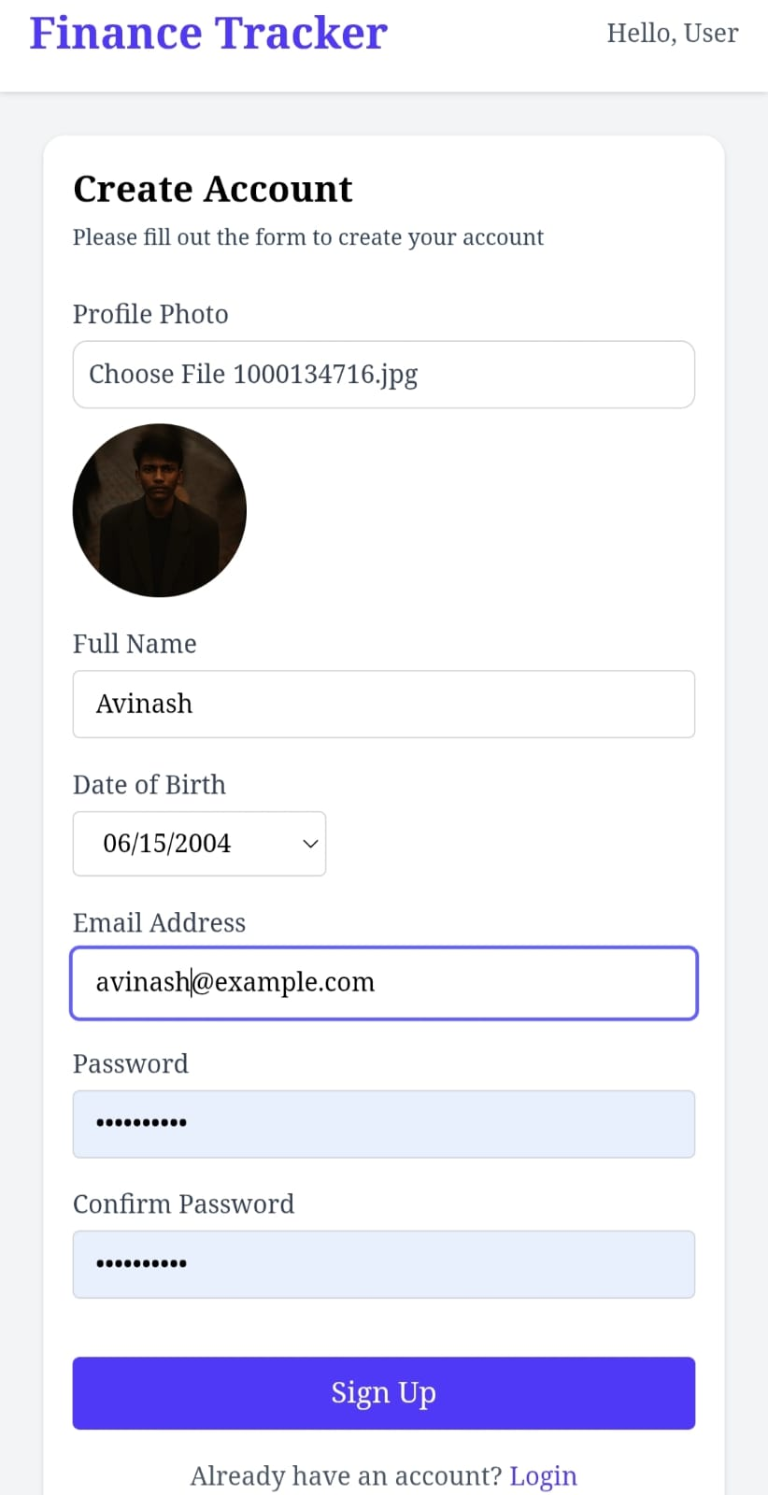

* **This is the **Login** page, where existing users securely sign in.**

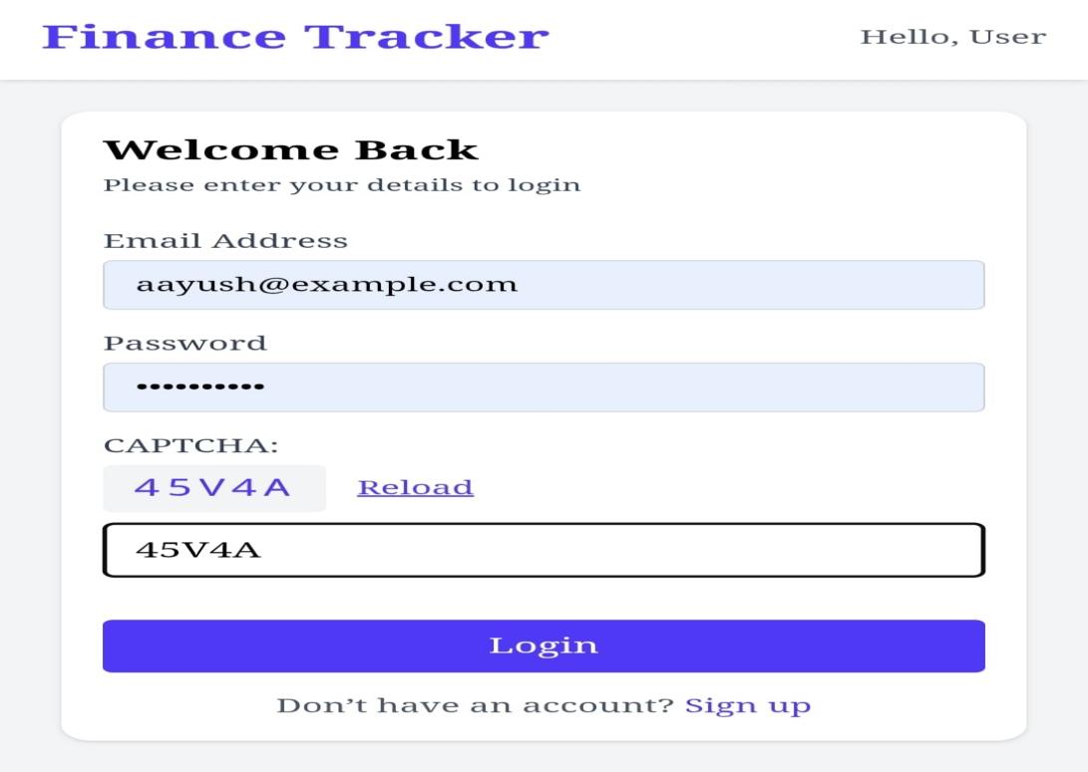

* **This is the **Sidebar**, where users navigate the app’s features.**

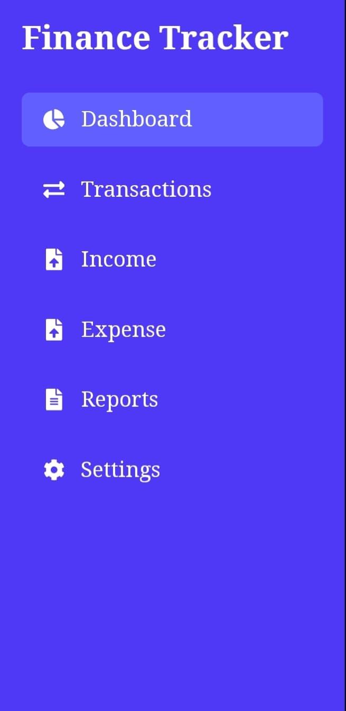

* This is **Dashboard** page, where financial summaries are displayed.

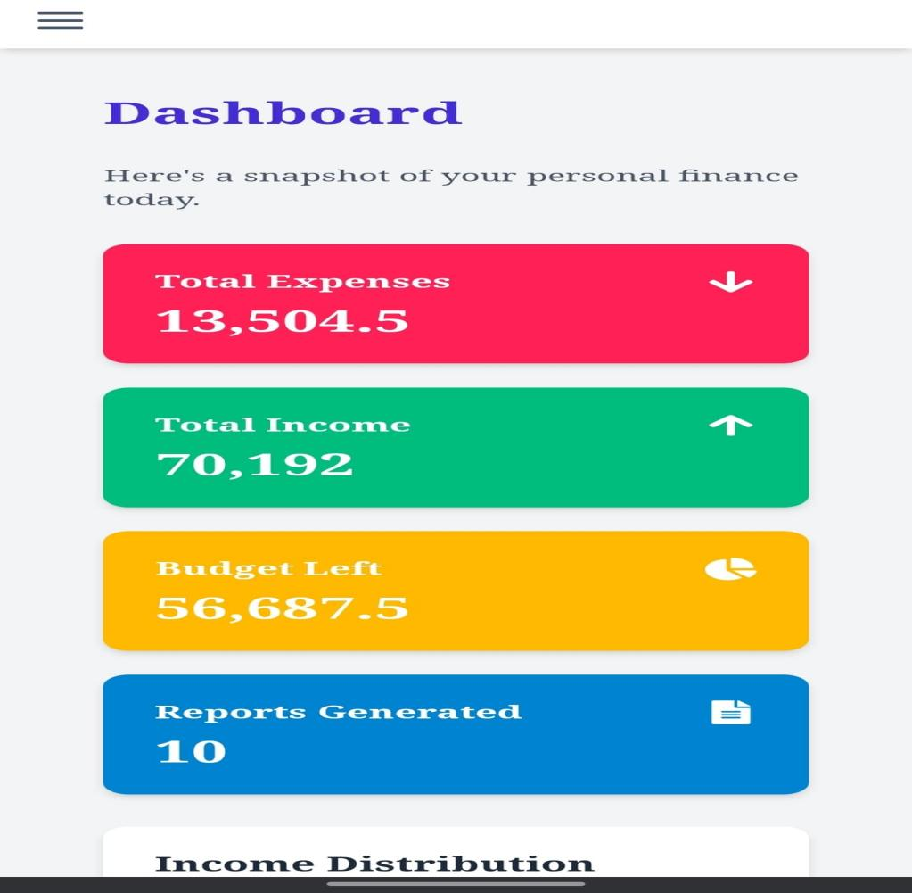

* **This is **Transaction** page, where users import bank statements.**

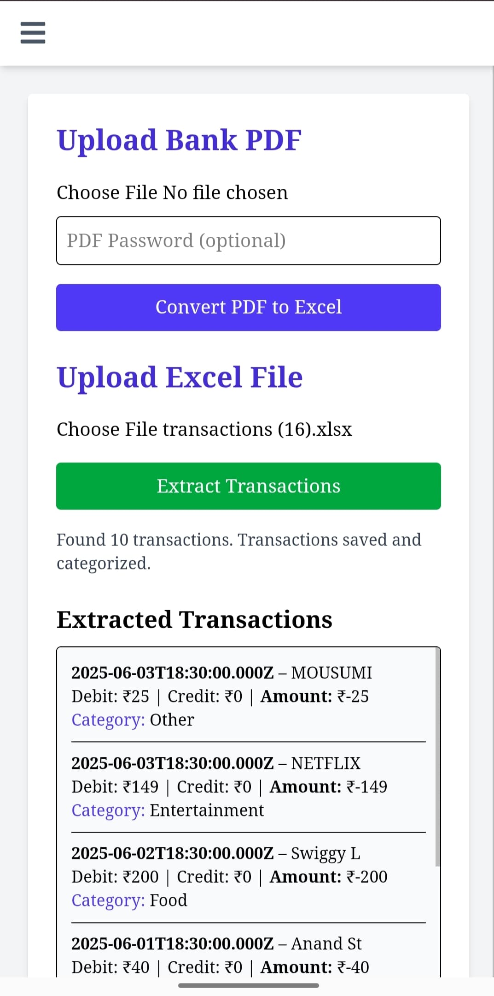

* **This is **Income** page, where all income records are shown.**

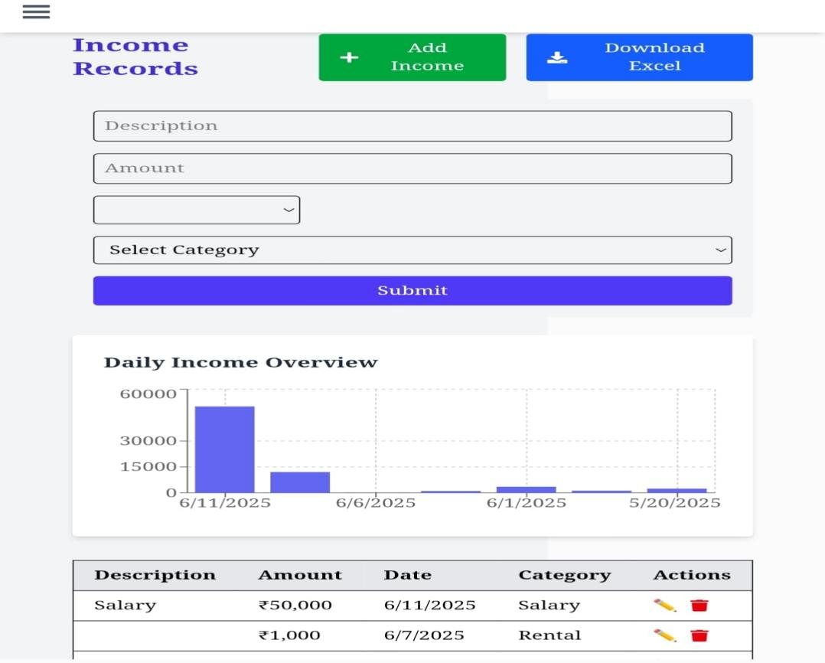

* This is **Expense** page, where users can track their spending.

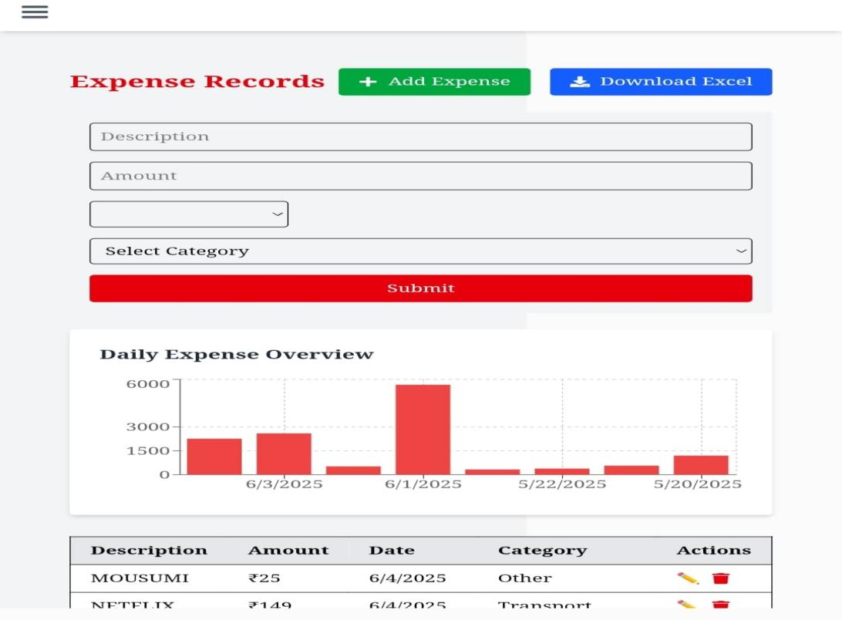

* **This is **Report** page, where users view detailed financial reports.**

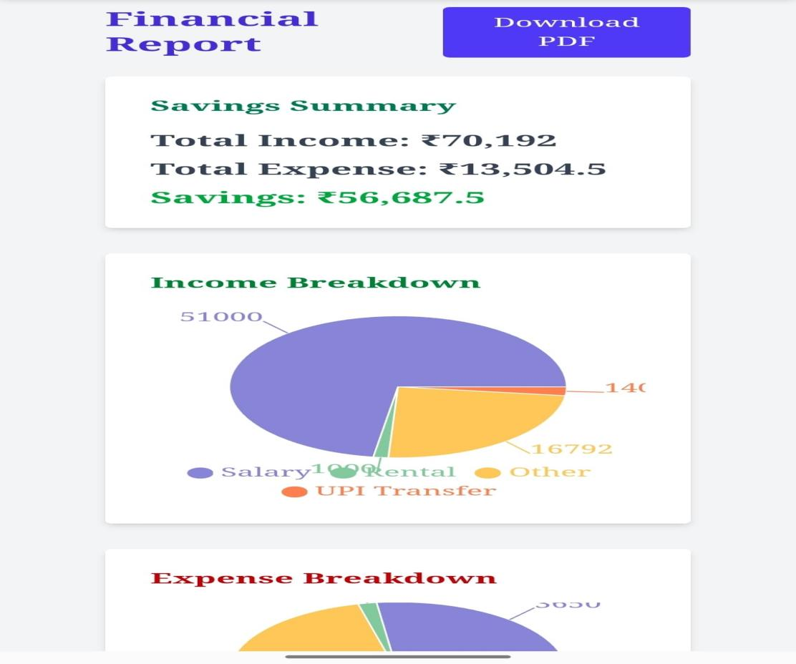

* **This is **Settings** page, where the necessary updates are made.**

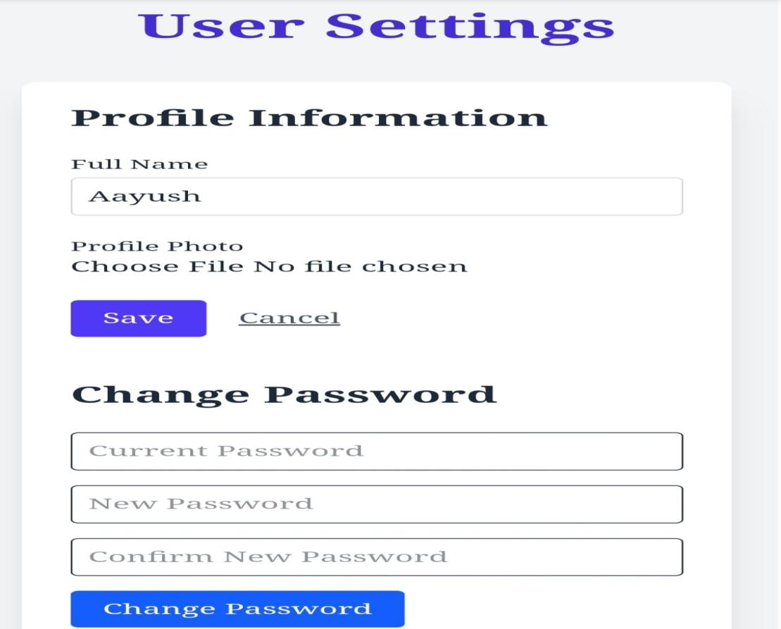

**CONCLUSION**

The **Personal Finance Tracker** stands as a comprehensive and user-friendly solution for personal budgeting and financial analysis. It streamlines the process of managing finances by automating transaction extraction from PDF/Excel bank statements, classifying them into meaningful categories, and presenting visual insights through graphs and summary reports. Users can effortlessly monitor income, spending habits, and savings trends over time. The application is built using a robust tech stack—React for a dynamic user interface, Express and Node.js for efficient backend handling, and MongoDB for secure data storage. Additionally, the integration of libraries for file parsing, authentication, and data visualization ensures a smooth, secure, and responsive experience.

Overall, the **Personal Finance Tracker** is not just a tool—it is a step toward building financially informed and empowered users. It turns static bank statements into interactive dashboards that encourage accountability and smarter money management. The project offers a solid foundation for future expansion and innovation in the field of personal finance technology.

**REFERENCES**

1. https://www.w3schools.com/react
2. <https://react.dev/reference/react>
3. <https://youtu.be/PQnbtnsYUho?si=VdV-E1_XITKIcWKu>
4. <https://www.geeksforgeeks.org/javascript>
5. <https://chat.openai.com>