Least-Privilege PIM Recommendation Assistant
Technical Documentation and Enterprise Scale-Up Proposal
Prototype: Local Streamlit + Python + Qwen/Ollama + Azure RBAC role cache
Prepared for team technical walkthrough | Estimated presentation duration: 60 minutes
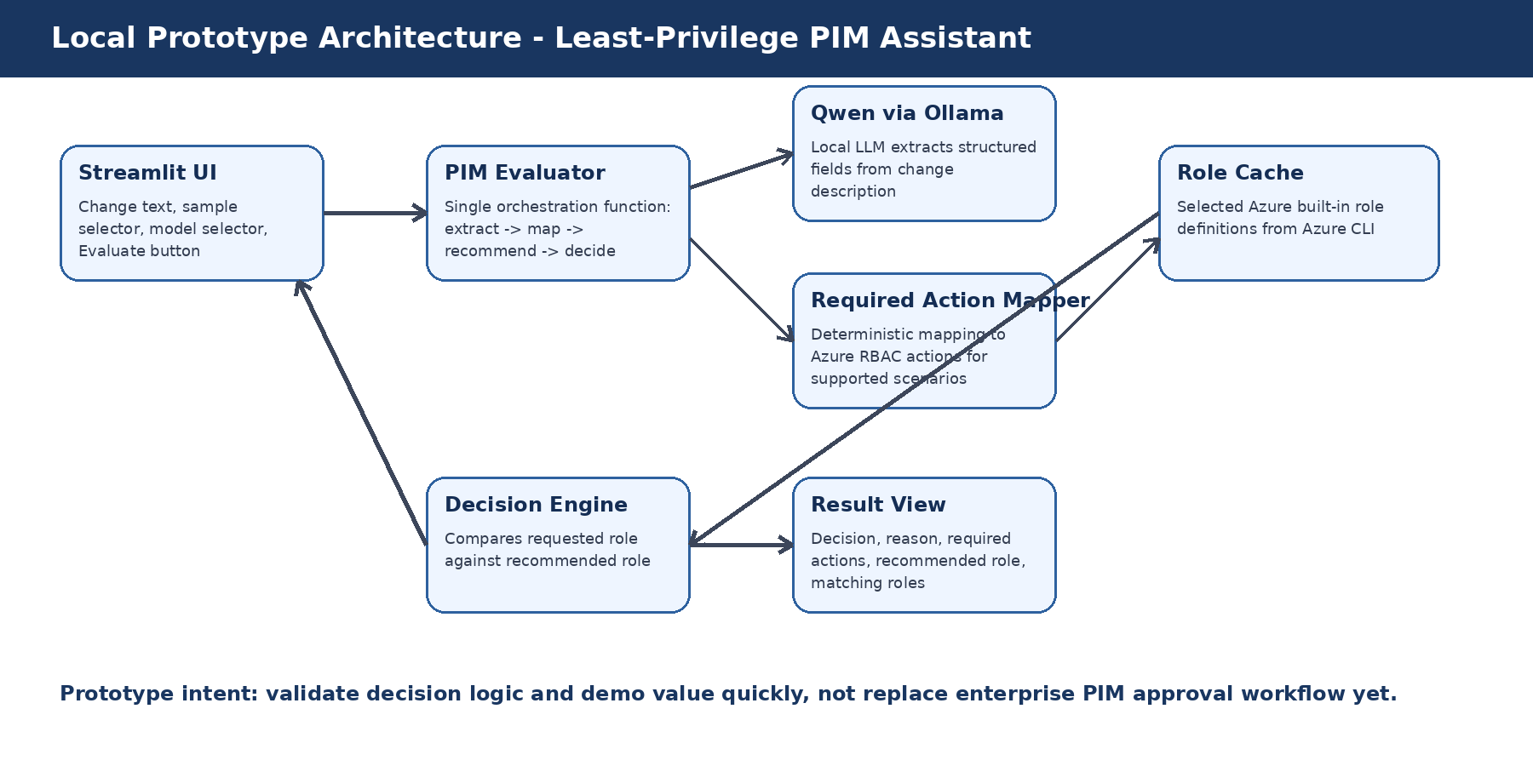

1. Walkthrough Agenda
This document is structured as a one-hour technical walkthrough. It explains the problem, the working prototype, the technical implementation, and the enterprise-grade target architecture.
Section | Topic | Suggested Time
1 | Problem statement, operational gap, and why this matters | 10 min
2 | Prototype overview and end-to-end workflow | 15 min
3 | Worked examples and screenshots | 15 min
4 | Technical implementation and folder structure | 10 min
5 | Enterprise scale-up design using Azure OpenAI and governed integrations | 10 min

2. Executive Summary
The Least-Privilege PIM Recommendation Assistant is a prototype that evaluates Azure PIM role requests from change descriptions and recommends a more appropriate built-in Azure role when the requested access is broader than required.
- It targets overprivileged temporary access requests, especially requests for Contributor when a narrower built-in role is sufficient.
- It uses an LLM only for structured extraction from change text; deterministic rule logic is used for required actions and RBAC role comparison.
- It demonstrates two working scenarios: storage account networking changes and NSG rule changes.
- It supports a human-in-the-loop approval model by producing a recommendation, reason, required actions, and matching roles rather than directly granting access.
- It can be scaled into an enterprise workflow using ServiceNow, Azure OpenAI, Microsoft Graph/PIM APIs, Azure Resource Graph, and centralized audit logging.

3. Problem Statement and Current Gap

3.1 What the Use Case Solves
In many change-management workflows, the implementer requests temporary privileged access through Azure PIM. The requested role is often selected manually from habit, urgency, or uncertainty. This commonly results in broad roles such as Contributor being requested even when the change requires only a small set of Azure actions.

3.2 Operational Gap
Current Gap | Impact | How the Prototype Addresses It
Change text is unstructured | Approvers must manually infer intent and required Azure actions | LLM converts change text into structured fields such as intent, resource names, requested role, scope, and duration
Requested role may be broader than needed | Temporary elevation increases blast radius during the change window | Role coverage logic compares required actions against built-in role permissions
Approver decisions are inconsistent | Different approvers may interpret similar changes differently | The recommendation engine applies repeatable rules and explains the decision
Evidence is hard to audit | Post-review evidence may not show why a role was approved or rejected | The design returns required actions, matching roles, recommended role, and decision reason
Manual review takes time | Approvers spend effort on repetitive access validation | Common patterns can be assessed quickly while exceptions route to manual review

3.3 Why It Is Important
- Reduces overprivileged access during implementation windows.
- Improves approval quality by giving approvers evidence instead of only a requested role.
- Supports least-privilege governance without blocking operational changes.
- Creates a path toward measurable controls: decision accuracy, override rate, request patterns, and high-risk roles avoided.
- Fits naturally into existing PIM and ITSM processes because it can recommend rather than directly enforce in the first phase.

4. Prototype Scope and Assumptions
Item | Prototype Scope
Supported scenarios | Storage account firewall/virtual network rule change; NSG inbound/outbound/security rule change
LLM role | Structured extraction only: change number, environment, intent summary, resource names, requested role, scope, and duration
Deterministic logic | Required action mapping, built-in role coverage, recommendation, and final decision
Role data | Selected Azure built-in role definitions cached locally from Azure CLI
UI | Streamlit local web app
Runtime | Python 3.11 virtual environment with local Qwen model served by Ollama
Non-goals for prototype | No automatic PIM grant, no direct ServiceNow integration, no production policy enforcement, no custom RBAC role generation

5. Prototype Architecture
The prototype is intentionally modular. Each responsibility is isolated into a Python service file so the notebook can be used for experimentation while the UI calls a stable backend function.

Figure 1. Local prototype architecture.

5.1 Component Responsibilities
Component | Responsibility | Prototype File
Streamlit UI | Collect change text, choose sample/model, display decision and evidence | app.py
PIM Evaluator | Orchestrates extraction, action mapping, role recommendation, and decision | services/pim_evaluator.py
LLM Adapter | Calls local Ollama HTTP API | services/llm_adapter.py
Change Extractor | Prompts Qwen and parses structured JSON fields | services/change_extractor.py
Required Action Mapper | Maps supported change patterns to Azure RBAC actions | services/required_action_mapper.py
Role Coverage | Checks if a role action list covers required actions, including wildcards | services/role_coverage.py
Role Recommender | Finds matching roles and selects the least-privilege recommendation | services/role_recommender.py
Decision Engine | Compares requested role against recommended role and returns final decision | services/decision_engine.py

6. End-to-End Workflow
The workflow begins with the change description and ends with a decision object that can be shown to an approver or written to an audit record.
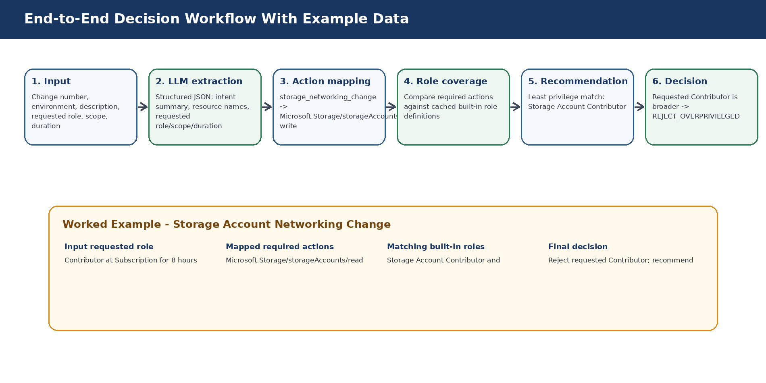
Figure 2. End-to-end workflow and example data transformation.

6.1 Stage-by-Stage Inputs and Outputs
Stage | Input | Processing | Output
1. User input | Raw change description with requested PIM role, scope, and duration | Streamlit passes text to backend evaluator | Raw text string
2. LLM extraction | Raw change text | Qwen extracts structured JSON fields | change_number, environment, intent_summary, resource_names, requested_role, requested_scope, requested_duration
3. Required action mapping | Extracted intent summary and resource names | Rule mapper matches storage or NSG scenario | Required Azure RBAC actions
4. Role matching | Required actions and cached role definitions | Wildcard-aware coverage logic checks which roles include required actions | Matching built-in roles
5. Least-privilege selection | Matching roles | Preference score prioritizes narrower roles over broad roles | Recommended role
6. Decision | Requested role and recommended role | Decision engine compares broadness/exact match | APPROVE_RECOMMENDED, REJECT_OVERPRIVILEGED, or MANUAL_REVIEW_REQUIRED

7. Decision Logic
The prototype does not ask the LLM to decide whether to approve access. The LLM is used only for extraction. The actual decision is deterministic and explainable.
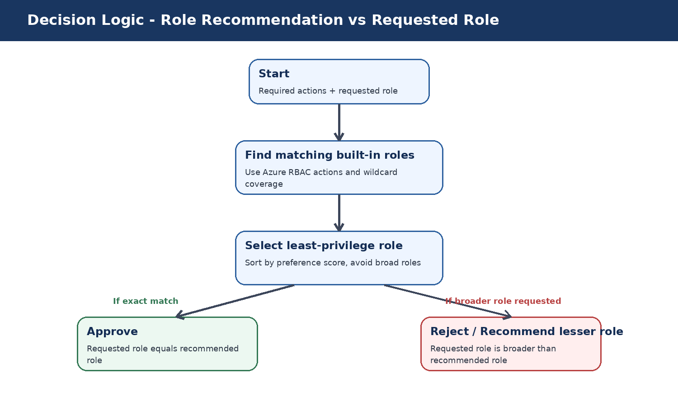
Figure 3. Deterministic decision logic.

7.1 Decision Types
Decision | Meaning | Example
APPROVE_RECOMMENDED | Requested role equals the recommended least-privilege role | Requested Storage Account Contributor and recommended Storage Account Contributor
REJECT_OVERPRIVILEGED | Requested role is broader than the recommended least-privilege role | Requested Contributor but recommended Storage Account Contributor
MANUAL_REVIEW_REQUIRED | The system cannot confidently map the change or find a role | Unknown change type or missing role coverage

8. Worked Example 1 - Storage Networking Change
The storage scenario demonstrates a common overprivileged request: Contributor requested at Subscription scope for a change that requires only storage account network configuration permissions.

8.1 Sample Input
Change Number: CHG12345
Environment: Production
Description:
Need to update firewall and virtual network rules on storage account stgprod001.
This is required to allow the application subnet to access the storage account during deployment.
Requested PIM Role: Contributor
Requested Scope: Subscription
Requested Duration: 8 hours

8.2 Stage Output
Output Field | Value
Extracted intent | Update firewall and virtual network rules on Storage Account stgprod001 to allow application subnet access
Matched pattern | storage_networking_change
Required actions | Microsoft.Storage/storageAccounts/read; Microsoft.Storage/storageAccounts/write
Matching roles | Storage Account Contributor; Contributor
Recommended role | Storage Account Contributor
Final decision | REJECT_OVERPRIVILEGED
Reason | Requested role Contributor is broader than recommended role Storage Account Contributor

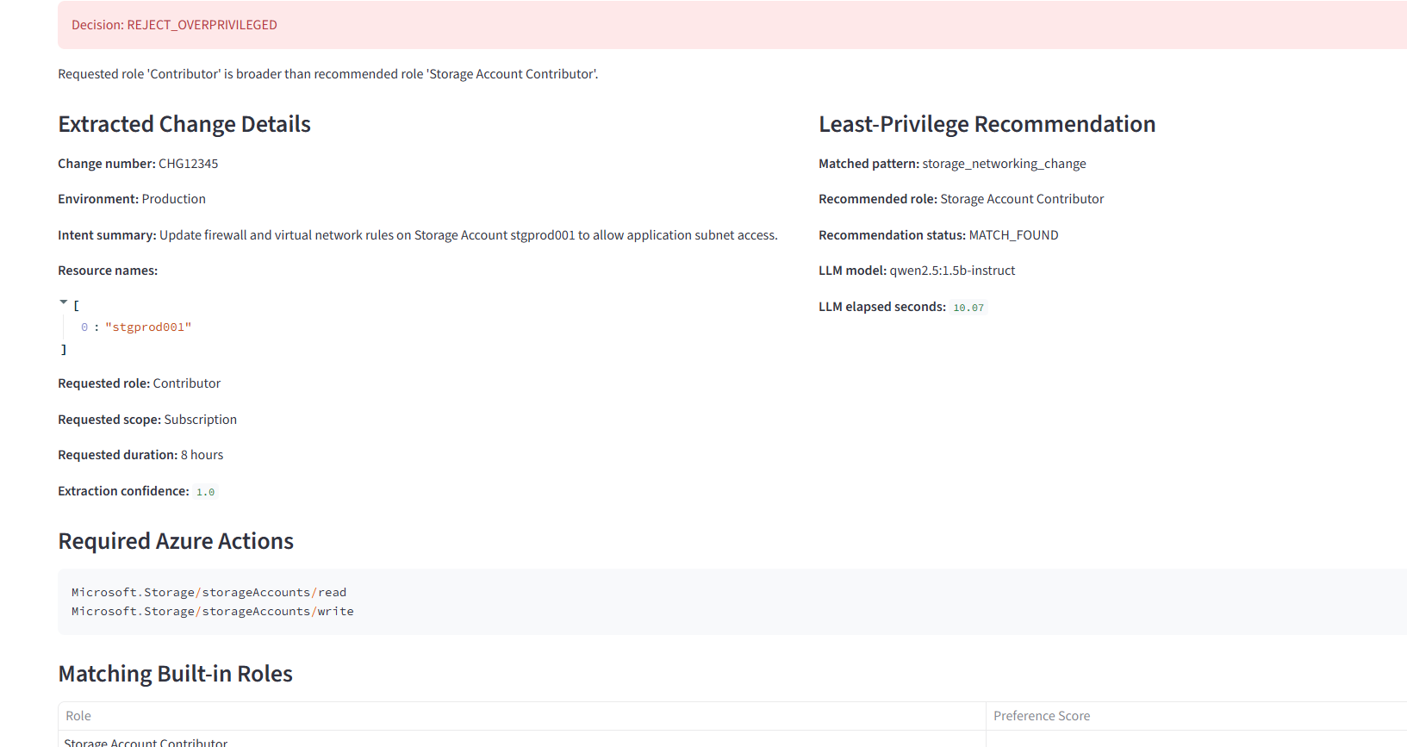
Figure 4. Streamlit prototype input and storage sample selection.
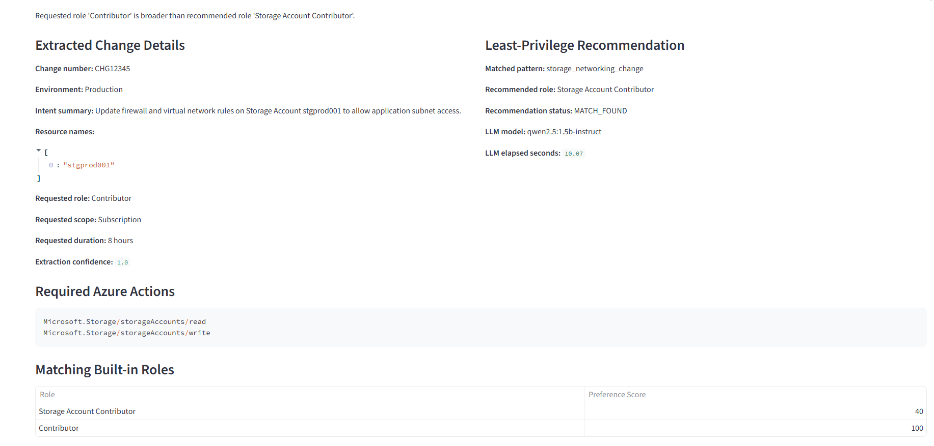
Figure 5. Storage scenario result: extracted details, recommended role, required actions, and matching built-in roles.

9. Worked Example 2 - NSG Rule Change
The NSG scenario validates that the same backend function can handle network security group rule changes and recommend Network Contributor instead of Contributor.

9.1 Sample Input
Change Number: CHG12346
Environment: Production
Description:
Need to update inbound security rule on network security group nsg-prod-app01.
The rule will allow application traffic from the approved subnet during deployment.
Requested PIM Role: Contributor
Requested Scope: Subscription
Requested Duration: 6 hours

9.2 Expected Output
Output Field | Value
Extracted resource | nsg-prod-app01
Matched pattern | nsg_rule_change
Required actions | Microsoft.Network/networkSecurityGroups/read; Microsoft.Network/networkSecurityGroups/write
Matching roles | Network Contributor; Contributor
Recommended role | Network Contributor
Final decision | REJECT_OVERPRIVILEGED

10. Prototype Screenshots
The following screenshots show the working local Streamlit application, model selector, output layout, and project folder structure.
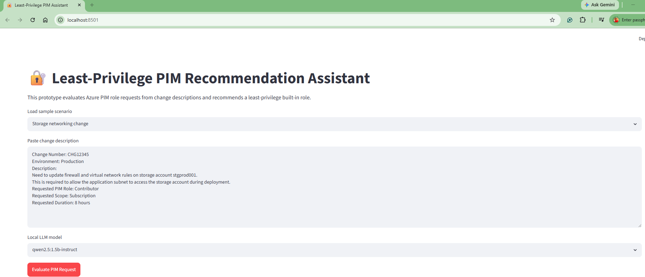
Figure 6. Streamlit input screen with sample scenario and local model selection.
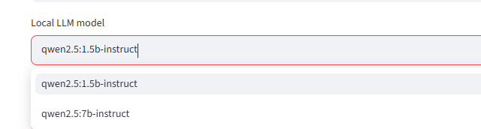
Figure 7. Local model selector: Qwen 1.5B and Qwen 7B options.
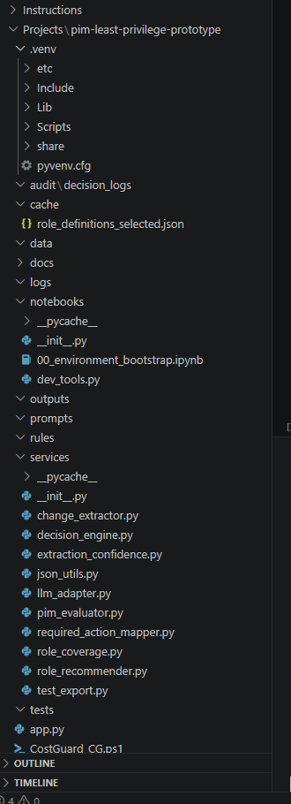
Figure 8. Local prototype folder structure in VS Code.

11. Technical Implementation Details

11.1 Runtime and Tools
Tool / Runtime | Purpose
Python 3.11 virtual environment | Stable runtime for Streamlit, service modules, and notebook testing
VS Code + Jupyter notebook | Stepwise prototype development and validation
Streamlit | Local web UI for the demo
Ollama | Local inference runtime/server for Qwen models
Qwen 2.5 1.5B / 7B Instruct | Local LLM for structured extraction
Azure CLI | Used to cache selected Azure built-in role definitions
JSON role cache | Local role permission source for the prototype

11.2 Folder Structure
pim-least-privilege-prototype/
├── app.py
├── cache/
│ └── role_definitions_selected.json
├── services/
│ ├── change_extractor.py
│ ├── decision_engine.py
│ ├── extraction_confidence.py
│ ├── json_utils.py
│ ├── llm_adapter.py
│ ├── pim_evaluator.py
│ ├── required_action_mapper.py
│ ├── role_coverage.py
│ └── role_recommender.py
├── notebooks/
│ ├── 00_environment_bootstrap.ipynb
│ └── dev_tools.py
├── audit/decision_logs/
├── rules/
├── tests/
└── outputs/

11.3 Core Backend Function
The UI calls a single orchestration function. This reduces UI complexity and keeps the decision logic testable outside Streamlit.
evaluate_pim_request(change_text)
-> extract_change_details(change_text)
-> map_required_actions(extracted)
-> recommend_least_privilege_role(role_cache, required_actions)
-> evaluate_role_decision(requested_role, recommended_role)
-> return final decision object

11.4 Why the LLM Is Not the Final Decision Maker
- LLMs are useful for interpreting unstructured change text but can be inconsistent for exact Azure action generation.
- RBAC decisions must be deterministic, auditable, and explainable.
- The prototype uses the LLM for extraction only, then applies controlled mapping and role-coverage logic.
- This design is safer for enterprise adoption because the model output is bounded and validated by rules.

12. Limitations of the Prototype
Limitation | Reason | Enterprise Fix
Only two scenarios supported | Prototype intentionally focuses on storage networking and NSG changes | Expand the rule/action catalog by resource provider and change type
Local role cache | Role definitions are cached manually from selected roles | Scheduled refresh from Azure role definition APIs
Local LLM runtime | Ollama/Qwen is suitable for prototype and offline testing | Use approved Azure OpenAI deployments and enterprise network controls
No ServiceNow integration | Manual text paste in Streamlit | Integrate with ServiceNow APIs or event-based change ingestion
No live PIM request comparison | Requested role/scope/duration are extracted from text | Read active PIM requests from Microsoft Graph/PIM APIs
No scope/duration scoring yet | Prototype focuses on role overprivilege | Add scope hierarchy and duration-vs-change-window validation

13. Enterprise Scale-Up Design
For enterprise usage, this prototype should evolve from a local demo into a governed service that integrates with ITSM, Azure identity, role definitions, PIM workflows, and centralized audit systems.
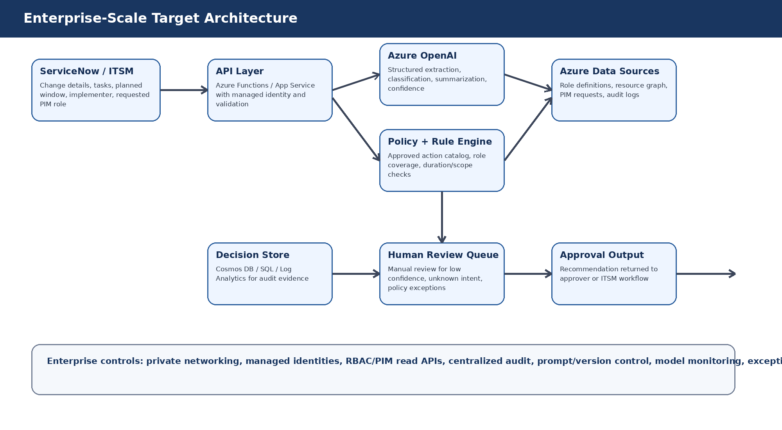
Figure 9. Enterprise-scale target architecture.

13.1 Target Enterprise Workflow
- Ingest ServiceNow change details, task details, implementer identity, requested PIM role, requested scope, and planned change window.
- Use Azure OpenAI to extract and classify the change intent into a controlled schema.
- Map the intent to required Azure actions using a version-controlled action catalog.
- Fetch or refresh Azure role definitions and compare required actions against built-in roles.
- Validate requested scope against impacted resource scope and requested duration against the planned change window.
- Return decision, recommended role, recommended scope, recommended duration, confidence, and evidence back to the approver workflow.
- Persist all input, output, model version, catalog version, role-cache version, and final decision into a tamper-evident audit store.
- Route low-confidence and unsupported changes to manual review rather than auto-approve.

13.2 Recommended Enterprise Components
Layer | Recommended Azure / Enterprise Component | Purpose
Ingress | ServiceNow API, Event Grid, Logic Apps, or Azure Function trigger | Receive change and PIM request context
API service | Azure Functions or App Service with managed identity | Backend orchestration and policy enforcement
LLM layer | Azure OpenAI / Microsoft Foundry model deployment | Enterprise-governed extraction and classification
Rule engine | Version-controlled YAML/JSON catalog plus Python/.NET service | Deterministic mapping from intent to required actions
Azure data | Azure Resource Graph, Microsoft Graph, Azure RBAC role definitions API | Resolve resources, scopes, identities, roles, and PIM context
Storage | Cosmos DB, Azure SQL, or Log Analytics | Decision history and audit evidence
Monitoring | Application Insights, Log Analytics, dashboards | Latency, error rate, override rate, unsupported intents
Security | Managed identity, private endpoints, Key Vault, RBAC | Credential-free secure operation

14. Model Strategy and Justification
The enterprise model strategy should be tiered. Most change descriptions are short and structured enough for a cost-optimized model, while ambiguous or high-risk cases can be escalated to a stronger model. Microsoft documentation describes GPT-4o as a multimodal model and documents Azure model deployment types including standard and provisioned deployments; Azure documentation also describes data, privacy, and security controls for models sold by Azure. The final model choice should be validated in the company tenant and region before production rollout.
Use | Recommended Strategy | Justification
Extraction from change text | Cost-optimized Azure OpenAI chat model such as GPT-4o mini or equivalent company-approved small model | Short inputs, structured JSON output, high volume, cost-sensitive
Complex classification / low-confidence fallback | Stronger model such as GPT-4o or equivalent enterprise-approved reasoning-capable model | Handles ambiguous descriptions and higher-risk changes
Production throughput | Start with standard deployment; consider provisioned throughput for predictable latency and steady workloads | The expected volume is modest initially, but enterprise adoption may require predictable latency
Safety boundary | Do not let the model directly approve access | Use deterministic rule and role-coverage logic for the final decision
Auditability | Store model deployment name, prompt version, rule catalog version, and role-cache version | Allows reproducibility and review of decisions

Key design point: the model should classify and extract; the RBAC decision should remain rule-based and auditable.

15. Governance, Controls, and Audit Requirements
- Human-in-the-loop approval should remain mandatory until the system is validated against historical changes.
- Direct user assignments should remain prohibited if the company policy requires group/PIM-based assignments only.
- All decisions should include recommended role, recommended scope, duration recommendation, confidence, required actions, matching roles, and reason.
- Every decision should reference catalog version, role-cache version, model deployment, prompt version, and timestamp.
- Unknown or low-confidence scenarios should never be auto-approved; they should route to manual review.
- Approver override should be tracked with reason codes to improve the rule catalog over time.

15.1 Suggested Audit Record
{
"change_number": "CHG12345",
"environment": "Production",
"requested_role": "Contributor",
"requested_scope": "Subscription",
"requested_duration": "8 hours",
"matched_pattern": "storage_networking_change",
"required_actions": [
"Microsoft.Storage/storageAccounts/read",
"Microsoft.Storage/storageAccounts/write"
],
"recommended_role": "Storage Account Contributor",
"decision": "REJECT_OVERPRIVILEGED",
"reason": "Requested role Contributor is broader than recommended role Storage Account Contributor",
"model": "qwen2.5:1.5b-instruct / enterprise Azure OpenAI deployment",
"catalog_version": "v1",
"role_cache_version": "timestamped"
}

16. Implementation Roadmap
Phase | Objective | Deliverables
Phase 1 - Prototype validation | Demonstrate value with storage and NSG changes | Streamlit UI, local evaluator, role cache, screenshots, demo recording
Phase 2 - Expand catalog | Add more resource providers and action patterns | YAML/JSON action catalog, automated unit tests, broader role cache
Phase 3 - Enterprise integration | Connect ITSM and Azure identity/RBAC data | ServiceNow ingestion, Graph/PIM lookup, resource resolution
Phase 4 - Governance and audit | Create production-grade traceability | Audit store, dashboards, model/prompt/catalog versioning
Phase 5 - Controlled rollout | Pilot with selected teams and compare recommendations with human approvers | Metrics, feedback loop, override analysis, approval workflow integration

17. Key Talking Points for Team Presentation
- This is not an auto-approval bot; it is a least-privilege recommendation assistant for approvers.
- The strongest design choice is separating unstructured-text interpretation from deterministic RBAC decision logic.
- The prototype already proves two common scenarios: storage networking and NSG rules.
- The recommendation is based on required Azure actions and cached built-in role permissions, not on vague model judgment.
- Enterprise scale-up should integrate with ServiceNow, Azure OpenAI, Microsoft Graph/PIM, Resource Graph, and centralized audit logging.
- Low-confidence or unsupported scenarios must route to manual review.

18. References
The following Microsoft documentation should be used to validate enterprise deployment choices, privacy posture, and model deployment configuration before production rollout:
- Microsoft Foundry Models sold directly by Azure - model concepts: https://learn.microsoft.com/en-us/azure/foundry/foundry-models/concepts/models-sold-directly-by-azure
- Data, privacy, and security for Azure Direct Models in Microsoft Foundry: https://learn.microsoft.com/en-us/azure/foundry/responsible-ai/openai/data-privacy
- Deployment types for Microsoft Foundry Models: https://learn.microsoft.com/en-us/azure/foundry/foundry-models/concepts/deployment-types
- Provisioned throughput for Azure OpenAI and Foundry Models: https://learn.microsoft.com/en-us/azure/foundry/openai/concepts/provisioned-throughput
- Azure OpenAI / Foundry Models REST API reference: https://learn.microsoft.com/en-us/azure/foundry/openai/reference

