UC2 - RBAC Group Access Review and Right-Sizing
Technical Explanation Documentation for Team Presentation
Sample Project: Evidence-based review of Azure group-level RBAC assignments

Document Area | Details
Use case | Review existing Azure RBAC assignments granted to Microsoft Entra security groups
Primary objective | Identify unused, rarely used, over-scoped, or low-confidence group-level access
Sample project technology | Python, Streamlit, pandas, mock Azure RBAC data, rule-based recommendation logic
AI position | Not required for the core recommendation; optional for explanation, summarization, and advanced right-sizing
Primary output | Recommendation, evidence, confidence, explanation, downloadable JSON review record

1. Executive Summary
This document explains UC2, a sample project for RBAC Group Access Review and Right-Sizing in Azure environments. The focus is to review existing RBAC role assignments granted to Microsoft Entra ID security groups and determine whether those assignments are still justified based on activity history and usage evidence.
The sample project demonstrates how group membership, role assignments, role definitions, and activity logs can be combined to produce access review recommendations such as KEEP_PERMANENT, MAKE_PIM_ELIGIBLE, REMOVE_CANDIDATE, KEEP_LOW_PRIORITY, INSUFFICIENT_VISIBILITY, and MANUAL_REVIEW_REQUIRED.
The core recommendation engine in this sample project is rule-based and implemented in Python. It is not dependent on an LLM for decision-making. AI can be introduced later to improve explanations, summarize access posture, and suggest best-fit roles, but the safety-critical recommendation should remain deterministic and auditable.

2. Problem Statement and Gap
In many enterprise Azure environments, access is granted to teams through Microsoft Entra security groups. These security groups are then assigned Azure RBAC roles at management group, subscription, resource group, or resource scope. This is operationally convenient, but over time it creates standing access that may no longer be required.
- Standing access risk: Permanent group-level access can remain long after the original operational need is gone.
- Over-scoped assignments: A role may be assigned at subscription level even though activity is limited to one resource group.
- Rare usage: Some roles may be used once or twice in several months, which may be better suited for PIM eligible access.
- Invisible read and data-plane activity: Azure Activity Log is strong for management-plane activity but not sufficient for every read or data-plane scenario.
- Manual review effort: Reviewing group assignments manually across many subscriptions and teams is time-consuming and inconsistent.

3. What the Sample Project Achieves
The sample project demonstrates a controlled way to review group-level RBAC access. It allows a reviewer to select a security group, review its membership and role assignments, analyze mock activity logs, and receive an evidence-based recommendation.
- Shows realistic organization-style security groups and members.
- Displays RBAC assignments for the selected group.
- Classifies role permission profiles into observable and unobservable actions.
- Matches activity logs against group members, role permissions, and assignment scope.
- Calculates matched operations, active members, member usage ratio, and last-used date.
- Generates recommendation, confidence, reason, and explanation.
- Provides downloadable JSON output for audit or workflow integration.

4. Is AI Used in This Use Case?
The current sample project does not require AI for the core recommendation. The decision engine is rule-based and implemented using Python conditions. This makes the output transparent, repeatable, and easier to audit.
Example of rule-based logic: if a write-bearing role has zero observable matching operations, it may be marked as REMOVE_CANDIDATE. If a role is used rarely or by only a small portion of group members, it may be marked as MAKE_PIM_ELIGIBLE. If a role is read-only, it may be marked as KEEP_LOW_PRIORITY because read operations are generally not visible in Azure Activity Log.
AI can still be useful as an enhancement, but it should not be mandatory for the safety-critical recommendation. Potential AI use cases include generating reviewer-friendly explanations, summarizing access posture across many groups, detecting unusual patterns, and suggesting role right-sizing options.
Area | Without AI | With AI Enhancement
Core recommendation | Rule-based Python logic; deterministic and auditable | AI should not own final decision; can support classification or justification
Explanation | Template-based explanation generated by code | LLM can generate clearer, role-aware explanation for reviewers
Right-sizing suggestion | Mapped from static catalog of roles and actions | LLM can suggest candidate roles, then deterministic validation confirms
Enterprise summary | Power BI / reports using stored results | LLM can summarize trends and high-risk themes
Governance risk | Low because rules are explicit | Requires guardrails, validation, and prompt/output controls

5. Technologies Used in the Sample Project
Component | Technology Used | Purpose
User Interface | Streamlit | Interactive web UI for selecting group, lookback period, assignment, and viewing recommendation
Backend Logic | Python | Implements data handling, usage matching, rule-based recommendations, and explanation generation
Data Processing | pandas | Displays group members, assignments, role actions, and activity logs as tables
Data Source | Mock organization-style data | Simulates groups, users, role assignments, role definitions, and activity logs
Recommendation Engine | Rule-based Python conditions | Produces deterministic decisions based on usage evidence
Output | JSON download | Exports review evidence and recommendation for audit or workflow integration
Future AI Option | Azure OpenAI | Optional explanation, summarization, and right-sizing assistant

6. End-to-End Workflow
The workflow follows a simple review pattern: select the group, load assignments, inspect role permissions, compare with activity evidence, apply rules, and produce a recommendation.
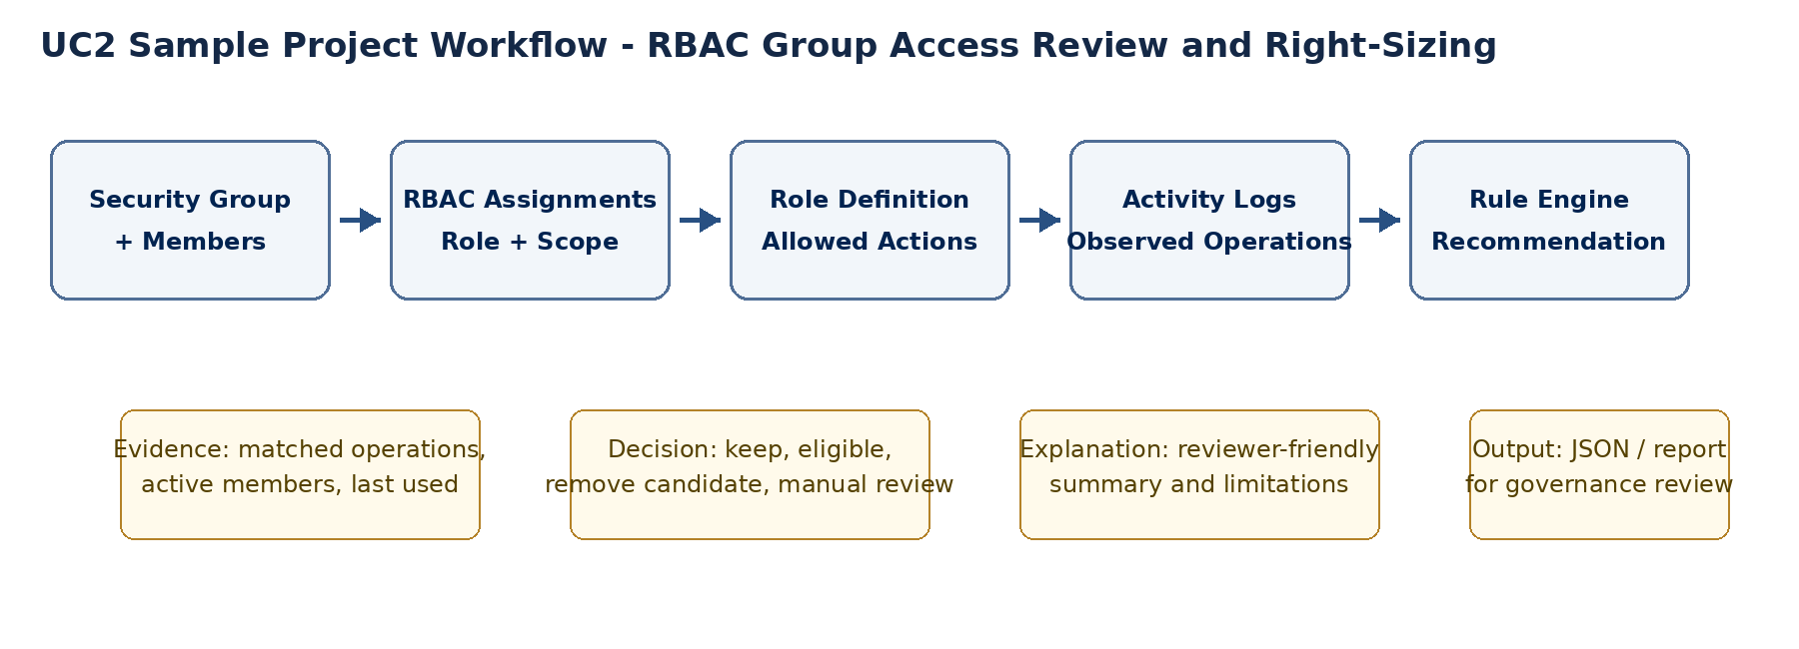
Figure 1: UC2 sample project workflow
- Reviewer selects a security group and review window from the Streamlit sidebar.
- Application loads group metadata and current members.
- Application lists RBAC assignments granted to the selected group.
- Application loads the selected role definition and separates observable management-plane actions from unobservable read/data-plane actions.
- Application matches activity logs where the caller is a current group member, the operation is covered by the role, and the resource is within the assignment scope.
- Rule-based engine calculates recommendation, confidence, reason, last-used date, and member usage ratio.
- Reviewer reads the explanation and downloads JSON evidence if required.

7. Screenshot-Based Walkthrough
The following sections explain the sample project screens based on the captured screenshots. Each screen supports a specific part of the review workflow.
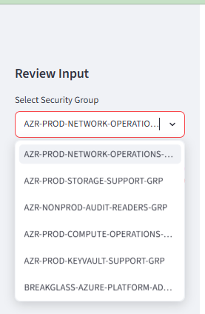
Figure 2: Sidebar group selection options
The sidebar allows the reviewer to choose which security group should be reviewed. Groups are modeled as enterprise-style groups such as network operations, storage support, audit readers, compute operations, key vault support, and break-glass administrators.
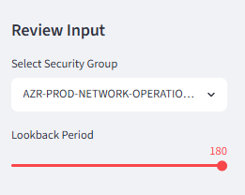
Figure 3: Lookback period selection
The lookback period represents the duration of activity history used for the review. In a real implementation, this should align with available Azure Activity Log retention or Log Analytics retention.
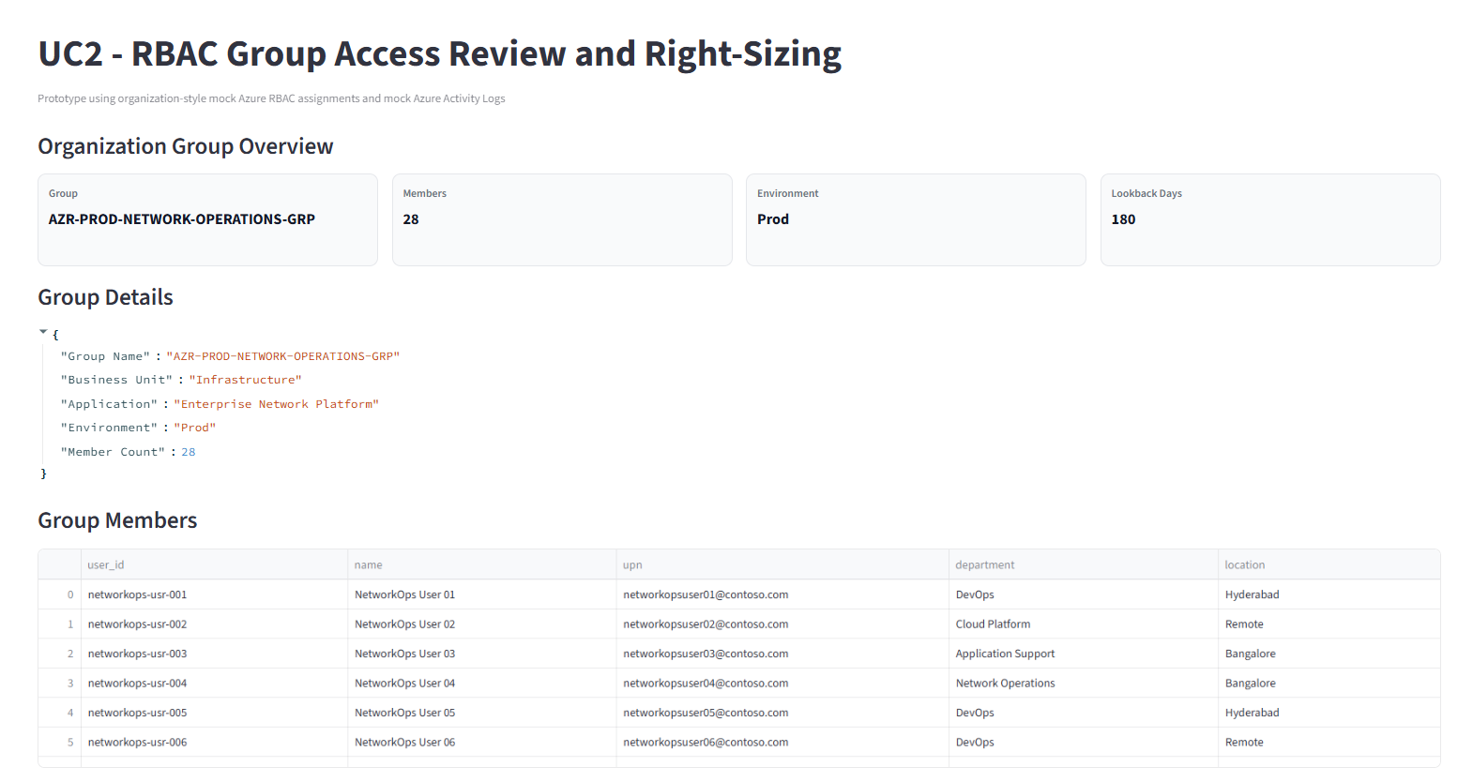
Figure 4: Group overview and group members
The selected group summary shows group name, member count, environment, and lookback period. The group details JSON gives business context such as business unit, application, and environment. The member table shows current group members.
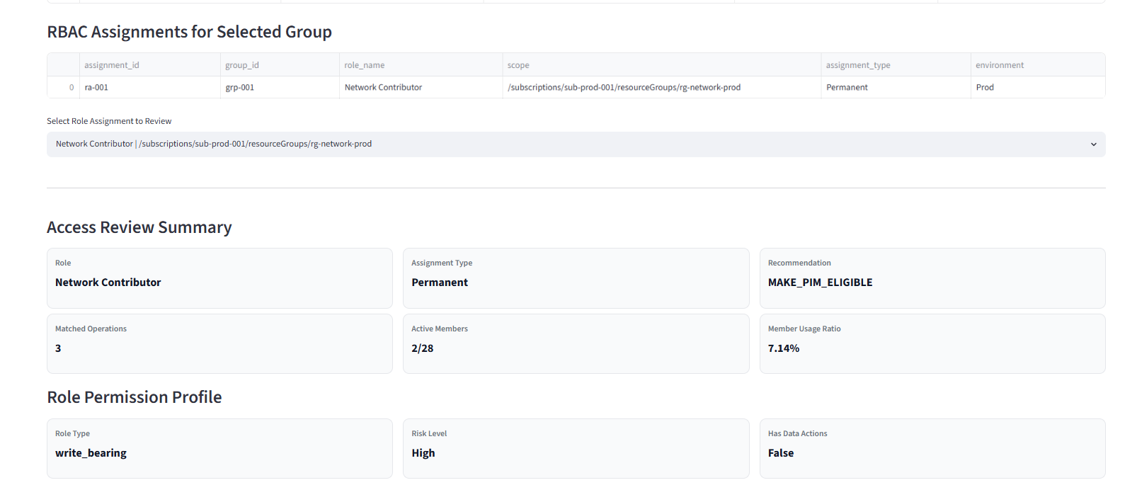
Figure 5: RBAC assignments and assignment selection
The RBAC assignments table shows the role assigned to the selected group and its scope. The reviewer chooses one assignment to analyze. Scope is important because a broad role at a broad scope increases risk.
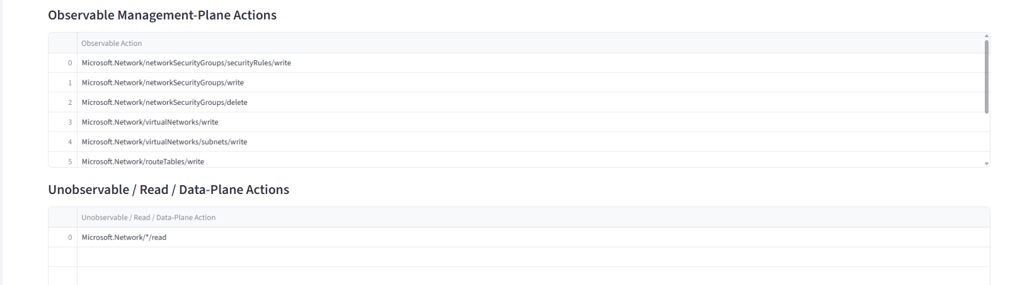
Figure 6: Network Contributor access review summary
For the network operations group, the role is Network Contributor. The tool finds three matching operations by two out of twenty-eight members, which results in MAKE_PIM_ELIGIBLE because usage is limited and the role is high-risk.
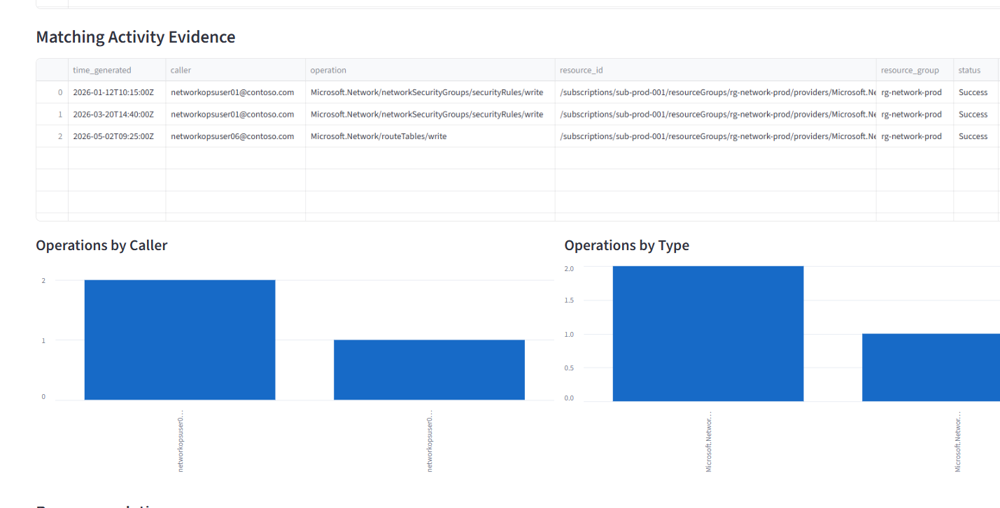
Figure 7: Observable and unobservable role actions
The role permission profile separates observable management-plane actions from unobservable read/data-plane actions. This prevents unsafe decisions based only on missing read activity.
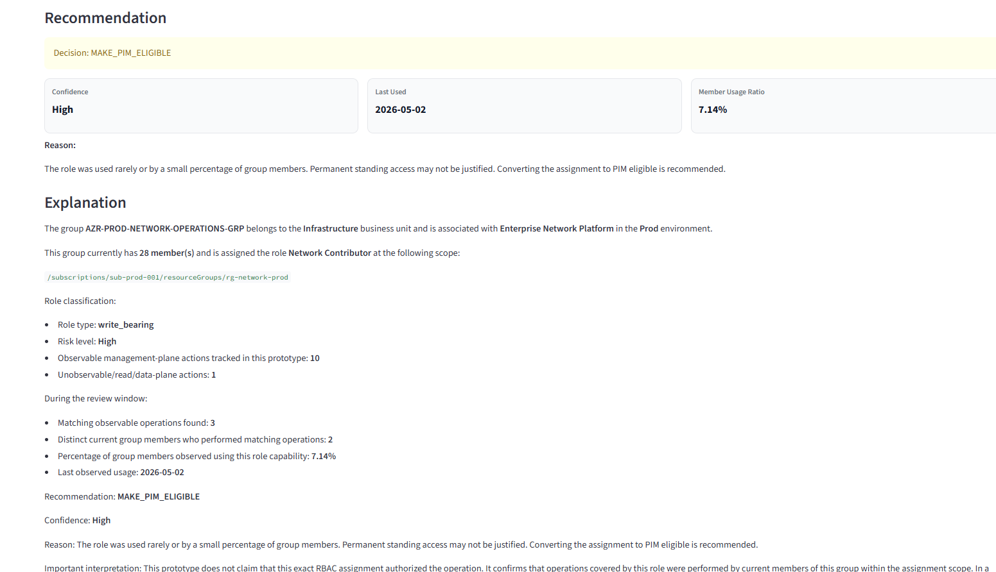
Figure 8: Matching activity evidence and charts
The evidence section shows actual matching operations and visualizes usage by caller and operation type. This supports the recommendation with evidence rather than opinion.
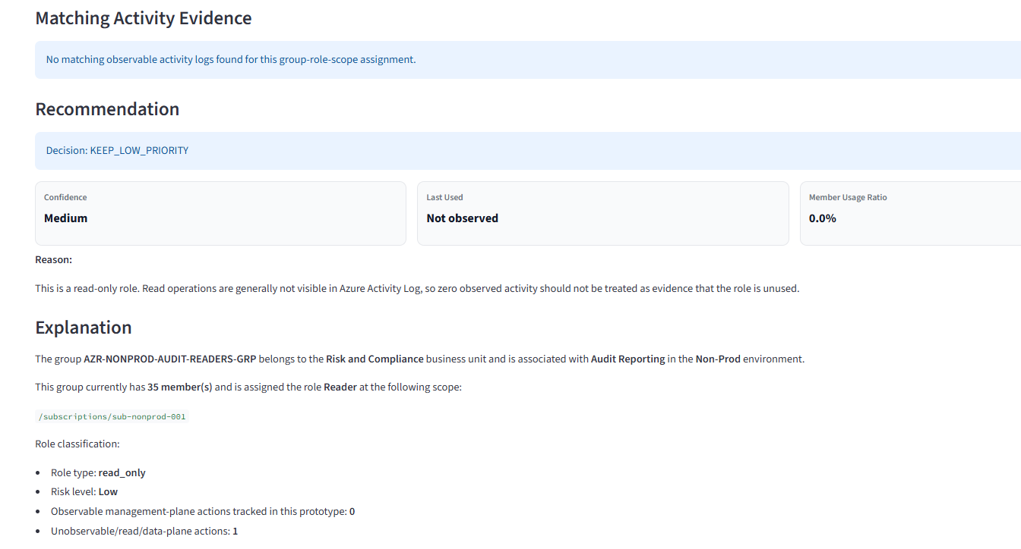
Figure 9: Recommendation and explanation for Network Contributor
The recommendation section shows MAKE_PIM_ELIGIBLE with high confidence. The explanation summarizes group context, role risk, observed usage, and the limitation that the tool does not prove exact authorization path.
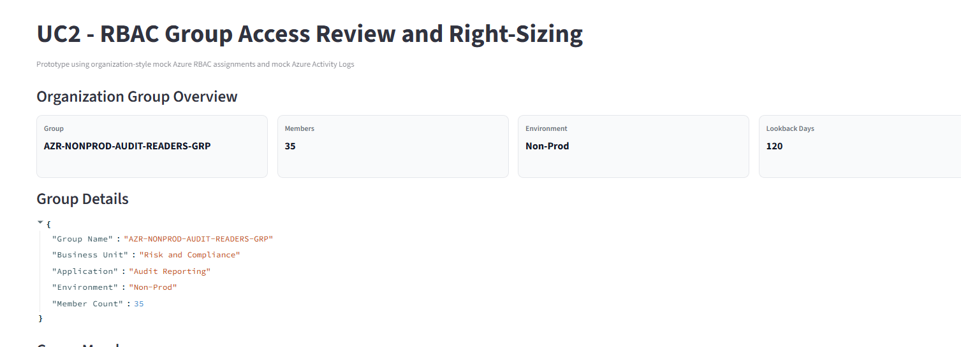
Figure 10: Reader role with no visible activity
For the audit reader group, no matching activity is found. Because read activity is generally not visible in Azure Activity Log, the recommendation is KEEP_LOW_PRIORITY rather than removal.
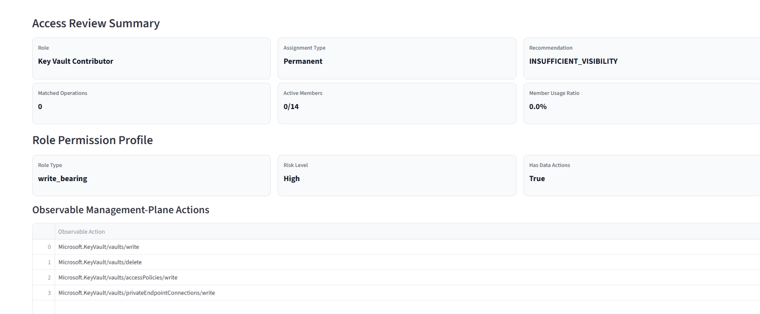
Figure 11: Group overview for audit reader scenario
This view shows the non-production audit reader group with thirty-five members and a 120-day lookback period. It demonstrates that read-only roles require different treatment.
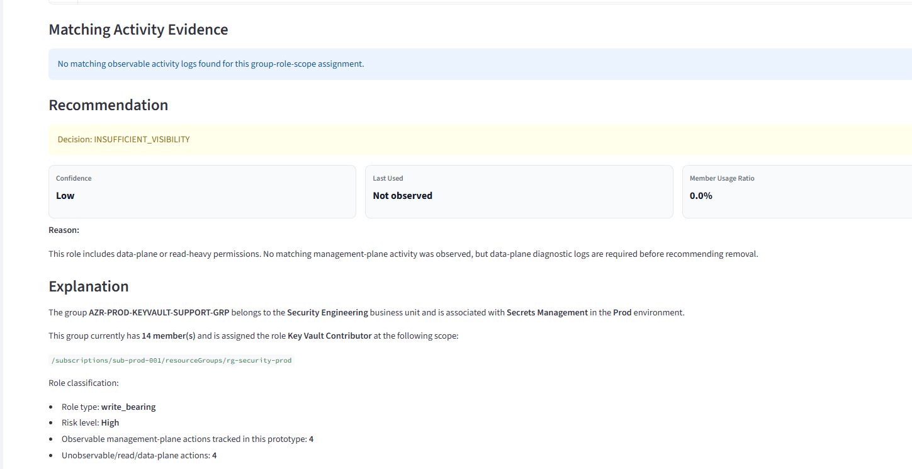
Figure 12: Key Vault Contributor insufficient visibility scenario
For Key Vault Contributor, no management-plane activity is observed, but the role has data-plane implications. The system returns INSUFFICIENT_VISIBILITY, meaning diagnostic logs are required before making a removal recommendation.

8. Scenarios Covered by the Screenshots
Scenario | Observed Evidence | Recommendation | Reason
Network operations group | 3 matching operations by 2 of 28 members | MAKE_PIM_ELIGIBLE | Role is high-risk and used by a small percentage of members; PIM eligible is a safer standing-access reduction option
Storage support group | 0 matching operations; role may involve data-plane activity | INSUFFICIENT_VISIBILITY | Data-plane diagnostic logs are needed before recommending removal
Audit reader group | 0 matching activity visible | KEEP_LOW_PRIORITY | Read-only role activity is generally not visible in Azure Activity Log; do not treat absence of logs as absence of use
Key Vault support group | 0 matching management-plane activity; role has data-plane implications | INSUFFICIENT_VISIBILITY | Sensitive access cannot be removed safely without diagnostic log visibility
Break-glass administrators | Rare or sensitive emergency use | MANUAL_REVIEW_REQUIRED | Break-glass groups should not be automatically downgraded or removed based on low usage

9. Recommendation Logic
The recommendation logic is rule-based. It uses evidence such as role type, matched operation count, distinct member count, data-plane visibility, and group exclusion status. This is intentionally deterministic so that the review result can be explained and audited.
Rule Condition | Recommended Decision | Explanation
Group is break-glass or excluded | MANUAL_REVIEW_REQUIRED | Sensitive access requires human review even if usage is low
Role is read-only | KEEP_LOW_PRIORITY | Read/list activity may not be visible in Activity Log
Role has data actions and no management-plane activity is visible | INSUFFICIENT_VISIBILITY | Data-plane diagnostic logs are needed before removal
Write-bearing role has zero matched operations | REMOVE_CANDIDATE | No observed write/action/delete evidence within the review window
Role has low usage or only few active members | MAKE_PIM_ELIGIBLE | Permanent standing access may not be justified
Role is used regularly by multiple members | KEEP_PERMANENT | Permanent access may be justified but should still be periodically reviewed

10. Limitations and Safeguards
- Activity Log limitation: Azure Activity Log is useful for management-plane operations, but it is not complete for read and data-plane activity.
- Retention limitation: The default Activity Log retention is 90 days. Longer review windows require diagnostic export and retention in Log Analytics, Storage, or Event Hub.
- Attribution limitation: The tool does not prove that the exact group assignment authorized the operation; the same user may have access through another path.
- Current membership limitation: The sample project uses current group membership. Enterprise implementation should include historical membership from Entra audit logs.
- No automatic remediation: The tool recommends actions but does not remove or change access automatically.
- Safety-first decisions: When visibility is incomplete, the tool returns INSUFFICIENT_VISIBILITY or MANUAL_REVIEW_REQUIRED rather than removal.

11. Enterprise-Scale Implementation
At enterprise scale, this sample project can be extended into a scheduled governance platform that continuously reviews group-level Azure RBAC assignments across management groups, subscriptions, and resource groups.
Enterprise Component | Recommended Implementation
Identity and access | Managed identity for read-only inventory; separate approval-gated identity for remediation
RBAC assignment inventory | Azure Resource Graph and Azure Authorization APIs
Group membership | Microsoft Graph current membership; Entra audit logs for historical membership
Activity history | Azure Activity Logs exported to Log Analytics with retention matching review window
Data-plane visibility | Resource diagnostic logs for services such as Storage, Key Vault, SQL, and App Services
Processing layer | Azure Functions, Azure Container Apps Jobs, or Azure Automation
Storage | Azure SQL, Cosmos DB, or Storage Account for snapshots and recommendation history
Workflow integration | ServiceNow, Azure DevOps work items, or Microsoft Entra Access Reviews
Reporting | Power BI or Azure Workbooks for trends and governance dashboards
Optional AI | Azure OpenAI for explanation generation, summarization, and role right-sizing suggestions

12. AI-Based and Non-AI Implementation Options
The use case can be implemented both with and without AI. A non-AI implementation is sufficient for the core recommendation if the rules are well defined. AI becomes useful when the organization wants more natural explanations, summarization across many groups, or advanced right-sizing assistance.
Implementation Mode | Description | Recommended Use
Without AI | Python rule engine calculates recommendations from activity evidence and thresholds | Best for core governance decision and auditability
With AI for explanations | LLM receives deterministic facts and writes clearer reviewer-friendly summaries | Useful for management reporting and access review communication
With AI for right-sizing suggestions | LLM suggests candidate roles based on observed operation patterns; deterministic validation confirms | Useful when role mapping is complex
Agentic AI | Agent can prepare tickets, summaries, and remediation plans, but should not execute changes without approval | Useful in mature enterprise workflows with strong guardrails

13. Cost Considerations
The sample project itself has no cloud cost because it runs locally with mock data. Enterprise costs depend on the implementation pattern and data volume. The largest likely cost components are Log Analytics ingestion/retention, compute for scheduled processing, storage for snapshots, and optional Azure OpenAI token usage.
Cost Area | Expected Cost Driver | Cost Control Approach
Streamlit sample project | Local development only | No meaningful cloud cost
Log Analytics | Data ingestion volume and retention period | Export only required categories; use retention aligned to governance need
Azure Activity Logs | Default 90-day retention is included; longer retention requires export | Use diagnostic settings and centralized workspace planning
Compute | Scheduled job frequency and number of subscriptions/groups processed | Batch processing and incremental scans
Storage | Recommendation history and evidence snapshots | Store summarized evidence rather than all raw logs where possible
Azure OpenAI optional | Token usage for explanation and summaries | Use small/low-cost models for explanation; keep core decision outside LLM
Power BI / reporting | Workspace licensing and dashboard usage | Reuse existing enterprise reporting stack where available
Cost note: official Azure pricing changes by region, model, and service tier. Log Analytics pricing is generally based on ingested data volume and retention. Azure OpenAI pricing is token-based and depends on the model selected. For a production estimate, use the Azure Pricing Calculator with expected log volume, retention period, number of groups, run frequency, and AI token volume.

14. Recommended Roadmap
Phase | Scope
Phase 1 - Sample project | Mock data, local Streamlit UI, rule-based recommendation, screenshot-based walkthrough
Phase 2 - Pilot with real data | Connect to selected subscriptions, Microsoft Graph, Azure RBAC APIs, and Log Analytics
Phase 3 - Governance workflow | Add evidence storage, approval workflow, ServiceNow integration, and review tracking
Phase 4 - Enterprise rollout | Tenant-wide scheduled scans, Power BI dashboard, historical trend reporting, and PIM conversion workflow
Phase 5 - AI enhancement | Use Azure OpenAI for explanation generation, portfolio summaries, and right-sizing suggestions with validation

15. Conclusion
UC2 complements UC1 by closing the access governance loop. UC1 helps ensure least privilege when new access is requested. UC2 reviews access that has already been granted and identifies whether it still deserves to remain permanent.
The sample project demonstrates the feasibility of reviewing group-level RBAC assignments using evidence from group membership, role assignments, role definitions, and activity history. It shows practical decisions such as moving rarely used access to PIM eligible, keeping read-only roles as low priority, and avoiding removal when visibility is insufficient.
The strongest design pattern is to keep the core recommendation deterministic and auditable, while optionally using AI for explanation and summarization. This approach is safer for enterprise adoption and aligns with least-privilege and access governance objectives.

16. References
- Microsoft Learn - Azure Activity Log: default activity log retention and diagnostic export guidance.
- Microsoft Learn - Azure RBAC role definitions: Actions, NotActions, DataActions, and NotDataActions.
- Microsoft Learn - Azure Monitor Logs cost guidance: Log Analytics costs depend on ingestion and retention.
- Microsoft Azure OpenAI pricing page: token-based pricing varies by model, region, and deployment type.

