Minimax-based 5×5 Tic‑Tac‑Toe & Prolog Expert System
ACI – Assignment2- PS10
GROUP 264 - Details:
S.NO | NAME | BITS ID | CONTRIBUTION %
1 | Nalla Manoj Kumar | 2024AC05141 | 100 %
2 | D Mallikarjuna Reddy | 2024AC05653 | 100 %
3 | Sajjala Ashok Reddy | 2024AC05829 | 100 %
4 | Adurti Sai Venkatesh | 2024AC05968 | 100 %
5 | M Satish Kumar | 2024AD05320 | 100 %

This report presents two artefacts: (A) an adversarial search agent that plays 5×5 Tic‑Tac‑Toe where the win condition is any four consecutive marks in a row, column, or diagonal, and (B) a logic expert system implemented in Prolog by converting a decision tree into a set of Horn‑clause rules. Part A details the problem formalization, a hand‑crafted static evaluation function, and the Minimax with alpha–beta pruning approach used by the AI player. Part B explains how to analyze a decision tree, derive if‑then rules for each root‑to‑leaf path, and run an interactive recommendation session. Screenshots of code execution will be inserted later into this document by the student.

Part A: Gaming

5×5 Tic‑Tac‑Toe with Minimax Algorithm

Theoretical Foundation

Board: a 5×5 grid initialized empty. Two players place marks: ‘X’ and ‘T’. The first to achieve four consecutive identical marks horizontally, vertically, or diagonally wins immediately. If the board fills with no such line, the game is a draw.
State representation: a 5×5 matrix of characters {‘X’, ‘T’, ‘.’}. A move is a pair (row, col) pointing to an empty cell.
A terminal state is reached when
- there exists a 4‑in‑a‑row for either player, or
- (ii) no empty cells remain.
Number of lengths‑4 windows:
• Horizontal: 5 rows × (5−4+1) =2 → 10.
• Vertical: 5 × 2 → 10.
• Diagonal – downwards: (5−4+1) × (5−4+1) =2×2 → 4.
• Diagonal – upwards: 4.
Total = 28.
Static evaluation: Sum contributions F(W) over all 28 windows W. Let a(W) be # of AI ‘X’ and h(W) be # of opponent ‘T’ in W.
Window rule F(W):
• If a(W) > 0 and h(W) > 0 → F(W)=0 (blocked).
• Else if a(W) > 0 → F(W)= +w(a(W)).
• Else if h(W) > 0 → F(W)= −w(h(W)).
• Else → 0.
Weights: w(1) =1, w(2) =5, w(3) =50, w(4) =100000.
Terminal wins/losses: ±1,000,000,000.
Center tie‑breaker: +1 for each AI ‘X’ and −1 for each ‘T’ in (3,3), (3,2), (3,4), (2,3), (4,3).
Final evaluation: E = ΣW F(W) + S_center.

Worked Example: scoring the sample board (AI = ‘X’)

No. | Cells (r,c) | Contents | a(X) | h(T) | F(W) | Running Σ
1 | (1,1) (1,2) (1,3) (1,4) | X... | 1 | 0 | 1 | 1
2 | (1,2) (1,3) (1,4) (1,5) | ...X | 1 | 0 | 1 | 2
3 | (2,1) (2,2) (2,3) (2,4) | .XT. | 1 | 1 | 0 | 2
4 | (2,2) (2,3) (2,4) (2,5) | XT.T | 1 | 2 | 0 | 2
5 | (3,1) (3,2) (3,3) (3,4) | ..XT | 1 | 1 | 0 | 2
6 | (3,2) (3,3) (3,4) (3,5) | .XTT | 1 | 2 | 0 | 2
7 | (4,1) (4,2) (4,3) (4,4) | .TT. | 0 | 2 | -5 | -3
8 | (4,2) (4,3) (4,4) (4,5) | TT.X | 1 | 2 | 0 | -3
9 | (5,1) (5,2) (5,3) (5,4) | .X.. | 1 | 0 | 1 | -2
10 | (5,2) (5,3) (5,4) (5,5) | X... | 1 | 0 | 1 | -1
11 | (1,1) (2,1) (3,1) (4,1) | X... | 1 | 0 | 1 | 0
12 | (1,2) (2,2) (3,2) (4,2) | .X.T | 1 | 1 | 0 | 0
13 | (1,3) (2,3) (3,3) (4,3) | .TXT | 1 | 2 | 0 | 0
14 | (1,4) (2,4) (3,4) (4,4) | ..T. | 0 | 1 | -1 | -1
15 | (1,5) (2,5) (3,5) (4,5) | XTTX | 2 | 2 | 0 | -1
16 | (2,1) (3,1) (4,1) (5,1) | .... | 0 | 0 | 0 | -1
17 | (2,2) (3,2) (4,2) (5,2) | X.TX | 2 | 1 | 0 | -1
18 | (2,3) (3,3) (4,3) (5,3) | TXT. | 1 | 2 | 0 | -1
19 | (2,4) (3,4) (4,4) (5,4) | .T.. | 0 | 1 | -1 | -2
20 | (2,5) (3,5) (4,5) (5,5) | TTX. | 1 | 2 | 0 | -2
21 | (1,1) (2,2) (3,3) (4,4) | XXX. | 3 | 0 | 50 | 48
22 | (1,2) (2,3) (3,4) (4,5) | .TTX | 1 | 2 | 0 | 48
23 | (2,1) (3,2) (4,3) (5,4) | ..T. | 0 | 1 | -1 | 47
24 | (2,2) (3,3) (4,4) (5,5) | XX.. | 2 | 0 | 5 | 52
25 | (4,1) (3,2) (2,3) (1,4) | ..T. | 0 | 1 | -1 | 51
26 | (4,2) (3,3) (2,4) (1,5) | TX.X | 2 | 1 | 0 | 51
27 | (5,1) (4,2) (3,3) (2,4) | .TX. | 1 | 1 | 0 | 51
28 | (5,2) (4,3) (3,4) (2,5) | XTTT | 1 | 3 | 0 | 51
Window sum ΣW F(W) = 51. Center bias over (3,3)='X', (3,2)='.', (3,4)='T', (2,3)='T', (4,3)='T' is +1 + 0 −1 −1 −1 = −2.
Final evaluation E = 51 + (−2) = 49. (Positive → better for AI ‘X’.)

Implementation:

• State & moves: 5×5 grid; a move fills an empty cell with the current player’s mark.
• Terminal test: scan all 28 windows; detect 4‑in‑a‑row or full board (draw).
• Search: Minimax with alpha–beta pruning; fixed depth chosen by the user at runtime.
• Move ordering: prefer center‑near moves to increase cut‑offs; does not change correctness.
• Evaluation: window scoring + center bias; terminal scores override with ±1,000,000,000.

Execution and Screenshots

- Source code can be found in uploaded ipynb file.
Game loop (human vs AI)
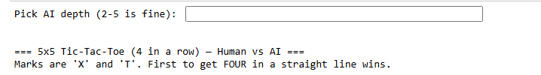
Let’s choose few things before the game begins:
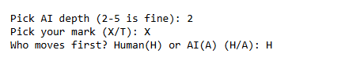
Initial Empty board:
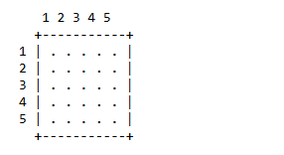
It prompts for first move:

It lets Human to chose rol,col for first move and then followed by AI first move:
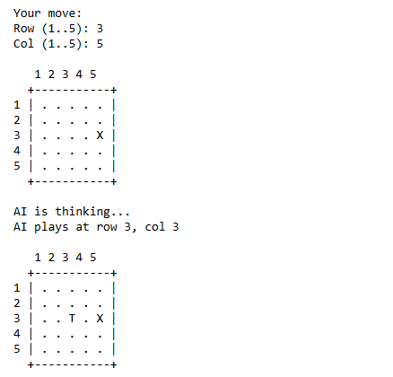
Followed by series of moves – based on Human inputs given:
This would be final step:
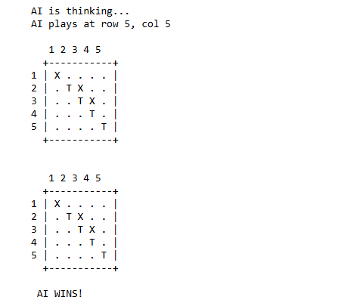
Let’s implement the same game with better GUI – Tkinter python module.
- Source code for the same can be found in ipynb file
- Initial state:
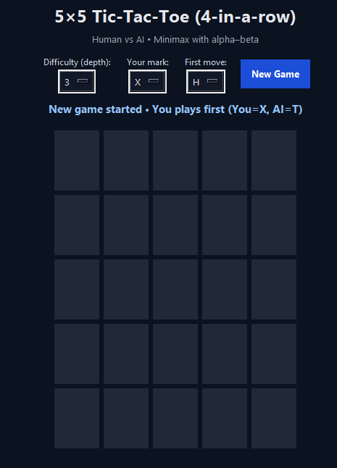

- We can chose the difficulty level, Mark (X/T) and who to make first move.
- Final state (one of the case where AI wins)
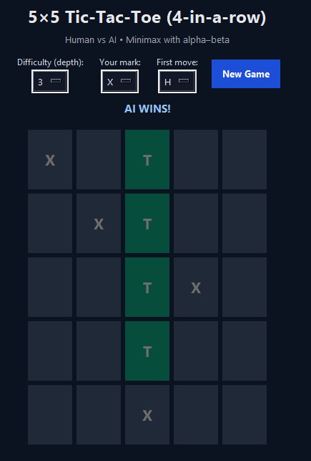

Part B: Logic

Goal: Convert the provided raisin-classification decision tree into a set of IF–THEN rules, encode them as Prolog rules, and implement an interactive expert system that asks for attribute values and outputs the predicted raisin type.
Scope: dataset description (features & classes), the exact decision tree in readable form, a rigorous rule derivation, and instructions for interactive behavior and validation.

Prolog Expert System - Raisin classification:

Dataset Details:

Typical numeric features used in the Raisin dataset (image-based shape descriptors):
Feature | Meaning (short description)
Area | Number of pixels within the region of the raisin (surface area).
Perimeter | Length of the boundary around the raisin region.
MajorAxisLength | Length of the major axis (longest diameter) of the fitted ellipse.
MinorAxisLength | Length of the minor axis (shortest diameter) of the fitted ellipse.
Eccentricity | Ellipse-based elongation; 0≈circle, closer to 1≈more elongated.
ConvexArea | Area of the convex hull of the region.
Extent | Ratio: Area / (bounding box width × height).

Target classes: Kecimen, Besni.

Decision Tree Provided:

Note: The screenshot shows a character artefact “ï»¿Area”; it denotes “Area”. The readable tree is:
MajorAxisLength ≤ 422.279133
├─ Perimeter ≤ 1006.375 : Kecimen (287.0 / 24.0)
└─ Perimeter > 1006.375
├─ Extent ≤ 0.7476
│ ├─ Perimeter ≤ 1122.831
│ │ ├─ Area ≤ 62835
│ │ │ ├─ Extent ≤ 0.701678
│ │ │ │ ├─ Extent ≤ 0.666255 : Besni (4.0)
│ │ │ │ └─ Extent > 0.666255 : Kecimen (4.0)
│ │ │ └─ Extent > 0.701678 : Besni (6.0)
│ │ └─ Area > 62835 : Kecimen (124.0 / 24.0)
│ └─ Perimeter > 1122.831
│ ├─ Extent ≤ 0.671309 : Besni (7.0)
│ └─ Extent > 0.671309
│ ├─ Eccentricity ≤ 0.75951 : Besni (22.0 / 7.0)
│ └─ Eccentricity > 0.75951 : Kecimen (9.0 / 1.0)
└─ Extent > 0.7476 : Kecimen (27.0)
MajorAxisLength > 422.279133 : Besni (410.0 / 41.0)

Rule Derivation (root-to-leaf IF–THEN rules)

Each rule corresponds to a unique root→leaf path and uses the exact thresholds from the tree.
R1. IF MajorAxisLength ≤ 422.279133 AND Perimeter ≤ 1006.375 THEN Class = Kecimen.
R2. IF MajorAxisLength ≤ 422.279133 AND Perimeter > 1006.375 AND Extent ≤ 0.7476 AND Perimeter ≤ 1122.831 AND Area ≤ 62835 AND Extent ≤ 0.701678 AND Extent ≤ 0.666255 THEN Class = Besni.
R3. IF MajorAxisLength ≤ 422.279133 AND Perimeter > 1006.375 AND Extent ≤ 0.7476 AND Perimeter ≤ 1122.831 AND Area ≤ 62835 AND Extent ≤ 0.701678 AND Extent > 0.666255 THEN Class = Kecimen.
R4. IF MajorAxisLength ≤ 422.279133 AND Perimeter > 1006.375 AND Extent ≤ 0.7476 AND Perimeter ≤ 1122.831 AND Area ≤ 62835 AND Extent > 0.701678 THEN Class = Besni.
R5. IF MajorAxisLength ≤ 422.279133 AND Perimeter > 1006.375 AND Extent ≤ 0.7476 AND Perimeter ≤ 1122.831 AND Area > 62835 THEN Class = Kecimen.
R6. IF MajorAxisLength ≤ 422.279133 AND Perimeter > 1006.375 AND Extent ≤ 0.7476 AND Perimeter > 1122.831 AND Extent ≤ 0.671309 THEN Class = Besni.
R7. IF MajorAxisLength ≤ 422.279133 AND Perimeter > 1006.375 AND Extent ≤ 0.7476 AND Perimeter > 1122.831 AND Extent > 0.671309 AND Eccentricity ≤ 0.75951 THEN Class = Besni.
R8. IF MajorAxisLength ≤ 422.279133 AND Perimeter > 1006.375 AND Extent ≤ 0.7476 AND Perimeter > 1122.831 AND Extent > 0.671309 AND Eccentricity > 0.75951 THEN Class = Kecimen.
R9. IF MajorAxisLength ≤ 422.279133 AND Perimeter > 1006.375 AND Extent > 0.7476 THEN Class = Kecimen.
R10. IF MajorAxisLength > 422.279133 THEN Class = Besni.
These rules are mutually exclusive and collectively exhaustive given the monotone ≤/> splits.

Interactive Expert System

Inputs required: MajorAxisLength, Perimeter, Extent, Area, Eccentricity (all numeric).
Run-time flow:
• Prompt user for values.
• Evaluate the tests in the exact order of the tree, printing each branch decision (e.g., “Extent ≤ 0.7476 → left”).
• Stop at the first matching leaf and print the final class.
• Validate with examples that purposely fall just below/above each threshold.

Validation & Screenshot Placeholders

- Source code is saved in prolog (pl) file
- Open command prompt and run swipl -s partb_raisin_class.pl -g start


As shown in screenshot, this will give the URL for Interactive webpage as below.

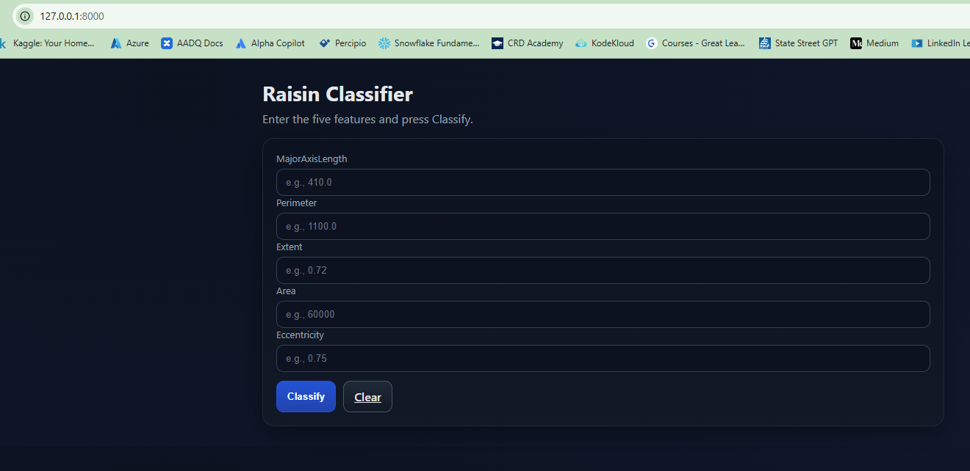

Lets run the example values for classification.
Class 1 (Kecimen):
Feature values: 410.0, 980.0, 0.70, 60000, 0.75

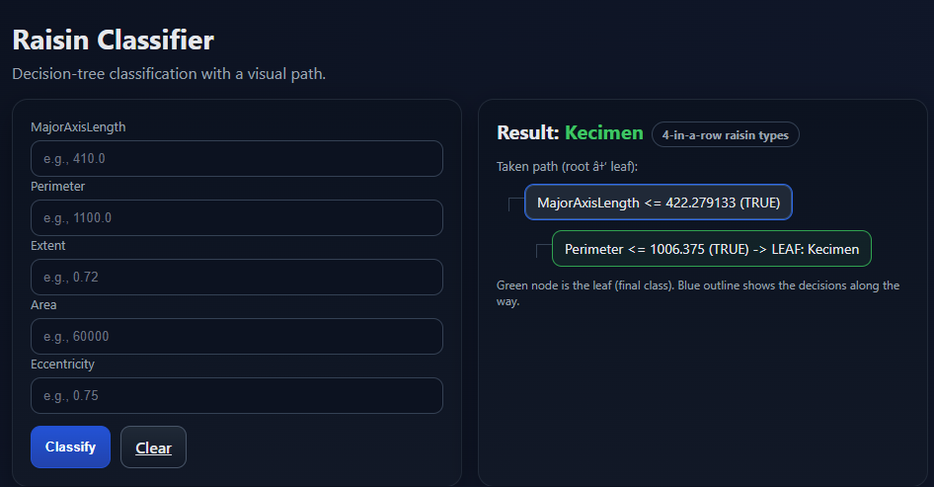

Class 2 (Besni):
Feature values: 430.0, 1000.0, 0.50, 50000, 0.60
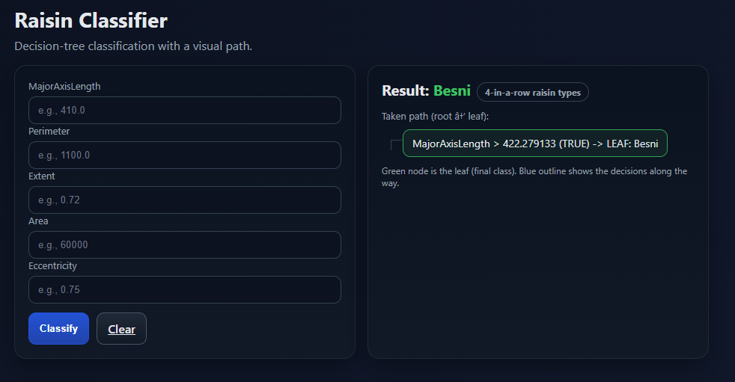

Both the classes have been correctly classified.

Conclusion:

We crafted and justified a static evaluation grounded in the 4‑in‑a‑row objective, implemented Minimax with alpha–beta pruning, and executed an interactive game loop. We also converted a decision tree to declarative rules and drove an interactive expert system session.
Key learning outcomes: translating problem rules into a heuristic, understanding optimal adversarial search, and mapping tree‑based models into symbolic logic rules.

------------------------------------------------End-------------------------------------------------------

